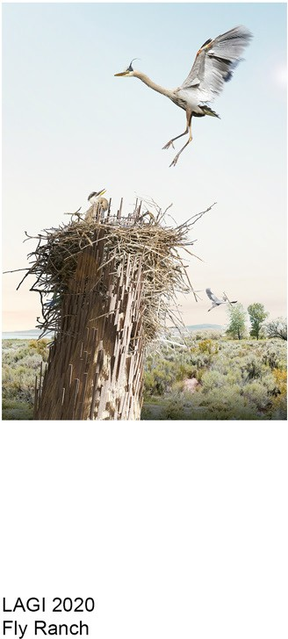

Lodgers

*Serendipity in the Fly Ranch Wilderness*

Contents

**Prologue: Project Statement**

Our response to the shelter / zero-waste

*... 3*

**Chapter 1: Design for Cohabitation and Environmental Education**

Environmental Impact Summary Trail for Education and Experience Environmental Education Center Temporality and Habitation

*... 5*

*... 6*

*... 7*

*... 10*

*... 15*

**Chapter 2: Inquires on the Site: Animals, Plants, and Humans**

Entanglement of Species at Fly Ranch Habitat of Native Animals

Art and Architecture for Positive Environmental Impact

Design Iteration

*... 17*

*... 18*

*... 19*

*... 20*

*... 22*

**Chapter 3: History, Material, and Construction**

Land Stewardship

Timber Industry and Recycling in Nevada Traditional Construction Methods Thatching

Parametric Design Construction Detail

Cost Estimate and On-site Prototype Strategy

*... 24*

*... 25*

*... 26*

*... 27*

*... 28*

*... 29*

*... 30*

*... 35*

**Appendix**

*... 36*

*... 37*

*... 38*

Fabrication Shop for Prototyping

Technology and Reference

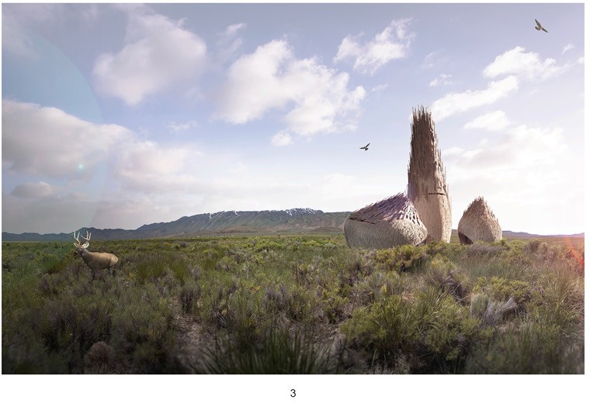

**Prologue: Project Statement**

*Our response to shelter and zero-waste*

Fly Ranch sits on a land of wonders with a diverse collection of natural conditions. Under the shared stewardship of the Burning Man Project and the indigenous people of the land, Fly Ranch inspires us to consider future scenarios and unexpected encounters on the landscape. What is the dream of Fly Ranch? Whose dream is it? What is the relationship between new and native “inhabitants,” plant and animal, and between the “inhabitants” and the land? How will we live together at Fly Ranch?

Art and Architecture are often confined by a human- centric perspective. This project explores an alternative vision for environmental stewardship and art where human interventions are not placed above the biosphere and geosphere. In this case, art is a medium to foster kinship between humans and our other-than-human neighbors – a device that lives and decays with the environment over time rather than alter it irrevocably

– and a catalyst for enriching biodiversity and environmental education.

Our vision for Fly Ranch is to build a collective dream that enables symbiotic relationships between the land, humans and other living things whose footprint precede us and who may stop by in the future. The *lodgers* encompass all inhabitants on the land, including humans, plants and animal species and our proposed ‘living’ structures. Overtime, *lodgers* will inevitably come, go or decay and return to the land. As the land responds to the changing of the seasons and the climate, it welcomes and responds to new *lodgers*. The *lodgers* we propose to build on the land act only as temporary guests for a sustainable future.

Therefore, with the mission to continue land stewardship and foster a growing lodger community, we propose

an educational center for environmental awareness and potentially a series of devices, three large and many small lodgers, across Fly Ranch. Our design proposal integrates the layered histories and realities of the natural resources, ecosystems, traditional construction methods local to the site.

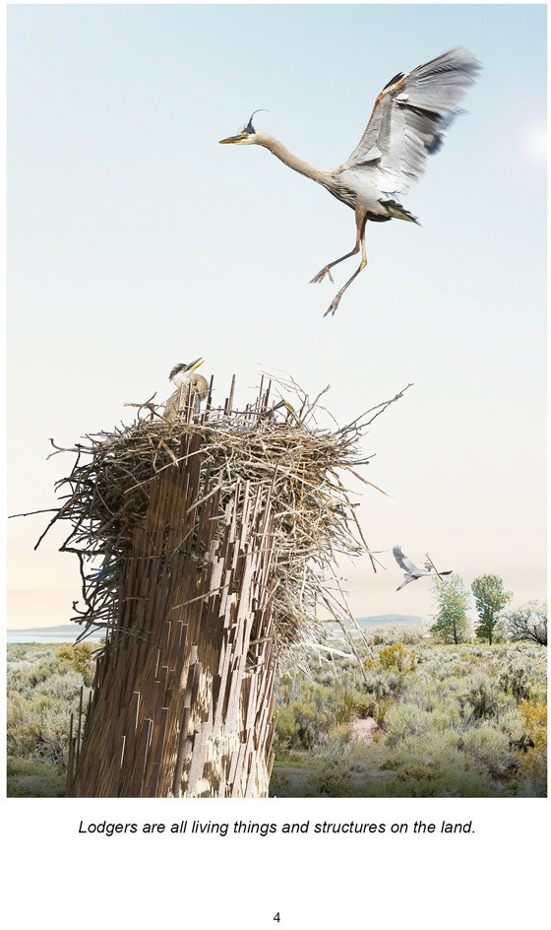

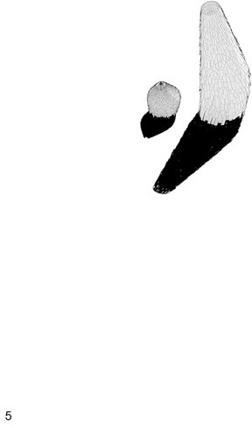

**Chapter 1**

Design for Cohabitation and Environmental Education

**Environmental Impact Summary**

*Rooted in innovations for shelter and regeneration, our proposal aims to minimize human’s impact on the environment and build symbiotic relationships between humans, plants and animals.*

Our design proposal emphasizes three main areas

to achieve sustainability, efficiency and net zero

– **material sources, construction methods, and prefabricated products**.

reinforcement every year. The compost toilet requires adding organic matters such as hydrate coco coir or peat moss and scooping out 20%-30% of the compost, frequency depending on the usage. However, if the structure is reinforced and the thatching is replaced, we can extend the life cycle. **If the structures are decommissioned, they can remain on-site, decay with time, and become a permanent home for animals and plants.**

Firstly, we **source renewable and reclaimed wood**, including typical dimensional timber for 95% of the structure and dried grass for 100% of the facade, for our design. The other 5% of the materials used in the design are the small metal components such as plates and bolts. The intention is to collect the wood on- site and from nearby demolition sites to reduce the carbon footprint in material transportation.

In conclusion, our proposal has low embodied energy in building materials, low energy intensity of construction methods, moderate expected lifetime of usefulness, and high recyclability of materials.

Furthermore, we **adapt the indigenous shelter and light timber framing construction methods**

**using computational tools** to iterate and test for low environmental impact. With light timber framing and thatching construction, we **eliminate the need for heavy equipment on-site and specialized training** for our crew. Moreover, we hope to engage communities at Fly Ranch in the construction process.

We have outlined strategies for monthly structure check-ups and mitigation in case of fire hazards. The Fly Ranch team can use the water hose on-site in case of a fire emergency. We also suggest a monthly check-up by a responsible staff or community member to maintain the artwork’s structural integrity.

Our proposal aims to deepen **community engagement** with the environment with a series of activities, including environmental education programs and creative upcycling workshops for

K-12 students and Gerlach residents. Moreover, we strongly advocate for **dialogues on-site with the Mumu and the Newe**, the indigenous stewards of Fly Ranch, to better our land stewardship practice and understand our relationship with the environment.

Finally, we will use **innovative and low environmental impact prefabricated products** to support the proposal’s function. Based on

our research, we choose to use an affordable footing available on the market that requires little excavation, no heavy tools, or specialized training for installation. This footing will be easy to remove if the structure is decommissioned in the future. We

also choose to use composting toilets to lower water usage and recycle waste into fertilizer.

With renewable wood materials as the main component, **the structures have around 10 years of design life cycle**. It requires a moderate amount of maintenance, including structural integrity examination every two months and thatching

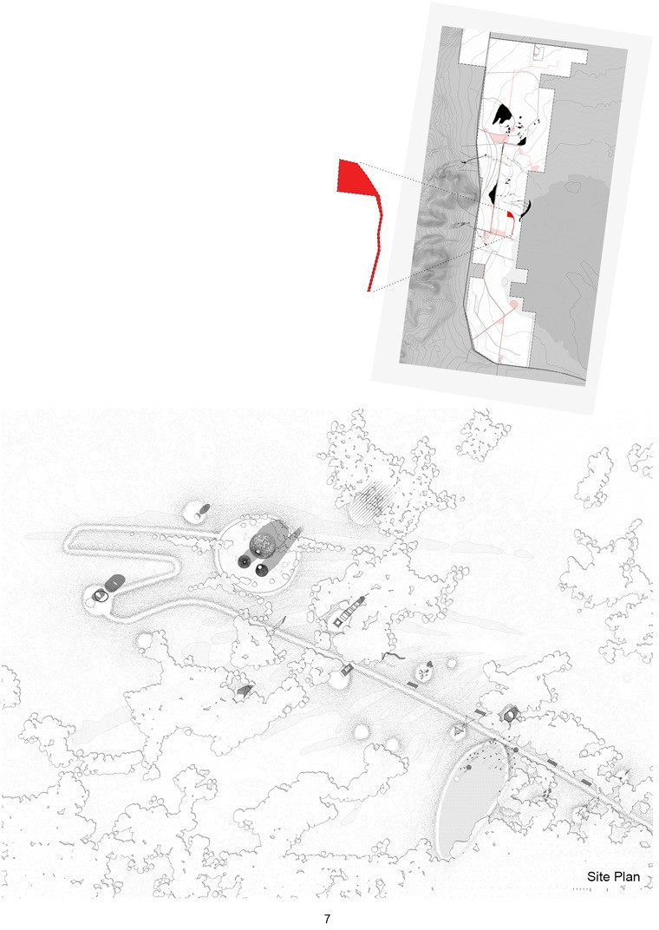

**Trail of Wild Habitat and Environmental Education**

We chose the site marked in red at Fly Ranch for intervention. Although we designed a collection of low-cost, small-scale installations for the land, by no means they should occupy the entire Fly Ranch.

Lodgers’ placement along the trail will be determined by specific site conditions, leading to the Environmental Education Center.

Visitors can interact with smaller lodgers on the trail. At the Center, they can participate in environment-themed workshops led by the Fly Ranch community and appreciate the natural landscape of Fly Ranch from the viewing tower.

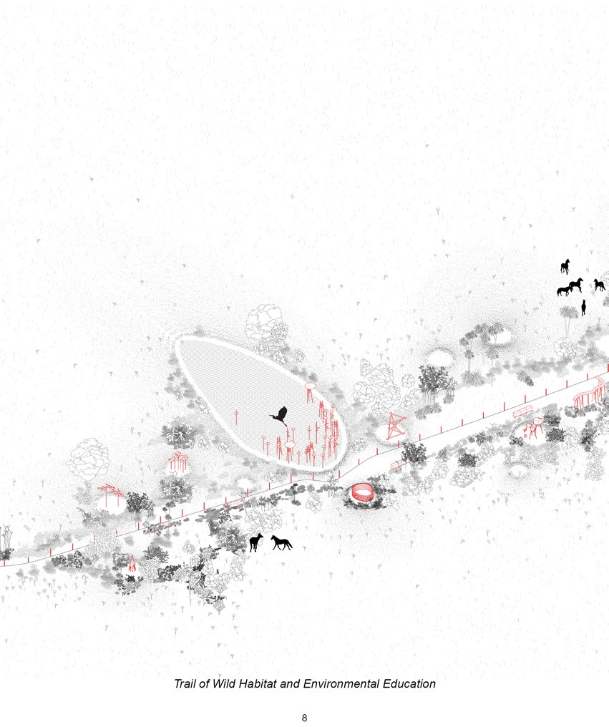

Inundated with plants, animals, and lodgers, the trail establishes a democratic relationship between humans and animals. Animals are here for food and shelter, while humans come to observe and learn from a distance.

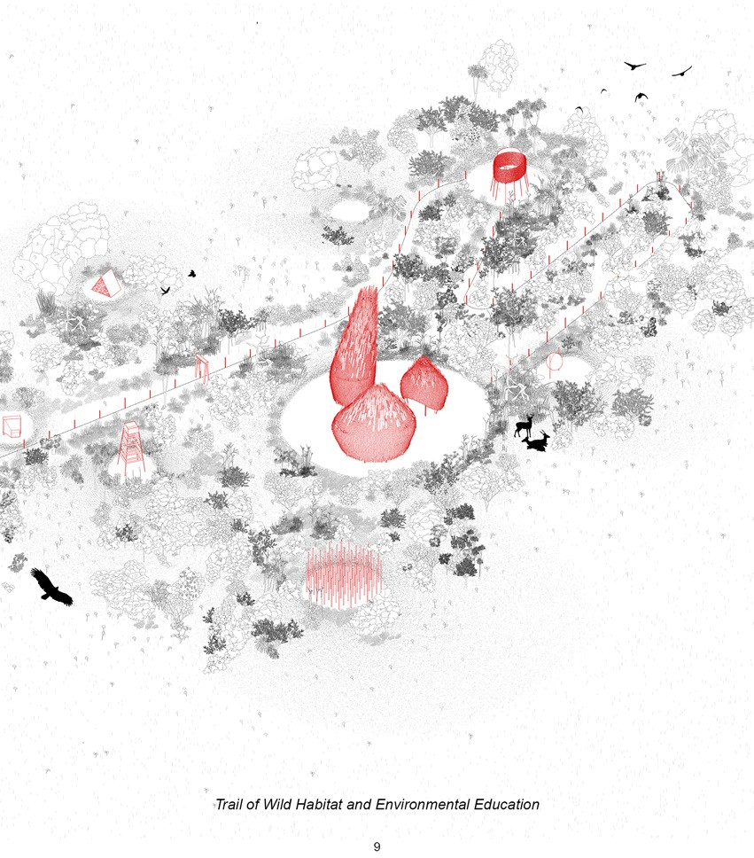

On the trail to the Center, visitors are greeted with lodgers that provide opportunities to interact with the environment. Our proposal also

provides a program for Gerlach K-12 students to learn about the region’s natural and historical environment.

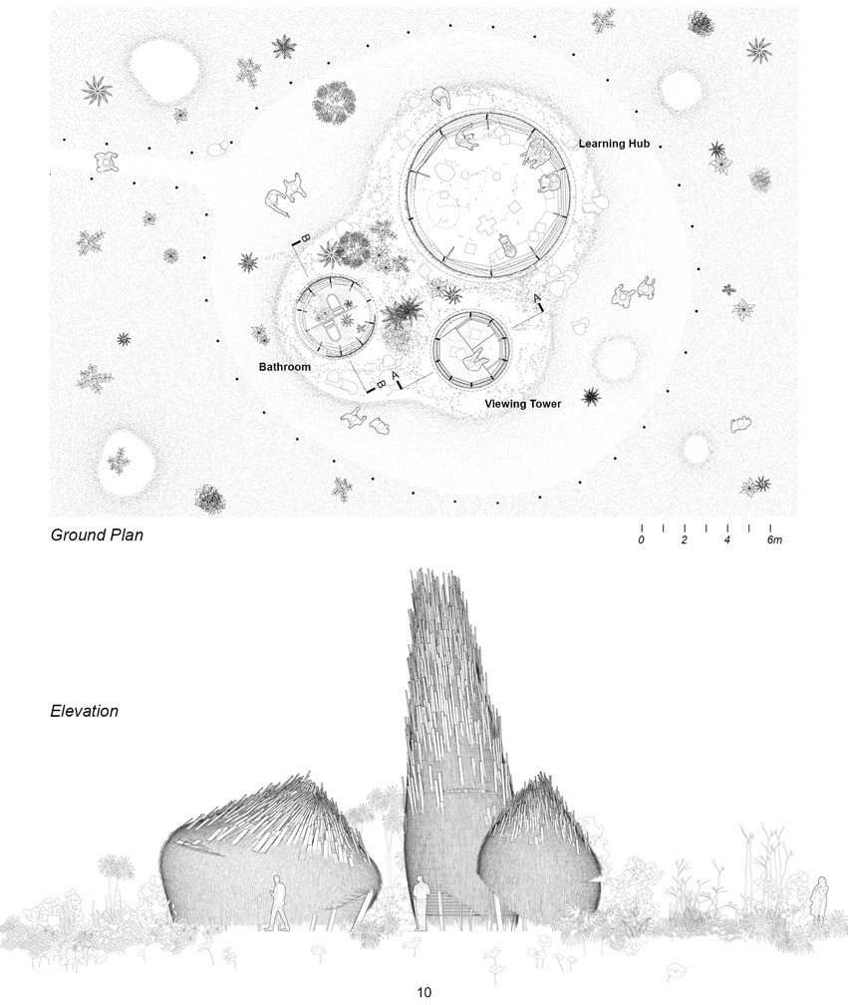

**Environmental Education Center**

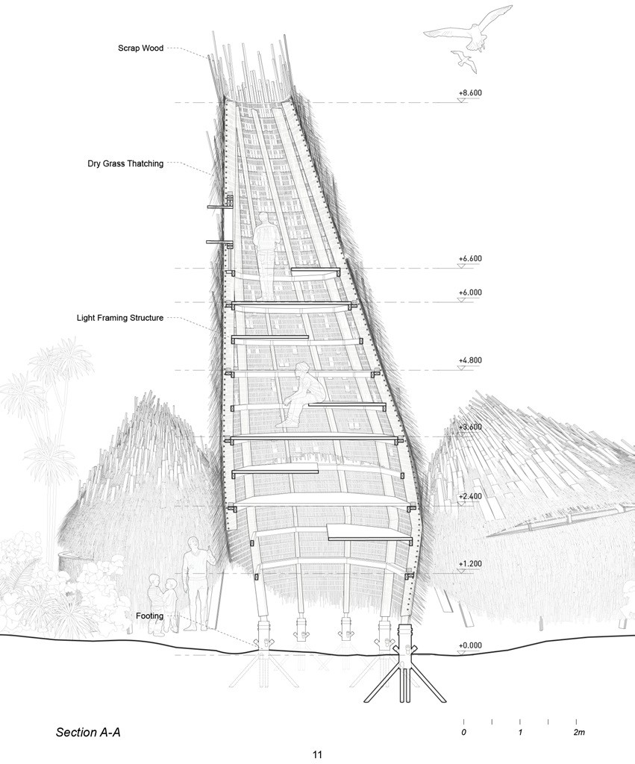

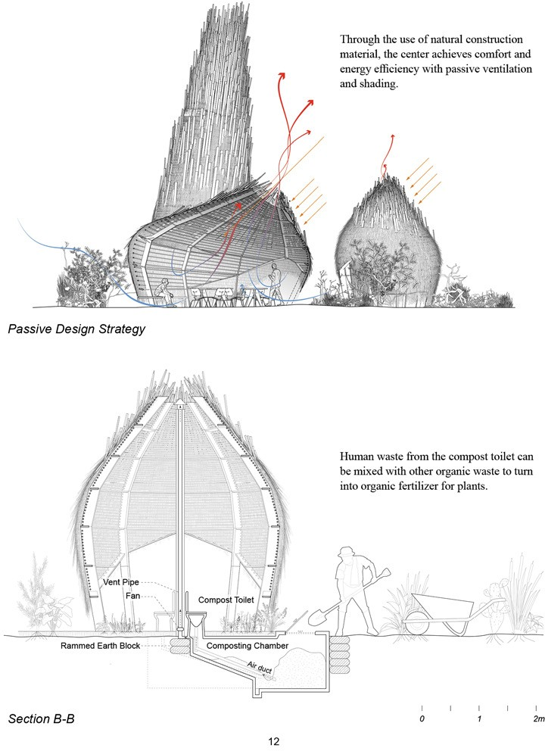

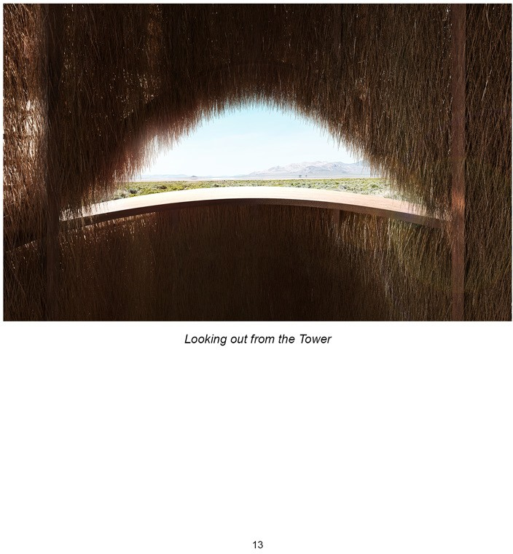

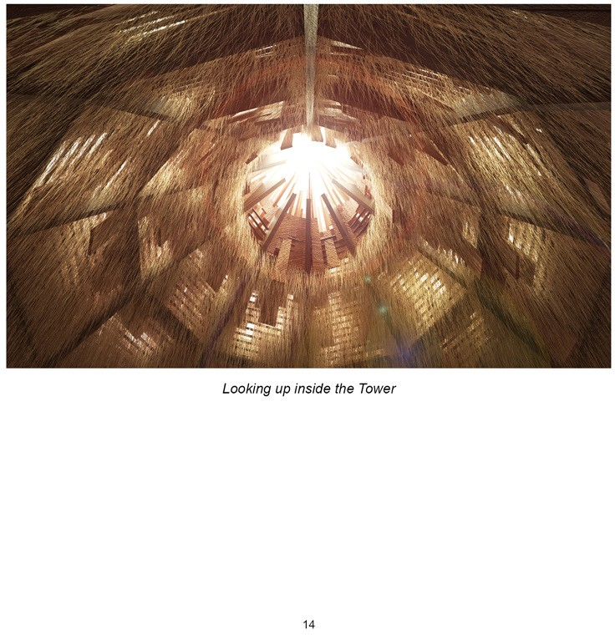

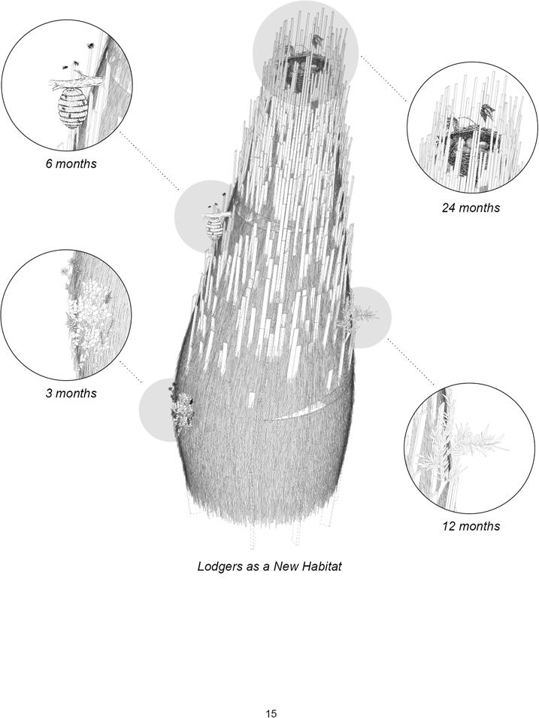

**Temporality and Habitation**

As time passes, plants and animals will eventually make homes in the lodgers. The lodgers will ultimately return to their most elemental form to nourish the other species’ growth. The expression of art and beauty manifests itself in the lodgers’ physical forms and their changes through time.

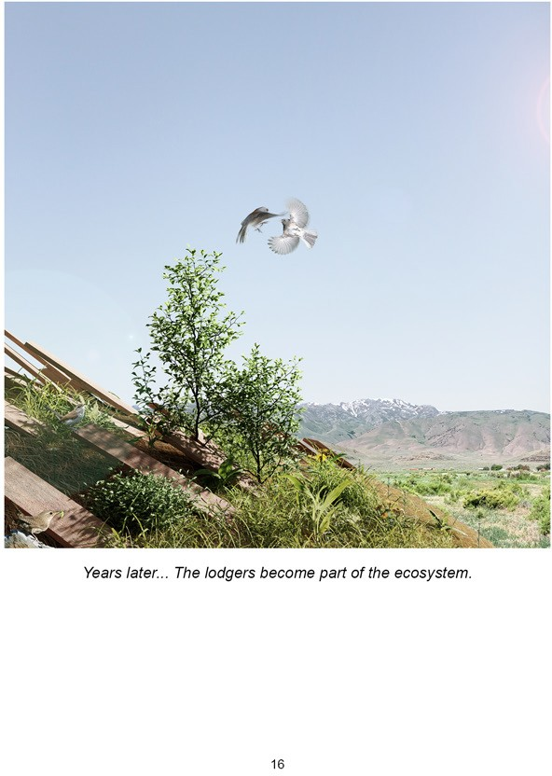

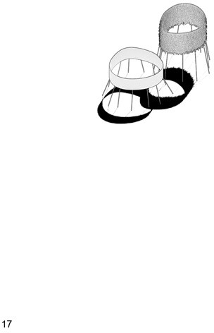

**Chapter 2**

Inquires on a Site: Animals, Plants, and Humans

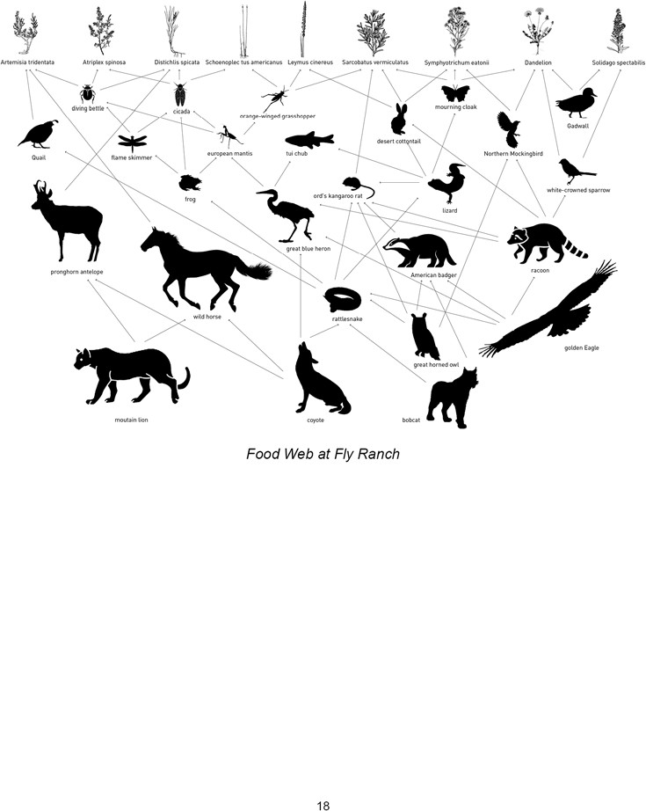

**Entanglement of Species at Fly Ranch**

*Research based on “Fly Ranch Species List” from “Fly Ranch - Burning Man Project”*

Fly Ranch has a rich biodiversity thanks to the centuries-long land stewardship

— it is home to dozens of animals and more than 100 types of plants. The species form a complex yet stable food chain that needs to be attended to when planning for human interventions.

Therefore, we took a deep dive into the extensive species list provided by the Burning Man Project. We categorized 142 plants, 103 birds, 14 mammals,10 reptiles & fish, and 23 arthropods observed at Fly Ranch based on their behavior and habit, location, and preferred habitat condition.

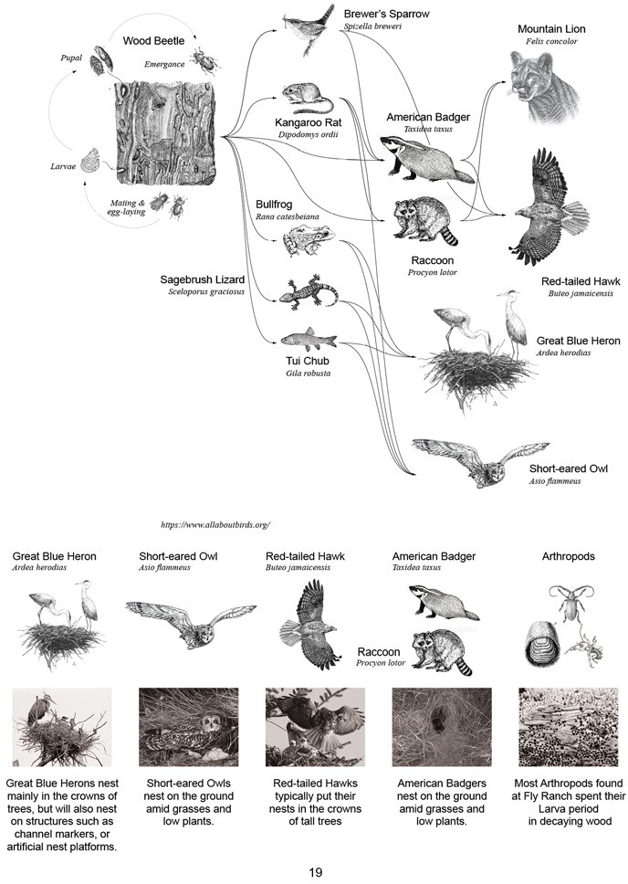

**Habitat of Native Animals**

*Research based on “Fly Ranch Species List” from “Fly Ranch - Burning Man Project”*

*Extracted Food Chain with Key Species*

Fly Ranch has its unique micro- ecosystem with a complete food chain from Producers to Quaternary

Consumers. A seemingly inconsequential link such as Wood Beetle or Kangaroo Rat has profound consequences to the entire ecosystem’s survival. We want our artwork to not only shelter humans but also care for these nature’s lodgers...

*Typical Nesting Conditions*

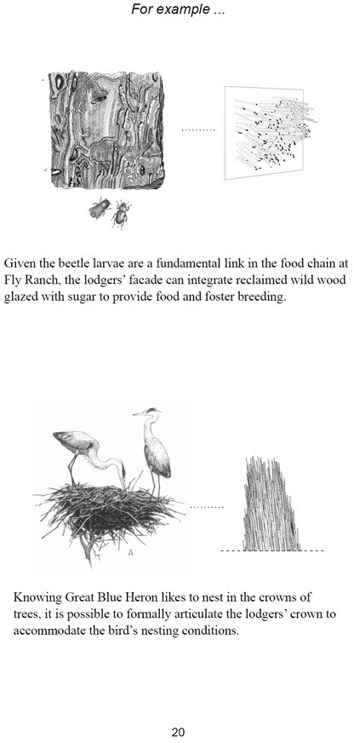

**Art and Architecture for Positive Environmental Impact**

...With the premise of building architectural lodgers for animal habitats whereas humans are occasional guests, the lodgers’ formal expression and materially should have a deep connection with native animals’ habitats. The lodgers have agencies to facilitate the growth of keystone species in a food chain and generate positive environmental changes.

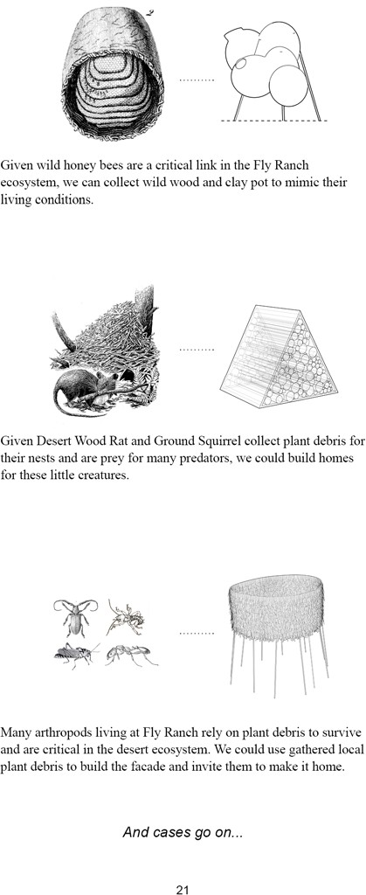

***https://underwoodillustration.com/artwork/3108927-Dusky-footed-Woodrat.html***

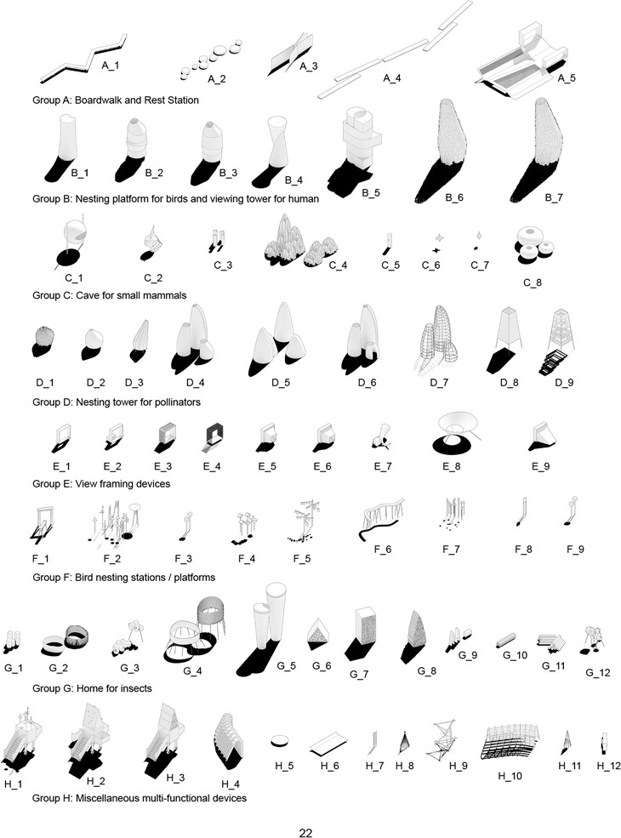

**Design Iteration**

*A collection of lodgers for animal habitation and human encounter*

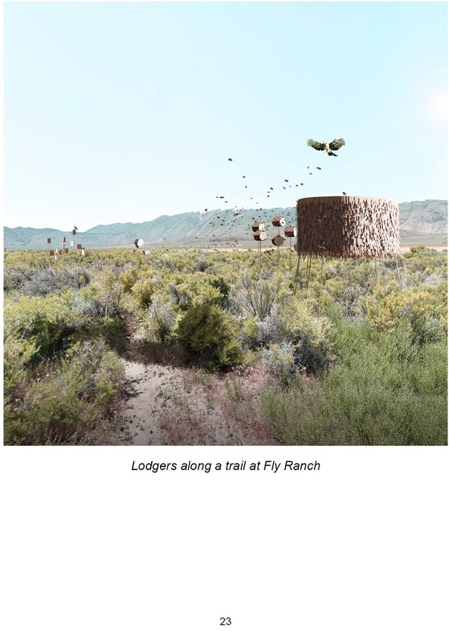

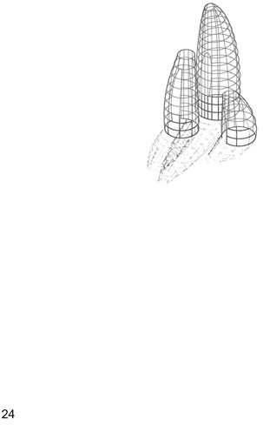

**Chapter 3**

History, Material, and Construction

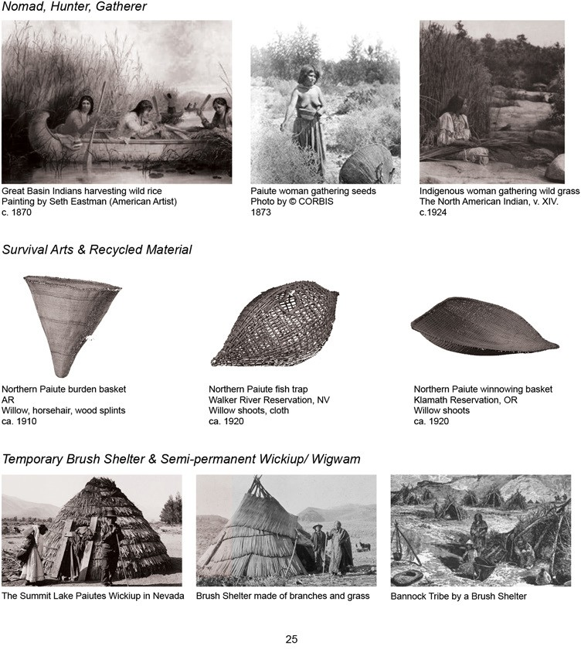

**Land Stewardship**

*Honoring the indigenous people’s harmonious relationship with the land*

Fly Ranch has over 10,000 years of history of stewardship by the Indigenous People. The Numu (Northern Paiute) and the Newe (Western Shoshone) have established their own way to live with the land in Nevada. Examples below show only a snippet of their lifestyle, crafts, and

shelter. We don’t claim expertise in the indigenous practice, and we believe that further dialogue and engagement with the Numu and the Newe are critical for continuing land stewardship.

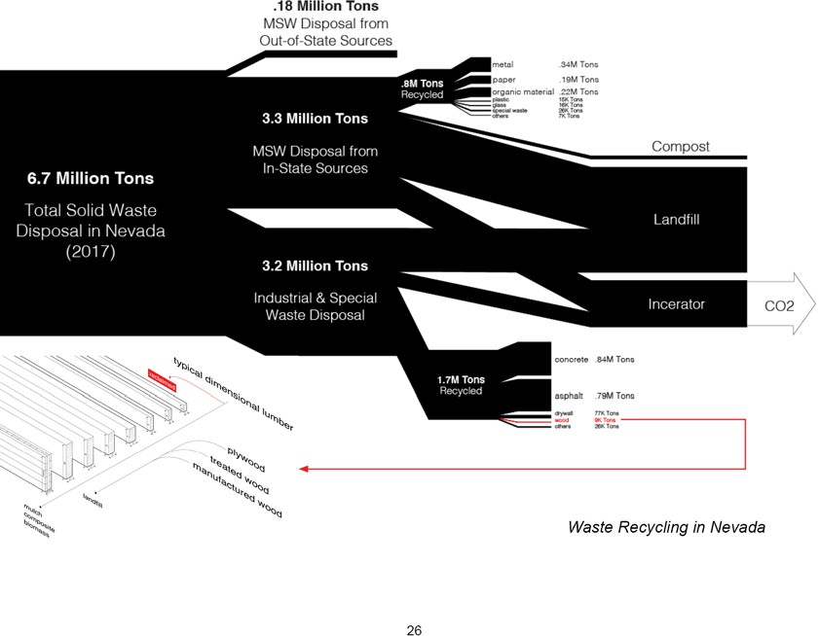

**Timber Industry and Recycling in Nevada**

*Problematizing the current construction practice*

The U.S. has a tradition of wood frame construction since the early nineteenth century. However, its approach and practice are way more invasive to nature than that of

the Numu. The timber and logging industry in the U.S. has grown substantially to fulfill the market demand. However, the practices have altered a large portion of native forests and reduced ecological resilience. The large- scale and rapid human intervention, shortening the cycle from forest to building to waste, has led to an alarming increase in carbon footprint and carbon emission.

Many states have ramped up their recycling practice in recent decades. Nevertheless, the low percentage of recycled wood needs to be further addressed by the industry and the administration.

For our artwork at Fly Ranch, we are looking into the possibility of using 100% reclaimed timber and collected wild wood for construction to minimize carbon emissions and embedded carbon in our work.

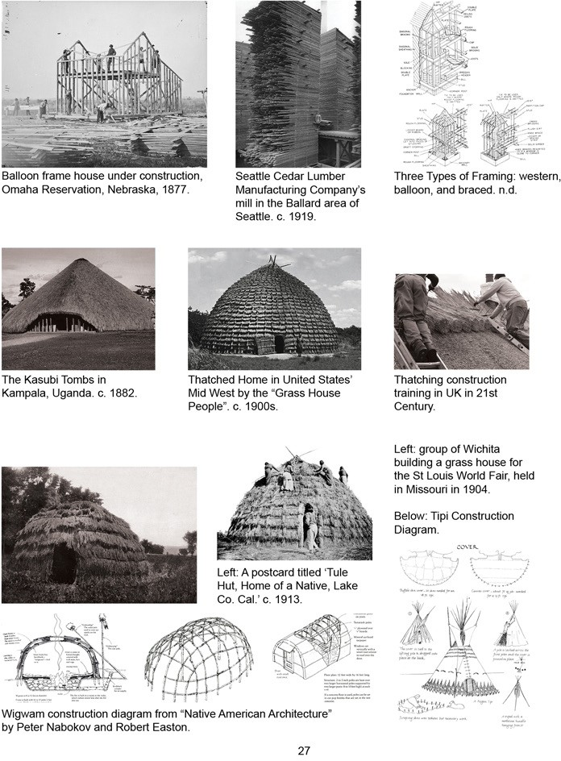

**Traditional Construction Methods**

*Learning from the past practices — low-tech, low-energy, high community participation*

Light Wood Framing

Craft of Thatching

Native American Shelter

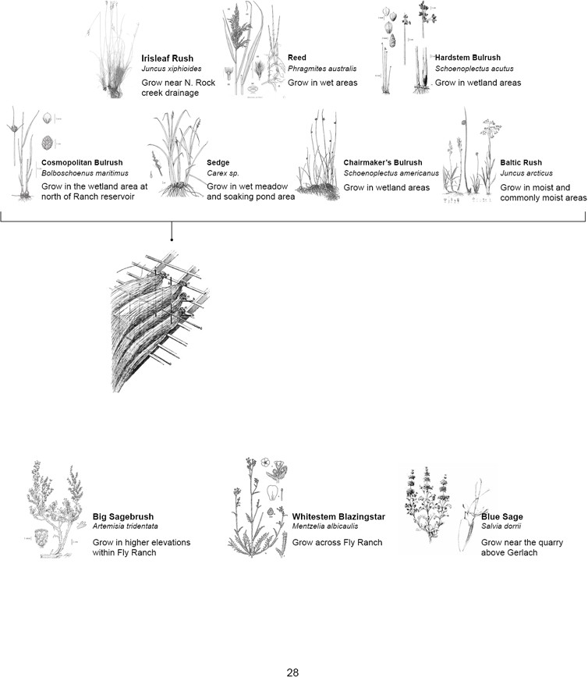

**Thatching**

*Using native plants for the facade to achieve low carbon footprint*

***Common Plants On-site for Facade Thatching***

***Facade Thatching Technique***

*The lodgers we propose use harvested plant material on site for facade thatching.*

***Aromatic Plants for Interior Thatching***

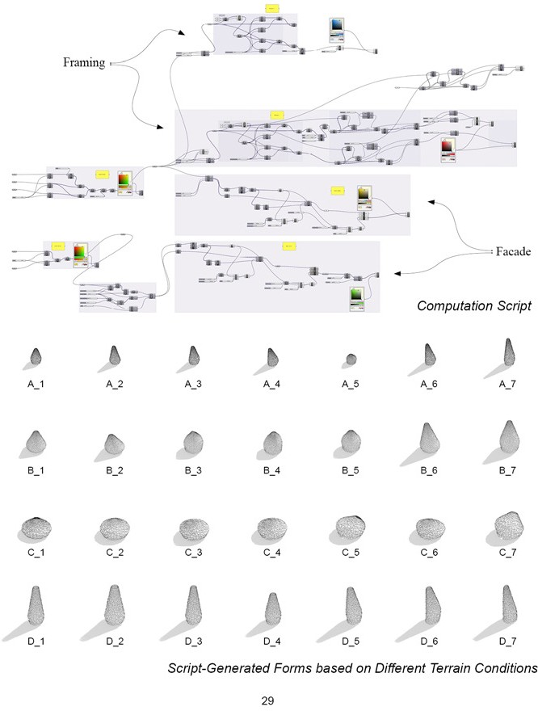

**Parametric Design**

*Reinvigorating traditional construction methods with computational tools*

With computational tools and parametric design strategies, we can reinvigorate historical ingenuity and adapt them to the contemporary design-build process. We developed a script that can modify the structure’s formal expression freely based on its touch points on the ground and simultaneously run structural calculations to understand its build-ability.

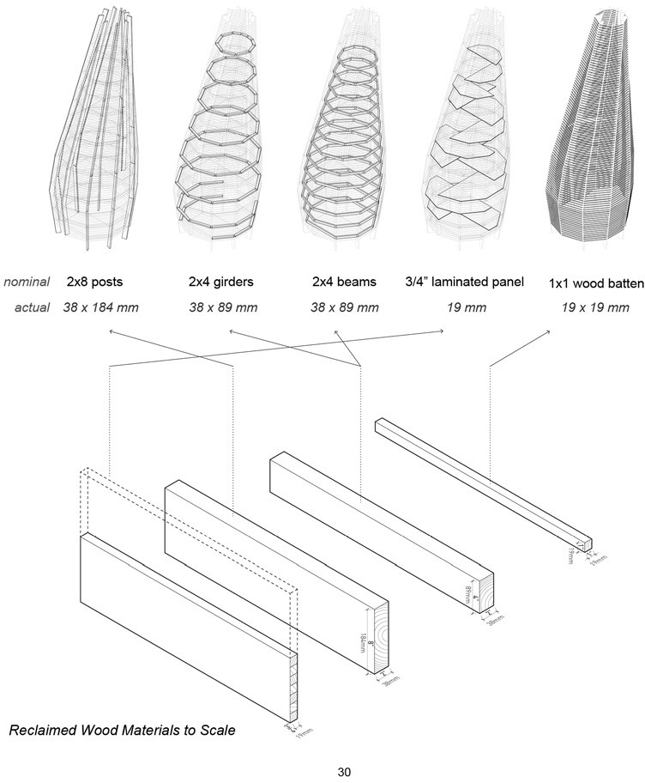

**Construction Detail**

We combine light timber framing construction, facade thatching technique, dimensional timber recycling, and indigenous material gathering practice to build our lodgers. The technologies we use are to achieve a low-tech, low-energy, and high community participation in the construction process and deliverable.

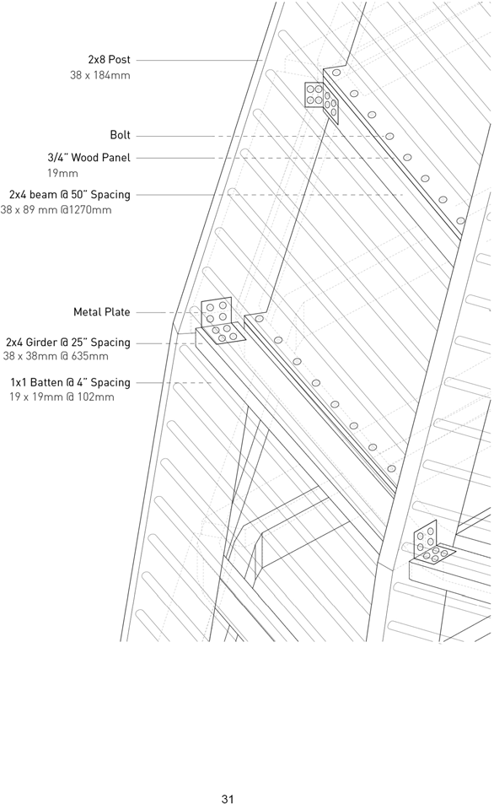

**Typical Wood Framing Detail**

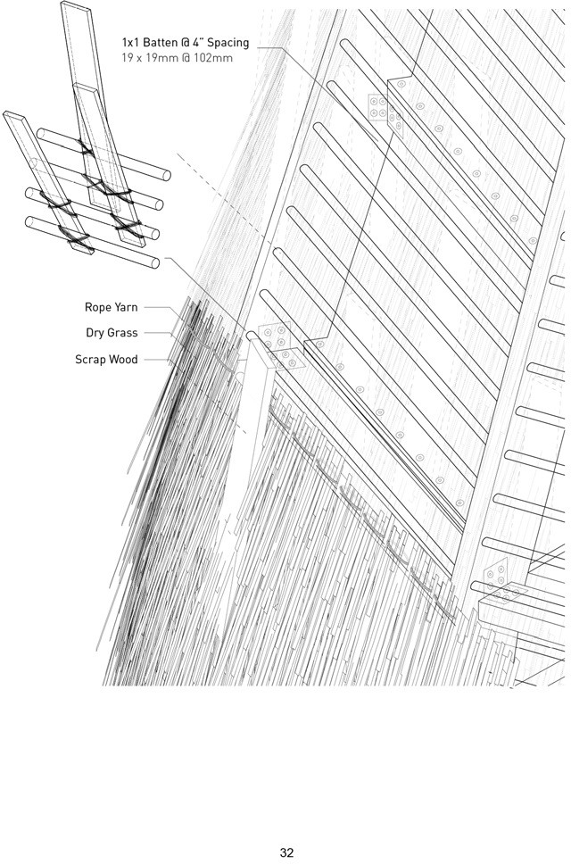

**Facade to Structure Detail**

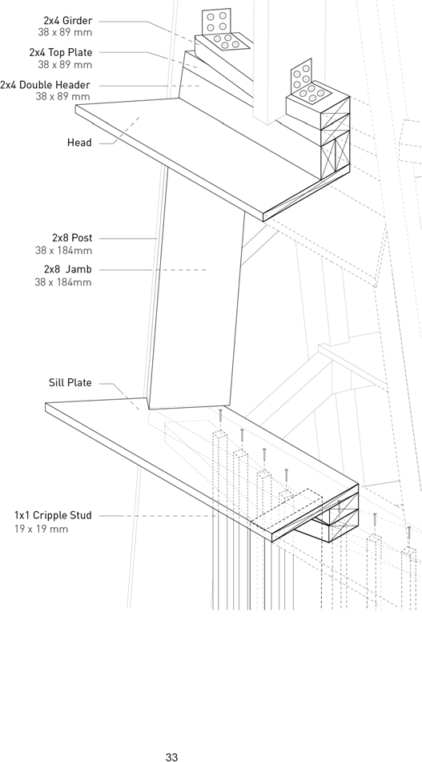

**Window Detail**

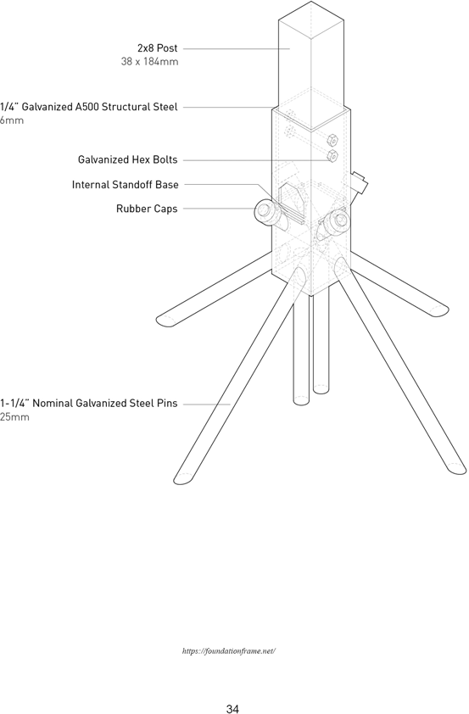

**Footing**

*Foundation Frame Technology by Foundations, Inc.*

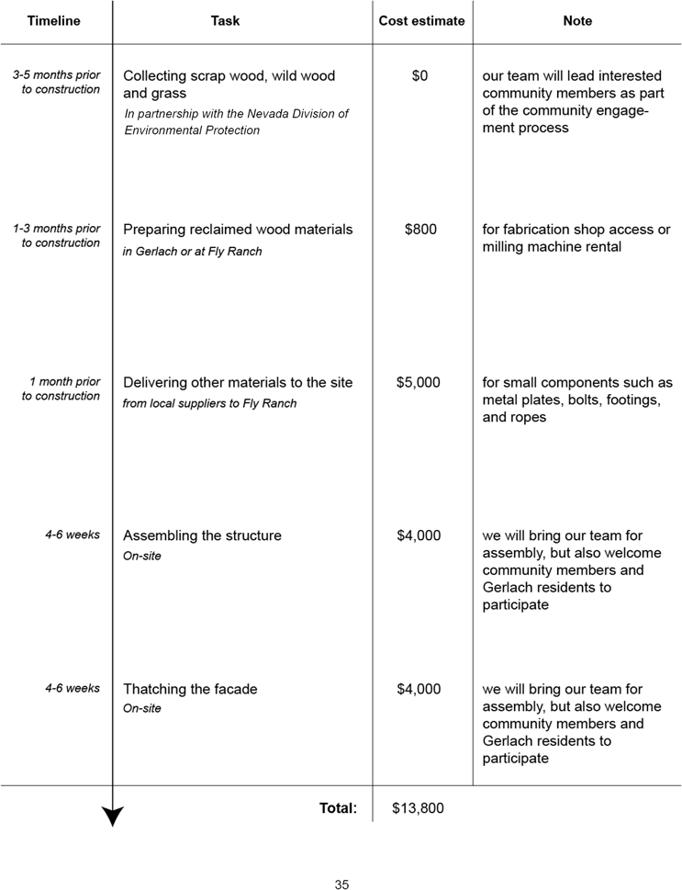

**Cost Estimate and On-site Prototype Strategy**

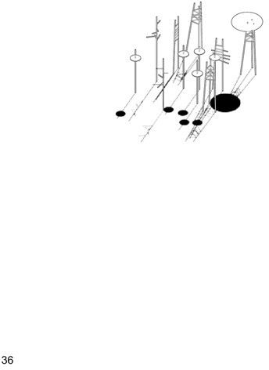

**Appendix**

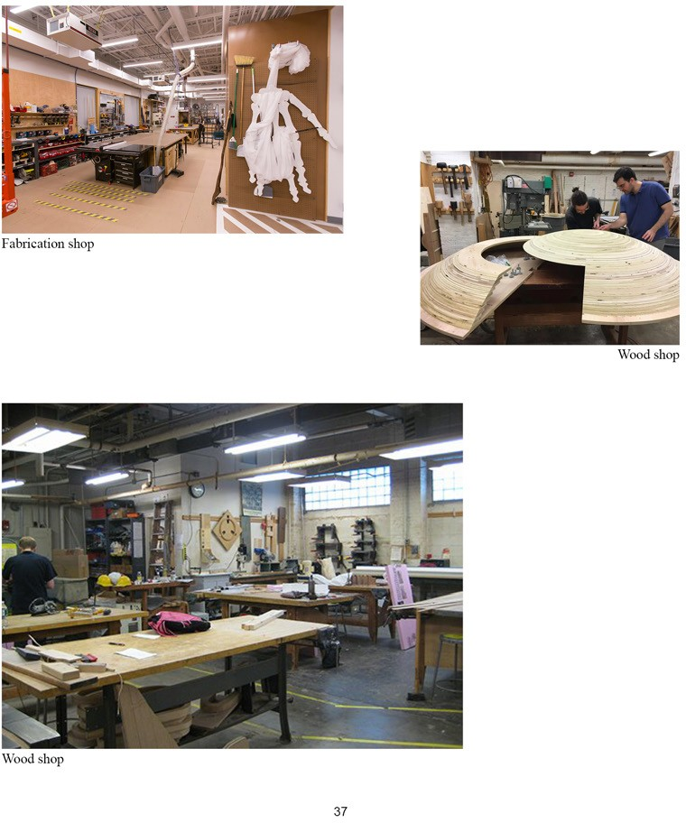

**Fabrication Shop for Prototyping**

*Tools: Carpentry, 4-Axis CNC Router, Robotic Arm, Wood Turning, Woodworking, 3D Printing*

We have fabrication shop access with tools for wood structure prototyping if we are chosen for the honoraria grant.

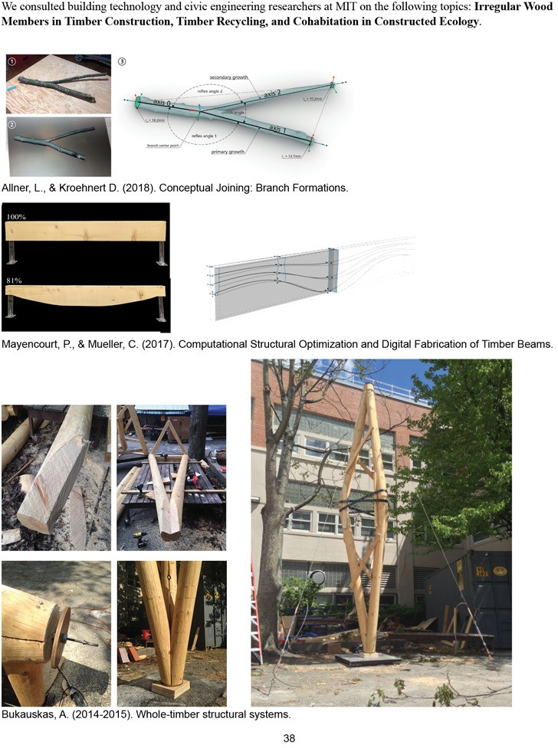

**Technology and Reference**

*Engaging Researchers and Owners of Proprietary Technology in Preliminary Dialogue*