TP_2.0.
The beaty of mathematics for an achievable utopia

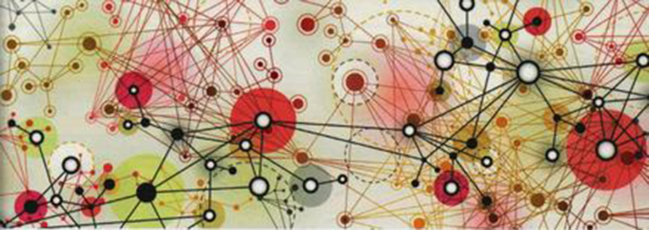
TP_2.0 is an innovative project which proposes a unique solution to interventions in different fields such as accommodation, small greenhouses, emergency home, facilities for agriculture and food production, facilities for tourist areas, food production, water storage and treatment and. At last but not least, energy production. Cost containment along with flexibility, design, standardization and recycling of raw materials are the basis of the project’s philosophy. TP_Project tries to improve the living conditions of much of the world population being able, at the same time, to become an element of artistic, cultural and landscape enhancement.

“Spora”, or the system’s unit

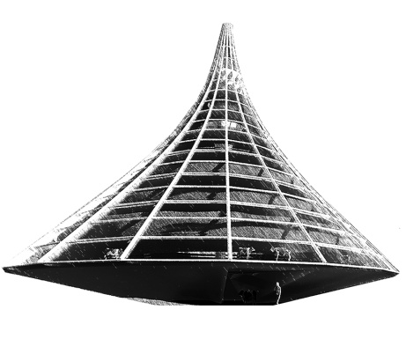
“Spora” is the basic unit of the project. In its minimal configuration, with a surface of 16 square meters, it can be used either as housing, as a stable for animals, such as green house or even as cistern for water storage to give accommodation to 2-6 people. Given the specificity of system’s building, Spore is perfectly suited to every environment and can withstand even most adverse conditions. A simple connection between several units facilitates the aggregation and the organic distribution in the territory so as to meet both the needs of individual as those of a wider community. Spore is studied and optimized with the algorithmic aided design. In this way it is possible to modify its dimensions without altering its spatial and structural configuration up to the creation of greenhouses for vertical farming. The flat packed design allows for the shelters to be transported via road, rail, water or even air. Early 30 Spore units can be transported on a single semi truck trailer, providing to house for 180 peoples (6 people/ unit).
Project’s technologies and materials

“Spora” uses low-tech solutions that could fit in any climate condition while maintaining a high standard of comfort. Exploiting the bioclimatic features of the structures in fact possible to adjust the internal temperature in a total natural way, and without use of advanced technology system. The possible equipment of integrated electricity generation’s systems, such as wind turbines and photovoltaic cells, makes Spore a very innovative structure. The assembly operations are extremely simple and can be carried by two people in about 30 min. The materials used are environmentally friendly, wood and recycled plastic materials.

Energy and maintenance

“Spora” is self-sufficient and does not produce waste. It uses renewable energy such sun and wind for his own operation and collect and treat organic waste in a special watertight tank, integrated into the structure and easily accessible for emptying and cleaning, in order to reuse them. Being mainly made up of modular wooden elements, its maintenance is easy and inexpensive, in continuity with the American construction tradition.

Costs

The cost of a single unit of 16 square meters is very low and should be contained in 8.000-100000 Euros, excluding supplies and furnishings.

Prototyping strategy

“Spora” is designed to be transported anywhere. All the structural components are made by numerical control processing. This guarantees precision in execution, speed in production and assembly operations, containment of production and sales costs.Every component arrive on site ready to be assembled without the use of special tools. So, the eventual realization of a prototype on the competition site would be easy and desirable.

Environmental impact summary

In the use that man makes of the territory, agriculture is the main activity. Pastures and arable land now occupy almost half of all the earth's land and require a quantity of water equal to 1/3 of human water consumption, a proportion that rises to 4/5 in the Asian continent.The production of vegetables and livestock heavily affects the environment, being the main source of water pollution from nitrates, phosphates and pesticides and at the same time the main source of GHG emissions such as methane and nitrogen oxide. The range of action and the methods underlying the current agrifood system have long been subjecting soils to deforestation, salinization, massive extraction of water from the subsoil and chemical treatments that impact on the environment causing soil erosion and a worrying loss of biodiversity. Each year, 12 million hectares of land, enough to grow 20 million tons of grain, are lost to desertification, roughly the size of Greece or Nepal. Insecticides, herbicides and fungicides are also used in order to maximize yields and at the same time minimize the risks associated with the presence of weeds or insects. Unfortunately, leaving aside the effects recorded on human health here, they also have a disruptive impact on the environment since, by eliminating plants and insects from crops, they act on the food chain, depriving birds and other animal species of their food source. Livestock farming represents an additional source of impact on the environment, of such magnitude that many scholars recognize it as the greatest problem among those caused by the agricultural sector. In fact, livestock alone releases an impressive amount of ammonia, equal to approximately 40% of global emissions of this substance against 16% released by fertilizers and 18% due to biomass combustion. Quantities destined to increase by 60% if, as estimated by the FAO, the trend in the demand for meat on a world scale continues to grow.

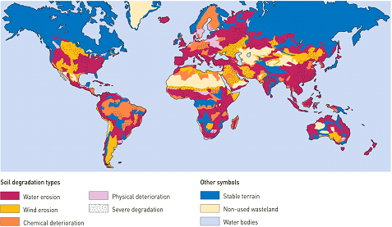
Soil degradation due to anthropogenic causes. (Source: Oldeman et al., 1991)

From these few data it is possible to understand what weight the current agricultural system has on biodiversity. Deforestation, soil compaction, reclamation of swampy areas to be used for agriculture are actions that are progressively reducing wild areas and fragmenting natural habitats, problems with which, according to FAO estimates, we will have to deal with different degrees for the next 30 years.
TP_2.0 stands as a practical contribution to these problems, proposing a radical solution in line with Yona Friedman's theories, a solution of an achievable utopia. The aim of the project is to achieve a survival architecture, therefore an architecture which, while facilitating the production of food, water supply and human and animal shelter for small communities like that of Gerlach, does not however weigh on the non-renewable resources of the planet

