NEXUS

SYMBIOTIC BUILDING SYSTEMS

Nexus investigates the possibility of assembling carbon neutral shelter and event structures for the purpose of sustainable education and social gathering across the Fly Ranch site. Inspired by the social context and environmental conditions of the area, the proposed building system utilises the resources available on site for construction purposes.

Together, building and construction are responsible for nearly a third of all carbon emissions in the world and the production and use of cement is responsible for a large portion of the CO2 emissions generated by the construction industry. For this reason, the selected material for the structural system is Ferrock - a sustainable alternative to concrete that absorbs CO2 through the curing process of the building components instead of releasing it. Ferrock is a relatively new and experimental material and this proposal will aim to push the boundaries of designing structures and pavilions out of environmentally friendly alternatives to regular cement. The goal is to experiment with small scale structures and use these as prototypes for larger structures scattered throughout the site. As more structures are built the lessons learned will be used to develop our knowledge of the material and serve as a template for the construction industry on how to build with environmentally friendly alternatives to cement.

The proposed shelters and event spaces across the Fly Ranch site serve as hubs for experiencing the identified microclimate zones - wetlands, grasslands, and playa. They have an allocated function specific to their location and work in symbiosis with the environment, geological conditions and vegetation - through structural form, material and vegetation incorporated into the interventions.

- SOCIAL CONTEXT

The design team looked closely at the social context for the Fly Ranch development and identified four key components to be taken into consideration - the Paiute people, Gerlach, Burning Man, and Friends of Black Rock High Rock. Drawing inspiration from the lifestyle and building techniques used by the Paiute, Nexus aims at developing shelters using materials available on site that work in symbiosis with the natural environment and leave no trace once deconstructed. The proposed intervention would contribute to the sustainable development of Gerlach by encouraging a steady influx of visitors and year-round activities close to the town. Nexus will be developed in unison with the Burning Man principles that align closely with the ambition behind Fly Ranch - inclusion, self-reliance, communal effort, and civic responsibility. Inspired by Friends of Black Rock High Rock, this proposal aims at creating structures for the purpose of sustainable education and social gathering aimed at experiencing and studying the unique ecosystem of Fly Ranch.

1.1. Paiute

The Paiute traditionally led a nomadic lifestyle that was moulded by the natural environment. Their understanding for the natural environment and how to use its resources lay the framework for sustainable interventions on the site.

Key words: life off the land, living cycles adapted to the cycles of the environment

1.2. Gerlach

Gerlach is a small town with one major influx of visitors per year (Burning Man). There are negatives and positives to this influx of visitors. Fly Ranch will give Gerlach a more sustainable and consistent way of moving forward.

Key words: sustainable development, community

1.3. Burning Man

Burning Man is the biggest social influence in the region. The Burning Man culture is felt year-round in the area, giving Fly Ranch a prime opportunity to leverage a culture that already has a strong foundation.

Key words: self-reliance, decommodification, self-expression, communal effort, civic responsibility, leaving no trace, participation

1.4. Friends of Black Rock High Rock

Friends of Black Rock High Rock are people who mostly live in the area (conservation specialists, historians). They use Fly Ranch as a campsite for educational experience.

Key words: sustainable education, social gathering

- ENVIRONMENTAL CONDITIONS

The proposed construction system and physical interventions respond to the environmental conditions of Fly Ranch - strong and able to resist the extreme climate while considering the sensitive nature and balance of the microclimatic zones. Nexus can achieve this by developing modular components requiring minimum footings and excavation work using local, carbon negative resources for construction and integrating the diverse flora into the proposed installations.

2.1. Extreme Climate

Temperature and weather events can be extreme - temperatures range from below 0 F in the winter to above 105 F in the summer. Specifically in the summer, temperature swings can be 65 F between day and night-time. The desert playa specifically is prone to dynamic, harsh conditions such as strong winds, lengthy aridity, and salty/turbid alkaline water.

Key words: dynamic, harsh, strong, resisting

2.2. Biodiverse

Black Rock Desert/High Rock Canyon consists of lava beds and desert playa/alkali flats which contain over 140 different plant species and 80+ types of birds, 15 mammals, 11 reptiles and fish, and 20+ varieties of insects. The site itself contains wetlands, natural spring-water pools, Fly Geyser, sagebrush-grasslands, and desert playa. When the desert playa is flooded, phytoplankton, shrimp, and water fleas can be found in the system.

Key words: diverse, rich, extraordinary

2.3. Semi-Arid / Dry Climate

The region falls within the semi-arid region of the Great Basin. Annual precipitation is approx. 6.75" (17 cm). Rainfall usually occurs late winter-early spring and generally comes in high precipitation periods. Floods occur every few years (or more with global warming) and creates deep mud in the desert playa.

Key words: dry, floods

2.4. Sensitive

Because of the arid nature of the climate, the soil is susceptible to physical disturbances and needs to be stabilized to maintain the ecosystem. The biological crust just below the surface of the soil contains algae, cyanobacteria, bacteria, lichens, mosses, liverworts, and fungi that are essential to the balance of the plant system.

Key words: sensitive, leave no trace

- PROJECT AIM

3.1. Sustainable education and social gathering

People will go to Fly ranch for experiencing the unique concentration of diverse micro-climates and the natural habitat. Visitors will conduct research on a range of sustainability and conservation topics. The purpose of the proposed structures is to encapsulate the habitat in each micro-climate zone and serve as a gathering space for conducting a range of social activities.

3.2. Microclimate hubs

The proposed shelters and event spaces serve as hubs for experiencing the identified microclimate zones - wetlands, grasslands, and playa. They have an allocated function specific to their location and work in symbiosis with the environment, geological conditions and vegetation - through structural form, material and vegetation incorporated into the interventions.

3.3. Participatory design

Nexus is built by the community and developed by the community over time. The system gives the opportunity for new hubs to be created, existing hubs to transform and grow with the visitors' participation, according to the needs of the community.

3.4. Construct off the land

The proposed shelters and building system utilise the available resources on site for construction purposes.

- GEOLOGY AND MATERIALITY

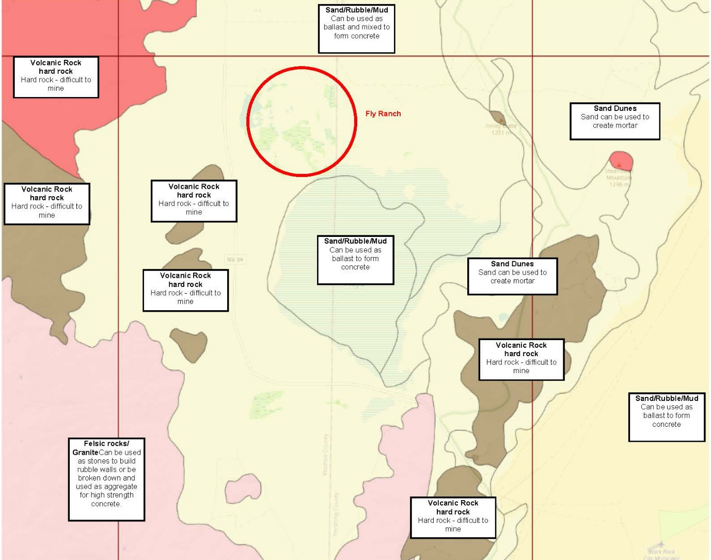
The design team looked at the available resources for construction both on site and within the immediate surroundings. The resources available directly on site are water, sand, rubble, mud, and natural fibre (grass). The quarries close to Fly Ranch provide granite and basalt in aggregate form. The quality of the materials is currently unknown; however, our assumption is that they can be used for rammed earth construction, rubble walls, adobe blocks, 3D printed sand, concrete, and Ferrock. Based on conversations with local businesses, the design team came to knowledge that both the sand and water in the area have a high level of salt, which is an undesirable component for most construction materials.

Fly Ranch surrounding area geological map
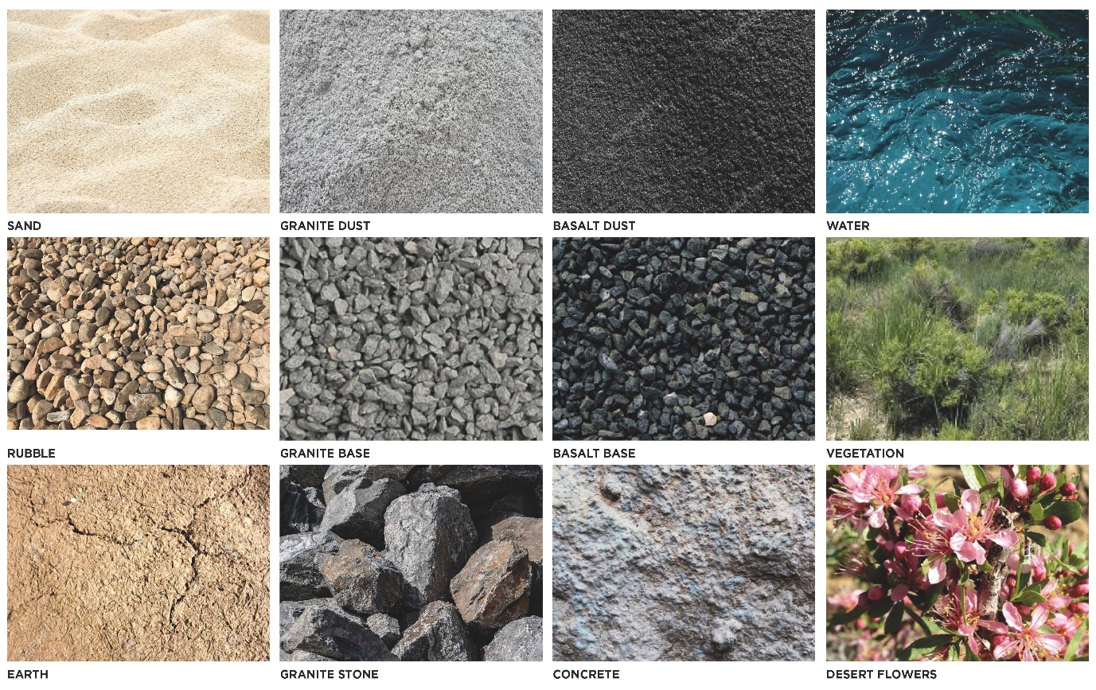
Fly Ranch materiality palette

Ferrock was selected as the most suitable material for Nexus due to its durability, low-tech fabrication method, low cost and sustainability value. Ferrock is a mixture that roughly consists of local aggregate (sand, rubble), steel dust (steel industry by-product), fly ash (electric power generating plants by-product), and recycled glass fibres. The iron within the steel dust reacts with C02 and rusts to form iron carbonate. It is fused into the matrix of Ferrock and, after it dries, retains its hard, rock-like qualities. One of the unique properties of Ferrock is that it becomes even stronger in salt environments, making it ideal for Fly Ranch. Rather than emitting large amounts of C02 as it dries, Ferrock absorbs and binds it, resulting in a carbon-negative process that helps to trap greenhouse gases.

- CONSTRUCTION TECHNOLOGY AND PROTOTYPE DEVELOPMENT ON SITE

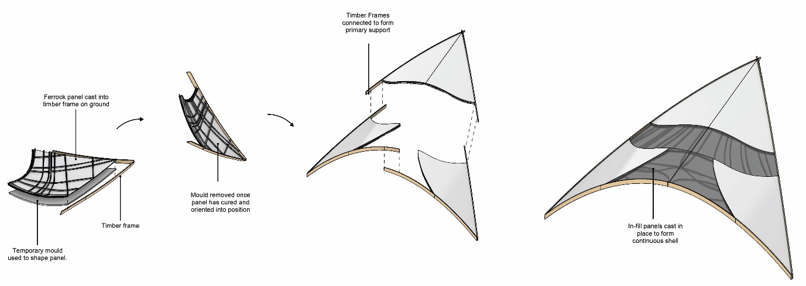
The aim of this proposal is to experiment with methods for building structures out of environmentally friendly alternatives to cement. Since some of these materials are new, the aim is to take an exploratory approach with this design proposal to encourage wider use of these environmentally friendly cement alternatives. Ferrock has been chosen as the material for the design as it meets the desired strength criteria and is composed of compounds which have a low carbon footprint or are recycled waste products from other construction processes.

Ferrock shell construction sequence

The main construction strategy is to build pre-cast Ferrock panels attached to timber frames that can be connected to form dome-like structures. The gaps between the pre-cast patterns will be filled in with more Ferrock to form a shell once the timber frame is in place The timber frame will act as the primary support structure of the shell while the Ferrock panels will be designed to be self-supporting and spanning between the timber beams. A ribbed pattern will be moulded in the ferrock panels to provide extra stiffness. These shells will be designed in such a way as to be modular so that more structures can be added on as needed. The intention is to build a single segment of the roof as a prototype for an estimated cost of $7000 and use the lessons and knowledge learned from this to construct more structures in future. This allows for the design proposal to be an ongoing experiment that can develop depending on the functional requirements and budget. Furthermore, the overarching goal is to encourage change in the construction industry by promoting the use of environmentally friendly cement alternatives and demonstrating their suitability for use in construction.

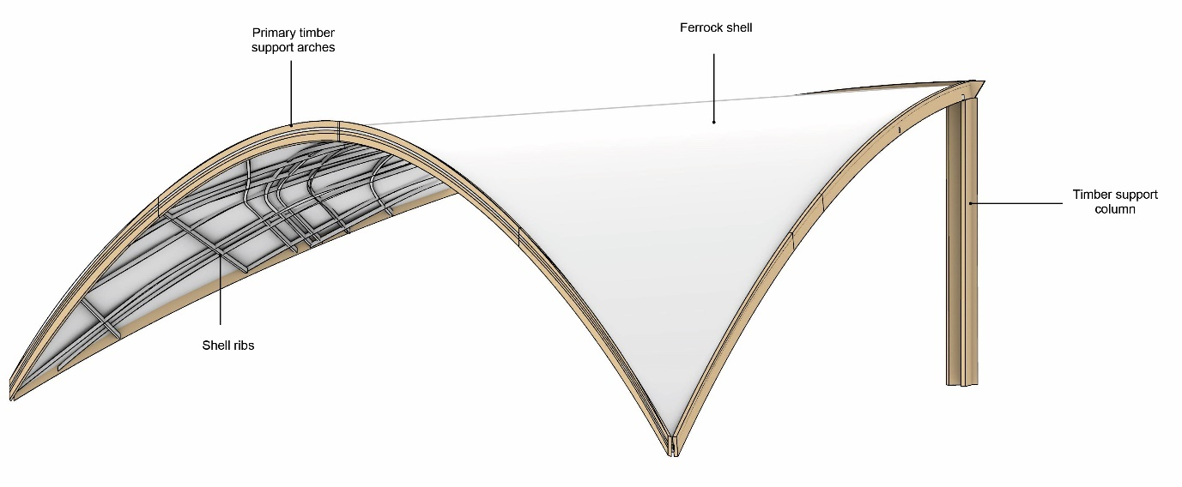
Site prototype

The photographs bellow illustrate the construction sequence of a small-scale prototype built by the design team.
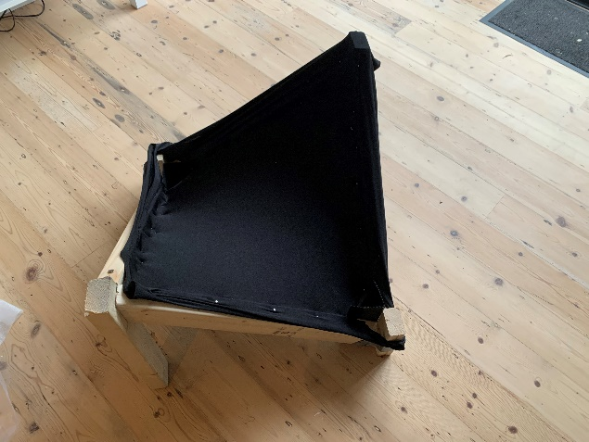
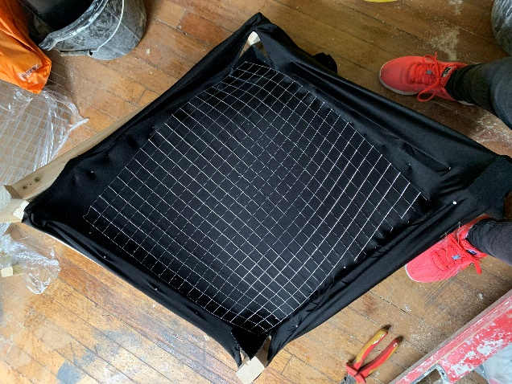
1| Fabric formwork on timber framing 2| Reinforcement

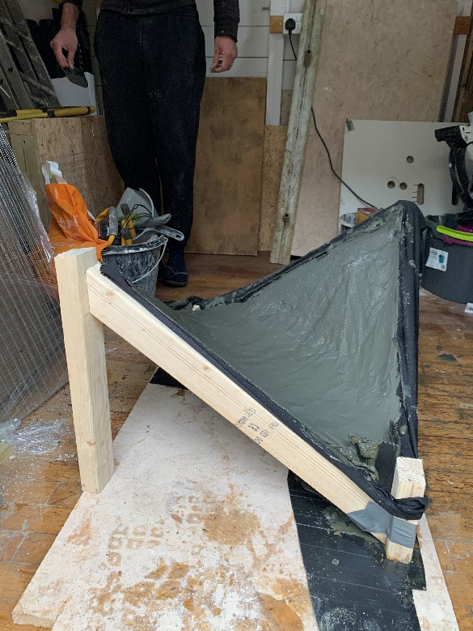

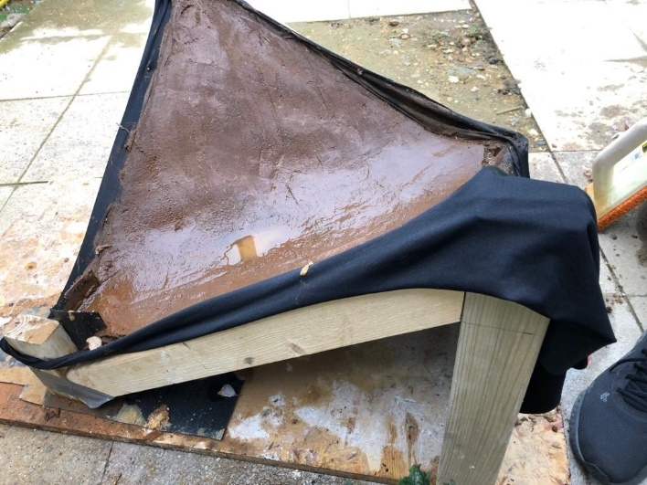

4| Ferrock mixture applied on the formwork 5| Curing process

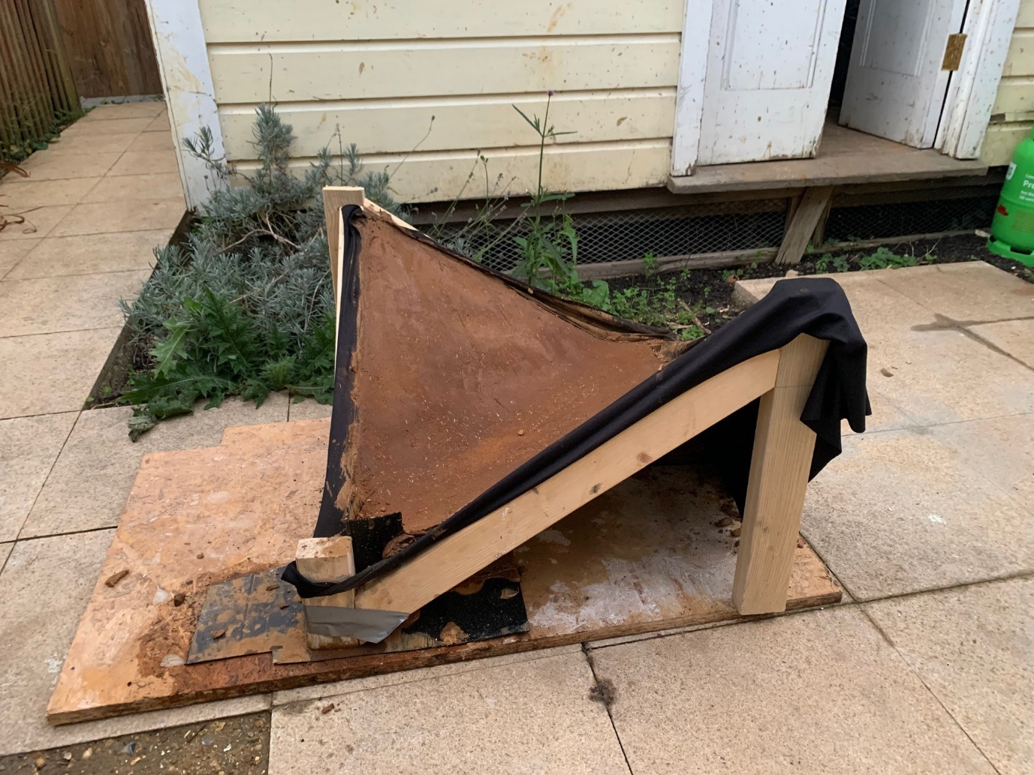
6| Fully dried prototype

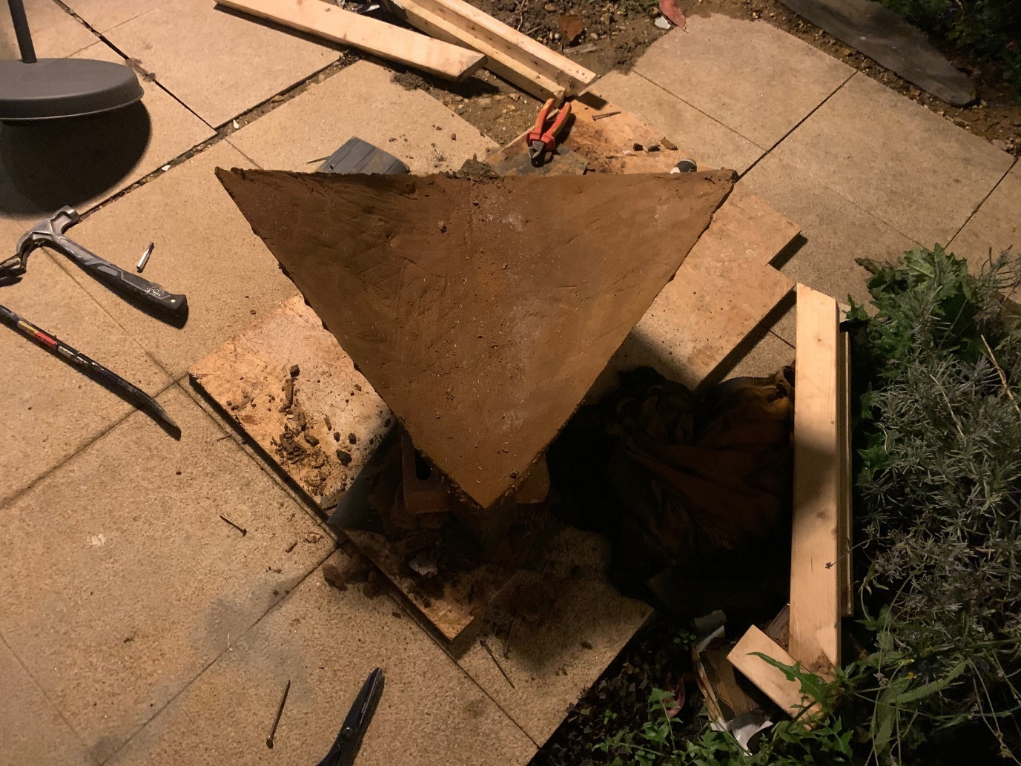
7| Removed formwork
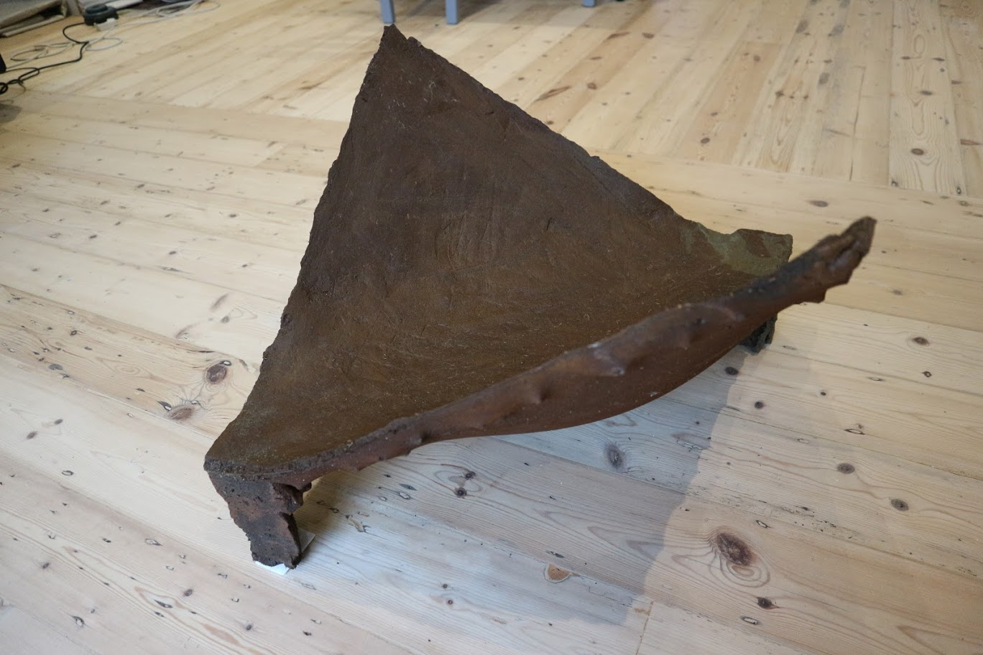
8| Removed formwork

