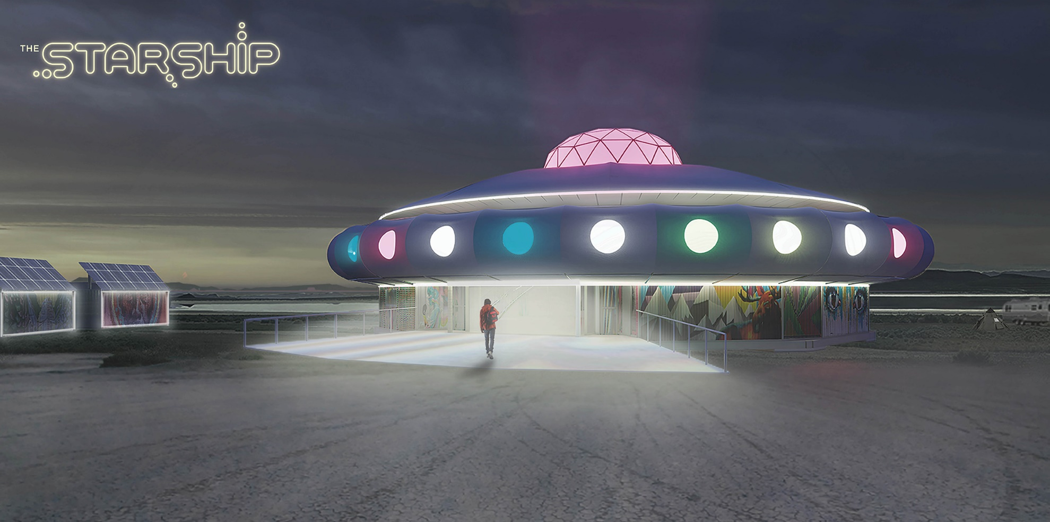
Artist Statement

As we transition from the age of Pisces into the age of Aquarius, every old system is crumbling.
Humanity has to create a completely new world in order to enter the golden age that is ahead of us.

Behold the Starship! A sustainable, off-grid, mobile, future-forward community concept.
The symbolism of the starship has been channeled to create a vibrant community, here on Earth.

Though this Starship exists on land, it is a metaphor and gateway to future space travel and a new way of life on Earth.
With political tension, natural disasters and systems breaking down all around us, mobility is our greatest insurance policy.
With this mobile Starship community, we will transition to a whole new world of communal living.

Introduction
The Starship has landed on the shores of Hualapai Flat to provide a hub for the activities at Fly Ranch. It will be a common house and focal point for this semi-permanent Burner community. The spaceship form provides live / work / gathering spaces inside a futuristic, circular structure. Surrounding the Starship will be a small village of campsites for nomadic visitors to inhabit during their stay at Fly Ranch. The Starship community is designed to support the wide range of activities that are envisioned at Fly Ranch such as symposia, arts workshops, entertainment events and even year round logistical support for Black Rock City.
The Starship is constructed of pre-fabricated components that can be assembled and utilized for a period of time on a particular site; and then be disassembled, transported and re-assembled on a new site. Modified shipping containers are re-purposed as flexible live / work and support spaces. The center of the Starship shall be a large gathering space for activities as varied as concerts, parties, meetings, maker space, and co-working.

The starship is supported by off-grid infrastructure components so that the entire facility, and adjacent temporary community, can operate off the grid. With this innovative concept, the Starship is a model for eco-conscious temporary communities.

Site
The proposed site is located at Middle Fly Ranch which is already being utilized as a location for events and a temporary community. The Starship will formalize those functions by proving a focal point, street network and off-grid infrastructure. The Starship will greet visitors entering the site from County Rd. 34, on the existing driveway. It will be the focal point of a radial street network which can provide parking / camping for 300-500 people. A northern road will connect the community to Northern Fly Ranch with its destination of geysers and hot springs. A southern road will connect to the nearby wetlands and to the site of the 1997 Burn. Two open spaces are reserved in the street grid for public gatherings and art. The western one provides an entry plaza, while the eastern one provides a backyard with views out to Hualapai Flat. The proposed radial street network has a diameter of 550’ and fits within the Middle Fly Ranch Primary Site Boundary.

Construction
The Starship uses the ordinary to create the extraordinary. Standard construction systems are utilized, but are combined in unique ways to create an out of this world experience. The structure is designed as a kit of parts that can be easily transported, assembled and disassembled. 20’ modified shipping containers are primary building module and provide a plug n play framework for interior spaces as well as the off-grid infrastructure components. The container modules and other elements will be covered with murals and other elements to integrate artistic expression throughout the Starship.

The container modules are designed to be easily transported between sites. Flip-down decks and ramps are attached to the containers with industrial grade hinges. During transportation, the decks flip up and are attached to the container allowing easy loading onto a truck or train. Once the container is placed on site, the decks flip down into place, allowing for quick and easy assembly.

The overall diameter of the Starship is 104’. The central gathering space provides a large flexible area for wide variety of activities including concerts, parties, meetings, presentations, working and making. At 3,980 SF, the capacity for the space is:

150 for banquet style table events
240 for seated presentation events
565 for standing room only events

The primary component of the Starship are (8) Flex Modules, which include a murphy bed and desk to create Live / Work / Meet spaces and glass garage doors that open to the main gathering space. Plumbing Modules provide restroom and shower facilities for the community. Other modules include Entries, Lounges, a Kitchen and support spaces. Container modules will be hard wired for lighting and power supply with quick-connect cabling providing power to individual container modules.
The spaceship utilizes a steel beam Wagon Wheel substructure to ensure accurate alignment of the components during erection. Leveling jacks allow the entire structure to adapt to a moderately sloped building site and provide a level, elevated floor surface. Concrete ballast pad foundations eliminate the need for footing excavation. The Modules are connected with standard shipping container connectors. Prefabricated railing / walkway / ramp and other components are bolted to the container modules.
To cover the Starship, a tensile fabric roof is stretched over aluminum Rock ‘n’ Roll trusses. It is designed to be assembled on the floor and then lifted into place with mechanized pulleys integrated into vertical truss columns. A collar, sheathed in fabric, completes the flying saucer aesthetic and provides additional usable space on the upper level.
While the modified shipping container modules are conditioned with mini-split heatpumps, the central gathering space is designed to be conditioned thru passive means. Insulation and a radiant barrier are sandwiched between fabric roof layers to enhance thermal comfort. A glass geodesic dome tops the roof to provide daylighting and solar gain in heating mode. In cooling mode, retractable awnings will be deployed to reduce solar gain. Operable vents in the dome, combined with air intake through Entry modules, provide natural ventilation via stack effect.

Infrastructure

The off-grid infrastructure components are also integrated into shipping container modules to facilitate transport and quick installation. These are located in a concentric ring outboard of the Starship. These modules can be expanded as the community grows and infrastructure needs increase:

Fresh Water
60,000 Gal. captured / Year
Roof water and atmospheric generated water is captured, filtered and stored in a pair of 3,000 Gal. tanks. Backup water is supplied from the nearby well.

Grey Water
40,000 Gal. captured / Year
Grey water from showers, sinks and the black water solar still is collected, filtered and stored in a 3,000 Gal. tank. Grey water supplies toilets and irrigation.
Black Water
1,000,000 Gal. treated / Year
Black water from toilets and other plumbing fixtures is treated in a multi-step process. An advanced membrane bio-reactor treats the water to tertiary standards. Membrane filtration is combined with biological action to remove bacteria, suspended solids and other chemicals from wastewater. The output is pumped to a solar still on the Black Water module roof. The sun heats the water in the basin, causing evaporation. Moisture rises, condenses on the cover and runs down into a collection trough, leaving behind the salts, minerals, and most other impurities, including germs. Additionally the moist air produced from evaporation can be transferred to an atmospheric water generation device where the moist air is utilized to condense water vapor into pure drinking water. The treated water is supplied to the fresh water module. Excess treated water is supplied to the Grey Water Module. The Bioreactor is emptied once a month as supply for composting units.

Food Production
Three food production modules provide fruits and vegetables for the spaceship. These greenhouses are placed on top of storage or composting units.

Solid Waste
Kitchen scraps and output from the Bio-reactors are combined in 2 Composting units (6-8 week processing time each). Recycling waste is sorted in a Solid Waste module for use in the community.

Storage Modules (5) Storage modules provide on-site storage for the Kitchen module (dry storage and refrigerated goods) and general storage for the Starship.
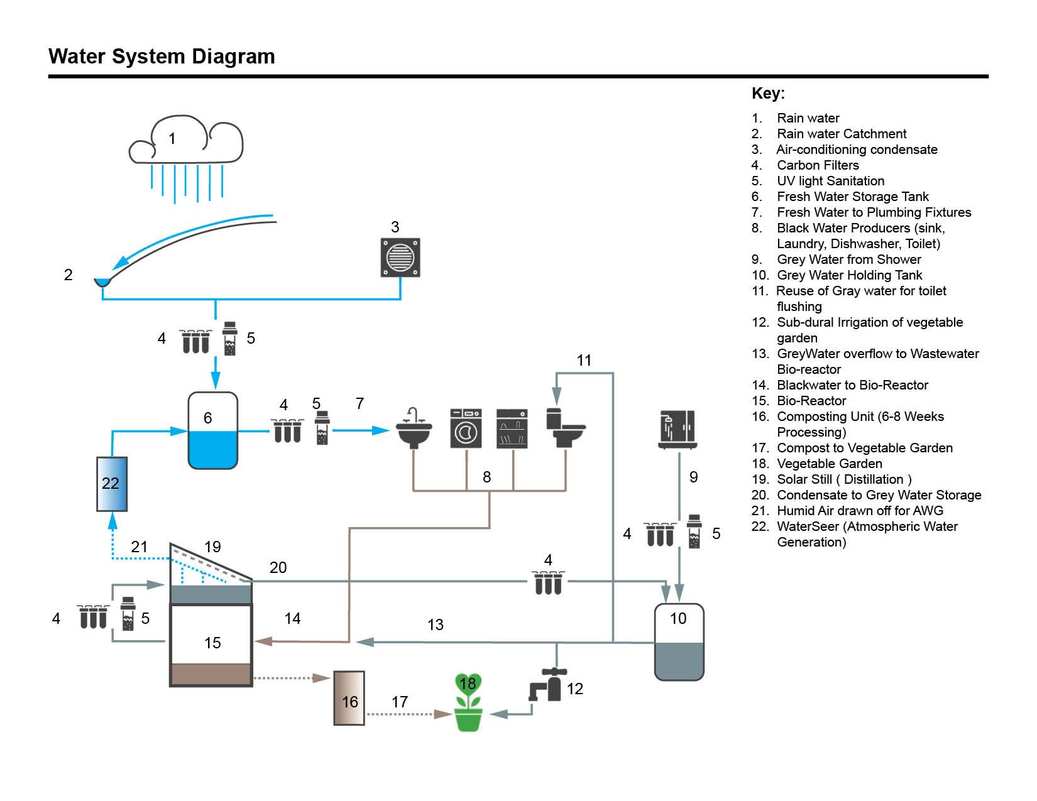

Costs and Implementation

The applicant intends to work with Burning Man and the northern Washoe County communities to construct and operate the Starship, on-site, at Fly Ranch. The applicant is currently undertaking fundraising activities to this end. To the greatest extent possible, the construction activities would engage Washoe County residents, and the primary components would be assembled on or close to the site to reduce transportation costs. An initial estimate of design, construction and installation costs for the Starship on a generic site is in the $ 6-7 Million range. The applicant hopes to work with local government, non-profit organizations and the greater Burning Man community for access to grants, volunteer labor and other ways to reduce these costs.

The applicant proposes to utilize the honorarium to prototype the fabrication and assembly of 2 stacked container modules and the associated components (shown below). Those containers would showcase a Flex Module above a Plumbing module below. This will provide proof of concept and allow us to analyzed constructability. The applicant is able to leverage additional funds to cover costs in excess of the honorarium, if required. With the award of the honorarium, the applicant will leverage this recognition for fundraising efforts with a goal to raise capital, and to construct the entire Starship, ASAP at the Fly Ranch. With existing funds in-hand, and an established network, the applicant has confidence that the fundraising and construction targets are achievable.

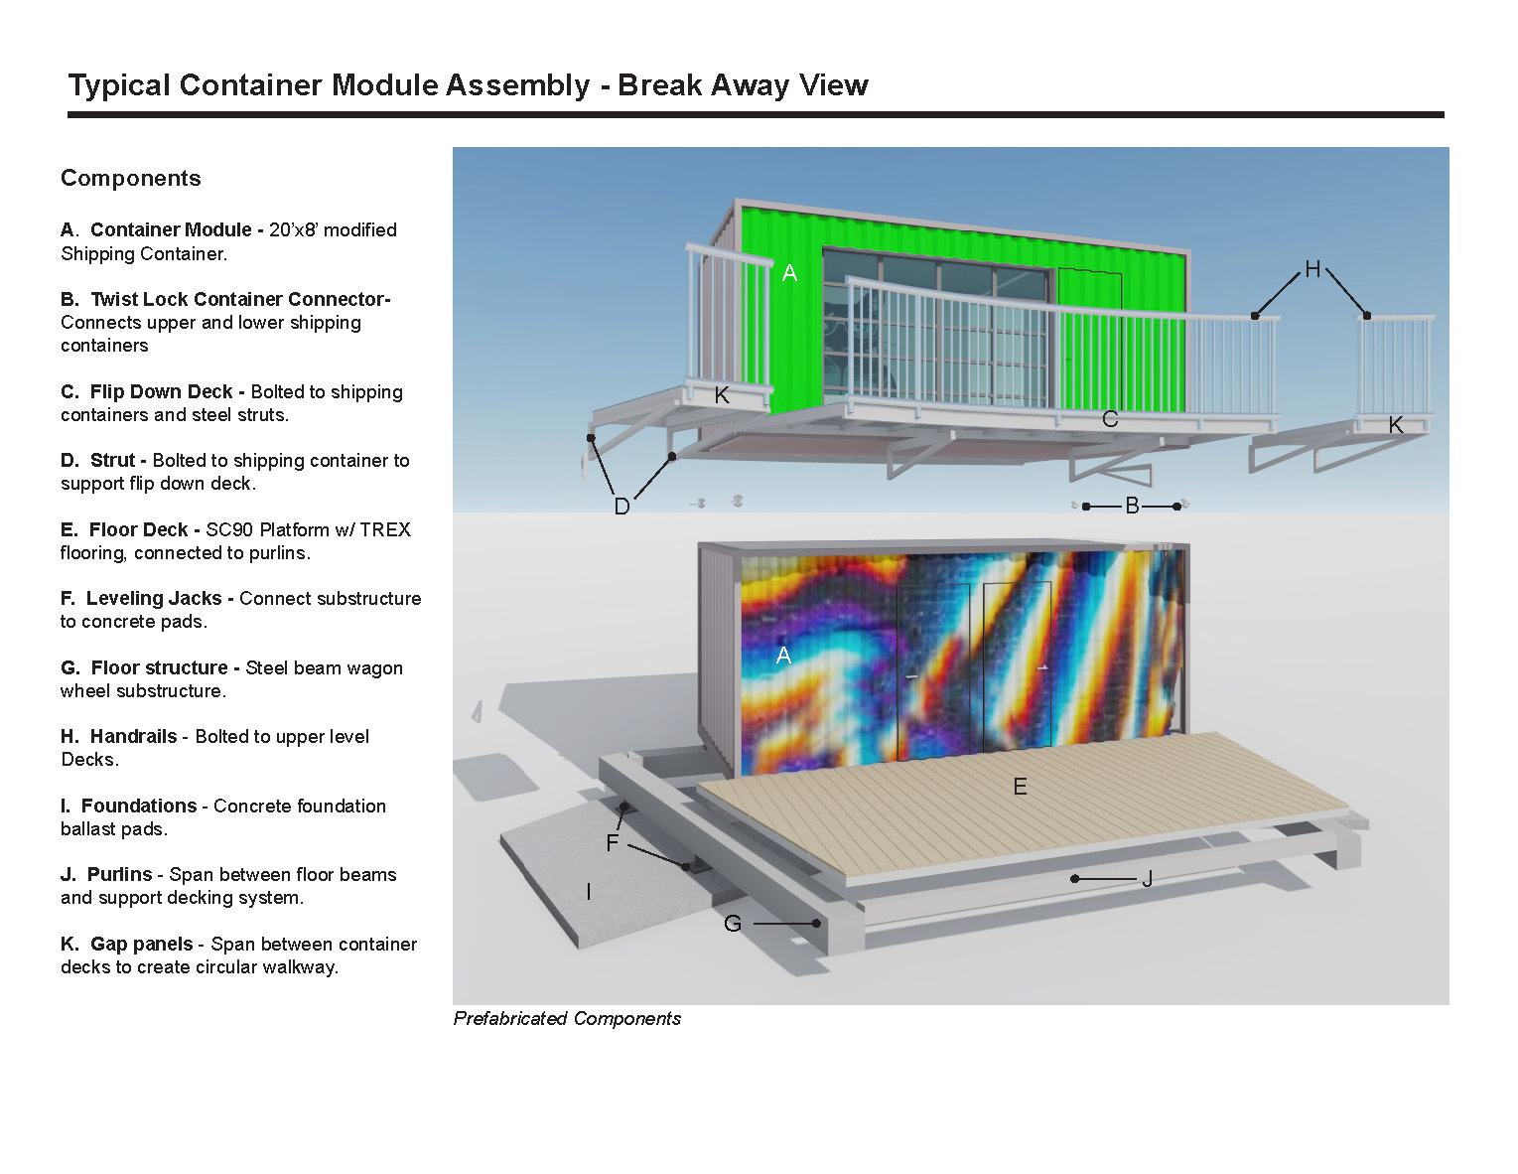
Environmental Impact Summary

The Starship is conceived as a temporary & portable structure. Therefore, in the future, when the needs of Fly Ranch change, the structure can be relocated from the site and allow the Starship to Leave No Trace. The structure is designed to have a light footprint on the land with no excavation required for footings, and minimal excavation required for utility infrastructure. Since the structure is designed to be self-leveling on a sloped site with up to 24” grade change (as is the proposed site), minimal to no grading will be required. The proposed site is currently being utilized for similar purposes (camping and events) and therefore is already disturbed. The greatest disturbance from construction will be construction of the radial dirt road network. The perimeter of the road network will employ erosion control measure both during construction and also for the life of the community. Upon the Starship’s departure, the site will require revegetation.

The Starship is designed to incorporate repurposed and recyclable materials. The primary building blocks are 20’ shipping containers which are upcycled for use as habitable spaces. The primary structural materials of steel and aluminum are both recyclable. The use of off-grid infrastructure will not deplete the areas resources and will enable the community to live on the land with a light footprint.

