Convergence Written Description

Although the future of Fly Ranch is uncertain, a confluence of ideas and innovation is inevitable. A community is forged on the gathering of like minded people, which I believe is what Fly Ranch has. There is always strength in numbers, and the greatest catalyst is providing a place for those numbers to interact. This proposal aims to be just that; a central landmark gathering place, where people of all different wavelengths would enjoy interacting and cooperating on some of our worlds greatest issues. Whether it be for site-wide dinners, group presentations, leisure and performances, a flexible gathering space is important where infrastructure is slim. Just as people come together in this pavilion, light from the sun converges to generate electricity. The innovative form of solar generation is displayed in a manner meant to inspire those who inhabit its space.
Fly Ranch is the next step towards permanence for Burning Man, however no human activity on this planet should be truly permanent. This is why deep foundations and great disruptions to vegetation are unfortunate. The pavilion gracefully touches the land, only penetrating the earth with a few critically placed anchors. Convergence is an adaptable structure relying on fundamentals found in thin-shell concrete structures. Through arches and vaults, forms can be adapted in scale and shape.
Efficiency of materials is of great importance to convergence. Instead of including a structural system and a power generation system, they are one. The rings holding the power spheres themselves support the total structure. Materiality simply consists of wood, recyclable water-filled glass hemispheres, and steel mounting hardware.
Previous instalments of solar sphere collectors prove its efficiency to cost ratio extremely appealing as compared to other means of energy production. The solar sphere concentrates light into a strong centralized beam. This is notable for two reasons. First, the concentrated beam allows use of a smaller PV-panel for an equal amount of actual absorption area. It is beneficial for the PV-panel to be small as this component is the least sustainable to produce and most likely to need replacement over time. Second, a concentrated beam of light allows solar generation even in low-light conditions. This could be overcast skies or early morning/late evening conditions. Normal PV-panels struggle to generate any electricity with this low intensity light, however the magnification properties of the sphere amplifies the light to be stronger in the smaller surface area to continue operation.
Cost estimate is on a per-module basis because of the project’s modularity and ability to be put together in an infinite number of configurations. Optionally, not all structural rings must hold a solar sphere which would reduce overall cost and conserve material. The entire structure is not hit by an equal amount of sun throughout the day and it makes sense to put the solar collectors in areas with maximum solar gain first. A structural ring would cost roughly $110 including hardware (varying with scale) and each solar sphere system would be estimated at $440. The proposed configuration includes 749 solar spheres and 904 rings. This totals to $429,000. This implementation with a 15m² footprint and 5m height grants 36 MWh annually, and both cost and power generation could be scaled.
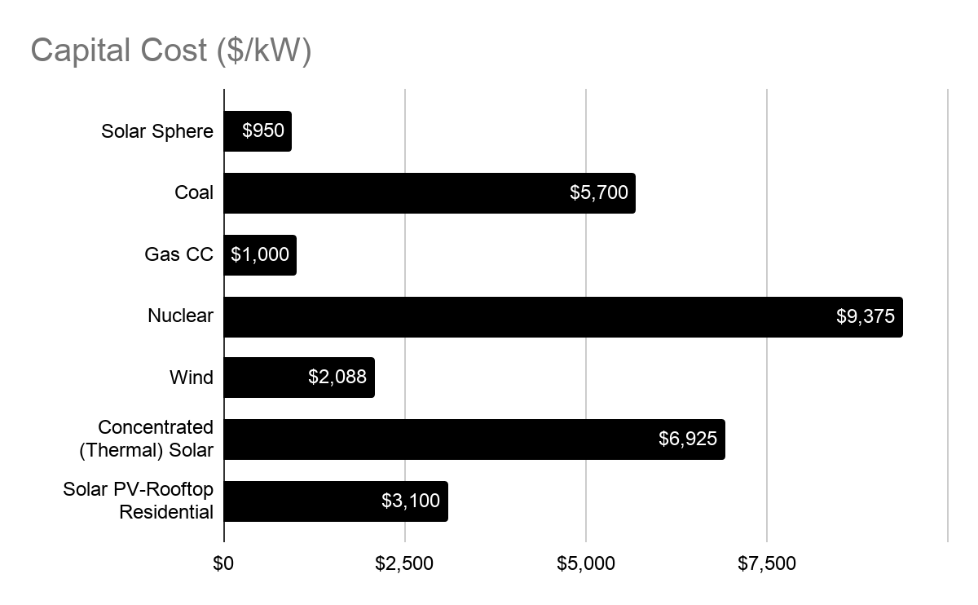
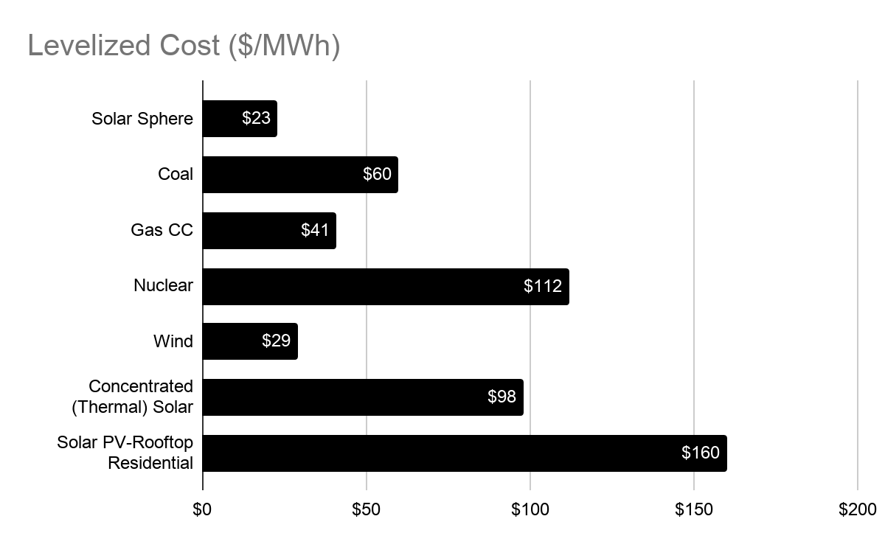
Comparison Of Costs Across The Energy Landscape

Ease of construction was another area of emphasis for this design. Everything may be assembled on-site without heavy machinery or skilled labor thanks to its simplicity. An additional benefit to this approach is cost savings. The maintenance is also simple, after initial setup, the PV-panels automatically track the sun throughout the year. With that in mind the prototyping of the system could be completely operational and at full scale, using fewer modulels. Local hardwood would be sourced and milled, manufacturers would supply the mechanical components, and assembly hardware would need to be purchased. The hardware may be a custom design for the final build, however in the prototype process less elegant off-the-shelf solutions would do just fine. With a one-to-one prototype of the modules the projected energy production could be tested and strength of the shell structure verified.

Environmental Impact Summary

Convergence has a small environmental impact on the site, and embodied carbon is minimal compared to most forms of electricity generation. Steps have been taken to both reduce the impact on site, and reduce embodied carbon. The light footprint keeps permanent damage from occurring once the project is decommissioned. In order to control the lateral forces of the base of the arched structure anchors must penetrate the soil in a few points, however this impact would be comparable to staking a large tent. The embodied carbon is reduced by using local lumber as a primary material. Additionally the PV-panels are smaller than comparable systems which reduces the embodied carbon in their production. Every module could be disassembled and moved or reconfigured to new locations. If ever decided to completely end the life cycle of this project, full disassembly would allow the recycling of each material and wood returned to the environment.

"Rawlemon." https://rawlemon.com/. Accessed 31 Oct. 2020.

