When it comes to climate, Fly Ranch is uncomfortable! Comfortable temperatures are only found a few months out of the year, and even then, only at limited hours of the day. Our main challenge was to create a comfortable environment to accommodate three essential human activities – gathering, resting, and creating – without overly prescribing the program. The philosophy guiding the project is that simple, low-tech strategies are more sustainable than high-tech ones, and solutions inspired by the genus loci of a site – its sense of place – are always the most appropriate.

A COMFORTABLE PLACE TO GATHER, REST, CREATE, & MORE!
Entirely accessible and wheels-friendly, the building is an inclusive space for everyone. The Dome is a place of lively, expressive, collaborative group interactions accommodating up to 49 people. It can be used for concerts, performances, parties, ceremonies, meetings, or as an informal hangout space. It also doubles as a productive space, such as a fabrication workshop, coworking space, or a greenhouse for plants. The Pods accommodate quieter or private activities. They can be used as sleeping quarters, meditation rooms, study spaces, sound baths, artist studios, and more! Variable pod sizes can accommodate one person up to a small group. Because the Dome doubles as a heat generator, it is intended to be used only at specific times of the day when temperatures within are comfortable, whereas the Pods can be used anytime of the day or night as they are comfortable virtually 24/7/365. At night, oculi in the Dome and Pods transform the building into a stargazing retreat!

LAYOUT & SIZE
The building consists of five Pods arrayed around a central Dome. The Dome is approximately 105m² with a diameter of 11.7 m, and its tallest point is 9.6 m above the ground surface. The Pods range in size from 10m² to 30m². A 22.8m long and 1.9m wide airlock corridor is used for circulation when the Pods are sealed off from the Dome. The majority of the structure is sunken below grade or earth sheltered above grade, with the soil surface ranging from 3m to 4.5m above the finished floor. The building is accessed by a 26m long entry ramp. In total, the building contains 301m² of usable floor area, is 56.6m in its longest direction, and is 33.8m in its shortest direction.

CLIMATE-INSPIRED DESIGN: HOW IT WORKS
Our research into local climate data demonstrated that the biggest challenge in creating human comfort at Fly Ranch was overcoming the large diurnal temperature swings and overall cold temperatures found most of the year. Fortunately, Fly Ranch is located at one of the sunniest locations in the world, allowing the sun to be harnessed as a natural heat source. The building employs simple, low-tech, non-mechanical, passive strategies varying by season to create a comfortable indoor environment rather than relying on high-tech or energy-intensive mechanical equipment. We anticipate our strategies will create a comfortable environment in each Pod for eleven months out of the year!
Spring & Autumn: During the spring and autumn months, cool to mild sunny days give way to cold nights. During the day, the glazed Dome induces a greenhouse effect and heats the air up to 20°C warmer than outside. Although greenhouses are efficient at turning solar radiation into heat, that heat is easily lost after sunset due to the glazing’s high thermal conductivity. To retain the heat for use at night when it is needed most, the warm air generated in the Dome is transferred to the Pods by means of an air flushout in the late afternoon. The stack effect is employed to move heated air from the Dome into the Pods, based on the principle that warm air travels towards cooler air and rises. By opening all interior doors as well as the oculus within each Pod, warm air will travel from the Dome towards the Pods as it tries to escape the building to reach the cooler outdoor air. In the process it will warm the Pods. Once the Pod reaches optimal temperatures, all doors and windows through the building are closed, sealing off the Pods from the Dome and from the outside.
To retain heat, the Pods are insulated by soil. The ground has much greater temperature stability and most of the year is closer to human comfort levels than the outdoor air, acting as a perfect natural insulator. We propose to use straw insulation above grade-parts of the structure and rigid insulation below-grade where moisture is a concern to further minimize heat loss.
Superadobe walls (0.4m thick) provide thermal mass that acts as a heat sink during the day, in particular those facing south and exposed to the sun. Through thermal lag, the release of heat stored within is delayed approximately 9 to 11.5 hours as a function of adobe’s material properties and thickness, meaning that the heat is released at night when it is needed most. The Dome will cool during the night and warm in the afternoon, but will maintain comfortable temperatures in late morning and early evening hours.
Winter: During winter, cold days give way to very cold nights. As in Spring and Autumn, the Dome will generate heat during the daytime and air will be flushed into the Pods once daily during the late afternoon after the Dome has gained sufficient heat. The Pods are then sealed off from the Dome through the night and the following morning. On the coldest and cloudiest days of the year when the Dome is unable to generate sufficient heat, the pool inside the Dome can be filled with geothermal water from the nearby geyser, providing needed heat and humidity. When dry heat is needed instead, the pool can be covered with a membrane, transferring heat into the Dome without adding water vapor. The Dome will be most comfortable in the afternoon, but will be cool to cold the rest of the time.
Summer: During summer months, warm to hot days give way to mild to cool nights. The greenhouse effect is not desired during this time, and the glazed Dome panels are removed and stored in one of the Pods for the season. This allows air to naturally flow through the Dome, allowing for a more comfortable environment than if the glazing were to remain. For days when it is hot and dry, cool well waters can be introduced into the pool, creating a localized evaporative cooling effect. The structural members of the Dome will remain in place and are designed to shade the space from the intense incoming high-angle summer sun. Within each Pod, the doors, oculus window, and porthole window will be opened during the morning and evening when outside temperatures are comfortable, inducing airflow through the stack effect. The thermal mass of the Pods also helps balance out the extreme diurnal temperature swings in summer. During mid-day when it is too hot, and night when it is too cool, the Pods will be sealed off to retain the desired comfortable temperatures within. A notable exception is July, when temperatures are comfortable throughout the nighttime hours, and windows can remain open through the night.

CONSTRUCTION TECHNOLOGY
Superadobe earthbags - long continuous bags filled with soil and stacked atop each other – comprise the primary structural system. The ceilings of the airlock corridor and Pods are domed or vaulted, creating a strong structure supporting the weight of the soil banked on top. These shapes also minimize the air volume of each space, creating a more energy efficient structure as it requires less heating. The adobe is finished with rust-colored plaster, the dark color which better absorbs the sun’s energy.
The structure of the Dome is made of laminated bamboo lumber, a rapidly renewable product. Glazing is transparent multilayered ethylene tetrafluoroethlyene (ETFE) membranes, which weigh less and have superior insulation qualities compared to glass or acrylic. The main Dome and smaller Pod domes are angled to maximize exposure to the low-angle winter sun and minimize exposure to the higher summer sun. The ETFE oculus at the main Dome can also be designed to contain optional photovoltaics if electrical generation is warranted.
The superadobe walls are supported by a concrete slab with thickened edges containing a minimum of 30% recycled content. Handmade terra cotta tiles cover the floors. We welcome local residents and visiting guests to join in the tile making process and design their own tiles.

PROTOTYPE POD
We propose to build the small Pod (13m²) as a summer-season shelter. This structure will seek to prototype superadobe earthbag construction used in an earth-sheltered dwelling, prove that thermal mass will balance out temperature swings and produce indoor comfort, and optimize the size and orientation of the openings to induce required air flows. We will also demonstrate our strategy to insulate and waterproof the structure, as well as develop the operable ETFE oculus.

ENVIRONMENTAL IMPACT STATEMENT
The entire structure and holding pond lays in the Primary Site area where excavation is permitted. The total area of site disturbance is 1,120m². The amount of soil to be removed is 150m³, most of which will be retained and replaced atop the subterranean structure once construction ends. When possible, plants within the area of site disturbance where excavation will occur will be temporarily relocated, and once construction ends will be replanted on the building’s green roof. To protect sensitive features on the site, the construction area will be fenced off so people or vehicles do not intrude into these fragile areas, and inadvertent wind-borne debris can be caught.
Before construction begins, if there are concerns about the building’s proposed location and associated impacts to plant or animal habitat, geological features, or historical-cultural resources that cannot be adequately mitigated, we will work with the appropriate persons to find another location on Fly Ranch to construct the building. During construction, if new conditions are discovered to which continued construction may be seen as harmful, we will stop construction and bring appropriate experts to evaluate the best course of action to mitigate the impacts, including re-evaluating the scope, design, and/or location of the project.
For the optional hydrological features (geothermal water and well water), pipes and ditches will be required to bring water to the outdoor holding pond and indoor pool from nearby springs or wells. These pipes and ditches will be located within the Primary Site area to the greatest extent possible. If the use of either of these water resources will create impacts that cannot be adequately mitigated, we believe the project can be implemented successfully without one or both of these hydrological features. To avoid erosion and associated negative effects on water quality, during construction exposed earth within drainage areas will be covered with erosion control mats. After construction, appropriate native species will be planted to stabilize the soil.
Any permanently installed lighting will be full-cutoff luminaires to eliminate light pollution and preserve night skies. We propose occupancy sensors and timers for all lighting fixtures so that they only illuminate when the building is in use.
No direct impacts to air quality are expected from the project. Indirect impacts to air quality, including from transportation or people, equipment, and materials to and from the site, as well as the use of some equipment on site, is expected. To mitigate air pollution we will encourage those participating in construction or visiting the project to ride share and to use low- or non-carbon-based transportation. To avoid wind-blown dust from excavated earth that could impact air quality, we will moisten and/or cover exposed soil during construction.
If selected we propose to create a project website to help promote the project’s sustainability strategies that can be used as a learning tool and resource for similar future projects. We also plan to post construction updates on the website.

LOCATION IN PRIMARY SITE AREA
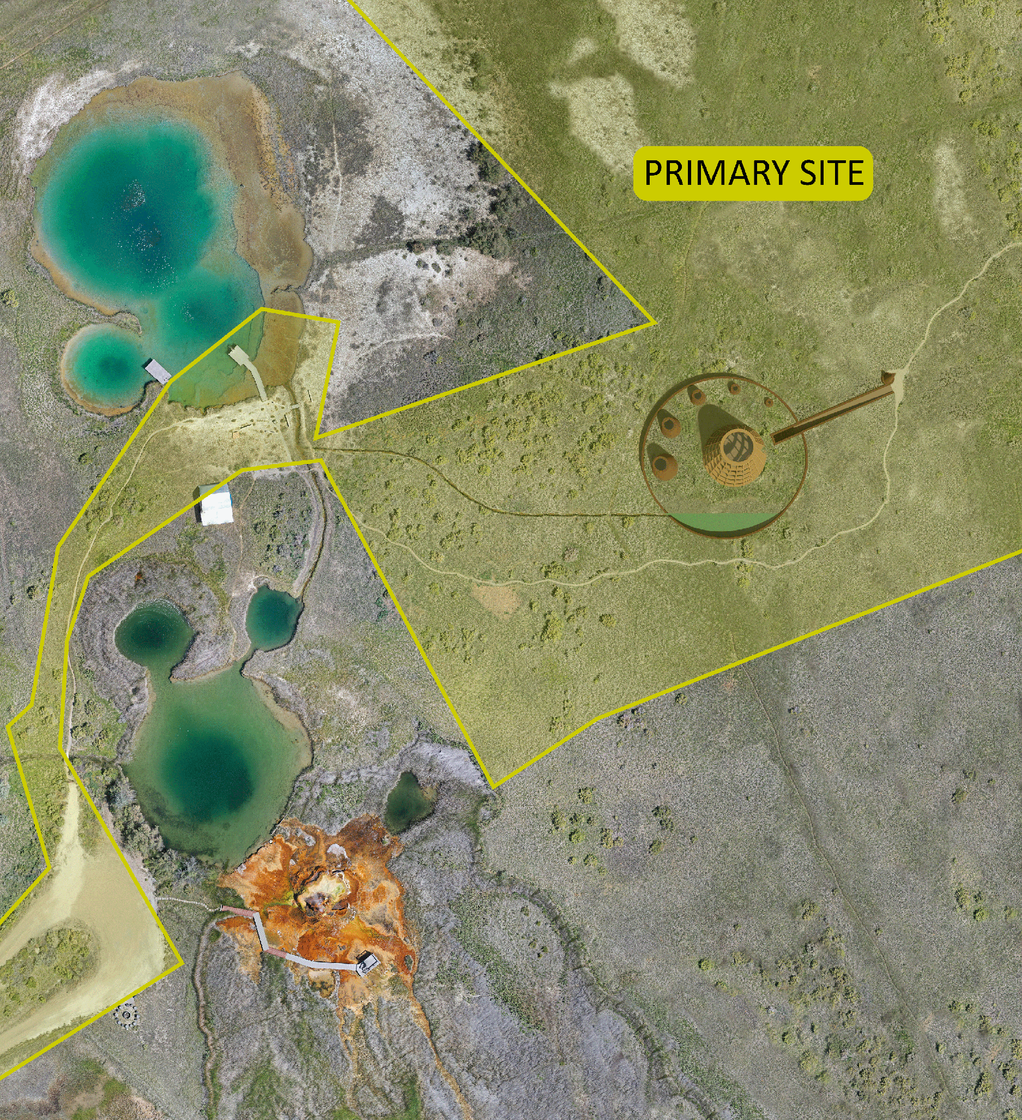
PROJECT BUDGET
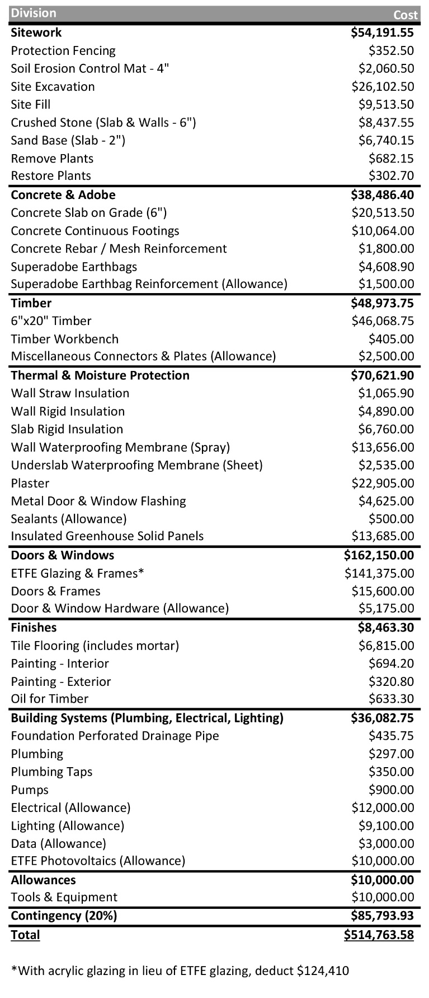
PROTOTYPE BUDGET
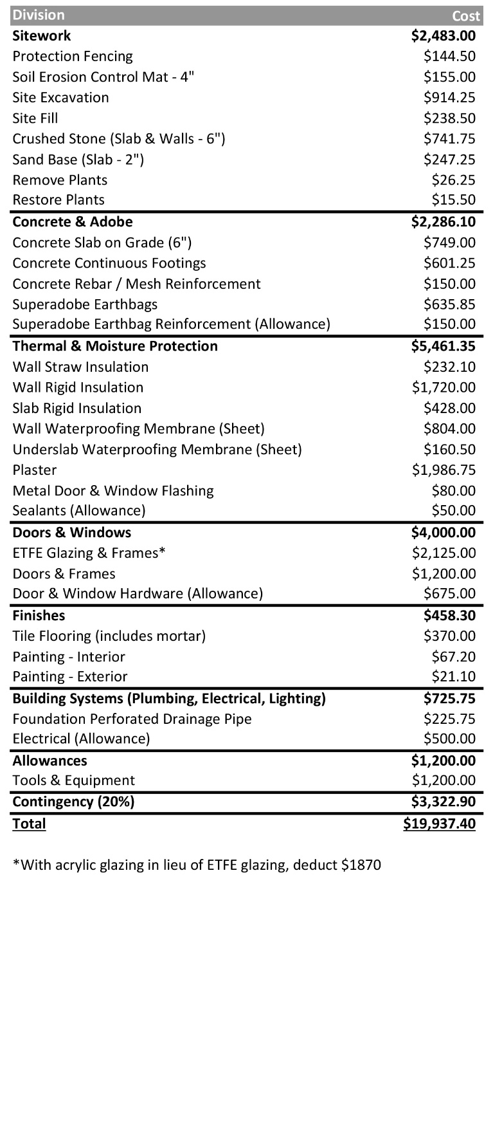
ARCHITECTURAL INSPIRATION
Primary architectural inspiration for the Domes comes from Fly Geyser. A natural folly, its organic form, height, and coloration contrasts with the flat immediate landscape. The overall circular shape of the structureis derived from the circular ponds scattered around the geothermal features on site.
Swedish architect Bengt Warne’s 1974 greenhouse-wrapped home served as a model for creating a comfortable microclimate inside the Dome. Earth sheltered dwellings of the American southwest, including the Navajo Hogan and Mesa Verde cliff dwellings, inspired the materiality of the project and use of earth as an insulator and temperature regulating device. Nader Khalili’s work at the California Institute of Earth Architecture was the inspiration for the use of vaulted and domed superadobe structures. The semi-dome workshop and performance space at Paolo Soleri’s Arcosanti inspired the dual use of our Dome as a place to both create and gather. Indian stepwells inspired the inclusion of an indoor pool for humidification and evaporative cooling, and also as a social gathering point.

