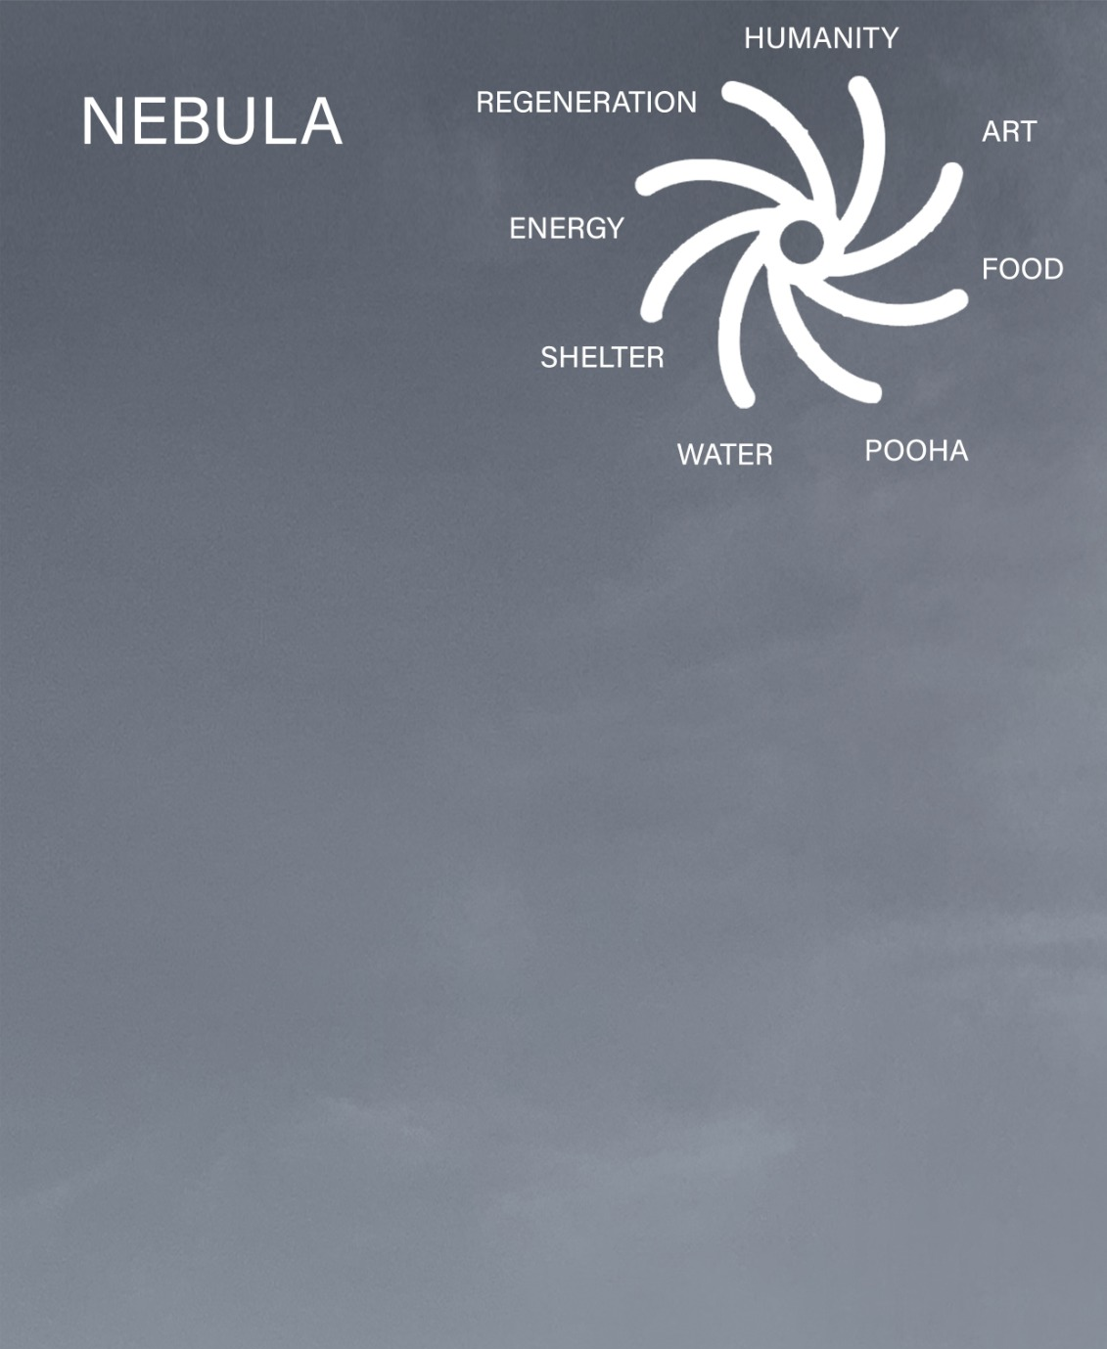

Nebula:
A nebula is a giant cloud of dust and gas in space. Some nebulae come from the gas and dust thrown out by the explosion of a dying star, such as a supernova. Other nebulae are regions where new stars are beginning to form.
From the dust of the Anthropocene, the epoch in which human disturbances outrank geological forces, a new star is beginning to form on the frontier of the Nevada desert. Human society is a vital process – a continuous development from atom to nebula. By respecting the Paiute people’s philosophy of pooha (power) embodied in each natural element, Nebula harnesses the embodied power of its environment to regenerate the ecosystem and nurture a healing community. Treating the different elements as living cells, shelter functions in symbiosis with nature and seeks to find simple, elegant solutions to complicated problems by mimicking the biorhythms of nature.
Nebula functions as a starseed that can support Fly Ranch as a continuous center for future innovation. We imagine a new community can flourish where there are equal access three main seeds of life – water, food, and energy. These elements are unified in our responsible system of shelters which gain resilience through biomimicry harnessing environmental flux from day to night. Carefully considering the embodied energy and upfront costs, our community seeks to become a closed-loop biosphere within 5-10 years and serve as an exportable model of responsible living in a desert climate.

Masterplan:
The masterplan is influenced by Native American community living, oriented around the sun, water, and changing seasons, with specific acupuncture points unifying the land. Three distinct forms of shelter work together to harness energy and maintain human comfort. The Nebula cloud is a soaring undulating canopy that unites the permanent Hemp House to the flexible and modular Solar-Shrooms and Water-Shrooms. We are imagining a new way of communal living that is also responsive to Covid-19 regulations by modeling how semi-outdoor workshop spaces can be comfortable, flexible, and healthy.
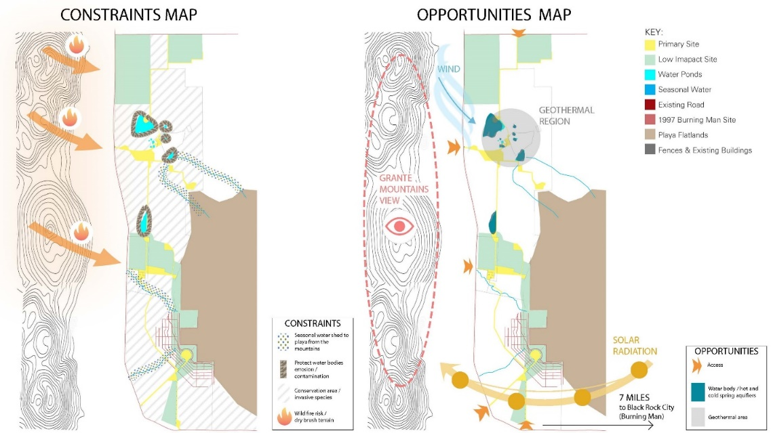
Strength and Opportunity Map : The location of the site was choses by analyzing the opportunity and constraints of the existing environment.

An important resource in researching the contextual background for this project was Native American Architecture by Peter Nabakov, and especially the theme of settlements being temporary and the sentiment of the home being a living connection between the earth and sky worlds.
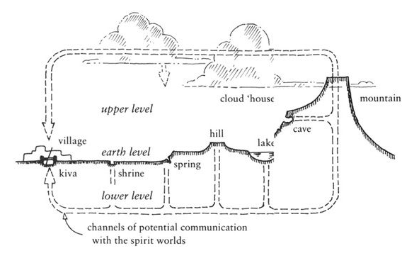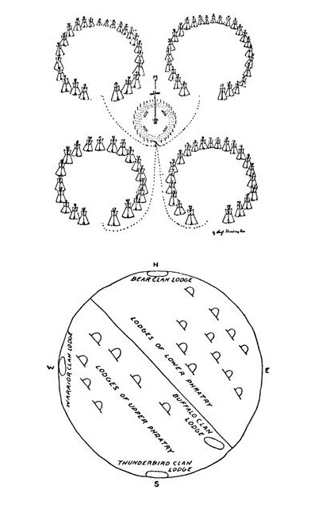
Spiritual connections of natural form and built form.

The Canopy
Soaring over the center of our camp, an undulating cloud is permanently fixed over the landscape to protect the users while interacting with the main energy source of the desert: the sun. The form is responsive of the site location, with solar and wind analysis, while providing a flexible forum below with thermal comfort.
“Meet me at the Fountain” will be a common phrase heard across Fly Ranch. The focus of the masterplan, the fountain is shaped in the geometry of the seed of life – interlocking circles symbolize resilience of life to regenerate and mimics a cell dividing 64 times. A kinetic wind sculpture of feathers float above the fountain reaching to the large oculus to passively direct the air and connect the people beneath the canopy to the exterior environment and the stars.
The Hemp House
The Hemp House can be an independent cellular system which can sustain human life by addressing water, food, shelter, energy and recycling. It uses passive strategies for healing and cooling with a large south-facing glass greenhouse that can grow food year-round and filter wastewater.
The Hemp technology opens fields for experimentation as the canopy functions as a second roof, leaving the hemp-roof and a non-structural element. Considering the growing market of hemp production, given recent US federal legislation, hemp can be a profitable and sustainable building material that is carbon-negative. Because hemp performs well in tension, we propose experiment with different vault and dome structures to frame the roof as means to protype the structural tension properties of different hempcrete mixes.
The form and frame draw inspiration from the resourceful seminomadic Paiute tribe whose survival in the Great Basin of Nevada depended on wise use of scare resources. The Great Basin fiber houses or wikiup utilizes the stick and brush fibers of the desert to bend sticks into domes and covering with thatch. To mitigate fire risk, we suggest cultivating the hemp plant and using its insulating fibers to give strength to our hemp domes.
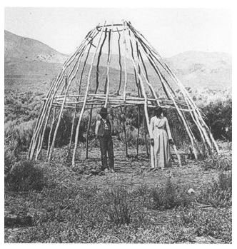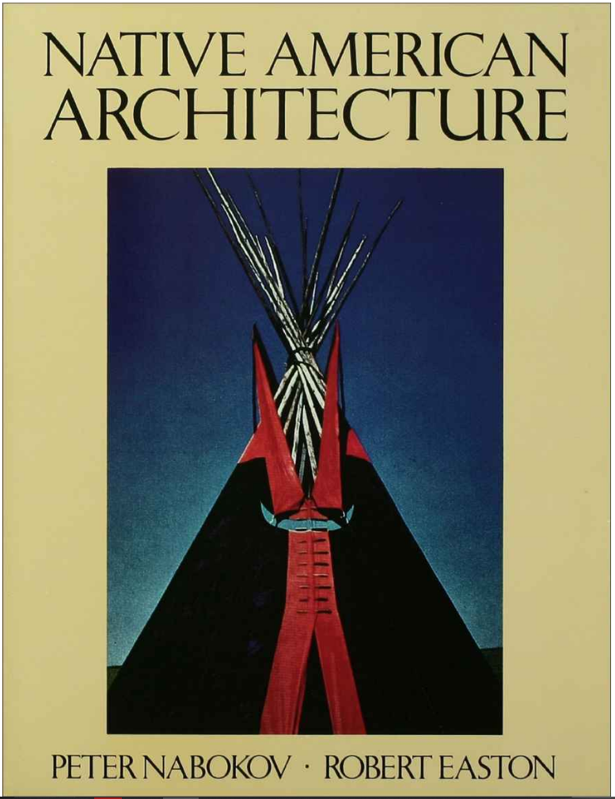
Winter house frame at Pyramid Lake

Shrooms
The Shroom forest is formed by scalable, modular units which work in tandem to provide solar energy and clean drinking water. The hexagonal structure offers flexible site configurations, and the lightweight assembly could be optimized to be prefabricated as an exportable emergency shelter for disaster-relief.
The kinetic structures easily transform into tents mechanically. Fluorescent yarn can be woven into this fabric and illuminated at night to create a glowing field of shrooms. This design effect was inspired by the mythos of a desert festival.
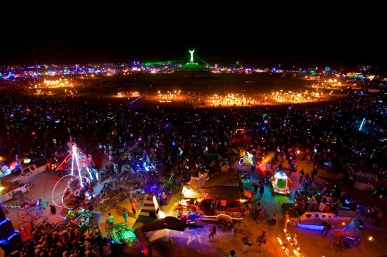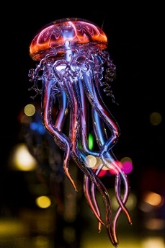

Healing Center
Situated in a peaceful nook near the thermal springs, the healing center is a flexible courtyard space as a healing biotope for yoga, massage, reiki, counseling, workshops, meditation, sound healing, sensory baths, tea ceremonies.
Circulation:
Re-Cycle bike sharing posts connect Nebula to other Fly Ranch outpost by a series of paths covered with phosphorescent paver that glows in the night, increasing the safety of mobility without adding light pollution.

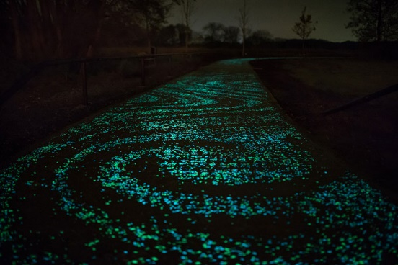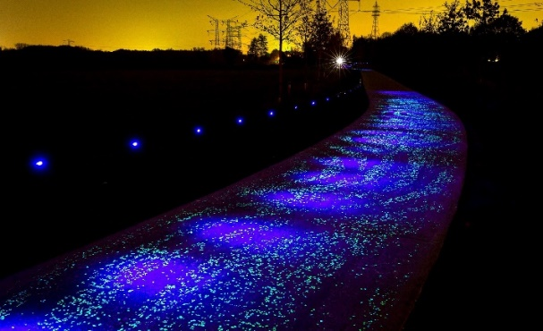
Xeriscaping
Considering the arid climate, the use of native and localized plant species and appropriate materials, such as natural gravels, stone and rock, can enhance sustainability as well as celebrate the local landscape character.

Technology / Material:
Respecting the Paiute tradition of pooha or the embodied power and spirit within all creatures, we select natural and local materials as much as possible. Taking reference of the spirit and connection to nature, we move into a new paradigm by implementing responsibly the technological advances of today to create a closed-loop utopia which can form as a model to sustain human communities in harsh arid climates.
The Canopy
The swirling form of the nebula cloud shows order within chaos, as each element is designed to adapt the advantages of the environment. The form finding process was driven by environmental factors by analyzing maximum solar radiation, sun path, and wind using the Ladybug plugin for Grasshopper in Rhino software. Resulting radiation results drove the form-finding for the slope of the canopy with parameter to maximize solar radiation for the PV panels.
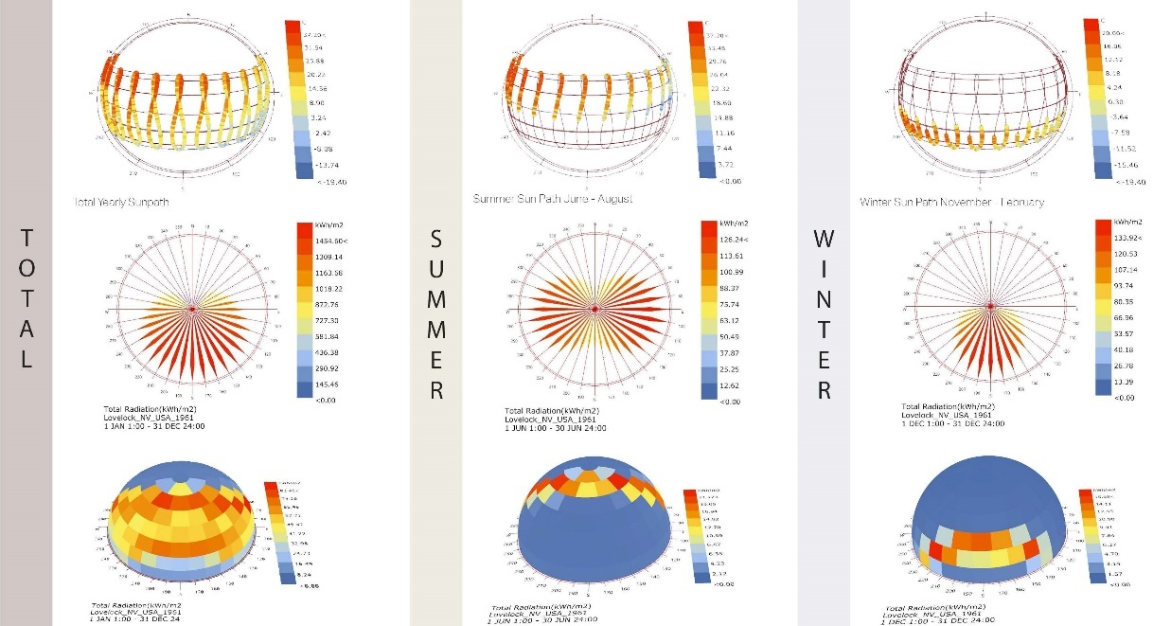
Seasonal Radiation Wheels – Winter versus Summer strategies
Yearly Radiation results on final form and sun pass

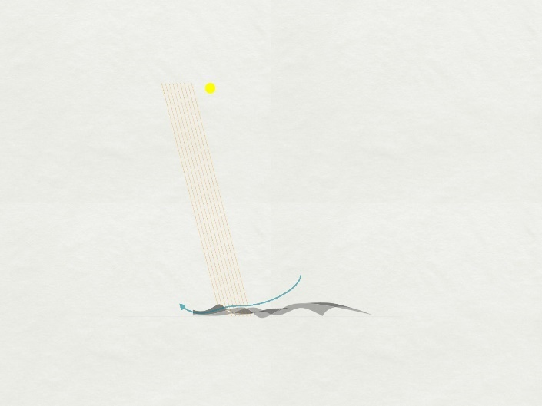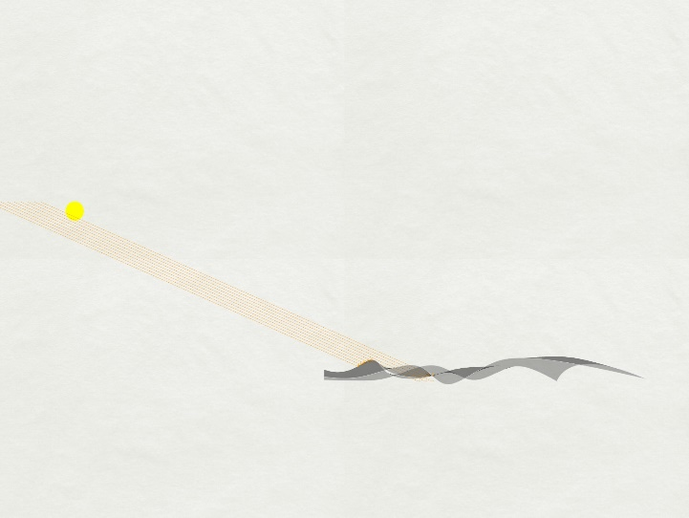
Wind pass from central oculus accelerated over Hemp House roof for passive cooling and sun rays at noon, June 21. Sun rays at noon, Dec. 21.

Graphene
Improving on the affordable yet inefficient Perovskite Solar Cells (PSCs) olar cell, graphine armor could revolutionize architecture, nanomaterial textiles, and batteries. It is super strong due to its composition of a single carbon atomic layer in a hexagon mesh, which is flexible, thermally insulating, and an electrical conduction.
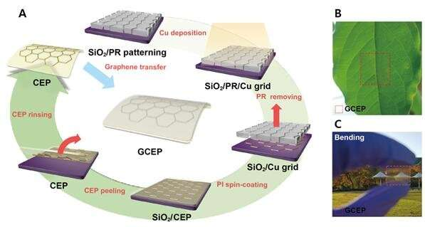
PSC solar cells and graphene armor
As graphene is on the frontier of development, Fly Ranch could be a pioneer in discovering new applications. We propose the flexible, translucent solar panels on the roof of the canopy and the Solar-Shroom, considering efficiency has reached 26.5%.
Graphene batteries are replacing silicon to create new super-batteries, which could serve for solar storage in our Solar-Shrooms or for the micro-grid.
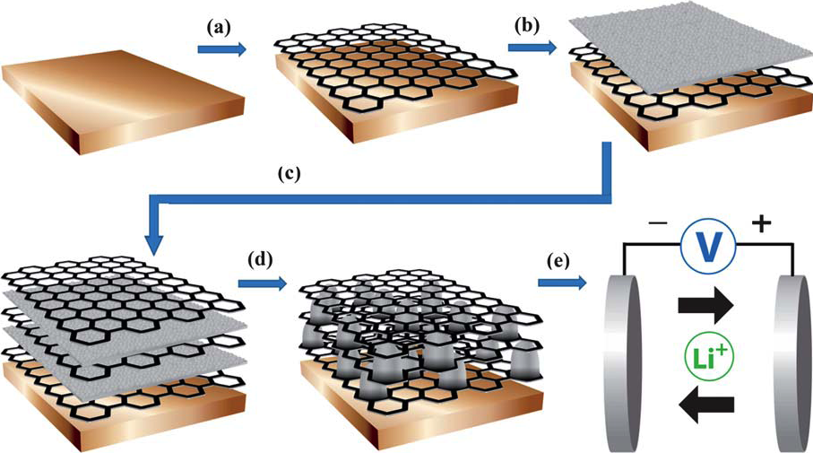
Graphene batteries may replace silicon for their durability and efficiency.
Another possible application of graphene in aerogel textiles, which can be 3D printed and are highly flexible and thermally insulating. We propose using this material as the canopy of the Solar Shrooms, which can be transformed easily to day position to closed shelters that utilize thermal massing. This material can also be deployed under the large canopies to create microclimates around the columns, coupled with geothermal radiant panels, that would comfortably allow people to work and play in open-air considering Covid-19.
The Fountain
A typical strategy in arid climates is to use evaporative cooling using a flowing water feature. Our central fountain unifies the site while cooling the amphitheater as wind passes from the open oculus above. Further, the feather art installation includes a system of porous terracotta tubes with filled with water, and a central tube of aluminum fins. The hot air enters like a wind catcher from the top of the canopy and gradually lowers the temperature as the porous terracotta acts as a heat exchanger, where it evaporates on contact with the air.
Terracotta cooling tube to be implemented in long spans reaching to roof wind catching.
Canopy Structure:
Undulating laminated timber roof structure frame covered with translucent flexible PSC graphene solar panels. Prototyping the structure would involve further form development utilizing Rhino software with T-Splines structural plugin, with Grasshopper Kangaroo doing a kinetic physics analysis to relax the form into the undulating shape.
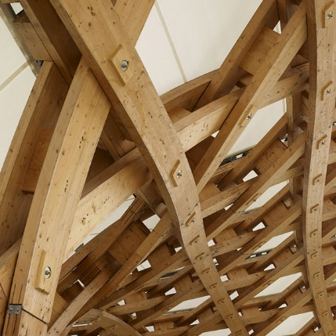
Structural Inspiration for frame: Centre Pompidou-Metz by Shigeru Ban.

The Hemp House
- South-facing windows oriented to 45 degrees to maximize solar exposure in the frozen desert winter and reduce direct gains in the summer.

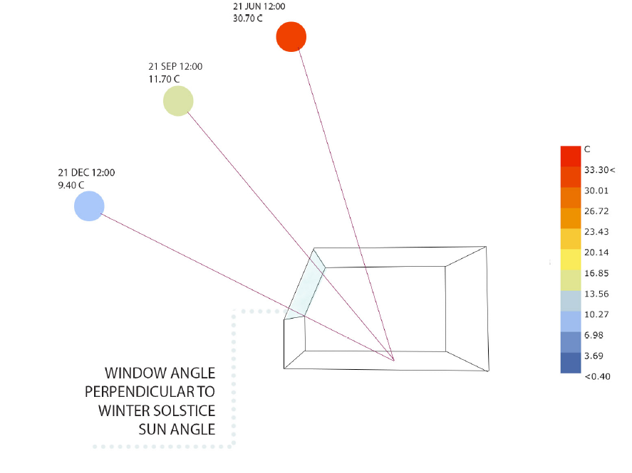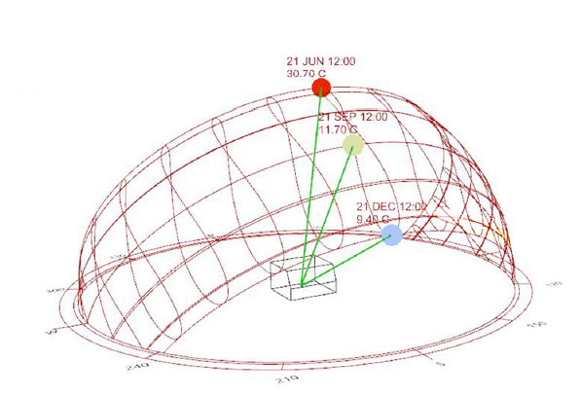
Traced angle to prototype Hemp House at noon.

- In-home organic food production with greenhouse in the south of the building, this receives the most sunlight which means the greenhouse is able to produce food to supply the communal kitchen of the Hemp House and provide nutritious organic food for all the Fly Ranch innovators.
- Trombe wall takes advantage of temperature swings between day/night to control thermal comfort by using the stored thermal energy in the warm greenhouse.
- Hemp House dug 2m below grade for passive geothermal potential of selected site location
- Garbage Management for circular economy: Recycled tires diverted from landfill reused as retaining wall for earth berm and prevent burning carbon.
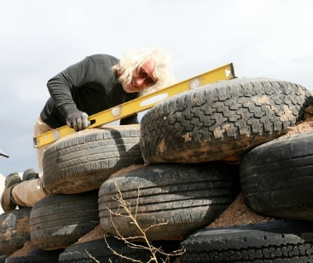
- Hempcrete is a great thermal insulator, can be constructed by volunteer labor, and grown locally in the site implementing permaculture strategies for water-soil regeneration.
- All natural materials include cheap available softwood wall framing with structural hemp domes. Natural earth flooring with geothermal water tubes integrated and sealed in a hemp oil.

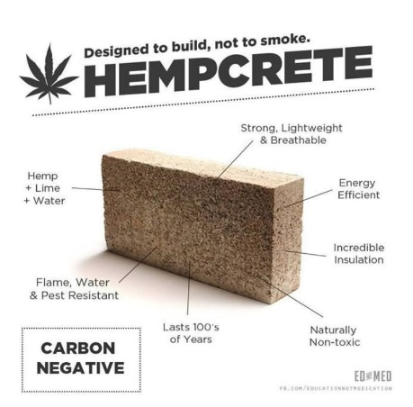

- Sewage Treatment – Self-contained sewage treatment and water cycling: The used gray water flows to interior botanical cells, where plants utilize and act as a primary filter for the water until it’s clean enough to be collected and pumped, on demand, to the toilet tank for flushing.

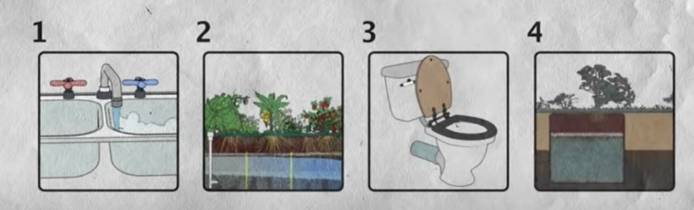

- Clean water – water harvesting from the parasol roof and long term storage in the cisterns below the earth of the amphitheater. It works in tandem with the Water-Shrooms to provide clean drinking water.

Shrooms
The Solar-Shroom annually produces 11,690 kWh per module. Power for local outlet, night lighting, and operating water pump, extra power to local microgrid.
The Water-Shroom captures rainwater and provides 20-40 L of clean drinking water by using solar radiation for convection across a 12-fin aluminum solar still.
Cycles: Recycled light-gauge steel construction, reusable, disassemble, and packable to be used to disaster relief in other contexts. Upcycled bike parts from Black Rock City can be engineered to operate the umbrella mechanism by pushing on the vertical extendable walls.
Shelter: Flexible kinetic Solar-Shroom uses low-tech mechanism to transform shape from daytime shading to nighttime sleeping pods, changing the conception of boundaries between spaces, leaving frontiers for expansion, and fostering community interactions.

Cost Estimate – Rough Order of Magnitude

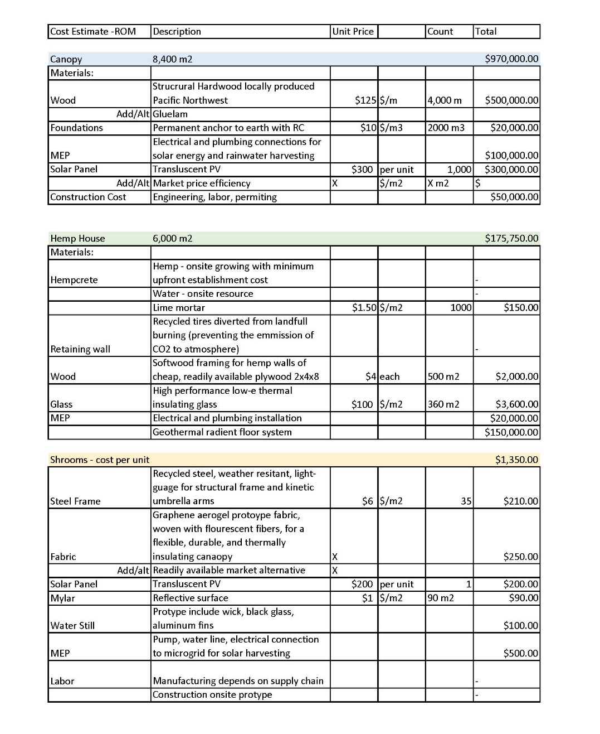
Energy Demand Estimation and Its Scalability
The goal of the project is to be a closed-loop system that can serve many functions from hosting large events to welcoming visitors for short stays while being off-grid and fulfilling its own energy needs. The produced energy must be greater than that consumed, to be carbon positive.
OUTPUT-INPUT > 0
As an example of operational system demands, we consider massive gatherings of dancing under the stars in the Nebula oculus. Considering peak energy consumption for the calculation: sounding system and lighting system for large events under parasol.
Considering a large concert up to 7,000 people would consume 254.4 kWh/year assuming one event per month and duration of 48 hours. Assuming max 20 reflector lights used, requiring 11,520kWh.

Outputs
Canopy:
- Energy: 4,540,068 kWh /year
- Rainwater: 12,750,000 L / year
Solar-Shroom (one unit):
- Energy: 11,690 kWh / year
Water-Shroom (one unit):
- Rainwater: 120,000 L / year
- Clean drinking water: 20-40 L / day (calculation based on protype efficiency, not dependent on the amount of rainwater as consider using other sources such as pond water)
Hemp House:
- Year-round food production in greenhouse to supply the community kitchen

The outputs of the system are scalable to meet the demands of the fluctuating Nebula. By creating a microgrid to responsibly manage the solar energy, the system can be a scalable community. The modular design of the Shrooms mean the water and energy capacity increases in tandem with increased users on site and create more flexible space for sleeping and working.

Prototype Strategy
Each of the three smart shelter cells can be prototyped, depending on the preference of the judges. Our interdisciplinary team is prepared to provide master planning, architectural and technical drawings, preliminary structural assessment, technology consultation, and construction management.
The Hemp House is a very low-cost and effective protype that considers the long-term use and productivity of the land – by cultivating Fly Ranch for productive farming under legislation of NDA. Hempcrete uses the chopped stalk and therefore uses less water, plus can claim to be better than carbon-zero as CO2 is absorbed by the plant while growing and locked in its woody fibers. For prototype purposes, hemp can be purchased from California and volunteer labor can mix the hempcrete while creating scaled models of framing for dome roof construction (innovations exploring the tensile strength of hempcrete). Depending on the results, these strategies could be rolled out full scale and even patent a new technology for implementation of hempcrete in buildings.

The Water-Shroom vertical multiple effect diffusion solar still will be optimized for the most effective number of aluminum plates condensing plates and the solar reflection angle of mylar panels to increase the efficiency of the device to produce 20-40 liters/day per unit.
The Environmental Impact of the overall project is carbon-positive as the structure is scalable to produce more energy and water than it consumes. Combined with the opportunities for community building and healing by caring for mother earth, the humanitarian impact could be even stronger.

Nabokov, Peter, Native American Architecture (Oxford University Press, 1989)
Nabokov, Peter, Native American Architecture (Oxford University Press, 1989)
https://phys.org/news/2020-07-solar-cells-graphene-armor.html
https://mgitecetech.wordpress.com/2011/08/09/graphene-nanocomposition-new-super-battery/
https://www.treehugger.com/natural-air-conditioner-terracotta-thibault-faverie-4857702
http://www.jdg-architectes.com/wp-content/uploads/2014/03/jean-de-gastines-shigeru-ban-details-pompidou-metz7.jpg

