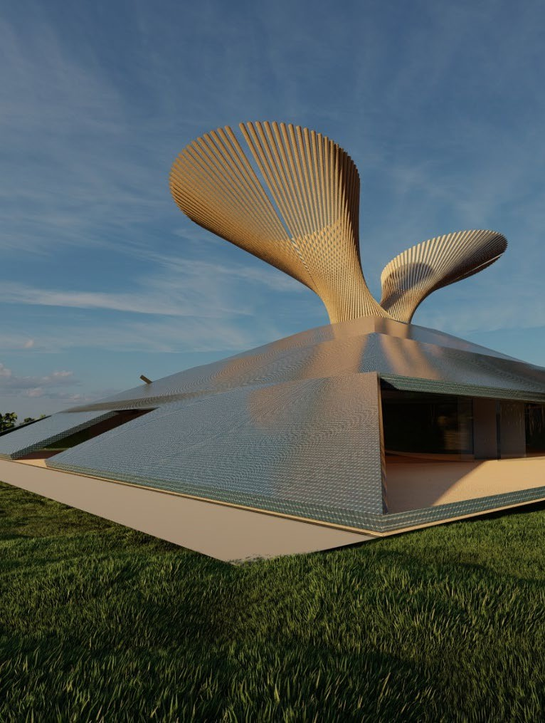

|  |  |
| --- | --- |
| VERTEBRA  [Document subtitle] | VERTEBRA |

# CONSEPT

A sustainable energy and water hub for the villag e of Marou

VERTEBRA is an autonomous architectural system designed to provide the village of Marou with clean water and renewable energy. At its core stands a bamboo hyperboloid structure — reminiscent of a spine or tree of life — that gathers, transforms, and redistributes natural resources.

The pyramid’s façades are fully clad in solar panels, while wind turbines operate on the second and third floors, capturing vertical airflows. Inside the central structure, hydroturbines harness the movement of water, forming a tri-source energy system.

Rainwater is collected from the structure and surrounding drainage systems, directed into an underground reservoir. After filtration, the purified water is pumped back to the upper branch and gravity-fed throughout the village.

A secure room inside the reservoir houses a medicinal depot and a morgue, providing vital support infrastructure for the community.

# COLLECTING WATER RESOURSES DURING FLOOD PERIOD

-As it was mentioned the hole Marou includes 67 homes with approximately 270-400 inhabitants. Our project has water collecting and destirilation options that at destiribute 250 m3 filtrated clean water.

**Option 1:** Population of 270 people

At 50 liters/day per person → 270 × 50 = 13,500 liters/day

→ 250,000 ÷ 13,500 ≈ 18.5 days

At 100 liters/day per person → 270 × 100 = 27,000 liters/day

→ 250,000 ÷ 27,000 ≈ 9.3 days

**Option 2:** Population of 400 people

At 50 liters/day per person → 400 × 50 = 20,000 liters/day

→ 250,000 ÷ 20,000 = 12.5 days

At 100 liters/day per person → 400 × 100 = 40,000 liters/day

→ 250,000 ÷ 40,000 = 6.25 days

# -In the tower that has two hands one will be used for rainwater the second will be for filtred water. Therefore collected energy can`t be saved for a long time this energy will be used for water that is regenerating underground to move to the other hand. This procedure will be done for using less energy when it will be needed to separate to the houses. The water will be gliding by itself with use of less energy.

-The one another technique is drains that we have in facades and in the perimeter of the building. The water from there will also go to the reservoir. By this way we will minimize water loss.

# SOLAR ENERGY CONSUMPTION

-Fiji, 17° south latitude → the optimal tilt angle for solar panels in this region is roughly equal to

the latitude, so about 15–20°.

Our panels are at 25°, which is a bit steeper than optimal, but still within a high-efficiency range. With a 25° tilt (instead of the ideal 17°), efficiency drops slightly by around 2–4%, depending on the season. Average solar irradiance in Fiji, considering a 25° tilt, is around **5.5 kWh/m²/day** (slightly less than the ideal ~5.7 due to over-tilt)

E=A×I×η×365

Where:

E = annual electricity production in kWh A = area of panels (3924 m²)

I = average solar irradiance (~5.5 kWh/m²/day) η = efficiency (0.18 or 18%) E=3924×5.5×0.18×365≈1,423,773 kWh/year **WIND ENERGY CONSUMPTION**

As it is known that Fiji in some periods has storms that makes us a chance to use wind energy.

We are using 4 wind turbines that makes energy.

each turbine has a **rated power of 1 kW**, operating at an average wind speed of **4.5 m/s or higher**.

# Annual energy production formula:

E=P×CF×8760

Where:

**P** = Rated power (1 kW)

**CF** = Capacity Factor (efficiency depending on wind speed)

→ For 4.5–5 m/s, this is about **15–20% 8760** = Number of hours in a year

For One Turbine: E=1×0.18×8760≈1577 kWh/year For 4 Turbines:

1577×4=6308 kWh/year

# MORQUE AND MEDICINE STORAGE

This special room locates -5.00 meters underground. That gives extra thermal insulation. We are placed it inside water reservoir and on the outside it has free space that makes extra insulation too. Weare expecting decrese temperature till 15 degrees.