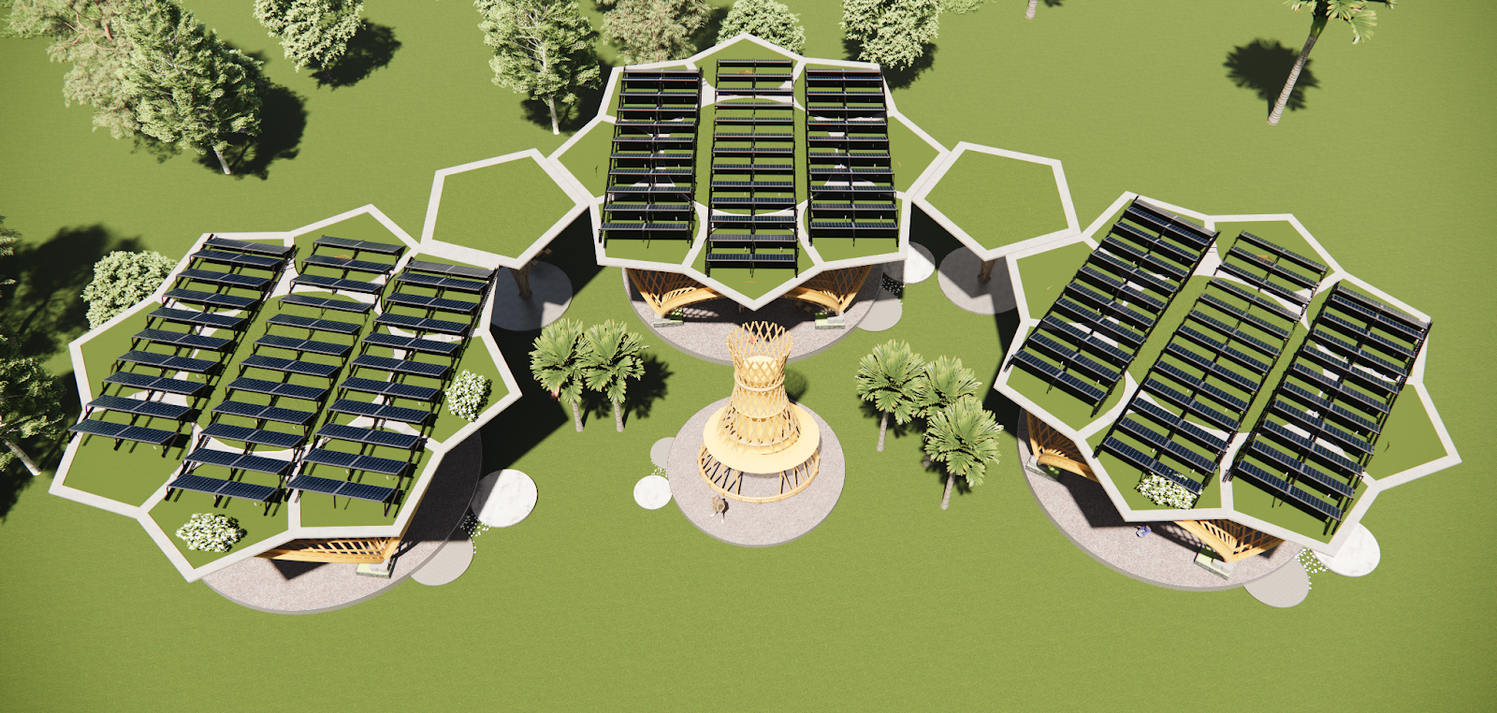

Solar Bloom Pavilion

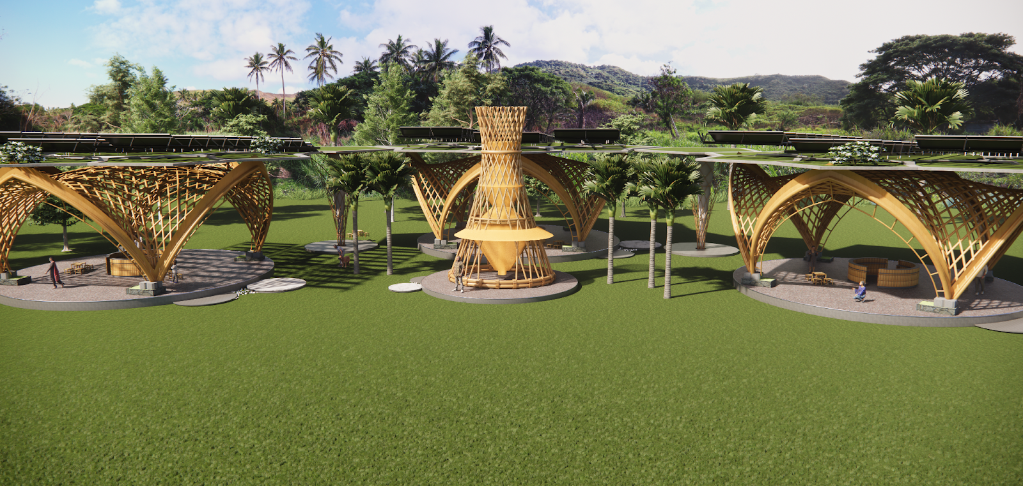

### 

### **1. Concept**

The **Solar Bloom Pavilion** is a community space designed to serve the people of Marou as a source of clean energy, fresh water, and social connection. Built with care using **natural and local materials** like bamboo, coconut fiber, and woven palm leaves, the Pavilion brings together traditional wisdom and modern ecological design to support the village’s long-term resilience and well-being.

At the heart of the design are **three flower-shaped bamboo structures**, arranged in a circle and connected by shaded walkways. These elegant, airy buildings provide a welcoming space for community gatherings, celebrations, meetings, and rest. The center of the circle is open, offering protection from sun and rain while staying connected to the land and sky. **The raised foundations also double as comfortable seating for community members**, turning the base of the structure into a place for rest, conversation, and connection. Every part of the Pavilion is made to be **beautiful, strong, and easy to maintain**, reflecting the natural rhythms and resources of the island.

A key strength of the Pavilion is its ability to provide water even during the dry season. A tall **atmospheric water tower** in the center draws moisture from the air and turns it into drinking water—no matter the weather. At the same time, **rainwater from the rooftops is filtered and stored** in an underground tank, giving the community a clean, steady supply of water year-round.

The Pavilion is fully powered by the sun. **Solar panels on the roofs** produce more than enough electricity for lighting, pumps, and community use, on top of providing power for the village below. All systems are designed to be easy to use and repair, with simple tools and local training.

To protect the site from heavy rains and strong winds, the Pavilion is surrounded by **berms and swales** that manage water flow naturally and prevent flooding. These earthworks are planted with **bamboo**, which grows quickly, holds the soil, and acts as a living windbreak. Over time, this bamboo can also be harvested to build new structures, making it part of a cycle that supports the community’s growth.

As Marou’s needs change, the Pavilion can grow too. **More solar blooms, water towers, and storage tanks** can be added easily, without disturbing the original design. This flexible, modular approach means the project can adapt over time and continue to serve future generations.

The **Solar Bloom Pavilion** is not just a building—it is a living, growing system that brings people together, honors nature, and supports daily life. It is designed to **strengthen the community, protect the environment, and celebrate the culture** of Marou through beauty, resilience, and shared purpose.

**2. Technical**

### **2.1 Flood and Typhoon Protection**

The Solar Bloom Pavilion is built on a **low-carbon cement slab foundation**, raised above historical flood levels to ensure long-term durability and climate resilience. The foundation doubles as **seating platforms and communal gathering spaces**, shaded and protected for comfort during daily use.

To manage stormwater, the site integrates **bioswales and earthen berms**, located strategically to the northeast and east—directions from which prevailing rains and cyclone winds arrive. These landscape elements are shaped to **slow, infiltrate, and redistribute runoff**, protecting the Pavilion and surrounding village infrastructure.

The berms are densely **planted with fast-growing bamboo**, which anchors the soil, absorbs water, and acts as a **wind buffer** against cyclones up to Category 5. This **living landscape system** not only reduces flood risk and wind impact but also supplies a **renewable building material**—harvested sustainably every four years to support future construction and repair needs.

### **2.2 Structure and Materials**

The Pavilion’s primary structure uses **locally sourced bamboo** chosen for high tensile strength, resilience to humidity, and seismic flexibility. Structural joinery uses **natural fiber lashings and concealed stainless steel fasteners** for added longevity.

This project supports national goals by coordinating with the **Fiji Bamboo Construction Project**, and initiating a **local bamboo propagation program** around the Pavilion berms to support future demand and community access to sustainable materials.

Materials are chosen for **low toxicity and carbon footprint**: low-carbon cement for foundations, **basalt rebar** for reinforcement (resistant to corrosion in humid/saline environments), and woven plant fibers for roofing. Roofing panels combine **aesthetic and technical performance**, using coconut, pandanus, and palm thatch techniques reinforced to resist uplift from strong winds.

Rainwater from the flower-shaped roofs is first passed through green roof vegetation for biofiltration, then captured in a 500,000-liter underground cistern. **The green roof includes layers of vegetation, soil substrate, and a drainage membrane, which cool the structure and improve water quality before storage.** A **multi-stage purification system** (sand, carbon, UV) prepares water for drinking and household use, delivered by **electric and manual pumps** to ensure water access in all conditions.

### **2.3 Solar Electric Systems: Clean, Reliable Power for Marou**

The Pavilion’s roofs are fitted with **high-efficiency photovoltaic panels of 400W**, capable of generating over **100 kW of solar electricity**—generating an abundance of clean energy. This abundance of energy can power nearby homes, enabling **distributed village-scale electrification**.

A **smart battery storage system**—housed in a **ventilated, tamper-resistant technical enclosure** below one of the main structures—ensures 24/7 energy availability. The system includes **charge controllers, inverters, lithium-ion battery banks**, and thermal safety shutoffs, all compliant with international standards.

Electricity powers lighting, water pumps, tool charging stations, educational equipment, and more. This decentralized system cuts fossil fuel dependence and provides **reliable, clean energy**, even during cloudy days or grid outages, enhancing the Pavilion’s function as a **resilient community hub**.

**3. Prototyping**

The prototyping phase of the Solar Bloom Pavilion will be carried out at the Marou pilot site. This first phase will focus on building one complete “solar flower” module. The structure will include a bamboo pavilion with a full solar photovoltaic system, a secure battery storage box, and integrated lighting and charging outlets.

To ensure water resilience, the prototype will include a 50,000-liter underground rainwater storage tank. Rainwater collected on the flower-shaped green roof first passes through layers of vegetation, soil, and drainage fabric, which act as a natural pre-filtration system by removing debris and sediment. Once stored in the underground tank, the water is then pumped—using both electric and manual pumps—through a multi-stage filtration system consisting of sand, activated carbon, and UV treatment.

Surrounding the solar flower, swales and berms will be shaped to manage stormwater and reduce flooding. These earthworks will be planted with fast-growing bamboo, which acts as both windbreak and future building material. As it matures, the bamboo can be sustainably harvested to construct the additional pavilion structures, enabling the community to grow the materials needed for expansion directly on-site. Though this initial prototype includes only one structure, it is fully functional and serves as a foundational unit that can be replicated and expanded upon.

A covered gathering space will be created at the center of the prototype, providing a shaded, multi-use area for community events and meetings. This pilot installation is designed to demonstrate the technical performance, community value, and aesthetic appeal of the Solar Bloom Pavilion.

**Implementation Timeline (12 Months)**

|  |  |  |
| --- | --- | --- |
| **Phase** | **Activities** | **Duration** |
| 1 | Site preparation, mapping, earthworks | 1 month |
| 2 | Berms, swales, and foundation construction | 1 month |
| 3 | Construction of the bamboo structure and roofing | 3 months |
| 4 | Installation of solar panels and battery system | 2 months |
| 5 | Installation of rainwater tank, filtration, and pumps | 2 months |
| 6 | Planting of protective bamboo zones | 1 month |
| 7 | Community training and testing | 2 months |

The design is modular, circular, and replicable. Once this first solar flower is completed and tested, additional units can be added laterally, allowing the Pavilion to grow with the community’s evolving needs while preserving its visual harmony and functional resilience.

**4. Maintenance**

**4.1 Maintenance of Solar Systems**A bilingual user manual (in Fijian and English) will be provided to the community, covering all aspects of care and safety. It will include:  
 • Monthly cleaning of the solar panels to ensure optimal performance.  
 • Quarterly checks of electrical connections, battery status, and system safety protocols.  
 • Simple LED indicators to help users monitor system alerts easily.

Hands-on technical training will be provided to at least three local residents (including at least one woman) to become community maintenance leads. They will be responsible for routine upkeep, supported as needed by regional technicians for more complex interventions.

**4.2 Structural Maintenance** • Biannual inspections of bamboo structural elements will be carried out, with onsite treatment if needed to prevent termite damage or mold.  
 • Locally sourced roof fibers are expected to last around 10 years before needing replacement.  
 • Annual maintenance of the swales and berms will be conducted to ensure proper water flow and erosion control.  
 • Every four years, mature bamboo planted along the berms will be sustainably harvested and treated onsite using non-toxic methods. This bamboo will be stored and prepared for use in future pavilion expansions or structural repairs, creating a regenerative building cycle rooted in the landscape itself.

**4.3 Monitoring of Water Production and Distribution** • The underground tank and water filtration system will be checked every six months, with filter to be cleaned and/or replacements as needed.  
 • The atmospheric water tower will be cleaned and inspected annually to ensure continued performance during dry seasons.  
 • A simple logbook will be used to record monthly water volumes, helping the community monitor use and anticipate demand.

**5. Environmental Impact**

The Solar Bloom Pavilion follows a holistic and regenerative approach to minimizing the environmental footprint while regenerating the local ecosystem:

### **5.1 Emission Reduction**

The Solar Bloom Pavilion is conceived as a carbon-conscious system from the ground up. Its main structures are made from fast-growing, renewable bamboo, harvested locally and treated on-site. All roofing uses locally woven plant fibers, and foundations are built with low-carbon cement and basalt rebar. Once operational, the Pavilion produces **zero emissions**, powered entirely by solar energy. It replaces fossil-fuel generators, cutting long-term emissions and operational costs while advancing Fiji’s climate commitments.

### **5.2 Resource Conservation**

The Pavilion incorporates multiple strategies for responsible resource use. Its flower-shaped roofs collect rainwater, which is filtered through green roof layers, stored underground, and treated via sand, activated carbon, and UV systems to ensure safe drinking water. An Atmospheric Water Tower extracts humidity from the air, securing **year-round access to clean water**, even in droughts. Manual and electric pumps ensure distribution for drinking, irrigation, and hygiene, reducing pressure on external water sources and infrastructure.

### **5.3 Landscape Regeneration**

Beyond the buildings, the project actively restores the surrounding landscape. Swales and berms reestablish natural water infiltration, reduce flooding, and recharge groundwater. These earthworks are planted with bamboo, which serves as a living windbreak, stabilizes the soil, and forms a **renewable construction resource** harvested every four years. Excess water supports agroecological gardens, reinforcing local food systems and community nutrition.

### **5.4 Safety and Health**

All materials used are non-toxic and suited to the tropical climate. The electrical systems are installed in child-safe, ventilated technical boxes, with clear indicators for safe operation. Easier access to filtered water reduces reliance on bottled water and helps eliminate **waterborne disease risks**. Shaded areas and natural ventilation in the structures ensure thermal comfort and protection from the elements, supporting both physical and mental well-being.

### **5.5 Social Cohesion and Resilience**

The Pavilion is a place designed **by and for the community**. From the participatory design process to ongoing training, local knowledge and labor are central. Three community members (including at least one woman) are trained in system maintenance and supported by regional technicians. The central plaza is a cultural anchor, hosting events, gatherings, and ceremonies. The biophilic and flower-inspired architecture fosters connection to land and identity, encouraging collective stewardship of shared resources.

### **Conclusion**

The Solar Bloom Pavilion is not just a solution—it is a regenerative ecosystem. It meets basic needs, renews the landscape, empowers local knowledge, and celebrates cultural identity. It offers Marou a resilient, replicable, and community-rooted pathway forward, where energy, water, and wellbeing bloom together in harmony with the island environment.