The
Land Actuator
stories of co-creation
LAGI 2025
Fiji

Concept Narrative

The land actuator is an ongoing process not a fixed form, co-writing stories each day, each season, each year. It begins with the planting of bamboo grown on a land formed of stories, past and present. The land is
then paced and marked. Voids are carved from its surface, the rich earth formed into bricks set out to cure in the heat of the sun. Cisterns and vaults formed of the bricks rise into being, reaching out into the landscape as they narrow into fine channels. The remaining earth shelters the vaults, as local grasses and wildflowers are reseeded within it. Positive and negative landforms folded into the land to offer moments of pause in an ever-flowing landscape, tempering storms and offering shelter.

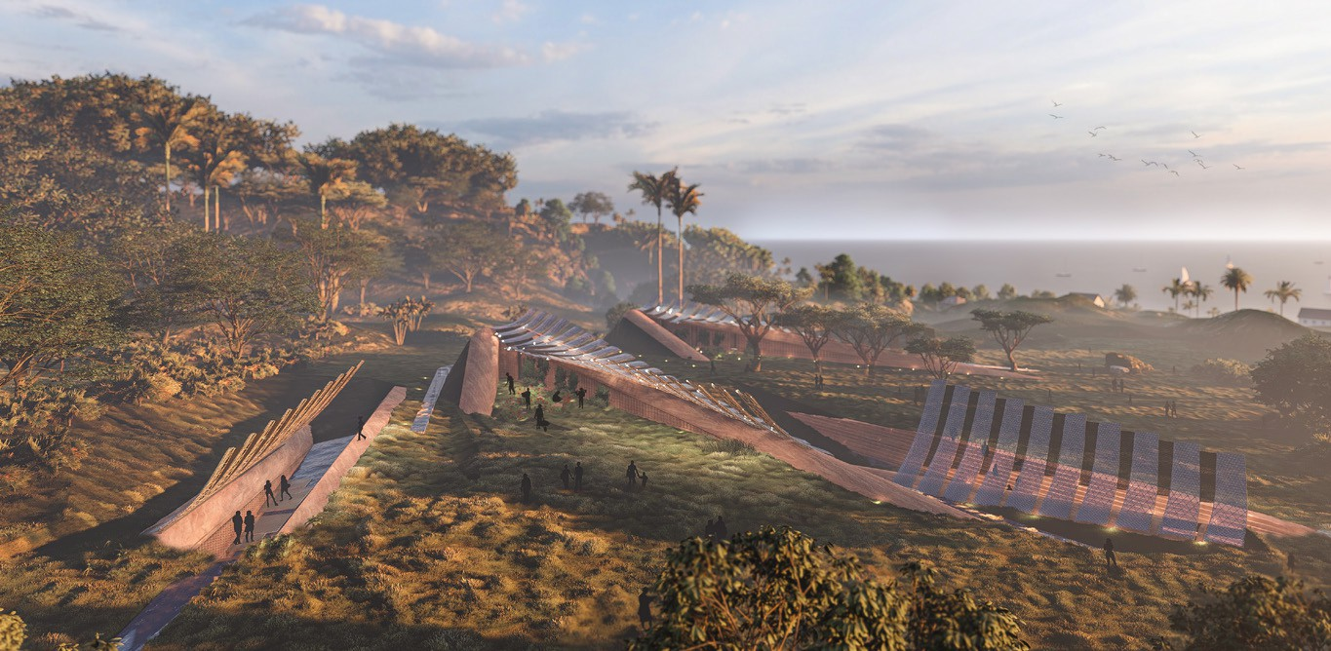

Bamboo nurtured by sun and rain is cut and crafted into elegant cradles under the shade of the trees using time honed skills. Adults teaching children, who in turn will teach their children. The bamboo cradles are carefully carried to the landforms and hoisted into place.

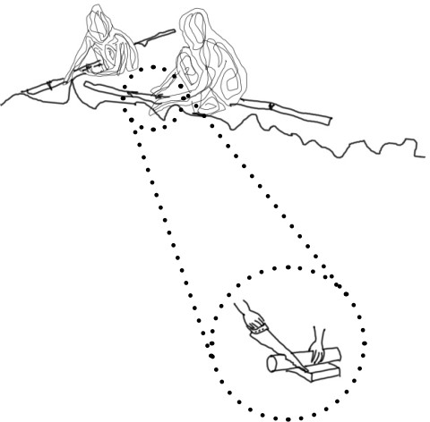

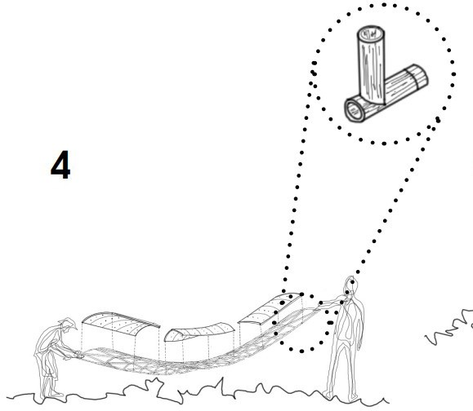

A boat docks, brass environmental instruments with glass photovoltaic fins glint in the sunshine as they are carried to the landforms to be strung and tuned. The land actuator comes into being to co-author new stories. Stories of sheltering within
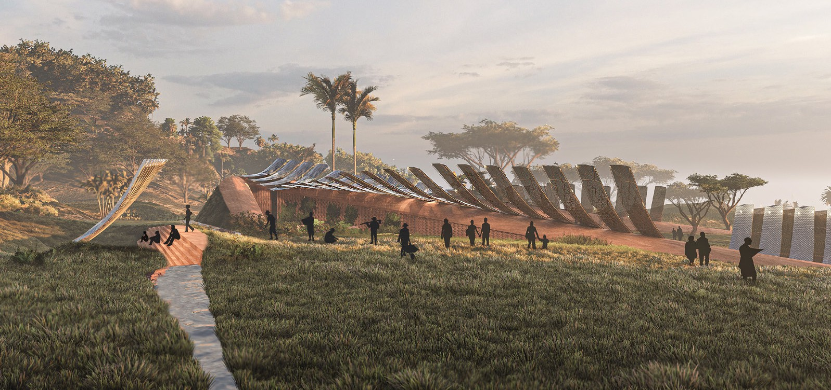
the vaults in a cyclone, of cisterns filling with water and negative landforms offering themselves as lakes to mitigate the deluge. Stories of times when the rain does not come and the cisterns offer fresh water, and of dark pathways lit by the harvested power
of the sun. Stories of community meetings and school lessons held under the shade of bamboo photovoltaic cradles within the cool breezes encouraged by the form. Stories
of tending and harvesting crops sheltered by the semi-transparent photovoltaics and watered by collected rain and fog. Daily stories becoming rituals as the land actuator tunes itself to the time of the place, reaching up to capture the morning mists to then sparkle with water droplets in the sunshine, then pivoting to catch the rays of the sun, closing down in a storm and sending out
cooling mists when a tipping point is reached and temperatures become extreme. Tales of burnt land and cracked earth sent into the sky, a distress call to engender action.

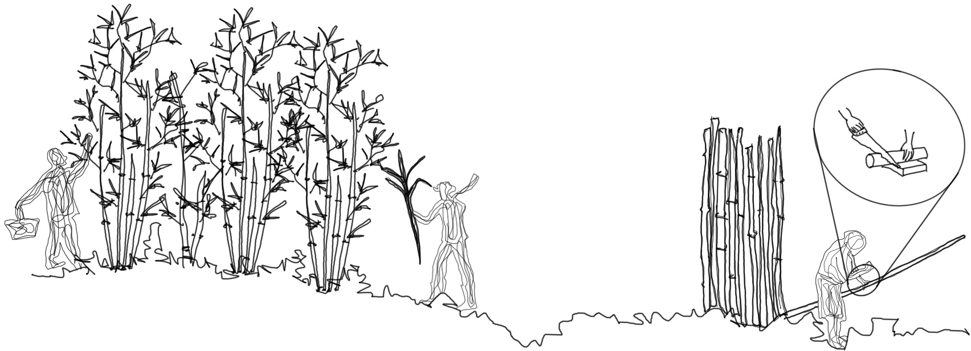
Bamboo is replanted, offering shelter to the sea breezes, as the cycle of the land actuator continues through repair and replacement. A story of co-creation, of people, of land, of sky.

Technical Narrative

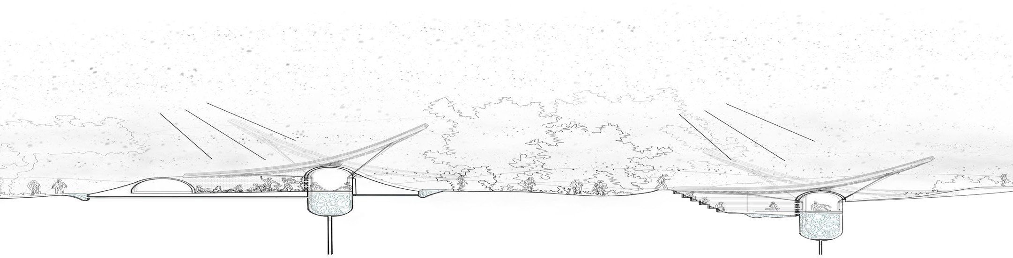
The land actuator is a deployable responsive structure. The landscape is folded and harvested to form structures to host technologies shipped to the site to activate the land’s potential for producing energy, water and crops. The land actuator is a collaborative process, an ongoing story of land, of sky, of people and of technology.

Earth: Land & Water

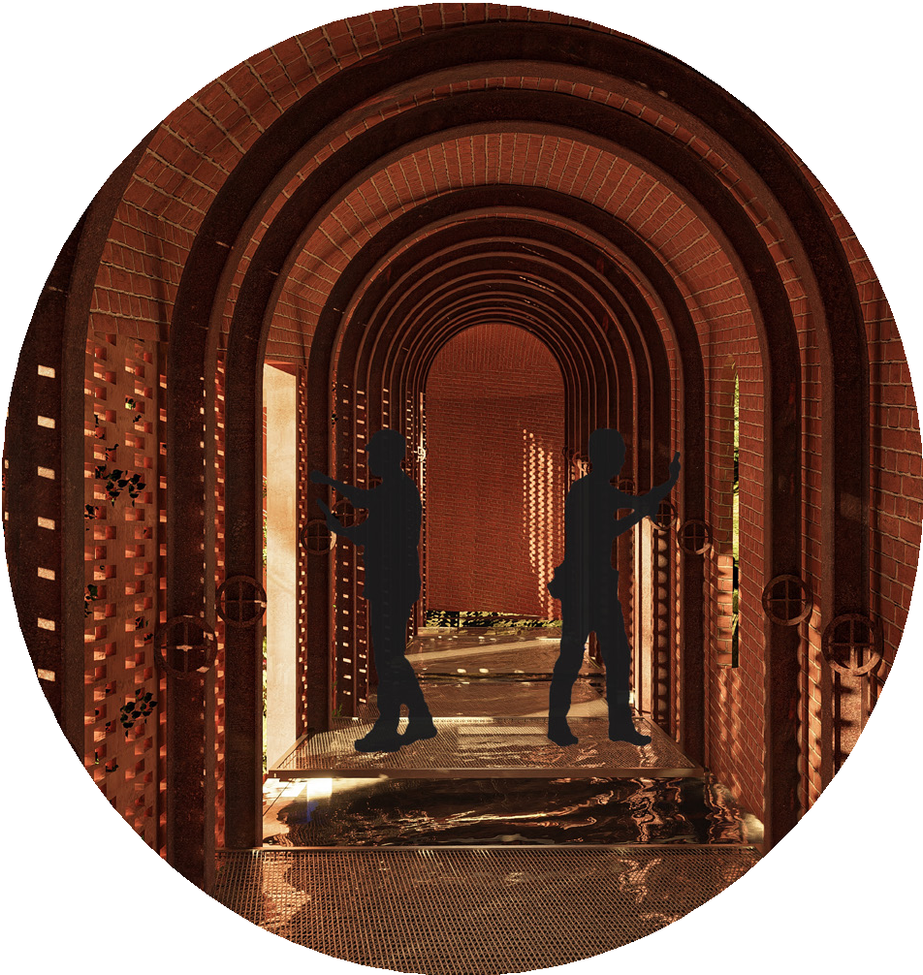
Landforms are folded from the ground to engender capacity to both hold water and temper its flow within periods of heavy rain. They are designed to alleviate flooding and the erosion that comes with this. The landforms are inhabited by vaulted cisterns that hold a total of 3030m3 of water that is cleansed through carbon filters for use in drought. The negative landforms offer the further facility to contain 750m3 of rainfall by filling to the brim as reservoirs. The vaulted spaces of the positive landforms
are also designed to offer shelter during cyclones.

The vaults open to the interior of the landforms with hit and miss compressed earth brick walls, and meld into the landscape on the outer side with local grass and wildflower seeded earth sheltered edges.
Voids run up through this edge, acting as mini solar chimneys to draw through
cooling breezes whilst carrying the cables for the kinetic photovoltaic fingers above. These spaces offer cool fishing stores with refrigeration powered by the photovoltaics, as well as hosting the batteries that store the sun’s energy.

The excavated earth from the negative landforms and cistern voids is used to make compressed earth bricks that cure for four weeks in the sun. Stabilised earth compressed bricks are made to line the cisterns with the addition of lime delivered by boat to offer stronger water
resistance. The vaults are constructed of the compressed earth bricks and then sheltered on their outer edges with the remaining soil.

Sky: Sun & Cloud

Native bamboo is planted on site to later be harvested and then crafted into elegant cradles to hold the photovoltaics; elegant fingers reaching out over the landforms.

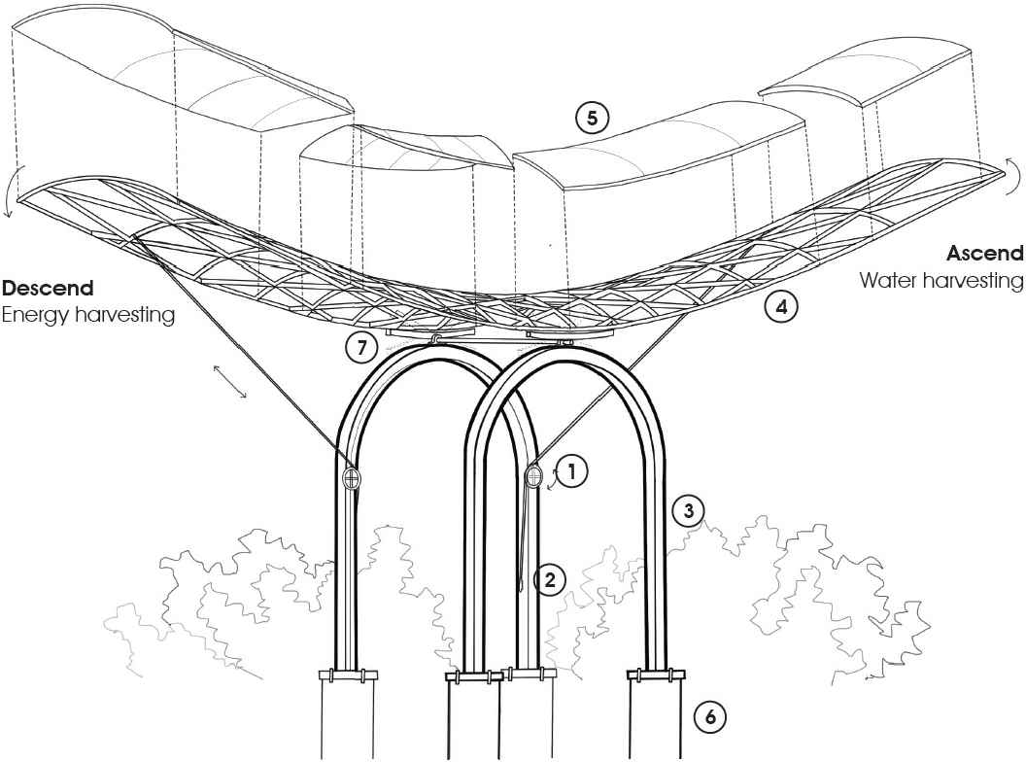

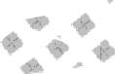
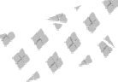
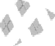
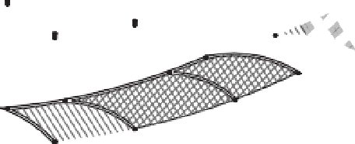

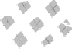
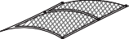



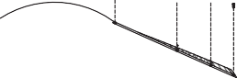
These bamboo cradles hold approximately 850m2 of BIPV semi-transparent glass panels generating around 100W per m2, totalling 85kW. Surplus energy is stored within batteries protected within the landform’s vaults. Pulleys informed by sailing technology control these kinetic bamboo PV fingers. At night they reach up to the sky, hoisting interdigit fog catchers vertically to catch the water of early morning fogs. As
the sun rises higher the fingers pivot their photovoltaics towards the light to capture its energy.

The positive landforms deploy agrivoltaics, with crops growing beneath the semi- transparent kinetic photovoltaic fingers, shielding them from the scorching sun and reducing watering requirements. In turn the presence of the crops aids the photovoltaics to produce more energy. In extreme heat a tipping point is reached and clouds of fine water droplets, using Mee Fog technology, emerge from the vaults of the positive landform to protect the crops. Clouds drift across the landscape, coiling into the sky signalling the truths of climate change.

Prototyping and
Pilot Implementation Statement

The prototype would be formed of one segment of the Land Actuator that would trial the story of the full proposal. In this form the Land Actuator reveals its capacity to be deployed across other landscapes and at other scales. The community are key
to the story of the Land Actuator, in both its initial construction and its day-to-day functioning. The story of the prototype would be:

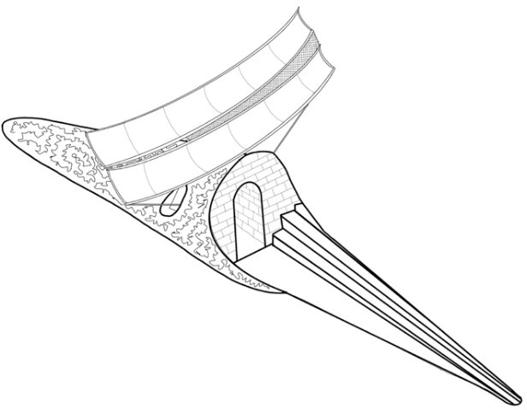
- The land would be marked and dug by the community to make a void for a contained cistern and water channel.
- The excavated earth would be used by the community to trial making compressed earth bricks. The making of stabilised compressed earth bricks would be tested through the addition of lime shipped to the site. A skilled craftsperson would lead the session, passing the skills to all.
- A contained vaulted cistern would be constructed by the community within the excavated void using the compressed earth bricks above ground level and the stabilised compressed earth bricks below grown level. A skilled bricklayer would lead the process passing on the skills to all. The remaining earth would be used to shelter the vault on all but the southern edge, where there an entrance through hit and miss brick walling would be formed.

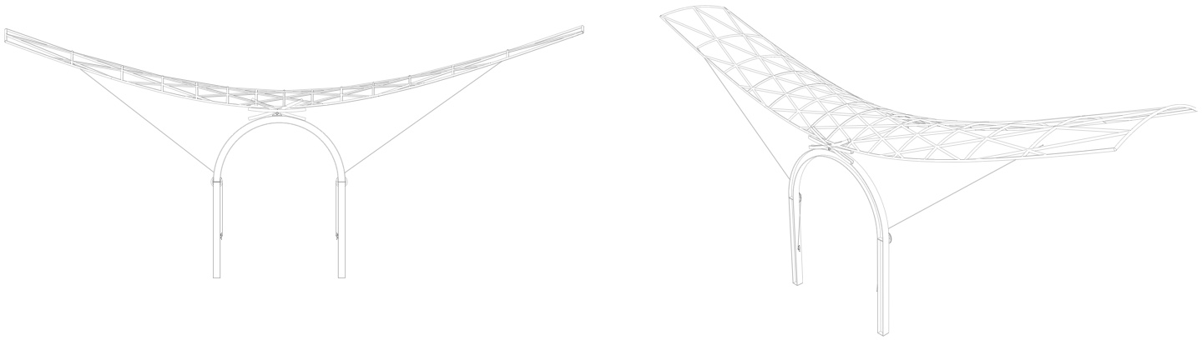
- Native bamboo would be cultivated, harvested and woven by the community into two cradles for the semi-transparent BIPV glass panels. A skilled craftsperson would lead the session, passing on the skills to all. Once complete the semi-transparent BIPV glass panels would be mounted on to the bamboo cradles.
- The recycled brass kinetic structure to hold and move the cradles would be fitted into the vault. The cradles would be hoisted up and connected both to this structure and a battery housed in the vault.
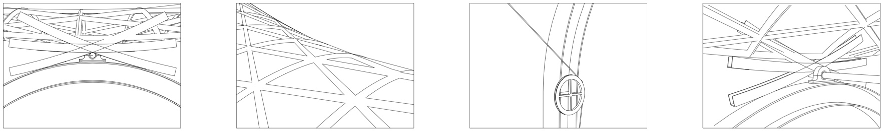
- The interdigit fog catcher would be attached between the two cradles.
- The tipping point fog maker with its temperature sensor to trigger action when a tipping point is reached would be fitted into the vault.

Operations and
Maintenance Statement

The land actuator is an ongoing process, a story written within the land, coauthored by the people, the sky and the earth. Its ongoing maintenance writes these stories into its fabric as we move through time.
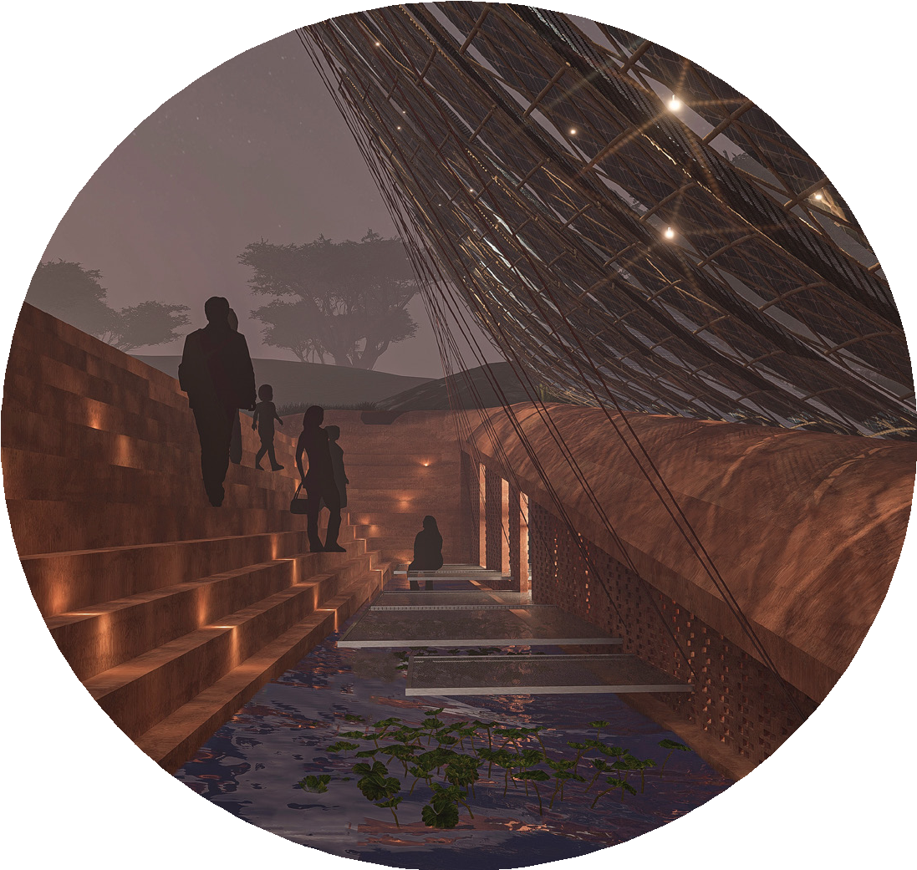
Tales of a season of heavy rains and cyclones marked by a mending and interweaving of new material. A draining and refinishing
of the cisterns, speaking of the passing of dry weather and the coming of the rains. A ritual of repair and renewal. Replaced worn compressed earth brick steps a memento of classes held, community meetings attended. Time writing memories into form.

Every remaking is a replaying and passing on of the skills learnt within the community. The hand of each individual bamboo worker is evident in each bamboo cradle, all slightly different. Each replacement is an act of remembrance of its making, and of the embedding of new stories, new memories
of the new maker. The subtle differences of the bamboo from each harvest hold further stories of months of sun and rain. Materials for these remakings are readily available from the land itself. Each bamboo harvested is replaced by a bamboo planted.

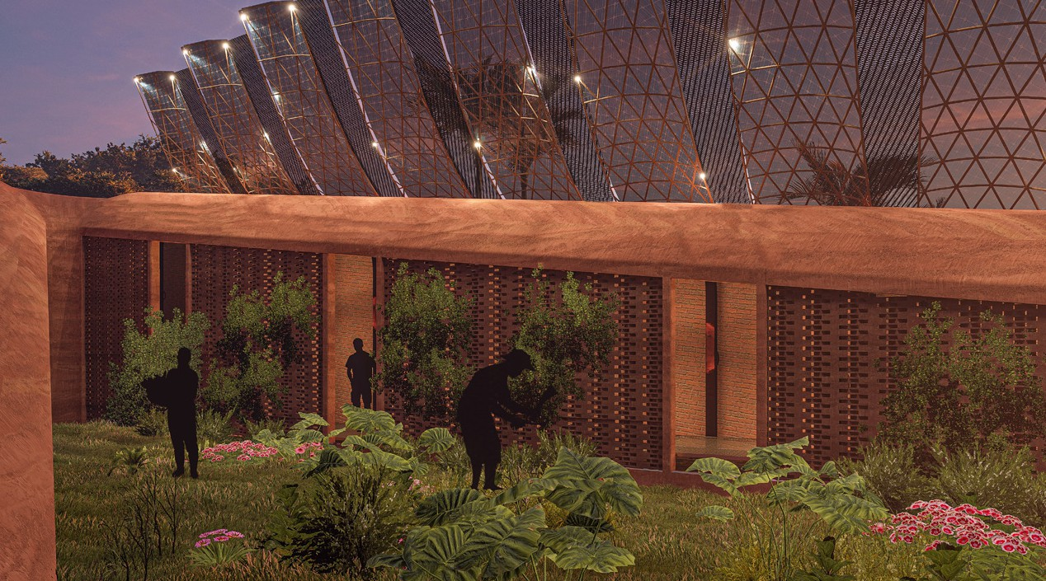
The land actuator is a partnership with the community who are actively involved in its daily calibration. Like sails, the photovoltaic fingers and fog catchers are trimmed to the conditions. The crops are tended, watered from the cisterns of collected rainfall and fog.

Environmental Impact Assessment

The Land Actuator’s ambition is to mitigate the impact of rising environmental extremes, whilst limiting negative consequences of making the intervention. Local materials and skill sets, both existing and learnt, are prioritised to make the system both robustly resilient and limit embodied energy.

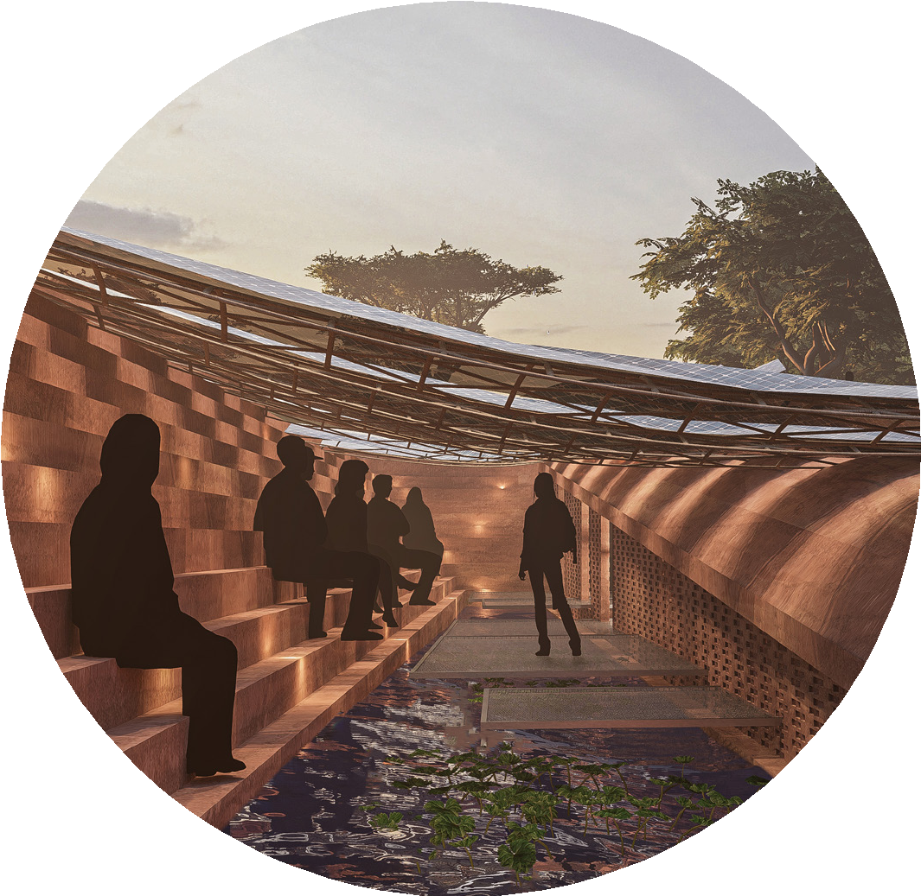
The land actuator is largely made of the land so if made redundant much can simply return to the land leaving little impact. The negative landforms could be refilled with the material from the positive landforms
in a reverse of their construction. The compressed earth bricks could just be broken up and returned to the earth. The bamboo cradles would simply biodegrade and could be composted, with initial shredding speeding the process.

The kinetic structure is made with recycled brass and is designed for deconstruction. In the case of redundancy the brass elements can simply be taken apart and recycled
for use elsewhere, limiting the need to further scour the earth for resources. Brass manufacture is relatively less energy intensive than other metals, and its durability lengthens the lifespan of the kinetic structure. BIPV semi-transparent glass panels hold embodied energy through their materials, manufacture and
transportation. Mitrex’s curved laminated glass panels use mono-crystalline silicon solar cells that enhance longevity, and low emission transportation would be used to bring these to site. The kinetic system lowers the PV fingers, closing the system down to protect them against a storm, limiting the need for replacement.

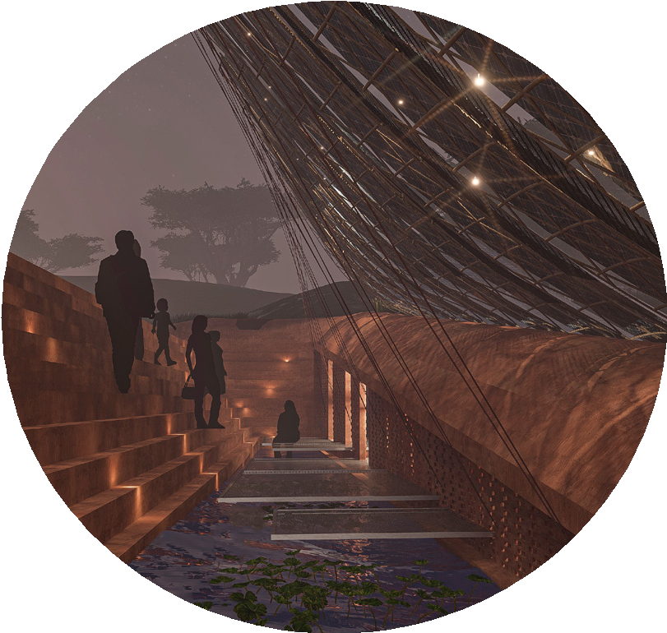
The impact of the land actuator on present eco-systems would be mitigated in the following ways. Digging the voids of the landform would dislodge current plants and disrupt the habitats these offered. This is mitigated by earth sheltering the vaults and seeding these with native grasses and wild flowers to both replace and enhance lost habitat. After heavy rainfall when the negative landform reservoirs are full, the
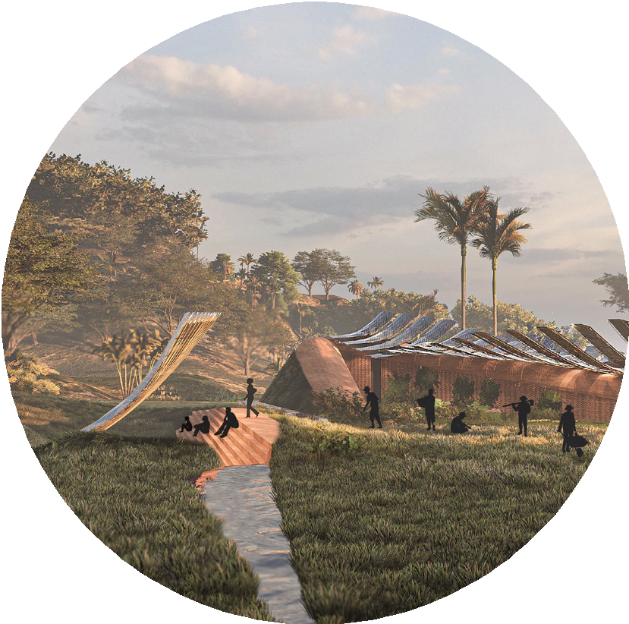
still water might encourage mosquitos if left. To mitigate this the reservoirs gradually drain through the cistern. Energy will be available to light previously dark paths which could disrupt local wildlife. A limited window for lighting determined by the community offers the rest of the night to the wild.

The Land Actuator aims to be a low impact, high output deployable adaptive structure that enables the community to plug into the energies of the land and sky.

LAGI 2025
Fiji
The Land Actuator

