**LAGI 2025 Fiji Narrative**

**La’ngi**

a platform for and with the elements

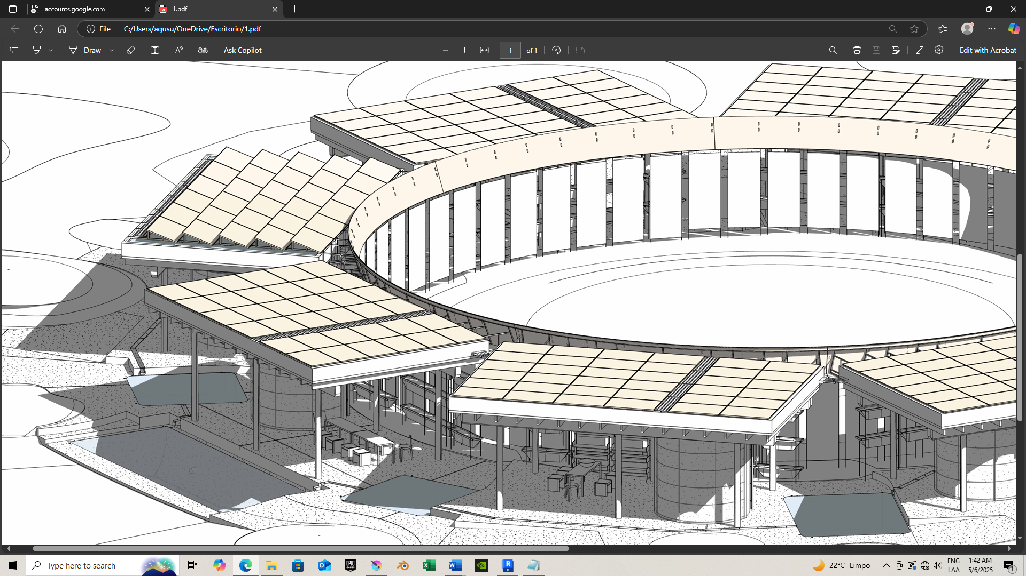

**La’ngi**

A platform for and with the elements

**1. Concept**

Rather than a power plant, this proposal may be a ‘platform’ since it encompasses many layers and aspects.

It aims to weave lines with and is influenced by some of the J. Turrell art expressions, and finding the same roots in works such as the Astronomical Park by Specific + Unit, the Benesse House by Tadao Ando, and, why not, the rudimentary original circle of Stonehenge.

La’ngi is about this universal kind of willingness to tune with the sun, the sky, the universe.

Here, since it's a platform for and of energy, it includes happenings related to the elements and how they generate electricity during different times of the day and scenarios. It is also different from the references mentioned, since it allows people to gather around flexible covered spaces. At one edge of Marou's Village, the platform set solar arrays at a certain height to avoid shadow from trees (existent and to be reforested), and also to catch clean rainwater, provide shadow for the BESS and other equipment, and, most importantly, provides shadow to support different type of events, gathering, agriculture, learning; making a whole experience around the core of the project.

ASPECTS INCLUDED

The proposal also offers flexible covered spaces for the local community and visitors, to gather, perform workshops, exhibiting art and crafts such as masi, and growing crops and plants both for commerce or for Village agriculture, in semi-shaded planters.

Apart from harvesting sunlight and rainwater, the platform can handle also desalinate saline water and generate electricity from the solar pumped hydro storages, with a micro turbine, not only for pico-electric extra electricity in peak hours. Also to create events, mist, enriching the water phenomena of the sky core at sunrise and sunset when the eater is released.

TELLURIC TILL LAN’GI SENSIBILITIES

We guess that this destination can be interesting: how a raw energy platform, without completely defining architecture in the primary sense, sets an experience encompassing sun, water, elemental phenomenology, being linked by the visitor itself when walking, feeling the telluric realm, the ramps, gathering at the social level, until elevating him/herself to the cosmic layer lookout. Some modern constructivists artists have worked up this levels idea: The telluric: the primitive side, the Earth, the ancestors. The ground floor: daily and present life. The upper level: cosmic, universe, intelligible entities.

Here, the telluric are semi-buried low simplified excavations, with the core as the main one, at the same time, willing to handle enough m3 of water storage, inhabited by the locals and visitors in events, workshops and exchanging when empty.

Water, stones, sunlight, clouds, the existent soil and trees; these elements are part of the ever-changing atmosphere, offering any visitor the opportunity to be closer to the telluric, the gathering, and the cosmos.

**2. Technical**

60 pv modules of 2 m2, at 19°, all black*, plus 180 pv modules at 0°, are likely to have a nominal capacity of about 85 kW. They are positioned to cover the precious water, and to partially emulate water reflections when seen from the lookout on the NW slab. They are separated by 10mm gap, that with a technical deck for maintenance, let the rainwater fall into the upper storage water-slabs.

Also, 64 flexible pv modules of 0.63 m2 at 71°, will better catch sunrise and sunset rays, to give the system power in peak hours. Flexible modules facing South receive sunlight in summer.

* see links at the end

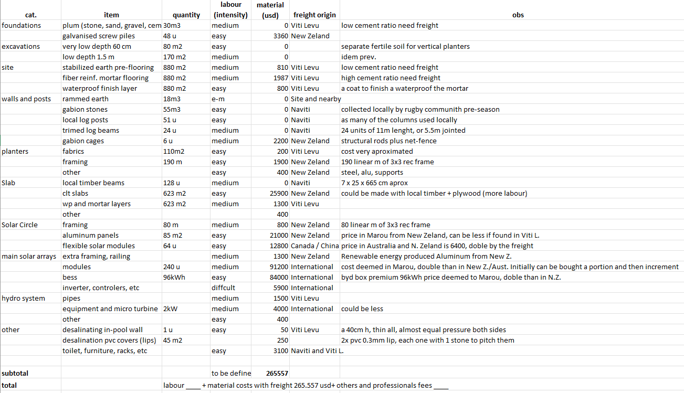

Inputs: solar rays, rainwater, saline water from well next to Sothern estuary,

Outputs: solar electricity, hydroelectricity, desalinated water

**How? Each part designed, responds to the aim of being able to really HANDLE the inputs. In different scenarios, the platform should function, even at the initial stage, foreseeing incremental steps that can improve aspects with the time.**

In that sense, the efforts to build up the timber slabs that can handle 350kg/m2 of water and solar arrays, can be justified when analyzing how the inputs can be converted to outputs with generosity but at the same time, with practical approach to conceive shapes, materials, techniques, as accurate as possible to build a great destination with respect to the materials itself taken from earth, to the hands that assembly it, fostering durability.

**3. Prototyping and Pilot Implementation**

The prototype can be one module of 6.9 x 11.3 m. It can be placed 3.5 m above ground, being supported by palm posts and a massive wall. At the ground, we could replace the semi-underground laps with a portable plastic storage tank or two, so solar re-flow* and picohydro release of rainwater can be tested. The slabs can be built before the posts, kind of prefabricating them, and also the steel and aluminum framing that support the array and the Solar Circle.

One team member is architect and carpenter, from a family of carpenters, with knowledge on handling steel, and having built small things and timber, steel and leather furnitures. The other team member is a model maker, with precision in her hands, she has less experience but sharpen eye and patience to detail. She has built and helped kids to build, clay crafts during 1 year job experience as kids responsible of a park.

The idea would be to help with drawings and with our hands.

Also, many local rocks are expected to be collected with the help of the rugby community, both professional (preseason) or colleges. This hard work is a great opportunity for the team, to bond, to get tougher, to collaborate with people and for a goal, as rugby essence as many other sports wants to foster as values.

**4. Operations and Maintenance**

Platform, can be in the sense it foster opportunities, it embrace happenings and is a set of physical n intangible entities with a clear location and mechanisms. These mechanisms need maintenance such us once per year empty and clean water storages (that also catch water), filters located in runnels, the pico-micro turbine, probably a Chinese propeller or micro Francis: [Micro Francis turbine - DLLP Power-Hydroelectric Equipment Solutions](https://dlldpower.com/micro-francis-turbine-2/) see chart.

The solar modules and battery system would need controllers, inverters and probably one person responsible for operations and maintenance.

The timber elements are protected against rain without strong winds. When a cyclone occurs, the wind would bring the rain next to some timber posts and beams, so they may need a varnish each 3 or 5 years on those parts. Some other (CLT or local timber + plywood) are isolated. It means the slabs as a whole, would not require much maintenance.

The steel and aluminum framings would need scarce maintenance. The distances between columns in general are balanced.

**5. Environmental Impact**

TREES, WOOD, TIMBER, CO2

The proposal allows to consider timber as input, and timber as output, each 25/30 years, since big parts of the platform are built with local timber. Meant to be renewed, the wood from the trees initially demanded, will be replaced. To replace that, in the site, we plan to forest low and mid-tall native trees and palms, calculating that we can essay varied species (non-mono) forest, and expecting to wait 25 years till sacrifice only 10% pf the new trees, so many can live and grow longer, aligned with Fiji's 30 million trees goal.

Aluminum is a key component, and we designed imagining buying renewable energy produced Aluminum from New Zealand: [nzas.co.nz/our-metal](https://nzas.co.nz/our-metal), as a key partner for only **2 CO2 ton/kg of aluminum.**

SOIL AND EROSION

The proposal modifies local soil at the site, being the footprint balanced and reduced, and also using stabilized earth instead of concrete slabs, since the covered spaces are outdoors. Also, the flooring is not continuous: grass circles and joint gaps allow permeability. The proposal uses steel and cement, durable materials that have an impact, but the aim is to wisely use them working up economic and reasonable constructive details to last, to enable the platform goals through the years.

Low depth excavations are preferred, and the project would separate the fertile first layer to fill the vertical planters of the solar circle.

The rest of the soil excavated will set the grass hills, so no waste takes place.

In severe floodings, the platform will certainly buffer some of the water than otherwise will run directly to the village. Incrementally, we think one or two extra 200 m3 low/depth excavated pod/laps (laps similarly to a skatepark bowl to reduce steel and concrete) can be created in further stages, between the channels and the first platform ground pop-lap.

**As briefed, by offering freshwater harvesting-storage generously jointly with sunlight harvesting, the platform responds to day and night, to the water cycles and also other cycles within the site, the Village and Yasawa islands, putting both in evidence, celebrating them.**

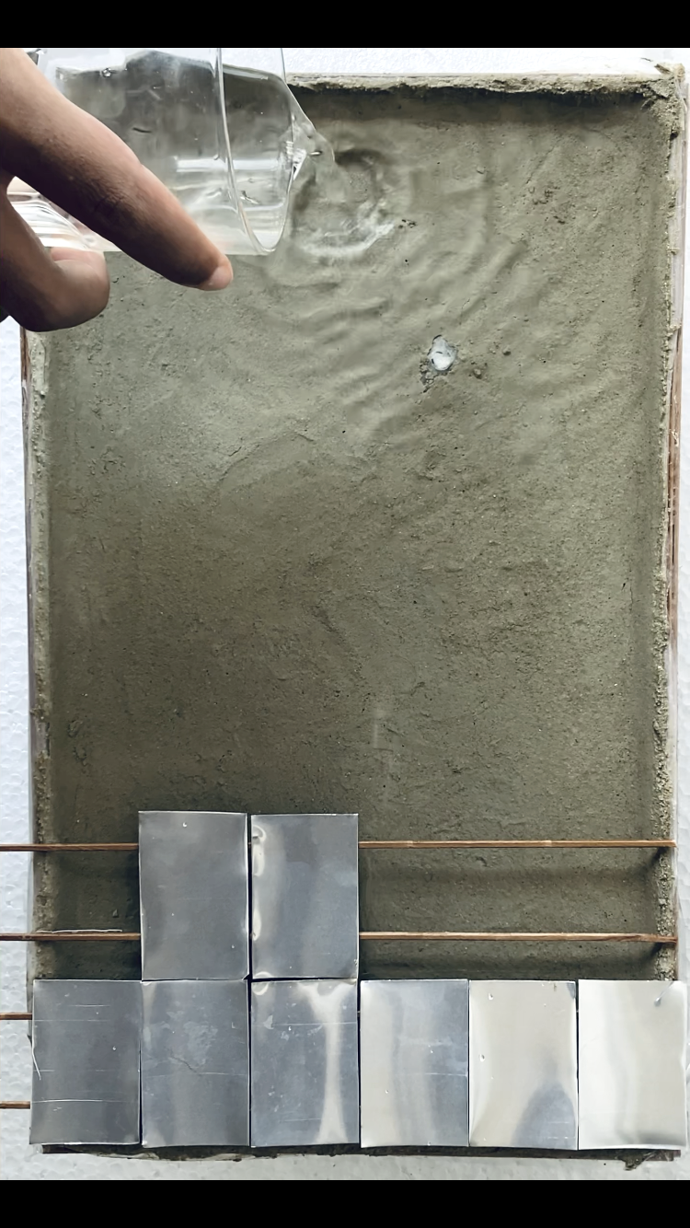

**Extra: Cost Estimate**

Local materials allow continuity and foster local building techniques.

By 0 Usd material cost, we consider that soil and trees of the site and nearby, have not an human owner. The natural species and soil resources demand labor to carry, prepare and assembly. In the case of small rocks, food to the athletes should be given in compensation for the great effort (an effort they need to tune up as a team for a season). Highlighting that everything has a cost, and ultimately it is related to the energy that powered the effort + a benefit. The food is energy, once growth by the sun energy. Wind is also solar energy, since the sun creates different temperatures that cause winds.

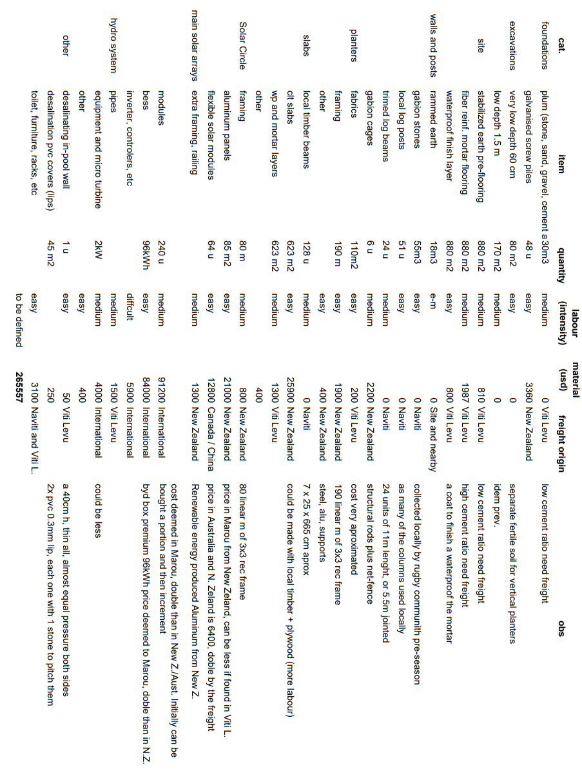

Product Links from Australia, New Zealand, Canda and China mainly:

<https://solarbatterysupermarket.com.au/products/byd-battery-box-premium-lvs?variant=46643225788695>

<https://aikosolar.com/au/products/neostar-2s54-mono-glass/>

<https://au.renogy.com/100w-lightweight-monocrystalline-solar-panel/>

PV modules summarized:

|  |  |  |  |  |
| --- | --- | --- | --- | --- |
| **module** | **tilt, facing** | **area** | **performance** | **size** |
| 60 pv of 2 m2 | 19° | 120m2 | highest efficiency | 1757 x 1134 x 30 |
| 180 pv of 2 m2 | 0° | 360m2 | high efficiency, water storage cover | 1757 x 1134 x 30 |
| 64 flex. pv of 0.63 m2 | 71° | 20m2 | sunrise and sunset moments | 1093 x 582 x 3 |
|  |  |  |  |  |
|  |  |  |  |  |

Video Link: drive.google.com/file/d/1JgySejlwUK-74WP7R0jbtZzyVy-XOniB/view?usp=drive_link

**La’ngi**