- Concept Narrative
Mataliki, also known as the Pleiades, is a cluster of stars in the constellation of Taurus. This constellation, visible to populations all over the globe, has always been associated with myths and legends. For the Fijians, its appearance marks the beginning of the navigation season. Our project draws inspiration from this constellation and the meanings that sea peoples have given it.

A series of lighting fixtures placed at the top of bamboo pillars recreate the iconic constellation, which can be recognized when observed from the summit of Vaturui. The new lighting system, powered by clean electricity, will breathe new life into the area, turning it into the heart of the village's evening activities. Beneath the canopies stretched between the bamboo pillars, various activities take place: from performances, and children’s games, to drinking kava, which is produced under another type of canopy in the area's outside skirt. Most of the space under the structures is intended for agriculture. After being harvested, kava is dried under the roof of a special building and then consumed or sold to help maintain the mini-grid. Kava is not the only plant that falls into these categories; the list also includes taro and bele, which need shelter from the sun and can be an important food source for the village.

The electricity for these activities and the village's needs is generated by flexible solar panels on the canopies. These are made from recycled fishing nets and shaped like triangles, inspired by the large sails of traditional Fijian boats. These modules, composed of fabric and panels, are designed to be easily installed. Thanks to their extremely low weight and minimal thickness they can be dismantled, folded, and stored in a specially designed structure within a few hours when a typhoon is approaching.

However, solar panels are not the only energy source. The sail system is integrated with small bamboo wind turbines. Solar and wind energy potential are inversely proportional throughout the year. The 2 systems ensure a constant energy supply for the village. Moreover, wind energy reduces the need for battery storage of approximately 37% by providing electricity when Mataliki shines in the night sky.

Just as the ancient Fijian navigators saw the appearance of Mataliki as the beginning of a new season of prosperity, our project marks the start of a new era for the inhabitants of Marou-one of energy equity, sustainable development, and environmental awareness.

- Technical Narrative
Infrastructure, the proposed project involves developing a mini-grid system designed to enhance energy sustainability and optimize power generation from renewable sources. It integrates a photovoltaic (PV) installation, vertical-axis wind turbines (VAWTs), an advanced energy storage system, and a system converter, ensuring reliable energy. At the core of the mini-grid is an 80.6 kWp photovoltaic system utilizing crystalline silicon modules.

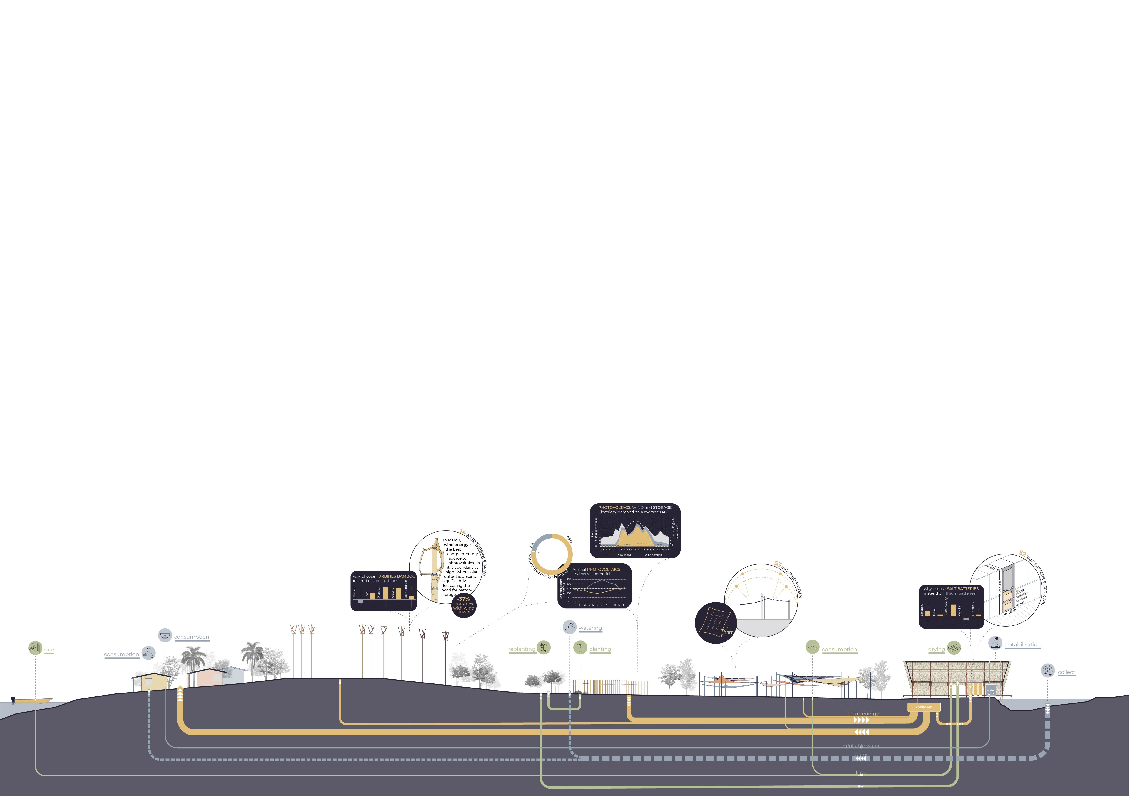A part of the photovoltaic modules (53, for a total capacity of 10.6 kWp), are installed on 4 triangular sails located at the center of the site. Two of these structures are inclined eastwards and two to the west to maximize energy production in the morning and evening when demand is higher. Most of the modules (350, for a total capacity of 70 kWp) are horizontal and mounted on smaller, more manageable structures, designed to allow cultivation underneath, combining agricultural production with clean energy generation. The selected PV modules feature high efficiency and durability and are optimized for reliable performance under various environmental conditions. This configuration maximizes land use while contributing to sustainable farming and renewable energy goals.

Complementing the PV array, the wind energy system integrates 14 vertical-axis wind turbines (VAWTs) into the mini-grid, each with a capacity of 1 kW. These turbines employ a Darrieus-type design with rotors constructed from bamboo, offering both environmental and structural advantages. Bamboo, being a lightweight yet robust material, reduces the overall carbon footprint while ensuring mechanical strength and resilience. The use of VAWTs allows for efficient wind energy harvesting regardless of wind direction, making them well-suited for the site’s varying wind conditions. The combined wind generation capacity of 14 kW provides a valuable supplement to solar power, particularly during periods of low solar irradiance. The installation of wind turbines also reduces the need for battery storage from 792 kWh to 498 kWh by generating energy during nighttime hours and when solar resources are unavailable.

To ensure grid stability and energy availability during periods of fluctuating renewable generation, the mini-grid is equipped with an energy storage system (ESS) utilizing salt-based batteries with a total capacity of approximately 500 kWh. Salt-based batteries are chosen for their high safety profile, long cycle life, and environmental friendliness compared to conventional lithium-based technologies. The ESS allows load balancing, peak shaving, and backup power capabilities, enhancing the overall reliability and resilience of the mini-grid.
The integration of various renewable energy sources and the storage system is managed by a system converter. This power conversion system ensures seamless operation regulating energy flows between the PV array, wind turbines, battery storage, and local loads. The converter optimizes energy utilization, manages grid interconnections, and supports islanding operations, when necessary. This mini-grid design leverages a hybrid approach to renewable energy generation, combining solar, wind, and advanced storage technologies to create a resilient and sustainable energy solution. The system not only promotes renewable energy adoption but also integrates agricultural productivity through agrivoltaic implementation.
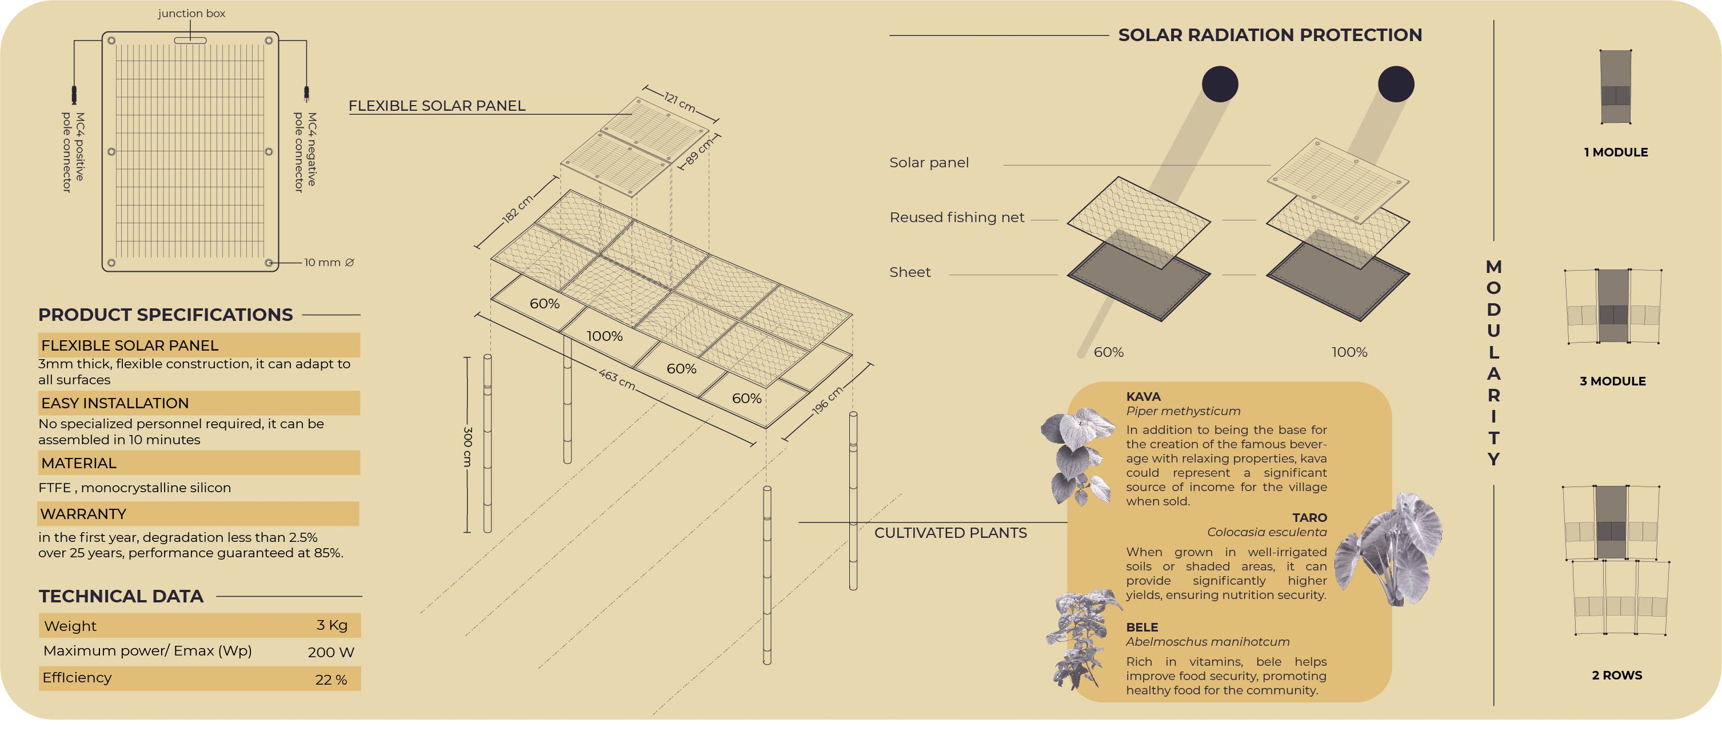
To address another major need of the inhabitants of Marou namely the supply of water a rainwater harvesting system has been designed at the edge of the project area. The system involves the construction of 2 artificial ponds, one with a volume of 2,600 m³ and the other with a volume of 3,230 m³. These ponds are located at the lowest point of the site, where rainwater naturally accumulates, and are connected by a small canal.

The water from the second pond, situated further downstream, is intended to meet the entire agricultural water demand of the agrivoltaic complex. The pond located upstream supplies the amount of domestic water needed that cannot be covered by the rainwater collected from the roofs of houses. Part of this water is also made potable using the SODIS method. The water is pumped from the pond into a 1,650-liter tank installed on the roof of the new building, where it is purified by solar radiation. The purification process takes approximately 6 hours on sunny days and up to 48 hours under cloudy conditions. The tank is sized to accommodate the worst-case scenario. Once purified, the water is channeled into a 2,000-liter storage tank, from which the villagers can draw their supply.

- Prototyping and Pilot Implementation Statement

Participation, the prototyping phase of the project will focus on constructing a small-scale system that demonstrates the core architectural and technological elements of the proposed mini-grid. Specifically, a support structure made from bamboo and repurposed fishing nets will be built to host a pilot photovoltaic (PV) array with a capacity of 1–2 kWp. This prototype will serve both as a functional energy generation unit and as a physical proof-of-concept for the final solar field layout.

The materials align with the project’s sustainability values, reducing environmental impact while showcasing the potential for low-cost, locally sourced construction methods. The pilot installation will test the mechanical stability, ease of assembly, shading performance, and overall integration of the structure with the PV technology. It will also be used to validate system performance under local environmental conditions and to refine installation techniques. This modular design approach allows for the direct replication of the prototype across the full-scale implementation. The final solar field envisioned as an 80.6 kWp system, will simply consist of multiple iterations of the same module developed during the prototyping phase. This repetition ensures scalability, cost control, and ease of maintenance over time. By implementing this pilot, we aim to engage local stakeholders early, foster technical training opportunities, and create a replicable model that integrates renewable energy with sustainable construction and land use. The prototype will thus act as a bridge between concept and large-scale realization.

At present, we do not have precise information regarding the local population’s knowledge of bamboo construction techniques. Therefore, it may be necessary to involve skilled workers from other islands of Fiji to assist in building the panel storage structure. Nevertheless, local residents could be actively engaged in the construction process.

As for the water supply infrastructure, the maximum depth of the two ponds has been kept below 2.5 meters. This will allow the excavation to be carried out by the community using manual tools, without encountering the deeper and more compact soil layers. The use of polyvinyl chloride (PVC) sheets to waterproof the pond beds has been selected as the most cost-effective, durable solution, with the material conveniently supplied in rolls. Thanks to the simplicity of installation, the inhabitants will be able to lay the PVC independently, with the support of our team.

- Operations and Maintenance Statement
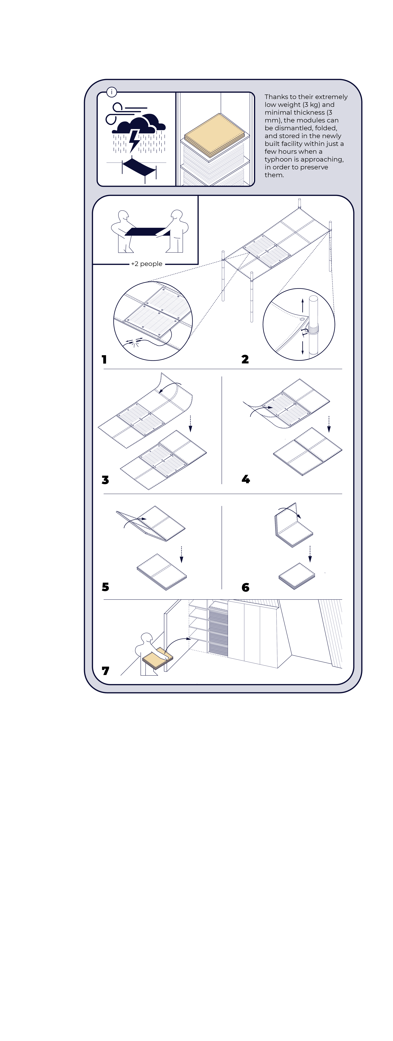Maintenance, one of the key strengths of the proposed mini-grid system is its low maintenance requirement, which enhances long-term sustainability and reduces operational costs.

The photovoltaic (PV) modules selected are high-quality crystalline silicon panels that require no routine maintenance. They are covered by a 25-year performance warranty, ensuring at least 85% of nominal output over their entire lifespan. This long-term reliability minimizes the need for physical intervention and guarantees stable energy production with minimal oversight. Similarly, the key electronic components, such as the inverter and the energy storage system, have been chosen for durability and minimal maintenance needs. The inverter is covered by a 10-year manufacturer’s warranty and is designed for robust operation in remote and variable environments. In the long term, replacing the inverter after its expected life cycle may be considered as part of the routine equipment update. The salt-based battery storage system is guaranteed a 20-year useful life and offers significant advantages in terms of safety, environmental impact, and longevity compared to conventional battery chemistries. No regular maintenance is required, aside from standard system checks.

Operationally, the entire support structure for the PV array has been designed to be modular and dismountable. In case of extreme weather events such as tropical cyclones-the structure can be dismantled and safely stored within the on-site technical facility. This enhances the resilience of the installation and ensures continuity of service over time.

All the other structures that make up the project are designed to ensure long-term durability while requiring minimal maintenance. The bamboo elements, such as the building and the wind turbines, are engineered to have a minimum lifespan of 50 years. Despite their longevity, both structures are assembled using dry construction methods, allowing for easy maintenance and even complete disassembly when necessary. In the case of extreme weather events, for example, the wind turbine blades can be quickly dismantled. This approach combines the durability of the components with the ease of replacement in case of damage or malfunction.

- Environmental Impact Assessment
Whole Life Carbon, is a term mainly used in the construction sector to refer to the total of carbon equivalent emissions associated with a building or infrastructure throughout its entire lifecycle. Typically, most emissions occur during the operational phase of the building, known as operational carbon. Since our project consumes almost no energy and produces a considerable amount of sustainable energy, the balance of this phase is very positive. Normally, environmental impact assessments of buildings focus exclusively on this operational phase. However, since in our case this phase clearly results in negative carbon equivalent emissions, we decided to investigate the other 3 phases: embodied carbon, end-of-life carbon, and Beyond Building Life.

Our study focuses on the 4 main materials used in the project: bamboo, recycled fishing nets, solar panels, and salt batteries. The batteries and solar panels are materials with a positive carbon cost and therefore the most polluting components of the project.

For the solar panels, two scenarios were considered: one where the silicon is extracted and refined in Japan, and another where the process occurs in Australia. In the first scenario, extraction has a lower environmental impact, and although transportation is by truck (whereas in Australia it is by rail), its impact is minimal. Silicon refining, while being the most energy-intensive phase, is less impactful in Japan due to the country’s higher share of renewable energy. Transportation from the refinery to the manufacturing plant is low in both cases (approximately half the impact of transport to the refinery). Manufacturing emissions are also lower in Japan. The only phase where Australia performs better is the final shipment since transport from Brisbane is significantly shorter than from Osaka. However, given the low weight of the panels (3 kg each), the impact of this final transport step remains relatively minor.

This is not the case for salt batteries. Similarly, two scenarios were analyzed: sourcing raw materials from China or from Australia. Here, due to the heavy weight of the batteries, transportation impacts favor Australia. However, extraction and processing emissions are still lower in China. Salt batteries offer two major environmental advantages: their lifespan is longer than lithium batteries, and their disposal has a much lower environmental impact, as they are primarily composed of salt. In conclusion, today the China-Japan supply chain is less impactful overall. However, if Australia increases its share of renewable energy, the Australia-based scenario could become more favorable due to the country's proximity to Fiji.

The other two key materials, bamboo, and recycled fishing nets, are locally sourced and have a negative carbon impact. Both can be transported from Suva using small barges, while trucks are considered for inland transport. For fishing nets, the carbon cost of hydro-cleaning has been factored in. For bamboo, the carbon release during decomposition has been considered, as part of the CO₂ captured during its growth cycle is released back into the atmosphere.

Overall, both materials have a strongly negative carbon footprint: Bamboo stores carbon through photosynthesis during its life cycle. Recycled fishing nets extend the lifespan of highly polluting plastic material, thus reducing the environmental burden of their disposal. Additionally, recycling nets have positive side effects, such as preventing them from ending up in the ocean and posing a threat to marine life.

Another potentially negative environmental impact, not on a global level but locally, is the construction of the artificial pond system. The system is essential to ensure water supply for the village, but it could pose risks regarding the introduction of alien plant species to Naviti. To limit water evaporation from the ponds during the dry season, to reduce water pollutants (part of which will be made potable), and to prevent the spread of mosquitoes, three plant species have been selected: Salvinia natans, Eichhornia crassipes, and Pistia stratiotes, all of which are present but not native to Fiji. Since it is difficult to verify whether these plants are already present on the island of Naviti and given the potentially invasive nature of some of them, our team foresees the possibility of using different species than those described, in agreement with the LAGI organization and the village of Marou.
