VAKABULA
Modularity field
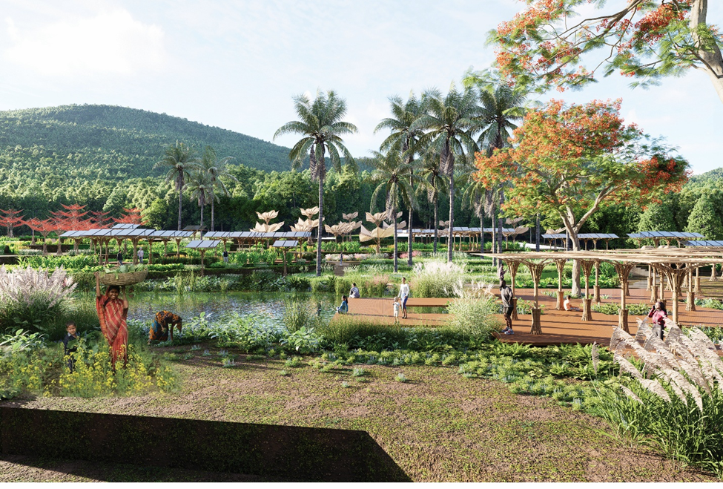
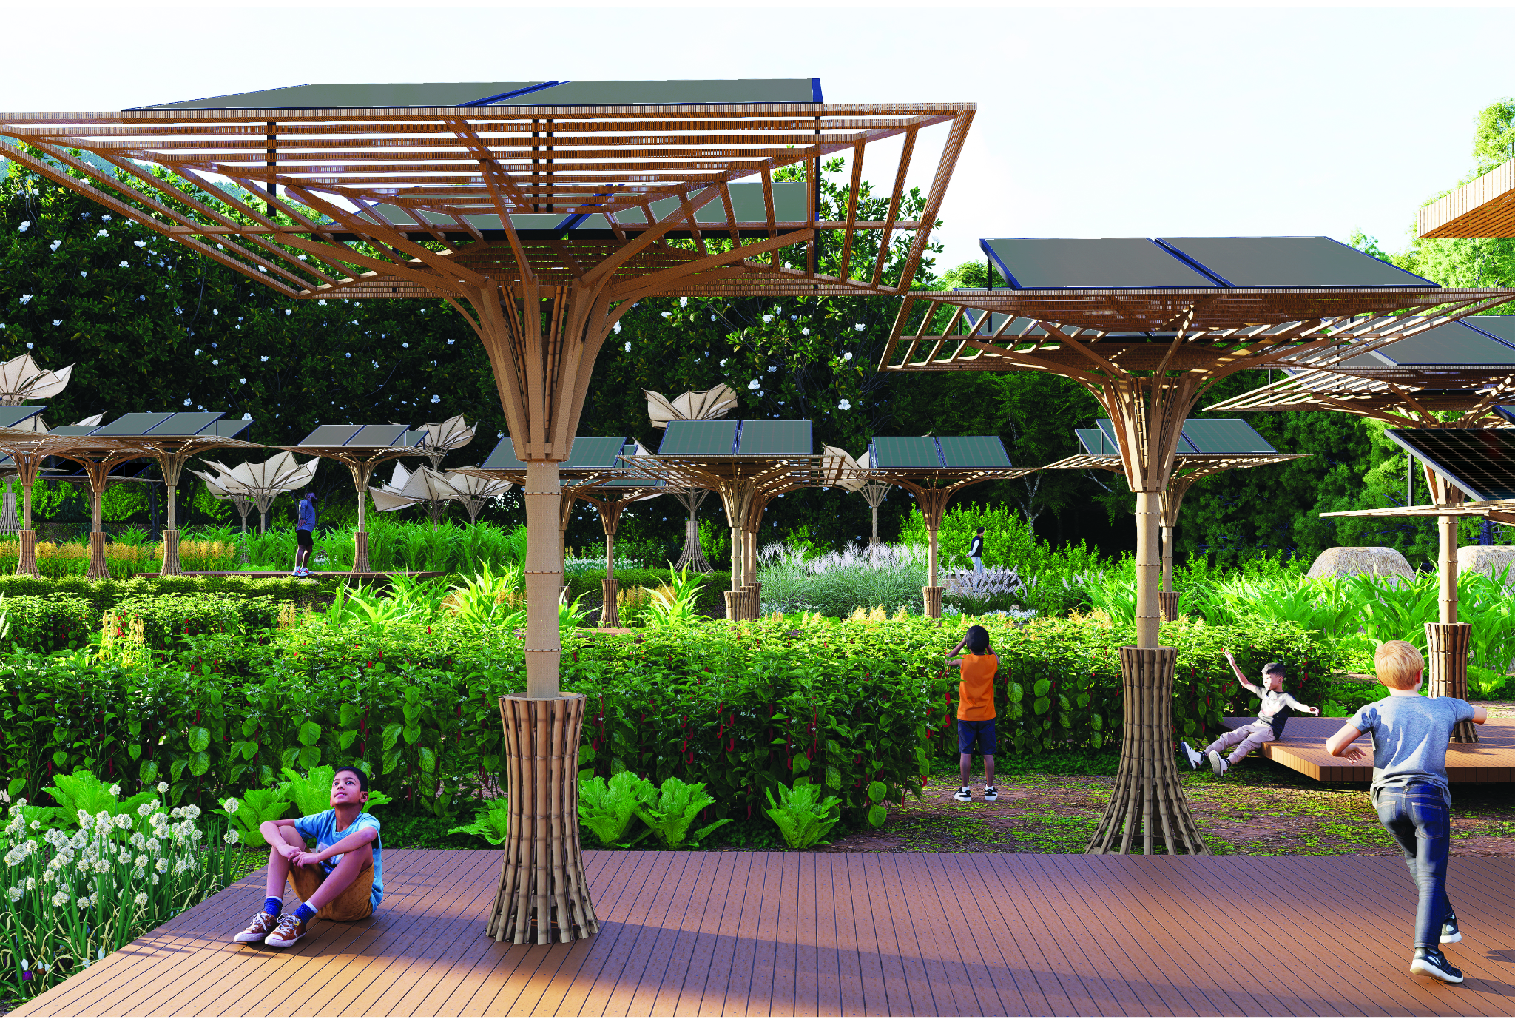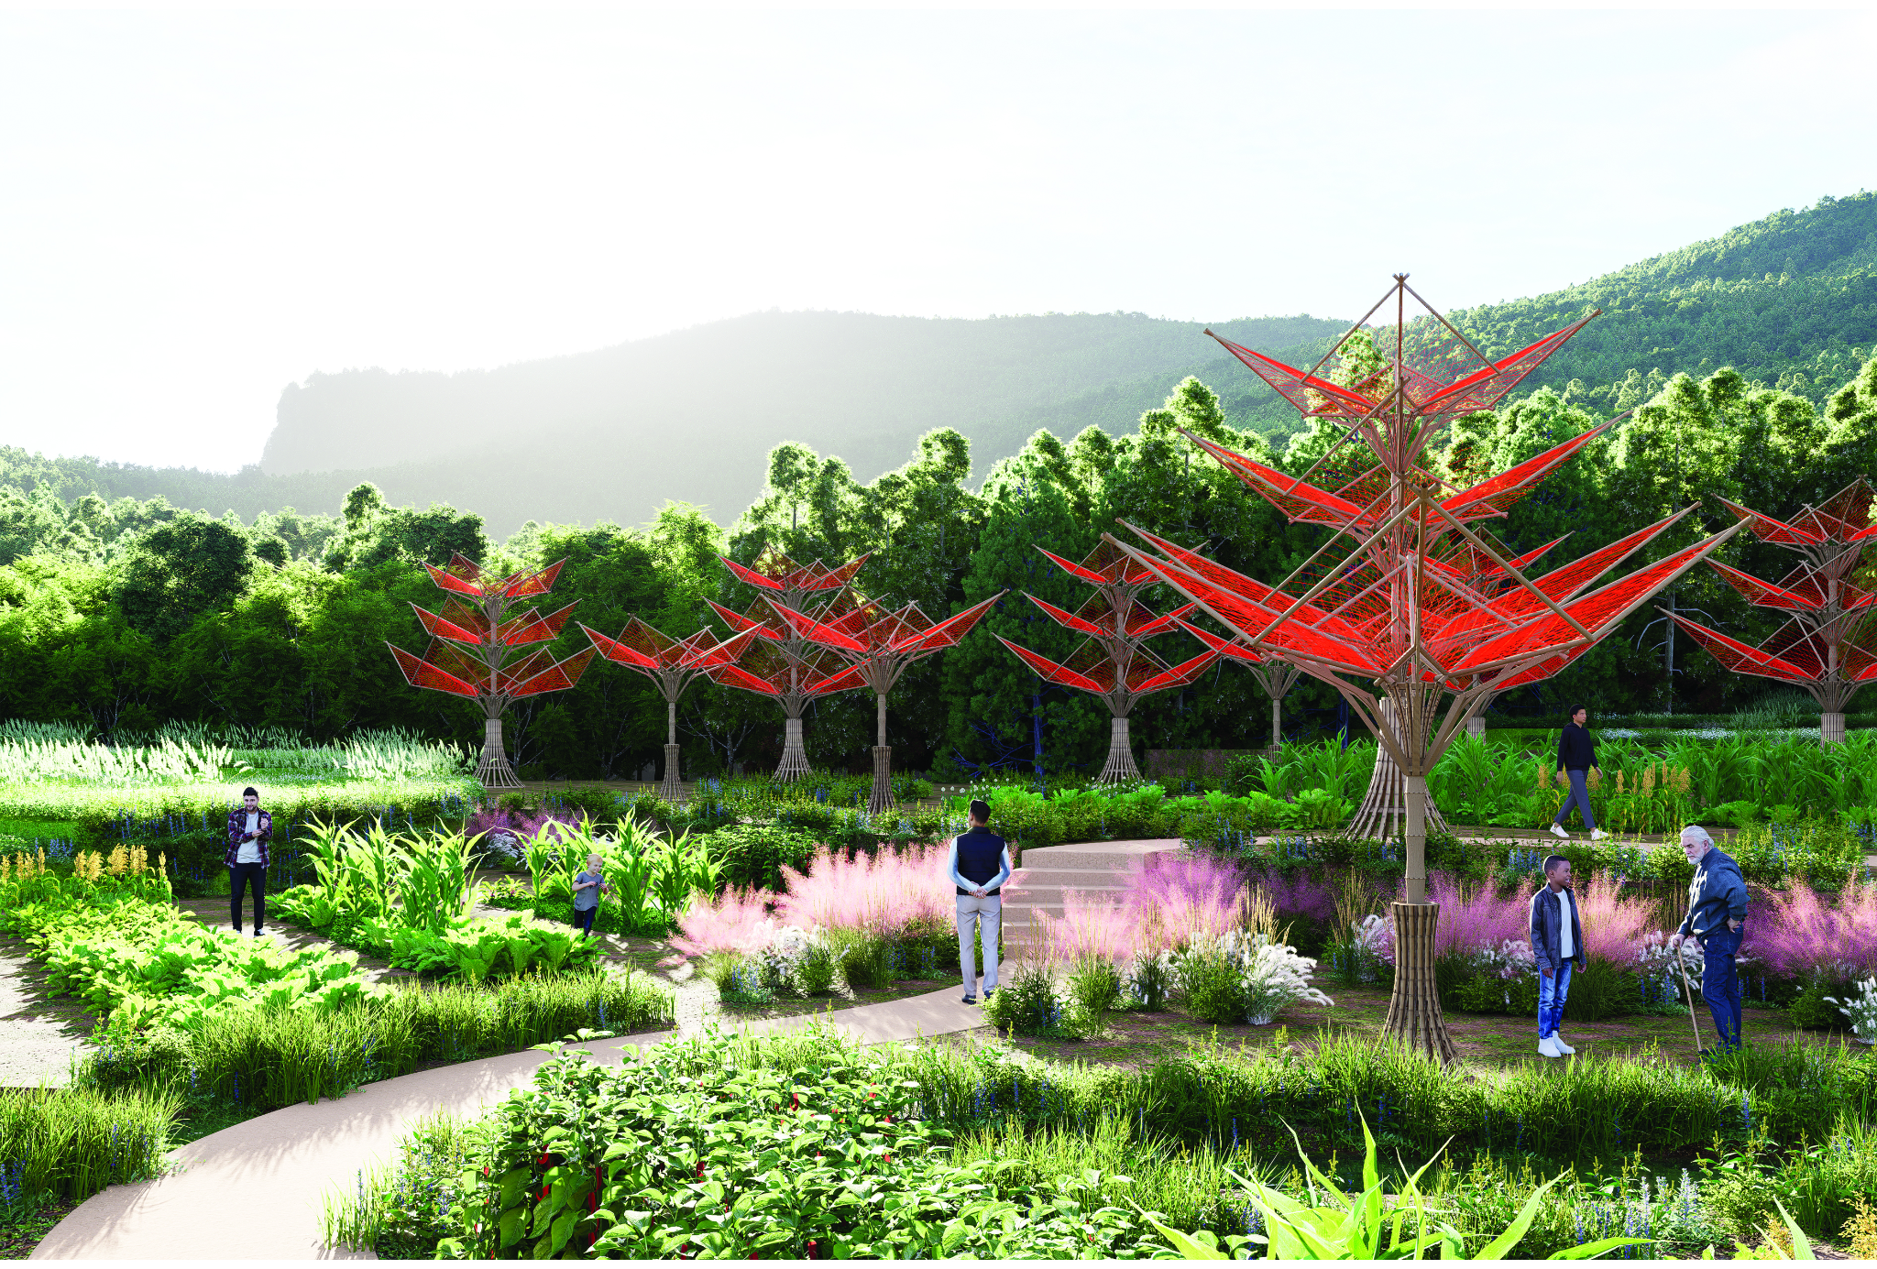

CONTENT

Prologue: Project Statement
VAKABULA Modularity field

01. Concept Narrative

02. Technical Narrative

03. Prototyping and Pilot Implementation Statement

04. Operations and Maintenance Statement

05. Environmental Impact Assessment

References:
1. Biogas Production from Agricultural and Food Waste
- Title: "Empirical Study on Factors Affecting Biogas Production"
- Authors: K. Prasad
- Published in: International Journal of Chemical Engineering, 2012
- Summary: This study examines the factors influencing biogas yield in digesters, focusing on variables such as temperature and the type of organic waste used. The findings are particularly relevant for optimizing biogas production in tropical climates like Fiji's.
- Link: Empirical Study on Factors Affecting Biogas Production
- Title: "Strengthening the Fiji Biogas Programme"
- Published by: Pacific Community (SPC), 2013
- Summary: This report outlines the implementation plan for enhancing biogas production in Fiji, emphasizing the use of agricultural residues and animal manure. It provides insights into community-based biogas systems and their benefits for rural energy needs.
- Link: Strengthening the Fiji Biogas Programme
2. Solar Power Implementation in Rural Fiji
- Title: "Solar Electricity for Rural Households at the Fiji Islands"
- Authors: M. Dornan
- Published in: Uppsala University Publications, 2012
- Summary: This bachelor’s thesis examines the economic, ecological, and social benefits of electrifying rural Fijian households using solar photovoltaic (PV) systems. The study includes both literature review and field research, providing a comprehensive analysis of solar energy's impact on remote communities.
- Link: Solar Electricity for Rural Households at the Fiji Islands
- Title: "Solar Energy for Power Generation in Fiji: History, Barriers and Potentials"
- Authors: S. Singh, A. Kumar, and R. Prasad
- Published in: Springer, 2020
- Summary: This chapter reviews the development of solar photovoltaic systems in Fiji, discussing historical progress, existing barriers, and future potential. It provides valuable insights into policy frameworks and technological advancements pertinent to solar energy adoption in the region.
- Link: Solar Energy for Power Generation in Fiji
3. Micro-Hydro Power Systems
- Title: "Reliable Electricity Supply in Rural Areas: A Case Study of the Fiji Islands"
- Authors: M. Jensen
- Published in: Pacific Regional Infrastructure Facility, 2011
- Summary: This report explores various renewable energy options for rural electrification in Fiji, including micro-hydro power systems. It assesses the feasibility, benefits, and challenges of implementing small-scale hydroelectric projects in remote communities.
- Link: Reliable Electricity Supply in Rural Areas
4. Wind Energy Potential
- Title: "Fiji Renewable Energy Report"
- Published by: Asian and Pacific Centre for Transfer of Technology (APCTT), 2007
- Summary: This comprehensive report evaluates various renewable energy sources in Fiji, including wind energy. It discusses wind patterns, potential sites for wind turbines, and the practicality of wind energy projects in the Fijian context.
- Link: Fiji Renewable Energy Report
5. Rainwater Harvesting in Fiji
- Title: "Water Quality Management for Domestic Rainwater Harvesting Systems in Fiji"
- Authors: S. Singh, M. Prasad, and S. Matheswaran
- Published in: Journal of Water and Health, 2015
- Summary: This study investigates the primary issues surrounding water quality management in domestic rainwater harvesting systems in Fiji. It provides insights into contamination sources and offers recommendations for maintaining safe drinking water standards.
- Link: Water Quality Management for Domestic Rainwater Harvesting Systems in Fiji
6. Fog Water Collection Techniques
- Title: "Water Harvesting Through Fog Collectors: A Review of Conceptual, Experimental, and Operational Aspects"
- Authors: M. Fessehaye, T. Abdel-Wahab, and M. S. Amin
- Published in: Renewable and Sustainable Energy Reviews, 2014
- Summary: This paper reviews the state-of-the-art in fog water collection, discussing various designs, materials, and efficiency factors. It provides a comprehensive overview of how fog collectors can be optimized for different environmental conditions.
- Link: Water Harvesting Through Fog Collectors
7. Solar-Powered Desalination Systems
- Title: "Innovations in Solar-Powered Desalination"
- Authors: A. Al-Karaghouli and L. L. Kazmerski
- Published in: Water, 2023
- Summary: This paper explores the relationships among water scarcity, energy-intensive desalination, and the development of renewable energy. It examines innovations in solar-powered desalination, considering both photovoltaic and solar thermal technologies, and discusses their applicability in regions like Fiji.
- Link: Innovations in Solar-Powered Desalination
8. Mangrove-Based Water Filtration
- Title: "Development and Climate Change in Fiji: Focus on Coastal Mangroves"
- Authors: S. Agrawala, A. Mohn, and P. Crick
- Published by: Organisation for Economic Co-operation and Development (OECD), 2003
- Summary: This report examines the role of coastal mangroves in Fiji, discussing their importance in natural water filtration, coastal protection, and biodiversity support. It provides insights into how mangrove conservation can be integrated into sustainable water management strategies.
- Link: Development and Climate Change in Fiji: Focus on Coastal Mangroves

9 Combined Rainwater and Fog Harvesting Systems
- Title: "Fabrication of Rainwater Harvesting Filter with Fog Collector"
- Authors: M. A. M. Roslan, M. F. M. Zain, and M. Z. M. Yusoff
- Published in: Scientific Journal of Science and Engineering, 2021
- Summary: This project aims to fabricate a rainwater filter integrated with a fog collector to obtain clean water. The system channels up to 90% of rainwater into the storage tank and includes a fog collector that captures water from the ambient environment, enhancing water availability in coastal regions.
- Link: Fabrication of Rainwater Harvesting Filter with Fog Collector
10. Vernacular Fijian Architecture
- Title: “Fijian Bure Kalou”
- Authors: Zachary Low, University of Auckland
- Published in: The University of Auckand, 2011
- Summary: The article explains the local vernacular architecture of Fiji, their cultural, social and contextual significance, building techniques and their hierarchical importance within Fijian societal systems.
- Link: Fijian Bure Kalou
These resources provide comprehensive information on various sustainable water supply solutions, including rainwater harvesting, fog water collection, solar-powered desalination, and the utilization of mangroves for water filtration. They offer valuable insights and data that can inform the design and implementation of effective water management systems in coastal communities like those in Fiji.

PROLOGUE
Project Statement

VAKABULA
VAKABULA, a Fijian word meaning “to bring to life” reflects the heart of our design mission: to uplift, empower, and protect. This project was born from a desire to improve the quality of life for the people of Marou, a small island community in the Fijian archipelago facing the dual challenges of climate vulnerability and resource scarcity.
In Marou, we found a culture rich with craftsmanship, community spirit, and resilience. Life is simple, yet deeply connected to the land, to the ocean, and to each other. But with the increasing frequency of hurricanes and seasonal droughts, their way of life is under threat. Rather than imposing a foreign solution, we asked: What if the answer was already there in their materials, their wisdom, their hands?
Drawing inspiration from vernacular knowledge and traditional materials like bamboo, tapa cloth, and magimagi rope, we developed a modular design system rooted in flexibility, repairability, and local empowerment. At the heart of this system is a foldable, umbrella-like module a structural form that embodies both adaptability and resilience. This core module can serve multiple purposes, transforming into a photovoltaic energy unit to generate clean electricity, a wind turbine panel that folds down during storms to prevent damage, and a fog harvester to capture moisture and provide water during dry months.
More than a structure, VAKABULA is a toolkit for survival and self-reliance, one that can be built, adapted, and repaired by the community using materials from their own environment. It is a system that respects tradition while responding to the future.
We believe that design is most powerful when it listens before it creates when it becomes a bridge between the past and the future, between heritage and innovation. VAKABULA is our answer to that belief: a humble, human-centered system that breathes new life into a community through the tools they already know only now, reimagined for the world they are facing.

01. Concept Narrative
Design Concept & Form
At the center of VAKABULA is a modular, foldable structure an umbrella-like unit inspired by the natural morphology of tropical flora and the adaptable spirit of vernacular architecture. These modules are lightweight, deployable, and scalable, designed for multifunctional use. Each form is derived through structural logic and parametric evolution (as illustrated in our module development diagram), enabling it to respond to different functions while maintaining visual and material coherence.
This biomimetic geometry is not purely aesthetic. It embodies a philosophy of resilience and transformation. The module can morph into
· Photovoltaic energy collectors, harvesting clean energy.
· Wind-responsive panels, designed to fold down during storms.
· Fog-harvesting structures, capturing moisture to supply water during dry spells.
· Canopies or shelters, offering shaded, communal spaces beneath.
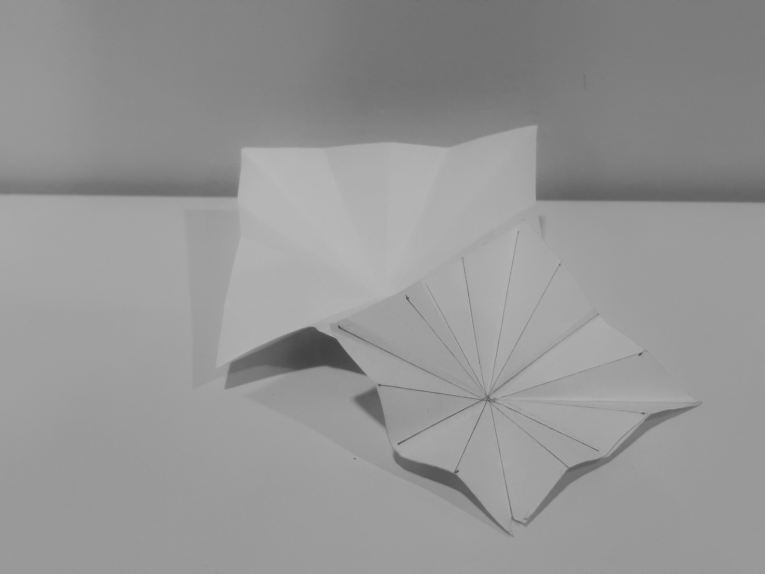
Began with paper folding techniques to explore the most effective structural form, testing balance, symmetry, and flexibility through simple material manipulations. The resulting shapes, resembling blooming or unfolding geometries, naturally support expansion, repetition, and modular adaptation. This analog modeling process informed our design's spatial qualities and reflected core values of simplicity, adaptability, and craftsmanship, bridging concept and constructability to discover a form language that is both expressive and functional

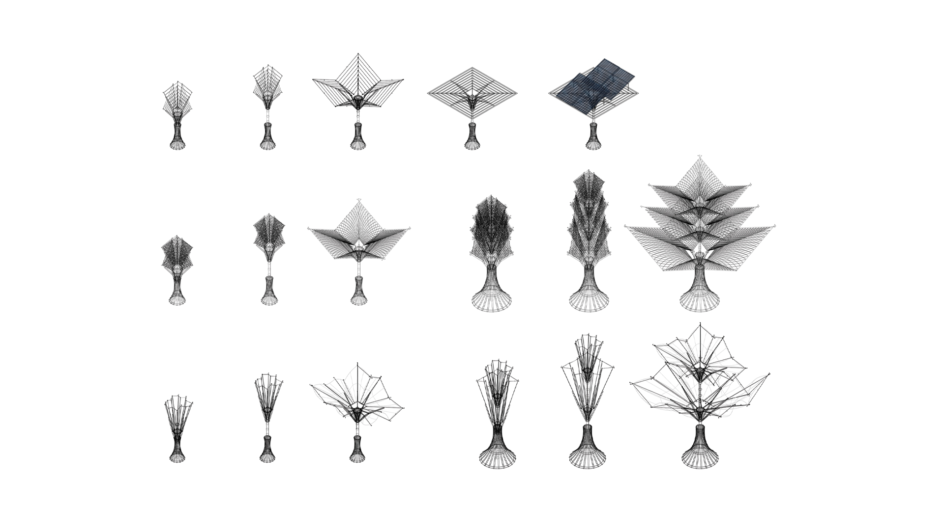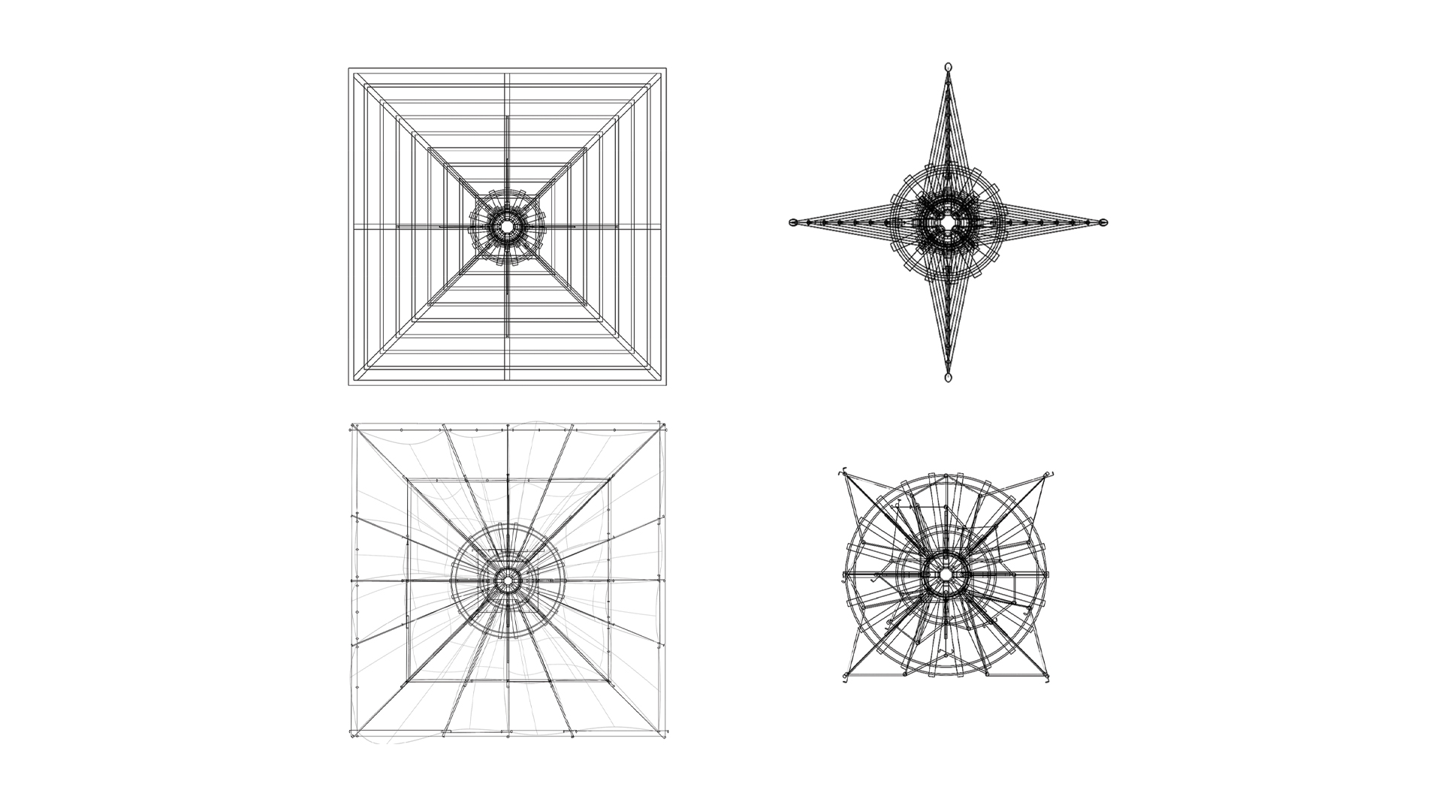
Materials & Construction
The system employs local, low-carbon materials such as bamboo, tapa cloth, and magimagi rope. Materials deeply embedded in Fijian craft and life. These resources not only make the module affordable and repairable but also preserve cultural identity. VAKABULA can be built by the community using familiar techniques, reducing reliance on external aid or complex technologies.
Visitor and Community Experience
For the people of Marou, VAKABULA is more than a structure it is an evolving landscape of hope and agency. It creates shaded gathering places, power hubs, and water sources that are integrated into daily life. Visitors experience a living system that breathes with its environment, adapting to wind, sun, and season. Every interaction with the structure reinforces the values of sustainability, ingenuity, and self-reliance.
Co-Benefits & Shared Land Use
Beyond its primary functions, VAKABULA fosters education, craftsmanship, and community ownership. It can be used as a teaching tool in schools, a workplace for artisans, or a communal infrastructure for food drying, gatherings, or storytelling. Its modularity allows for phased growth and shared land use, weaving into both public and private spheres without disruption.

02. Technical Narrative
VAKABULA utilizes passive technologies in its design to be able to harness natural forces available on Naviti Island. These strategies of harnessing nature are incorporated in reasons explained two-fold. One, Marou is a small village with 67 households, the amount of energy and water supply created via these passive technologies cover all of the 91.7kW/day and 30,000L/day needed for average usage, with surplus on both 221.7kW of energy and 70,614L of water respectively, and two, in accordance to the brief of replicability and sustainability, the construction of each of the five types including; the biogas dome, fog harvester, retention pond, wind shear modules and photovoltaic modules are all replicable in mass quantities from locally sourced materials, in our case, bamboo and mangrove and mulberry timber/fibre. Construction techniques also follow that of the timber constructions utilized in traditional Fijian vernacular architecture, namely the magi-magi rope, which uses fibre from coconut husks to create rope to be tied around anchor and intersecting points of the timber/bamboo joinery.
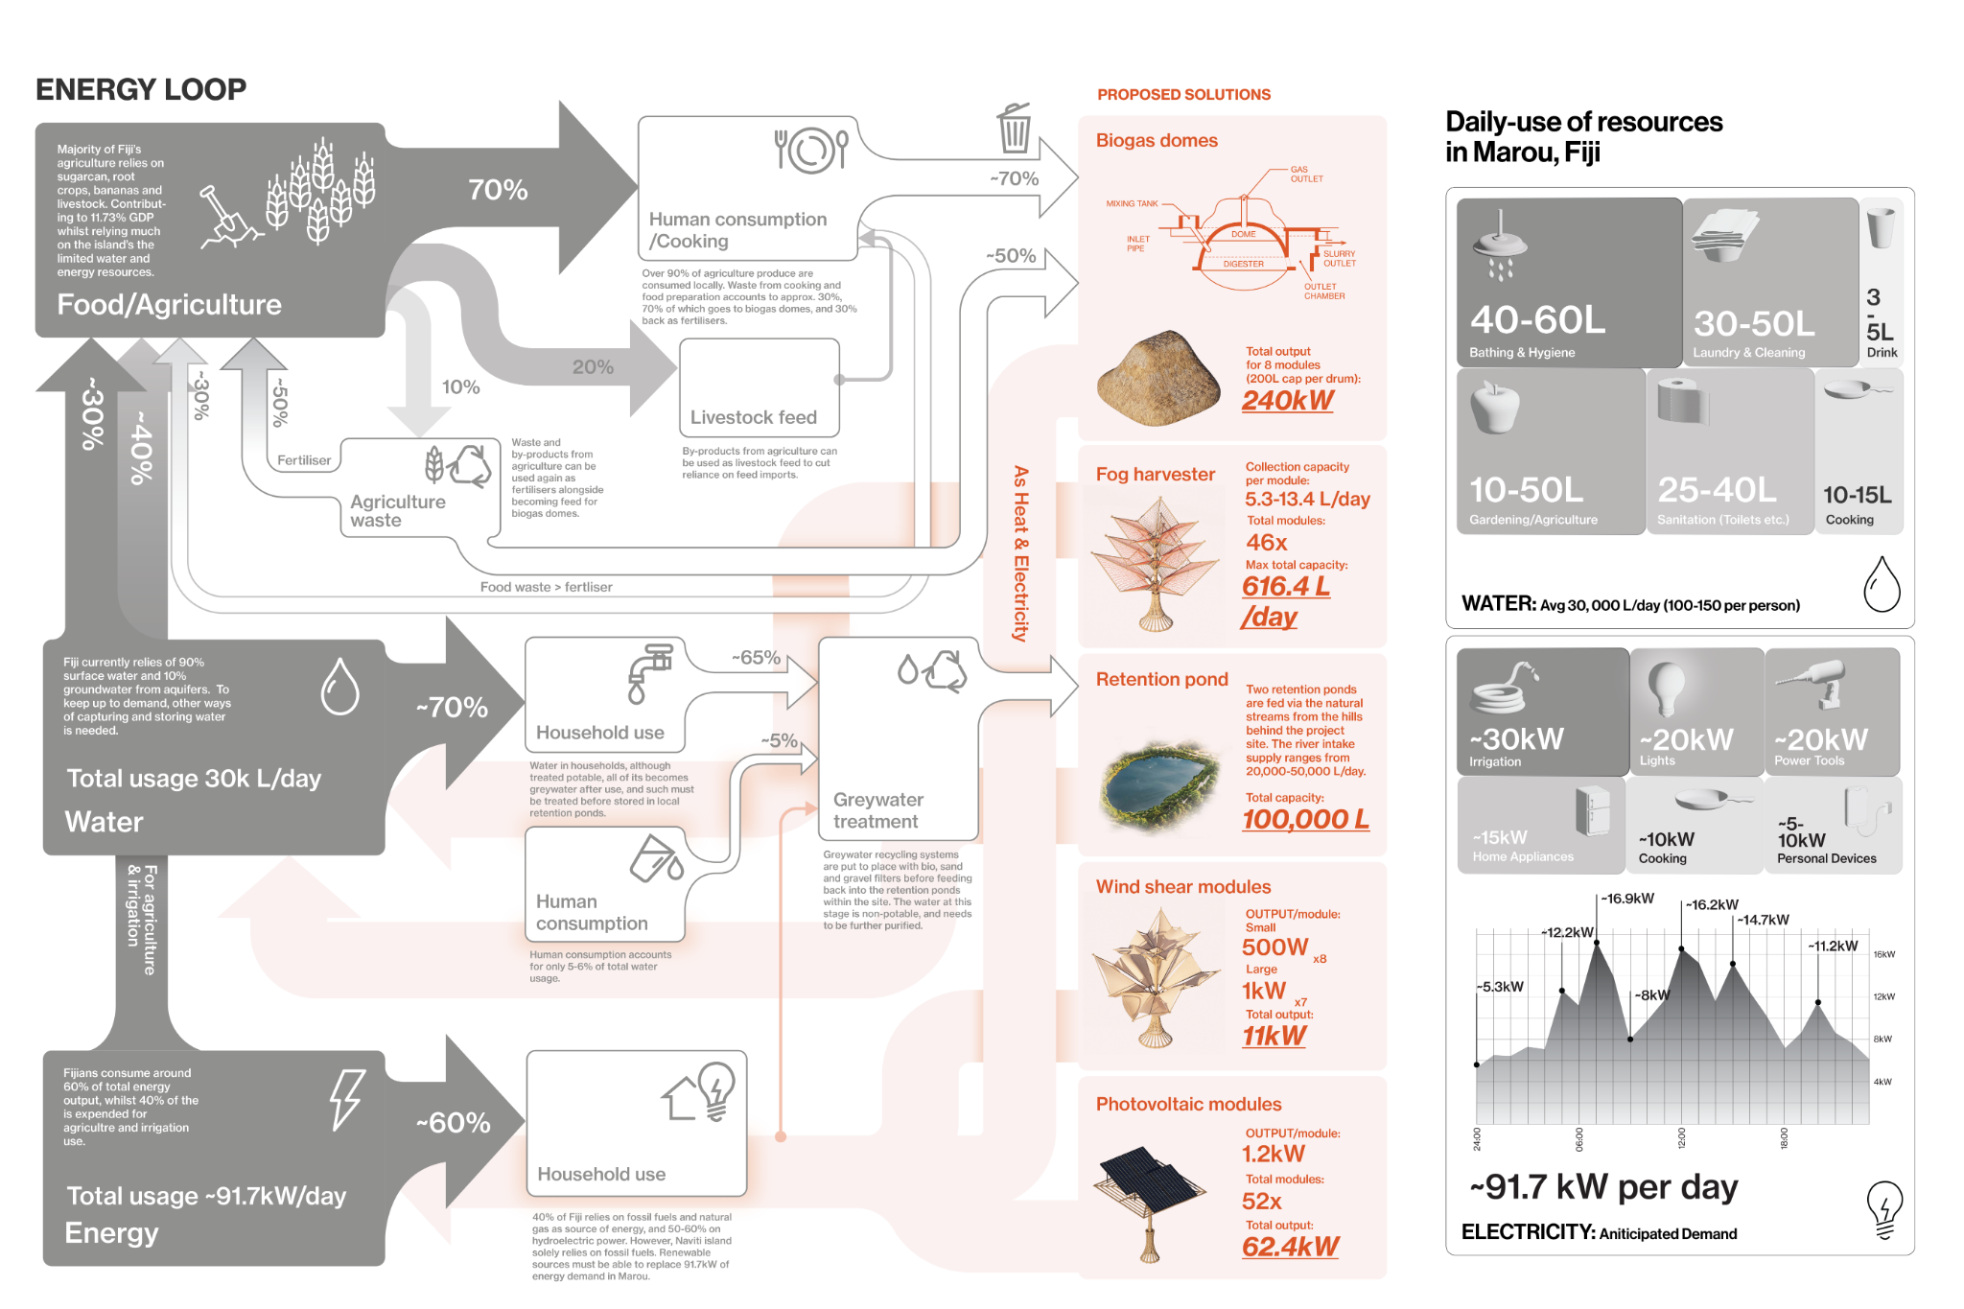

Energy systems:
Sunlight via photovoltaic panels: outputs total of 62.4kW/day
Wind via wind shear modules/turbines:outputs total of 11kW/day
Biogas via biogas domes: outputs total of 11kW/day

Water storage:
Rainwater & river intake: 20,000-50,000L/day
Greywater from household usage: 30,000L/day
Storage after treatment at a total of 50,000-80,000L/day +/- evaporation and ground seepage.

03. Prototyping and Pilot Implementation Statement
Our team would begin the prototyping process by creating scale prototypes from locally sourced materials as a means to both study the possibilities of our design and as a visual guide during the process of the full-scale pilot construction involving local communities and craftspeople, in the same vein as how local masters (maitasau) pass down their architectural knowledge from generation to generation. Each of the components and their constituent materials are laid out to identify the best possible fit for each use case ie; tightly woven masi fabrics as wind turbine blades, and coconut husk ropes as joinery. Once the scale prototype passes the litmus test, the close collaboration with local artisans and craftspeople begins. Each of the elements, parts and joinery of the project reflect local techniques that would already be familiar to the local craftspeople, including techniques such as bure or house-building, n’drua canoe sail weaving, and natural fibre fishing nets. Over the course of two-four week workshops, the shaded sunken courtyard in the centre of the project becomes a local community centre where each of the five modules are workshopped together with the local community of Marou.

04. Operations and Maintenance Statement
The design structure will mainly use bamboo as its construction material, which is easily sourced within the island of Naviti, and has a projected life time of around 3-5 years. The design is purposely created to be modular, both for the ease of construction and the ability to be maintained in parts, swapped or changed when need be. The modules are inspired by the mechanism of an umbrella which allows the modules to close up during heavy winds and storm, and opening up again depending on the weather conditions and use cases. For the long-term maintenance of each module, each part could be easily reproduced using local materials and techniques and changed when they need replacing.
‘Magimagi’ ropes, using mangrove fibre and coconut husks, are traditionally sourced for many daily use cases and as such are easily dependable to be used on large tensile structures such as the turbine and fog harvesting sails.

05. Environmental Impact Assessment
Even though VAKABULA is designed to work with nature, we know that any installation can still have an impact. Clearing land or using too many natural resources like bamboo or tapa cloth affect the local ecosystem if we're not careful. That’s why we’re taking steps to make sure the system stays sustainable:
- We encourage responsible harvesting of materials, making sure we never take more than nature can give back.
- We plan to build lightly, using raised or minimal foundations to avoid disturbing the soil or native plants.
- We’ll work with local groups to keep an eye on how the environment is doing and adjust our methods if needed.
- The system is flexible, so if certain materials become scarce, we can swap them out for others without harming the design
- Most importantly, we want the community to lead giving them the tools and knowledge to care for both the system and their land.
SDGs achievement
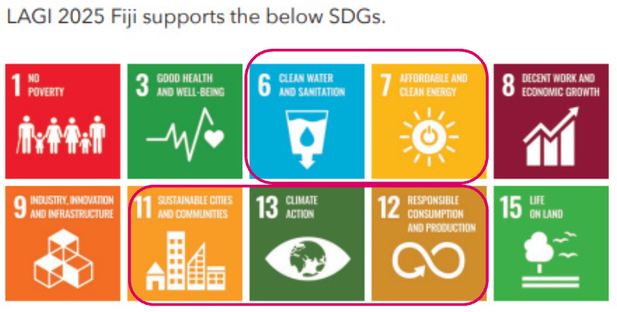
This care for the environment also aligns directly with several UN Sustainable Development Goals (SDGs):

SDG 6 – Clean Water and Sanitation: Fog catchers and rainwater harvesting give the community access to safe, reliable drinking water, especially during dry months.
SDG 7 – Affordable and Clean Energy: Solar panels, wind turbines, and biogas systems bring renewable energy to remote areas. Cutting emissions and reducing dependency on fossil fuels.
SDG 11 – Sustainable Cities and Communities: Our design supports climate resilience through local materials, modular systems, and housing that is safe, affordable, and adaptable.
SDG 12 – Responsible Consumption and Production: By using local resources and turning organic waste into energy, we promote a circular, low-impact way of building and living.
SDG 13 – Climate Action: VAKABULA helps vulnerable coastal communities prepare for and respond to the realities of climate change through both mitigation and adaptation.
SDG 14 – Life Below Water: Cleaner energy and water systems reduce pollution and runoff, helping to protect nearby marine ecosystems.

