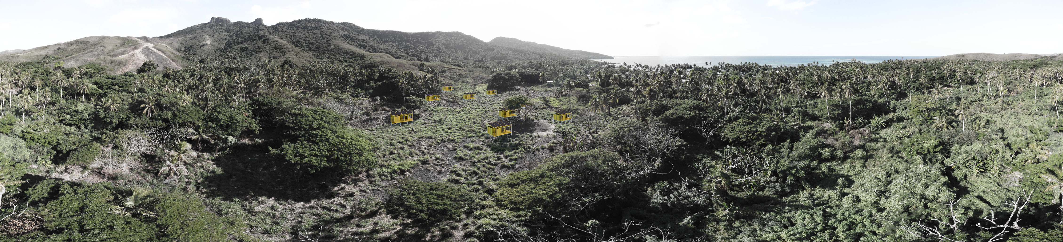
Energy RE:balance
Concept
Re
CONTENT

1. Concept Narrative 3

2. Technical Narrative 5

Applied Technologies and Their Justification: 6

System Inputs and Outputs: 6

3. Annual Energy Production and Water Yield Estimates: 7

1. Concept Narrative
The aim of the proposed project is to create a self-sustaining, community-based energy production and water supply system that not only includes functional built elements but also generates spaces of social and ecological significance. The project will be implemented in a coastal settlement in Fiji, where site characteristics are seen not as constraints but as opportunities.
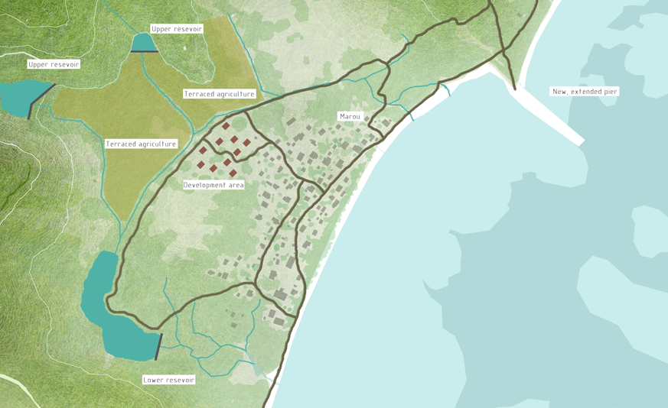
At the heart of the concept are ten mono-pitched roof huts forming a community energy village. The layout of the huts follows local village building patterns, ensuring organic integration into the built environment. The structures serve as bivouac lodgings and communal spaces, providing opportunities for residents and visitors to experience a nature-oriented lifestyle and energy-independent operation.
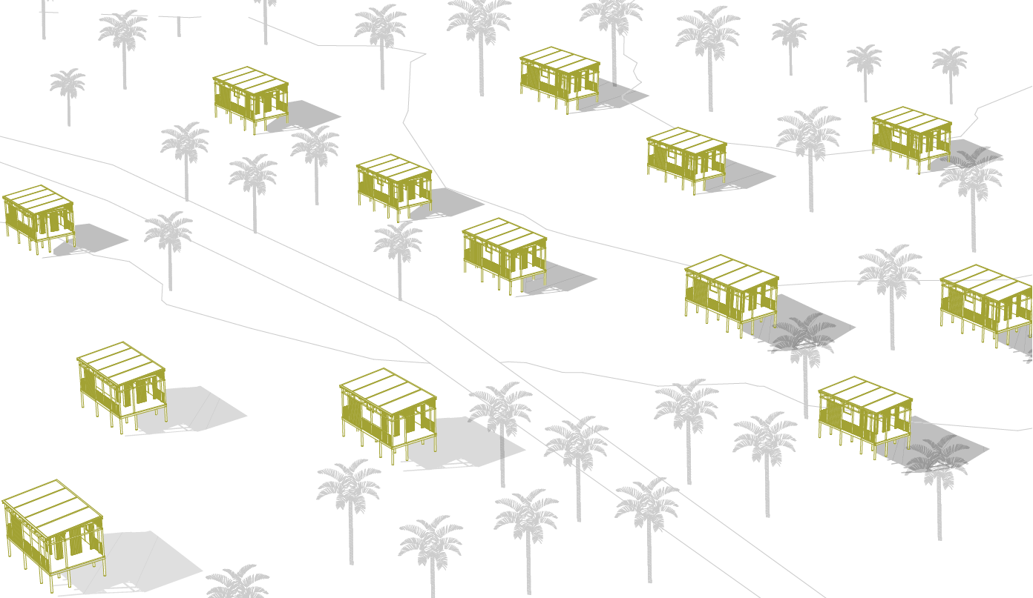
c
The use of local materials is a fundamental principle in the implementation. The main structural framework consists of bamboo, which is readily available, rapidly renewable, and has excellent structural properties. The frame system is complemented by bamboo-woven wall structures and louvered, unglazed openings. Durable structural joints are ensured through prefabricated hardwood cone elements fitted to the ends of the bamboo rods using threaded bars and locknuts. The foundation uses a ground screw system, avoiding major soil disruption and allowing for rapid, adaptive construction.
The roofs of the huts also function as rainwater harvesting surfaces. Solar panels mounted on the roofs convert sunlight into electricity while channeling rainwater into collection tanks placed beneath the huts. The tanks are interconnected: utilizing the slope of the terrain, water can flow gravitationally between the units. Additionally, electric pumps powered by the generated electricity return water to the topmost tank, enabling the system to also store energy. If necessary, small turbines can recover electricity during water return flow.
The operation of the system is clearly visible and educational for visitors, reinforcing awareness of energy and water use. The huts’ open communal layout allows for shared use, events, workshops, and educational activities.
So, the project is not merely a technical installation, but a community-driven, social, and ecological initiative that can serve as a model for other island communities.

2. Technical Narrative
The proposed architectural and technological system offers a sustainable, locally resourced solution for communities in Fiji. The architectural design of the huts, along with their energy and water systems, have been developed in a unified, integrated approach. The goal of the system is low-energy operation, maximal utilization of renewable energy, and a combined system for water and energy storage.

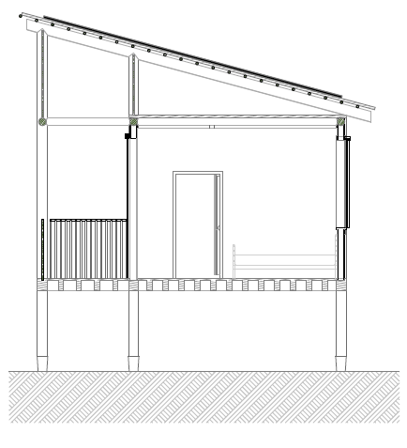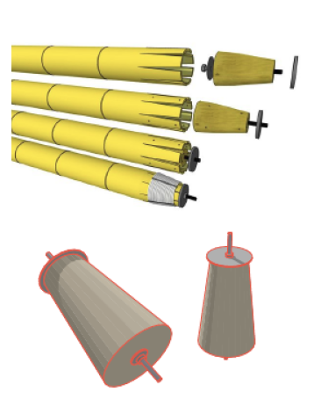

Applied Technologies and Their Justification:
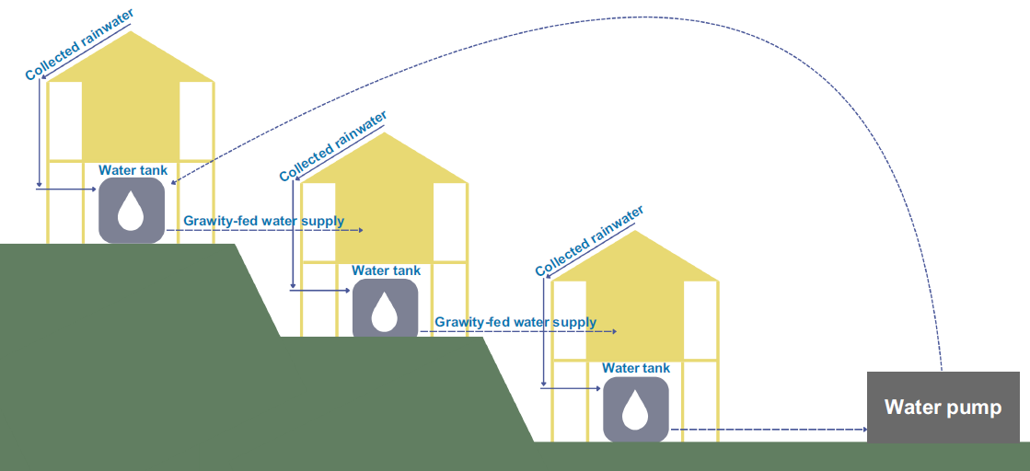
Each hut's roof structure will be equipped with approximately 50 m² of solar panel surface, totaling 500 m² of active solar panel surface across the 10-unit installation. The roofs are mono-pitched and sloped northward, optimizing the tilt angle of the solar panels for maximum annual energy production based on the island's geographical location. The panels serve a dual function: generating electricity and collecting rainwater.
The electricity generated by the panels is partly used directly and partly stored in batteries. A unique feature of the system is that surplus energy also plays a role in gravitational water supply: pumps return water from lower-level rainwater tanks to the highest-level tank. This allows for temporal energy storage—not only in electrical form but also as potential energy.

System Inputs and Outputs:
• Inputs: solar energy (photovoltaic system), rainwater (from roof surface), low-level electricity consumption from community use.
• Outputs: electric power (lighting, pumping, low-voltage appliances), usable rainwater (after pre-treatment as drinking water, or as greywater), recoverable electricity through turbines during gravitational water discharge.

3. Annual Energy Production and Water Yield Estimates:
A 50 m² solar panel system in Fiji can produce approximately 7,000–8,000 kWh of energy annually. The entire system can thus provide 70,000–80,000 kWh per year across the 10 huts.
From a rainwater harvesting perspective, assuming an annual precipitation of 2,500 mm, the total roof surface could collect up to 1,250,000 liters of water per year. This amount can cover the majority of the basic water needs of local communities.
The planned system is robust, modular, and low-maintenance while ensuring a high degree of self-sufficiency. Every element is adapted to local climatic, topographical, and social conditions.
