～Splicing Waves～

1.Concept Narrative
The waves accompany Marou Village every day and every night. The waves are the villagers' close friends, bringing food, wind and water. When the sunlight falls on the small hill to the northwest of Marou Village, each unit module immediately "surges", piecing together to form a special "wave". These devices occupy the gentle slopes on the mountain and will not cause damage to the original ecology. Each module creates a small space for people to move around, rest, enjoy the scenery, cultivate small plants, and so on. More importantly, they are "alive", and their lives come from nature. The waves in the early morning make a rhythmic gurgling sound, and a low rumbling sound comes from afar. When they rush into the curved bay, it turns into a gentle tinkling sound of shells being tapped. At night, the entire village sleeps in the breath of the waves, and even dreams sway gently.

2.Technical Narrative
1）On rainy days:
The curved surface made of flexible solar panels is concave on the ground to form a rainwater collector. A rainwater filtration membrane connected below the center of the curved surface. The filtered rainwater is transported to the water storage system at the bottom of the device through a rainwater transmission pipe embedded in a rigid metal rod. Each Splicing Wave water storage system is equipped with four floating module activity units, and each one has a specially designed floating module connected to the rainwater transmission pipe. The increase in water volume within the floating module activity unit drives the floating module to float up. The rigid metal rod then rotates at an angle, expanding the flexible solar curved surface and increasing its area for receiving rainwater.Each Splicing Wave is connected by water storage connection pipes, so the underground will become a huge water storage system.

2）On sunny days:
The solar system is equipped with an app to monitor the power generation situation. When there is no need for emergency water supply, the water volume in each Splicing Wave's water storage system is relatively small. The floating module in the activity unit sink to the bottom, driving the rigid metal rods to contract inward, increasing the curvature of the flexible solar surface. The solar radiation is reflected through the surface and converges to one point, at which point the solar collection efficiency is the highest.

3）Solar Power generation estimation：
Solar panel power output: 0.20kW/m²
Solar panel energy production per square meter（calculate 6 hours a day）: 1.20kWh / day
The area of solar panel each Splicing Wave: 4.0m²
Total solar panel area: 376.0 m²
Total energy output per day: 451.2 kWh

- Prototyping and Pilot Implementation Statement
We hope that after the installation is completed, the villagers of Marou Village will evenly distribute 2 to 3 Splicing Wave modules according to the number of households. We hope that Splicing Waves can expand the living space of the residents. Villagers can regard their own modules as their own land because our installation meets the needs of entertainment and growing small crops. After Splicing Waves is built, its texture map will become a QR code (as shown in the picture), and villagers can monitor the storage volume of clean water resources and the status of solar power generation in real time by scanning the QR code.
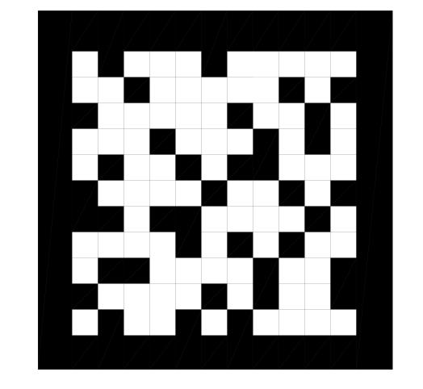

4.Operations and Maintenance Statement
The device will change its form by itself due to weather changes during its life cycle. The specific operation mode has been explained in the above process.Regular cleaning of flexible solar panels can maintain their power generation efficiency. It is generally recommended to clean them once a year. It can be cleaned with a soft-bristled brush, a high-pressure water gun or professional tools. The power generation situation can be monitored on a daily basis through the app that comes with the photovoltaic system.

5.Environmental Impact Assessment

Splicing Waves require the excavation of a certain amount of soil to form an underground water storage system. During the construction process, attention should be paid to the damage caused by extreme weather to the site, and typhoon weather should be avoided as much as possible to prevent the formation of soil erosion from damaging the village. Therefore, we chose to adopt prefabrication methods to pre-produce the above-ground part of the device. The construction process was simply to assemble the components, so villagers could add or dismantle it by themselves.

