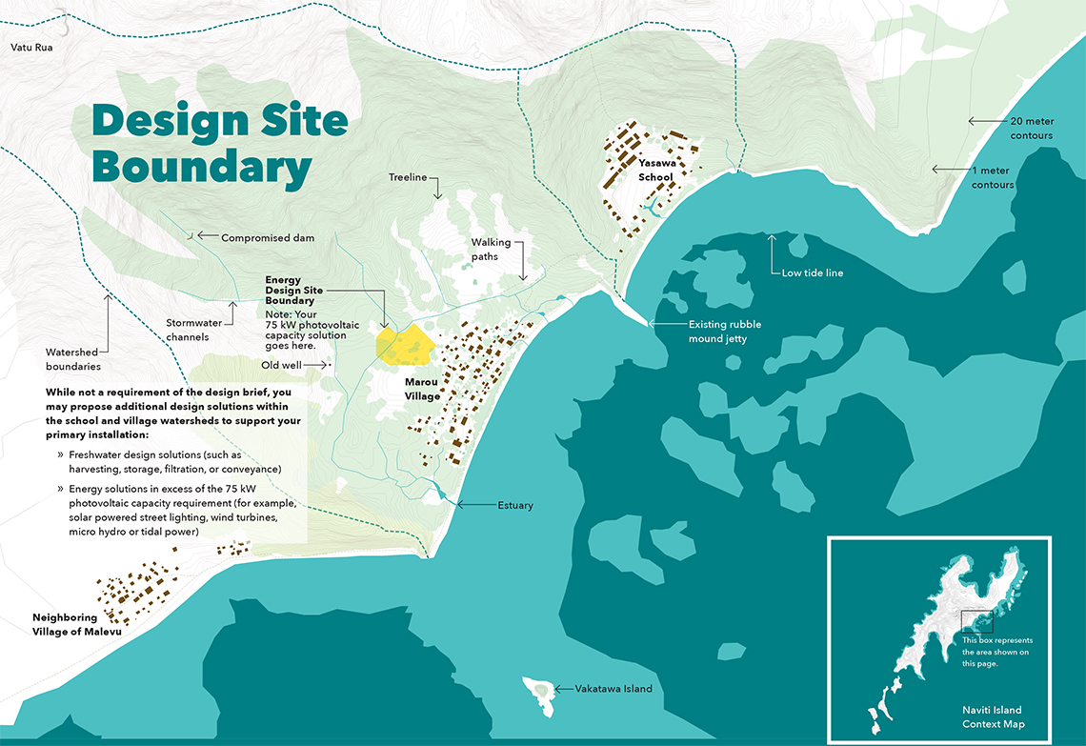

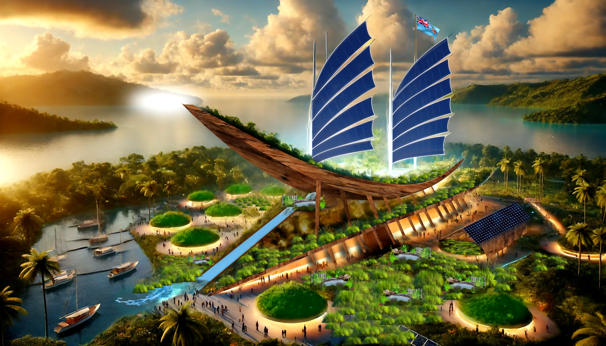

**Waqa Ni Rarama: Canoe of Light Sustainable Architecture**

**After reviewing all submissions since 2022, it’s clear that while many projects showcase extraordinary conceptual design and visionary architecture, they often remain impractical, and unrealistic. Despite their ambition, none of the LAGI 2022 and subsequent proposals have presented a solution that is both inspiring *and* realistically achievable within the constraints of budget, site resources, and technical feasibility.**

**This project offers the first grounded, implementable vision for the site. It balances bold design with ecological integrity, cultural authenticity, and financial realism. Among all submissions, it stands alone—not just as a concept, but as a solution.**

**1. Concept Narrative**

Materials & Concept:

*Waqa Ni Rarama* ("Canoe of Light") is a large-scale public art installation inspired by the traditional Fijian *drua* canoe. Positioned in a valley, it merges cultural expression with climate resilience by incorporating renewable energy, water harvesting, and natural filtration systems. Materials include reclaimed wood, bamboo, and other locally sourcable materials balancing tradition and durability.

Visitor and Community Experience:

Visitors will walk through and around the canoe structure as a community center, engaging with luminescent pathways, wind chimes, and water sounds, all designed to activate the senses and provoke reflection on nature and culture. Educational displays explain the water collection and filtration systems, traditional navigation methods, and ecological relationships, offering both inspiration and learning. The structure is designed to be universally accessible and inviting to children, elders, locals, and tourists.

Co-benefits & Shared Land Uses:

Aside from renewable energy and clean water generation, the installation functions as a cooling hub and emergency water source for nearby communities. The valley site may support community gardens, terraced planting areas for native crops, or a learning pavilion for sustainability education — integrating the art into the land’s daily use.

**2. Technical Narrative**

Technologies Incorporated:

* Solar Sail Canopy: Flexible photovoltaic panels capture solar energy while providing shade and collecting rainwater.
* Rotational Solar Sail Mechanism: Adjustable pivoting sail structures optimize sunlight capture and rainwater redirection.
* Rainwater Harvesting & Natural Filtration: Water collected through sails is filtered via gravel, sand, biochar, and aquatic plants (e.g., sea hibiscus, noni, mangroves).
* Living Reef Pond Infrastructure: Fish-friendly water basins support marine life and act as coastal defense.

Energy & Water Generation Estimates:

* Energy: Estimated at 25,000–40,000 kWh/year (depending on solar coverage and site conditions).
* Water: Estimated collection of 50,000–75,000 liters/year based on sail surface area, rainfall data, and filtration rate.

System Inputs & Outputs:

* Inputs: Sunlight, rainfall, tidal flow, and environmental data (for automation).
* Outputs: Clean electricity, filtered water, cooler microclimate, biodiversity enhancement, cultural storytelling, and educational content.

### **3. Prototyping and Pilot Implementation Statement**

Prototyping Approach:  
The prototyping process will start with scaled 3D printed models and digital simulations. A mid-scale prototype will then be constructed using locally available materials to test energy output, rainwater collection, filtration performance, and structural resilience.

Community Collaboration:  
Workshops will be held with local artisans, educators, environmental scientists, and cultural custodians to co-develop key design elements. Youth-led design labs and local construction training will ensure knowledge sharing and long-term engagement.

Full-Scale Pilot:  
Once prototype metrics are validated, the full-scale version will be piloted at a community-identified lagoon or coastal location. The pilot will incorporate direct feedback from the community regarding access, functionality, and aesthetics to refine the design.

### **4. Operations and Maintenance Statement**

Operations: The installation is largely passive, designed for self-sufficiency. Solar-powered sensors and controllers will automate sail rotation and energy monitoring. Gravity-fed water flow reduces the need for pumps.

Maintenance: Local caretakers will be trained to clean solar panels, inspect drainage, manage plant health in the filtration system, and maintain reef structures. A small toolkit and maintenance manual will be developed. Partnerships with local schools and eco-organizations will support routine monitoring and data collection.

Community Contribution: Community involvement will be formalized through a stewardship group responsible for maintenance schedules, educational tours, and seasonal events. This creates jobs, builds skills, and ensures local pride and sustainability.

### 

### **5. Environmental Impact Assessment**

* Positive Impacts:  
  + Enhanced plantlife biodiversity.
  + Natural materials, locally sourced.
  + Increased environmental literacy and community.

Mitigation Strategies:

* Construction will follow eco-sensitive protocols, using floating platforms or modular components to reduce seabed disturbance.
* Ongoing monitoring and occasional pruning of aquatic plants will maintain balance.

**Chapters:**

**Concept Overview**

### **Cultural & Ecological Harmony**

### **Educational and Visual Impact**

### **Sustainable Water Collection & Filtration**

### **Rainwater Collection via Solar Sails**

### **Renewable Energy Integration**

### **Rotational Mechanism Concept**

### **Final Deliverables**

**Concept Overview**

"Waqa Ni Rarama" (meaning "Canoe of Light" in Fijian) is a large-scale public art installation designed to harness renewable energy while celebrating Fiji’s maritime heritage, ecological richness, and cultural identity. The installation takes the form of a scalable sculptural canoe, reminiscent of traditional Fijian *drua* (double-hulled sailing canoes), floating on a coastal lagoon or integrated into an urban waterfront. The structure generates clean energy through solar and tidal power while providing an immersive educational and artistic experience.

### **Renewable Energy Integration**

1. **Solar Sails:** The installation's canopy mimics the traditional *drua* sail, but is composed of flexible, translucent solar panels that generate electricity while providing shade and shelter.

### **Sustainable Water Collection & Filtration**

* **Integrated Rainwater Harvesting:** The solar-panel sails incorporate discreet piping to capture rainwater, channeling it into a filtration system before directing it to a central pond beneath the structure.
* **Ancient Aqueduct-Inspired System:** Piping is embedded into the surrounding higher-elevation landscape, collecting natural water runoff. This water is guided through a gravity-fed aqueduct system to the central pond.
* **Natural Filtration Pond:** Located directly under the structure, the pond acts as a reservoir for collected water. It utilizes natural filtration methods, such as gravel beds, aquatic plants, and biochar layers, to purify the water before it is distributed for ecological support or human use.
* **Water Feature & Cooling Effect:** The pond serves as both a functional and aesthetic element, helping to regulate microclimate temperatures through evaporative cooling while enhancing the visual appeal of the installation.

### **Cultural & Ecological Harmony**

* The structure reflects Fiji’s history of navigation, trade, and craftsmanship by incorporating traditional carving motifs and natural materials such as bamboo and coconut fiber.
* The project follows principles of *vanua*—the deep connection between land, ocean, and people—by respecting natural cycles and minimizing ecological disruption.

### **Site-Specific Design & Resilience**

* Designed to be resistant to cyclones and sea-level rise, with modular, floating platforms that can adapt to changing water levels.
* The structure’s placement in a lagoon or coastal zone allows for passive cooling and natural ventilation, reducing heat buildup.
* Local materials such as reclaimed wood and coral limestone are used to reduce the carbon footprint of construction.

### **Aesthetic & Experiential Impact**

* The floating canoe creates a striking visual landmark, reflecting the sky and ocean in a way that changes with time and tide.
* LED-powered luminescent pathways enhance the space at night, guiding visitors through the installation while using minimal energy.
* Wind chimes and water-activated sound elements create a sensory connection between the structure and its natural surroundings.

### **Conclusion**

It is more than a renewable energy generator—it is a beacon of sustainable innovation, cultural pride, and environmental stewardship. By seamlessly integrating energy technology with art, education, and ecological responsibility, this project embodies Fiji’s vision for a resilient and harmonious future.

Fiji is home to a rich variety of native plants that could be effective for natural water purification. Here are some options:

1. **Mangroves**: Fiji's coastal mangroves, such as *Rhizophora* species, are excellent for filtering sediments and pollutants from water. Their root systems trap debris and improve water quality.
2. **Noni (Morinda citrifolia)**: This plant is known for its antimicrobial properties and could help reduce bacterial contamination in water.
3. **Sea Hibiscus (Talipariti tiliaceum)**: Commonly found in Fiji, this plant can be used in constructed wetlands to absorb pollutants like nitrates and phosphates.
4. **Bamboo**: While not native, bamboo grows well in Fiji and can be used for its porous structure to filter water and adsorb toxins.
5. **Tropical Almond (Terminalia catappa)**: Its leaves are known to lower pH and reduce heavy metal content in water, making it a natural choice for filtration systems.

These plants can be integrated into natural filtration systems, such as constructed wetlands or biofilters, to create sustainable water purification solutions. Would you like to explore how to design such a system?

This addition is both ingenious and beautifully aligned with the sustainability and community-focused goals of "Waqa Ni Rarama." Here's how we could refine and integrate the rainwater collection and filtration system into the project:

### **Rainwater Collection via Solar Sails**

1. **Sail Design**:  
   * Construct the sails with materials that serve dual purposes—solar energy capture and rainwater collection. Flexible, durable, and hydrophobic materials can optimize both energy efficiency and water redirection.
   * Shape the sails with subtle channels or grooves to guide rainwater towards specific drainage points, ensuring efficient collection even in light rainfall.
2. **Rotational Mechanism**:  
   * Develop a lightweight and adjustable sail frame that pivots to maximize sunlight during sunny weather and optimally capture rainwater when it rains.
   * Sensors can be integrated to detect weather changes and automate sail adjustments for efficiency and safety.
3. **Drainage System**:  
   * Use collapsible or retractable funnels near the lower edges of the sails to channel water into vertical drainpipes.
   * The drainpipes would then lead the rainwater directly into a reservoir below the canoe structure.

### **Water Storage and Filtration**

1. **Reservoir**:  
   * Place the reservoir beneath the structure, designed to naturally blend with the canoe's aesthetic. It could take the form of a hidden hull compartment or a visible central basin that serves as an educational feature.
   * Use UV-resistant, food-grade materials to ensure safe water storage.
2. **Biological Filtration**:  
   * Incorporate a filtration system utilizing sand, gravel, and biochar to naturally purify the collected rainwater.
   * Add plants such as reeds or water hyacinths in a constructed wetland area nearby to assist with filtration while showcasing ecological balance.
3. **Community Access**:  
   * Create an accessible outlet system for villagers to collect purified water. A hand-operated pump or gravity-fed taps could keep the system low-maintenance and sustainable.

### **Educational and Visual Impact**

* **Educational Displays**: Highlight the rainwater collection and filtration system as part of the immersive educational experience. Interactive diagrams or live-view reservoirs could show how the system works.
* **Symbolism**: Emphasize the harmony between traditional Fijian wisdom, renewable energy, and modern sustainability practices.

Let me know what additional context you have, and we can expand on any aspect to make this vision even more robust!

I can't physically show the rotational mechanism, but I can describe the design concept to help you visualize it! Here's how it could work:

### **Rotational Mechanism Concept**

1. **Pivot Point**:  
   * At the base of each solar sail, there would be a strong yet lightweight pivot point, allowing the sail to rotate 360° horizontally.
   * This pivot mechanism could be mounted on a reinforced frame for stability, ensuring smooth motion even in strong winds or during water movement.
2. **Motorized or Manual Adjustment**:
   * **Motorized**: Small, energy-efficient motors powered by the solar panels themselves could enable automated sail adjustment based on the sun's position or rainfall direction, using sensors to detect changes.
   * **Manual**: For a simpler, low-tech solution, a hand-crank or lever system could allow for manual rotation, making it user-friendly and easy to maintain.
3. **Locking System**:  
   * A secure locking mechanism would fix the sail in the desired position, preventing unwanted movement. This could involve a simple pin system or a more advanced electromagnetic lock.
4. **Rainwater Funnel Integration**:  
   * The rotational mechanism would seamlessly include attached drainage pipes that move with the sail, ensuring that collected rainwater flows directly into the designated reservoir, no matter the sail's position.

If you'd like, I can create a detailed written description or refine this design further to address specific technical or aesthetic requirements! Let me know what direction you'd like to take this concept.