UNLEASHING THE VANUA
Living Systems for Community Resilience

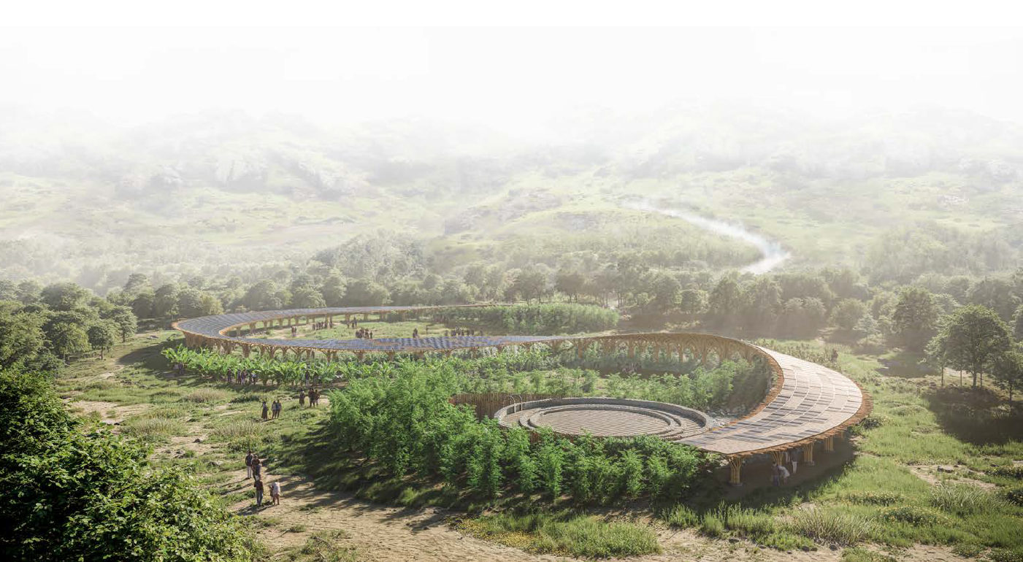
v

CONTENTS

Prologue | Responding to Marou’s Challenges
Chapter 1 | Spatial Framework and System Organization
Chapter 2 | Integrated Systems for Energy, Water, and Landscape
Chapter 3 | Prototyping and Pilot Implementation Statement
Chapter 4 | Operations, Maintenance, and Growth Strategy
Chapter 5 | Environmental Impact Assessment
Epilogue | Conclusive Remarks and Performance Summary
Reference

Prologue

Responding to Marou’s Challenges
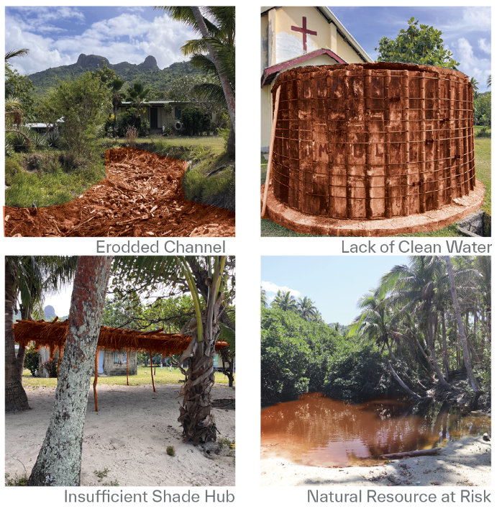
The coastal village of Marou in Fiji faces urgent and interconnected challenges: energy scarcity, unreliable access to clean water, and increasing pressure from a changing climate.
Unleashing the Vanua addresses these issues by reactivating the indigenous concept of Vanua, which emphasizes the unity of land, people, and spirit. The approach introduces a decentralized, community-managed system that integrates infrastructure seamlessly into daily life.

Catalyst Project
The first phase centers on a Solar-Water Hub: bamboo-framed canopies are angled to generate solar power and capture rainwater; stormwater is directed through constructed wetlands via water channels; and decentralized UV-purified tanks supply clean water for both household and agricultural needs. These interventions revive the vernacular wisdom of culturally protected water bodies, reintegrating communal infrastructure into the everyday rhythm of village life.
As the system expands, modular solar-water nodes create shaded courtyards where farming, social gatherings, and cooperative maintenance become part of daily routines. The flexible layout allows the system to grow gradually with the village's needs, avoiding centralized disruptions.
At the same time, traditional landscape techniques such as bamboo matting, stone revetments, and planted breakwaters help stabilize eroding riverbanks and coastal edges. These strategies restore ecological balance and strengthen resilience against climate impacts.
Over time, Marou transforms into a living prototype of regenerative development. Natural systems, cultural identity, and human activity become deeply intertwined. Infrastructure is not hidden but experienced: residents move through shaded walkways, grow food along wetland edges, and gather under canopy-covered communal spaces. Visitors engage with the site as a learning environment, exploring Fijian culture, observing ecological restoration, and witnessing sustainable village resilience in action.
Rather than a fixed installation, Unleashing the Vanua is a flexible and replicable framework. Rooted in tradition and designed for a changing climate, the project envisions a future where land, water, and community are co-managed, revitalized, and able to thrive together.
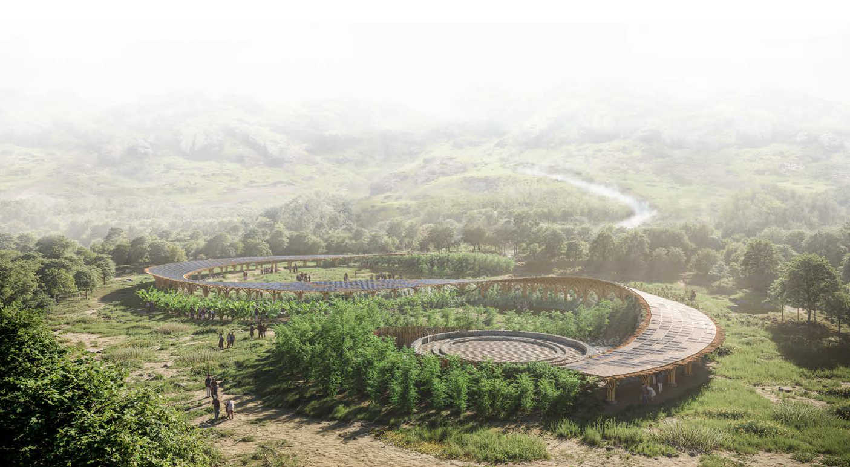

Chapter 1. Spatial Framework and System Organization

This project presents a resiliency framework with three integrated strategies.
A water purification system uses natural topography and ecological processes. Bamboo structures are built with local materials and labor to support the community. Solar energy provides a sustainable power source. Together, these elements promote economic growth and long-term sustainability in the Marou region.

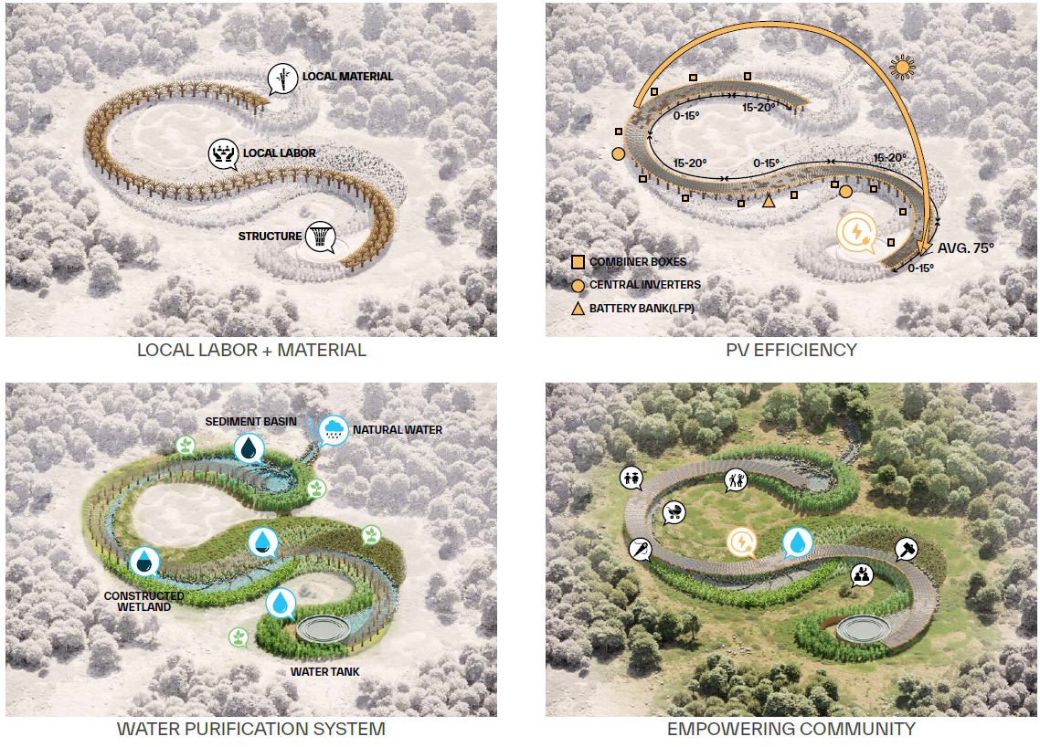

Local Labor + Material
The bamboo canopy system is designed with unitized parts sized for manual transport and on-site assembly. Standardized joinery and lightweight materials allow for decentralized, low-tech construction without machinery. By aligning construction with available resources and skills, the system ensures long-term maintainability by the community.

Solar Energy
At the project’s core are bamboo-framed solar canopies, tilted 15–20° for optimal photovoltaic performance. While solar orientation guides their angle, placement also follows the site’s hydrology and topography, ensuring accessibility and protecting natural drainage.
Each solar-water hub is modular, designed to serve 3–4 households. The system expands flexibly without needing centralized restructuring, adapting over time to the community’s evolving needs.
The modular system enables future expansion while this phase establishes its core framework.

Water Purification System
Water from mountains on the North and rainwater from canopy panels is collected via bamboo gutters and directed into open channels that follow the slope of the land. These channels serve as constructed wetlands, where water slows, sediment settles, and filtration occurs through layers of native vegetation. After filtration, UV systems purify the water, which is then stored in decentralized underground tanks distributed across the site.
This infrastructure does more than deliver utilities, it shapes the spatial experience of the village. Shaded paths follow canopy lines, connecting homes, gardens, and communal spaces. Clearings between canopies and wetlands become flexible gathering areas for resting, play, or work. Farming strips run along the channels, supporting food production near dwellings and reinforcing daily interaction with land and water.

Empowering communities
Visitors experience this not as background infrastructure, but as a spatial and cultural rhythm: moving along shaded walkways, watching water thread through wetland beds, passing between gardens and gathering spaces. The system is not hidden, but it is inhabitable.
In this way, Unleashing the Vanua transforms Marou into a regenerative village, where energy, water, and communal activity co-exist in a fluid, resilient, and participatory environment.

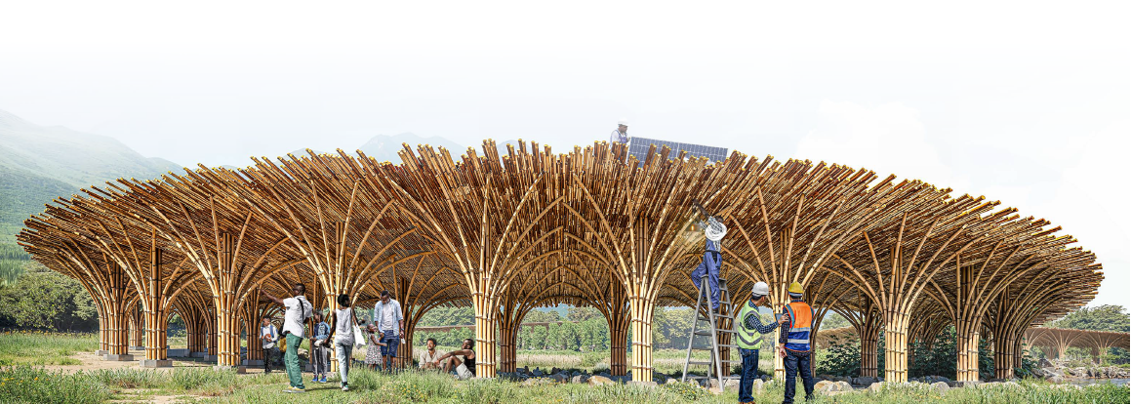

Chapter 2. Design Approach

Integrated Systems for Energy, Water, and Landscape
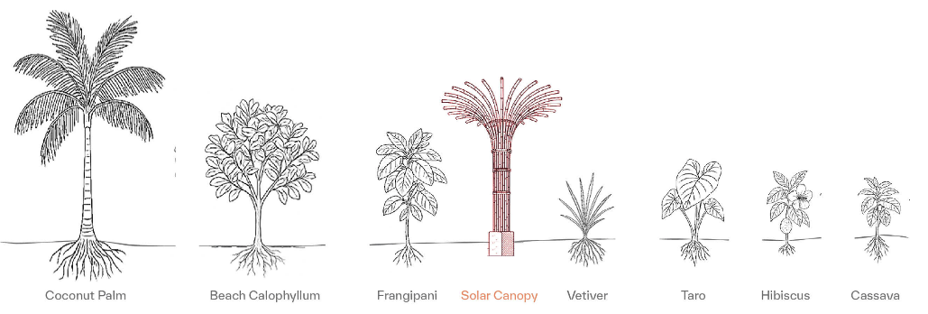
2.1 Solar Canopy – Bamboo Structure

The proposed canopy responds to the shared ownership and responsibility of land and trees within the village. As solar panels require an open sky, the structure bridges the need for exposure with the communal value of vegetation. Bundled bamboo columns reflect the forms of native species, creating minimal ecological disruption while providing infrastructure for energy collection.
This design allows the solar canopy to coexist with existing trees, reinforcing both spatial continuity and social equity.

Structural System
Structure
In a bundle of each structure, 6 vertical bamboo columns (90–110 mm) are anchored in shallow foundations. And the other curved bamboo members (60–70 mm) form horizontal and diagonal braces, stabilizing the canopy and echoing local vegetation patterns.
Connection
Rope lashings offer flexibility and traditional aesthetics. Steel clamps or pins reinforce key stress points for durability.
Bamboo Gutter Ceiling System
Suspended below the solar panels, split bamboo gutters serve dual functions:
Rainwater Collection: Gutters sloped 1–2% channel rainwater into landscape-integrated filtration zones.
Ceiling Formation: Rhythmic rows of bamboo gutters filter sunlight and airflow while visually integrating the structure with its setting. Gutters are built in 2-meter modules and can be removed individually for inspection and cleaning.
Maintenance Access
Based on the estimated electricity demand(75kW), 250 PV panels were selected. Each 1.0m x 1.6m panel can be maintained by a two-person team without the need for heavy machinery.
Removable gutter panels allow access to solar panel undersides. Lightweight ladders stored on-site are used for inspection and cleaning. Solar Integration and Expansion. Quick-release brackets allow easy removal. The canopy integrates structure, energy, and ecology—serving as both infrastructure and a public, environmental interface.
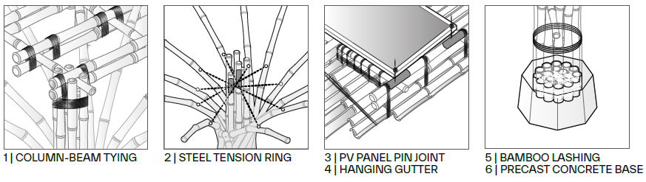
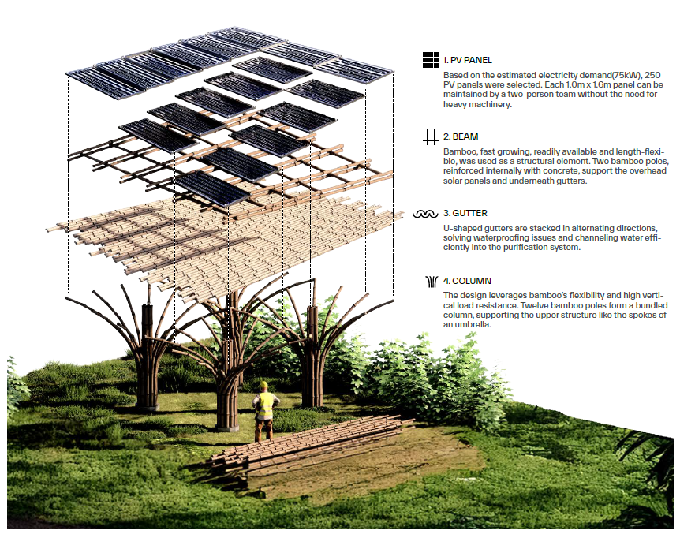

Chapter 3. Integrated Systems for Energy, Water, and Landscape

Stormwater + Rainwater Collection and Clean Water System
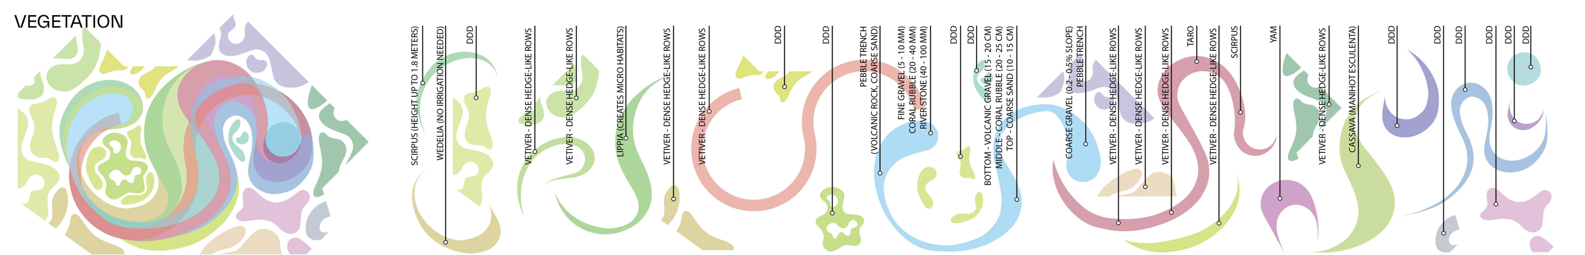
The water system of Unleashing the Vanua extends an upland stormwater stream into the village, forming the basis for a decentralized, gravity-fed clean water network. Rainwater from solar canopies and runoffs is integrated into a multi-stage, landscape-based treatment system, combining sedimentation, wetland filtration, UV purification, and distributed storage.
Stormwater Collection and Channel Integration
At the village’s upper edge, a stormwater stream is diverted into widened, sloped bioswales. Rainwater from bamboo gutters supplements this flow. Channels become visible infrastructure, guiding water while activating adjacent community landscapes.
Primary Sedimentation Zones
Water first enters the sedimentation basins:
- Dimensions: 20–25m long, 10–3m wide, 0.5–1.5m deep
- Vegetation:
- Scirpus (outer edge) acts as a flood-tolerant buffer
- Vetiver grass (inner) stabilizes soil and slows water
- Taro patches trap debris and contribute to food resilience
- Erosion Control:
Basin edges are reinforced with bamboo fiber matting, preventing soil loss during rainfall and integrating with planting systems. This lightweight, locally available material adds surface stability while promoting root anchoring.
- Surface layers:
- River stones for splash reduction
- Coral rubble and fine gravel for sediment filtering
Overflow weirs protect the system during high rainfall.
- Constructed Wetlands
Filtered water flows through planted wetlands:
- Dimensions: 50–60m long, 1.5–8m wide, 0.4–0.6m deep, 0.5–1% slope
- Vegetation structure:
- Vetiver at inlet
- Spike rush at mid-zone
- Scirpus at outlet
- Soil layers:
- Crushed volcanic gravel (bottom)
- Coral rubble (middle)
- Coarse sand (top)
The gradual slopes are stabilized using planted vegetation and bamboo matting, ensuring long-term durability with minimal engineered intervention.
Wetlands offer secondary filtration and create biodiverse public landscapes that blend infrastructure with ecology.
Final Polishing Zone
Water passes through a final vegetated wetland:
- Length: 15–20m
- Vegetation: Fimbristylis spp., Cyperus species stabilize and clarify flow before disinfection.
UV Sterilization and Storage
Water enters a sump basin and is pumped into an inline UV sterilizer (e.g., Viqua PRO10), delivering ≥40 mJ/cm² UV-C exposure. Solar-powered with battery backup, the system is fully off-grid.
Treated water flows into a central cylindrical tank:
- Size: 16m diameter × 6m height
- Volume: 1,200m³
- Supply: Serves ~300 people for ~130 days (75L/person/day + buffer)
- Material: Precast mortar panels assembled on-site
The tank is placed near gathering spaces for visibility, access, and thermal regulation.
Farming Integration
Farming beds are placed along wetland edges, using:
- Taro, cassava, banana, papaya, and sweet potato—traditional, water-tolerant, and low-maintenance crops.
These reinforce food independence while blending agriculture with environmental infrastructure.
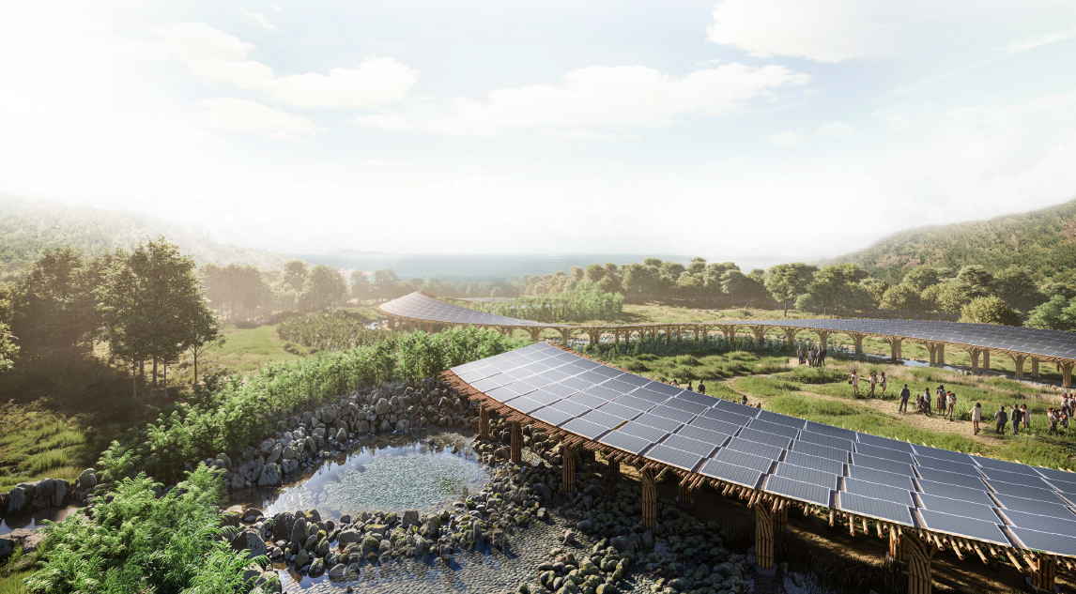

Chapter 4. Prototyping and Pilot Implementation Statement

Prototyping and Pilot Implementation Statement
To embody the Vanua principle—the unity of land, water, and community—Unleashing the Vanua integrates prototyping as both a design tool and a participatory process. This includes transportable scale models for dialogue and on-site, full-scale construction for collective testing and learning.
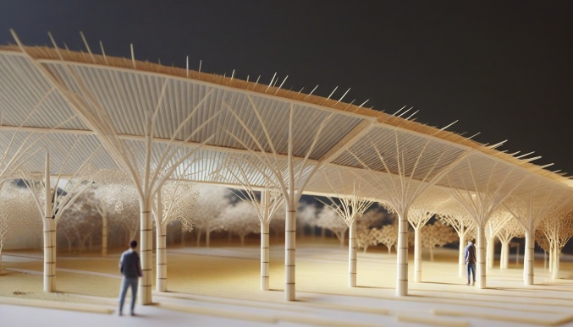
Scaled model rendered reference(left) and Bamboo fabrication workshop in Bali, Indonesia(right)

Modular Prototyping
Landscape + Water System
A 1:50 scale modular model will be fabricated and transported to the site to communicate core systems: terrain shaping, stormwater diversion, natural filtration, and community farming integration. This compact model offers an accessible, visual way to share construction logic and inspire site-specific adaptation.
Solar Canopy Structure
Another 1:50 scale model demonstrates the bamboo canopy’s logic, column positioning, roof slope, bamboo gutter layout, and solar panel integration. It combines flexible wood, 3D-printed components, and sample rope-lashing to simulate real-world joint methods.
These modular tools serve not only for demonstration but also as collaborative conversation starters with residents and local craftspeople.

On-Site Pilot Construction
Bamboo Solar Canopy (1:1 Segment)
One full-scale canopy column, designed to support six solar panels, will be constructed with the community.
- Materials: Locally harvested bamboo for columns, gutters, and curved arches
- Foundation: Lightweight precast concrete footing fabricated by a local builder and transported to site
- Gutters: Bamboo will be halved, trimmed, and secured with steel wire and rope lashing
Landscape Water Demonstration
Next to the pavilion, a small-scale swale and sediment trench will be hand-dug to demonstrate water collection, flow redirection, and basic filtration logic using native soil and stone.

Community Collaboration
Participatory Workshops
Residents will join in hands-on sessions: preparing bamboo, tying gutter systems, assembling canopy modules, and shaping micro-landscape elements. Through these steps, knowledge is shared and construction confidence is built.
Mutual Learning and Adaptation
Rather than instructing, the prototype process fosters two-way knowledge exchange between design intentions and local experience. The goal is to ensure that both the infrastructure and the act of making it are rooted in cultural relevance and technical resilience.

Chapter 5. Operations, Maintenance, and Growth Strategy

Operations, Maintenance, and Growth Strategy
The long-term success of Unleashing the Vanua depends on community-led maintenance, low-cost operations, and diversified funding. Stewardship is embedded in everyday life and reinforced by education, rotating responsibility, and adaptive infrastructure growth.
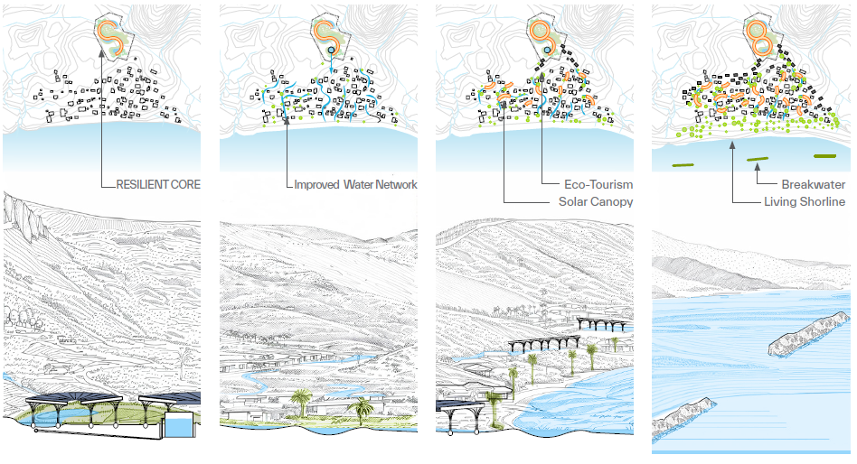

Stewardship Integration
Maintenance tasks are woven into daily village routines.
Residents observe gutter flow, plant health, and sediment buildup while farming or walking shaded paths. Key actions, such as clearing gutters, replanting wetland edges, or inspecting panels, become cultural practices, not burdensome chores.
This stewardship is supported by seasonal activities and generational learning:
- Workshops during installation phases
- Quarterly maintenance days
- Youth engagement programs that transfer knowledge and responsibility
By embedding infrastructure visibly within the landscape, the system encourages ongoing care through use and observation.

Operational Model
Maintenance follows a predictable and low-cost schedule:
Frequency | Key Tasks
Weekly | Visual inspections, clearing gutters and debris
Monthly | Basin cleaning, solar panel dust removal
Quarterly | Bamboo joint checks, UV sterilizer maintenance
Annually | System performance review, replanting wetlands
Responsibilities rotate among household clusters. Most repairs use natural, locally sourced materials such as bamboo, stone, or rope. Solar-powered systems operate off-grid, with only batteries and UV lamps requiring periodic replacement (3–5 years lifespan).

Funding Strategies
A mixed funding model sustains both installation and ongoing operations:
- Local Community Contributions
Micro-contributions and seasonal fundraising events support small repairs and replacements.
- Government and International Climate Funds
Grants or low-interest loans aimed at climate adaptation, rural electrification, and water security assist broader expansion.
- Private Investment Incentives
Operational rights to future eco-tourism infrastructure, such as workshops or cultural pavilions, may be offered to early private partners.
- Philanthropic and NGO Support
Partnerships with organizations focused on regenerative development, Pacific resilience, or island adaptation provide long-term backing.
This diversified approach reduces dependence on any single channel while reinforcing community agency and project credibility.

Phased Growth and Long-Term Adaptation
Unleashing the Vanua is inherently modular, designed to evolve with changing needs through clear implementation phases:
Phase 1: Foundational Activation
- Solar-water hub installed near the residential core
- Stormwater stream extended and treated through sedimentation and UV systems
- Two stainless steel tanks installed
- First public paths, wetlands, and farming beds activated
- Supports ~15–20 households
Phase 2: Network Expansion
- Additional solar canopy nodes and farming beds added
- Wetland corridors and bioswales extended
- Cluster-based stewardship groups formed
- Supports up to 50 households
Phase 3: Full Village Integration
- Complete system coverage
- Coastal stabilization with stone revetments, bamboo matting, and breakwaters
- Eco-tourism pilots and small-scale markets integrated
- A local Sustainability Council is formed
Long-Term Evolution
- Solar canopies connect into a microgrid
- Storage expands as population or tourism grows
- Wetlands regenerate degraded zones
- Education and climate stewardship remain embedded

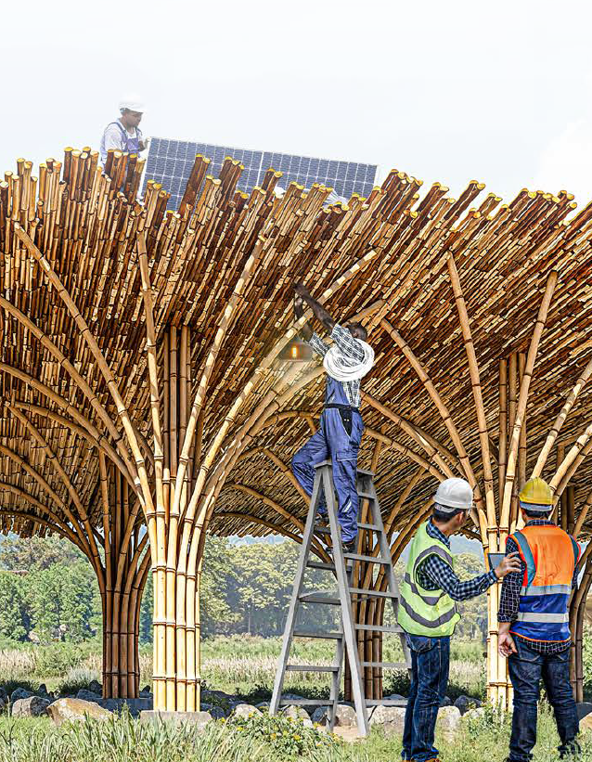
Through this living framework, Unleashing the Vanua grows into a resilient, adaptive model where energy, water, landscape, and community responsibility evolve in step.

Chapter 6. Environmental Impact Assessment

Environmental Impact Assessment
Unleashing the Vanua minimizes environmental disruption by working with, not against, natural processes. The system enhances resilience through modular, low-impact infrastructure that evolves with ecological conditions and community needs.

Immediate Environmental Benefits: Phase 1
Solar Energy Transition
A bamboo-framed 75kW solar canopy generates 300–350kWh/day, meeting the full energy needs of ~300 residents. This eliminates dependence on fossil fuels for basic electricity use.
Water Security Through Landscape
Rainwater is captured from solar canopies and combined with diverted stormwater from an upland stream. This water flows through constructed wetlands for filtration, then into decentralized UV purification and underground storage. Two 20,000-liter stainless steel tanks provide clean water for 130 days during dry seasons.
Stormwater Supplementation
A 50cm-wide stream supplies 40,000–80,000 liters daily during average flow, reducing reliance on rainfall alone.
Material Footprint and Local Integration
The use of bamboo, gravel, and stone reduces carbon-intensive imports. Foundations are light and shallow, minimizing soil disturbance and preserving hydrological function.

Long-Term Environmental Gains: Phased Expansion
Decentralized Renewable Energy
Additional canopy nodes expand solar coverage across the village, reducing grid vulnerability and future emissions.
Constructed Wetlands and Bioswales
Extended water channels enhance groundwater recharge, control erosion, and reduce flood risk. As these systems mature, they also improve soil quality and capture nutrients, benefiting both ecology and farming.
Erosion Control and Coastal Protection
Bamboo fiber matting lines streambanks and sediment basins. Planted breakwaters, stone revetments, and root-stabilized berms guard the coastline and riverbanks against sea-level rise and flash erosion.
Habitat Recovery and Biodiversity
Native planting and wetland expansion are expected to increase local biodiversity by 30–40%. Fish, birds, pollinators, and amphibians are attracted to restored aquatic corridors, turning technical infrastructure into a living habitat.

Projected Outcomes
- 100% renewable energy for residents and public infrastructure
- Secure, decentralized clean water for ~300 people
- Soil stabilization and flood risk reduction
- Wetland habitat corridors and restored ecological networks
- Long-term resilience to climate shocks, drought, and sea-level rise

Regenerative Design Outlook
Rather than a fixed system, Unleashing the Vanua functions as a regenerative platform: it grows and adapts through stewardship, nature-based solutions, and modular logic. By aligning land, water, and energy systems with the rhythms of place, the project avoids environmental cost while maximizing ecological value.
Marou Village thus becomes a living model of how climate adaptation can enhance, not degrade, cultural landscapes and environmental health.

Epilogue: Conclusive Remarks
Unleashing the Vanua is not just infrastructure—it’s a living system rooted in the indigenous values of land, water, and collective care. By integrating decentralized solar, ecological water treatment, and regenerative land practices, Marou Village becomes a model for low-impact, high-resilience island development. Its modular approach offers replicable strategies for other Pacific communities adapting to climate risk.

Performance Summary
Category | Result
Energy | 75kW solar → 100% daily village needs
Water Storage | 40,000L tank + wetland flow = 130 days
Biodiversity | +30–40% increase through wetland growth
Climate Resilience | Flood + erosion protection via bio-swales, bamboo matting, and breakwaters

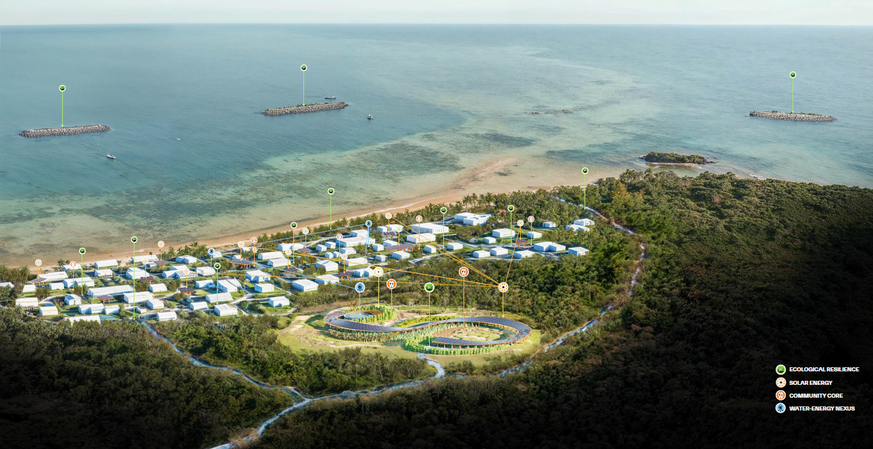

REFERANCE
Waldheim, C. (2006). The Landscape Urbanism Reader. Princeton Architectural Press.
Janssen, J.J.A. (2000). Designing and Building with Bamboo. INBAR Technical Report No. 20.
Nainoca, W. (2011). The Influence of the Vanua on Fijian Community-Based Natural Resource Management. PhD Thesis, University of the South Pacific.
UN-Habitat (2019). Planning for Climate Resilient Urban Development: A Practical Guide.
IRENA (2021). Renewable Energy for Pacific Islands: Status Report.
IUCN (2020). Nature-based Solutions for Water. International Union for Conservation of Nature.
World Bank & WRI (2019). Integrating Green and Gray: Creating Next Generation Infrastructure.

