SIGAWAI 8ANUA

“Where life flows forever”

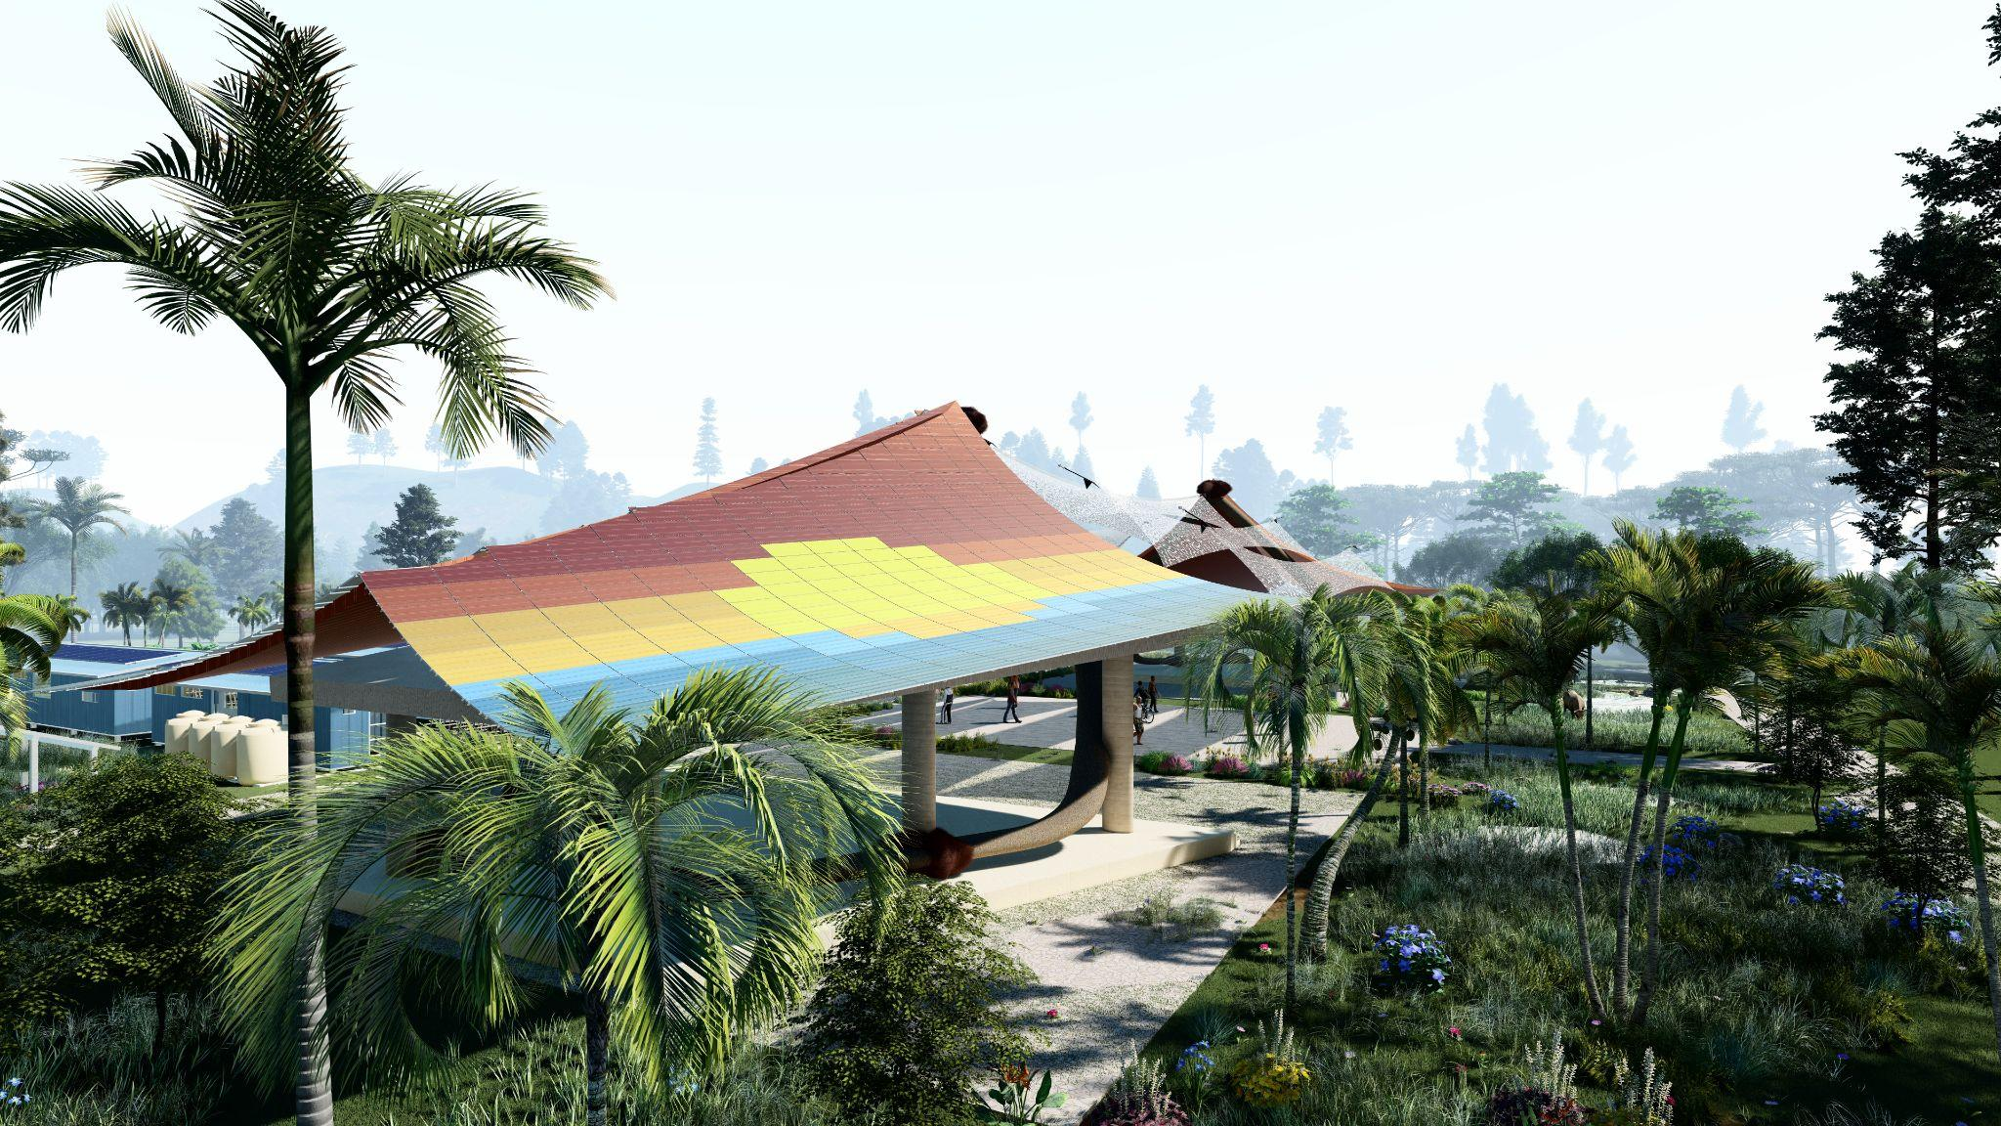

A realization of the coastal community, live on land but breathe in the water, yet they depend on the sun.

**CONTENT**

**I. CONCEPT 2**

**II. PROPOSED TECHNOLOGY 4**

1. Solar panel 5

2. Rainwater Harvesting Tank and Constructed Wetland 8

3. Polyculture Cassava Farming 12

**III. IMPLEMENTATION STRATEGY 13**

**IV. OPERATIONAL & MANAGEMENT 16**

**V. ENVIRONMENTAL IMPACT ASSESSMENT 17**

**VI. REFERENCES 19**

# I. CONCEPT

SIGAWAI 8ANUA is originally from Fijian language “Siga i wai ni vanua” that translates as “The Sun over the Waters of the Land”. Sigawai represents solar and water as our primary sources of renewable energy, while Vanua refers to the land where we live and where plants grow, embodying the foundation of life and sustenance. The symbol 8 (representing infinity) signifies the sustainable and never-ending cycle of energy supply and use, highlighting the continuous flow and regeneration of natural resources within this system.

The proposed concept connects all elements of life e.g. community, environment-ecosystem, energy, and economy in an integrated system. We encourage Marou villagers as the main part of the system and keep the site into a sustainable implementation. With the concept of circular economy, the site will link energy generation, fishery industry, farming production, and water storage from nature and use its residue to optimally support the lives of the village.

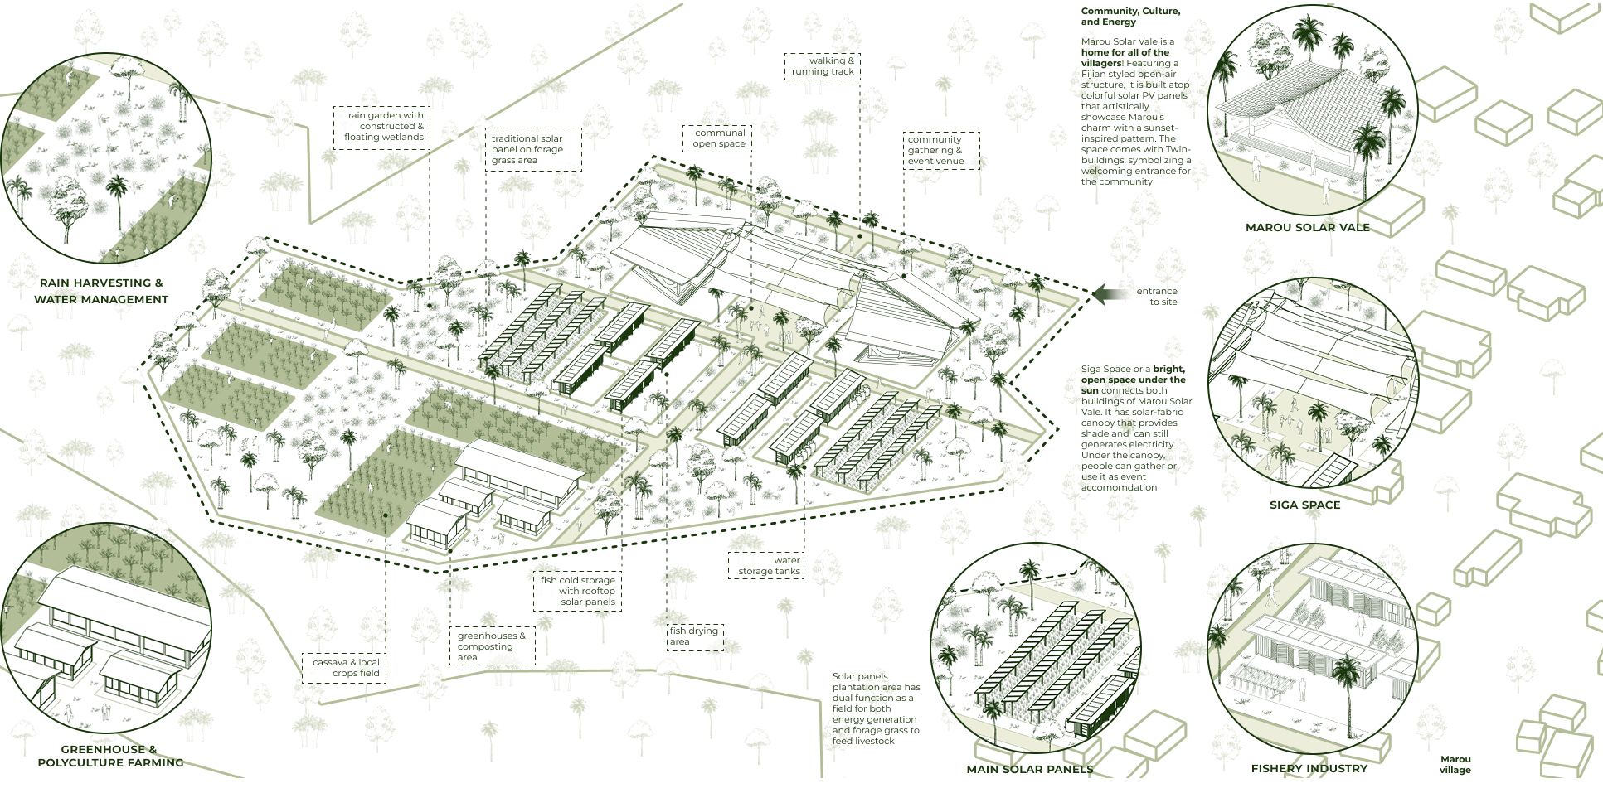

***Figure 1.1*** *Site Masterplan*

# II. PROPOSED TECHNOLOGY

The proposed design divides the site into 5 main zones: the residential area, communal area, constructed wetland area, fishery industry, and cassava farm. Figure 2.1 explains how the proposed concept interconnected all 5 zones to benefit one another through one full looped cycle.

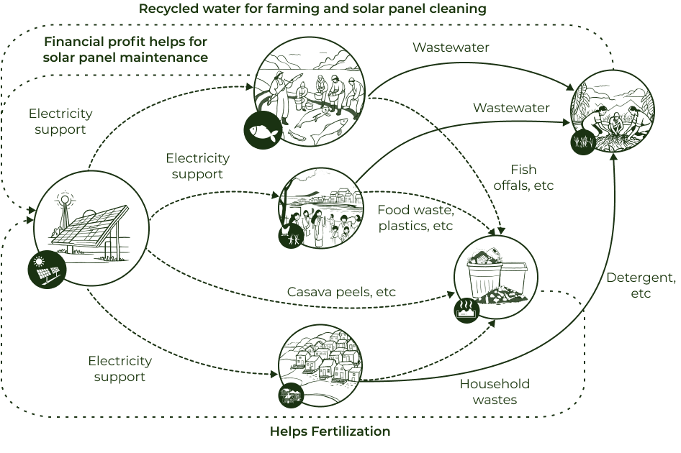***Figure 2.1*** *Circular Economy System in Energy Site*

Figure 2.1 illustrates a circular system where solar panels generate electricity to support activities. These activities in turn produce waste. Organic solid waste is converted into fertilizer for farming, while wastewater treated through the constructed wetland is reused for household needs, fishery industry, solar panel cleaning, and dry-season irrigation. Profits from farming and fishing are used to fund community needs and solar panel maintenance, as for the harvest production will also be used for daily needs in Marou village.

## Solar panel

The site has a relatively high solar irradiance of 5.5 kWh/m²/day. As a tropical region, the site only has two seasons: wet and dry. Solar intensity might decrease during the wet season due to cloud cover, but overall solar irradiation remains stable. A hybrid system combining solar panels and diesel generators is the most ideal choice. The power generated exceeds residential needs, so the power can be stored in batteries and also be used to support productive economic activities.

This Sigawai 8anua uses three types of solar panels. First, traditional solar panels are chosen for their ease of maintenance and high efficiency. Then, there are two others: solar fabric and colored photovoltaics, selected for their aesthetic appeal while still maintaining fairly high efficiency, although slightly lower than the traditional ones. Colored PVs are the main highlight, as they are arranged like a mosaic puzzle that will eventually form a painting themed around Marou Village.

One innovation we propose is integrating solar panels with a cassava plantation, although there are challenges involved. Since cassava requires full sunlight, shading becomes an issue. The strategy we propose is arranging the spacing and tilt of the panels. As the site is located at Latitude 12° 26' 00'' and Longitude -13° 28' 00'', the panels must be tilted at 18° facing 0° azimuth to achieve maximum exposure (Global Solar Atlas, 2025). Rows of solar panels also need to be spaced about 4–8 meters apart to ensure sunlight can still reach the plants. In addition, the panel structures should be elevated at least 2–3 meters above the usual planting height.

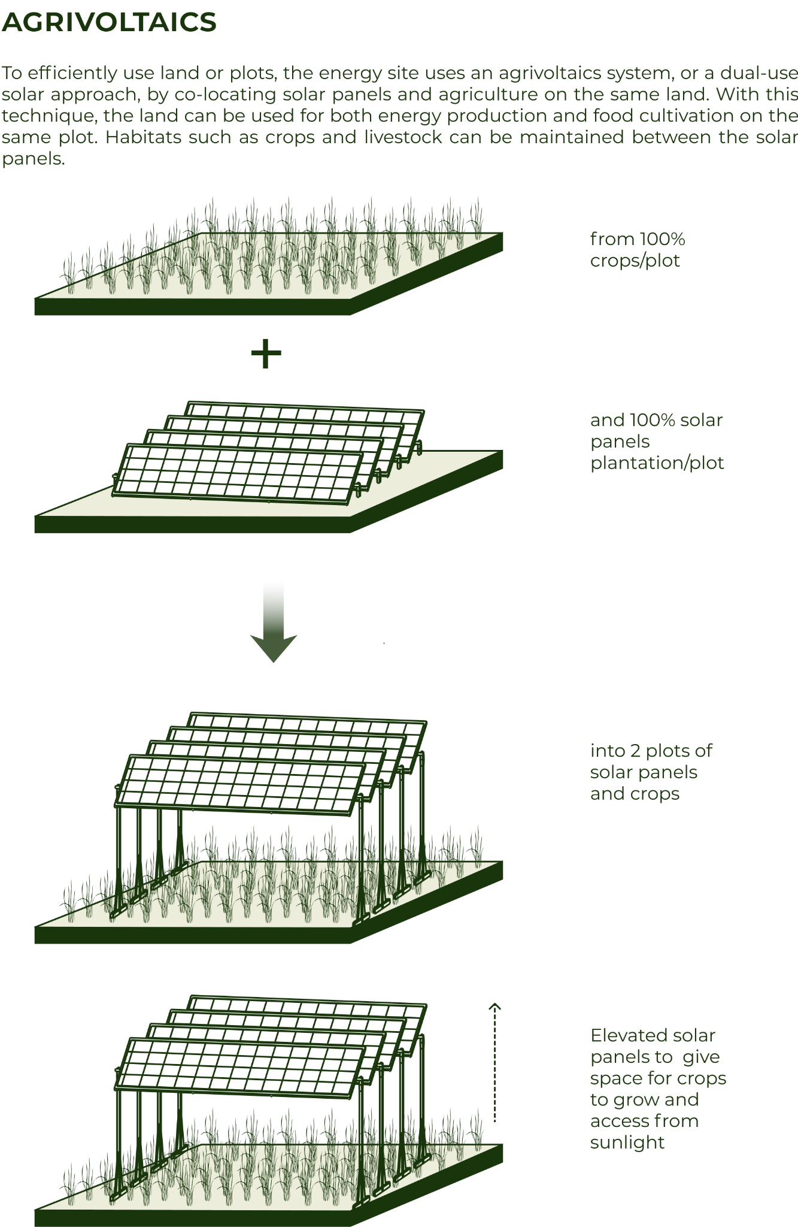

***Figure 2.2*** *Agrivoltaics System*

Power Generated by Solar Panels are calculated with the result of 232,913 kWH/year at Dry Season and 155,736 kWh/year at Wet Season. The energy demand of Marou Village for household use is 244 kWh/day, and the supply from the communal solar panels (ground-mounted and solar PV) surpasses this demand. Among the 4 options proposed, these top two options will be prioritized for installation.

***Tabel 2.1*** *Calculation of Power Supply*

| **System** | **Area (m²)** | **Eff.** | **PR** | **Dry Season** | | **Wet Season** | |
| --- | --- | --- | --- | --- | --- | --- | --- |
| **Per day (kWh)** | **Per year (kWh)** | **Per day (kWh)** | **Per year (kWh)** |
| Ground Embedded | 324 | 0.2 | 0.8 | 329 | 60,017 | 219 | 40,011 |
| Rooftop | 96 | 0.2 | 0.8 | 97 | 17,768 | 65 | 11,853 |
| Rooftop | 84 | 0.2 | 0.8 | 85 | 15,552 | 57 | 10,364 |
| Solar Fabric | 180 | 0.1 | 0.7 | 80 | 14,579 | 53 | 9,720 |
| Colored Solar PV | 720 | 0.2 | 0.75 | 685 | 124,997 | 459 | 83,788 |
| **Total** | **1,404** |  |  | **1,276** | **232,913** | **853** | **155,736** |

## 

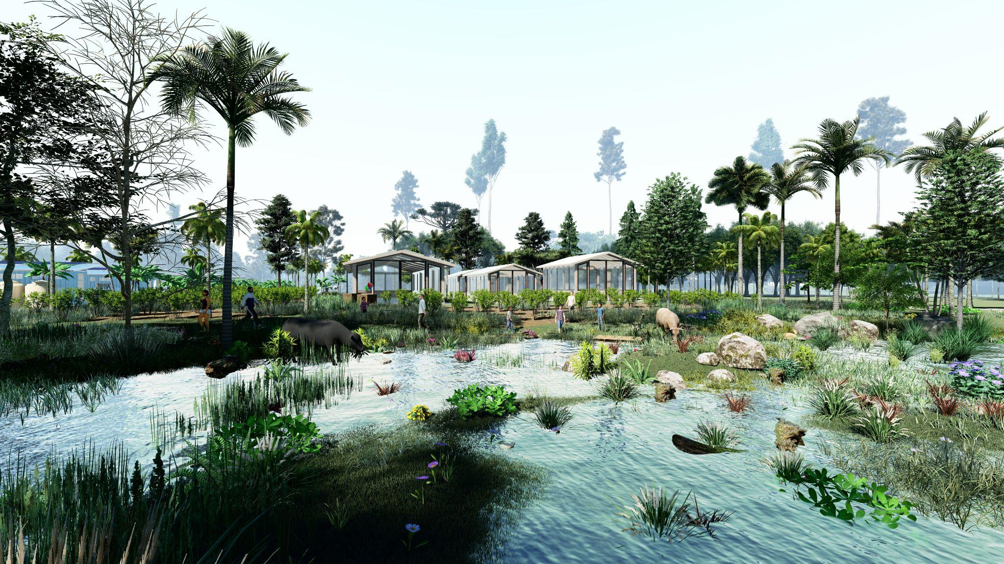

## Rainwater Harvesting Tank and Constructed Wetland

We found that rain harvesting has long been practiced by the villagers, using a method where large tanks or gallons are connected to pipes to channel the water. From this method, we proposed an upgrade by introducing a nature-based solution hybridized with tanks and pipes. The method we chose is a constructed wetland. This is quite suitable because there is a stormwater runoff issue and minor flooding coming from the mountain peak. This wetland can function as a multifunctional space—during dry periods, it can be used as a children’s play area or open space, and during rainy periods, it will slow down the water and store it later for groundwater recharge.

In addition, the wetland can also serve as a water treatment system by filtering pollutants from agricultural activities, and even support carbon absorption into the soil. Another function is that it can become a habitat for our local small animals and other local plants, while the maintenance is relatively simple. From an aesthetic perspective, it’s also very appealing—creating beauty and a cooling effect. We use the Sub-Surface Flow Constructed Wetland system, selected based on projected water needs and environmental impact assessment. The plants used are encouraged to be native wetland grasses and species that can thrive in tropical coastal climates like in Marou village.

***Table 2.2*** *Type of Wetland Vegetation*

| **Plant Species** | **Type** | **Key Benefits** |
| --- | --- | --- |
| Eleocharis dulcis, eleocharis ochrostachys, eleocharis geniculata | Sedge | Nutrient removal  Erosion control and Sediment Stabilitation  Cultural and economic value  Habitat |
| Cyperus spp | Sedge | Nutrient removal  Habitat |
| Juncus spp | Rush | Soil stabilization |
| Scirpus spp | Bulrush | Root zone aeration |
| Phragmites australis | Reed | High biomass, filtration |
| Typha latifolia | Cattail | Nutrient uptake |
| Ludwigia octovalvis | Water primrose | Nutrient removal |
| Nymphaea capensis | Water lily | Surface cover, nutrient uptake, enhance habitat |
| Canna spp. | Ornamental | Nutrient removal |
| Heliconia spp. | Ornamental | Organic and nutrient removal |
| Zantedeschia aesthiopica | Ornamental | Pollutant removal |
| Iris spp. | Ornamental | Nutrient, phosphorus and metal removal |

*Source: Syranidou (2017); Ash & Ash (1984); Sandoval, et. al. (2019); Brix (2003)*

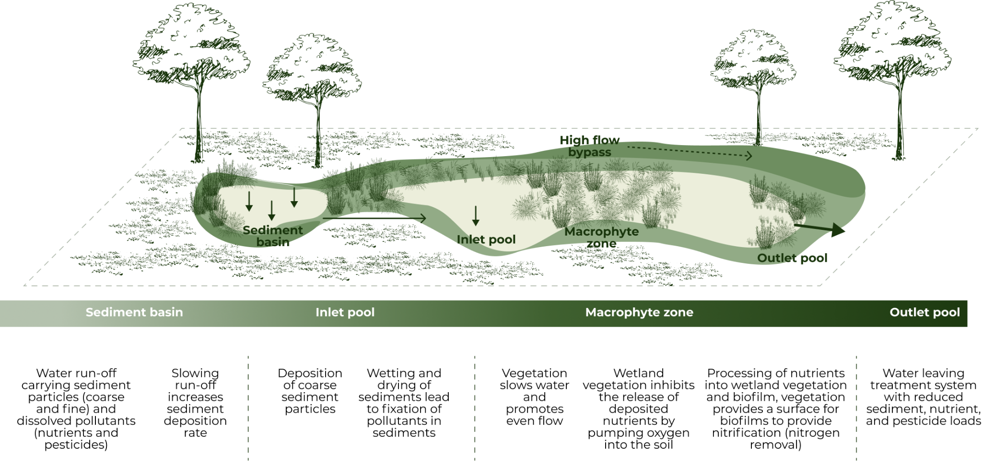

***Figure 2.3*** *Sub-Surface Flow System*

This proposed design uses Subsurface Flow Constructed Wetland. With an area of 4,500 m² and the addition of rainwater harvesting tanks, water supply would be:

*Capacity (L/day) = 45 L/m²/day x 4,500 (m²) = 202,500L/day*

After supplying the fishery industry and households, the remaining water supply is 166,666 L/day. This remaining water can be used for irrigation and to provide water to nearby villages.

| **Activity** | **Standards and Assumptions** | **Estimated Demand** |
| --- | --- | --- |
| Fishery Industry | 67 Fishermen  20 work days/month  15kg/fisherman-day  3L water/raw kg for processing | 70.035 L/month |
| Household Use | 100L/person/day | 33.500 L/day |
| Cassava Farming | Rainfed with 400 mm - 1,700 mm average annual rainfall | Rainfed and supplementary irrigation of 62.5 mm/month for optimal harvest. |

*Source: Tomczak-Wandzel,* [*et.al*](http://et.al)*., 2015; Akbarpour & Azizi, 2018; Krishna Devi, et. al., 2005); Howeler, 2013*

## Polyculture Cassava Farming

From the masterplan, we also propose using a polyculture system for farming, especially since the main commodity is cassava. We hope the site not only provides one function but also ensures food security with various types of plants that can be grown. This system is basically like mixed cropping in one land area, which can save land and grow various species, like how in one plate, you can get carbohydrates and fiber. For cassava itself, there are three types of recommendations that can be mixed in one plot of land: first, other root crops due to their compatible characteristics with cassava; second, vegetables that are most suitable during the cassava seedling stage, as the vegetables can still get enough sunlight (usually vegetables can be harvested in the middle of the cassava growth period); and lastly, it can be planted close to woody trees like coconut and other tropical plants.

***Table 2.3*** *Category of Recommended Plants in Marou Village*

| **Category** | **Common Name** |
| --- | --- |
| Root Crops | Cassava, dalo (taro), ginger, etc. |
| Vegetables | Broad beans, capsicum, carrot, chillies, chinese cabbage, cowpea, cucumber, eggplant, etc. |
| Tree Crops | Avocado, banana, breadfruit, cashew, cinnamon, cloves, cocoa, coconut, coffee, durian, grapefruit, etc. |

*Source: Manaaki Whenua Landcare Research, 2025*

# 

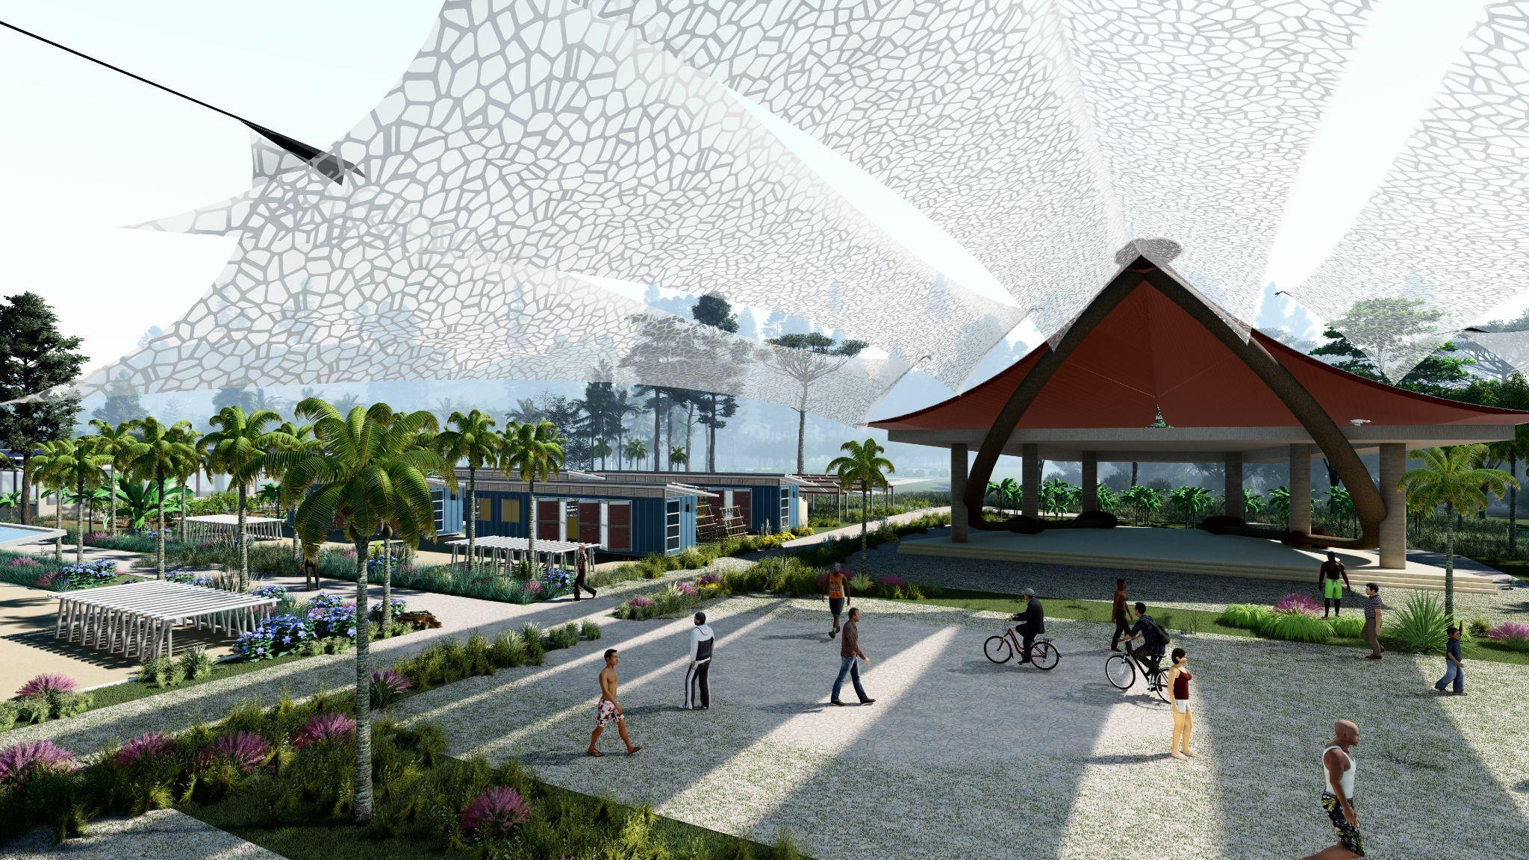

# III. IMPLEMENTATION STRATEGY

We believe the community will be the fundamental point of implementation. Even though it still needs to be connected across different sectors, the key to making the system sustainable lies in how much the people are involved, take ownership, and play an active role. Therefore, this project is planned and implemented through a collaborative approach involving relevant stakeholders and the local community. This is to ensure that the benefits generated by the project are genuinely experienced by those directly affected. There are four key principles used for the design implementation framework, which are Empowerment and Capacity Building; Institutional Support; Social and Economic Incentives; and Policy Involvement.

**Table 3.1** *Stage and Phasing*

| **No** | **Phase** | **Implementation** |
| --- | --- | --- |
| 1 | Formation of the Community Working Group | A working group is formed using the penta helix model with clear roles and responsibilities that are defined to ensure inclusive participation, shared ownership, and accountability |
| 2 | Capacity Building and Participatory Workshops | The project’s objectives and innovations are introduced to stakeholders to map resources and local challenges while validating existing data and local knowledge for future planning |
| 3 | Ideas Factory | The working group contributes ideas and solutions for contextual relevance that result in suggestions being grouped, prioritized, and a shortlist of improvement plans is created |
| 4 | Revision and Discussion | The proposed design is revised based on collective input while planners also prepare for the next stage |
| 5 | Action Planning Workshops | Specific requirements for implementation, monitoring, and maintenance are identified with a detailed action plan with timelines, milestones, goals, and responsibilities is formulated through FGDs |
| 6 | Financial Planning and Resource Allocation Workshops | Funding needs for labor, operations, and maintenance are addressed, ensuring transparency in costs |
| 7 | Implementation | The system is implemented by stakeholders in line with their agreed responsibilities and roles |
| 8 | Supervision, Evaluation, and Adjustment | Supervision ensures adherence to the action plan, while regular evaluations measure progress and challenges, and necessary adjustments are made based on feedback for continuous improvement (from villagers) |

*Source: Zari, et. al., 2020; Central Europe Eco-Tourism, 2020; modified by author, 2025*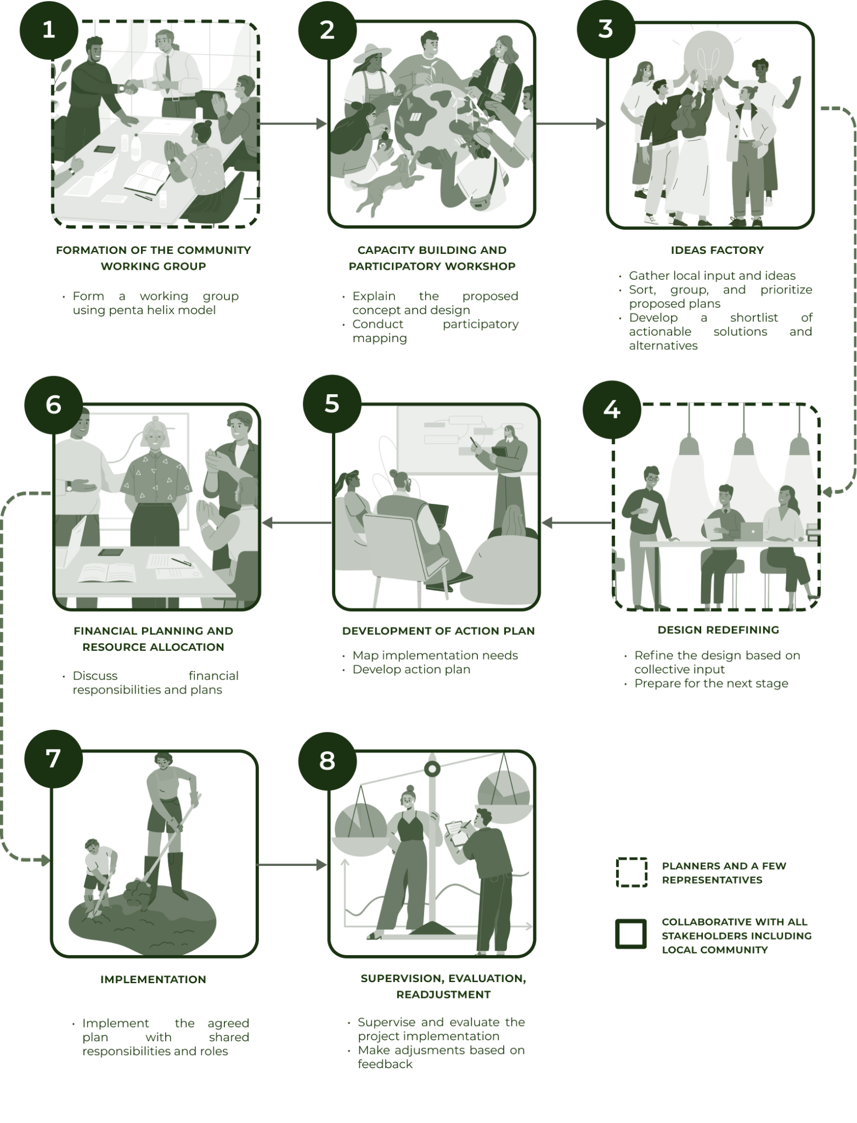

# 

# IV. OPERATIONAL & MANAGEMENT

The operation and management of the solar panel energy source were chosen with consideration of ease. Solar panels themselves generally have a lifespan of 25–30 years, and the manufacturer guarantees 80% of the output (Solar Power Europe, 2025; Huawei, n.d.; ShopSolar, 2025). Because it is simple, maintenance requires four straightforward steps. The first is performance monitoring and data analysis to control the output of the solar panel. The second is inspection and routine cleaning, such as cleaning dust, cables, or dealing with any animals. This can be done in an organized manner by the community, forming a solar panel operational team in groups. Finally, periodic electrical checks by technicians, along with performance logging of the solar panels.

Meanwhile, in terms of water management, since it uses a nature-based solution, it can last longer than grey infrastructure. The wetland could last over 40 years with the only infrastructure needed being a pumping station that must be replaced every 7–10 years. The sedimentation results, which become sludge, are minimal because the waste solids decompose biologically. We adopt the maintenance methods from the Department of Environment, Science and Innovation, Queensland, 2024; RACO, n.d.; Sample & Wang, 2013; Auckland Council, n.d. for wetland management. First, water management needs to be regulated to maintain the appropriate water level. Then, periodic monitoring of water quality should be done using BOD, TSS, or nutrient tests and sediment levels, and hydraulic structure inspections must be conducted to avoid blockages. Additionally, pest and algae control may be added to prevent damage to the plants in the wetland.

To achieve maximum operation, community engagement is necessary, in this case, the residents of Marou village. We propose the need for a specific committee to manage local operations and oversee the site, with a leader or supervisor appointed. There should be designated people responsible for organizing inspections and routine maintenance. The residents should also be trained to take turns managing operations, fostering a sense of ownership that this site is collectively owned since the benefits are shared. For example, regular cleaning, such as communal work events, or organizing campaigns and events at the site, where they can discuss improvements or how to maintain the site effectively.

# 

# 

# V. ENVIRONMENTAL IMPACT ASSESSMENT

As a conclusion in the environmental assessment, the two main components of energy generation are solar panels and water management using wetlands. This is an interconnected cycle. For example, water from the wetland will be used to clean the solar panels, ensuring the panels experience minimal disruption and are frequently visited by the community, with a mix of land crops underneath to keep it maintained. Additionally, the wetland can also use natural emissions to absorb pollutants and utilize native local plants.

***Table 5.1*** *Mitigation Environmental System*

| **Installation** | **Environmental Impact** | **Mitigation Strategy** |
| --- | --- | --- |
| Solar Panel | Water needed for cleaning and cooling | Supply water from constructed wetlands (CW) |
| Habitat and soil disruption from large-scale ground setup | Combine with agriculture to maintain soil function for plants and animals |
| Hazardous materials and resource depletion | Enforce manufacturer responsibility for materials |
| Constructed Wetland | CH₄ & N₂O emissions | Use SSFCWs/VSSFCWs, control O₂, carbon, salinity, and plant types; maintain C/N ratio |
| NH₃ volatilization | Use SSFCWs, choose effective plant species, and control pH and nutrient loading |
| VOC emissions | Use subsurface-flow systems to reduce gas exchange |
| H₂S emissions | Keep pH neutral to slightly alkaline |
| Invasive plant spread and biodiversity loss | Use diverse native plants, monitor vegetation, and remove invasive/emergent species |

*Source: Kostel (n.d.); Hu, et. al. (2023); Pachaiappan (2022); Yu (2023)*

# VI. REFERENCES

Akbarpour, A., & Azizi, M. (2018). Determine components of household water consumption per capita in rural communities (Case study: South Khorasan province, Iran). *Water Harvesting Research, 3*(1–2), 41–51.

Ash, J., & Ash, W. (1984). Freshwater wetland vegetation of Viti Levu, Fiji. *New Zealand Journal of Botany, 22*(3), 377–391.<https://doi.org/10.1080/0028825x.1984.10425269>

Auckland Council. (n.d.). *Wetlands operation and maintenance guide*.<https://www.aucklandcouncil.govt.nz/environment/looking-after-aucklands-water/stormwater/docsmaintenanceguides/wetlands-operation-maintenance-guide.pdf>

Brix, H. (2003, May). Plants used in constructed wetlands and their functions. In 1st International Seminar on the Use of Aquatic Macrophytes for Wastewater Treatment in Constructed Wetlands (pp. 81–109). Lisboa, Portugal.

Central Europe Eco-Tourism. (2020). Guidelines for developing a sustainable tourism in protected areas.

Department of Environment, Science and Innovation, Queensland. (2024). *Treatment wetlands — Construction and operation*. WetlandInfo.<https://wetlandinfo.des.qld.gov.au/wetlands/management/treatment-systems/for-agriculture/treatment-sys-nav-page/constructed-wetlands/construction-operation.html>

FAO, & WHO. (2023). *Safety and quality of water used in the production and processing of fish and fishery products*. World Health Organization.

Ghazanfar, S. A. (2001). *Eleocharis dulcis (kuta)*, a plant of economic and cultural importance in the South West Pacific: Habitat restoration efforts in the vanua of Buca, Vanua Levu, Fiji. *The South Pacific Journal of Natural and Applied Sciences, 19*(1), 51–53.

Howeler, R. H., Nebambi Lutaladio, Thomas, G., & Food and Agriculture Organization of the United Nations. (2013). *Save and grow: Cassava: A guide to sustainable production intensification*. Food and Agriculture Organization of the United Nations.

Huawei. (2024, May 28). *Solar panel longevity: The real lifespan of PV systems*.<https://solar.huawei.com/en/blog/2024/lifespan-of-solar-panels>

Hu, S., Zhu, H., Bañuelos, G., Shutes, B., Wang, X., Hou, S., & Yan, B. (2023). Factors influencing gaseous emissions in constructed wetlands: A meta-analysis and systematic review. *International Journal of Environmental Research and Public Health, 20*(5), 3876. https://doi.org/10.3390/ijerph20053876

Krishna Devi, D. M. S., Kumar, P., & Kumar, Y. (2005). Household domestic water consumption patterns in a rural semi-arid village: A case study of Kumbha village in Hisar district, Haryana. *Population, 17*, 9.

Kostel, J. (n.d.). Q: The Wetlands Initiative is helping farmers install wetlands to naturally reduce nutrient runoff. How exactly do wetlands remove nutrients? The Wetlands Initiative.<https://www.wetlands-initiative.org/nutrient-removal>

Mackenzie, S. M., & McIlwraith, C. I. (2015). *Constructed farm wetlands – Treating agricultural water pollution and enhancing biodiversity* (2nd ed.).<https://www.wwt.org.uk/farmwetlands/>

Manaaki Whenua Landcare Research. (2025). *Crop suitability – Soils of Fiji*.<https://fiji-psp.landcareresearch.co.nz/n/crop-suitability?crop=cassava>

Pachaiappan, R., Cornejo-Ponce, L., Rajendran, R., Manavalan, K., Femilaa Rajan, V., & Awad, F. (2022). A review on biofiltration techniques: Recent advancements in the removal of volatile organic compounds and heavy metals in the treatment of polluted water. *Bioengineered, 13*(4), 8432–8477. https://doi.org/10.1080/21655979.2022.2046232

RACO. (n.d.). *Constructed wetlands*.<https://www.racoman.com/blog/constructed-wetlands-wastewater-treatment-explained>

Sample, D. J., & Wang, C. Y. (2013). *Best management practice, fact sheet 13: Constructed wetlands*.

Sandoval, L., Zamora-Castro, S., Vidal-Álvarez, M., & Marín-Muñiz, J. (2019). Role of wetland plants and use of ornamental flowering plants in constructed wetlands for wastewater treatment: A review. *Applied Sciences, 9*(4), 685.<https://doi.org/10.3390/app9040685>

ShopSolar. (2025, April 26). *How long do solar panels last?*<https://shopsolarkits.com/blogs/learning-center/how-long-do-solar-panels-last>

Solar Power Europe. (2025, February 18). *Operation and maintenance: Best practice guidelines version 6.0*.<https://www.solarpowereurope.org/insights/thematic-reports/operation-and-maintenance-best-practice-guidelines-version-6-0>

Solargis. (2025). *Global solar atlas*.<https://globalsolaratlas.info/map?c=-17.131604>

Syranidou, E., Christofilopoulos, S., & Kalogerakis, N. (2017). *Juncus spp.*—The helophyte for all (phyto)remediation purposes? *New Biotechnology, 38*, 43–55.<https://doi.org/10.1016/j.nbt.2016.12.005>

Tomczak-Wandzel, R., Vik, E. A., & Wandzel, T. (2015). *BAT in fish processing industry: Nordic perspective*. Rosendahls-Schultz Grafisk.

Yu, G., Chen, J., Wang, G., Chen, H., Huang, J., Li, Y., ... & Yu, Z. (2023). Recent advances in constructed wetlands methane reduction: Mechanisms and methods. *Frontiers in Microbiology, 14*, 1106332. <https://doi.org/10.3389/fmicb.2023.1106332>

Zari, M. P., Blaschke, P. M., Jackson, B., Komugabe-Dixson, A., Livesey, C., Loubser, D. I., ... & Archie, K. M. (2020). Devising urban ecosystem-based adaptation (EbA) projects with developing nations: A case study of Port Vila, Vanuatu. *Ocean & Coastal Management*, *184*, 105037.