***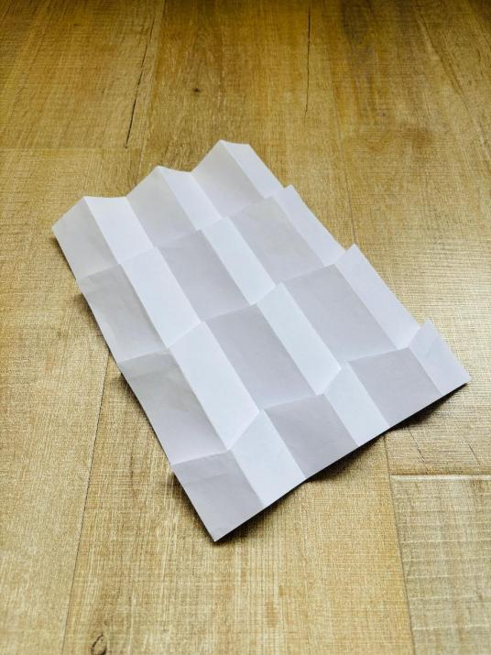*****LAGI 2025 Fiji Competition Entry - CRISPY PARK** Process model photos

1. **Concept Narrative**

* With consideration to Fiji’s beautiful landscape and powerful oceanic influence, our scheme proposes a humble installation that would focus not on the sophistication of the design but on providing locals with an elegant PV array to supply clean energy and create functional spaces to benefit the community.The overall form for the PV array came from origami folding which creates a thin structure that looks “crispy”, thus giving the project its name as CRISPY PARK.
* The scheme aims to avoid cutting down any existing trees, which leaves few options for its placement. The current choice of location within the site boundary is close to the center, surrounded by three groups of trees. The size of the scheme measures roughly 30x22.7 meters, a footprint small enough to avoid occupying large open areas. The empty land within the site boundary can be preserved for future development or agricultural activities.
* The design consists of two parts: one is the PV array, which acts as a shading device for the space below; the other is the ground-level landscape design, featuring a small outdoor theater and patches of greenery. The ground area also includes several architectural spaces: two utility rooms for solar energy storage and future fog-harvesting water storage, and a pair of guest suites to host visitors to the village.
* The arrangement of the solar panel units is highly flexible. The current proposed shape has corner modules removed to allow for a more fluid, dynamic airflow to mitigate cyclone impacts. The PV array also includes hollowed-out squares in the middle to allow larger patches of light to enter the space below, illuminating the theater and planting areas. Due to a 1.8-meter elevation difference between the northwest and southeast areas, the design incorporates a multi-height landscape with steps and planting pots.
* Besides the public school, the Marou village lacks major public buildings. Including communal functions in our project would greatly benefit village life. A small outdoor theater accommodating events for around 60 people is placed beneath the PV array. The stage is flanked by informal stepped seating on three sides, encouraging communication and community interaction. Attendees can use the space freely, sitting on the ground or grassy planting areas. The two guest suites, each approximately 26m², include full-fledged bathrooms, which are scarce in the village. Doors and major openings face away from public spaces, opening instead toward the surrounding landscape to ensure privacy and scenic views.

1. **Technical Narrative**

* Our scheme mainly focuses on generating electricity with panels made from high-efficiency monocrystalline photovoltaic cells, as required by the project brief. Within the project, there are significant areas that could accommodate fog-harvesting nets for water generation. However, the scheme currently prioritizes the design of the PV module mounting.
* The PV module consists of primary beam members, a supporting space truss, mounting purlins, and two photovoltaic panels. The panels are facing to the north with a tilting angle of 19 degrees which should be the optimal angle for receive maximum sun rays. The the pair of panels would each further tilt to the east and west with 19 degrees. To suit the geometric requirements, each panel is parallelogram-shaped, with an effective PV cell area of 2m². Given that each square meter provides approximately 200W of solar power, each panel has a power rating of 400W. The design includes 96 PV modules, producing 192 panels in total, resulting in a peak capacity of 76.8 kW (192 panels × 400W). Using a capacity factor of 21%, the total energy generated per day would be 387 kWh (76.8 kW × 24h × 21%), and per year would be 141 MWh (76.8 kW × 8760h × 21%).

1. **Prototyping and Pilot Implementation Statement**

* For the prototyping phase, our team plans to manufacture and test the prototype in our country. Factory-based production is required to ensure the precision of the mounting space truss. The prototype will be designed to be easily assembled and disassembled. All materials will then be shipped to Fiji for test installation. We can send one team member to Fiji to assist in facilitating the installation process.
* 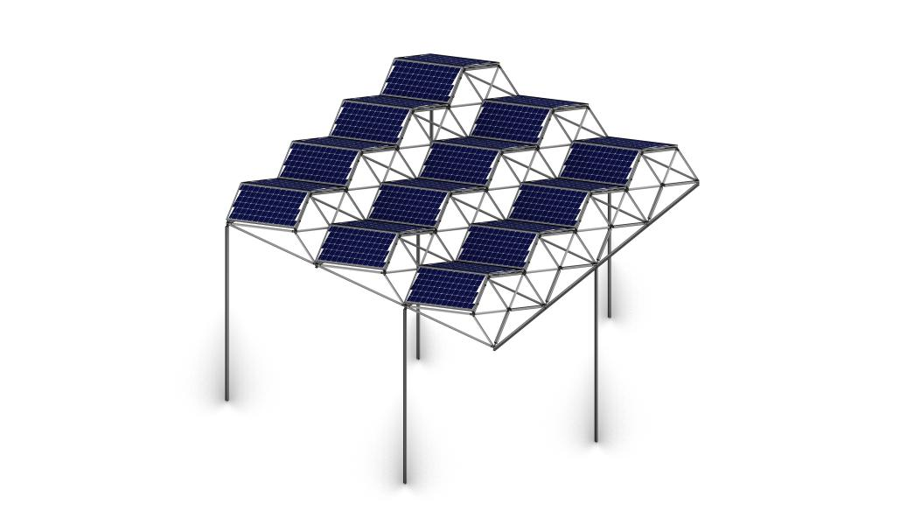An array with 12 modules mounted on posts and beams is an ideal prototyping size, resulting in dimensions roughly measuring 7.5x7.2m² and standing 4 to 5 meters tall. Although each panel is parallelogram-shaped, it is possible to source suppliers to produce custom-shaped panels within a reasonable budget.
* For the full-scale implementation stage, the PV module components should still be outsourced and shipped to the site (unless Fiji has the capacity to manufacture them). The ground-level elements—including stone pavement, wood plank seating, local planting, concrete structures for the few rooms, and stone tiles for the façade—can be locally sourced. The ground construction process will be simpler, and villagers can actively contribute to this phase. The interiors of the two guest rooms can be finished in a vernacular style, with final details to be decided during discussions with the village council.

1. **Operations and Maintenance Statement**

* The design itself already accounts for cyclone impacts. With further engineering development to determine the sizing of steel members, the structure should be able to withstand Fiji’s worst-case cyclone scenarios. The PV panels can also be easily dismounted from the modules to avoid damage from flying coconuts. Villagers will be trained to safely dismount panels ahead of severe weather, preventing debris generation. Should accidental structural damage occur, enough components to construct 5 PV modules will be ordered as extras during the implementation stage. Post-installation, annual inspections will assess the structure’s integrity and its interaction with the surrounding environment, ensuring no unintended impacts on soil stability or plant health.
* Maintenance for the two guest suites can be managed by the village council. Villagers can use online platforms like Airbnb and Booking.com to promote Marou’s visibility. Management details will be finalized in later discussions.

1. **Environmental Impact Assessment**

* What effects might your installation have on natural ecosystems and what steps can be taken to mitigate any foreseeable issues?
* The proposed solar array and community space installation in Fiji is designed to minimize disruption to natural ecosystems while delivering renewable energy and communal benefits. The project’s footprint, measuring approximately 30x22.7 meters, is intentionally compact to preserve existing vegetation, with no trees slated for removal. Three clusters of trees surrounding the site will remain intact, maintaining habitat continuity and reducing soil erosion risks. The elevated PV array, positioned on steel space trusses, allows sunlight to reach the ground through strategically hollowed sections, supporting understory plant growth in landscaped areas below. Native species will be prioritized for planting, fostering local biodiversity and creating microhabitats for insects and small fauna.
* However, certain aspects of the installation require careful consideration to mitigate potential ecological impacts. During construction, soil disturbance from foundation work and material delivery could temporarily affect soil structure and nearby root systems. To address this, the prototyping phase will occur off-site, minimizing on-site construction errors and reducing the duration of ground-level activity. Prefabricated components will be assembled with precision in controlled factory conditions, limiting the need for heavy machinery at the final location. Additionally, permeable stone paving and gravel pathways will be used to promote natural water infiltration, mitigating runoff that could otherwise alter soil composition or harm adjacent vegetation.
* The PV array’s shading effect, while partially offset by its hollowed design, may still influence light-dependent species in the immediate area. To counter this, the landscaped zones beneath the panels will incorporate shade-tolerant native plants, ensuring ecological continuity. The design also avoids impermeable surfaces in planting areas, allowing rainwater to nourish greenery and reducing the risk of localized drying. Furthermore, the structure’s cyclone-resistant engineering—featuring truncated corners and wind-optimized geometry—prevents debris displacement during extreme weather, safeguarding surrounding ecosystems from secondary damage caused by structural failure.
* Finally, the project’s emphasis on local material sourcing—such as stone, timber, and vegetation—reduces transportation-related emissions and supports ecosystem preservation by avoiding invasive species introduction. By integrating community stewardship into maintenance protocols, the installation ensures long-term ecological oversight, aligning renewable energy goals with the preservation of Fiji’s natural landscapes.
* In summary, the project’s ecosystem impacts are anticipated to be minimal, with proactive measures in place to address construction, shading, and climatic risks. Through adaptive design, native species integration, and community-led oversight, the installation seeks to harmonize clean energy infrastructure with the ecological resilience of its host environment.