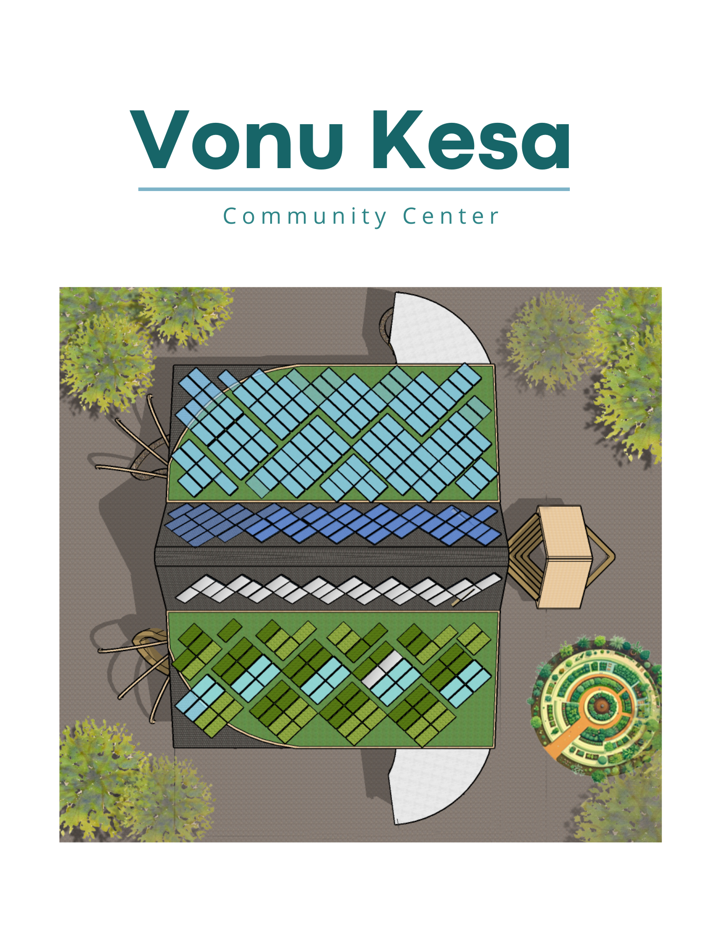

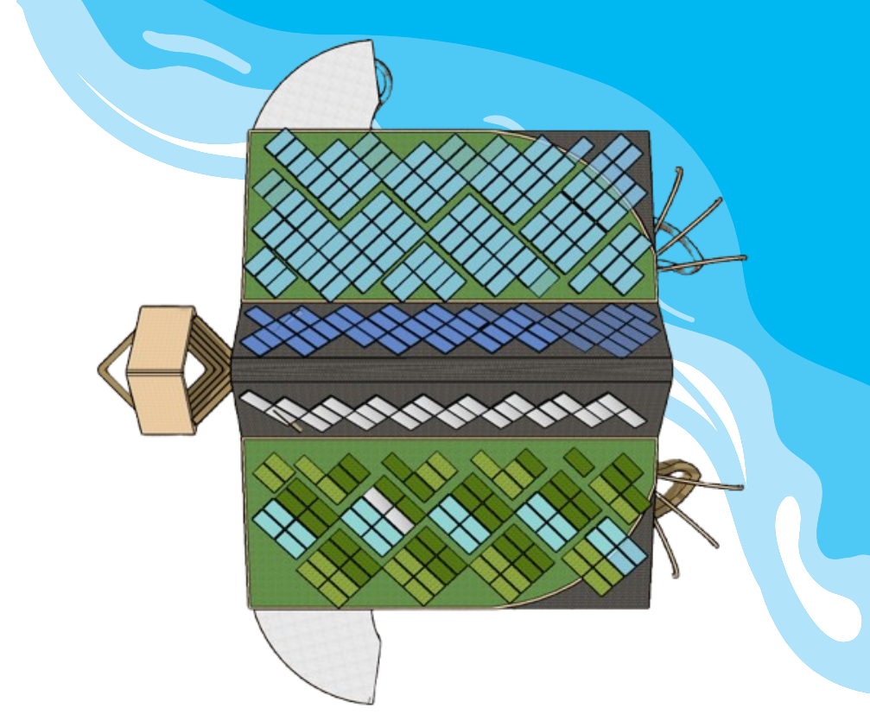
1. Concept Narrative

Vonu Kesa—“Turtle of Abundance” in Fijian—embodies the spirit and cosmology of Marou village. Rooted in local myth, the turtle is a guardian linked to Dengei, appearing in times of need to guide, protect, and unify. It symbolizes resilience, prosperity, and harmony between people and nature.
The Vonu Kesa Community Center brings this sacred symbol to life, offering shelter, food, energy, water, and connection. Deeply rooted in tradition yet oriented toward the future, it serves as a regenerative, inclusive hub that honors place-based wisdom.
Solar Energy: A Shell of Power
The turtle-shaped roof integrates 80 kW of solar panels arranged like scutes, powering lighting, refrigeration, water systems, and contributing energy to the wider village. A lithium battery Powerwall ensures secure, sovereign energy access.
Water Systems: Rain and Reuse
Rainwater is filtered through native vegetation and soil aggregates on the green roof, stored in an underground cistern, and pumped (solar or manual) to a filtration unit. Recycled greywater and blackwater irrigate gardens through constructed wetlands, closing the water loop sustainably.
Turtle-Inspired Architecture
Facing east, the center greets village and wind.
- Head and front legs resist typhoon winds, symbolizing guardianship.
- The rear opens to the surrounding nature, emphasizing interconnection.
Each form carries cultural and ecological meaning, making the building a living expression of tradition and innovation.
Natural and Regenerative Materials
A basalt and stone gabion foundation lifts the structure above flood level and doubles as seating. Walls of hyperadobe and cob, made from local earth and recycled materials, offer thermal mass, resilience, and beauty. Lime plaster and traditional motifs reflect Marou identity. Sustainably harvested wood and woven ceilings celebrate local craft. The green roof combines solar panels and native vegetation for insulation, biodiversity, and landscape unity.

Purposeful Spaces
- Head: A ceremonial amphitheater with a panoramic view, cooking area, and Aeolian harp that transforms wind into ancestral music.
- Southern Flipper: A community kitchen with solar appliances and filtered rainwater.
- Northern Flipper: A workshop for crafts, tools, and the solar system.
- Center: An earth-sculpted amphitheater for storytelling, dance, and community events.
- Southern Hind Flipper: Bathrooms with wetland-filtered greywater toilets.
- Northern Hind Flipper: A wind-protected children’s play area, open to nature.
Living Landscape
Surrounding gardens grow native species and food, irrigated with recycled water. Berms and basins manage stormwater, recharge groundwater, and prevent floods. The site becomes a living pantry and ecosystem.
A Turtle for Every Village
Vonu Kesa is modular and scalable. More “turtle” structures—homes, workshops, or hubs—can grow nearby, each with its own self-sufficient systems. The design adapts to future needs while remaining grounded in culture.
Artistic Themes
- Climate resilience
- Harmony with land and water
- Pacific Island heritage in form and sound
- Architecture as living storytelling

2. Technical Narrative

Cultural Integration: The Wisdom and Resilience of the Turtle
- The design is inspired by the turtle, a powerful cultural symbol for the Marou people, representing wisdom, longevity, and protection.
- The building is oriented with its front facing east, symbolizing connection to the heart of the village and the prevailing winds. Its shape, inspired by the turtle’s head, legs, and shell, holds cultural significance, reflecting the community’s identity and collective memory. This design not only honors tradition but also ensures resilience to typhoons, with its aerodynamic form and choice of materials offering protection against the dominant winds.

Detailed System Overview:
- Photovoltaic Generation:
  - System Size: 80 kW (approx. 200 panels, each rated at 400 W).
  - Energy Output: Estimated annual yield ≈ 120 MWh/year, considering Marou's average solar irradiance (5.5 kWh/m²/day).
  - Mounting System: The solar panels are mounted atop an aluminum-clad wooden roof structure, using low-profile brackets made from marine-grade stainless steel or anodized aluminum. This system is designed for high resistance to humidity, salt air, and cyclonic winds, ensuring durability in the coastal environment while maintaining a low environmental footprint.
- Energy Storage:
  - 350 kWh storage via modular Lithium Iron Phosphate (LFP) batteries, offering 8+ years cycle life and safe, stable chemistry.
  - DC-powered appliances (lights, pumps, refrigerator) for higher efficiency and reduced conversion losses.
  - Redundancy with AC backup to support appliances in case of fluctuations.
  - 3 hybrid inverters for seamless AC/DC management and microgrid balancing, ensuring stable energy distribution.

- Water Harvesting:
  - Total Roof Surface: 600 m² dedicated to rainwater collection.
  - Expected Harvest: 870,000 liters/year based on Marou's 1,600 mm/year rainfall.
  - System: A lined underground polypropylene (PP) modular water harvesting system, equipped with first-flush diverters to ensure clean water capture and multi-layer filtration for basic use.
  - Pumping System: A solar-powered submersible pump delivers water from the storage tank, ensuring energy-efficient water distribution. For redundancy, a manual mechanical pump is available to maintain access in case of solar system failure.
  - Filtration: The water undergoes initial sediment filtration through fine sediment filters and is further purified with a ceramic filter for drinking water, ensuring safe and reliable water for both the community center and village.
- Smart Microgrid:
  - Decentralized energy management.
  - Plug-and-play architecture to allow easy scaling in the future.
  - Future integration possibility with national grid or mini-grid expansions.

Schematic (Textual Form):
Sunlight → Solar panels → Charge Controller → Hybrid Inverter → Battery bank → Distribution panel → Community power access points
Rainfall → Green roof → Sediment filtration → Underground storage tank → Pump → Water filters → Water tap points

Structural Engineering:
- Cyclone Resilience: The design is engineered to withstand Category 5 cyclones with wind speeds up to 280 km/h, ensuring the building's structural integrity even in extreme weather conditions.
- Turtle-Inspired Shape: The building’s aerodynamic form, inspired by the turtle’s head and legs, provides natural wind resistance, further enhancing its ability to endure high winds and protect its occupants.
- Minimal Impact Foundations: The foundations are designed for minimal environmental impact, utilizing gabion walls made from locally sourced basalt and mesh. These walls offer both structural support and environmental harmony by minimizing excavation and preserving the natural landscape.
- Stabilized Hyperadobe Earth Bags: The walls are built using hyperadobe earth bags, a combination of earth and sand stabilized for strength. This technique ensures high thermal insulation and structural resilience while reducing the need for external materials.
- Flood Resilience: The gabion foundation elevates the structure, providing added protection against flooding, while the integration of earth-based materials ensures the building is grounded in local ecological practices.

3. Prototyping and Pilot Implementation Statement

Pilot Phase:
- ● Initial Module: Northern Flipper (Community Workshop)
○ A 108 m² workshop space will be the first structure built, set on a gabion foundation of local stone and basalt rebar.
○ Hyperadobe walls with lime plaster and cob detailing will provide thermal mass and cultural expression using earth and recycled materials.
○ The roof will host 15 kW of solar panels, supplying energy for lighting, tools, pumps, and village needs.
○ A lithium-ion Powerwall system will store electricity and manage energy distribution.
○ Rainwater will be harvested and stored in a 10,000-liter underground cistern, filtered for safe use.
○ A solar pump with manual backup will ensure reliable water delivery.
- As the community’s first energy and water hub, this module will demonstrate core regenerative systems and serve as a space for tools, training, and traditional crafts.

Community Co-Design:
- 3 participatory workshops during the design finalization phase to adjust artistic and functional elements based on community feedback.
- Local artists and weavers are invited to contribute motifs to the solar sail patterns.
Testing and Scaling:
- Mechanical Testing: Conduct tests on the compressed earth mix with stabilizers, evaluating its strength and performance under various conditions.
- Water Resistance Testing: Assess the water resistance of different plaster mixes to determine their durability and suitability for the local climate.
- Wind Loading Tests: Perform stress tests to simulate wind loading and evaluate the resilience of the structure, ensuring it meets the required safety standards for cyclonic conditions.
- Energy and Water Monitoring: Implement a simple digital dashboard to monitor real-time energy and water outputs, allowing the community to track performance and adjust systems as needed.
Potential Partnerships:
- Local Contractors: Engage skilled builders with knowledge of traditional techniques and sustainable practices to ensure community involvement and job creation.
- University of Fiji (Environmental Monitoring): Collaborate with universities or research institutions for environmental monitoring and data analysis, expanding student opportunities in sustainable technologies.
- Fiji Rural Electrification Fund (FREF): Continue working with FREF to integrate the center into national energy access efforts.
- Agricultural and Water Experts: Partner with groups like the Fiji Agricultural Department or local water experts to refine sustainable systems.
- Renewable Energy Providers: Work with renewable energy companies like Sustainable Energy Fiji to improve efficiency, enhance training, and adopt new technologies.
- Local NGOs and Community Organizations: Partner with NGOs focused on development, environment, or disaster resilience to increase outreach and long-term sustainability.
- Cultural and Heritage Experts: Work with cultural heritage groups to maintain relevance and support traditional knowledge.
4. Operations and Maintenance Statement

Minimal yet strategic upkeep ensures the long-term durability and performance of the entire system.
Maintenance Framework:
System | Maintenance Frequency | Tasks | Responsible
Solar panels and structures | Every 3 months | Cleaning panels, inspecting fasteners, checking for corrosion | Trained village technician
Battery bank | Every 6 months | Inspection, cycle testing, cooling system check | Energy Committee
Water harvesting and storage | Every 6 months | Cleaning, emptying first flush system | Trained villagers
Green roof plant | Every 3 months | Green roof plant care to preserve biodiversity and roof efficiency | Trained villagers
Water filter | Every 6 months | Clean the filters and put them back in place - no need to replace | Trained village technician
Training Plan:
- "Train the Trainers" model: 5 village members trained intensively in their field.
- Delivery of an illustrated O&M manual in English and Fijian.

Sustainability Measures:
- A spare parts kit will be stored locally.
- Remote troubleshooting is available via GSM-enabled inverter monitoring.

5. Environmental Impact Assessment

All the materials used are non-toxic and chosen for their low environmental impact. They do not pose any risk to residents, soil, water, fauna, flora or groundwater. In addition, the project provides for the creation of habitats for animals, pollinating insects and local plants, promoting a balanced ecosystem, integrating into the green roof and gardens. In addition to powering the center, this system creates a living ecosystem that benefits the entire village, promoting nature regeneration, ecological education, and collective resilience.
By bringing the community center to life, the whole village breathes, becomes greener, more autonomous, and reconnected to nature.
Positive Environmental Outcomes:
- Reduction in diesel dependency: Replacing potential diesel generators with solar electricity.
- Improved water security: Harvesting rainwater, reducing pressure on groundwater and risk of contamination.
- Biodiversity enhancement: Native landscaping under shaded areas to attract pollinators and stabilize soils.
- Minimal habitat disruption: Project built on already cleared land.
Materials Sustainability:
- Panels: Cradle-to-cradle certified manufacturing.
- Structure: The soil used in the Hyperadobe bags walls comes from the rainwater tank excavation, and the roof structure is built from sustainably harvested wood.
- Foundations: The gabion baskets are built using basalt rebar, chosen for its environmental sustainability and resistance to rust, and filled with locally sourced stones.
Lifecycle Carbon Savings:
- Projected CO^{₂} savings: 110 tons/year compared to a diesel-based solution (based on 2025 diesel generator emissions factors).
Waste Management Plan:
- All construction waste sorted and recycled where possible.
- End-of-life plan for batteries and panels established through extended producer responsibility programs.

Supporting notes for our submission:

· Three A1 posters could be structured as follows:

Poster 1: Concept and Design Evolution
  - Title: “Vonu Kesa: Resilient Design Inspired by Land and Tradition”
  - Description:
This poster shows how the Vonu Kesa Center blends Fijian cultural symbols with sustainable design. It highlights the turtle-inspired form, use of local materials, and the integration of systems that support both resilience and community identity.

Poster 2: Adaptability and Environmental Integration
  - Title: “Designed for Replication, Rooted in Place”
  - Description:
This poster illustrates how the center can grow in modules and be adapted to other contexts. It also shows how the design responds to sun, wind, and rain to enhance resilience and sustainability while blending naturally into the landscape.

Poster 3: Culture and Community in Action
  - Title: “A Living Space for Culture and Connection”
  - Description:
This poster shows the center as a vibrant gathering space—alive with cultural activities and rooted in tradition. Its patterns, forms, and materials reflect the community’s heritage and identity.

