**HydroLife**

1. **Concept Narrative**

HydroLife is a journey from the arid deserts of Iran to the lush shores of Fiji. Sistan and Baluchestan, the land of wind and sun in southeastern Iran, is a place where thousands of years of civilization have compelled humans to invent creative responses to aridity and water scarcity. In this region, indigenous communities—drawing upon the wisdom of their ancestors—developed simple yet ingenious systems for flood management and water storage. Among these are the traditional systems of **Hootak**, **Degar**, and **Khooshab**.

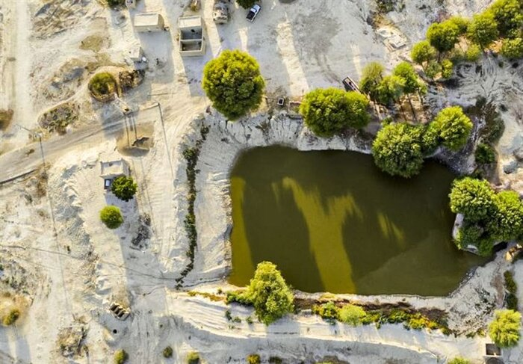

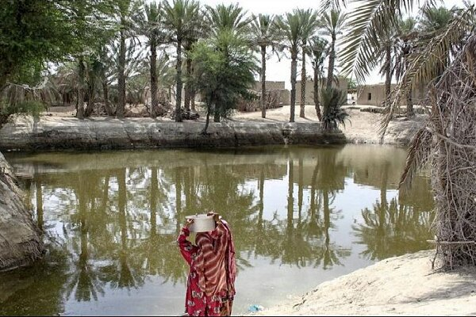

**Hootak** functions as an earthen reservoir, collecting seasonal floodwaters to serve the needs of both humans and livestock. **Degar** refers to flat agricultural lands irrigated by floodwater, enabling cultivation in otherwise dry conditions. **Khooshab** comprises a network of earthen barriers and channels constructed to direct and retain floods for the purpose of cultivating grains, legumes, vegetables, and date palms.

These indigenous systems not only secure water supplies but also prevent soil erosion, recharge groundwater aquifers, and mitigate the destructive power of uncontrolled floods. They represent elegant and sustainable solutions, harmonized with the local ecology.

Inspired by this indigenous wisdom, our project for the village of Maro in Fiji was conceived as a contemporary reinterpretation of these traditional systems—designed to meet today’s essential needs while honoring timeless knowledge.

Our proposed design is organized into a cohesive spatial framework encompassing four main functional zones:

* **The Hootak Zone**: A system of rainwater harvesting basins, featuring retaining walls inspired by the architectural language of historic Iranian bridges and water dams—such as the iconic Si-o-se-pol—strategically located along the site’s natural waterways.

|  |  |
| --- | --- |
|  |  |

* **The Agricultural Zone**: Fields positioned adjacent to the Hootaks, allowing efficient use of stored water for crop cultivation.
* **The Shelter and Multipurpose Zone**: Located in close proximity to the residential area, this space is designed for gatherings, education, safety, and daily community activities.
* **The Tourism and entertainment Zone**: Heavily vegetated areas of the site are allocated for ecotourism, leisure, and social interaction—supporting local economies while celebrating cultural identity.

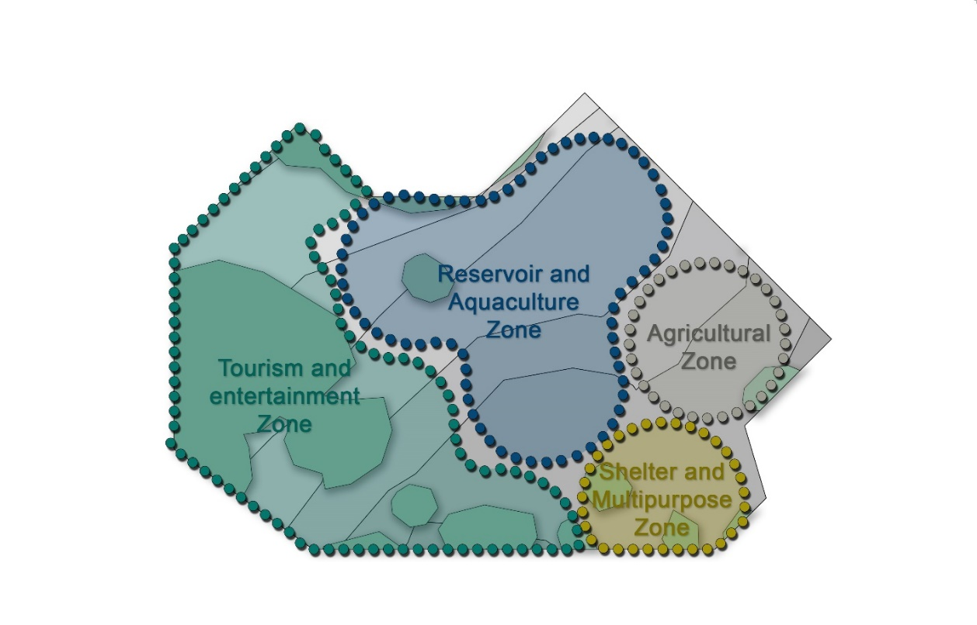

Throughout all these zones, the fluid interplay between water, soil, vegetation, and human life tells a new story of coexistence with nature—a story that not only addresses the urgent needs of the present, but also forms a bridge between a proud past and a sustainable future for the village of Maro.

1. **Technical Narrative**

The proposed design is a synthesis of modern technologies—such as photovoltaic (PV) systems—with traditional indigenous water collection and storage techniques. This dual approach integrates two branches of sustainable and green technologies into a unified, environmentally sensitive system.

A key advantage of indigenous technologies lies in their minimal reliance on specialized labor, advanced machinery, or high-embodied-energy materials. By utilizing local community skills in both construction and maintenance, the project fosters a sense of ownership and social participation while significantly reducing the project's carbon footprint through lower transportation and material demands.

Each hootak (traditional water cistern) in the project is capable of storing approximately 420 to 620 cubic meters of water. Under optimal rainfall conditions, the total storage capacity reaches nearly 1.5 million liters, which will be utilized across agricultural, aquacultural, and domestic applications.

To provide renewable energy for the site, a solar farm consisting of 215 photovoltaic panels—each with an average output of 320 to 350 watts—is strategically located between the hootaks in sun-rich corridors. This centralized solar array supplies power for essential project functions, including lighting systems, water pumps, and educational and recreational infrastructure. The centralized placement, as opposed to installing panels on the hootak surfaces, improves maintenance accessibility and energy efficiency.

Pathways throughout the site are illuminated by independent solar-powered lights and include kinetic energy-generating fitness equipment, which transforms human motion into usable energy, adding both functionality and interactivity.

To enhance resilience and sustainability, several solar water stills are distributed along public and recreational routes. These low-tech, low-maintenance systems use solar energy to evaporate and condense surface or brackish water into clean drinking water.

The stills are built from simple, accessible materials such as UV-resistant glass or polycarbonate sheets, black thermal-absorbent surfaces, and condensation grooves, and are capable of producing 3 to 5 liters of potable water daily without requiring electricity or fossil fuels. Beyond their functional role in providing emergency hydration, these systems serve an important educational purpose, raising environmental awareness about local and sustainable water solutions.

By weaving together indigenous wisdom and clean technologies, HydroLife addresses critical water and energy challenges while restoring the cultural landscape with a resilient, low-impact approach.

1. **Prototyping and Pilot Implementation Statement**

The primary focus of the prototype will be the construction of a full-scale Hootak reservoir system, integrated within a scaled representation of the four core programmatic zones: agriculture, aquaculture, shelter, and recreation.

The geometry of the Hootak walls, inspired by traditional Iranian circular motifs and carefully angled diagonal lines, has been developed to allow for modular stencil-based construction. This approach facilitates rapid and precise replication at various scales, while maintaining consistency and structural integrity across the site.

Our team proposes that the construction process be carried out on-site using simple prefabricated molds along with locally sourced, low-carbon materials such as compressed earth, lime-stabilized soil, and natural stones. The material selection not only aligns with the project’s environmental objectives but also ensures the system’s affordability, reparability, and cultural resonance.

We are committed to establishing a strong collaboration with the local community in Maro village. If necessary, a project liaison from our team will be present on-site to engage directly with residents, facilitating knowledge transfer and leveraging local labor during the construction phase. Furthermore, local expertise will be actively integrated into the refinement of zone layouts to ensure contextual sensitivity and functional optimization.

The prototype construction will serve as a critical step for testing key aspects of the project, including:

* Hydraulic performance and water storage capacity of the Hootaks,
* Structural stability of the modular wall system,
* Energy generation efficiency of the integrated solar components,
* and social functionality within the public spaces.
* This hands-on phase will provide valuable data for scaling up the project while maintaining environmental, cultural, and technical fidelity.

Conceptual Timeline Diagram for the Construction Phase of the "HydroLife" Prototype:

|  |  |
| --- | --- |
| Phase | Description |
| 1. Site Preparation | Clearing the site, initial leveling, and preparing the foundation for the Hootak systems. |
| 2. Modular Formwork Installation | Using pre-fabricated templates to define the precise shape of the Hootak walls. |
| 3. Soil Filling and Material Stabilization | Completing the walls with compacted soil, stabilized with lime, sarooj, or other local natural materials. |
| 4. Installation of Solar Systems | Mounting solar panels on the Hootak edges and installing energy-generating devices. |
| 5. Construction of Agricultural and Tourist Pathways | Creating access roads and preparing lands for flood-based farming activities. |
| 6. Initial Water Filling and Performance Testing | Testing the water storage capacity, checking for leakage, and verifying the operation of solar panels and other equipment. |
| 7. Preparation of Public Spaces and Handover | Finalizing public areas and officially transferring the project to the local community. |

1. **Operations and Maintenance Statement**

Given the specific design features of the HydroLife project, the maintenance strategies are organized into three main categories: **Maintenance of earth-water structures (Hootaks)**, **Maintenance of solar energy systems**, and **Landscape and agricultural management**.  
This framework relies on local materials, community workforce, and sustainable technologies.

**1. Maintenance of Hootaks and Earth Structures:**

If proper care is taken during the construction phase and traditional techniques such as **dry-stone walling** are applied, the designed systems can remain stable for decades without requiring complex repairs — as supported by similar case studies across Iran.  
The Hootaks are built using local materials, with construction carried out by the residents of Maro village, assisted by simple machinery (such as excavators and tractors). This ensures that, if maintenance is needed, the community itself can undertake the necessary repairs easily.   
Maintenance actions include:

* Semi-annual inspection of Hootak walls for potential damage,
* Cleaning and dredging the Hootak basins after heavy rainfall seasons,
* Localized repairs using stabilized soil or traditional materials.

**2. Maintenance of Solar Energy Systems:**

* Cleaning of solar panels every two months to optimize performance,
* Periodic inspection of electrical connections and inverters once a year,
* Battery replacement every approximately 5 years,
* Training of local workers for basic system monitoring and maintenance.

**3. Maintenance of Agricultural and Recreational Areas:**

* Land preparation for farming activities before each flood farming season,
* Repair of pathways and public spaces annually or as needed,
* Reinforcement of vegetation using drought-resistant native species,
* Seasonal water quality monitoring in ponds and aquaculture systems.

**Management Approach:**

All maintenance operations will be carried out by a working group comprised of local residents, trained by the project team or our official representative. This approach will not only create sustainable employment opportunities for the community but also foster a sense of ownership towards the project and contribute to its long-term success.

|  |  |  |
| --- | --- | --- |
| Activity | Frequency | Responsible Party |
| Inspection of Hootak walls | Every 6 months | Local maintenance team |
| Cleaning of solar panels | Every 2 months | Trained local workforce |
| Electrical systems inspection | Once a year | Local technician or support contractor |
| Dredging of Hootak basins | After each heavy rainfall season | Local workers with light machinery |
| Preparation of agricultural fields | Annually (before the farming season) | Local farmers |
| Water quality monitoring | Once every season | Project local representative |

1. **Environmental Impact Assessment**

From an environmental perspective, the proposed systems will play a crucial role in the long-term preservation of several tons of soil (suspended flood sediments) within the watershed area. By effectively managing sedimentation, these systems prevent erosion and contribute to the sustainable management of natural resources in the region.

Leveraging indigenous knowledge, and where necessary, combining it with modern scientific advancements, is not only valuable but essential for the sustainable development of water, soil, and the environment. This approach fosters a harmonious relationship between traditional and contemporary practices, promoting environmental resilience and resource conservation.

The widespread use and success of these systems in traditional Iranian architecture highlight their vast potential for flood management in the region. Historically, such systems have proven effective in recharging groundwater tables, controlling floods, reducing sedimentation, and restoring vegetation. They have been adopted as a model for sustainable watershed management and water resource development, and their integration into modern projects continues to offer a sustainable solution for enhancing water security and environmental stewardship.