SigaWai Canopy Park

A Sustainable Low-cost Modular Art Installation and Sponge Park for Energy Generation and Water Conservation

LAGI 2025 Fiji Narrative

**Table of Content**

1. Concept Narrative 4

1.1. Weather-Resilient Modular Structure 4

1.2. Low-Cost Construction and Transportation 5

1.3. Simple Operations and Maintenance 6

1.4. Supporting the Local Economy 6

1.5. Support Community Health and Quality of Life 6

1.6. Celebrating Traditional Culture through Design 7

1.7. Positive Environmental Impact 8

2. Technical Narrative 9

2.1. Solar Energy Generation and Storage System 9

2.1.1. IKEA-style modular structure 9

2.1.2. Hybrid battery and thermal energy storage 10

2.1.3. Energy System Performance Summary 10

2.2. Rainwater Collection and Filtration System 11

2.2.1. Passive Rainwater Collection through a Constructed Wetland 11

2.2.2. Potable Water Filtration and Automatic Dosing System 12

2.2.3. Water System Performance Summary 12

2.3. Solar-powered Standalone Smart Outdoor Path Lighting 13

3. Prototyping and Pilot Implementation Statement 13

3.1. Prototyping Plan 13

3.1.1. Cost and Timeline Estimation 13

3.1.2. Prototyping phases 14

3.2. Full-scale Pilot Implementation Plan 14

3.2.1. Cost Estimate 14

3.2.2. Pilot Phase 15

4. Operations and Maintenance Statement 16

4.1. Solar Energy Generation and Storage System 16

4.1.1. Operations 16

4.1.2. Maintenance 16

4.1.3. Community Involvement 17

4.2. Rainwater Collection and Filtration System 17

4.2.1. Operations 17

4.2.2. Maintenance 17

4.2.3. Community Involvement 18

4.3. Solar-powered Standalone Smart Outdoor Path Lighting 18

5. Environmental Impact Assessment 18

5.1. Positive Operational Impacts 18

5.2. Embodied Carbon 19

5.3. Circular Design and Material Reuse 19

5.4. Minimal Ecological Disturbance 20

# 

# 1. Concept Narrative

SigaWai Canopy Park is a sustainable initiative in Marou Village, Fiji. It generates electricity, provides potable water, and reduces seasonal flooding by combining low-cost solar modules with a wetland sponge park. "Siga" means "sun" and "Wai" means "water" in Fijian—symbolizing harmony between light, nature, and water, which are central to Fijian culture.

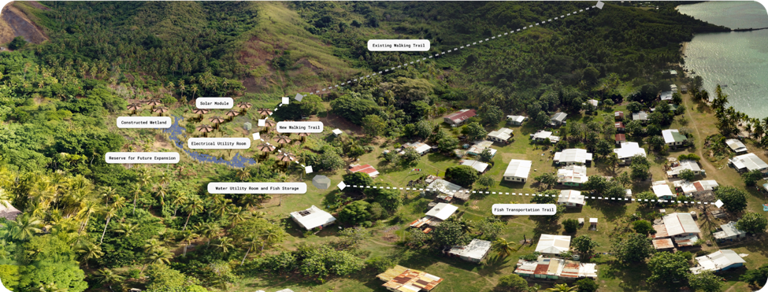

## 1.1. Weather-Resilient Modular Structure

* The solar module is designed to withstand strong winds, heat, and coastal erosion. Its movable, foldable, and detachable form reduces cyclone damage and lower construction, transport, and maintenance costs.
* The wetland, shaped by natural topography, captures rainwater to reduce flooding and supply water for potable filtration.

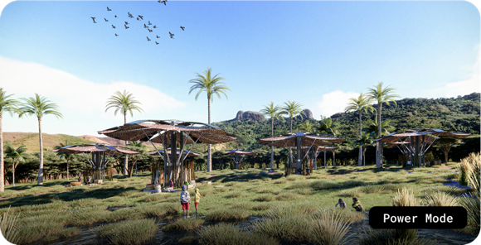

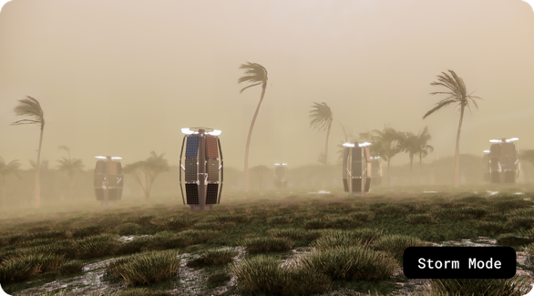

## 1.2. Low-Cost Construction and Transportation

* At $6.7/W, the 86kW system includes materials, logistics, tax, local training and installation. It uses monocrystalline solar panels mounted on marine-grade aluminum and stainless steel. The canopy and fences use recycled sailcloth and local bamboo. Components are shipped in standard boxes for efficient, IKEA-style assembly.

The wetland follows the land's natural contours, lowering construction costs. Water is stored in surface bodies and three tanks, minimizing infrastructure needs.

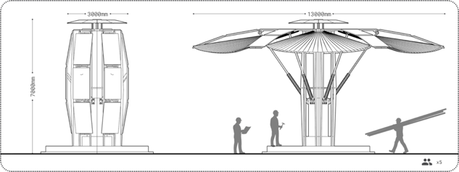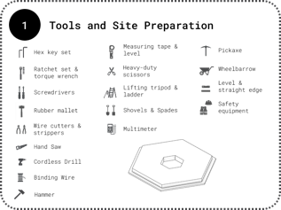

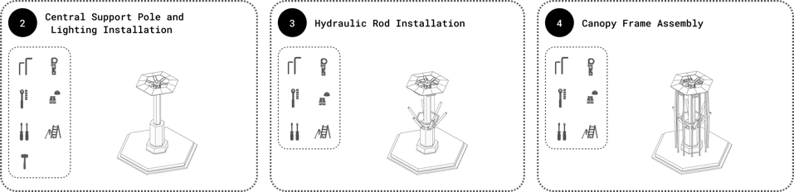

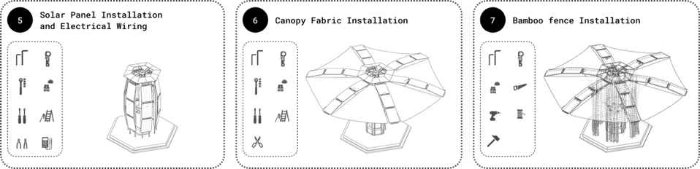

## 1.3. Simple Operations and Maintenance

* The canopy stays open year-round and will be folded only during severe weather. Routine cleaning and easy panel swap design ensure long-term use. A smart control system automates hybrid battery and ice energy storage for fish storage.
* Wetland needs minimal maintenance each season. The mechanical dosing and filtration systems need servicing periodically.

## 1.4. Supporting the Local Economy

* Create 28 local jobs: 25 part-time jobs for solar module installation, canopy and bamboo fence production, and water system construction; 3 full-time jobs for operations and maintenance of the energy and water systems.
* The park offers space for local crafts and commerce.
* Villagers are trained to operate and maintain the systems.
* The bio pool cultivates native reeds that are used in traditional weaving.

## 1.5. Support Community Health and Quality of Life

* Fiji loses 86 lives and contributes to 3,000+ DALY (Disability Adjusted Life Years) yearly due to unsafe water. A central water dispenser will improve health and quality of life.
* Each solar module provides shade for 5–10 people, encouraging social interaction and cultural gatherings like Lovo and Kava ceremonies.
* Solar modules provide nighttime gathering and celebration infrastructure with wildlife and dark sky friendly LED lighting.
* The wetland park provides recreational space and environmental education for locals and visitors, especially children.

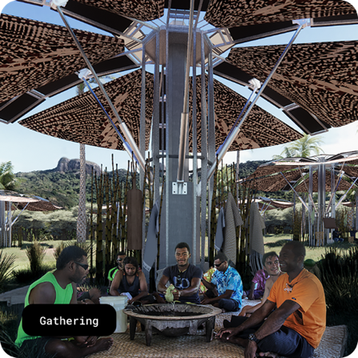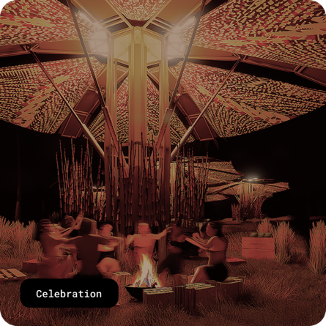

## 1.6. Celebrating Traditional Culture through Design

* The solar module’s hexagon shape features Fijian Masi patterns to honor local heritage.
* The canopy, made from recycled sails, mimics traditional Drua sails.
* The bio pool design is inspired by Naviti Island.

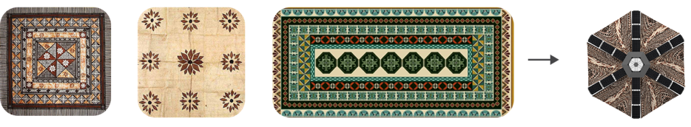

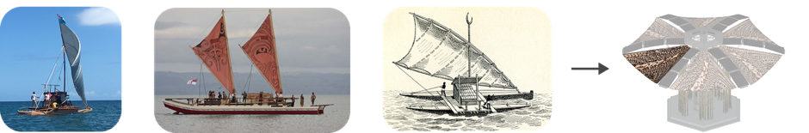

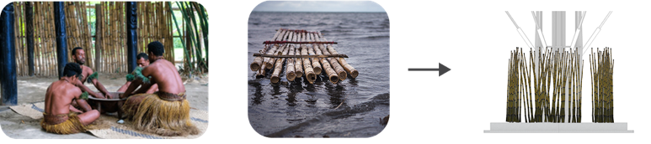

## 1.7. Positive Environmental Impact

* Solar power reduces diesel dependency, lowering emissions and pollution.
* Canopies lessen heat island effects, improving land usability.
* The wetland cools the area, improves solar efficiency, and supports native species.
* Bio pools follow the site’s natural form, avoiding tree removal and preserving biodiversity.

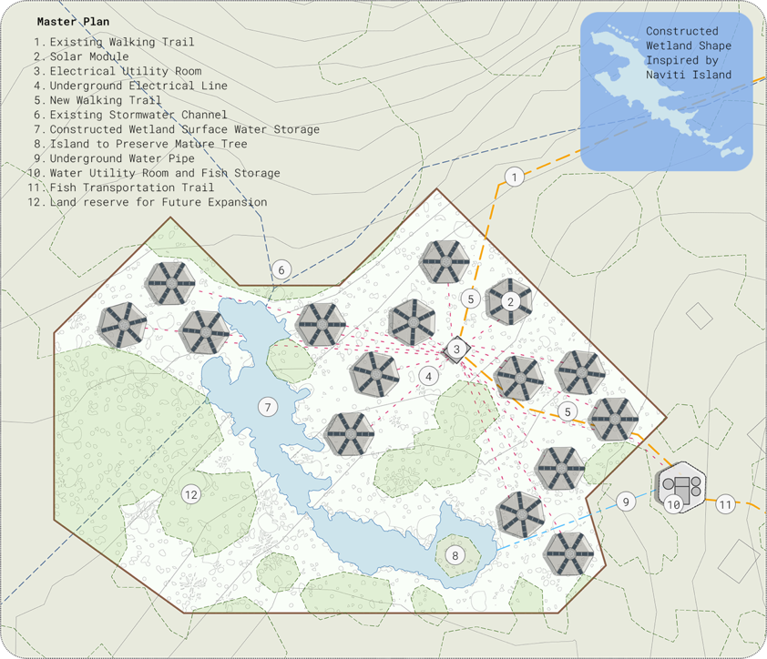

# 2. Technical Narrative

## 2.1. Solar Energy Generation and Storage System

The all-inclusive low-cost ($6.7/W) energy generation (86kW) and storage system exceeds current demand (75kW) and allows land reserve for future expansion.

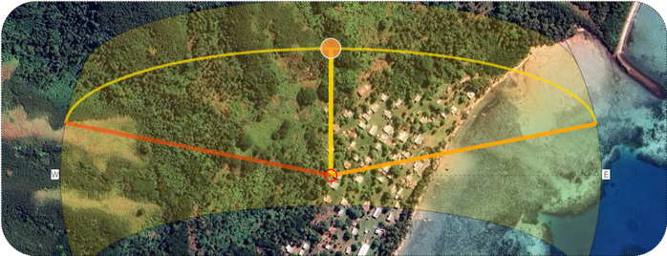

### 2.1.1. IKEA-style modular structure

Each solar module is designed for simple, cost-effective assembly by using standard shipping boxes — similar to IKEA furniture.

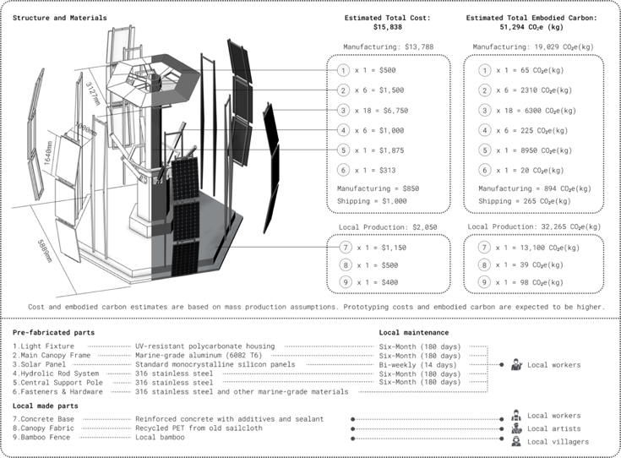

### 2.1.2. Hybrid battery and thermal energy storage

To improve energy utilization and system reliability, the solar setup integrates lithium iron phosphate battery storage with thermal energy storage via an ice bank that supports a fish storage facility.

A smart control system enables real-time monitoring and remote operation to optimize performance, as seen in the diagram below.

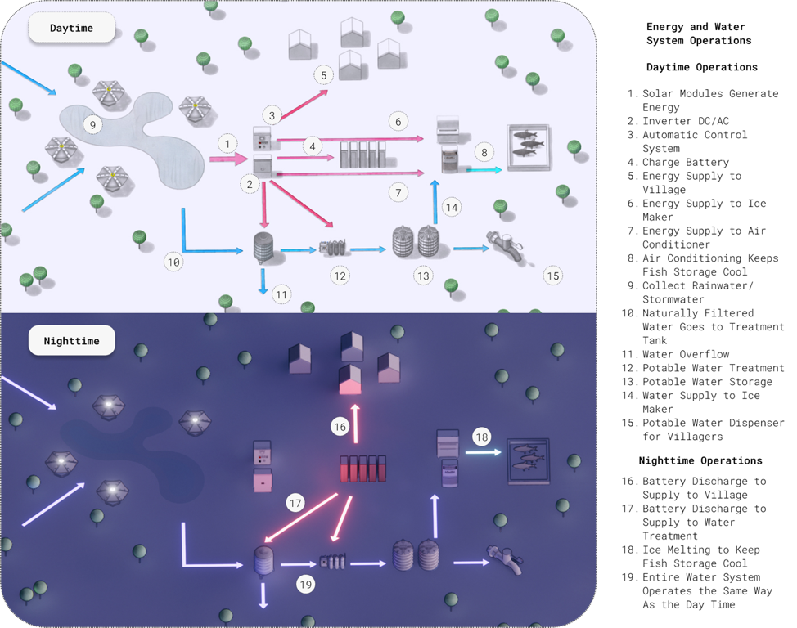

### 2.1.3. Energy System Performance Summary

*Design Inputs:*

* Average sun-hours: 5.5/day
* Total solar area: 443 m²
* Battery capacity: 200 kWh
* Thermal loads: 4kW (ice maker), 8kW (air conditioning)
* Ice storage capacity: 800 kg
* Thermal facility: 40m³ at -20°C
* System efficiency: 0.8

*Performance:*

* Solar generation capacity:
  + 86 kW total
  + 5.7 kW per module
* Energy generation:
  + each module:
    - 25 kWh/day
    - 9,250 kWh/year
  + 15 modules:
    - 1,949 kWh/day
    - 711,500 kWh/year
* Thermal storage resilience: 27 hours for 1,600 kg fish
  + 18 hours battery
  + 9 hours ice storage

## 2.2. Rainwater Collection and Filtration System

The system ensures water security during the dry season with low-cost construction and maintenance design. System design’s 115 days of potable water supply aligned with current village needs while allowing future expansion with surface water and tank storage.

### 2.2.1. Passive Rainwater Collection through a Constructed Wetland

Rainwater is captured through a four-stage natural system—constructed wetland, reed bed, gravel filter, and bio pool. This passive method reduces mechanical costs and supports wildlife habitat and flood mitigation by absorbing stormwater runoff.

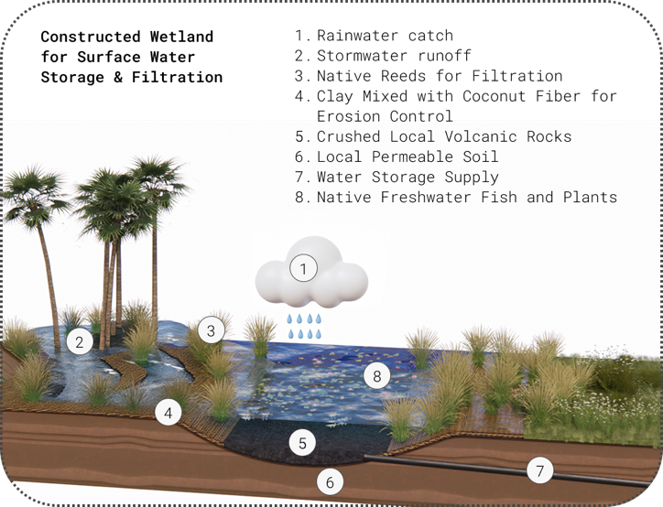

### 2.2.2. Potable Water Filtration and Automatic Dosing System

For potable water, the system uses automatic dosing, carbon, and nanofiber filtration to meet international standards (e.g. ANSI/NSF 42, 53, 401, 244, P231). This ensures high-quality drinking water with minimal operating costs.

### 2.2.3. Water System Performance Summary

* *Design inputs:*
  + Annual rainfall: 2,500 mm
  + Dry season duration: 180 days
  + Evaporation and seepage losses: 10%
  + Daily demand: 8,100 L (67 Households, fish storage, school and other usage)
* *Performance:*
  + Total capacity: 1,040,000 L
  + Bio pool: 1,000,000 L (1,300 m² surface area × 0.8 m depth)
  + Treatment tank: 20,000 L
  + Potable tanks: 20,000 L (2 × 10,000 L)
  + Supply autonomy: 115 days (3.8 months)

## 2.3. Solar-powered Standalone Smart Outdoor Path Lighting

To increase safety and accessibility at night, solar-powered standalone smart lights are installed on the walking paths connecting the village, school and the park. Features include:

* Motion, sound, and light sensors
* Wildlife-friendly spectrum (for birds and turtles)
* No light pollution to preserve dark sky
* 3 kW in energy savings
* No need for underground wiring, reducing infrastructure costs

# 3. Prototyping and Pilot Implementation Statement

## 3.1. Prototyping Plan

The prototype will focus on the solar module. The thermal storage and water systems will not be prototyped, as they use established, standardized technologies.

### 3.1.1. Cost and Timeline Estimation

The prototyping timeline is estimated at 12 weeks. A detailed cost breakdown is shown below.

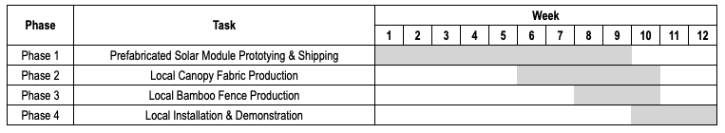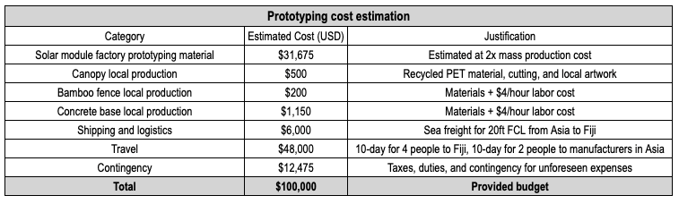

### 3.1.2. Prototyping phases

#### Phase 1: Solar Module Prototyping

The solar module uses an IKEA-style assembly model with standardized parts to streamline prototyping and reduce costs. The preliminary design includes 9 core component types, material specs, and a full parts list, as seen in Section 2.1.1.

We will partner with OEM/ODM (Original Equipment Manufacturer and/or Original Design Manufacturer) in Asia to access affordable solar panels, precision metalwork, and skilled labor. Key steps include:

* Selecting a factory with tropical-climate solar experience
* Finalizing engineering drawings and material specs
* Confirming assembly procedures and certifications
* Building the prototype and running performance testing
* Testing disassembly and reassembly for durability
* Integrating a lithium iron phosphate battery pack for demonstration

#### Phase 2: Local Canopy Production

In Fiji, the canopy will be made from recycled PET sailcloth from boats. Local communities will cut, shape, and paint the fabric, engaging youth and artists in cultural storytelling.

#### Phase 3: Bamboo Fence Construction

Local villagers will build bamboo fences around each module for protection and to create display areas for crafts, goods, and artwork.

#### Phase 4: Concrete Base Construction

Local skilled workers will build a concrete base to support the entire module.

## 3.2. Full-scale Pilot Implementation Plan

The full pilot includes the entire energy system (generation, storage, control, and thermal storage) and the full water system (collection, natural filtration, potable water treatment).

### 3.2.1. Cost Estimate

Preliminary cost estimates are shown in table below for reference only and will be refined as more data becomes available.

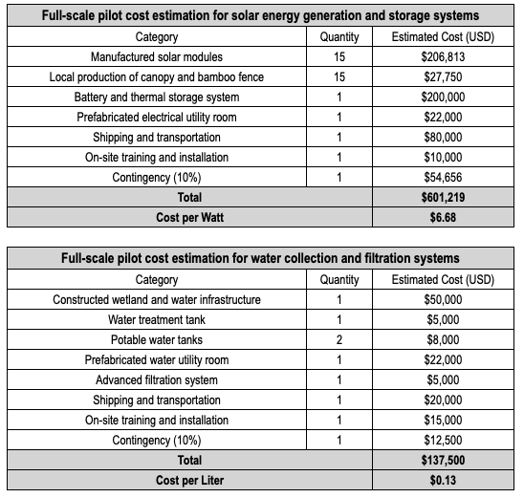

### 3.2.2. Pilot Phase

The pilot implementation includes 5 phases. Each phase will have heavy involvement from the local community, including technical training and capability building, labor work, arts and crafts, cultural integration, as well as environmental impact.

#### Phase 1: Site Preparation and Community Engagement

Site selection involves environmental assessment and participatory mapping. Community workshops provide orientation, with basic training offered to selected residents. Land agreements and shared responsibilities are developed collaboratively.

#### Phase 2: Wetland and Energy Infrastructure Construction

Engineers and villagers shape wetlands, plant native species, and construct solar foundations, water infrastructure, and utility rooms using prefabricated panels.

#### Phase 3: Energy and Water Systems Installation

Locals, guided by engineers, install solar panels, battery/thermal storage, water tanks, and filters. They also construct the concrete bases, assemble and paint the canopy, construct bamboo fences for markets and crafts.

#### Phase 4: System Integration and Testing

A trained local team tests and rehearses system operation and maintenance with engineer support.

#### Phase 5: Monitoring and Performance Evaluation

Local teams monitor performance and collect community feedback. These insights will inform scale-up efforts and ensure future phases remain community-centered.

# 4. Operations and Maintenance Statement

## 4.1. Solar Energy Generation and Storage System

### 4.1.1. Operations

The foldable solar module operates like an umbrella. In extreme weather, trained locals follow a simple protocol: remove the canopy, fold the panels, and secure the system to reduce cyclone damage.

The system uses hybrid energy storage—lithium iron phosphate batteries and an ice bank. Solar power runs equipment, charges batteries, and activates an ice maker for thermal storage. Ice cools fish storage during cloudy periods or at night. A smart control system manages energy flow, performs remote diagnostics, and supports predictive maintenance, as seen in the diagram in Section 2.1.2.

### 4.1.2. Maintenance

Designed for coastal conditions, the system requires biweekly solar panel cleaning and quarterly checks on batteries and electrical components. Hydraulic rods and the frame are inspected every six months. Software updates and full annual inspections ensure long-term durability.

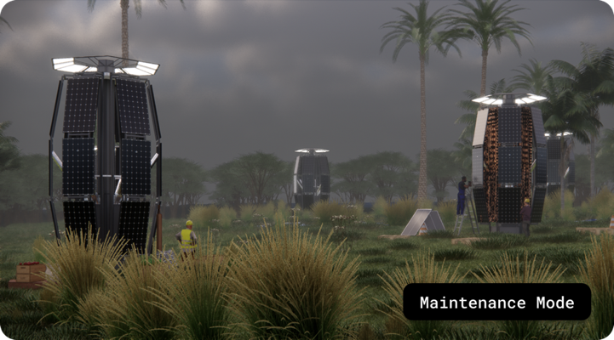

### 4.1.3. Community Involvement

Local villagers are trained in basic maintenance, using a simple interface to report issues. Designated “solar stewards” coordinate upkeep with support teams. The fish storage facility serves as a shared community resource, encouraging ownership and sustainable operation.

## 4.2. Rainwater Collection and Filtration System

### 4.2.1. Operations

The rainwater system uses gravity-fed passive filtration through wetlands, reed beds, gravel filters, and a biological pool to remove impurities. During rains, the wetland also acts as a sponge to reduce village flooding.

After natural filtration, water goes through a three-stage mechanical system with automatic dosing and pressurized filtrations to meet drinking standards. Automated pumps and valves ensure continuous operation and water delivery to a central dispenser.

### 4.2.2. Maintenance

Wetland maintenance includes monthly debris clearing, water quality checks, and plant health monitoring. Gravel replacement and seasonal replanting may be needed.

Mechanical filtration units require filter changes every six months and biweekly checks on the dosing system. Potable water tanks are cleaned every six months, and flow control systems are checked monthly for leaks or issues. A local logbook tracks all tasks.

### 4.2.3. Community Involvement

Locals help maintain the wetland, while trained local technicians handle the mechanical system. Students support landscape care, and volunteers keep the water dispenser clean. Education promotes shared responsibility and good hygiene.

## 4.3. Solar-powered Standalone Smart Outdoor Path Lighting

Each solar path light is self-contained, with an integrated solar panel, battery, LED, and smart controller. Lights activate at dusk, adjusting to light, motion, and sound. They dim when inactive to save energy and minimize wildlife disturbance. The system is fully autonomous and maintenance-free.

# 5. Environmental Impact Assessment

SigaWai Canopy Park is a low-carbon, eco-integrated solution that meets energy and water needs while strengthening environmental and community resilience. By combining renewable energy with nature-based systems, it offers a replicable model for sustainable development in Pacific Island communities.

The design minimizes both operational emissions and embodied carbon through recyclable materials and prefabricated, IKEA-style modules. Construction avoids large-scale land clearing, uses existing topography, and embeds ecological functions throughout—from the solar module’s shading effect to the wetland’s biodiversity benefits.

## 5.1. Positive Operational Impacts

The 86kW solar energy system replaces diesel generators, reducing potential CO₂ emission while eliminating noise and air pollution. Ice-based thermal energy storage enables nighttime cooling without battery use, improving efficiency.

Each 5.7 kW module generates about 9,250 kWh per year, potentially displacing roughly 8,325 kg CO₂ equivalent annually from diesel generators, a total of 124,875 kg CO₂equivalent for all 15 modules.

The gravity-fed wetland filtration and mechanical purification system treat rainwater with minimal energy input. The bio pool, filled with native plants and fish, restores biodiversity and creates a cooler microclimate, supporting public health, solar panel performance, and ecological restoration.

## 5.2. Embodied Carbon

We estimate each solar module’s embodied carbon at 51,294 kg CO₂ equivalents—37% from manufactured parts and 63% from local production on Naviti Island. This figure includes material-related emissions, as well as manufacturing and transport.

The main source of embodied carbon is the concrete base, which can be made locally by trained villagers, reducing emissions from shipping. Using recycled materials further cuts embodied carbon: the canopy is made from recycled PET sailcloth, and all metal components—aluminum and stainless steel—are fully recyclable. The table below shows the preliminary embodied carbon estimation.

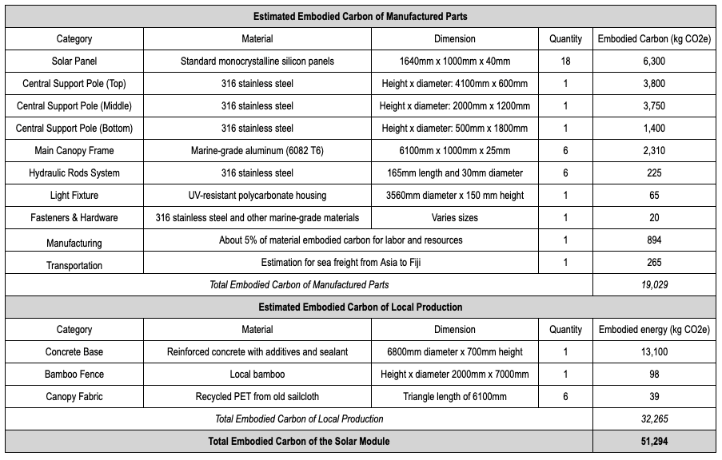

## 5.3. Circular Design and Material Reuse

Designed for disassembly, all components are modular, shipped in standard boxes, and easy to relocate or scale. End-of-life materials are recyclable or reusable. Bamboo fencing and landscape elements use biodegradable, native resources.

The wetland system is regenerative by design—built from local gravel, clay, coconut fiber, and native plants, avoiding synthetic liners or concrete channels.

## 5.4. Minimal Ecological Disturbance

Development avoids mature tree removal and works with the land’s natural contours. The wetland supports native birds, fish, and plants, enhancing habitats and restoring water flow.

The solar canopy resembles a large tree, with bamboo fencing and painted fabrics blending into the environment. Path lighting uses wildlife-friendly LED spectra to protect nocturnal species like turtles and birds while ensuring nighttime safety.

Overall, SigaWai Canopy Park shows how infrastructure can serve human needs while regenerating ecosystems—a model for resilient, community-centered climate adaptation.