**LAGI 2025 Fiji Narrative**

**Stretch Point**

**Concept**

* Our design consists of two building entities: 1) THE STRETCH: a long (163 m) and narrow (10 m) structure that connects the Marou village and the farm fields and 2) THE POINT: a freeform building that hosts emergency shelter and recreation spaces. They both have timber structure from local woods – e.g. mahogany. The Stretch is an open play of physical parts, covered by solar energy arrays and roof, protecting underneath a shadowed path, small buildings as well as energy and water systems.
* The co-benefits that the design provides to the local community are the possibility to construct and maintain the wooden parts together.
* The design is modular, flexible, changeable and replicable.
* The name stretch point comes from that that we wanted to avoid professional jargon when naming the long and round buildings. At the same time, these terms refer to sustainability: The humans are stretching the capacity of the Earth and we have come to the point where one needs to change our lifestyles. The Point is also a gathering point for the community.

1. **Technical Narrative**

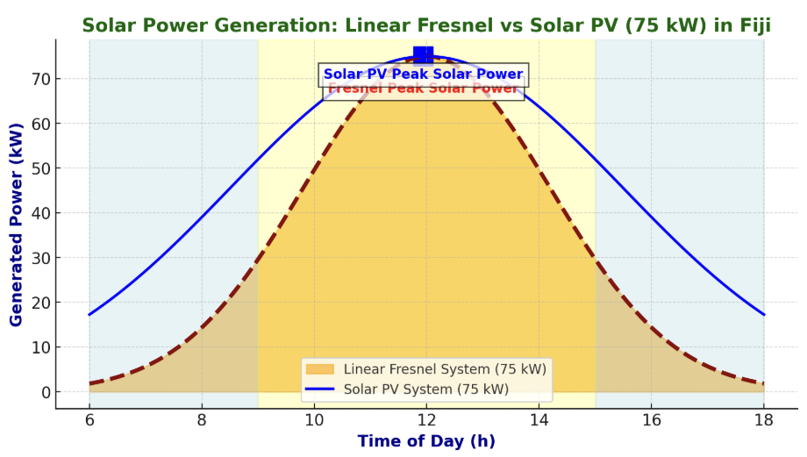

Our design incorporates different locally feasible and easily maintained (reasonably low-tech) energy and water systems integrated into a functioning process whole: 1) Linear Fresnel (LF) thermal energy system for heating water by solar mirrors, 2) Multi-Effect Distillation (MED), where heat from solar collectors boils seawater and rain water, and the resulting steam is condensed to produce fresh water, 3) Photovoltaic (PV) solar panels, 4) Electricity turbine run by steam, 5) Molten Salt Thermal Energy Storage (TES) and 6) Lithium battery electricity storage for 24/7 distribution. The bearing structures are made of local timber, e.g. mahogany. The solid timber structures of the line are orthogonal and the shelter has a diagonal grid structure made of curved LVL timber.

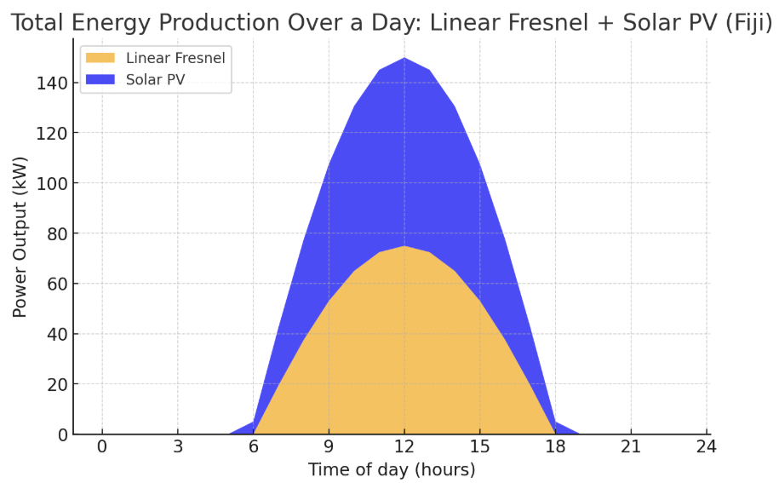

# System inputs

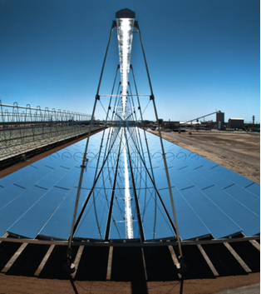 <https://www.energy.gov/eere/solar/linear-concentrator-system-concentrating-solar-thermal-power-basics>

1. 100 kW Linear Fresnel system / incoming solar energy: 1916×336m2=643,776kWh/year=643.8MWh/year (solar input)

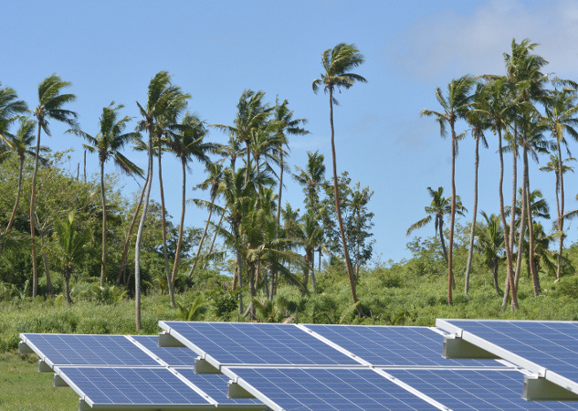 <https://www.eca-uk.com/2019/06/26/review-of-rooftop-solar-pricing-in-fiji/>

1. Incoming Solar Energy (kWh/year)=panel area (m²)×solar irradiation (kWh/m²/year)=336×2,000=672,000 kWh/year=336×2,000= 672,000 kWh/year = 672 MWh/year) of incoming solar energy per year.

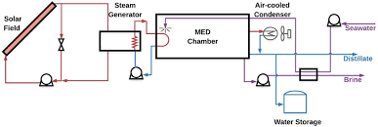 <https://www.sciencedirect.com/science/article/pii/S0011916421005221>

1. Sea water for steam generation including salt separator

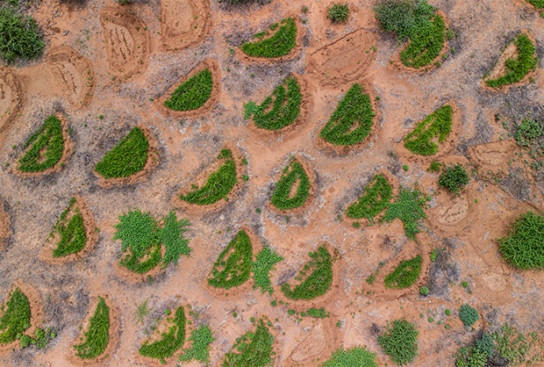 <https://www.thesafaricollection.com/earth-smiles-regreening-samburu/>

1. Rainwater collected on roof and landscape: so-called demi lunes in the image: downhill water collectors which are flat on upper side and have an embankment on the lower side.

# System outputs

1. Linear Fresnel electricity: 100kW×8,760h×0.21 = 183,960kWh/yr (183,9MWh/year).
2. Photovoltaic Panel electricity: 75kw x 8,760 hrs/yr x 0.2 =131,400kw/yr (131,4 MWh/ year).
3. Fresh drinking water produced from sea water (3/4 of LV’s output): LF Power Converted to Heat (40% Efficiency): 0,56 MW×0.40=225 kW thermal energy; Annually 225 kW x 8,760 hrs/yr = 1,9 MWh. This will produce app. 17–33,75 m³ fresh water/day; Annually 7,500–13,000 m³.

* The embodied energy required to construct the design with a preference for lower upfront carbon solutions:

1. Wooden Skeleton for the Stretch (Local Timber): **Embodied energy** **(EE)** ≈ 496,000 MJ, **CO₂e** ≈ 55,800 kg
2. Photovoltaic Solar Panels (336 m²) + Battery: **EE** ≈ 990,000 MJ, **CO₂e** ≈ 43,600 kg
3. Linear Fresnel (750 m²): **EE** ≈ 56,250 MJ, **CO₂e** ≈ 75,000 kg
4. Steam Generator (¼ LV steam to electricity): **EE** ≈ 150,000 MJ, **CO₂e** ≈ 12,500 kg
5. Multi-Effect Distillation System + Seawater Pumping: **EE** ≈ 11,500 MJ, **CO₂e** ≈ 1,200 kg
6. Molten Salt Storage: **EE** ≈ 150,000 MJ, **CO₂e** ≈ 22,500 kg
7. Timber Cabins: **EE** ≈ 12,000 MJ, **CO₂e** ≈ 1,350 kg
8. The Point (Local Timber): **EE (timber)** ≈ 20,000 MJ, **CO₂e (timber)** ≈ 2,250 kg; **EE (steel)** ≈ 90,000 MJ, **CO₂e (steel)** ≈ 10,800 kg

* Total Estimated Embodied Energy & CO₂e Footprint: 1,975,750 MJ, 225,000 kg CO₂e. One needs to take account the considerably lower use energy and CO2 footprint during the use of the structures, compared to conventional energy and material solutions. The CO2 footprint can be mitigated by planting trees.

1. **Prototyping and Pilot Implementation Statement**

The residents of Marou will be included as much as possible in the implementation process, including final spatial dimensioning and detailed design through installation. Local timber and sawmill will be used. The construction system and the concept have flexibility, changeability and scalability to meet the eventual local spatial requirements.

1. **Operations and Maintenance Statement**

The buildings and construction structures can be operated and maintained by the local community, as well as the technical energy and water systems as long as training and manuals for this are sufficient and spare parts available.

1. **Environmental Impact Assessment**

The surrounding landscape has been developed by ecological principles using ponds and demi lunes, with new plantations in between, increasing water collecting and infiltration as well as diminishing the negative effects of flooding and helping in gathering rainwater.