KAUKAU VOLAU, A POWERFUL JOURNEY
- Concept Narrative
- The aim of our design is to create energy and water systems that can help the community of Marou village adapt to the increasingly frequent climate challenges they face, be less dependent on external resources, and preserve a strong connection to their cultural heritage and traditional knowledge. We have set out to achieve this goal by developing integrated design solutions that, while respecting the island’s natural context, generate renewable energy, harvest and filter rainwater, and create spaces for food production, recreation, and play. Kaukau Volau promotes a landscape that weaves together people, nature, and culture to achieve sustainability and resilience. Taking inspiration from iTaukei history and culture, our installations are meant to represent a collective journey towards a more sustainable future. The solar photovoltaics or palmvoltaics are abstractions of coconut palms (Cocos nucifera), a tree highly present on Naviti island; the pavilions, which are to be built together with the local community using traditional thatched housing (bure) methods and locally sourced materials, are abstractions of islands; the pathways connecting them and bearing traditional textile masi (tapa) patterns are abstractions of water and link the community’s cultural heritage to ecosystem services; and lastly the engineered wetland system further embodies the significance of water as a source of life and community. Place-making and community building are key to a successful journey towards adaptable and resilient communities, thereby at the core of Kaukau Volau is the concept of solesolevaki as a means of working together, sharing knowledge, and ultimately reaching a new ecological trajectory that not only promotes connections among people, but also between communities and the natural environment in which they are nestled.
- Technical Narrative
- To optimize land use, solar photovoltaic installations are inspired by agrivoltaics and designed to generate power, harvest rainwater, and provide spaces for food production, shade, and recreation. Areas under agrivoltaics are more water efficient maintaining higher soil moisture (Adeh et al., 2018), while plants provide transpirational cooling of the panel underside leading to a greater power output (Barron-Gafford et al., 2019). The ‘leafs’ of the palmvoltaic are custom-shaped, tinted, high-load, monocrystalline solar panels, which have a high energy conversion efficiency. Each palmvoltaic has 6 ‘leaves’ that, combined, can generate approximately 27kW. A minimum of 14 palmvoltaics is needed to produce the required 75kW. Rainwater from the solar panels is collected into a cistern, with a storage capacity of approximately 20,000 litres, built around the palmvoltaic ‘trunk’. Aside from harvesting rainwater, given that the area floods during the rainy season, the cistern also doubles as a raised food-producing space, aimed at protecting crops from being periodically submerged.
- To ensure energy generation at night or when overcast, earth battery systems are to be constructed within the two largest pavilions. Excess power generated by the solar photovoltaics is used to heat electric heating pads which, in turn, heat a chamber of volcanic rock located beneath the pavilions. Warm air brought in through ducts in the walkways contributes to superheating the chamber during the day. At night, the warm air released from the chamber forces the angled blades of the pinwheel fans to rotate around a central point and generate rotational mechanical energy that can subsequently be converted into electricity. The pavilions are also to provide spaces for cold food storage, charging devices, education, shade, community building, and other recreational activities.
- Pavilions are to be oriented with their short sides facing the direction of incoming winds to minimize wind pressures. Foundation (yavu) are to be elevated and consist of a traditional earth floor with a retaining wall of stacked river rocks to prevent flood-related erosion and wind from passing underneath the pavilion. Walls (lalaga) are to be made of woven reed and bamboo thatch on termite-resistant, native harwood frames. Roofs (doka) are to have minimal overhangs and a 55° slope to minimize uplift pressures. Traditional fixings, such as coconut twine (magimagi) or walai vine, and notched timber connections are to be used to allow for stretch and movement under wind stress and thus minimize cyclone-induced damages.
- To limit land erosion caused by water channels during the rainy season and increase resilience of Marou village residents to seasonal fluctuations in water availability, we propose to construct an engineered wetland. Water from the channel crossing the site is to be diverted to three collection ponds using ephemeral stream diversions that mimic natural hydrology and symbolize a connection between land and water. The ephemeral stream flow is to generate additional renewable energy through a water wheel. Native plants and clay lining are to be used to stabilize the wetland banks and prevent erosion. UV filters clean the water for drinking purposes.
- Prototyping and Pilot Implementation Statement
- A digital model of a palmvoltaic would be created and stress tested with the appropriate software to ensure that the system meets solar photovoltaic construction standards and necessary structural requirements (e.g., lateral loads, attachment design) to withstand the extreme weather conditions that Marou village experiences.
- Based on digital test results, a physical prototype palmvoltaic model would be built. ‘Leaf’ solar PV modules are to be individually held using locking, vibration-resistant bolt hardware, sized to endure corrosion for an average of 25 years. Static and dynamic load tests representative of Category 5 cyclone winds as well as ASCE 7 connection tests, rigidity assessment, and wind-tunnel testing would be carried out in consultation with structural engineers, equipment and module suppliers, and installers to confirm that the scaled model bears actual wind pressures and site conditions.
- The palm leaf-shaped photovoltaic panels will be supported by a central stiffing rib resembling the midrib, which is the primary vein of a leaf running along its centre (see schematic below). The water channels connecting the tip of the leaves to the “trunk” will provide additional mechanical stability.

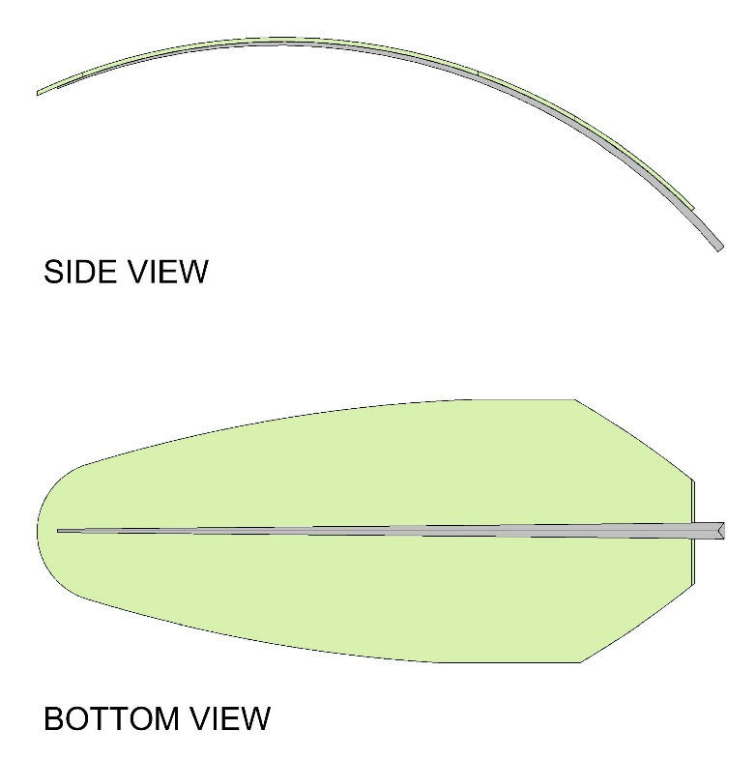

- A model earth battery and heat sink path would be constructed to fine-tune the heat capture process, in consultation with specialized engineers.
- A pavilion would be built together with Marou village residents according to their traditional construction methods and materials, which are safer and more capable of withstanding cyclone events than contemporary houses with corrugated steel roofs (Elkharboutly & Wilkinson, 2022).
- A small wetland section will be created to test filtration efficiency and water storage capacity and a scaled model water wheel will be built to assess the energy generation potential.
- Operations and Maintenance Statement
- Through a collaborative approach grounded in the concept of solesolevaki, our intent is to involve the local community in the implementation, operation, and maintenance of all proposed energy and water systems, which have been located within the design site in a way that maximizes people’s exposure and interaction with them.
- Marou village residents will participate in choosing the traditional textile masi (tapa) patterns as well as in building and maintaining pavilions and playground equipment. Further, the local community will be taught how to monitor and manage the wetland vegetation as well as how to empty sedimentation ponds, on an as-needed basis, to ensure and maintain optimal filtration and functioning, and thus habitat conditions.
- Moving parts such as trackers have been avoided on engineered components of both energy and water installations due to damage susceptibility and need for specialized maintenance.
- Specialized technology is to be used only when unavoidable, e.g., solar panels, UV filters, and water pumps.
- Play equipment for the playground is to be made of locally sourced, recovered Cocos nucifera.
- Native hardwood for structural framing is to be saltwater-treated and fumigated. Further, timber posts are to be surrounded by charcoal and compact gravel to provide additional protection from termites and rot. Framing posts are to be dug a minimum of 1.5 m into the ground, while the central post delivering loads from the roof to the foundation is to be embedded 3 m.
- Environmental Impact Assessment
- Efforts will be made to preserve and promote native ecosystems and thus create a functional and beautiful landscape that well integrates in the surrounding natural environment and supports both social and environmental values. Land changes for the construction of pavilions, palmvoltaics, walkways, and engineered wetland are to be minimized. All new plant materials will be native.
- Despite leading to changes in the current water flow, the construction of the wetland will help limit land erosion caused by the overflow from the existing water channels during the rainy season; contribute to the water security of Marou village residents; reduce greenhouse gas emissions by functioning as a carbon sink; and enhance biodiversity and habitats for local flora and fauna.
- Overall, by leveraging local resources and knowledge through the practice of solesolevaki and by preserving and promoting native ecosystems, Kaukau Volau can help Marou village residents adapt to climate change-driven challenges and increase their quality of life and well-being.

References

Barron-Gafford G, Pavao-Zuckerman MA, Minor RL, Sutter LF, Barnett-Moreno, et al. (2019) Agrivoltaics provide mutual benefits across the food–energy–water nexus in drylands. Nature Sustainability. 2: 848-855 https://doi.org/10.1038/s41893-019-0364-5

Burgess C, Detweiler S, Needham C, Oudheusden F (2020) Solar under storm part II: Select best practices for resilient roof-mount PV systems with hurricane exposure. Rocky Mountain Institute, Clinton Foundation, FCX Solar.

Burgess C, Goodman J (2020) Solar under storm for policymakers: Select best practices for resilient underground PV systems with hurricane exposure. Rocky Mountain Institute.

Burgess C, Locke J, Stone L (2020) Solar under storm for policymakers: Select best practices for resilient PV systems for small island developing states. Rocky Mountain Institute, Clinton Foundation, UN-OHRLLS.

Elkharboutly M, Wilkinson S (2022) Cyclone resistant housing in Fiji: The forgotten features of traditional housing. International Journal of Disaster Risk Reduction. 82: 103301 https://doi.org/10.1016/j.ijdrr.2022.103301

Hassanpour Adeh E, Selker JS, Higgins CW (2018) Remarkable agrivoltaics influence on soil moisture, micrometereology, and water-use efficiency. PLoS ONE. 13: e0203256. https://doi.org/10.1371/journal.pone.0203256

Ho L, Healy E (2022) Vanua: Solesolevaki nurturing communities through revitalization of collective building culture. Swayn Open Research.

Tanner CC, Depree CV, Sukias JPS, Wright-Stow AE, Burger DF, Goeller BC (2022) Constructed wetland practitioner guide: Design and Performance Estimates. DairyNZ/NIWA, Hamilton, New Zealand.

