Contents

- Concept Narrative
- Technical Narrative
- Prototyping and Pilot Implementation Statement
- Operations and Maintenance Statement
- Environmental Impact Assessment

- Concept Narrative

Marou Village, like many coastal communities across the Pacific, stands at the edge of crisis. Rising sea levels slowly swallow shorelines. Cyclones strike with increasing force and frequency, bringing destruction, displacement and fear. Frequent flooding contaminates drinking water, cuts off electricity and destroys homes. Meanwhile, centralized infrastructure fails to reach or serve the village adequately, leaving the community vulnerable, isolated and dependent on outside aid. Beyond the environmental threats, there is also the risk of cultural erosion. As traditional practices wane and younger generations migrate, Marou’s identity, rooted in its land, rituals and communal spirit, faces fragmentation.

In response to the intensifying challenges, The Flow of Life (TFOL) has been envisioned as both a resilient architecture and a regenerative land art that restores, protects and uplifts the Marou Village community. At the heart of the design lies a holistic approach built on five foundational elements:

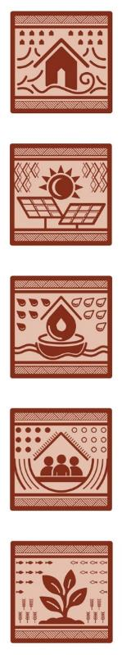
Self-sufficiency
And beyond, the land is not just land, it is the pantry, the pharmacy, the promise. Here, roots dig deep. Gardens stretch in terraces, nourished by sun and sweat. Chickens roam. Smoke curls from cooking fires. Nothing is wasted. Everything is shared. This is not survival. This is sufficiency, dignity and peace.

Water access
When the sky breaks open with rain, it is not a threat, but a gift. Roofs become open palms, catching each drop. Rainwater is gathered, guided and filtered through layers of earth and craft. Guided gently by the land, water flows through sculpted channels, pausing in ponds where fish swim and plants breathe.

Electricity supply
As the sun returns, its warmth is captured and shared, not just in light, but in power. Power that runs quietly, cleanly. No wires from elsewhere, no waiting. Just what is needed, when it is needed.

Cyclone shelter
When the winds howl and the water climbs, people seek more than shelter, they seek one another. High above the flood line, a place waits, open yet strong. Here, they gather. Not in fear, but in quiet defiance. A beacon against the storm and a cradle for stories when the skies clear.
Community space
In the heart of the village, a space breathes with song, memory and the quiet pulse of togetherness. It is a place shaped by memory and belonging, echoing the rhythms of Fijian life. In gentler seasons, it opens its arms to visitors, becoming a home of welcome and warmth.

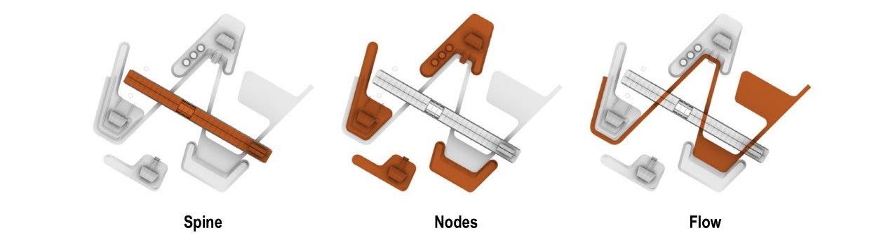

The design embraces and choreographs the hydrological cycles, transforming vulnerability into vitality. The site is articulated into three (3) interconnected zones:

- Zone 1: Gathering Canopy, a social and cultural node with an amphitheater and open communal space.
- Zone 2: Nourishing Terrace, a productive landscape for farming, livestock care and outdoor cooking.
- Zone 3: Living Reservoir, a hydrological landscape composed of interconnected ponds.

A linear architectural “spine” made of multiple modular timber units is located in the center, functioning as a multifunctional shelter. Elevated above ground, it becomes a temporary shelter during climate-induced extremes and transforms into a social exchange space in ordinary times. Along its length, a series of nodes branch outward strengthen The Spine’s function and create a web of activity and connection. A redirected waterway, the bioswale, weaves through the site beneath The Spine, linking all nodes in a continuous hydrological circuit that mirrors the flow of life. Together, The Spine, the nodes and the surrounding landscape form an integrated system that stitches ecology, community and sustainability into a regenerative continuum.

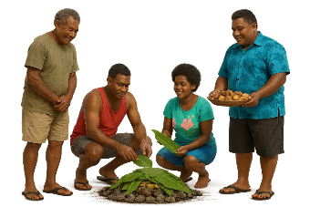

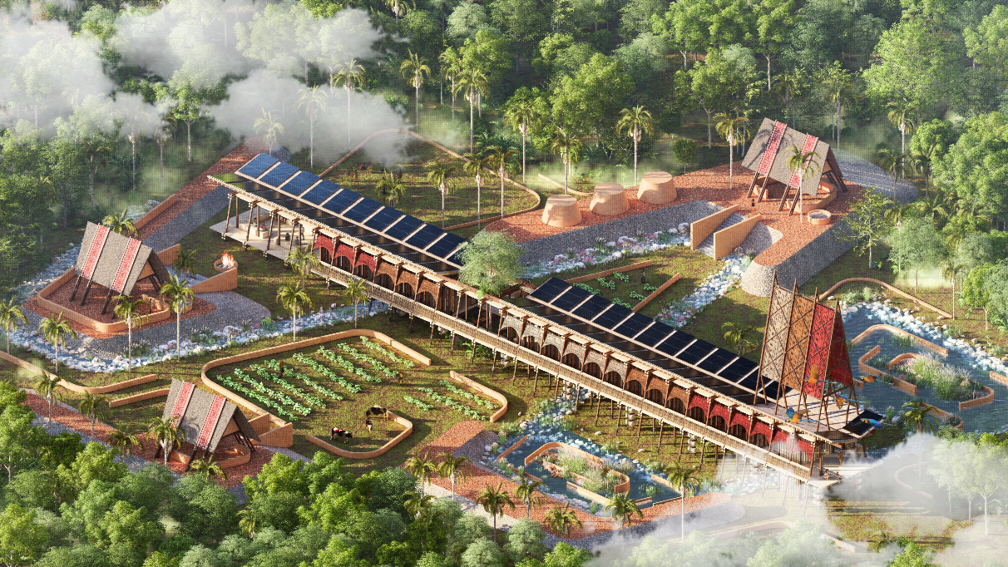

Cultural integration forms the backbone of TFOL’s concept, ensuring that the design is not just for the people of Marou Village, but by and with them. Rather than superimposing foreign architectural styles or development ideologies, the design emerges from the lived realities, values and traditions of the local community. Each element of the design, from the materials to spatial layout, seeks to enhance rather than disrupt the cultural rhythm of the site.

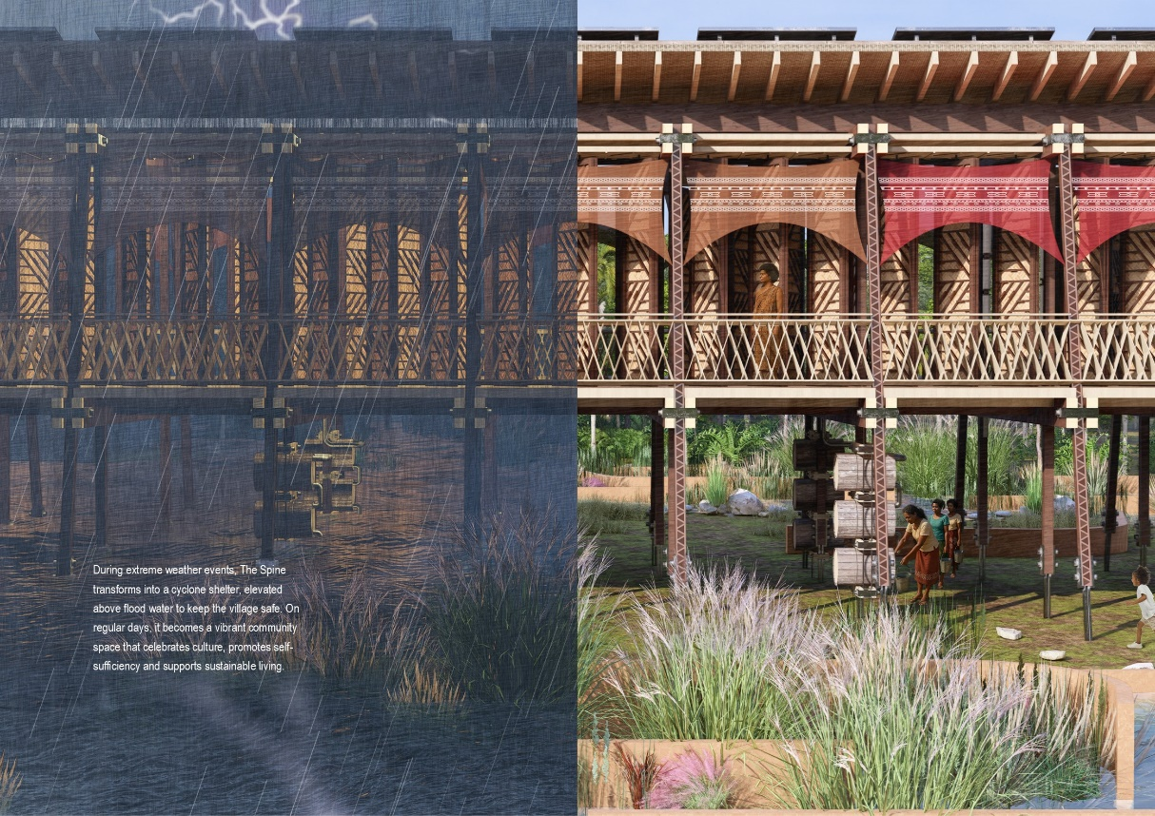

Landscape design
The surrounding regenerative landscape is designed to bring water access closer to the village, mimicking natural hydrology while enhancing biodiversity. Water bodies also serve as scenic and cooling landscape features to the surroundings. Rather than treating as waste, excavated soil from ponds and trenches is reused, it is compacted to create elevated platforms and design components. This reduces environmental disruption and reinforces a closed-loop, zero waste construction logic aligned with circular economic principles.

A polyculture agroforestry system, merging yam vines, taro beds, banana trees, cassava, medicinal herbs and nitrogen-fixing leguminous cover crops into a symbiotic planting layout. The landscape is designed as a living habitat that supports and is supported by livestock. Livestock fertilizes the soil and maintains grassland as they roam. This reciprocal relationship turns both into co-stewards of the ecosystem, closing the loop between food, habitat and ecology in a way that regenerates both the land and the life it sustains.

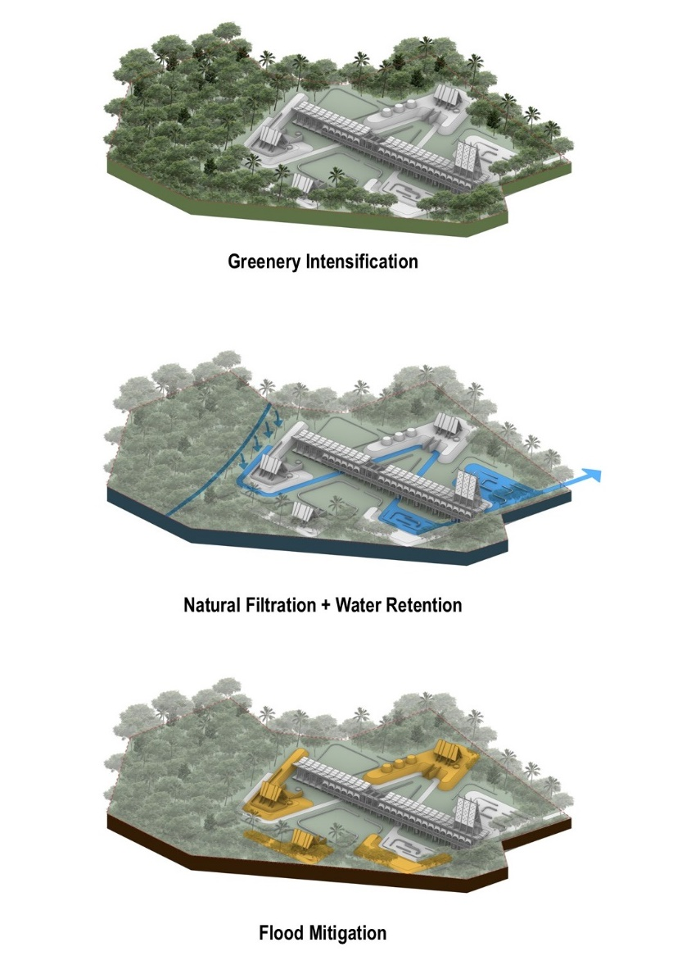

Construction Techniques and Materials Selection
Low-carbon, locally sourced and crafted materials have been selected as primary construction materials for their environmental performance, cultural familiarity and suitability for modular reversible construction. TFOL has been conceived not as a one-off installation but as a prototype for plug-and-play, replicable and community-led regeneration. The design has intentionally favored low-cost, low-maintenance and vernacular architecture to ensure adaptability across varying socio-economic and ecological contexts. Critical to its replicability is the modular building system and decentralized utility infrastructure, which allows to scale up or down depending on land availability, population and funding. Each module can be dismounted, relocated and reassembled into something else and somewhere else.

TFOL prioritizes naturally abundant and native building materials, offering aesthetic and tactile familiarity within island settings. The distinctive patterns of locally crafted materials are not only decorative but also adds layers of texture, storytelling, cultural identity expression and symbolic meanings rooted in Fijian heritage, reinforcing a sense of place and belonging.

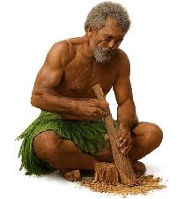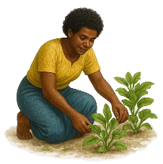

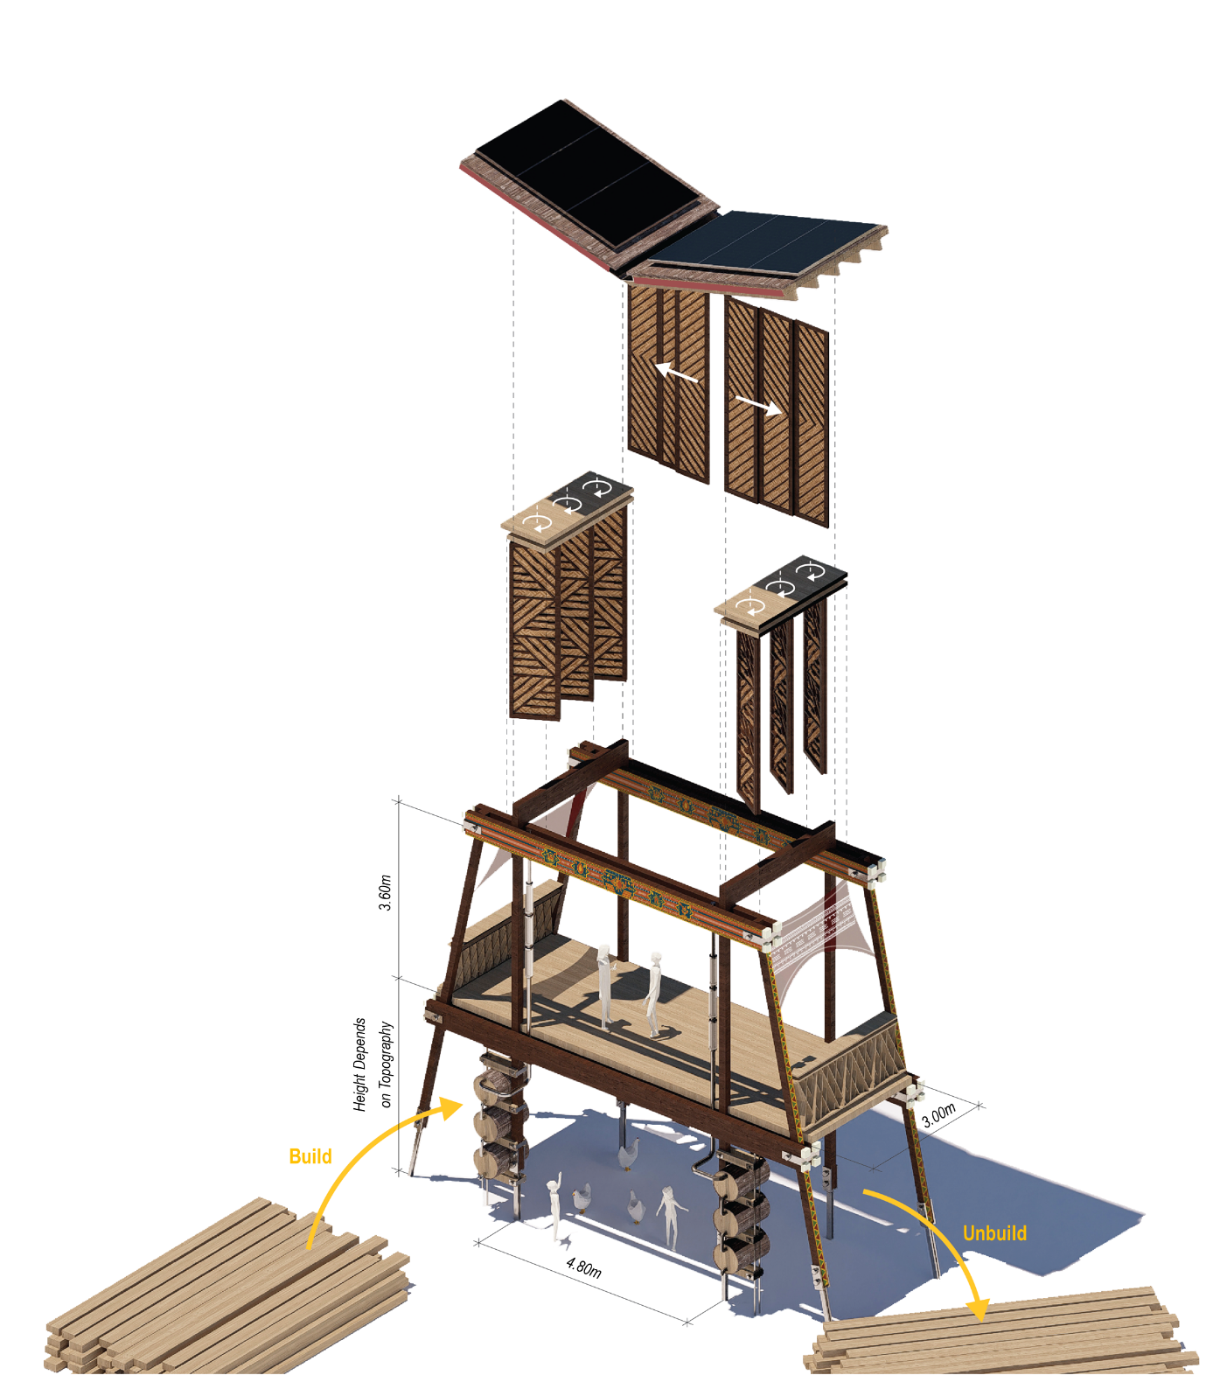

Visitor and community experience
Upon arrival at Marou Village, visitors are greeted by a striking fabric canopy printed with traditional Fijian motifs, acts as a mist catcher serving both symbolic and functional role. It is designed to harvest moisture from the environment, making the installation an icon visible from afar and an emblem of sustainable living. A butterfly roof design further enhances both the aesthetic and allows self-cleaning during rain.

The visitor and community experience in TFOL has been intentionally designed to foster inclusiveness, cultural immersion and shared learning. Visitors are welcomed into the rhythms of village life and communal gatherings. This communal space serves as a hub for daily life and a cultural homestay that allows guests to live alongside residents and experience traditions firsthand. During festivals or gatherings, performance, storytelling and celebration deepen cultural appreciation for both locals and guests. This creates opportunities for cultural exchange and community-led tourism, generating income while preserving heritage. This approach also encourages younger villagers to stay engaged with their roots, blending tradition with new entrepreneurial ventures and strengthening intergenerational bonds in the process.

TFOL is more than just a design, it is a living dialogue between tradition and innovation, permanence and adaptability, human need and environmental responsibility. TFOL stands as a beacon for others: proof that when people, culture and nature are harmonized, even the smallest villages can light the way to a thriving and resilient future.

- Technical Narrative

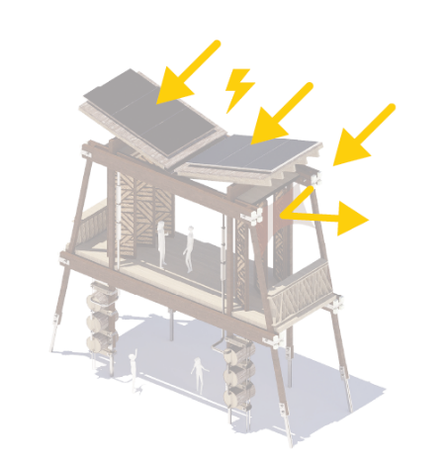

Hybrid Solar Photovoltaic-Thermal (PV-T) System
High-efficiency monocrystalline module is deployed to simultaneously produce electricity and capture waste heat that would otherwise be lost from the solar modules. By removing excess heat, the PV panels operate at a lower temperature which improves the performance by 3 - 4%. The recovered thermal energy is repurposed to preheat water for cooking and hygiene needs. Simulations indicate that The Spine’s rooftop can receive an annual average solar irradiance >1,900 kWh/m²/year, enabling it to generate >150,000 kWh/year of electricity, paving the way for Marou Village to becoming a net zero energy village.

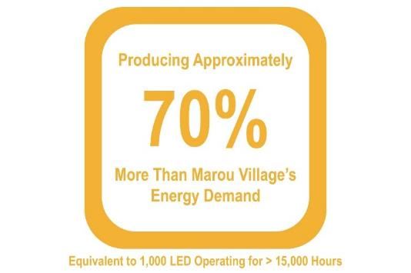

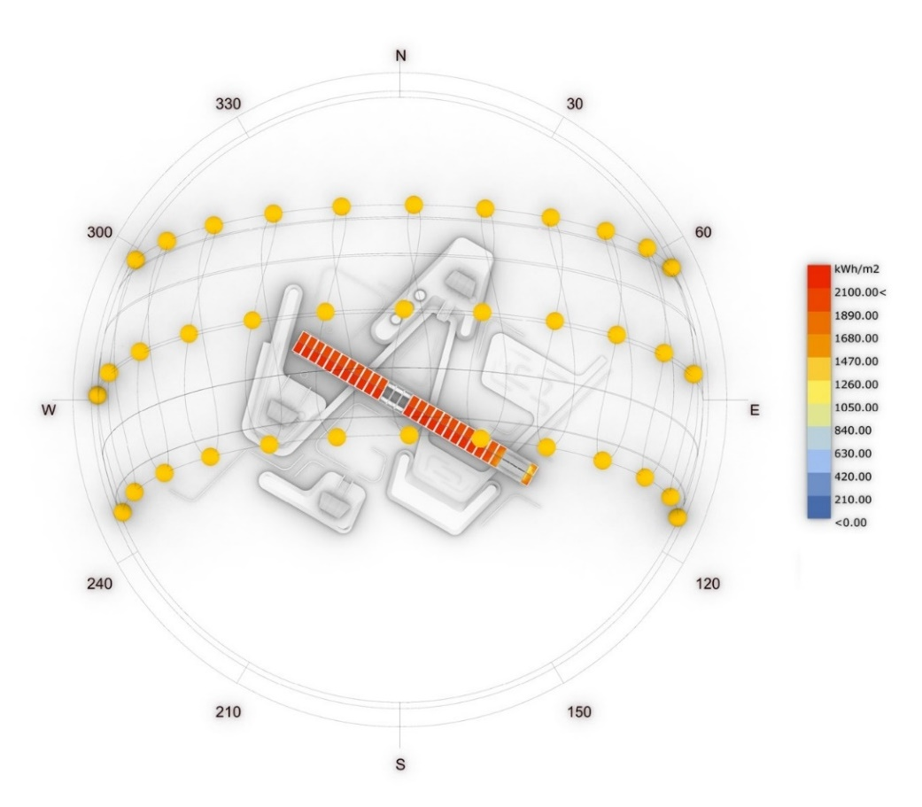

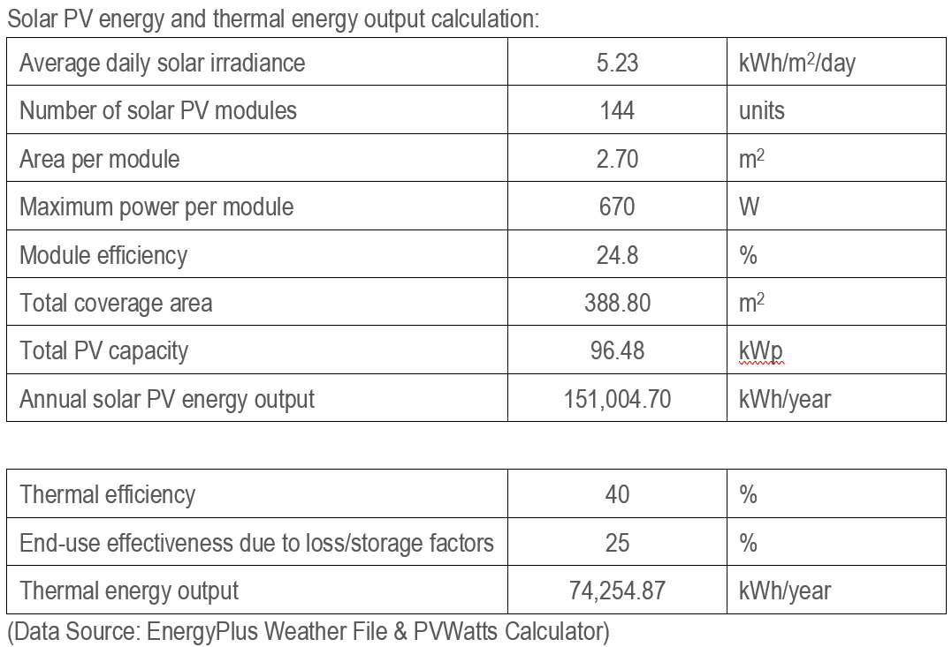

Battery Storage System
To ensure energy reliability, especially during overcast days or nighttime, the installation features a lithium iron phosphate (LiFePO4) battery storage system. It stores excess solar power and supplies it back when needed, allowing for 24/7 energy availability in the village. To manage fluctuating solar generation and optimize energy distribution, the system prioritizes essential loads. Inverter with built-in switching capability enables seamless energy transition. When solar power generation drops below the load requirement, the inverter detects this in real-time and switches the load to draw from the battery bank.

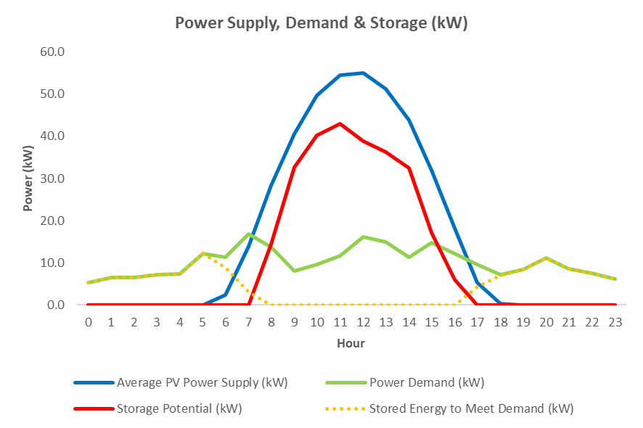

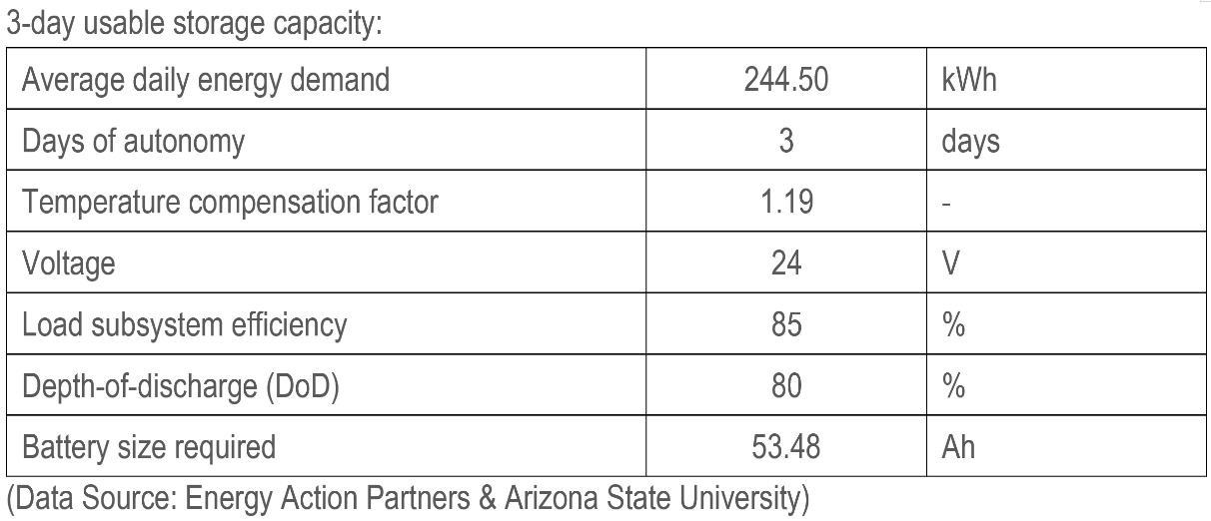
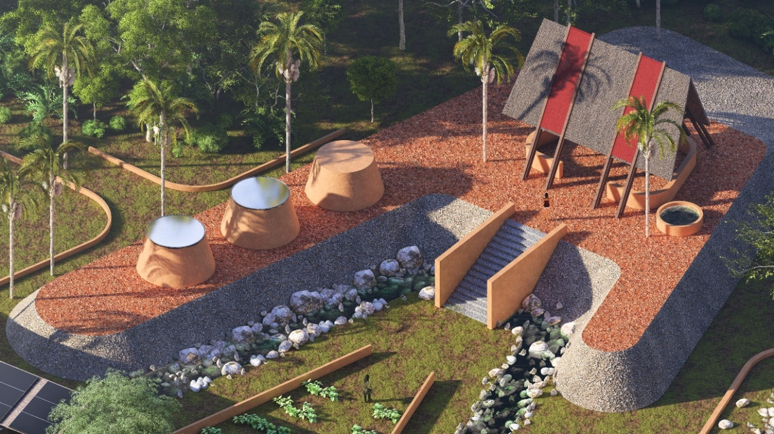

Solar Dryer
Solar dryer is designed as a natural and zero-energy food preservation solution that extends the life of local produce. Its main structure is built using rammed earth, a material chosen for its thermal mass, durability and low embodied carbon. The cover is constructed from polycarbonate panels, which are impact-resistant, lightweight and provide better UV protection compared to glass. These transparent panels allow ample sunlight to enter, trapping heat inside while keeping rain and pests out, creating a greenhouse effect that efficiently dehydrates local produce.

Biogas Digester
The biogas digester converts organic matter such as crop residues, food waste and livestock manure into usable biogas under anaerobic conditions. Biogas, primarily composed of methane, is piped directly to communal kitchens for low-emission cooking by reducing dependence on firewood or charcoal. The digestate byproduct, a nutrient-rich slurry, is applied back onto the agroforestry landscape as organic fertilizer, contributing to better waste management and agricultural productivity enhancement.

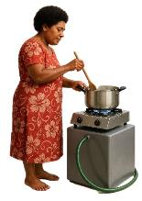
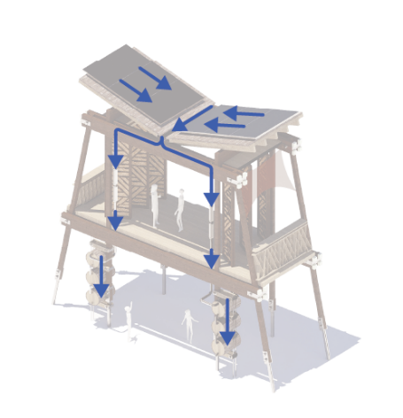
Rainwater Harvesting with Multi-Stage Filtration System
The butterfly roof serves as the rainwater catchment area and directs the rainwater to flow into the gutter which is positioned in the center. Rainwater is then channeled through gravity-fed multi-stage water filtration system which is mounted to the vertical timber column. The water filtration system includes sand and sedimentation filters, activated carbon filters and UV disinfection unit. Water is then stored in the timber barrels, traditional in appearance but innovative in function. Inspired by the “Hippo water roller” concept, these timber barrels are mobile, allowing residents to conveniently transport water back to their homes.

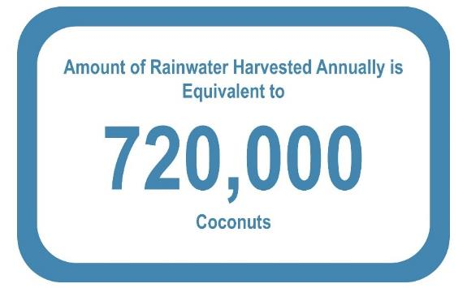

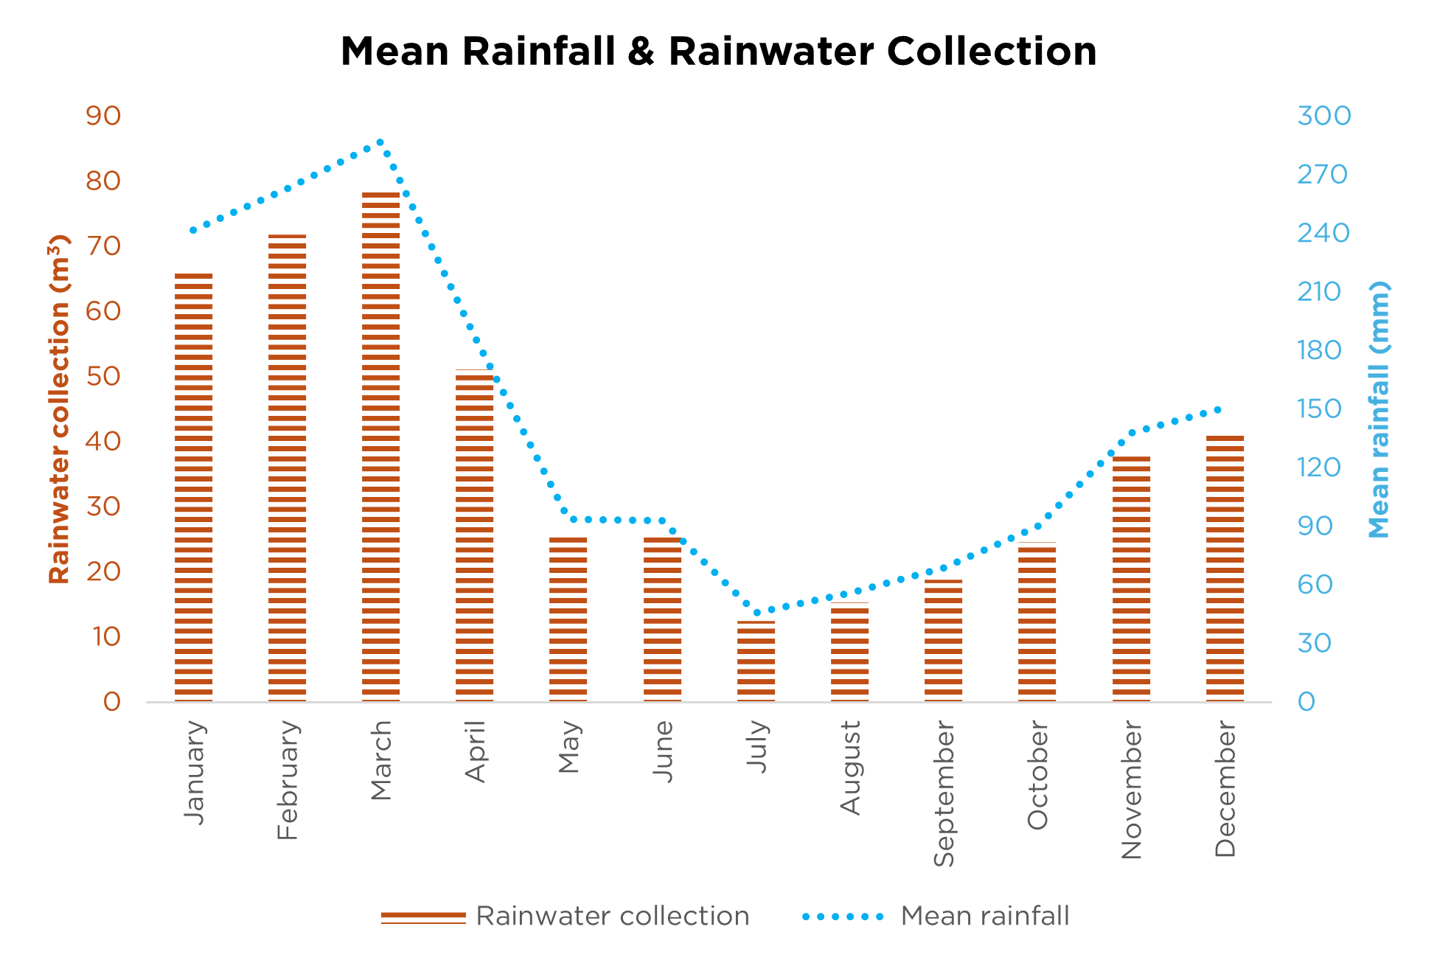

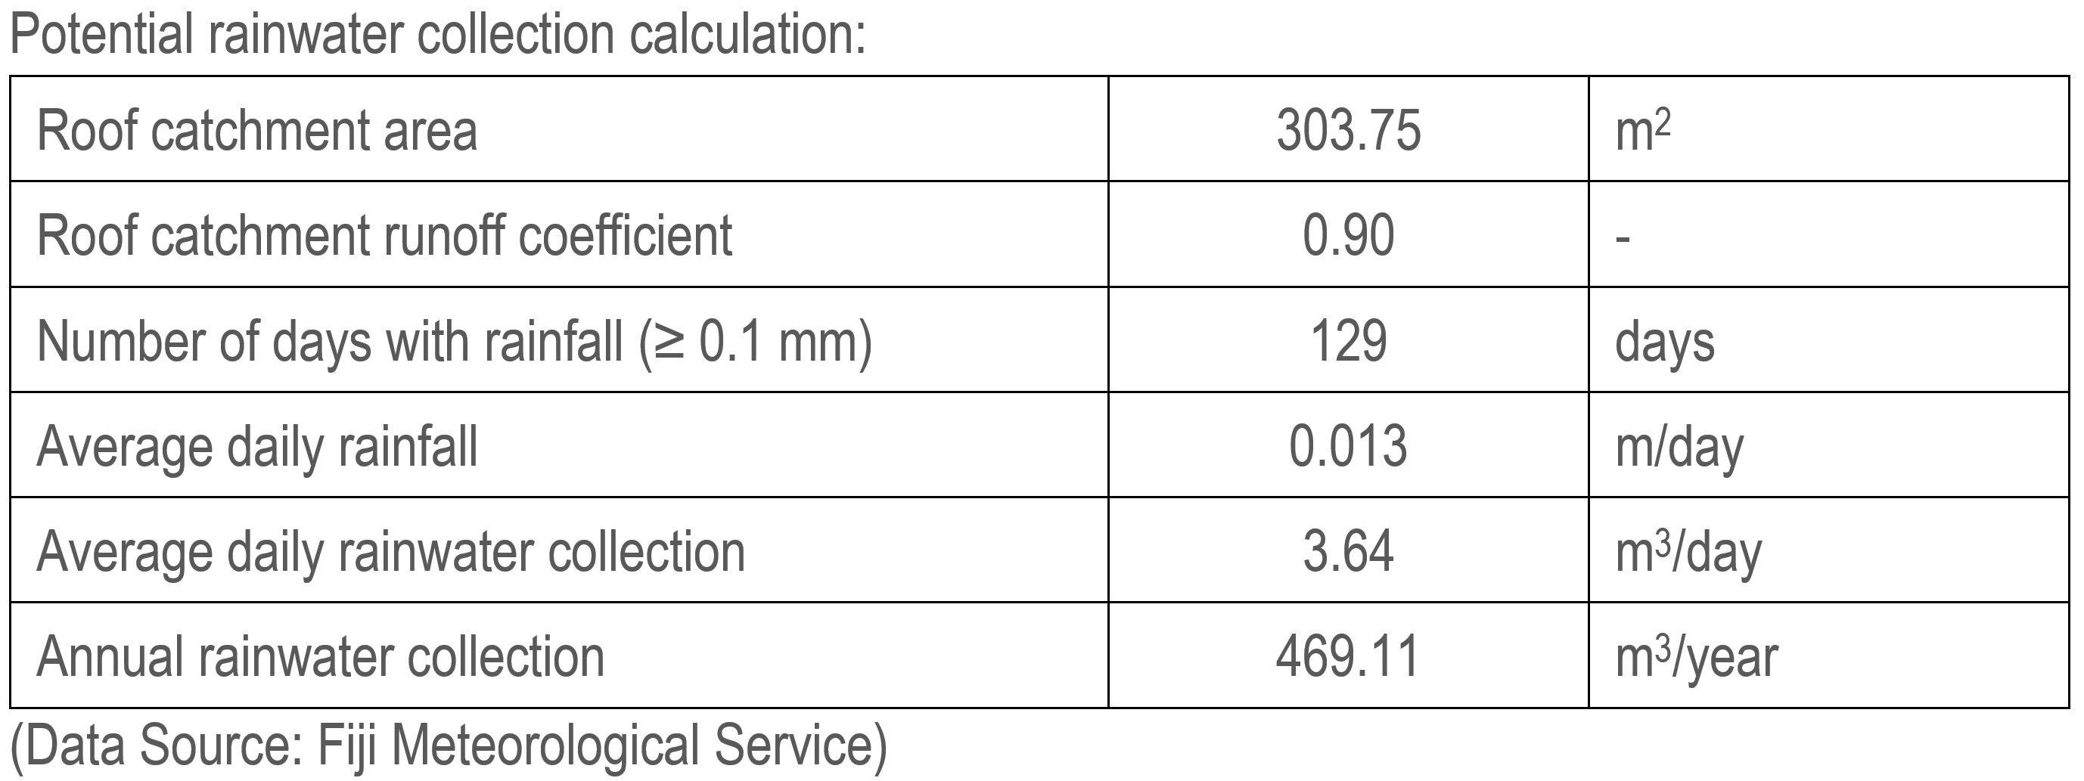

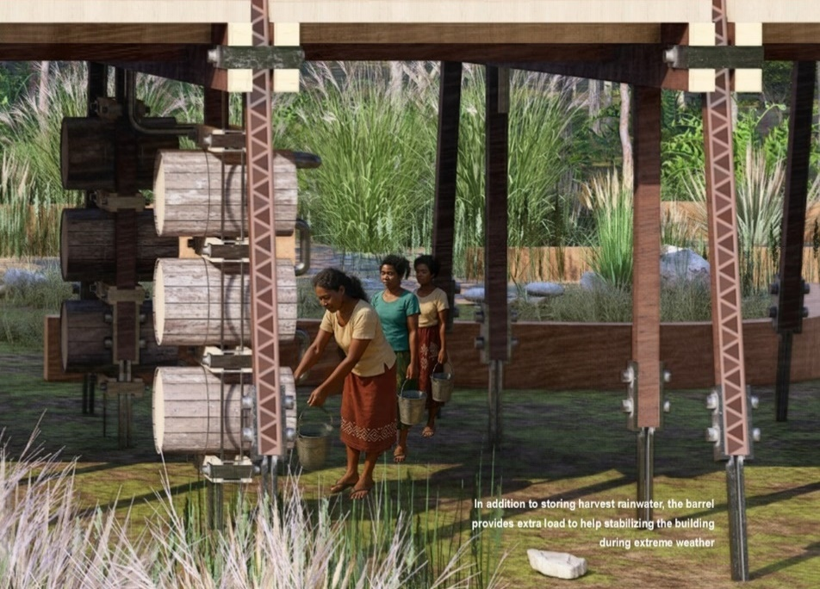

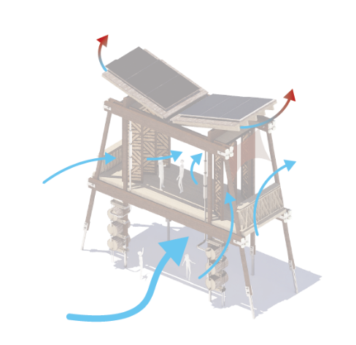

Passive Design Strategies
The Spine embraces a suite of passive design strategies that prioritize thermal comfort, natural ventilation and visual connection to the outdoors. Cross ventilation is optimized through operable doors that can be rotated to face the incoming wind direction, enhancing indoor air movement. The perforated doors allow airflow when closed during rain but preserve outward views and a sense of connection to the surrounding landscape. The elevated design facilitates a secondary cross ventilation path beneath the deck where cooler air flows under the structure. The butterfly roof design enables hot air generated from internal loads to escape through stack effect. Locally crafted materials are repurposed as sun-shading devices that filter harsh sunlight, reducing glare while allowing soft diffuse daylight to illuminate the interiors.

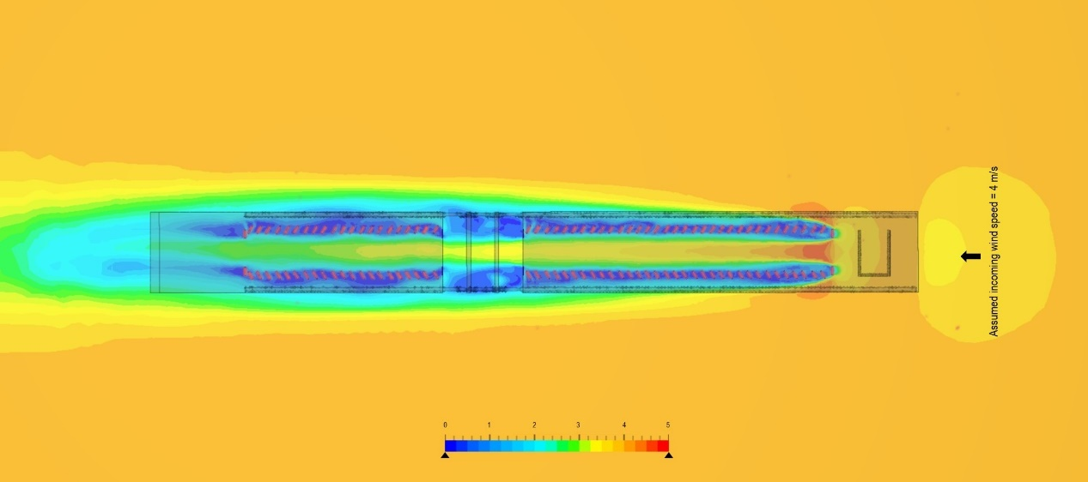

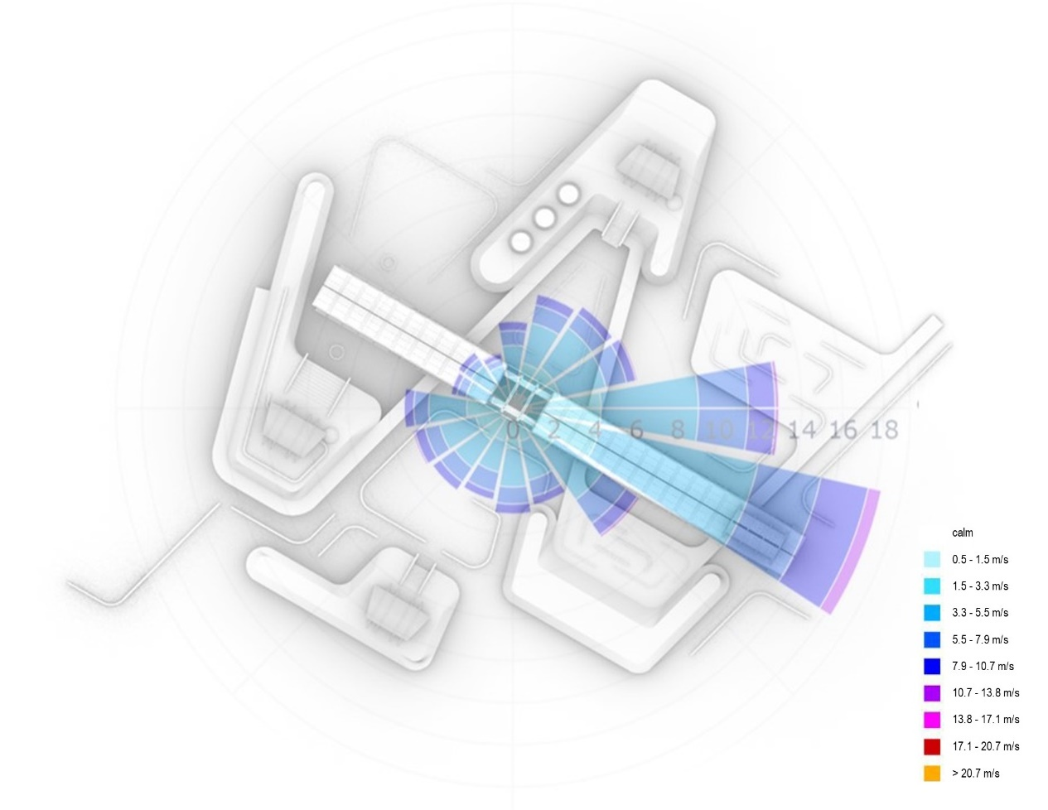

Mist Catcher
Greenery intensification fosters a cooler microclimate through evapotranspiration, increasing ambient moisture and enabling mist formation. A lightweight mist catcher harnesses this natural process to collect water passively. Designed for resilience, it can be easily dismounted during extreme weather events to reduce wind load and protect the structure.

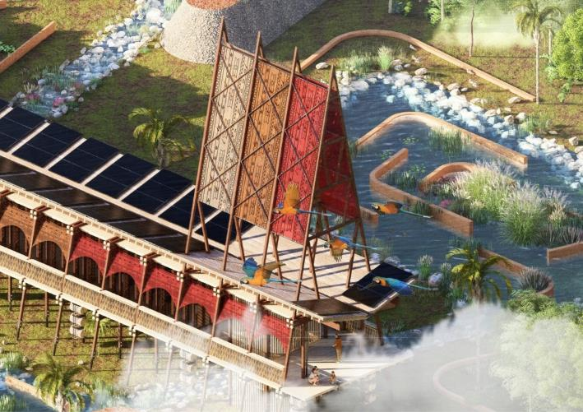

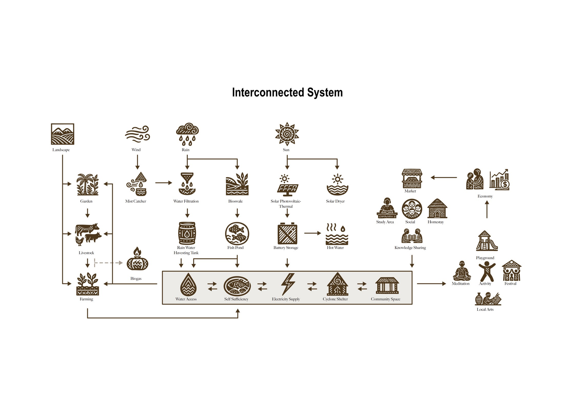

- Prototyping and Pilot Implementation Statement

Prototyping Process
A prototype of a single module unit of The Spine will be constructed at actual scale to demonstrate the simplicity of assembly, as each unit is part of a modular system designed for easy replication and flexibility. The structure will be built using mainly timber. Simultaneously, a comprehensive 3D model of the entire site boundary will be developed to illustrate the integration of landscape systems, decentralized utilities and spatial arrangements. This model will be used to communicate the project’s vision to stakeholders and support future training and educational outreach.

Full-Scale Pilot Implementation
For the full-scale pilot implementation, a community volunteering program will be initiated to increase manpower and accelerate the construction timeline. Volunteers will be invited to either stay with local residents through homestay arrangements or rent rooms on nearby islands. This hands-on building experience is expected to be particularly enriching for students from built-environment backgrounds, offering them an opportunity to bridge academic learning with real-world applications. Meanwhile, local community will be engaged in fabrication of culturally significant elements. Training sessions and knowledge transfer workshops will be conducted to empower residents with the skills to operate and maintain the site. Collaborative planning with the community will also explore how the regenerative land art can be activated as a homestay destination, fostering local entrepreneurship and sustainable economic opportunities in the future.

- Operations and Maintenance Statement

Locally Sourced and Locally Crafted Materials
Structures are designed to require minimal mechanical systems, reducing the dependency on external servicing. The choice of timber, thatch, rammed earth and stone ensures that TFOL’s construction is inherently maintainable by the community using familiar techniques. Natural finishes, breathable materials and modular connections minimize wear and allow components to be repaired or replaced individually without disrupting the whole system.

Solar PV-T and Battery Storage System
Solar PV-T modules are installed on roof, capturing energy while allowing rainwater to wash off dust and debris. These modules typically have a lifespan of >20 years, a long-term investment with minimal upkeep. The setup is paired with battery storage to store excess energy generated during the day. The batteries and inverters generally have a lifespan of around 10 years and are designed for easy replacement and compatibility. Simple visual indicators and analog meters are used to monitor system performance without the need for complex software. Local technicians can be upskilled to handle future replacements and minor troubleshooting, creating new green job opportunities while reinforcing self-sufficiency of the village.

Rainwater Harvesting with Multi-Stage Filtration System
Timber barrels used as storage tanks are highly maintainable, can be readily sourced, repaired or replaced by local carpenters. The multi-stage filtration system is mounted vertically on timber columns, allowing for gravity-fed flow and eliminating the need for pumps. Each filter is designed to be individually removed and replaced when needed, reducing downtime. The system is community-manageable to ensure long-term functionality.

- Environmental Impact Assessment

Vegetation and Ecosystem
While TFOL seeks to minimize ecological disruption, certain impacts are unavoidable. Some existing trees on site will need to be responsibly harvested and repurposed as construction materials. Where feasible, mature trees will be carefully relocated to other parts of the site to preserve canopy cover and ecological continuity. To further mitigate the initial disturbance, greenery intensification strategy is proposed to enhance local biodiversity, strengthen the habitat network for wildlife, stabilize soil to prevent erosion, regulate microclimates and support the water cycle through improved evapotranspiration. This short-term disturbance will turn into long-term regenerative opportunity.

Embodied and Operational Carbon
A 50-year projection on both embodied and operational carbon has been assessed, the development is on track to achieve net zero carbon before 2050. This aligns with Fiji’s national commitment under its updated Nationally Determined Contribution (NDC) to the United Nations Framework Convention on Climate Change (UNFCCC), reinforcing TFOL’s role not just as a sustainable prototype, but as a model of climate leadership rooted in place.

