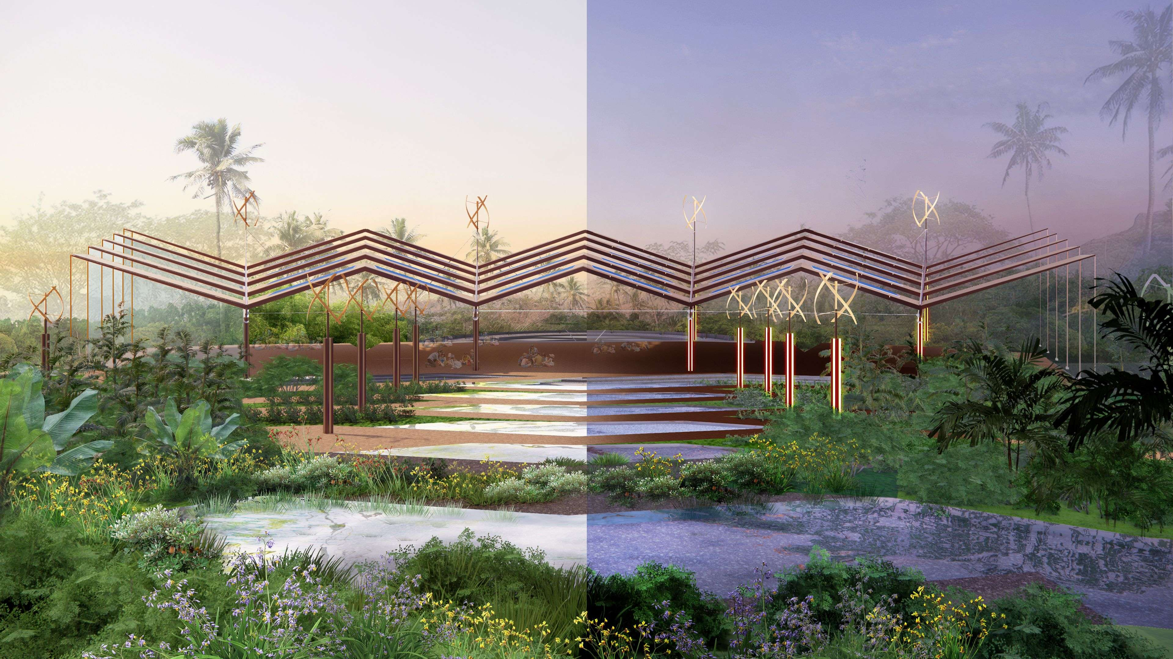

Threadscape
Weaving Marou Village’s Energy, Water, and Community Threads into an Ecological Artwork

LAGI 2025
Marou, Fiji

Table of Contents
Chapter 1: Concept Narrative 3
Method 4
Metaphor 5
Material 5
Matter 5
Chapter 2: Technical Narrative 6
Energy Production 7
Water Purification 7
Landscape Features Promoting Cultural Gathering 9
Material Consideration 9
From Resources to Resilience 9
Chapter 3: Prototype and Pilot Implementation 10
Prototyping Process and Timeline 11
Estimated Budget Breakdown 12
Chapter 4: Operations and Maintenance 14
PV Panels 15
Wind Turbines 16
Landscape and Water System 16
Severe Weather Resilience 17
Chapter 5: Environmental Impact Assessment 18
Material Selection 19
Zero Emission Operation 19
Low Impact Landscape 19
LCA Considerations 20
Appendix 21
Simulation Setup and Calculation Assumptions 21
PV Panel Specifications 21

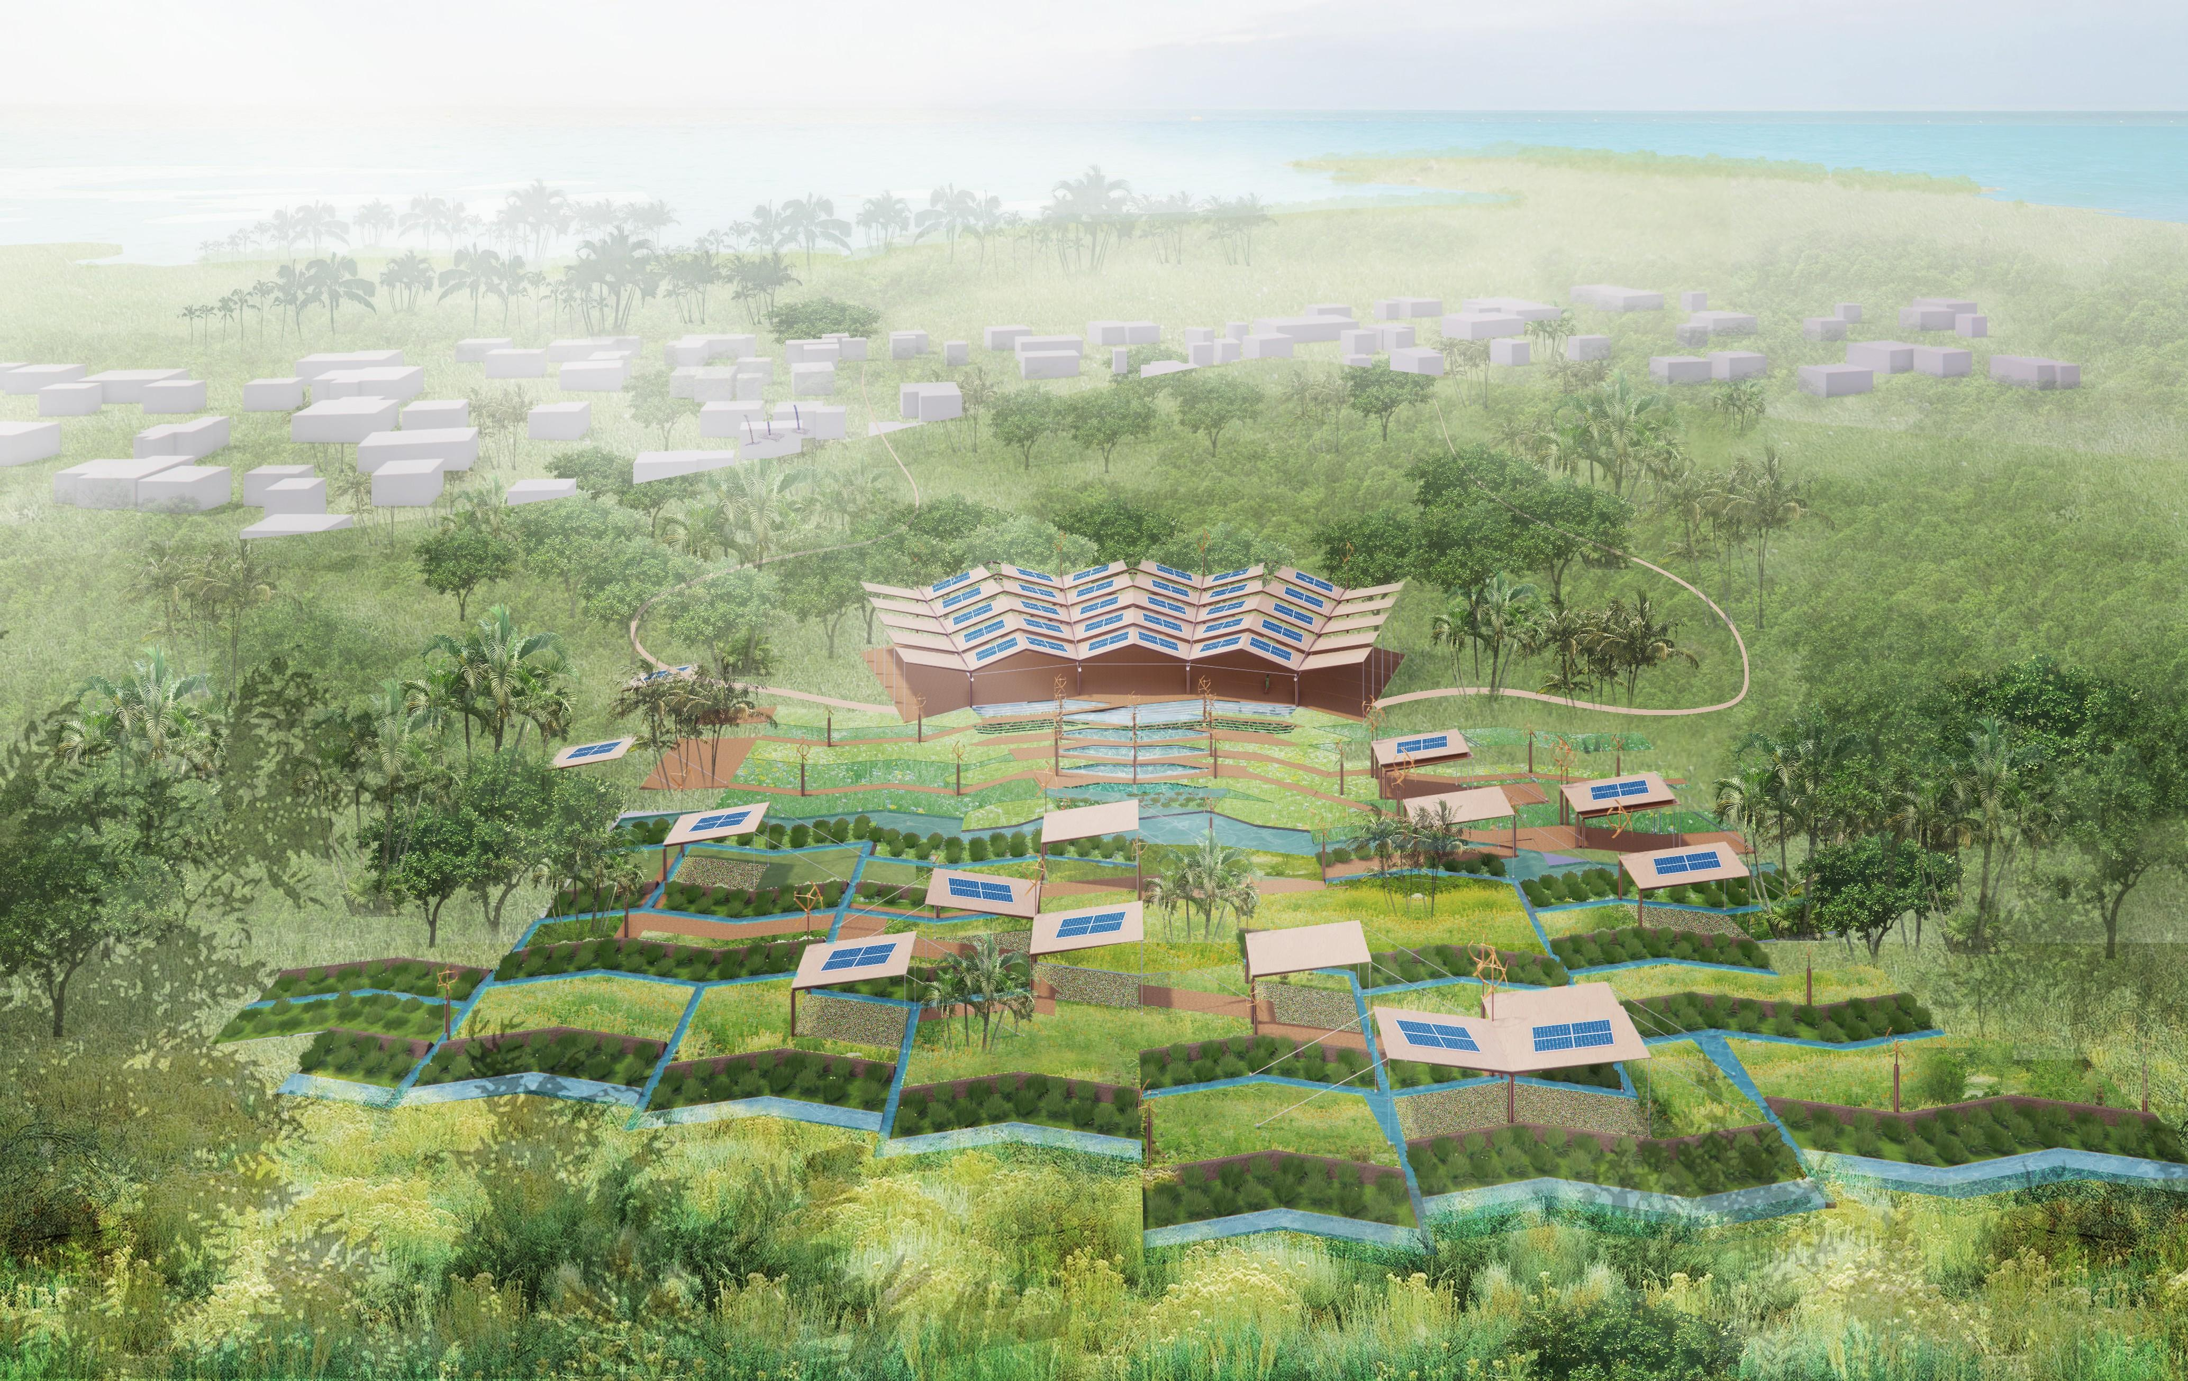

Chapter 1: Concept Narrative

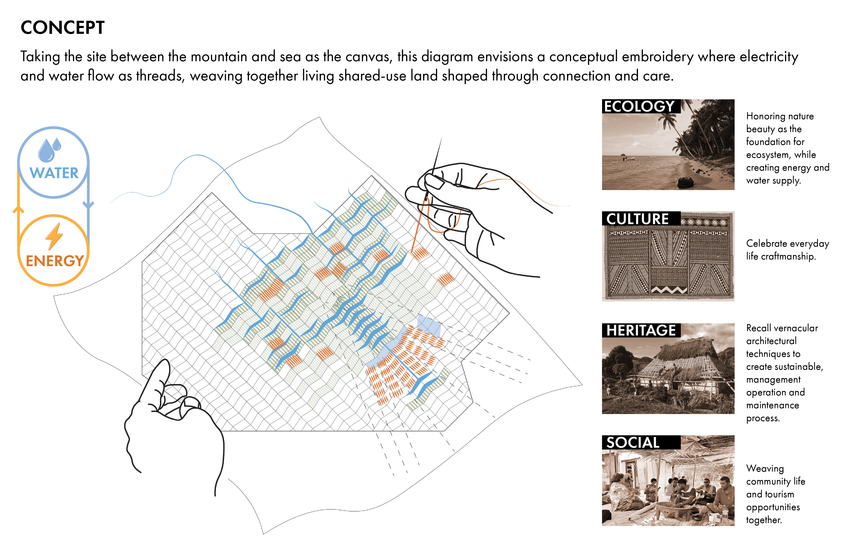

Threadscape addresses the escalating climate and energy challenges in the Village of Marou by building a design vision rooted in resilience and celebration of the village’s cultural tradition. Inspired by TaliTali, the Fijian practice of weaving used in daily life, the project utilizes weaving as both method and metaphor to interlace energy, water, culture, and social life into a living, adaptive system. In Threadscape, the site becomes a landscape of learning, where the physical embodiment of energy and water systems offers an immersive experience that makes the village’s climate adaptation strategy visible and participatory.

Method
The core of the project is a collective, living toolkit, composed of Canvases, Patches, and Stitches. Together, it offers a framework for building, learning, and thriving among the residents of the Village of Marou.
- Canvas: Large functional elements located on the site, including the land-art pavilion, evaporation pond, and fountain pond. They drive the generation, filtration, or storage of energy and water. They anchor social focal points, providing gathering spaces for community activities.

- Patch: 1) Scattered, stand-alone installations that prototype micro-energy generation and provide shade along the site pathway; 2) Landscape treatment parts, such as filter strips, conveyance channels, treatment planters, and sand gravel filters. Together, they occupy the in-between spaces on the site, helping to connect and weave the energy and water system’s components.

- Stitch: 1) Lightweight infrastructural and lighting poles strategically placed across the site, offering easy-to-install options for street lighting, wind generation, and local connectivity; 2) Drinking fountain pipes that provide accessible potable water. Together, they create pinch points that highlight moments of serendipity as one wanders through the site.

Metaphor
Threadscape practices weaving as a collective action of shared land stewardship. It serves as a precedent of how Marou residents can imagine the future of their village, where population growth and tourism opportunities emerge on the living land. On the one hand, Threadscape allows for flexibility: it is an ever-growing ecological artwork. Canvases, Patches, and Stitches can be added or removed based on the evolving needs of the village. On the other hand, Threadscape empowers the sense of community ownership by creating gathering spaces that interweave daily life with cultural heritage, craftsmanship, and lived knowledge.

Material
Threadscape also emphasizes that nature is an active agent and an integral part of the artwork. We prioritize vernacular materials—such as Fijian bamboo, woven textiles, and fronds from screw pine and coconut trees—to achieve a low-carbon footprint, while balancing the use of off-the-shelf products that are cost-effective, transportable to Marou Village, and resilient to high-wind events.

Matter
Designed to be replicable and adaptable, Threadscape is more than a place-based built artwork. It is a process of sharing, connecting, and caring that can extend beyond the Village of Marou. Our proposal envisions a form of art where nature is the co-creator, residents are the owners, and the future is not fixed, but woven.

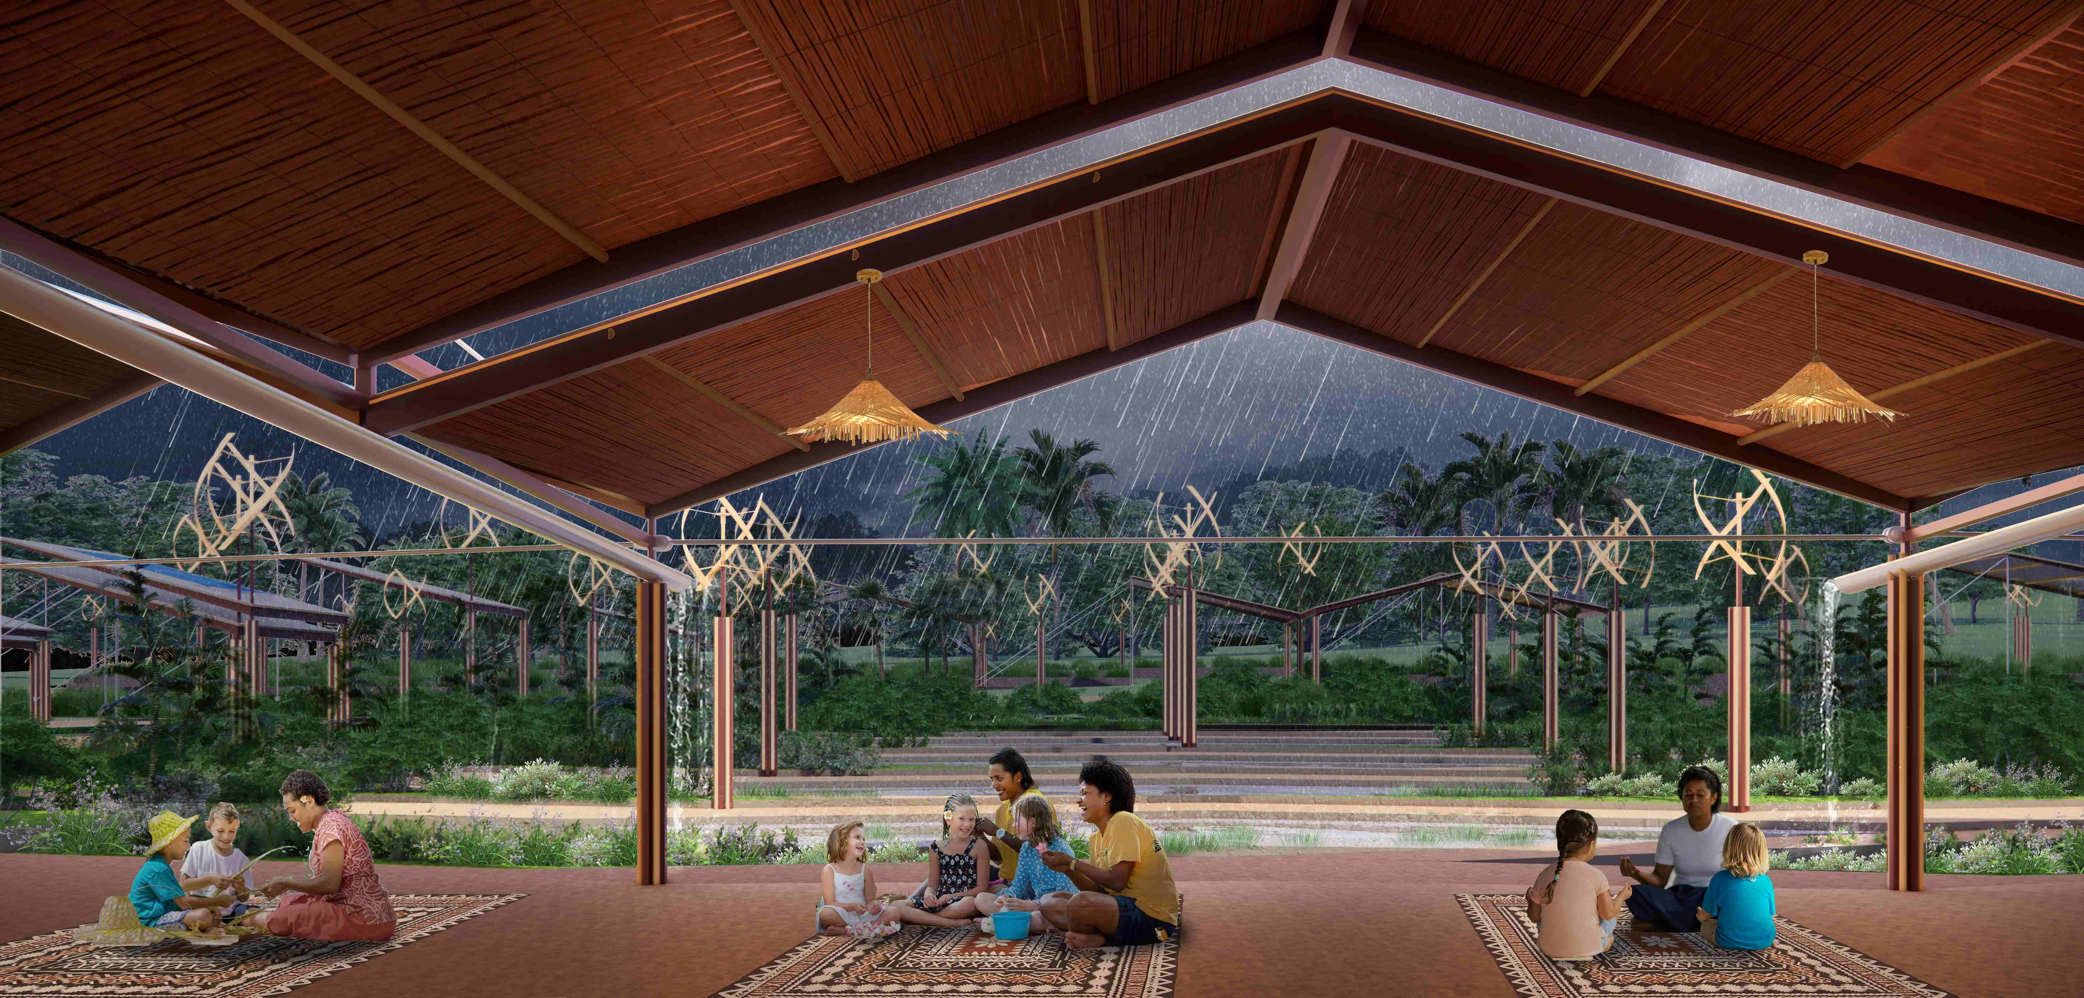

Chapter 2: Technical Narrative

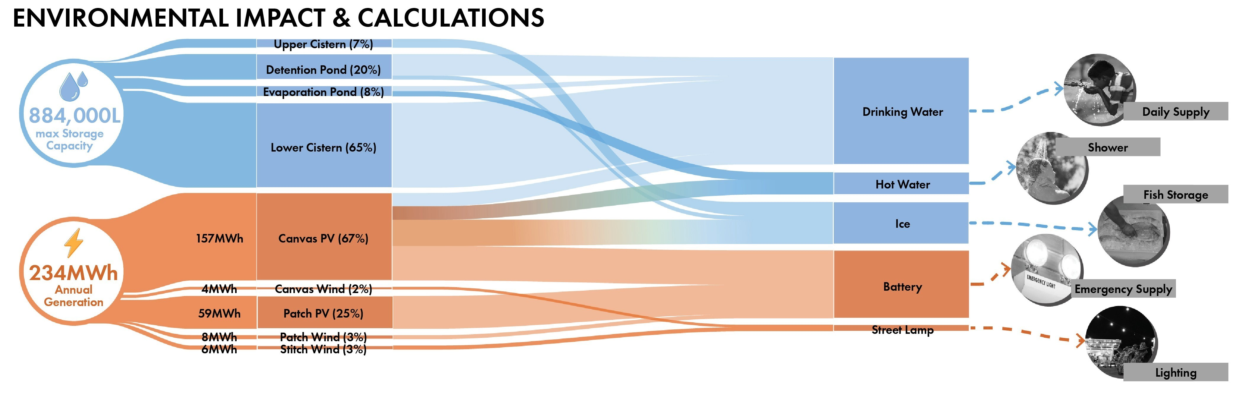
Threadscape is a land art installation that interlaces energy production, water purification, and cultural gathering into a living system. This project integrates ecological infrastructure across three architectural scales: Canvas, Patch, and Stitch. Each structure plays a role in delivering renewable energy, managing water, and shaping a resilient public realm for the Marou Island community.

Energy Production
At the center is Canvas, a large pavilion that functions as a community hub and primary energy generator. Its rooftop supports 120 monocrystalline solar panels (84 kW total), producing 157 MWh/year, which exceeds the village’s estimated demand of 138 MWh/year. Vertical-axis wind turbines (VAWT), present across all scales, supplement solar generation by an additional 8%, while serving as kinetic markers of resilience. Patch structures extend this logic in modular form, offering shaded spaces and power at smaller scales. Stitch, the smallest unit, combines wind turbines and LED lighting strips to improve nighttime safety and visibility.

Water Purification
The water system follows the same weaving logic, integrating natural cycles with engineered interventions. Inspired by the region’s clean rainfall and forested watershed, the design collects rainwater via roof surfaces and landscape run-off. Water is filtered through vegetated treatment basins, then moves through a detention pond before entering an evaporation pond powered by solar and PV electricity. The resulting distilled water is stored in a 580,000-liter cistern, which nearly doubles the village’s existing storage capacity and is intended primarily for dry season use. We designed the system to have 1 MWh battery storage, enough to power the village for 12 hours at peak load and more than 2 days with regular usage. To reduce battery reliance, thermal energy is stored via the evaporation pond’s heated water and ice produced during periods of excess power, which supports fish preservation and interior cooling during outages.

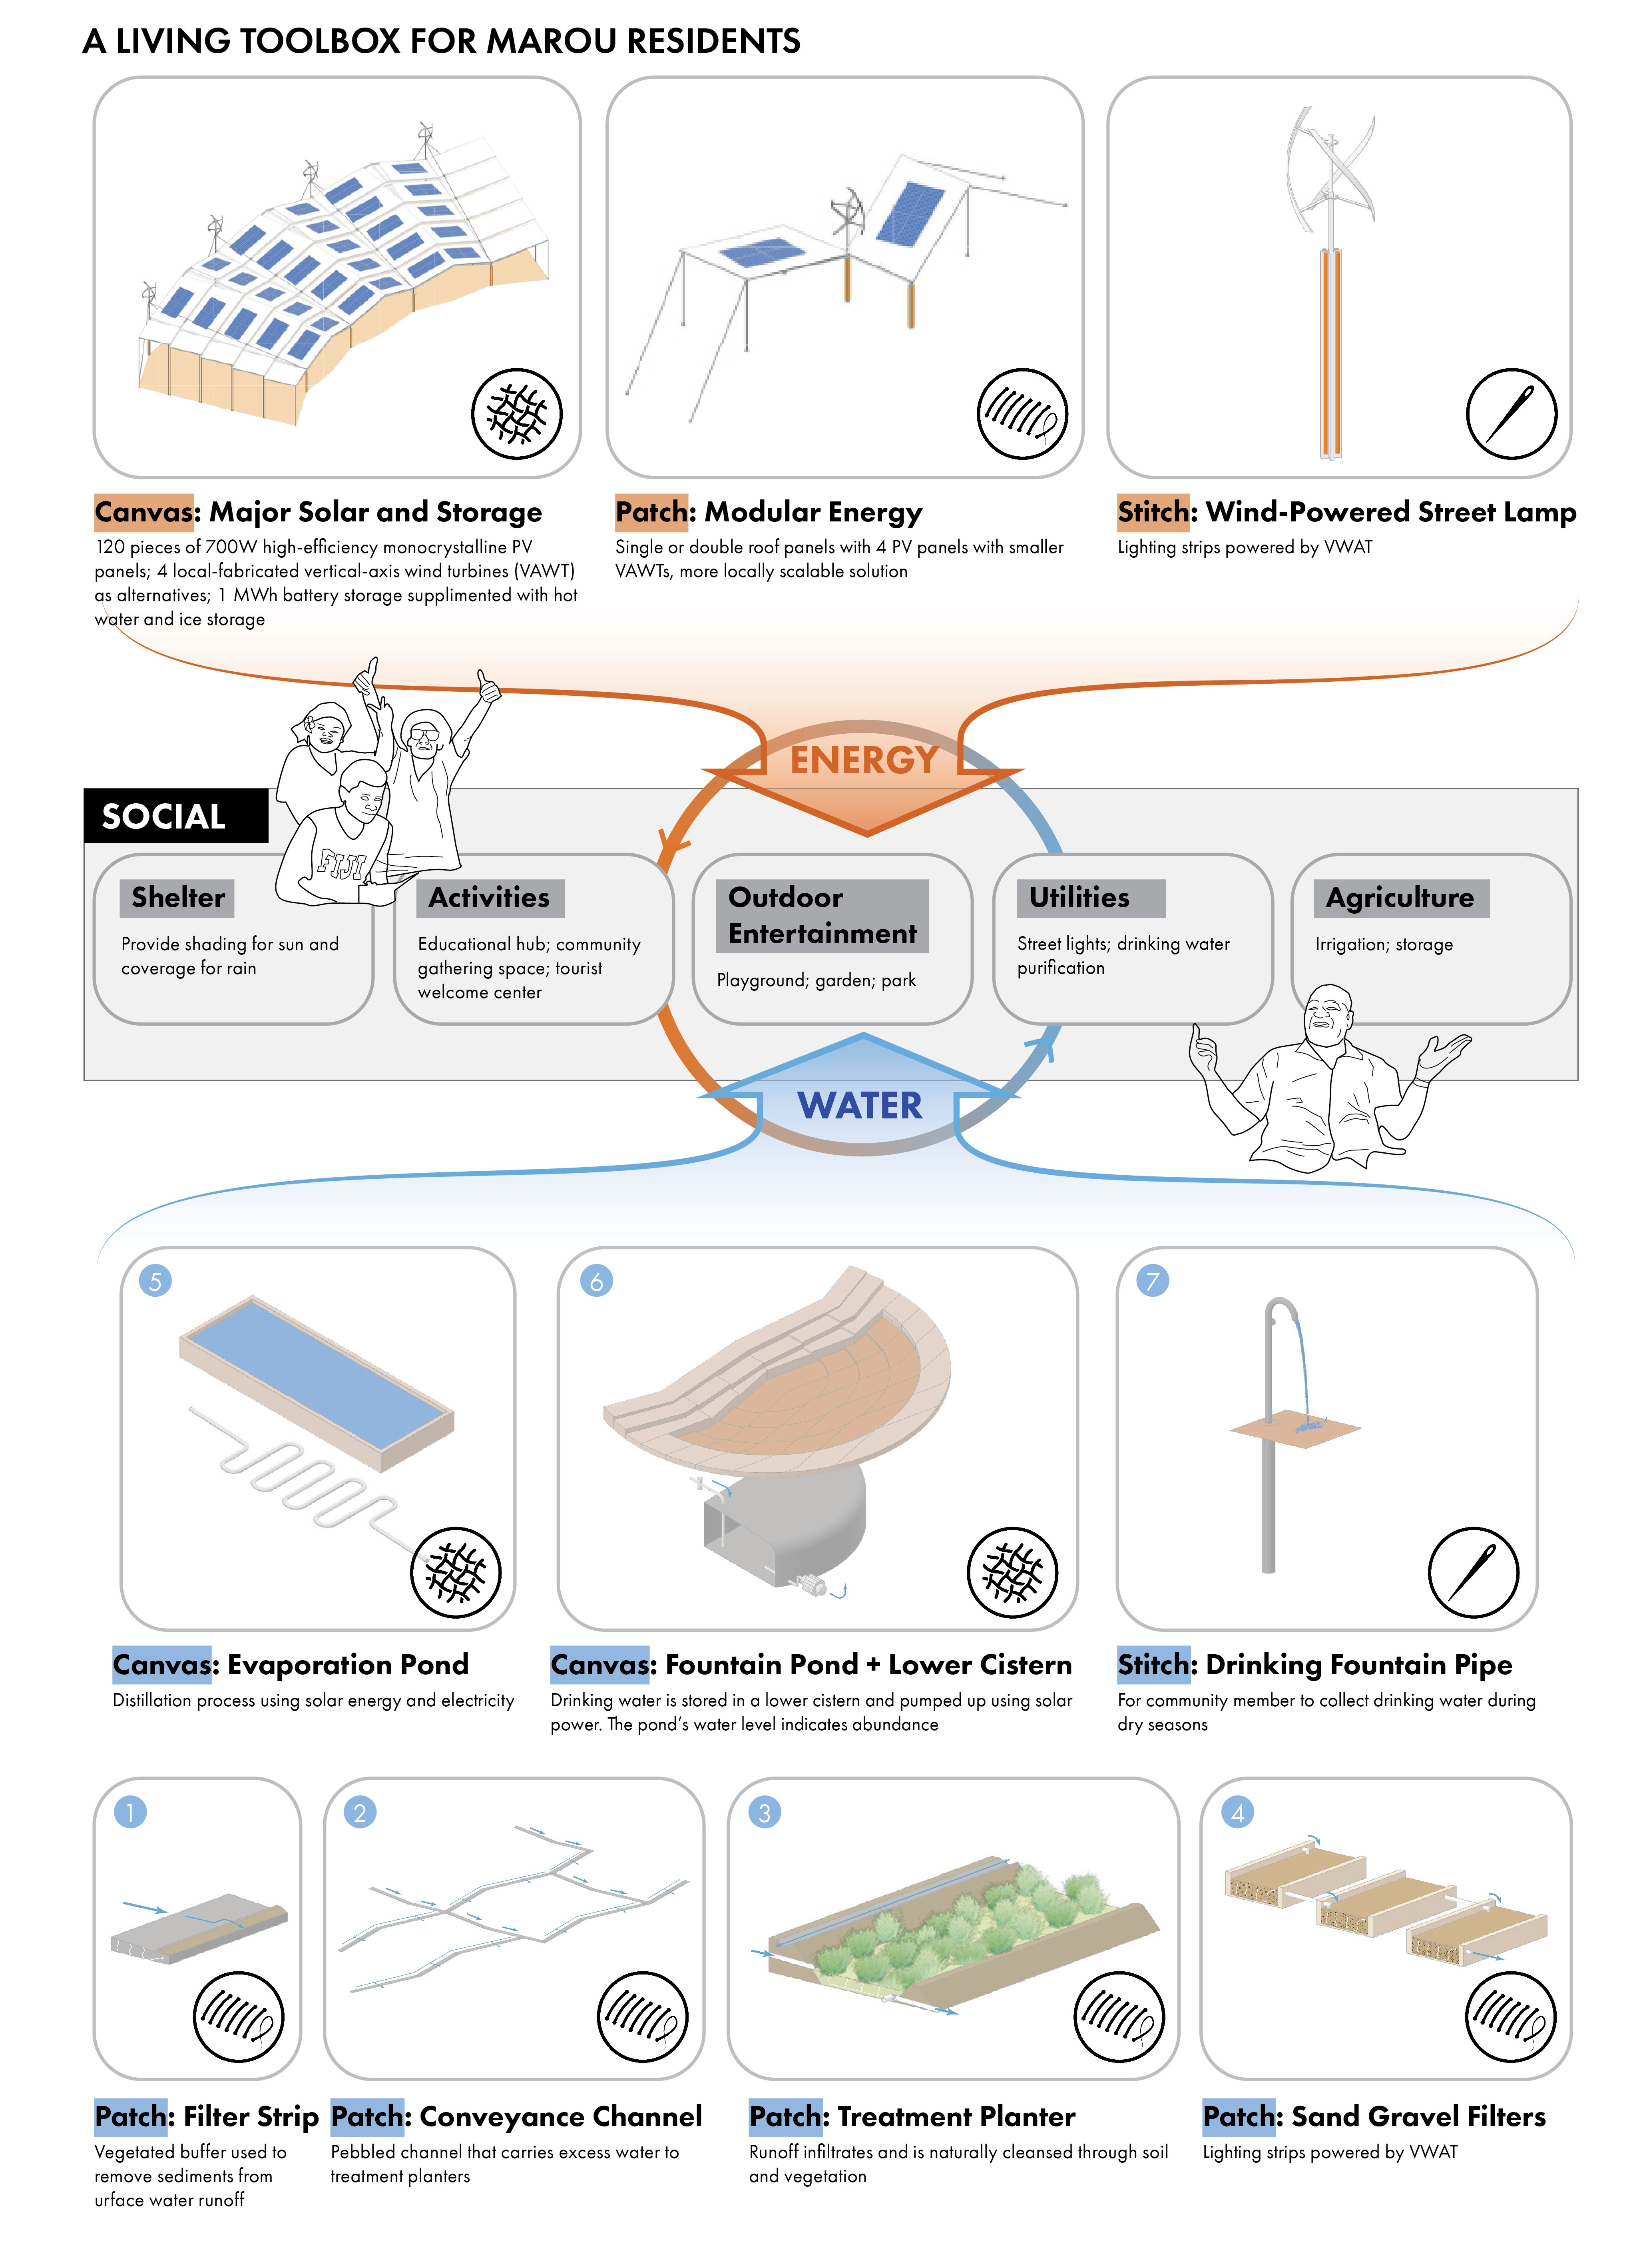

Landscape Features Promoting Cultural Gathering
The landscape strategy also employs a series of check dams and retaining walls to prevent erosion from mountain slopes and periodic flooding. Native plants stabilize soil, enhance filtration, and reflect local biodiversity. The water system culminates in two ponds near the central pavilion—one for surface runoff filtration and gathering, and the other as a scenic, potable water reservoir with an amphitheater for the village.

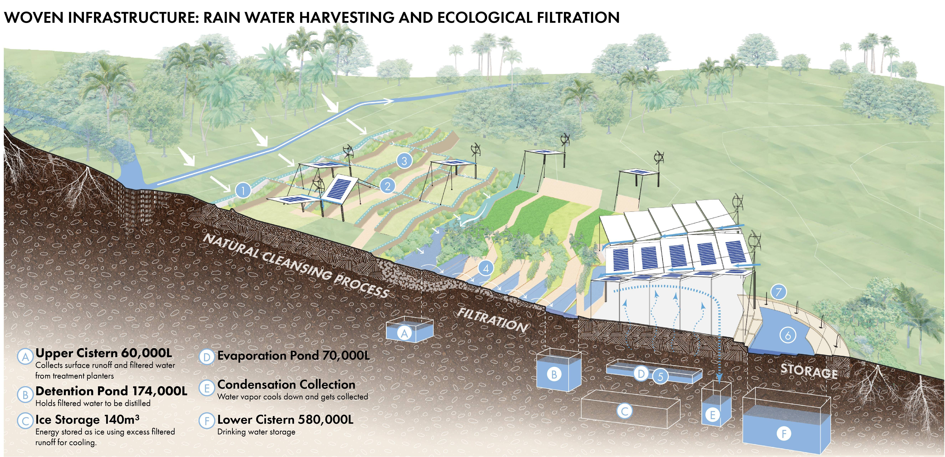

Material Consideration
Material choices prioritize low-carbon, vernacular construction: Fijian bamboo, woven textiles, and fronds from screw pine and coconut trees are paired with recycled steel and on-site concrete. These components are resilient, repairable, recyclable, or biodegradable at the end of their lifecycle.

From Resources to Resilience
The abundant and site-specific system inputs include solar radiation, wind, and rain. The outputs are transformative: clean energy, drinking water, thermal storage, and vibrant communal space. Together, these systems form a woven infrastructure, a Threadscape that sustains life, celebrates culture, and adapts to Marou Island’s evolving needs.

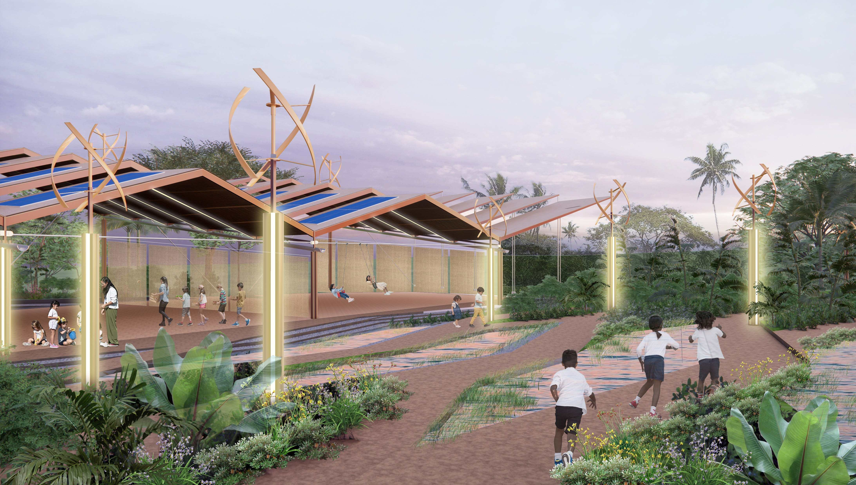

Chapter 3: Prototype and Pilot Implementation

Our team’s prototyping strategy is designed to serve as a technical proof of concept and a catalyst for community engagement and capacity-building. With the $100,000 award, we propose to prototype the Patch installation component. This mid-scale, modular structure embodies the core architectural, ecological, and infrastructural principles of our entire system, while being appropriately sized for pilot testing in both fabrication and community use.
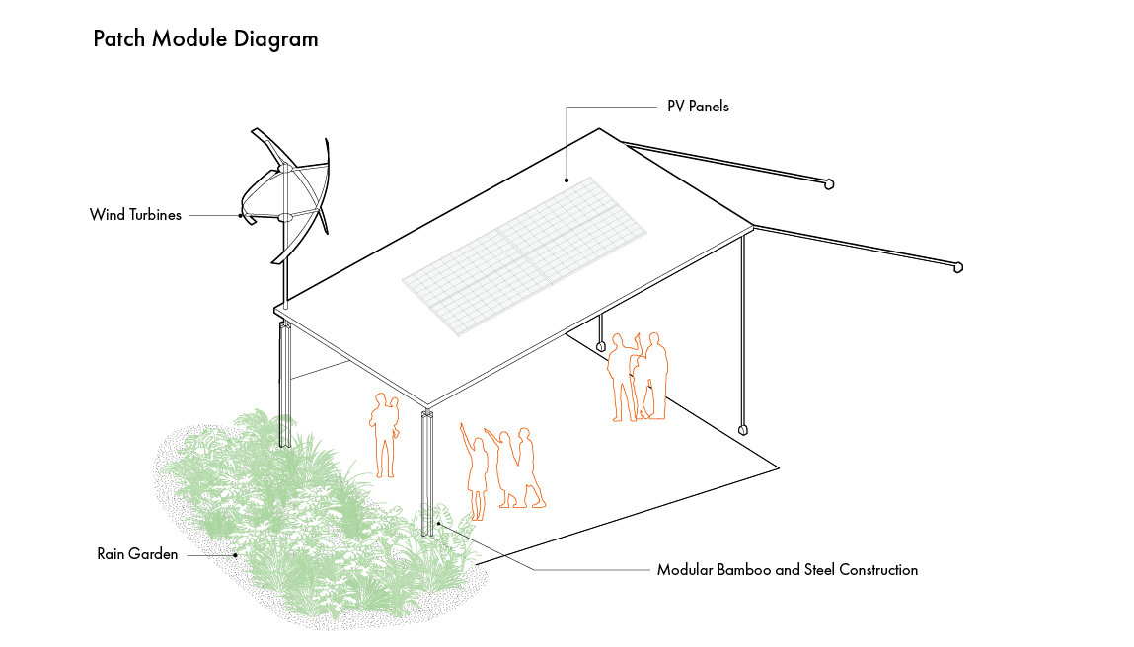
The Patch represents the larger Canvas pavilion and is scalable into smaller Stitch units. It contains critical elements of our proposal—PV panels, wind turbines, passive water collection and filtration systems, and modular bamboo and steel construction—allowing us to validate the technical integration of energy, water, and material systems. Its scale makes it logistically manageable for transport, construction, and iterative testing. Lessons learned from this pilot will directly inform full-scale implementation while creating an immediately usable space for villagers.

Prototyping Process and Timeline
Our prototyping process will be staged across three key phases:
- Design Refinement and Fabrication Preparation (Month 1–2):
  - Finalize construction drawings and structural detailing of the Patch module.
  - Identify material suppliers and local craftspeople.
  - Collaborate with engineering advisors to confirm electrical integration for PV and wind systems.
- On-site Construction and Assembly (Month 3–4):
  - Team of 4–6 core members, including one architect, one structural designer, one systems engineer, and one fabrication coordinator.
  - Additional on-island support team: local builder liaison, community coordinator, and student apprentices from local schools or training centers.
  - Collaborate with local craftspeople to build:
    - Furniture made from local straw and bamboo.
    - Hanging carpets for flexible interior division.
    - Roof thatching using fronds from palm, pandanus, and native grasses—materials traditionally used in Fijian vernacular architecture.
- Testing and Community Engagement (Month 5):
  - Monitor energy and water systems.
  - Host open workshops with residents to demonstrate system function and gather feedback.
  - Co-create maintenance routines and visual instruction guides with community members to embed knowledge locally.

Estimated Budget Breakdown
Category | Description | Estimated Cost
Materials | Bamboo, recycled steel, PV panels, wind turbine parts, water system hardware, roofing thatch | $30,000
Barge Transport | Inter-island shipping for all construction components (est. 8-10 tons) | $12,000
Local Labor | Craftsperson contracts, community stipends, site prep | $20,000
Design + Engineering Oversight | Travel, coordination, and remote consultant support | $15,000
Community Workshops & Toolkit Development | Printing, facilitation, translation, and educational materials | $8,000
Contingency | Reserved for inflation, weather delays, or material shortages | $15,000
Total |  | $100,000

Our team is committed to involving local participation. Rather than importing finished solutions, we will work shoulder-to-shoulder with the community to co-create this prototype. This includes sourcing native plant materials, selecting meaningful design elements (e.g., weaving patterns for interior dividers), and establishing long-term stewardship roles. The skills and knowledge generated during prototyping will support system longevity and empower the community to adapt and replicate components over time.
The Patch prototype thus becomes more than a test structure: it is a living node of knowledge transfer, a celebration of Fijian building traditions, and a stepping stone toward a fully woven, self-sustaining, and locally owned infrastructure for Marou Island.

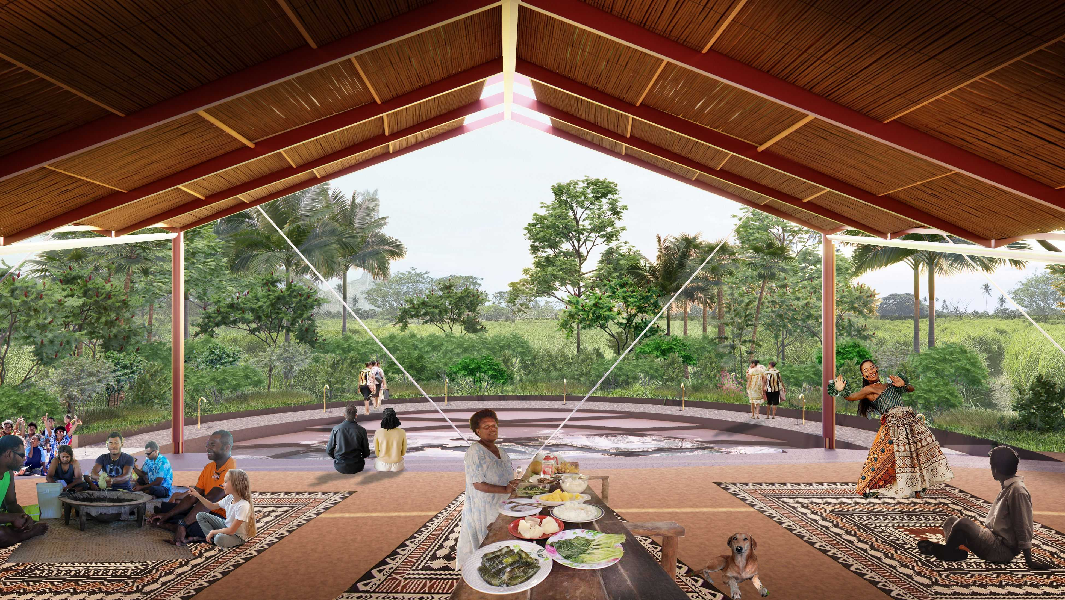

Chapter 4: Operations and Maintenance

Our project is committed to community ownership, ecological integration, and long-term resilience. Our operation and maintenance strategy is rooted in low-tech simplicity, intuitive systems, and the empowerment of Marou Island residents through a practical, locally adaptable toolkit. From energy generation to water treatment to landscape management, every component is designed to be maintainable by the community, with minimal technical expertise and infrastructure.

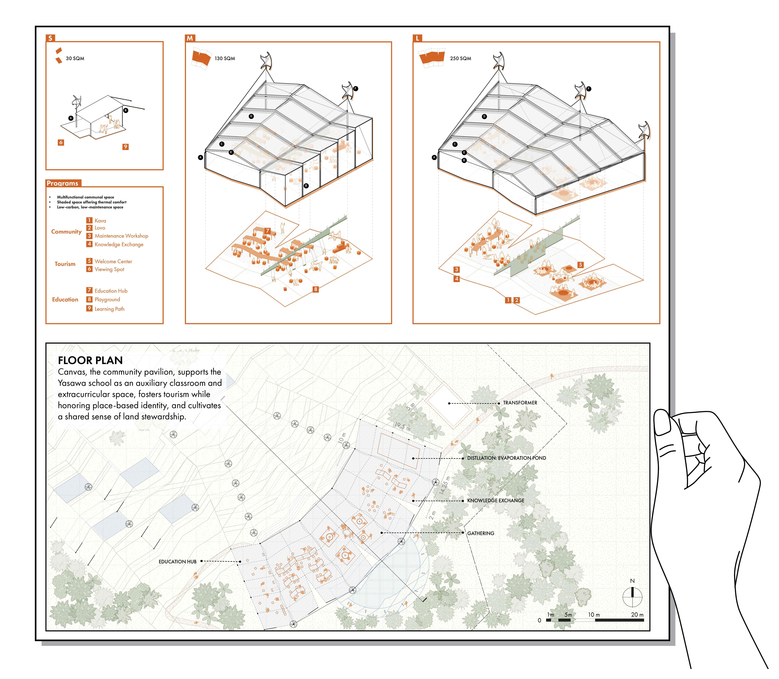

PV Panels
The solar photovoltaic panels are mounted atop the elevated Canvas and Patch structures. These fixed, stationary systems require minimal maintenance, with routine cleaning to remove dust or salt buildup that may reduce efficiency. Their elevation protects them from physical disturbance and flooding, and with a 25-year product warranty, they offer long-term reliability. Maintenance consists primarily of visual inspection and occasional rinsing, which can be easily incorporated into seasonal routines.

Wind Turbines
VAWTs are handcrafted using local bamboo, ensuring that repairs can be done within the community. Unlike conventional turbines, their compact and low-profile design makes them more stable in high-wind conditions yet allows for quick disassembly and repair in the event of cyclone damage. We propose engagement events to transfer maintenance knowledge, with quarterly checks and repairs for the Canvas pavilion. Community repair events, supported by training and visual guides, foster shared skills and long-term resilience.

Landscape and Water System
The passive and layered green infrastructure of the water system—integrated with the natural topography and native forest—requires minimal maintenance. Stormwater is passively channeled into a forebay, then flows via gravity-fed channels into a series of treatment planters for biofiltration. It is then stored in an upper cistern for sedimentation before being further filtered through sand and gravel beds, followed by biofiltration strips. The planters will feature perennial phytoremediation species such as Fiji Fan Palm, Fijian Ginger, and Tava, selected for their ability to naturalize and integrate into the island’s existing ecology with minimal long-term intervention. Open water features only appear after rainfall, serving as visual indicators of water abundance. Under dry conditions, the water treatment elements remain mostly dry but continue to follow the site's natural hydrological patterns, requiring only basic debris removal at outlet points. Seasonal trimming and clearing are also needed to maintain unobstructed flow.

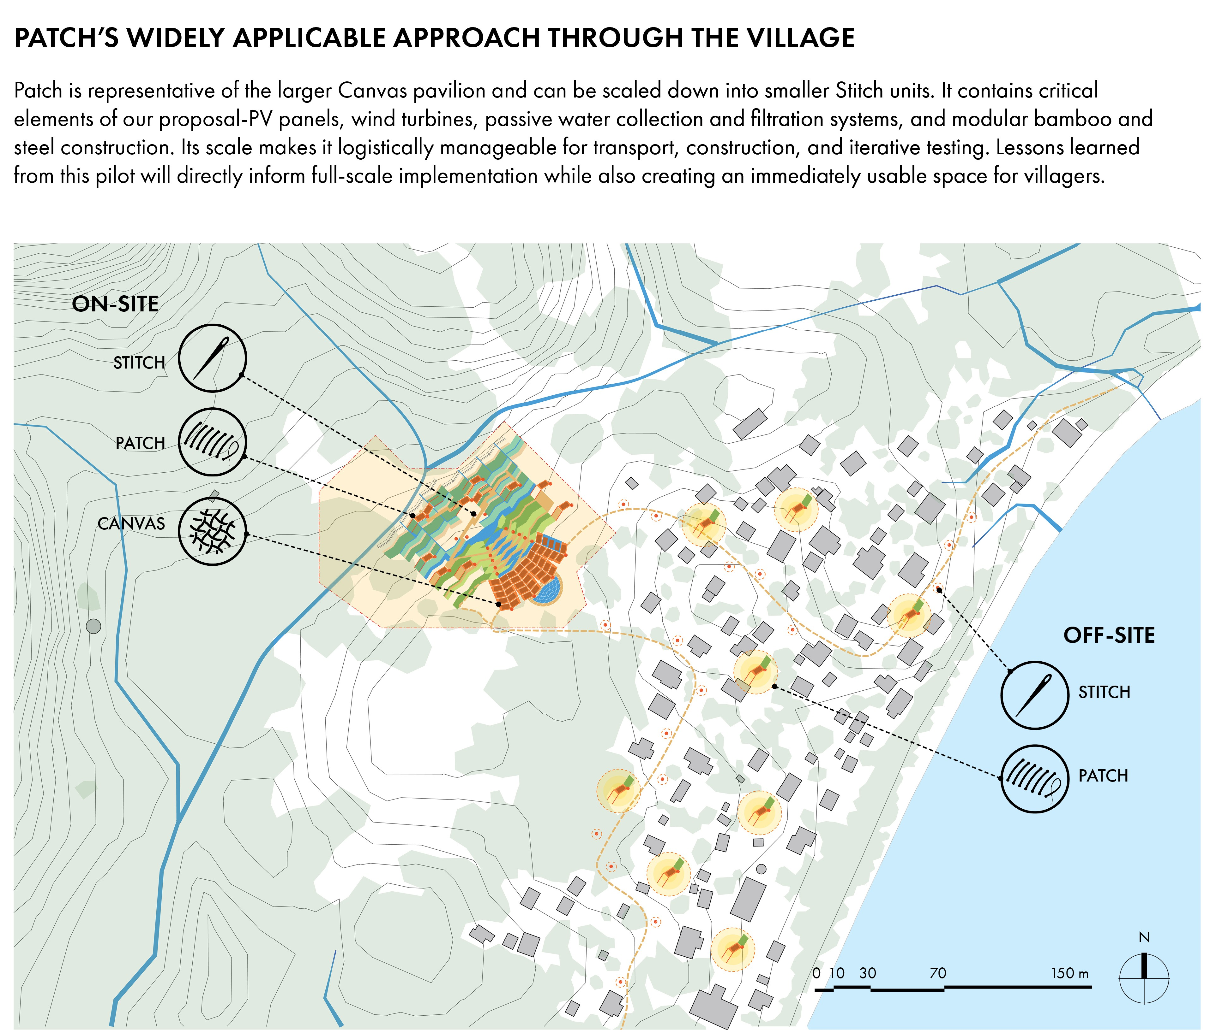

Severe Weather Resilience
Anticipating severe weather, including cyclones and flooding, our design incorporates multiple resilience strategies. The Canvas and Patch structures include drainage-integrated forms and enhanced joint connections. All energy and water components are modular, allowing quick replacement or temporary removal. Vegetated slopes and permeable groundcover help prevent erosion, while ponds are built with overflow protection and reinforced berms. After major storms, the landscape and infrastructural elements can be assessed and restored using community-led protocols defined in the toolkit. This includes replanting wind-damaged areas, removing debris from channels, and reassembling wind turbines using local labor and salvaged parts.

Together, these systems create a living infrastructure that weaves water, energy, and ecology into a self-sustaining, adaptable framework. By prioritizing local materials, intuitive maintenance practices, and hands-on stewardship, the installation supports the health of the Marou Island community and its autonomy and resilience in a rapidly changing climate.

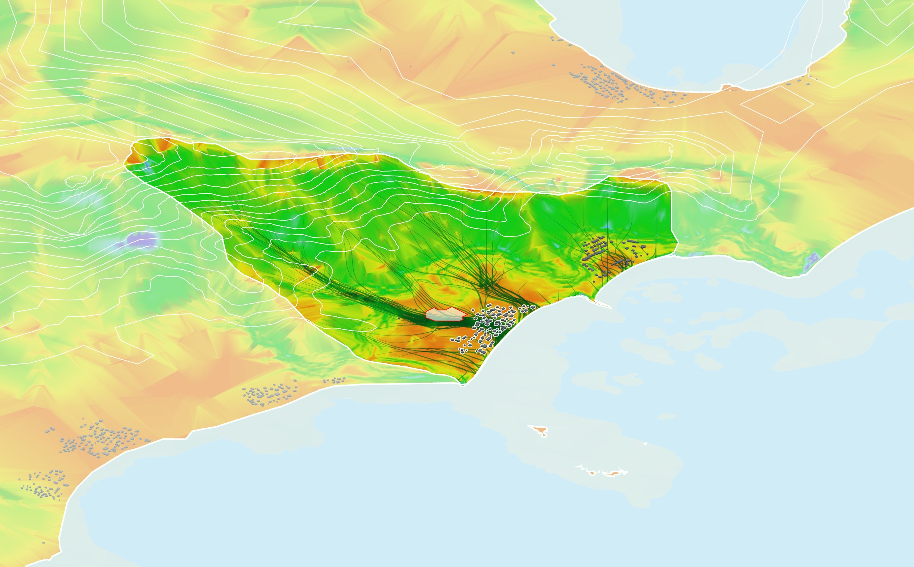

Chapter 5: Environmental Impact Assessment

Our design concentrates on ecological sensitivity to minimize harm to natural ecosystems and actively supports environmental restoration, resilience, and long-term sustainability. Every decision, from material selection to operational strategies, reflects a deep respect for the island’s delicate ecological balance and a desire to contribute positively to its environmental future.

Material Selection
The material palette is intentionally composed of local, low-embodied carbon materials that reduce the environmental burden from extraction, manufacturing, and transportation. Structural elements rely on bamboo, recycled steel columns, and cast-in-place concrete, with thoughtful detailing to minimize material use. These materials are durable and adaptable, extending the lifespan while allowing for future reuse or repurposing. Furniture, wind turbines, and hardware are locally sourced and fabricated, reducing the need for imported components and supporting the local economy. At the end of its lifecycle, recyclable materials such as steel and concrete can be recovered and reintegrated into new construction, and organic components like bamboo and thatch are biodegradable, leaving minimal environmental trace.

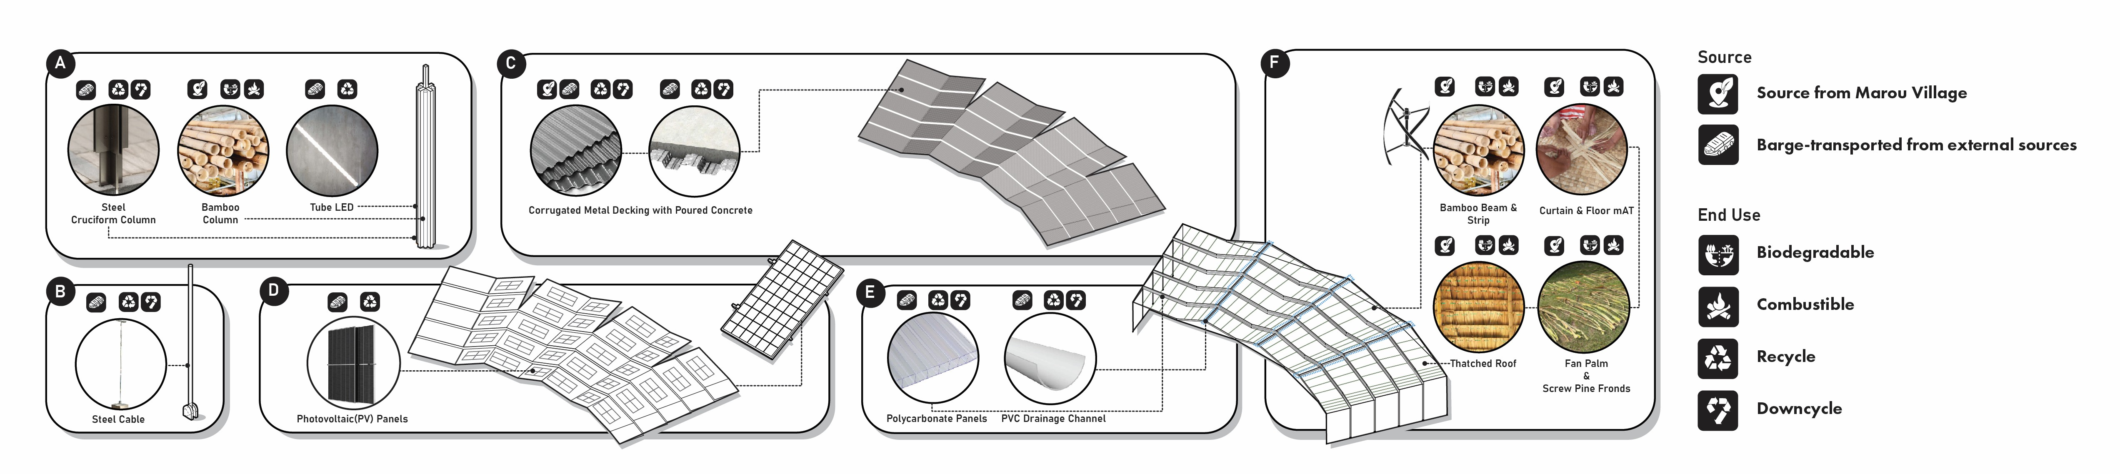

Zero Emission Operation
A cornerstone of the project’s environmental responsibility lies in its energy strategy. The solar panels used in the installation are designed to generate significantly more energy than their embodied carbon footprint over their lifespan. Combined with gravity-fed water movement, passive water distillation, and low-tech mechanical systems, the operation of the entire installation is effectively zero-emission. This means no fossil fuel combustion, no complex electronics requiring hazardous disposal, and no emissions associated with daily use. Heat from the evaporation pond is repurposed for domestic hot water needs, and excess solar power is used to produce ice, offering passive cooling for fishery cold storage and indoor spaces during outages. These approaches allow us to minimize battery size and chemical-based storage systems, which are typically high in embodied carbon and difficult to recycle.

Low Impact Landscape
Our water system reinforces this low-impact ethos through natural filtration and gravity-based circulation. Rather than relying on chemicals or pumps, the water is treated using native vegetation, sedimentation ponds, and solar-powered distillation, resulting in clean drinking water without introducing foreign substances into the environment. Runoff is carefully managed to avoid erosion or contamination, and the water system is closed-loop in nature, ensuring no adverse impact on nearby waterways or groundwater. To reduce the installation’s visual and physical footprint, our landscape uses native plant species that are non-invasive and suited to local soil conditions. By avoiding imported species or artificial groundcover, we mitigate the risk of ecological disruption while supporting natural succession and long-term reintegration into the surrounding environment.
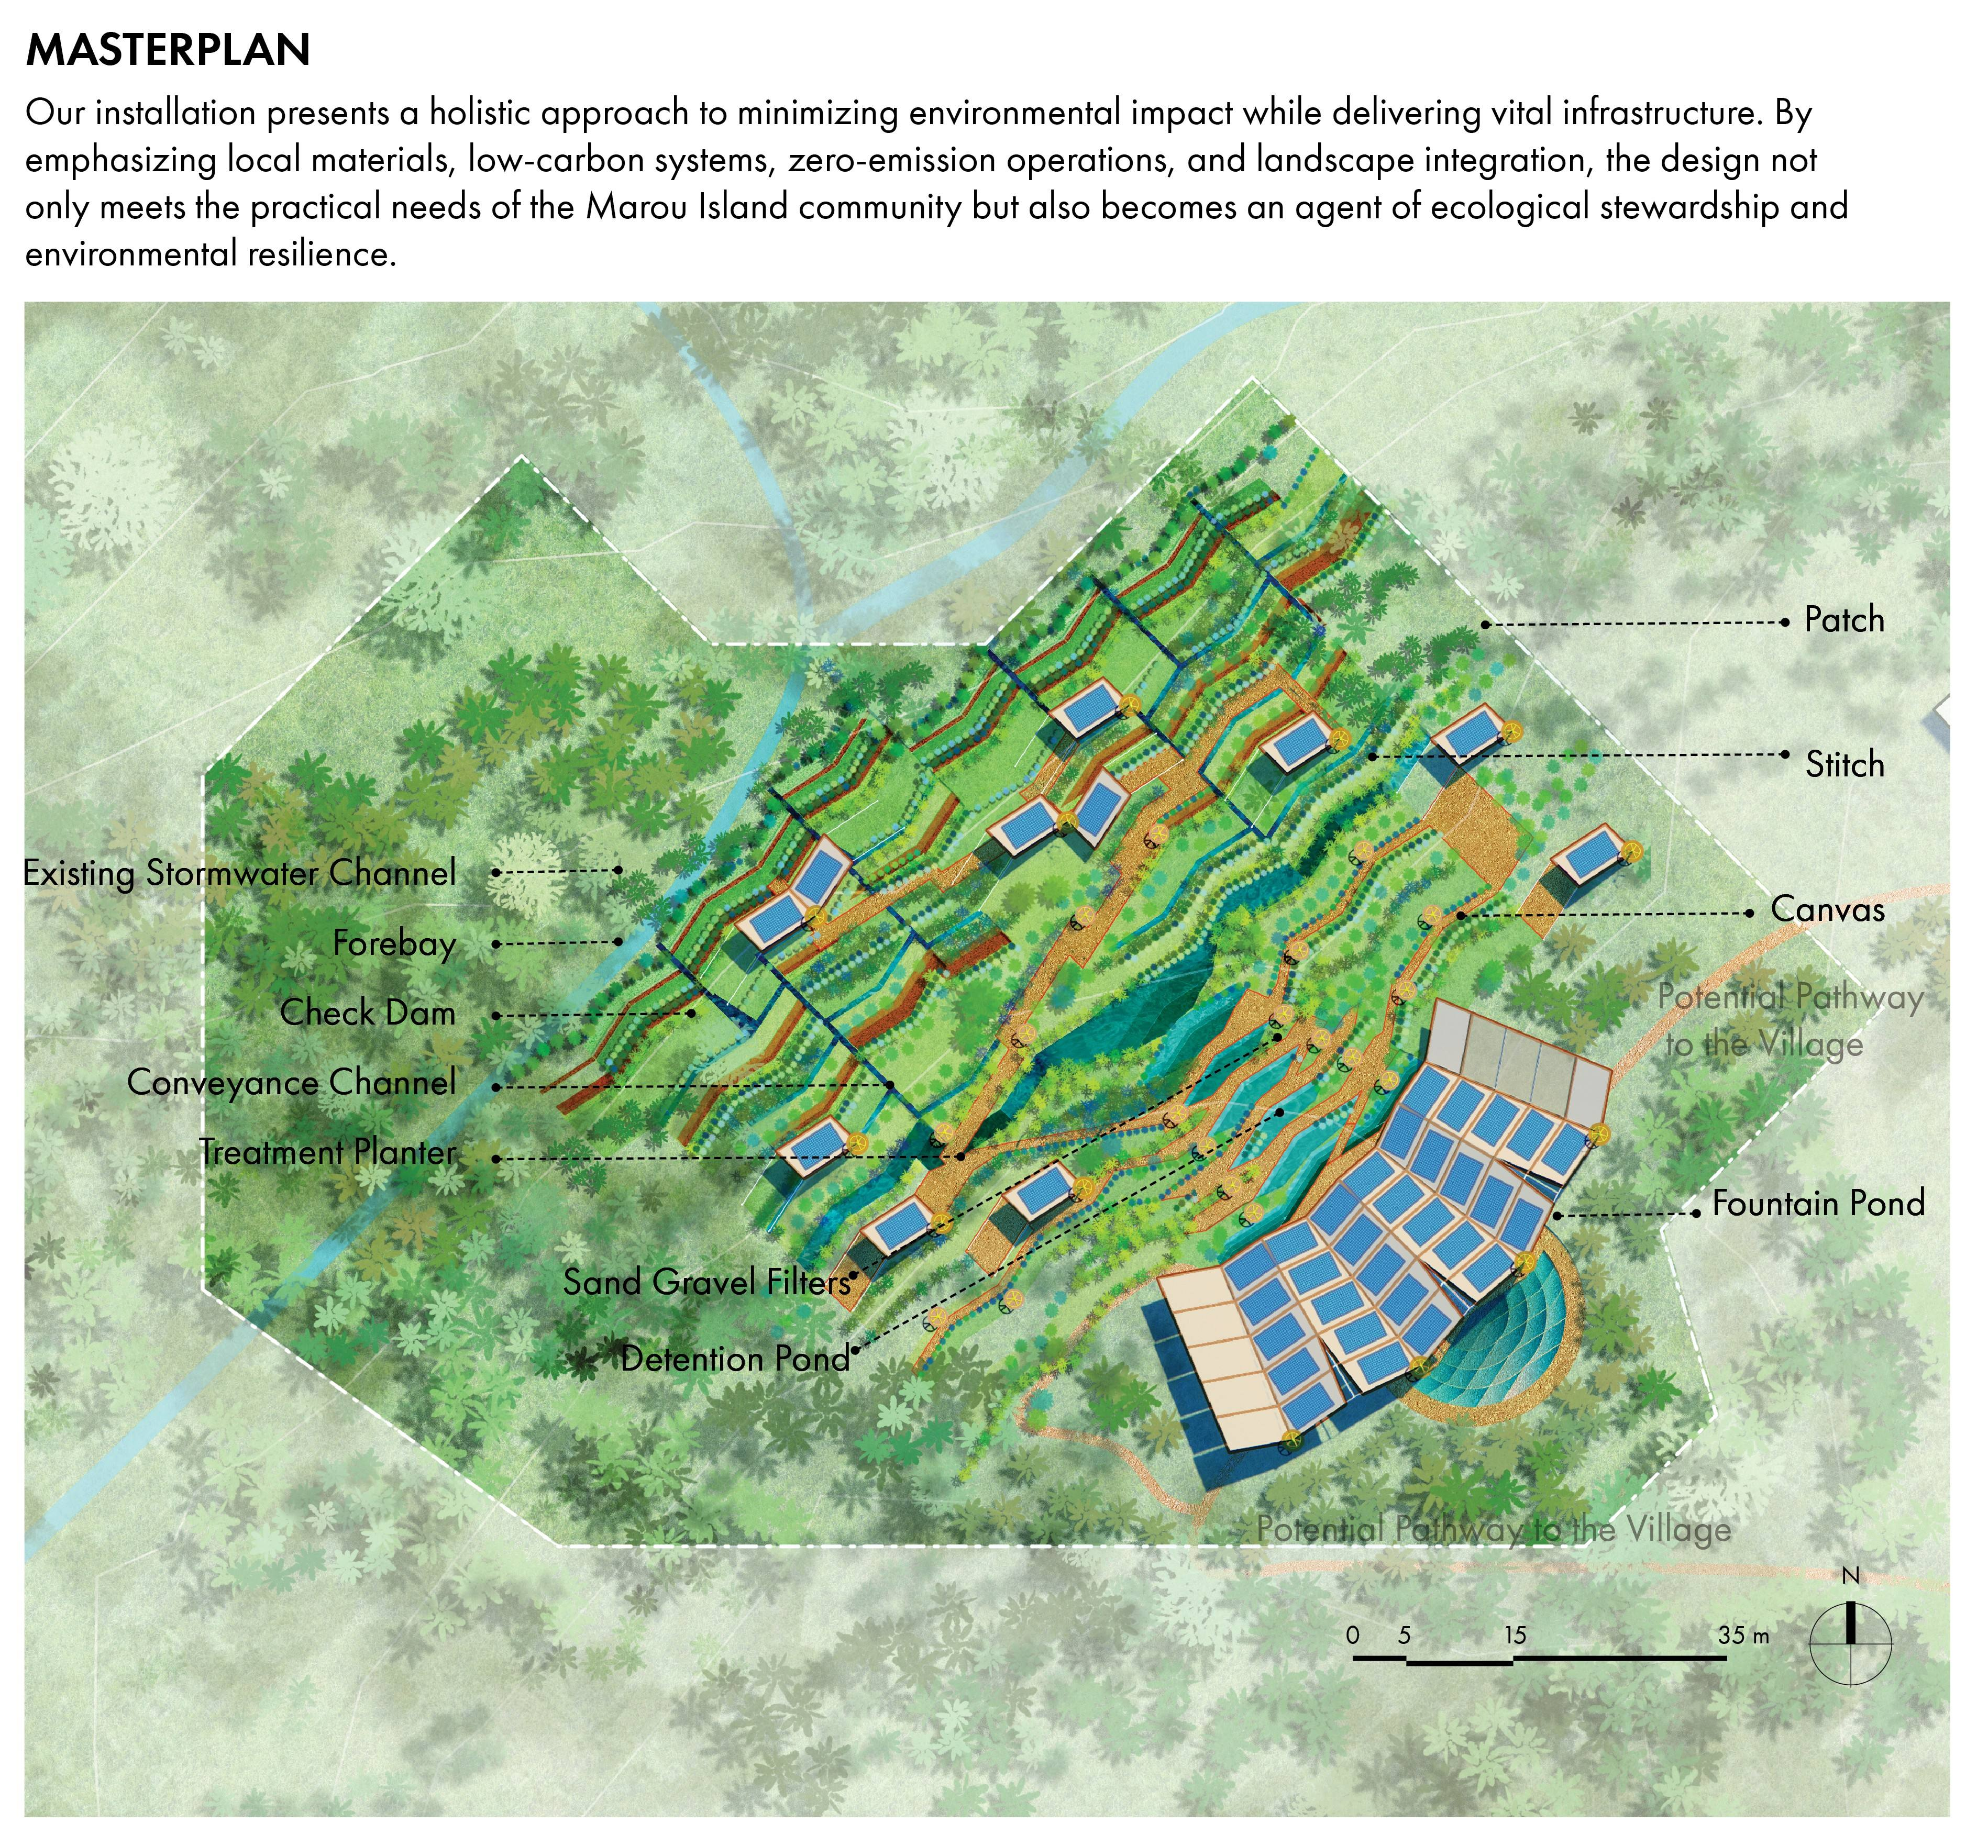

LCA Considerations
To further minimize long-term impact, we’ve considered the full lifecycle of the project. All major components are modular, reusable, biodegradable, or recyclable, enabling easy disassembly and low-waste deconstruction at end-of-life. Maintenance and restoration activities, such as those following storms, are designed to be low-disruption, relying on hand tools, manual labor, and locally available resources, ensuring that the repair process remains environmentally benign.

Appendix

Simulation Setup and Calculation Assumptions
- PV panel generation is simulated in ClimateStudio using the TMYx weather file of Yasawa-i-Rara
- The energy generation of the vertical-axis wind turbines (VAWT) is calculated with the formula P = 0.5 * ⍴ * A * Cp * V³, under the following assumptions:
  - The average wind speed (V) is assumed to be 6 m/s
  - The air density (⍴) is assumed to be 1.2 kg/m³ for humid tropical sea-level
  - The power generation coefficient (Cp) is assumed to be 25% for a hand-crafted wind turbine
- 1 MWh battery system selected to power the village for 12 hours under peak load or > 2 days under regular consumption

PV Panel Specifications
Parameter | Value | Unit
Module Power | 700 | W
Module Efficiency | 22.5 | %
Module Weight | 38.3 | kg
Module Length | 2384 | mm
Module Width | 1303 | mm
Module Area | 3.1 | m²
Short-Circuit Current (Isc) | 18.49 | A
Open-Circuit Voltage (Voc) | 49.4 | V

