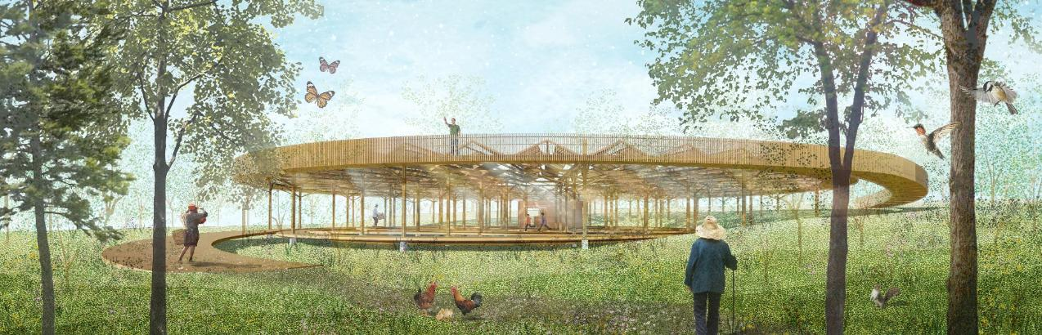

BETWEEN THE SKY & EARTH
"ENA MALIWA NI LOMALAGI KEI NA VANUA"

A Land Art Generator Pavilion for Marou Village in Fiji

CONTENT

Prologue: Project Statement …3
Project Premise & Approach

Chapter 1: Concept Narrative: Of the Sky & Earth …6
Inspiration from Fijian Culture & Art
Context & Concept Derivation
Design Overview

Chapter 2: Design Features: Of the Nature & Culture …13
Design Configurations & Components
Spatial Experience
Contextual-Oriented Materiality & Construction Method
Construction Details

Chapter 3: Technical Statements: Of the Tradition & Technology …19
Energy & Water Generation Systems
Energy & Water Generation Calculation
Prototyping and Pilot Implementation Statement
Operations and Maintenance Statement

Epilogue: Conclusive Remarks …24
Environmental Impact Assessment
References

PROLOGUE
Project Statement

Project Premise & Approach

Framed within LAGI 2025’s theme of ‘Climate Resilience and Adaptation for Island Communities’, the project is bound to its contextual respond for a site which has scarce infrastructure and remotely located. Located at the Marou Village within the Naviti Island in Fiji, this raises the local challenges include lacking of ready framework for sustainable systems, absence of efficient toolset or materials, difficult logistic and transportation, changing climate etc. The site is at the same time, embraced with rich natural resources, beautiful culture, and resilient communities, turning these challenges into an opportunity to create a model of land art energy generator adapted for remote island communities.

In this project, we started with the vital question: ‘where does the equilibrium lies between the pragmatic and poetic dimensions of land art energy generator within Fiji context?’ This question also poses the underlying objectives in the design, to seek harmonious balance between the tradition and technology, the nature and culture, within a limited environment. It is a quest to transform the notion of the usual infrastructural and utilitarian elements into a beautiful embodiment for energy generation- one that is multipurpose and shared by the community, one that can reflect the local context with its unique aesthetic, and one that is inspired by its sky and earth.

In that sense, we find the typology for the land art generator to be a typological convergence between a structure and landscape, constructed via the interconnectivity of regional ecosystems while being an independent art piece. It is designed to be integrated, self-reliant, resilient, zero-carbon, incorporating circular material cycle, and the idea of ‘leaving no traces’ in construction. Low-tech construction and organic materiality are adopted as a strategic approach to assure the implementation is practical for the project context and cost lesser in the aspect of economy, environment, and social. The pavilion upholds its ethos as the resources and material ecology that mirrors nature’s cycles. Every input- whether material, energy, or water- to be seen as a part of a loop rather than a one-way transaction.

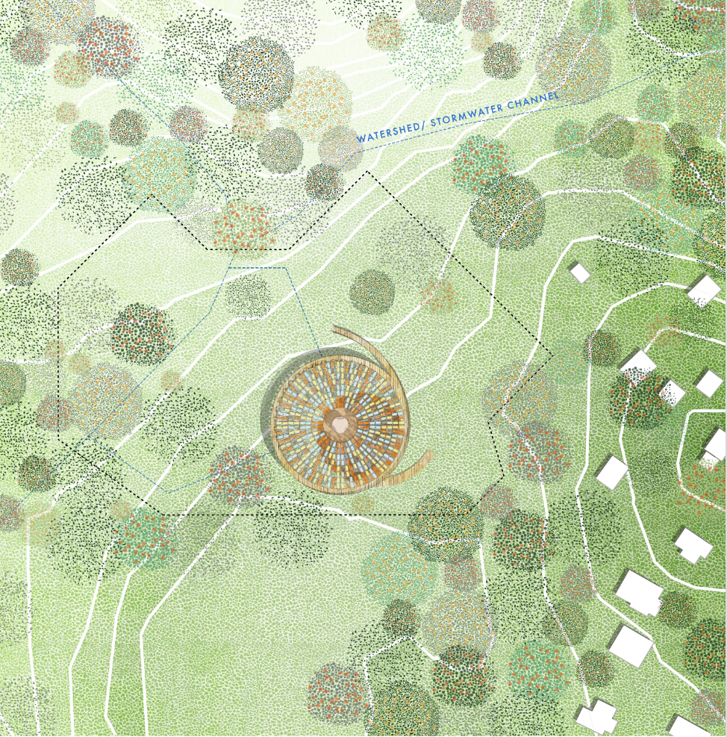
Located on the higher topography from Marou Village, the land art generator is looking like a cultural totem rested in its landscape from the aerial view. It is analogous to a guardian of landscape, also a place for the villagers to gather and share the blessings.
Site Plan

CHAPTER 01
Concept Narrative:
Of the Sky & Earth
Inspiration from Fijian Culture & Art
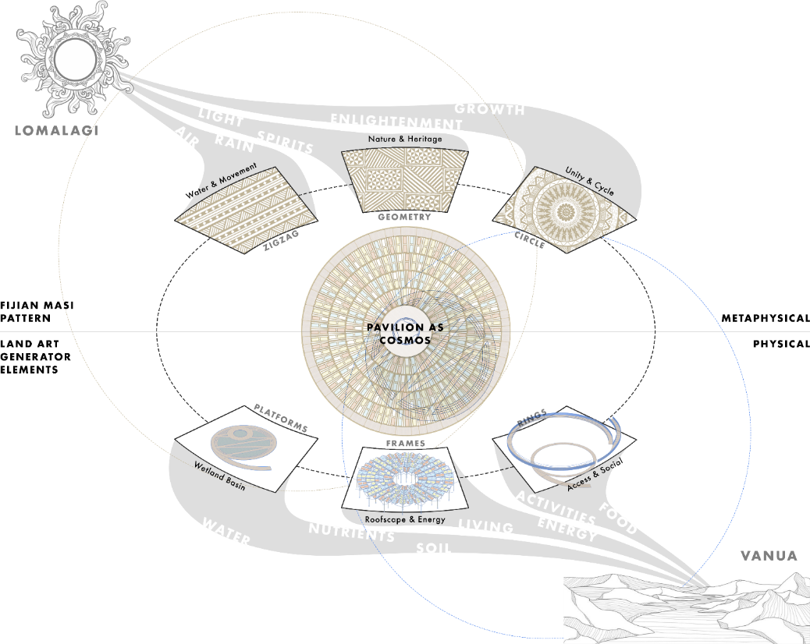
We are moved firstly by iTaukei’s (Fijian people) resiliency which thrives through the limited condition of their living landscape, but later inspired by their belief and ancestry in ‘vanua’- the land, and ‘lomalagi’- the sky. These terms portray a greater sense from their literal meaning, shaping Fijian’s worldview and their profound relationship between their local culture and nature, physically and metaphysically. The land art generator combines both ideas in a cultural and holistic meaning, where the design articulation represents the rooted sense of land and belonging, while its mechanism integrates with its air and atmosphere to bring sources of life. Composed with the reinterpreted elements embedded in traditional Fijian Masi pattern, the land art generator can be realized as multifunction pavilion of common ground for Marou Villagers to share and enjoy.

Context & Concept Derivation
Reflecting the both the ‘vanua’ and ‘lomalagi’ in the construct of the pavilion, turns into two circular planes overlapping each other- one touches lightly on ground, and one afloat receiving the sky. Everything happens between is a forest of natural sequences and movement of lives. Extensively, the Fijian Masi’s patterns including the circular motives, zigzags, and geometry are derived into the platforms, wetland basin, and the folding canopy respectively. The integration of these elements completes a pavilion of its own ecosystem, standing independently as a physical totem inspired from Fijian’s culture and art, while connects to the nature in a metaphysical exchange of energy, water, air and all the presence of living beings around. The overlaying patterns of the pavilion is thus, picturing the multitude of beauty lies when sky meets earth, nature meets culture, and tradition meets technology.

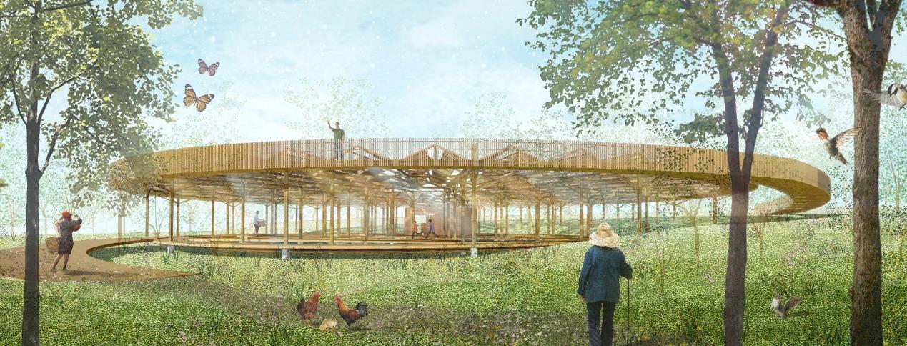
Design Overview

It is a land art generator and an everyday pavilion at the same time, providing sources of renewable energy and water, while being a common place for community farming, gatherings, events, and festivals.

CHAPTER 02
Design Features:
Of the Nature & Culture
Design Configurations & Components
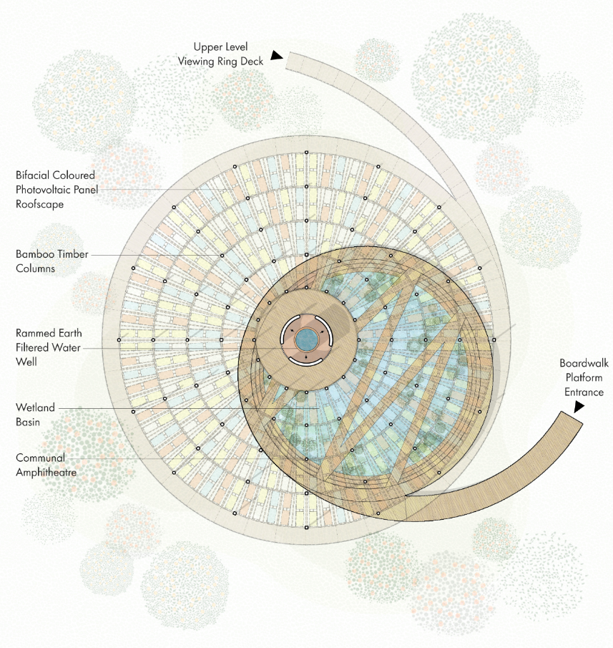
The design configurations of the pavilion are orchestrated in a sophisticated emblem of different systems, converge in a single, independent body. They consist of photovoltaic generating and shade system, rainwater harvesting system, storage and distribution system, communal and multifunction systems, ecological and wildlife system. These systems are configured by the combination of the pavilion’s components including its photovoltaic canopy, viewing ring deck, bamboo structures, water and energy storage, boardwalks, amphitheater seatings, and wetland basin. By the multi-scalar and modular integrations from single element, assembly, components, and the overall pavilion, the craft of the pavilion is thus, a symphony from indigenous materials, construction, culture, art and nature.

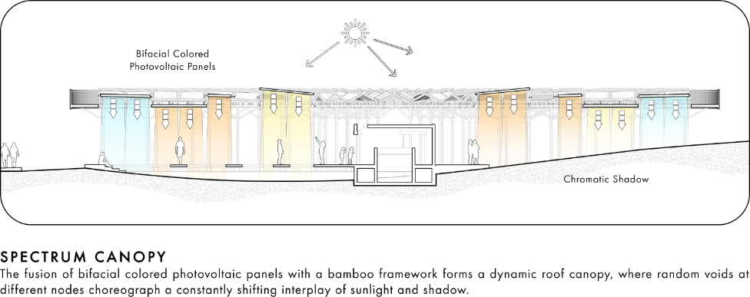
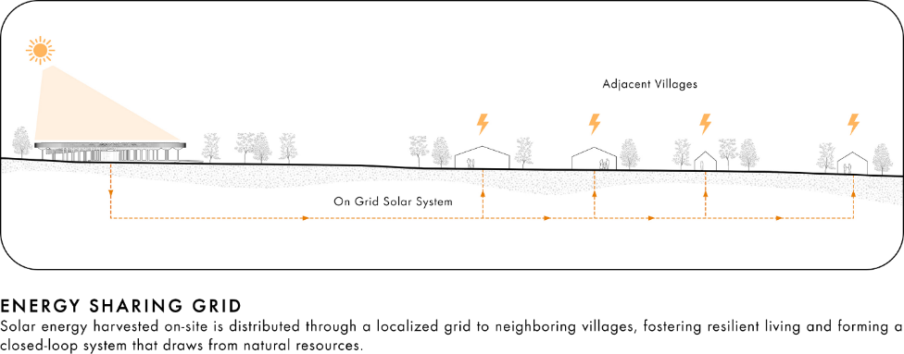
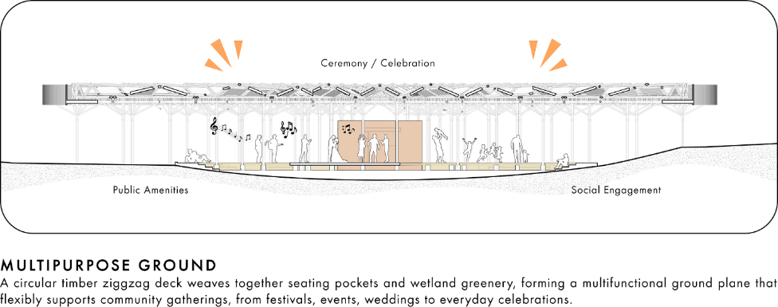

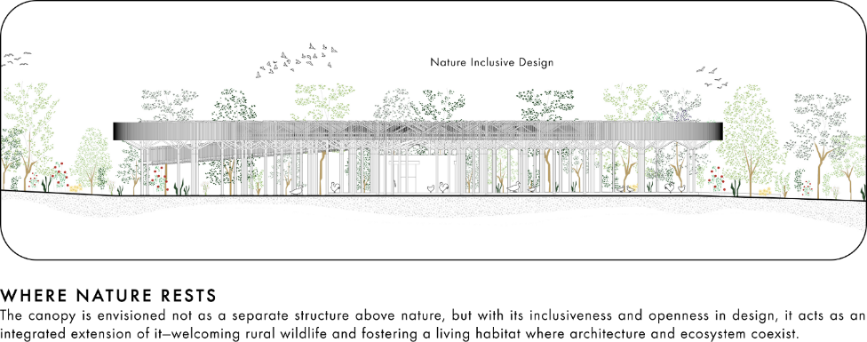
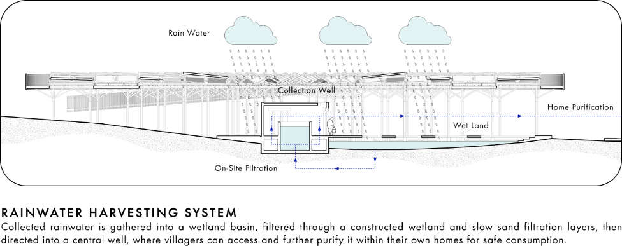

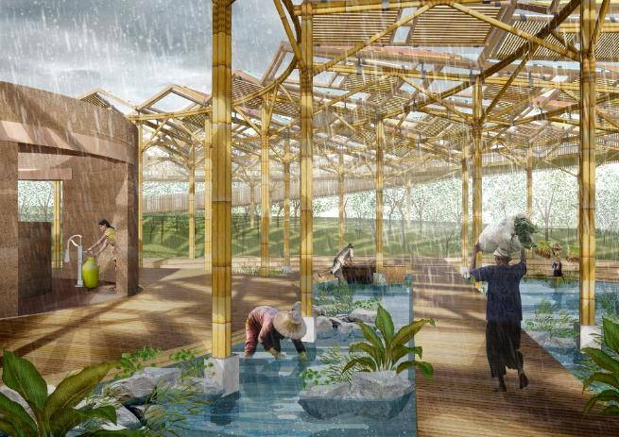
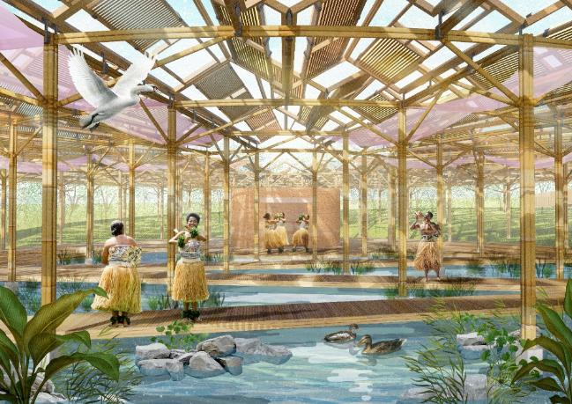
Spatial Experience
Between the gap of modular roofs structure, allows rains to fall directly to the wetland basin for rainwater harvesting and filtration, while completing an ecological cycle to also nourishing the wildlife or aquaculture underneath the large roof coverage.
The colored photovoltaic panels arrayed in a radiating gable roof form, create a dynamic interplay of light and shade as an experiential pavilion for the Marou Community to house various community-based events- becoming a place for collective memories.

Located at the higher topography of Marou Village, the pavilion is also a viewing deck itself spanning horizontally to offer panoramic views towards the village and sea, and its circular-shaped layout embrace the surrounding context too as a continuum.
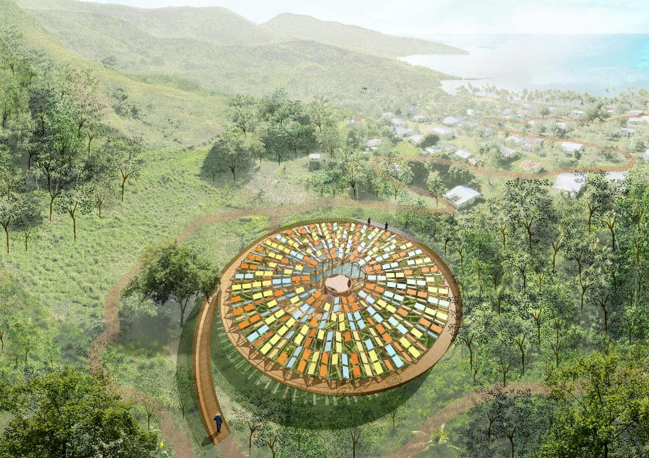

Contextual-Oriented Materiality & Construction Method
Considering the limited resources and difficulty of logistic for on-site industrialized construction in Marou Village, the design of the land art generator takes a vernacular twist to incorporate indigenous materials and construction method in a responsive manner to its context. The design of the 48m-diameter pavilion can be divided into 8 identical modules of segment, and each segment contains 4 tiers of band in different radius sizes. Each band comprises of bamboo roof trusses and columns mounted on concrete footing, lifting the photovoltaic panels fixed in gable-form steel frame. All these modules can be break down in smaller, lightweight parts to be transported more easily. The construction method is rather hands-on, less-relying on machineries, incorporating low-tech strategy, and encourage participatory initiative to create an accessible and practical way to replicate by the Marou community.

The material selection for the construct also adhere to the notion of low carbon footprint and as naturalistic as possible to complement a recovering cycle of material ecology. Large portion of the pavilion uses mainly locally grown bamboo to form the overall columns and roof structures. Whereas the accessible platforms are made in recycle timber planks or local hardwood species, namely Dakua, Vesi, Rosawa, or Damanu. The well and the feature structure is made of rammed earth casted with mixture of mud, soil, and sand too. The only industrialized components are the roofscape with a total of 360 colored photovoltaic panels in gable-form galvanized mild steel frames. The assembly of all these elements are designed in non-destructive joineries, hence allow disassemble and reassemble when replacing parts or reconfiguration.
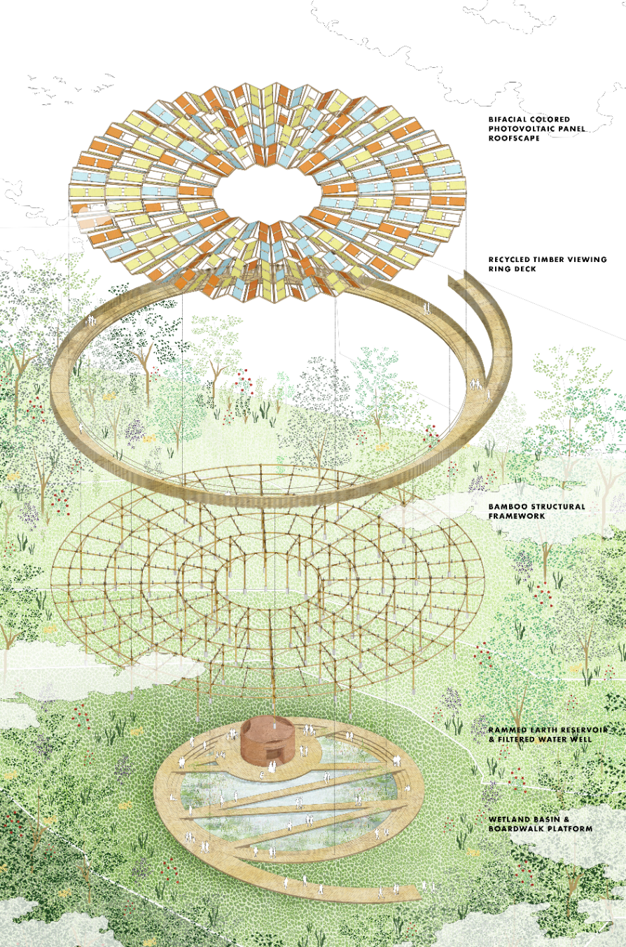
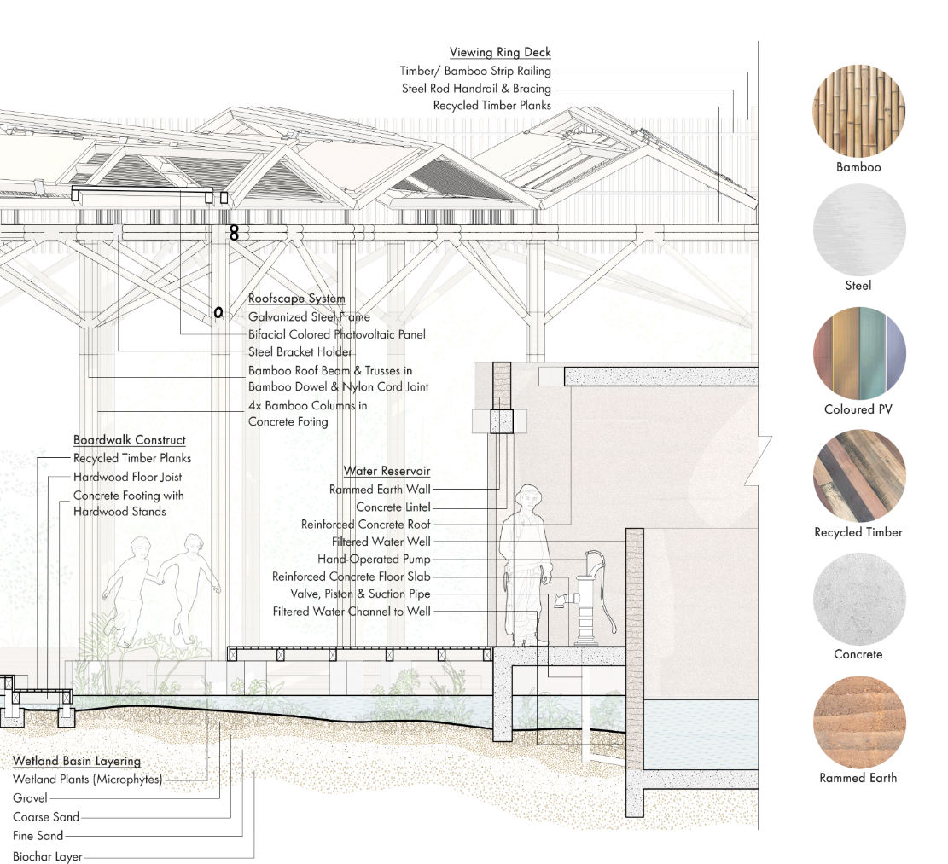
Construction Details

CHAPTER 03
Technical Statements:
Of the Tradition & Technology
Energy & Water Generation Systems
The land art generator implements mainly photovoltaic panel system for its energy generation as it’s the most efficient and feasible choices for the Fijian context. However, instead of using conventional photovoltaic panels, the proposal suggests the bifacial colored photovoltaic panel system which it brings aesthetic qualities both above and below the roofscape, while providing extra output for the rear surface utilizing the reflection from the water in wetland basin. Alternatively, if the cost, total energy generation efficiency, and supply source are the prior concerns, the modular design of the pavilion can be integrated with the conventional photovoltaic system too. The generated energy will be connected to the village’s mini grid and distributed throughout the households in demand of electricity.

Aside of the energy generation system, the pavilion encompasses the rainwater harvesting, storage, filtration and distribution system too. Utilizing the existing gable roofscape with integrated photovoltaic panels, the free-flow surface runoff from the panels is collected directly to the wetland basin. The wetland basin consists of constructed wetland and slow sand filtration layers, including wetland plants (microphytes), gravel, coarse sand, fine sand, and biochar. The filtered water is partially stored in the rammed earth well at the pavilion for non-potable and irrigation uses, while the rest is largely distributed via gravity to the water storage tank in the village located at a lower topography. The water can be safely drink after boiling, UV, or ceramic filtration installed in household.

Energy & Water Generation Calculation
Generation Systems | Area | Energy/ Resources Generation Calculation
Bifacial Colored Photovoltaic Panel System | 1400 m2 | Front-side efficiency (due to color loss) = 18% or 0.18  Rear-side gain = 15%  Effective total efficiency:  Total Efficiency = 0.18 × (1+0.15) = 0.207  Total number of panels (1.7m2) = 360  Peak Power per panel = 1.7m2 × 1000 × 0.207 = 351.9 W  ​Peak Power = 351.9 W x 360 = 126.68 kW  Total energy generated (kWh of energy)=  Peak capacity (kW of power) x Hours x Capacity factor  = 126.68 kW x 8,760 x 0.21  = 233, 040 kWh (233 MWh) per year  OR = 638 kW per average day
Constructed Wetland & Slow Sand Filtration System | 500 m2 | Rainwater Harvesting & Storage Volume:  Annual Rainfall (avg): 2000 mm/year  Catchment Area: 500 m2  Runoff Efficiency: 90%  Collected Rainwater = 2000mm × 500m2 × 0.90  = 900,000 liters per year  OR = 2465 liters per average day  Water Filtration & Distribution Volume:  Filtration Efficiency: 80%  Filtered Water = 900,000 liters x 0.80  = 720,000 liters per year  OR = 1970 liters per average day

The estimation of energy generation is more than the required 75kW peak capacity with the current pavilion design to cater the anticipation of growing demands and future proof. With the modular design and component-based strategy, the pavilion can be started with just few segments or bands first to fulfil the current demand, and extend further in the future- hence allow flexibility and adaptability across other site around Fiji that needs renewable energy supply.

Prototyping and Pilot Implementation Statement
The reason for the land art generator designed as a pavilion is due to the notion not only to allow the construction to be made as lightly as possible for its impact to the landscape, but also to allow it being installed in modules at a manageable scale. The 48m-diameter pavilion is made of 32 modules in 8 identical segments, and each segment contains 4 tiers of band in increasing radius sizes- where the prototype can be tested first with 1 module. The prototype with a single module is suitably sized as for the pilot scope to experience the whole flow- from the sourcing and transportation of materials to the site, down to the construction and assembly on-site. Workshops can be conducted for local community to involve in the practice of hands-on construction for knowledge exchange and educational purpose, meanwhile cultivating a participatory framework for social engagement.

With the use of mostly naturalistic and lightweight materials made in small parts, all the logistics and transportations can be applied what is already available around the site or sourced from its regional suppliers. The only items that require import from main cities or other countries are the bifacial colored photovoltaic panel and steel structures for the roof components. As the design complements handmade quality, the pavilion takes shape without a high finesse level of workmanship, but any imperfections from the traces of construction can be parts of the beauty holistically. In general, the prototyping and pilot implementation can be conducted pragmatically and sensemaking to materialize the design in its natural state.

Quantitative and qualitative metrics will be collected during the pilot phase around 3 months, understanding how the prototype works. These include:
- Energy output (kWh/day), storage performance, and usage patterns
- Rainwater capture volumes, seasonal variation, and first-flush efficacy (optional)
- Water filtration quality, measured by turbidity, pH, and microbial content (optional)
- User behavior insights, from ease-of-use to cultural appropriateness
- Maintenance frequency and system resilience under extreme weather
An evaluation report will be prepared to assess functionality, local uptake, and design adaptability. This iterative learning will inform material choices, construction methods, operation and maintenance protocols for the final pavilion at full scale.
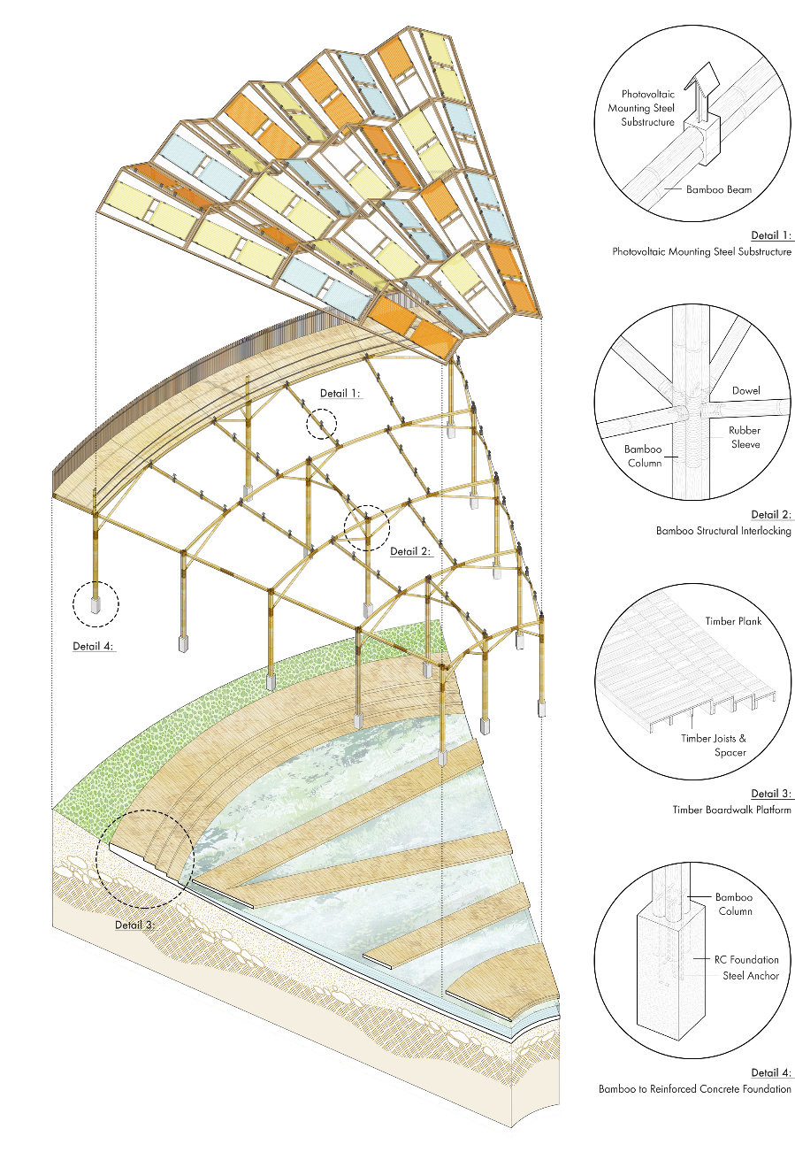
Operations and Maintenance Statement
The pavilion's renewable energy system comprises 360 bifacial colored photovoltaic panels, designed to meet domestic use demands, including lighting, refrigeration, digital operations, small appliance use, and the extra for energy storage. Regular monitoring and daily observations will be carried out by a trained village caretaker, using an intuitive monitoring interface to track solar output, inverter status, and battery levels to ensure optimal performance. Monthly maintenance includes the visual inspection and gentle cleaning of PV panels to remove dust, organic debris, or salt spray — a common concern in coastal settings. Annually, a qualified technician or trained local steward will conduct a comprehensive check of wiring, inverter health, and mounting structures. An assessment will verify performance consistency and identify any components requiring upgrade or recalibration. Where possible, these checks will be paired with seasonal events or gatherings to build collective ownership and visibility of the system.

On the other hand, the 500 m² constructed wetland integrated with a slow sand filtration bed as natural treatment process is designed to purify close to one million liters of water annually is also requiring a consistent frequence for operation and maintenance aside with its aquaculture activities. Ongoing care involves weekly monitoring of water flow to prevent channeling or clogging, and monthly visual assessment of plant health. Every six months, the surface of the sand bed will be gently raked to remove accumulated organic matter, with periodic top-ups of fine sand when needed. Annually, water samples will be lab-tested to verify potability and adjust filtration layers if necessary. The entire system is designed to be visible and accessible, providing an educational landscape that celebrates indigenous ecological knowledge and regenerative design.

To support long-term sustainability, initial training will be provided to all maintenance roles through on-site workshops and illustrated manuals in both English and Fijian. A living maintenance log will be maintained on-site to allow performance tracking over time. Community training will be revisited annually, with the potential to bring in regional sustainability partners or educational institutions to provide further mentorship, particularly to youth stewards. In the greater picture, the success of the maintenance strategy, environmental stewardships and future scaling plans will be empowered with the active participation of the community.

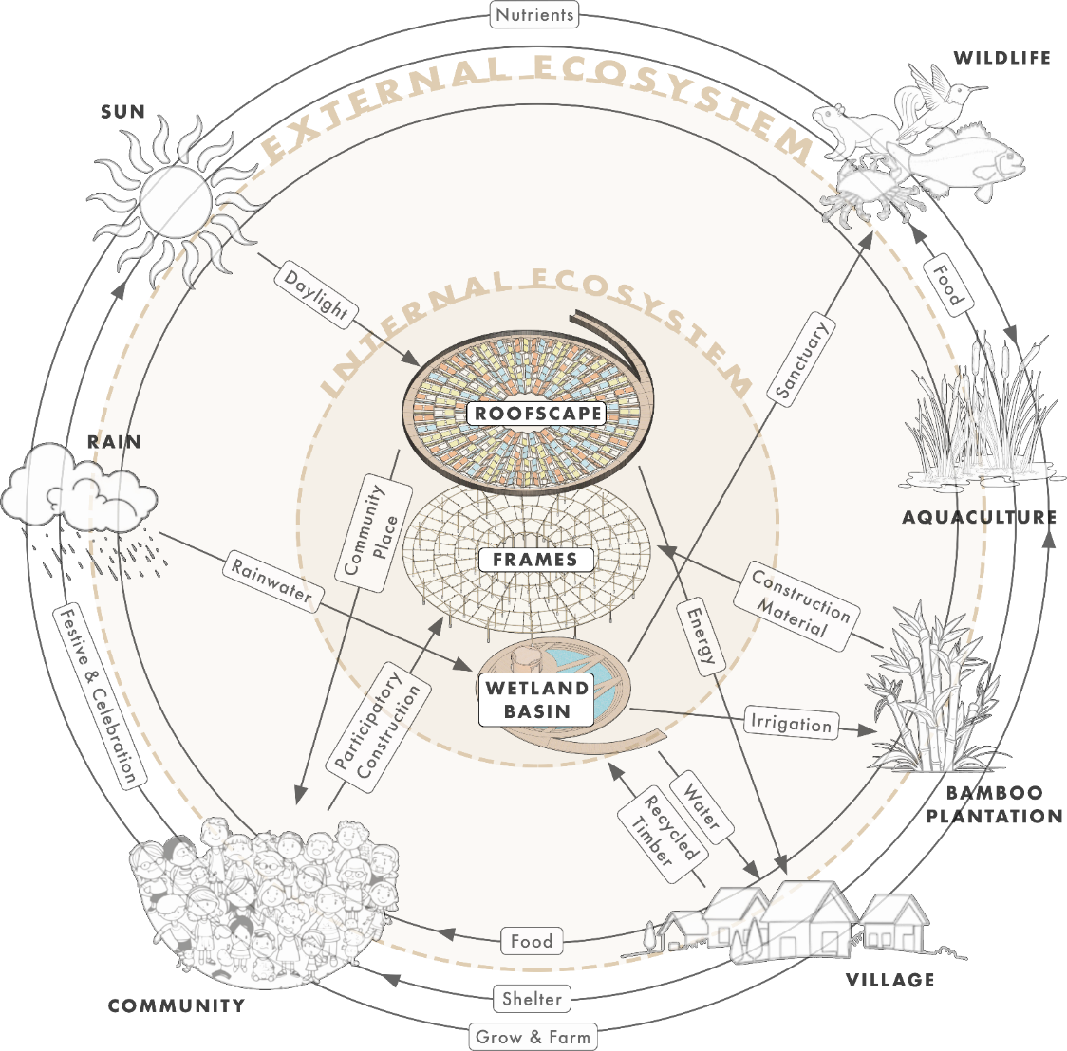

EPILOGUE
Conclusive Remarks
Environmental Impact Summary
The design proposal of the land art generator revolves around the key notion to fabricate a modular pavilion of that is deeply-rooted within its environment, culture, context, and community. As an ecosystem vessel more than merely an infrastructural or utilitarian device. The convergence between all these multifaceted aspects listed below is envisioned into a beautiful form of energy- integrated, self-reliant, resilient, and zero-carbon:

1. Low-Impact Vernacular Material & Construction
The pavilion employs locally sourced and renewable materials to minimize embodied carbon and transport emissions. Indigenous bamboos and hardwoods are selected for their durability, pest resistance, and cultural significance, ensuring longevity with minimal chemical treatment for the main structure works. Modular and lightweight construction techniques reduce site disturbance, enabling easy disassembly, reuse, repair, and even relocation. The pavilion’s almost naturalistic and lightweight footprint avoids concrete-intensive foundations, preserving the integrity of the surrounding soil ecology- a literal portrayal of touching the landscape lightly.

2. Renewable Energy Generation
With 360 bifacial colored photovoltaic panels, the pavilion will generate about 230, 000 kWh per year- providing net-positive electricity to support village-scale use. These panels harness sunlight from both the sky and reflected water surfaces, optimizing output without increasing material scale and pavilion footprint. The energy system is designed as a closed-loop, using smart inverters, optional battery storage, and community dashboards to regulate consumption and empower local energy sovereignty. Surplus energy may be redirected to community refrigerators, health stations, or education spaces- linking climate action to quality of life.

3. Natural Water Generation System
Water flows, harvested, filtered, distributed through the pavilion via a natural and low maintenance model. A 500 m² constructed wetland system generates around 700,000 liters of filtered rainwater and surface runoff from the hills annually, with the aid of slow sand filtration system. The nature-based treatment process not only purifies water but also regenerates biodiversity through aquatic planting and microbial activity. Treated water is gravity-fed to the village for community use for drinking, cooking, hand-washing, and ceremonial purposes, replacing reliance on imported or chlorinated sources.

4. Climate Resilience & Biodiversity Regeneration
The design responds directly to climate risks such as clean water scarcity, stormwater runoff, and heat stress. The photovoltaic panels roofscape and constructed wetland doubles as a microclimate buffer, mitigating heavy stormwater runoff from hills to village, while reducing ambient temperatures and providing a habitat for birds, pollinators, and amphibians. Native plantings are curated not just for environmental function, but for social connection- involving human aquacultural and agricultural activities. The pavilion therefore becomes an act of land healing- a biocultural landscape where human presence amplifies ecological diversity rather than diminishing it.

5. Circular & Reciprocal Ecology
Central to the pavilion’s design is a circular material ecology that all inputs whether material, energy, or water- is seen as a part of an ecological loop. The bamboo and recycling timber as stock for future scaling, are grown using the harvested rainwater from the pavilion, whereas the rainwater collected in the wetland basin becomes a catalyst for the growth of aquaculture plants for village consumption too. The generated energy also at the same time feeding back to the water pump distribution system around the village, while the water can be use for cleaning and maintenance of the roofscape too. The multipurpose pavilion complements its own functions as a circular and reciprocal system, benefiting both the village and its environment.

5. Education & Stewardship for Future Generations
Beyond its physical structure, the pavilion serves as a living classroom for sustainable practices rooted in Fijian knowledge systems. It is an inclusive educational and cultural platform itself- not in isolation, but as part of the broader ecology of Marou Village. Stewardship roles formed by the village ensure intergenerational knowledge transfer and collective responsibility, extending the environmental impact beyond the project site. Extensively, being a living example for the other Fijian villages and set forth of the reciprocity in the generation of renewable energy and water even in a rather challenging remote context.
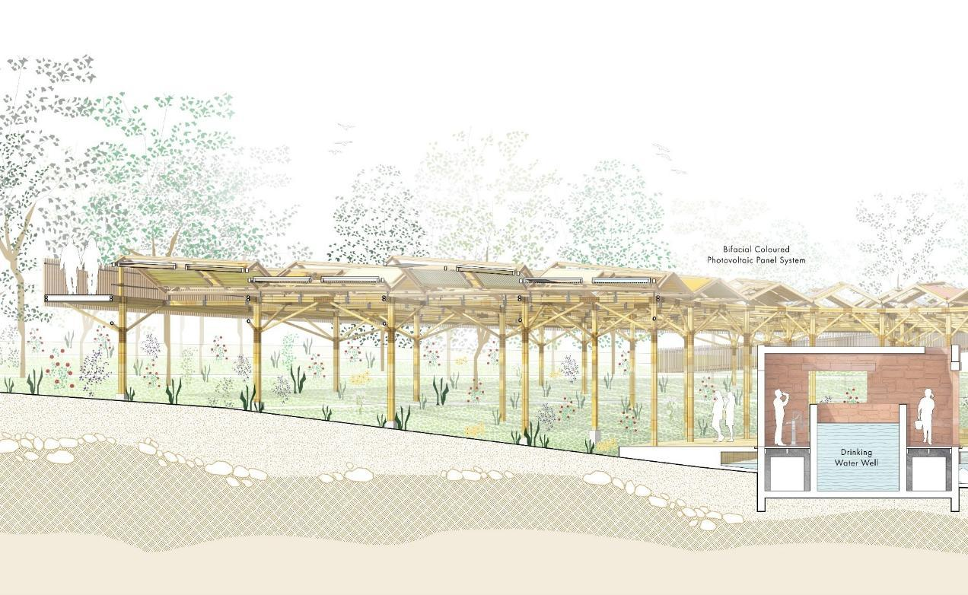
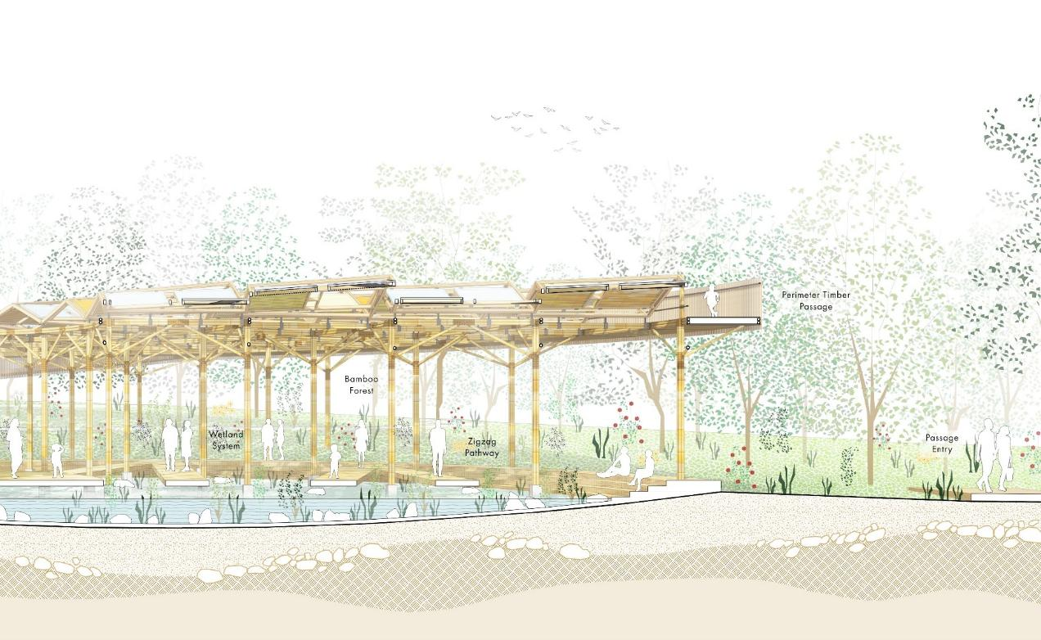

References
- Allen, R. et al. (2010). Constructed Wetlands for Greywater Treatment in Small Island Contexts.
- ArchDaily. (2015). The Bamboo Playhouse / Eleena Jamil Architect. Retrieved from https://www.archdaily.com/777325/the-bamboo-playhouse-eleena-jamil-architect
- Christophi C. (2011). Ecological research & Macro Algae monitoring facility, North Arsenale, Venice. RIBA Presidents’ Medal.
- Eleena Jamil Architect. (n.d.). Projects Tagged 'Bamboo'. Retrieved from https://ej-architect.com/project-tag/bamboo/
- Eta Emele Varani-Norton (2017). iTaukei Indigenous Fijian masi as an education framework: Retaining and adapting tradition in epistemology and pedagogy for a globalized culture. The International Education Journal: Comparative Perspectives Vol. 16, No. 2, 2017, pp. 131-145.
- FAO Pacific Forestry Study. (2009). Bamboo and Timber Use in Traditional and Modern Fijian Architecture.
- Graves R. et al (2019). A Social-Ecological Approach to Architecture and Planning, Journal of Architecture and Construction, 2(4), pp. 33-44.
- Huisman, L. & Wood, W. E. (1974). Slow Sand Filtration. WHO Technical Paper Series.
- Land Art Generator Initiative (2019). A Field Guide to Renewable Energy Technologies, Second Edition.
- Land Art Generator Initiative (2025). A Field Guide to Regenerative Water Technologies.
- LONGi Solar. (2023). Bifacial Module Technical Specifications.
- Nabobo-Baba, U. (2006). Knowing and Learning: An Indigenous Fijian Approach. Institute of Pacific Studies, USP.
- NREL – National Renewable Energy Laboratory. (2022). Best Research-Cell Efficiency Chart & PV Performance Metrics.
- Ravuvu, A. (1983). The Fijian Way of Life. Institute of Pacific Studies, USP.
- Solar Power World. (2021). Colored Solar Panels: Aesthetic Options and Their Efficiency Tradeoffs.
- UN-Habitat. (2014). Guidelines on Rainwater Harvesting for Pacific Island Countries.

