Siga Siga – The Pavilion of First Light
["Siga", Fijian: 1.day; 2.sun] 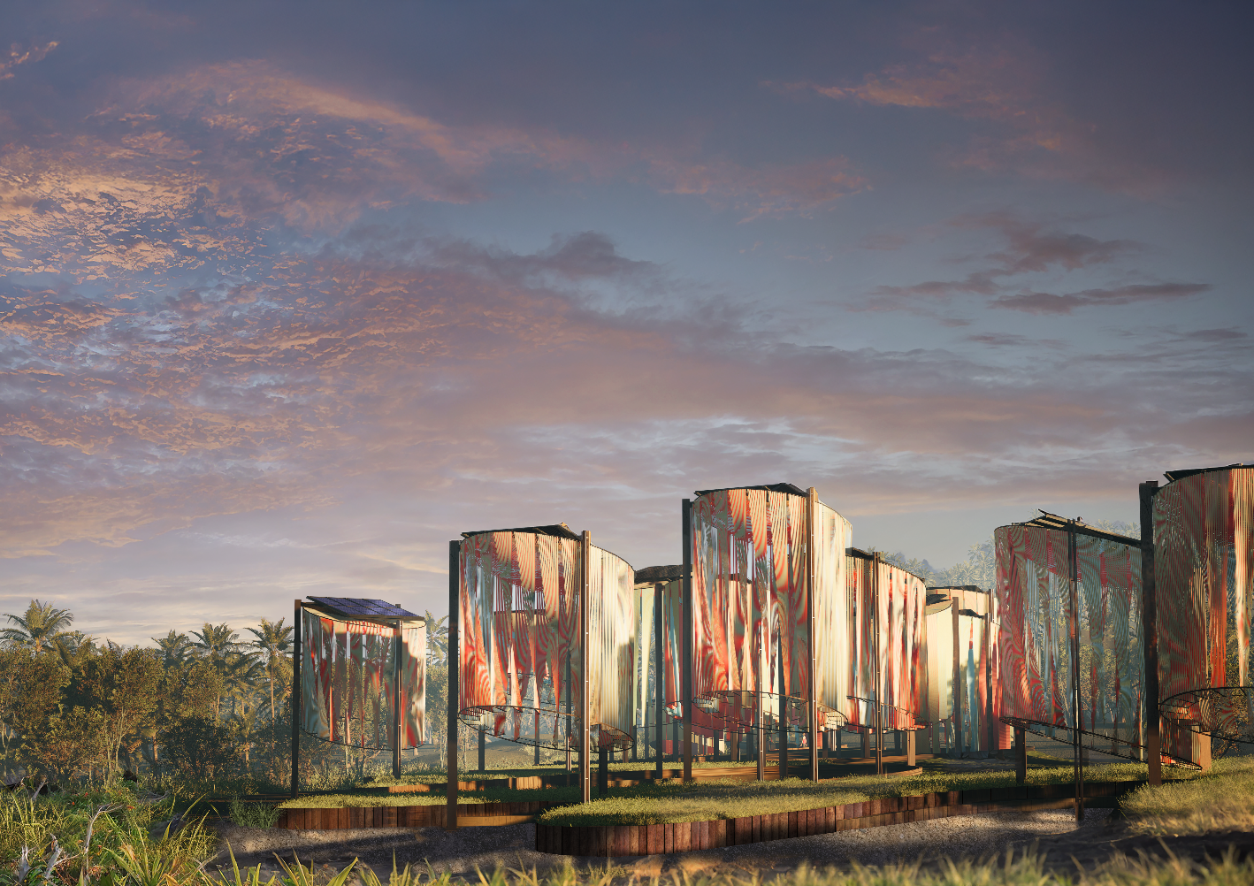
- Concept Narrative
At 5:50 AM on a summer day, the morning arrives in Fiji Islands earlier than most parts of the world just like any other day, turning a new page on the calendar. Red, orange and gold slowly wash over the beach, slip over the hills, and wake the village in a hush of light. Birds stir, plants lift their leaves, and the rhythm of life begins again. In Fiji, this daily miracle is more than beauty; it is a rhythm, a signal, a beginning. But as climate change threatens these remote shores, the sunrise now asks more of us. Can light become protection? Can nature power resilience?
Siga Siga – The Pavilion of First Light answers with an energy harvesting site that is deeply contextual, responding to light and water, and simultaneously spiritual, celebrating every sunrise as a special event.
Each morning, as sunlight kisses this remote island, a gleam of red, pink, orange and blue slowly unfolds in the lush woods - Siga Siga pavilion awakens. The floating pavilion over the field reveals its secret within as the solar panels begin to generate electricity and the pavilion’s woven façade gradually shifts, an ensemble of sunrise rhythm powered by the light itself. A slow, graceful motion—like the first breath of the day—transforms the structure from stillness to celebration.
Rather than introducing a foreign monument, the design weaves itself into the fabric of Fijian life and landscape. The softly shimmering curtain made from locally sourced plant-based ropes wraps the installation like a cloak. Neutral on the outside, vibrant within, the curtain shifts open each morning, not only to shade and shelter, but to mirror the traditional weaving practices deeply embedded in the culture. The colors, revealed by the sun’s energy, reflect both nature’s palette and the hidden resilience of the community.
More than a single structure, the pavilion is envisioned as part of a constellation—scattered across villages as gathering places, shaded rest stops, educational tools, and climate infrastructure. Together, these installations offer both immediate function and long-term resilience: clean energy, water harvesting, irrigation, and flood mitigation. But just as importantly, they offer presence—spaces for ceremony, conversation, and connection. Visitors are invited not only to observe, but to experience—walk among the shifting ropes, trace the patterns of light, and understand the intertwined challenges of place and planet.

- Technical Narrative
Siga Siga – The Pavilion of First Light is a network of modular solar installations that translate natural forces—sunlight, wind, and rain—into energy, motion, and shared space. Each unit is designed with efficiency, visibility, and ease of replication. Components and materials that are widely available and that are suited to Fiji’s climate are used.
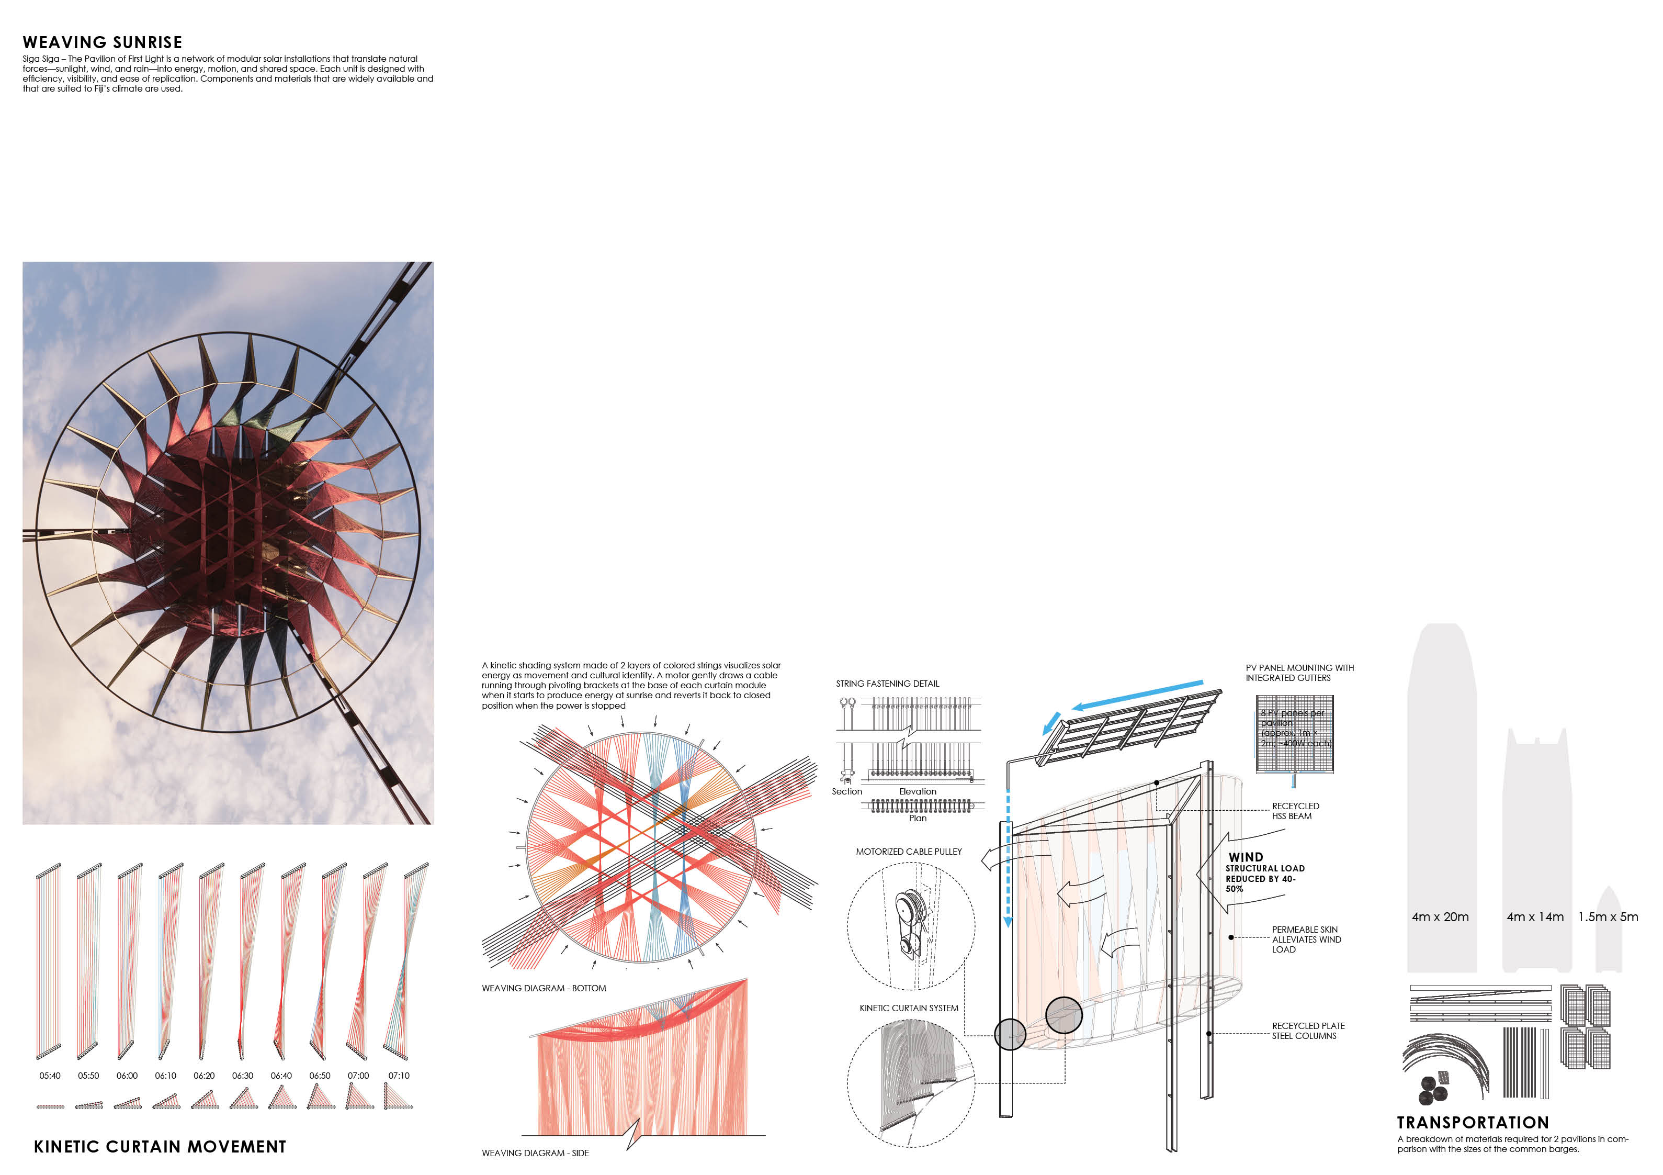
Solar Energy System
Each pavilion integrates a compact rooftop solar array that powers both the structure and the experiences it creates:
- 8 monocrystalline PV panels per pavilion (approx. 1m × 2m; ~400W each), most common commercial unit in market
- Panels are mounted at a 15° angle—optimized for Fiji’s latitude
- Total installed capacity per pavilion: ~3.2 Kw
- Annual energy output: ~4,200–4,800 kWh per unit
Across the site:
- 25 pavilions form a grid that meets the 75 kW energy target while providing a variety of spaces
- Pavilions can be orientation in different directions to meet the peak demand: East-facing for morning, North-facing for midday peak and West-facing for afternoon/evening use
The panel frame integrates gutters to harvest rainwater and to protect the structure. The mounting system with drainage is currently available from multiple manufacturers, such as SOLOPORT.

Soft Kinetic Skin
A kinetic shading system made of 2 layers of colored strings visualizes solar energy as movement and cultural identity. A motor gently draws a cable running through pivoting brackets at the base of each curtain module when it starts to produce energy at sunrise and reverts it back to closed position when the power is stopped:
- Ropes are plant-based and biodegradable
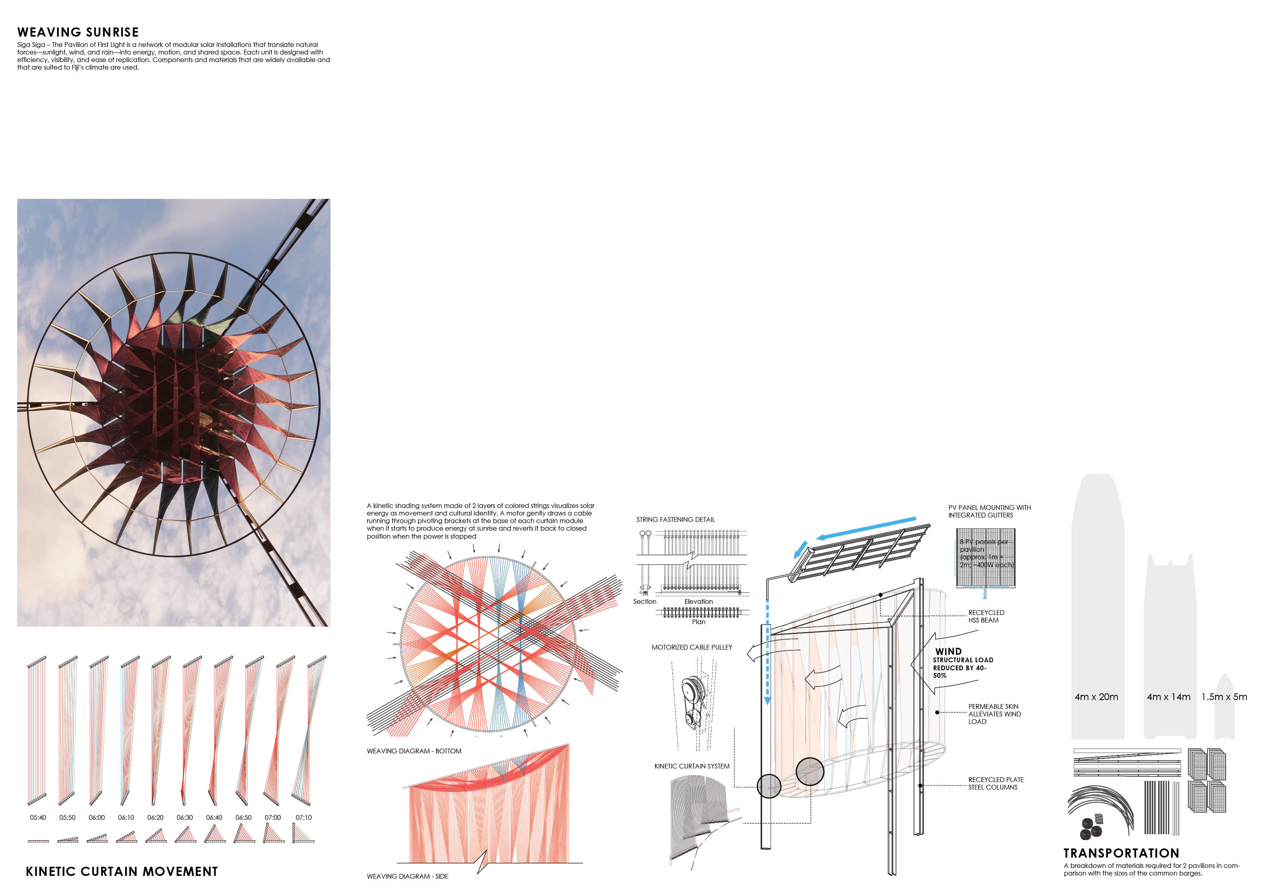
- Natural dyes give them vibrant colors on the inner layer
The curtain system is not only expressive but also functional. The pavilion’s resilience also lies in the permeable skin on the perimeter. This soft and tactile skin is also designed to alleviate wind load during cyclones:
- Reduces lateral wind loads by 40–50%
- Minimal load from the shading system due to the lightweight material
- Smaller structural elements and lower cost

Battery Storage and Community Use
Energy that isn’t immediately used is stored in a nearby offsite battery system:
- Modular lithium-ion storage in weatherproof enclosures
- Continue to power night-time demands, such as landscape lighting, telecommunication, ice-making, heating.
- Emergency backup during outages
Rainwater Harvesting + Bioswale System The landscape integrates passive stormwater management to respond to Fiji’s intense seasonal rains:
- Rain falls onto solar panels and flows into integrated gutters
- A bioswale running parallel to the stormwater channel filters runoff and directs it to a storage tank or nearby channel
- The elevated surround landscape is sloped to direct the rainwater runoff towards the bioswale and to protect the village from the seasonal flooding
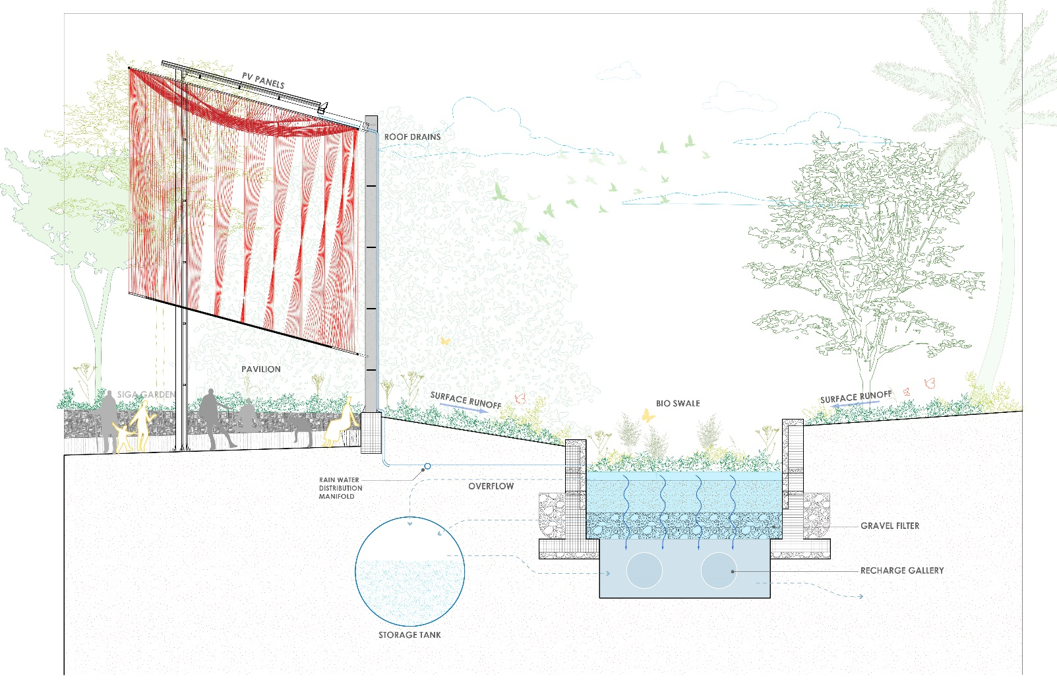

- Prototyping and Pilot Implementation Statement
The development of Siga Siga begins with people—craftspeople, students, and local residents who will help shape both the form and meaning of the pavilion. From the start, the project invites participation, co-creation, and learning.
Ho will we develop the design: (Test systems and gather feedback, partial-scale prototypes will be developed)
- Curtain Module: One rope segment will be tested to evaluate tensioning, pivot action, and the solar-powered cable mechanism. Natural fiber ropes such as sisal and coir will be evaluated alongside wax treatments for water resistance and UV durability. Exposure tests will guide material selection and maintenance intervals.
- Structural System: A steel column and partial beam will be tested for strength, especially at joints and in simulated wind. Foundation options such as screw piles or anchored footings will be reviewed to ensure resilience in cyclone-prone conditions.
- Drainage Integration: Commercial solar racking with built-in gutters (like SOLOPORT) will be tested for waterproofing and rain capture. Flashing or sealing between panels will be included to minimize leaks and maximize water yield.
- Design for Easy Transport: All parts of the system are already tailored to be easily transported in all seasons using the regular barge.
How will we collaborate:
- The rope curtain is designed for easy fastening, with simple hardware and tools
- All moving parts are positioned at an accessible height for ease of maintenance
- Ropes can be removed and replaced individually
- The top loop detaches without disrupting curtain alignment
- Natural rope dyeing will use local plant sources such as mangrove bark, turmeric, and beetroot. Colorfastness and UV resilience will be tested. Wax or oil finishes will help extend lifespan.
How does the installation process engage community:
- Weaving workshops with artisans to incorporate traditional Fijian patterns
- Local dyeing and rope treatment using cultural knowledge
- Hands-on installation training for long-term care and replication
How will the pilot module be installed:
Following prototyping, a full-scale pilot will be installed with the community; location will be chosen with local input—likely near a school or communal hub.
- Steel and solar components prefabricated; rope modules co-produced locally.
- Battery and solar systems will include monitoring displays to support local learning.
The pilot pavilion will serve as a model, classroom, and climate adaptation hub, enabling replication across other Fijian communities.
- Operations and Maintenance Statement
Siga Siga is designed for low maintenance, local repair, and long-term stewardship. Located near a village school, it also serves as a hands-on educational tool—offering students the chance to learn about renewable energy, sustainable design, and cultural craftsmanship through real-life engagement. Community members will be trained in care routines suited to Fiji’s climate and resources.
System Maintenance
- Steel structure: Inspected annually; marine-grade coatings protect against salt corrosion.
- Solar panels: Washed 2–3 times per year; sealed joints prevent leaks
- Battery system: Housed in ventilated, shaded enclosures. Lithium iron phosphate (LiFePO4) preferred for long life and safety. Charge controllers display real-time system status
Curtain System
- Mechanisms are accessible at waist level
- Ropes are individually replaceable; wear monitored regularly
- Plant-based ropes will follow a replacement cycle (e.g., every 3–5 years depending on exposure)
- Treated with wax or rope sealer to extend durability
Water System
- Rainwater captured from sealed solar roof surfaces
- Gutters and downpipes cleared seasonally
- First-flush diverters recommended to improve water quality
- Bioswale maintained by trimming, debris removal, and seasonal replanting
Community Energy Committee
- Two local stewards trained per pavilion
- Educational visits and curriculum tie-ins for nearby school students
- Opportunities for students to participate in seasonal maintenance, rope dyeing, or environmental monitoring as part of school programs
- Illustrated manuals provided in English and Fijian
- Local youth programs involved in rope dyeing, reweaving, and periodic maintenance.
Maintenance becomes a cultural act—keeping the pavilion vibrant, clean, and alive with local energy.

- Environmental Impact Assessment
Siga Siga is built to coexist with its environment, offering resilience without damage. Its light footprint, biodegradable materials, and passive systems make it a gentle and regenerative presence in the village landscape.
Each pavilion uses shallow screw piles or anchored footings that avoid deep excavation, preserving site ecology. The structure’s 5.8 m diameter footprint adapts to existing vegetation and topography, and can be relocated with minimal disruption.
Steel components are standard profiles with potential for recycled content. The rope curtain is composed of durable, wax-treated plant fibers such as sisal or coir. UV-stable natural dyes, including mangrove bark and charcoal, will minimize fading. Rope testing will inform a maintenance cycle for scheduled replacement.
Rainwater harvested from the tilted solar roof flows into gutters and downspouts, guided to bioswales planted with native vegetation. These swales:
- Filter runoff and allow infiltration
- Store clean water in tanks for reuse
- Form a buffer during flooding, protecting surrounding homes and paths
No lights or speakers disrupt the local ecology. The pavilion’s movement and cooling are passive. Its color fades gently with time, and ropes re-dyed or re-woven continue the cycle.
In essence, Siga Siga is not just a structure—it is a living system. One that breathes, adapts, and returns as much as it receives from the land.

