Mount of Energy of Marou
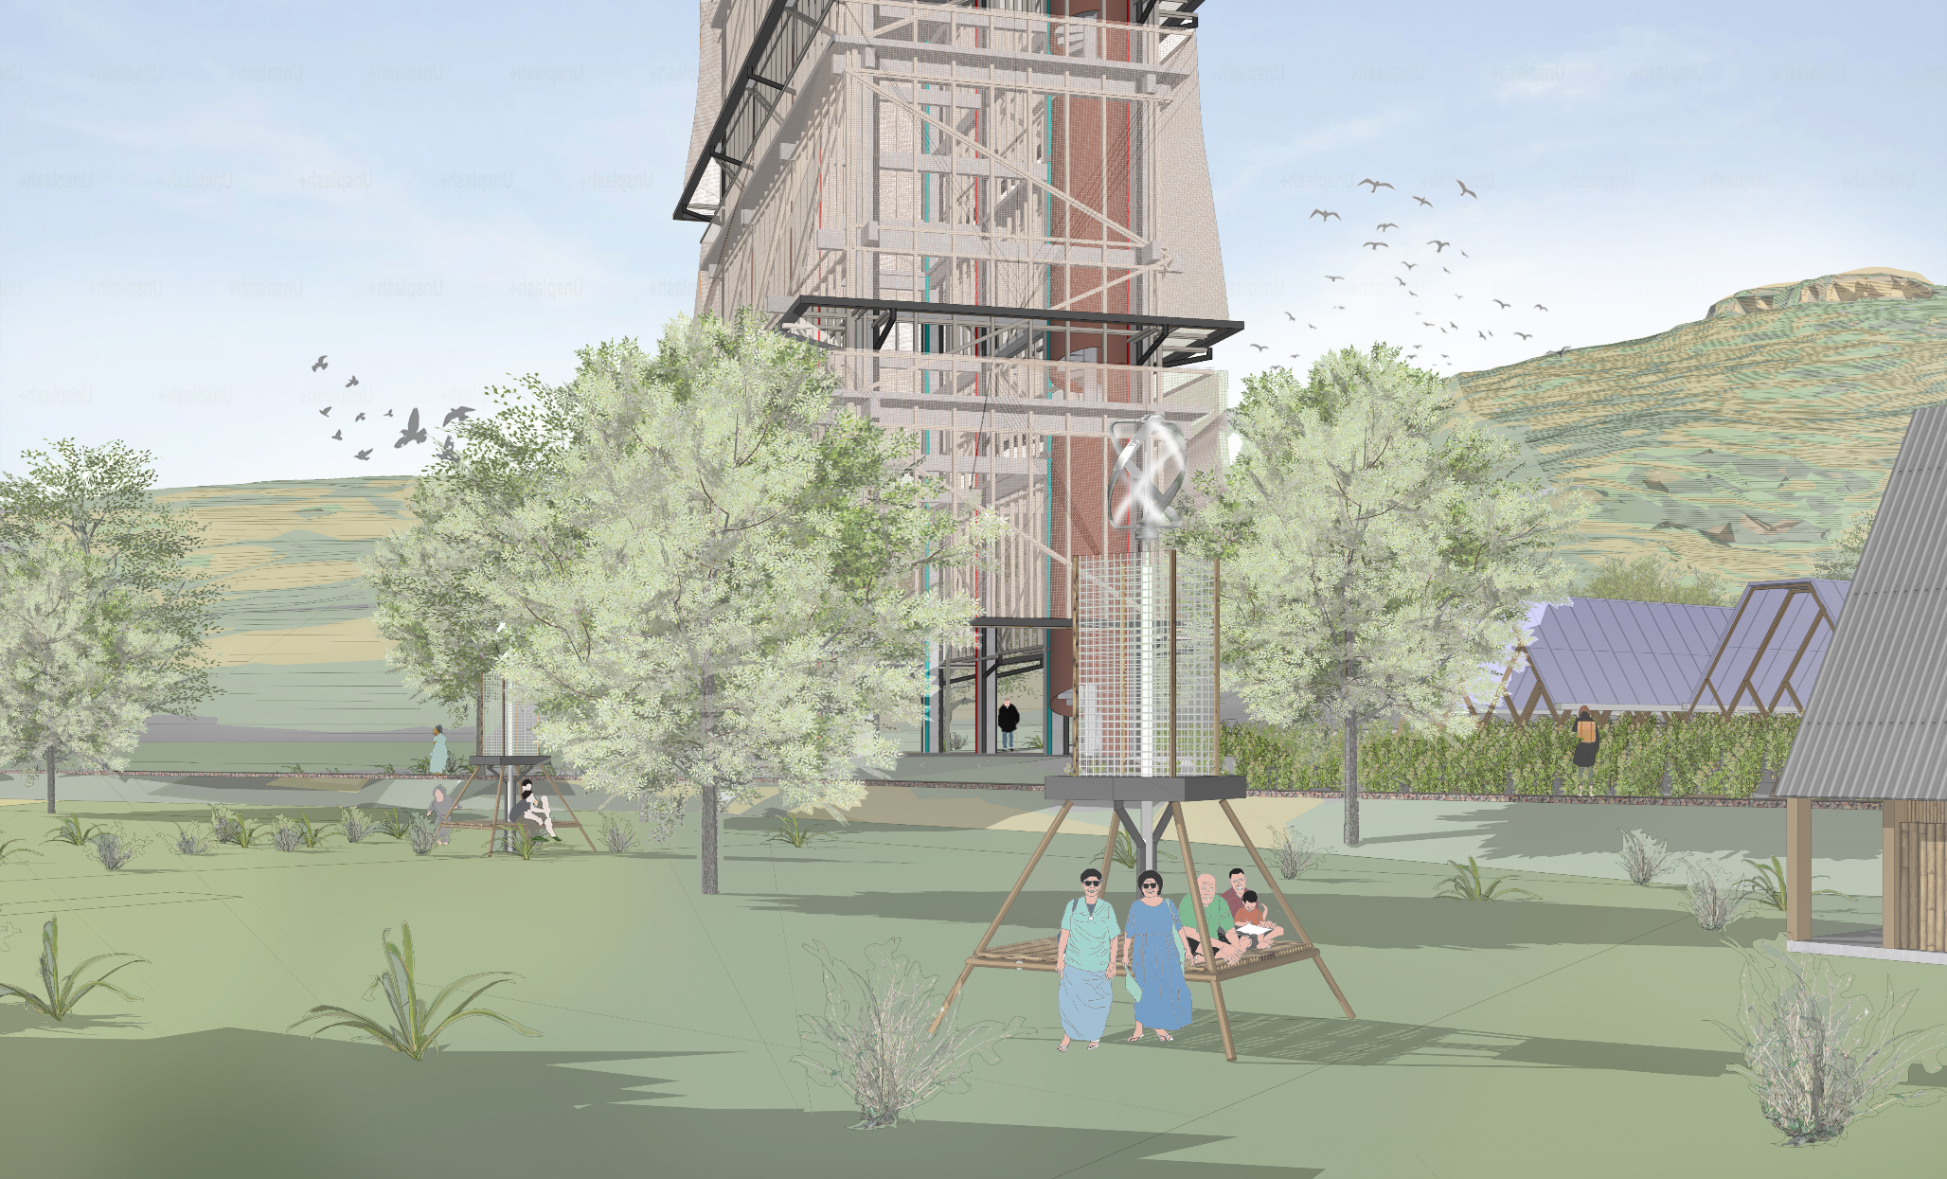
Implementing an Integration of Local Habitude and Material With The Renewable Energy Movement

2025
TABLE OF CONTENT

Design Narrative: Narrative Prologue…………………………. 3
Purposes Driven Design……………………. 4
Architectural Language………………………4

Technical Narrative: Site’s Intervention…………………………… 5
The Energy Tower ……………………………6
PV Roofing Structure ………………………...7
Gathering Pods ……………………………….8

Prototyping Implementation: Smale Scale…………………………………...9
Large Scale……………………………………9

Operation and Maintenance:
The Tower…………………………………...10
PV Roofing and Gathering Pods ……………11

Environmental Impact Assessment:
Rigid Structure………………………………12
Re-shapable Model………………………….13

DESIGN NARRATIVE

Narrative Prologue
The existence of an energy is closely related to the ability of humans to capture and manage the surrounding energy to benefit the surroundings and especially for the long term of our existence. The location of a site is also a consideration in understanding what natural energy coexists and can be managed to make the energy useful for our surroundings. Marou Village is located on Naviti Island as a part of Yasawa Island, and has diverse natural and energy potential, which is also because it is in an archipelago. Based on the data that has been collected for the site, it has a lot of potential. Besides sun energy, wind can also be an alternative solution in procuring renewable energy on Naviti Island.
Energy is a very relevant need in Marou Village. There are mainly two biggest pressing needs in the village are reliable electricity and year-round access to fresh water. At the same time, new energies such as solar and wind power also come with considerable challenges, including aesthetics and land use. To make the community feel more ownership and kinship, the goal of the project is to integrate these new energies with local culture and materials to enhance the landscape as well as the village.
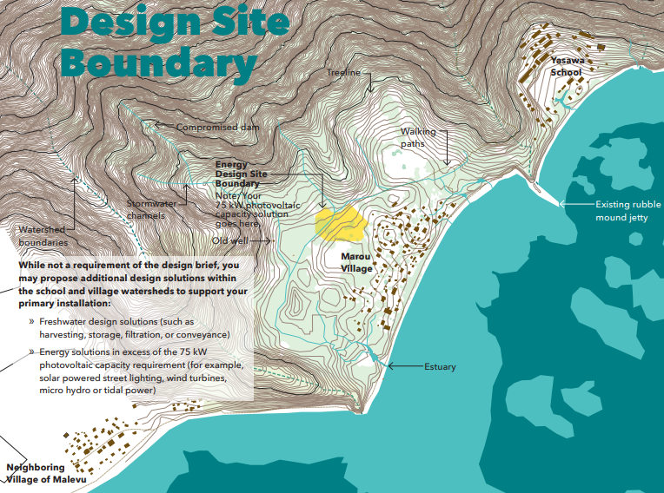
(Source : LAGI 2025 Design Guidelines page 11)

Purposes Driven Design
Designed with the intention of fully connecting all the dots, not only with the energy machine itself, but also with the people in the village. Local activities such as gatherings and traditional events are the main considerations in creating the space. A space that connects these activities with the energy machine simultaneously. Moreover, shape and material also contribute to making the intervention flawless and, in the long term, this intervention will be familiar to the local people.

Architectural Language
One of the design integrations carried out on the project is to equate the local design language with the intervention carried out, which will later become the basis for developing the entire design on this site. The language that can be found from the compilation images is the shape of the roof, which has a steep slope with a horizontal hump on top.
For the materials, it is not uncommon to see the use of bamboo materials either for the walls, wall finishing or roof structure. One more thing that can be seen is how they all tend to sit on the floor rather than chairs, which creates a greater sense of togetherness and kinship. This analysis forms the basis for the development of a design that is integrated with the flawless and familiar.
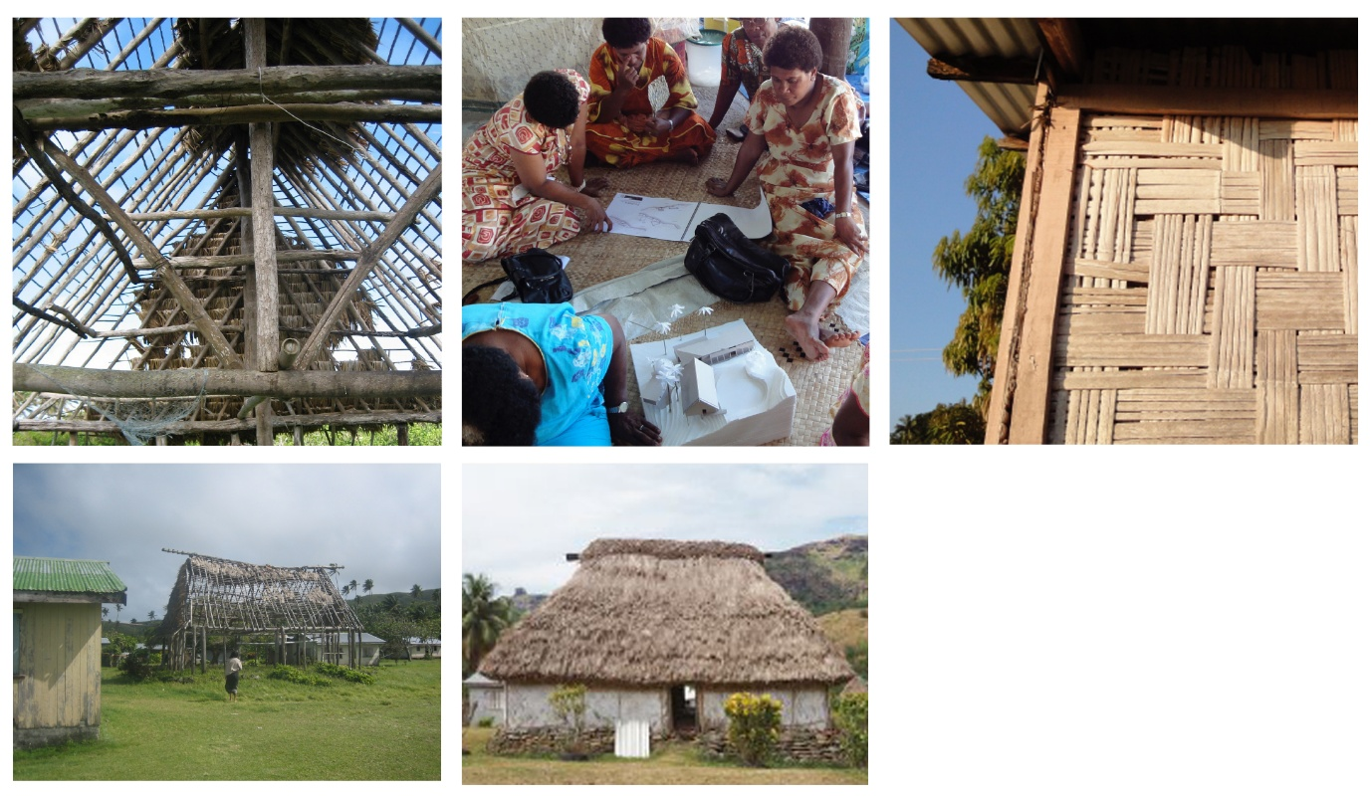
(Source :VANUA Women Build Guide to Local Practice)

TECHNICAL NARRATIVE

Site’s Intervention
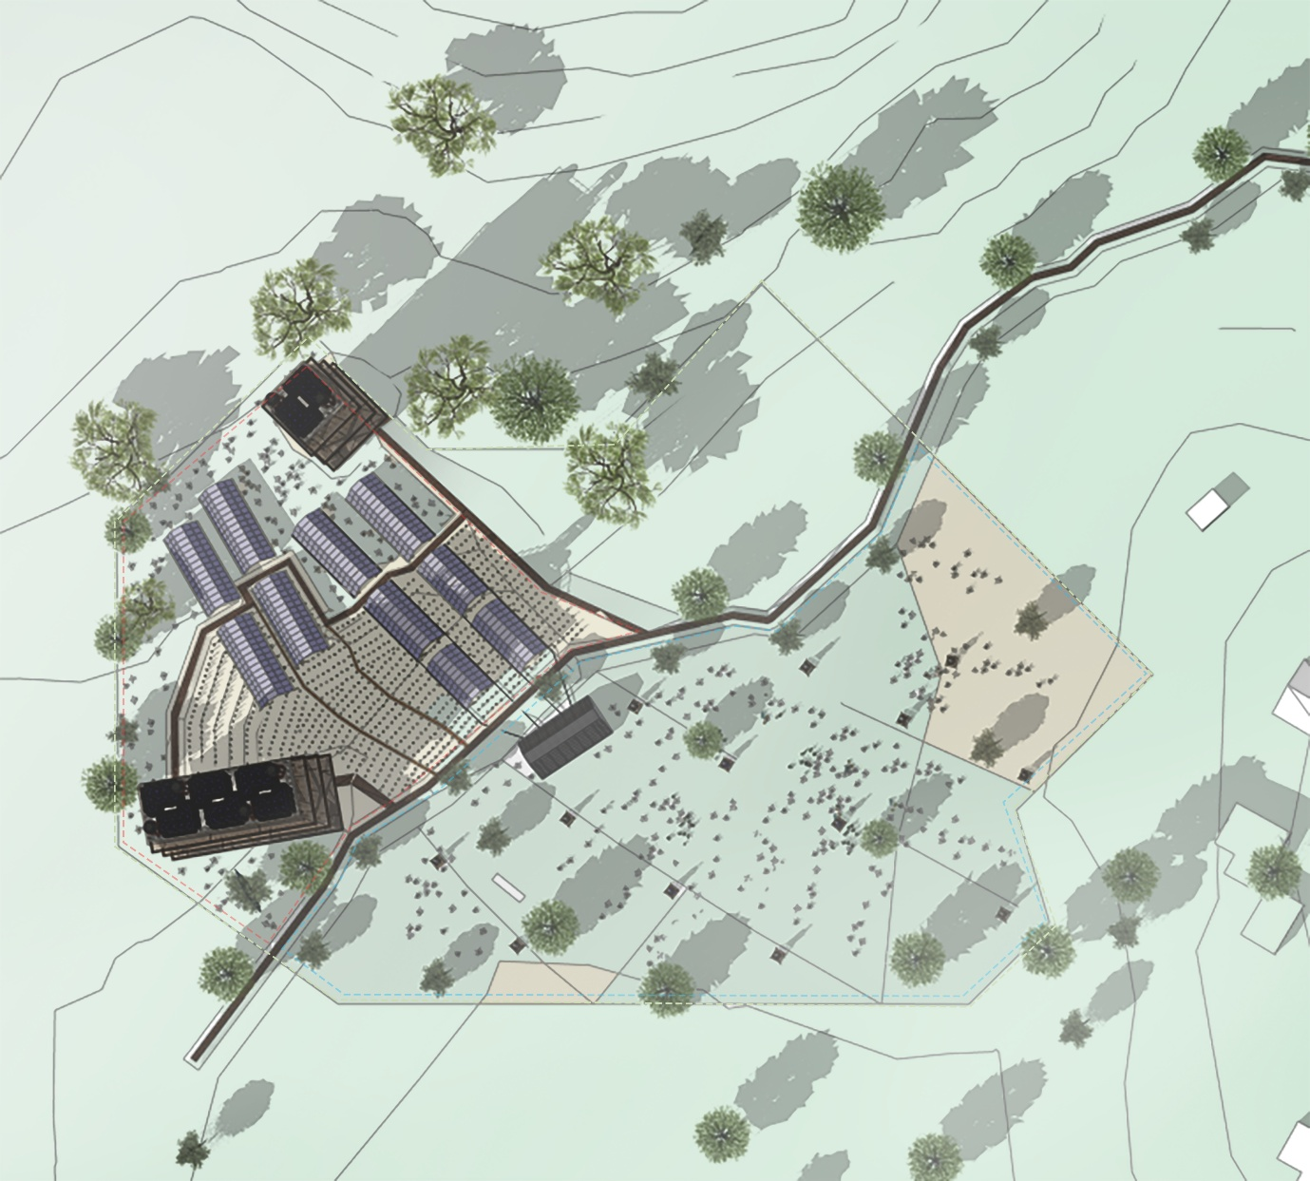
In this project, I try putting the intervention and the design at the highest elevation of the site. The reasons themselves are to maximize the potential of the tower, which includes a water tower that can function more optimally at the highest point. The placement of the tower is also adjusted to the view of Vatu Rua, with the shape of the tower divided into a large tower and a small tower, according to Vatu Rua. The rest of the site will be left as it is or planted with plants that support the working system of the energy machine itself.

The Energy Tower
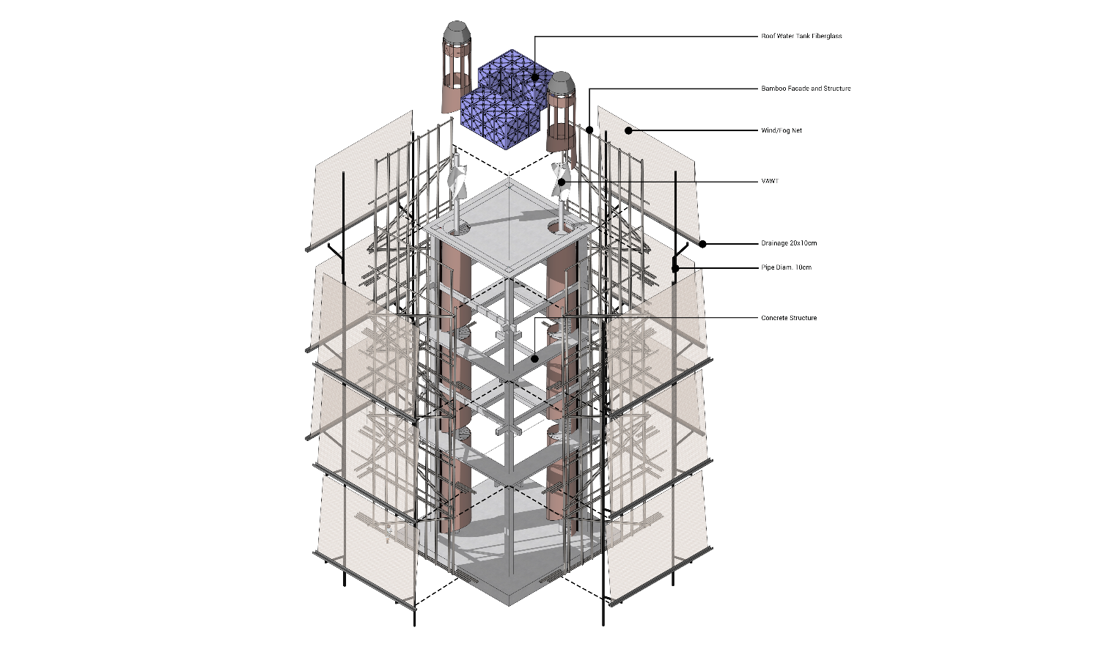
One of the problems in Marou Village is the availability of clean water that continues throughout the season, because until now the community has mostly used groundwater. The energy tower collects water through fog/wind harvest technology, where water is extracted from fog or wind passing through Naviti especially Marou's area.
Roof water tanks are also placed at the highest point of the tower to store clean water and also to distribute water by gravity to Marou Village without using electricity. At the highest point of the tower there is also a VAWT to capture wind at a higher point. Based on the data, the wind towards the Marou area is intense and consistent enough to be an additional machine to generate electricity.
Under optimum circumstances, where the wind is blowing and consistently, the Savinous Type VAWT can produce about 7.5 kW of electricity, which is a great addition to the main electric-producing machines like PV Modules. The fog/wind harvesting can produce up to 108 liters for the large tower and 36 liters for the small tower. By maximizing water capture in every energy environment available on site, it can also maximize the storage of water throughout the season for the people of Marou.

PV Roofing Structure
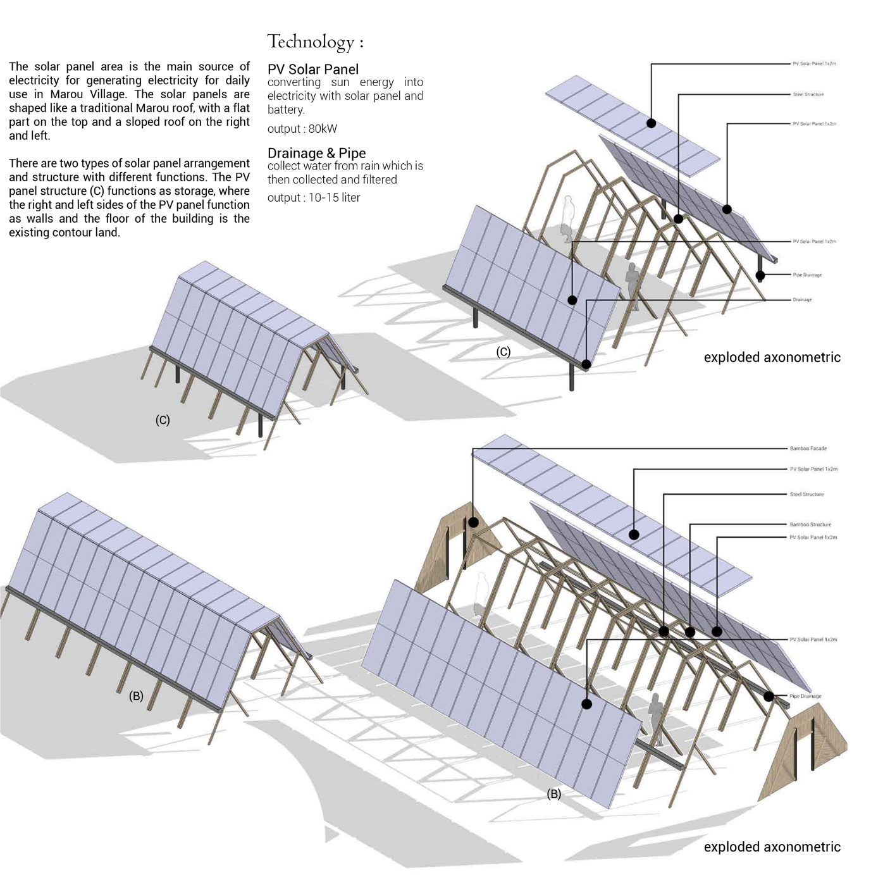

As the main part of generating electricity for the needs of the Marou community, this section is an array of PV panels shaped like a traditional Marou roof. Using a steel structure as its structural framework, this area is shaped like a roof so that the lower part can still be utilized by gaining optimal protection benefits from the sun and rain. There are two types of modules that are adapted to the contours.
Module B also functions as a storage area, which can also be used for water tanks before being pumped to the roof water tank. This part can function as storage because it is placed on a contour that is quite flat against the solar panel, so that the side of the PV panel also functions as a wall. Module C serves for shade, where the bottom can also be used to plant plants that do not need enough sun access, such as yams.

Gathering Pods
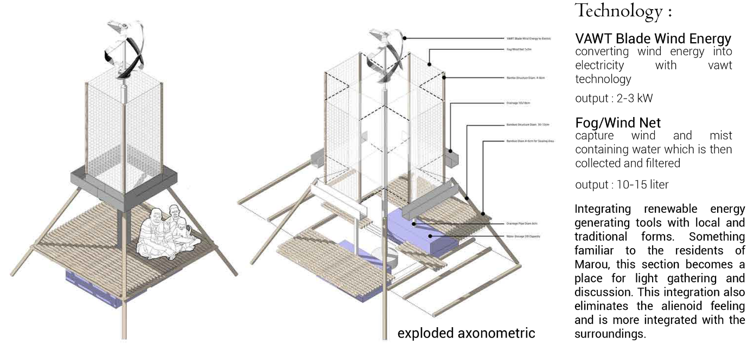
Gathering Pods are small gathering areas that can generate electrical energy and water. The electrical energy uses a VAWT Helix Shape which, with optimum wind, can produce 2.5kW, which can be an additional electrical input for people. The top is also a fog/wind harvest in a smaller form which can also be an additional water resource for the Marou community.
Fog/wind harvest uses a small water tank to collect water from the fog/wind harvest which can then be treated to become cleaner water. All of this becomes an installation that can also be a place of interaction so that it becomes an active place.

PROTOTYPING IMPLEMENTATION

Smale Scale
The intervention design in this project is a combination of various modules with small modules, namely the PV Roofing structure and gathering pods. The PV Roofing Structure has a simple structure but needs to be deepened regarding its connection to other PV parts to maximize its function as a shade and wall. Another thing to consider is to connect the PV with the drainage system. Other than that, the shape of the structure itself is quite reasonable, but what needs further consideration is to calculate the maximum solar capture with the shape and minimize the use of the structure so that there is still an area of the bottom that can be utilized.
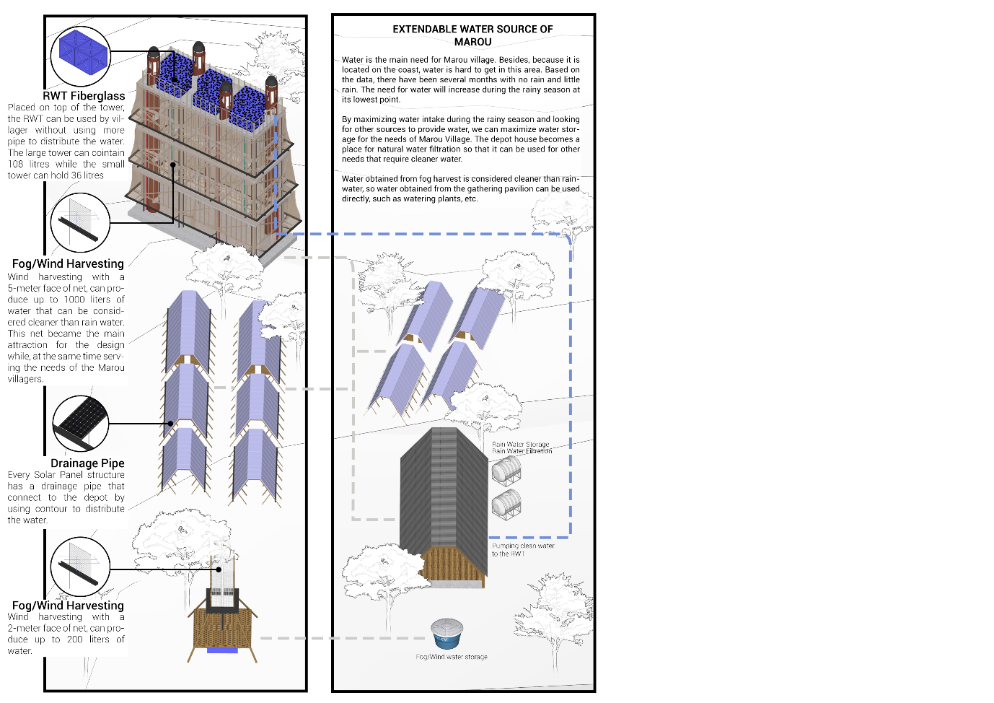

Large Scale
On a larger scale, optimum conditions are needed to check the success of fog/wind harvesting as this technology is central to the tower section. Consideration of this technology is based on existing data where there is sufficient fog and wind to carry water, but this part can be tested at the site directly. The Tower section is significant with this technology in producing water, so conditions must be replicated as much as possible to test the success of producing water.
Other systems such as the roof water tank and the Savonious Type VAWT can be replicated to test the optimization of the electricity generated. The roof water tank system itself can be customized in its development, which connects pipes from the roof water tank to each house and area of the Marou community.

OPERATION AND MAINTENANCE

The Tower
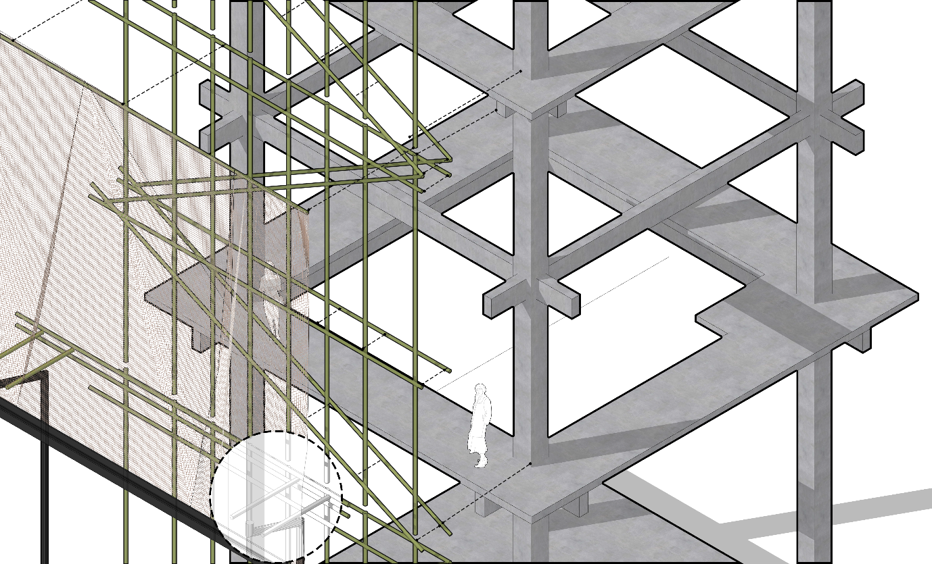
Most of the designs and interventions can operate by themselves, such as a fog/wind harvest that can capture water by itself without the need to operate. Another thing is the VAWT, which can operate on its own but does require regular maintenance to ensure the machine is working optimally.
One of the main things in the tower to worry about is the storm that occurred several times in Marou. The characteristics of the fog/wind harvest net are easily entangled or damaged in the event of a storm. The approach taken is to build it with lightweight construction such as with bamboo and maximize an easy installation system so that it can be rebuilt by the community and can operate again in a relatively short period of time.
Installation details such as the joining of bamboo using ropes or nails are also important in its maintenance, so that in the future, this part of the joining can be further developed and is quite open. Open enough here means that the shape of the facade can be changed in any way during future maintenance.

PV Roofing and Gathering Pods
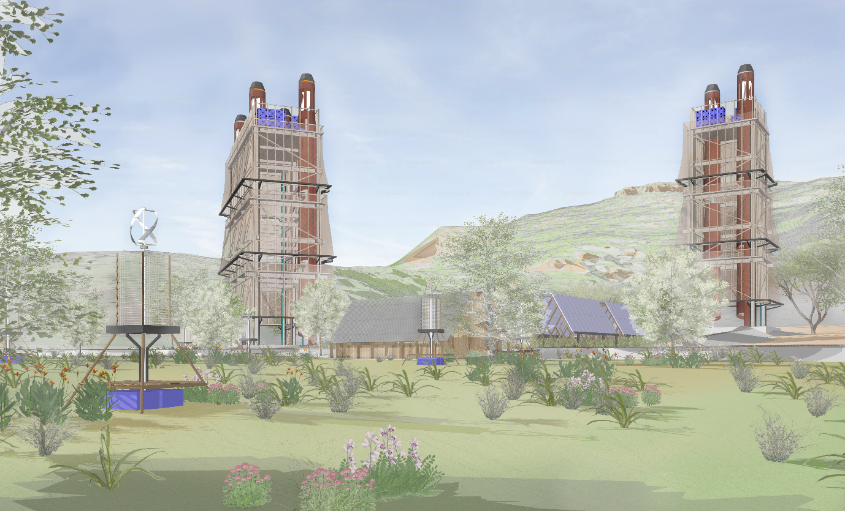
PV Roofing is self-maintaining in the sense that it can generate optimum electricity without having to be actively operated by the Marou community. Points that need to be considered are cleaning the PV solar panel, which is followed up with a shape that is not too steep so that it can be climbed by humans to clean the sides and top of the PV Roofing.
Drainage systems in PV roofing modules can be added with automatic leaf filters, to reduce the possibility of clogging due to falling leaves. Further operations related to converting electricity into batteries that can be used by the community occur in the added building, namely the depot building, where all processing occurs in that place which can be used as learning and knowledge for the people of Marou.
Gathering Pods is one of the parts that can involve the community to the fullest in the sense that it can operate on its own and become a place that can also be actively occupied by Marou residents. The VAWT itself comes with a self-maintained system which then needs regular maintenance in the rotor system and engine.
Once the fog/wind net has produced water that fills the water tanks under the gathering pods, the water tanks can be exchanged for empty ones. This makes it necessary to periodically check whether the water is full or not before being taken to the depot for natural filtration.

ENVIROMENTAL IMPACT ASSESMENT
Rigid Structure
The tower and roofing PV solar panels were built and conditioned to withstand the frequent storms that occur at the Marou site. The Tower is built with a foundation that adapts to the need to withstand roof water tanks and periodic storms. At the same time, PV Solar Panels can be built according to the PV installation guide that can withstand storms so that they are not easily damaged.

Re-shapable Model
Other parts, such as the gathering pods and part of the tower, which is the fog/wind harvesting net module, are made simple enough to be able to be recreated in case of damage due to storms or other environmental problems. These parts are a combination of materials that are quite easy to obtain on-site and can be further customized to produce more optimal shapes in the future.

For example, the gathering pods use a wooden base structure and bamboo flooring as one of the familiar aspects, but it is also possible for the Marou community to further develop these aspects. The customizable and re-adjustable design itself can create a sense of ownership and become something that is long-lasting and sustainable.

