*"The greatest impacts often lie within the simplest actions."*

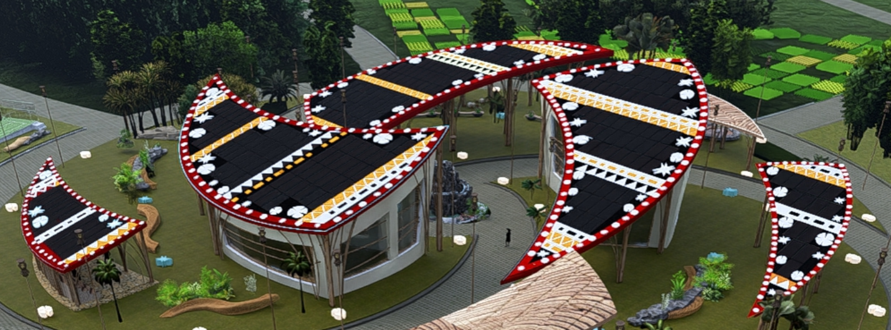

**The Five Elements of Nature**

#### Artistic and Conceptual Design Description

While climate change is partly a cyclical phenomenon for the planet, human activities—such as greenhouse gas emissions, intensive agriculture, and industrial livestock farming—have created a profound imbalance. This disruption threatens not only the climate but also the diverse flora and fauna of the Earth. Restoring this equilibrium is crucial to ensure the sustainability of humanity, which faces significant peril if we continue our current practices.

It is time for humanity to draw upon its inherent wisdom and take responsibility for its mother, "the Earth." Today presents a unique opportunity to reflect together and uncover the genius loci, the spirit of the place. In Marou, the splendor and fierceness of nature coexist, as do abundance and scarcity. Can we reconcile these opposing forces to build sustainably? How can we harmonize seemingly incompatible elements? The Fijian tradition offers an answer through the concept of Masi, which urges us to "*act with full awareness and intention*."[1]

The *Masi* (or *tapa*) is a traditional textile where motifs, reinterpreted based on needs, serve as cultural metaphors. Drawing inspiration from this approach, we incorporated designs onto black photovoltaic panels, chosen for their simplicity, neutrality, and reliability. This black background highlights the motifs and colors, transforming the panels into carriers of symbolic messages.

The proposed motifs, though carefully designed, are intended to be revised and adapted by local communities, custodians of traditional knowledge. This collaboration ensures cultural authenticity and allows for the design’s continuous evolution.

Created with water-resistant paint that complements the black panels, the motifs make each structure unique while maintaining overall aesthetic harmony. Over time, the natural wear of the paint provides opportunities to renew the designs to meet emerging needs, allowing the artwork to remain dynamic and ever-evolving. This project, at the intersection of tradition and modernity, celebrates local artistic expression while fulfilling functional and environmental objectives.

Water "*Wai*", fire "*Buka*", earth "*Vanua*", wind "*Cagi*", and the sea "*Wasawasa* are the fundamental elements that collectively sustain life. These natural forces are at the heart of our project, designed as a celebration of their harmony and interconnectedness.

The project draws inspiration from a helix, symbolizing mobility (*Cagi*), enclosed within a circle that represents the unity of land and sea and the cycle of life. The reinforced concrete structure, supporting photovoltaic panels, embodies strength and resilience. Its helical form converges at a center marked by a **waterfall**, an allegory of **water** as the **source of life**.

The inclined structures, positioned at a 15° angle to capture solar energy (*Buka*), symbolize fire and are oriented toward the sun. The colors—ochre red, black, white, and burnt orange—evoke natural elements and traditional Fijian *masi* motifs, blending tradition and modernity in a harmonious central focus (*covu*).

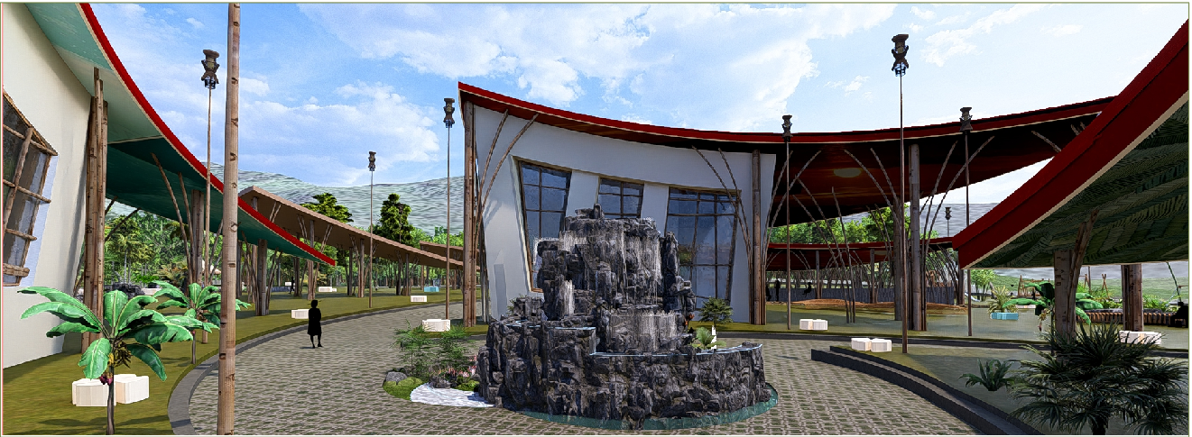

**Helical Waterfall, A Convergence Point of the Overall Helical Design**

The design reflects the movement of natural energies and offers an immersive experience. The inner slanted surfaces visible from the village, serve as artistic spaces open to local expression. By selecting themes and artists, the inhabitants create a participatory dynamic that strengthens their connection to the territory.

This project celebrates nature, blending symbolism, sustainability, and innovation. It embodies a vision where art, culture, and technology converge to reconnect humans with their environment while offering an aesthetic and functional space.

Conceptual paintings illustrate the future appearance of the project, inspiring local artists and highlighting the interaction between art and nature.

#### The design, deeply rooted in *iTaukei* culture, draws inspiration from the article "*iTaukei Indigenous Fijian masi as an education framework: Retaining and adapting tradition in epistemology and pedagogy for a globalised culture*".

### Meaning and Symbolism of the Paintings

1. **Sunset (top)**

Represents solar energy, transformation, and life's cycle, with warm tones like orange and brown symbolizing the harmony of fire (Buka) and earth (Vanua).

1. **Ocean (left)**

Depicts water (Wai), its variability, and constant flow through contrasting blue hues, unified by the circular design.

1. **Vegetation (right)**

Symbolizes growth and vitality (Cagi), with green and red tones reflecting fertility and dynamic renewal.

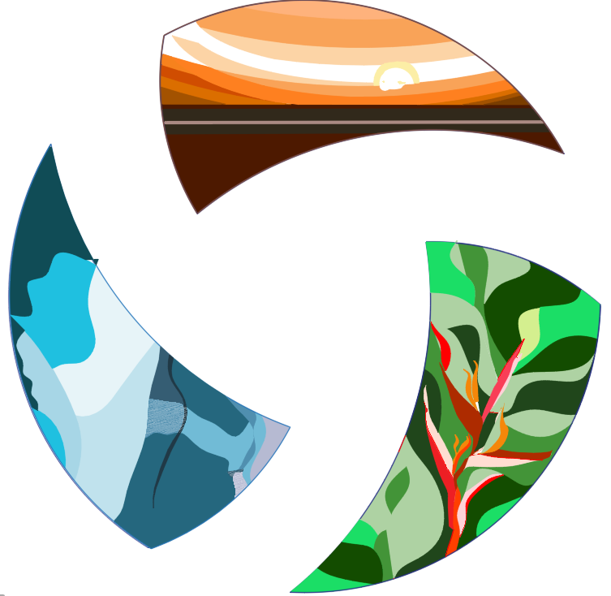

**The paintings on the inner slanted surfaces**

### Reinforced Concrete Structures and Their Uses

#### The reinforced concrete structures, chosen for their durability against strong winds and frequent cyclones, support photovoltaic panels. The project includes three large structures and two smaller ones, designed to be multiplied in a circular progression to meet future needs. Existing bamboo structures complement the form and can be replaced with concrete versions if necessary. To reduce the carbon footprint, the concrete incorporates local materials such as regional aggregates and eco-friendly binders, optimizing water management while ensuring resistance to corrosive climates. Inspired by natural forces, the helical shapes combine aesthetics, symbolism, and landscape integration.

#### Coconut fiber straw insulation, stabilized by a thin concrete layer, protects the spaces beneath the photovoltaic panels while ensuring robust anchoring. Two large structures will house community facilities determined through consultations with Marou residents. The third structure will provide a covered area for celebrations and events. The smaller structures, designed as additional shelters, can host activities or protect spaces.

#### Technical Description

#### The Marou project is a complex and holistic initiative that goes beyond the creation of a functional artwork designed to provide electricity and potable water. It represents a global vision - urban, human, and natural - that, much like the Fijian *Masi*, aims to weave connections between human needs and those of the environment. Several interconnected components are envisioned:

#### Photovoltaic Power Station

A solar power plant powered by photovoltaic panels is at the heart of this project.

Given the **space constraints of a rooftop installation**, our analysis led us to select the **Jinko Tiger Neo 625W panel** due to:

* **High efficiency** (maximizing power per m²).
* **Lower cost** compared to European alternatives.
* **30-year warranty**, ensuring long-term performance.
* **Reduced structural and labor costs** (optimized for rooftop use).

This choice balances **performance, cost, and space efficiency** for an optimal rooftop PV system.

Here’s a step-by-step sizing of a **75 kW AC photovoltaic system with battery storage**, using **Jinko Tiger Neo 625W panels** at a **15° tilt** and **4.38 kWh/m²/day** irradiation:

**1. PV Array Sizing (DC Side)**

**Target:** 75 kW AC output

* **Typical DC/AC ratio:** 1.3 (to account for losses)
* **Required DC capacity:**

PDC=75 kW×1.3=97.5 kW

* **Number of panels (Jinko Tiger Neo 625W):**

N=97,500 /W625 W/panel=156 panels

* **String sizing:**
  + Assume 12 panels per string (voltage within inverter MPPT range).
  + **Total strings:**

156/12=13 strings

**2. Battery Storage Sizing**

**Key Assumptions:**

* **Autonomy:** 1 day (full backup for 24h).
* **Daily load:** Assume 75 kW × 4.38 h = **328.5 kWh/day** (scaled to match PV production).
* **Battery type:** Lithium-ion (LiFePO₄).
* **DoD (Depth of Discharge):** 80%.
* **Round-trip efficiency (η):** 90%.

**Calculation:**

Battery Capacity (kWh)=Daily Load (kWh)/(DoD×η)=328.5/(0.8×0.9)=456 kWh

* **Examplebatterychoice:**
* **BYD B-Box HV** (e.g., 10 × 46 kWh modules).

**3. Inverter& Charge Controller Sizing**

* **Hybrid inverter(s) required** (handles PV + battery).
* **Total AC output:** 75 kW (e.g., 3 × 25 kW inverters).
* **Battery inverter capacity:** Must handle peak discharge.

Pbat_inv=PDaily Load/24h×Peak Factor=328.5/24×2≈27 kW

* 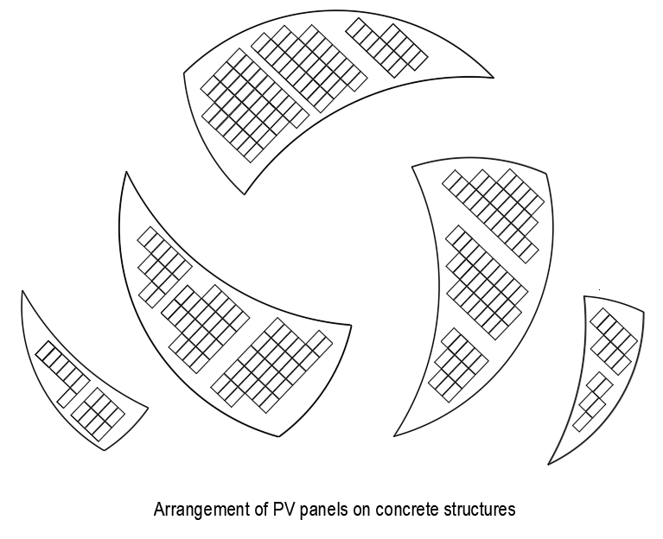**Example:** SMA Sunny Island 8.0H (3 units for 24 kW continuous).

1. **Single-Line Diagram**

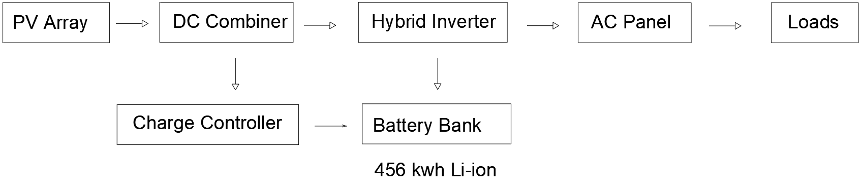

**5. Component Summary**

| **Component** | **Specification** |
| --- | --- |
| PV panels | 156 × Jinko Tiger Neo 625W (97.5 kW) |
| Batterystorage | 456 kWh Li-ion (e.g., 10 × 46 kWh modulesBYD B-Box HV) |
| Hybridinverter | 75 kW AC (e.g., 3 × 25 kW SMA Tripower) |
| Charge controller | 150A MPPT (e.g., VictronQuattro) |
| Roof area | ~395 m² (15° tilt) |
| Battery area | 5 m². |

#### The population of Marou and the local authorities need to be made aware of the importance of creating a micro-enterprise or a dedicated team, which will be trained to ensure the maintenance and recycling of the station's equipment. This team could expand its operations to other regions once the project is scaled up.

#### Village Potable Water Supply Network Inspired by the Fouggaras

#### The foggara is an ingenious system that harnesses gravity to transport groundwater without the need for mechanical pumping. Used in North Africa for millennia, this method is valued not only for its practicality but also for the curiosity it arouses among tourists, who are drawn to the wells that punctuate the water’s journey.

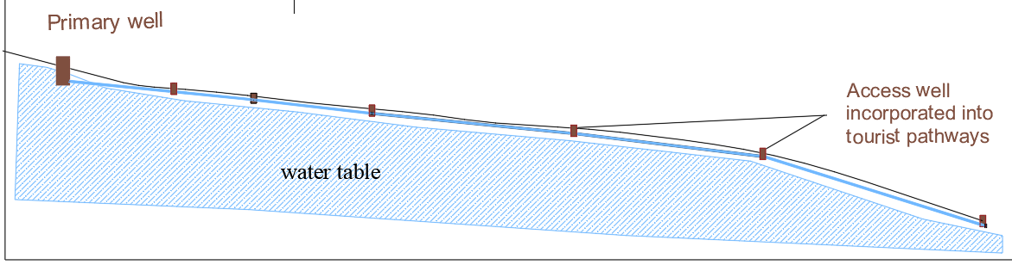

**Diagrams illustrating the foggara system**

### Water Collection and Transportation

This project draws inspiration from traditional systems by utilizing gravity to manage water flow. A strategically placed well at an elevated altitude captures water, which flows naturally along a controlled slope via a channel with an integrated pipe. These wells, spaced 200 to 300 meters apart, serve as control points equipped with valves and pressure mechanisms. Additionally, they act as refreshment stops with taps providing fresh water, turning these stations into tourist attractions. At the endpoint, a distribution network efficiently delivers water to the village through flow and pressure controls.

### System Advantages

The water flows exclusively through gravity, eliminating the need for pumps and reducing energy costs significantly. The constant flow rate relies on aquifer replenishment through precipitation or infiltration. Buried pipes within the channel protect the water from evaporation and weathering, while regular maintenance of valves and controls ensures system efficiency. This approach guarantees a sustainable potable water supply.

Included in the proposal are a well and a pipeline delivering water to the village, supported by an explanatory drawing. However, implementing this concept requires detailed geotechnical studies and precise site surveys. The proposal serves as an illustration of the foundational concept.

### Preliminary Calculations

Initial estimates suggest that a well located 30 meters above the village and 400 meters away could provide approximately 10,000 m³ of water annually. The system is scalable to meet current needs and future demand, as determined through community surveys. Additional volumes can also support agricultural use. This project combines sustainability with innovative methods to address essential water needs.

### Hydro-Electric Station Using a Foggara System

Complementing the water supply project, this initiative uses gravitational water flow to generate electricity and revitalize arid regions through irrigation. Inspired by the ancient foggara system, it involves drilling a high-altitude well to harness water pressure for driving a turbine. The generated electricity supports local needs, while the water, after passing through the turbine, is directed to a permeable basin layered with gravel and sand for groundwater recharge.

From this basin, a network of pipes distributes water for irrigation and ecological restoration. The project envisions a mixed plantation of fruit trees, native species, and specialized vegetation, developed with input from regional experts. This effort aims to restore biodiversity, rebuild ecological balance, and promote sustainable land use.

### Community Impact

The local community plays an active role in the project, benefiting from the agricultural and forest products, which could generate significant economic value. With proven success, this strategy could be replicated in other regions, amplifying its environmental and social impact.

#### Preliminary Studies

#### The project hinges on geotechnical studies to confirm feasibility, including aquifer assessment. This conceptual proposal envisions collaboration with local authorities and residents, merging innovation with tradition to create a sustainable development model.

#### Urbanization and Future Development

#### As part of the village's future urbanization, new constructions will be placed on elevated terrain behind the current settlement. This location on sloped land will aid rainwater drainage and provide better flood protection.

#### In response to climate change and increasing hurricane intensity, the strategy also reduces exposure to rising water risks. Vegetative barriers in adjacent areas will mitigate strong winds, stabilize the soil, and improve the local climate long-term.

#### A multifunctional pathway network will delineate residential zones and public spaces. Built with locally sourced stone, these paths manage rainwater, support traffic, and resist erosion, with widths of 6 to 8 meters.

#### Coastal and Soil Protection

#### A tree belt along the coastline will stabilize soil and reduce erosion. Temporary measures like sandbags or coconut fiber strips will provide short-term protection. Over time, the belt will expand, while constructed areas may include stone paving for resilience.

#### Tree planting will safeguard the coastline, restore biodiversity, improve air quality, and recharge groundwater. Expert consultation will guide species selection and belt dimensions for optimal adaptation.

#### Creation of Micro-Enterprises

#### To ensure the project's sustainability, local micro-enterprises will be established. A specialized team will handle the maintenance of photovoltaic panels and potentially support other villages as the initiative scales. Another team will oversee the operation of the potable water network and, if applicable, the hydroelectric station.

#### Dedicated teams will also focus on planting and maintaining vegetation, addressing climate-related challenges. Concurrently, digital content will showcase local activities and Fijian culture, boosting visibility and facilitating the promotion of traditional practices and local products.

#### Finally, a delivery service will be introduced to reduce travel and, consequently, lower CO₂ emissions. This integrated approach aims to strengthen community resilience while fostering sustainable development.

#### Prototyping and Pilot Implementation

#### One or more visits to the Marou site will be essential to conduct a thorough assessment and immerse ourselves in the local environment. During these visits, a detailed survey will be conducted among the residents, prepared in advance with specific objectives: social, economic, environmental, and aesthetic. This phase of observation and dialogue will help us better understand the project’s potential impact on the local ecosystem and evaluate necessary adjustments.

#### The data collected, complemented by open discussions with residents and local authorities, will inform the design of an operational prototype tailored to the realities of the site. This prototype will be a scaled-down but fully functional version, tested on-site to validate its technical performance and social acceptance. Adjustments made during this phase will ensure the success of the second stage: the pilot implementation.

#### From a design perspective, our project is structured to accommodate modifications while preserving its core integrity. For instance, the convergence of circles towards a symbolic center integrates seamlessly into the site, as demonstrated in Marou, where the outer circle was opened to encompass the entire village and anticipate its future expansion.

#### This participatory approach, centered on the active involvement of the local population, ensures that the project will progressively and sustainably meet the community’s needs. Local teams trained on-site will play a pivotal role, not only in managing and maintaining the installations but also in raising awareness in other communities. The success of this project in Marou—economically, aesthetically, and culturally—will serve as a model for other localities, encouraging them to adopt this innovative concept that harmonizes modernity, tradition, and sustainability.

#### Environmental Impact

#### This project combines renewable energy, sustainable water management, and reforestation to address local environmental and climatic challenges. The photovoltaic panels, adorned with Fijian motifs and contrasting colors, enhance their visibility to birds, reducing risks to wildlife while minimizing visual impact for humans. This artistic approach highlights cultural traditions while addressing ecological concerns. Additionally, a gravity-fed irrigation system, inspired by foggara techniques, provides an energy-efficient and environmentally friendly water solution. Reforestation, integrating local species and fruit trees, restores ecosystems, stabilizes soil, and sustainably supports communities. By actively involving the local population at every stage, this project fosters a harmonious balance between innovation, culture, and sustainability.

***"From Marou to Africa, this is a project we envision transcending the Pacific islands, extending across all tropical regions, passing through Asia before reaching Africa."***

1. (Sewell & St. George, 2008, p. 205-6)"iTaukei Indigenous Fijian masi as an education framework: Retaining and adapting tradition in epistemology and pedagogy for a globalised culture"