**Preamble - Our Story**

It was early April 2025 and somehow everything had aligned at the last minute and the trip to Fiji was on. I was nervous and excited.

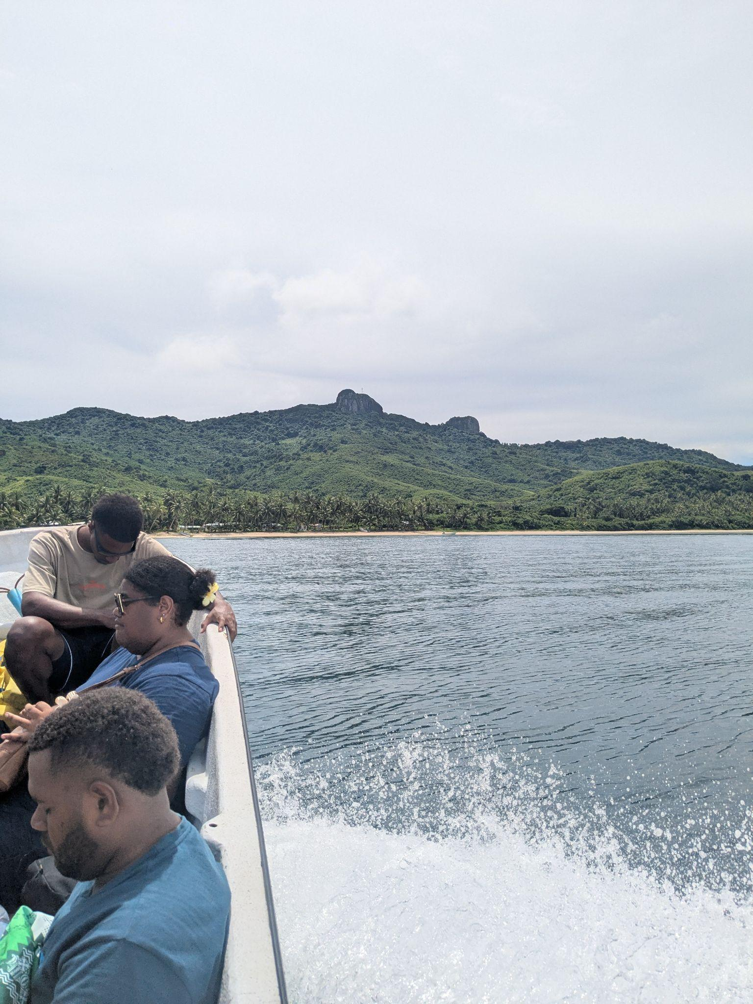

Upon arriving in Marou Village I was greeted warmly by the Marou Village Chief. After the Kava Root was handed over by my guide the *Roku, we had* a traditional lunch.

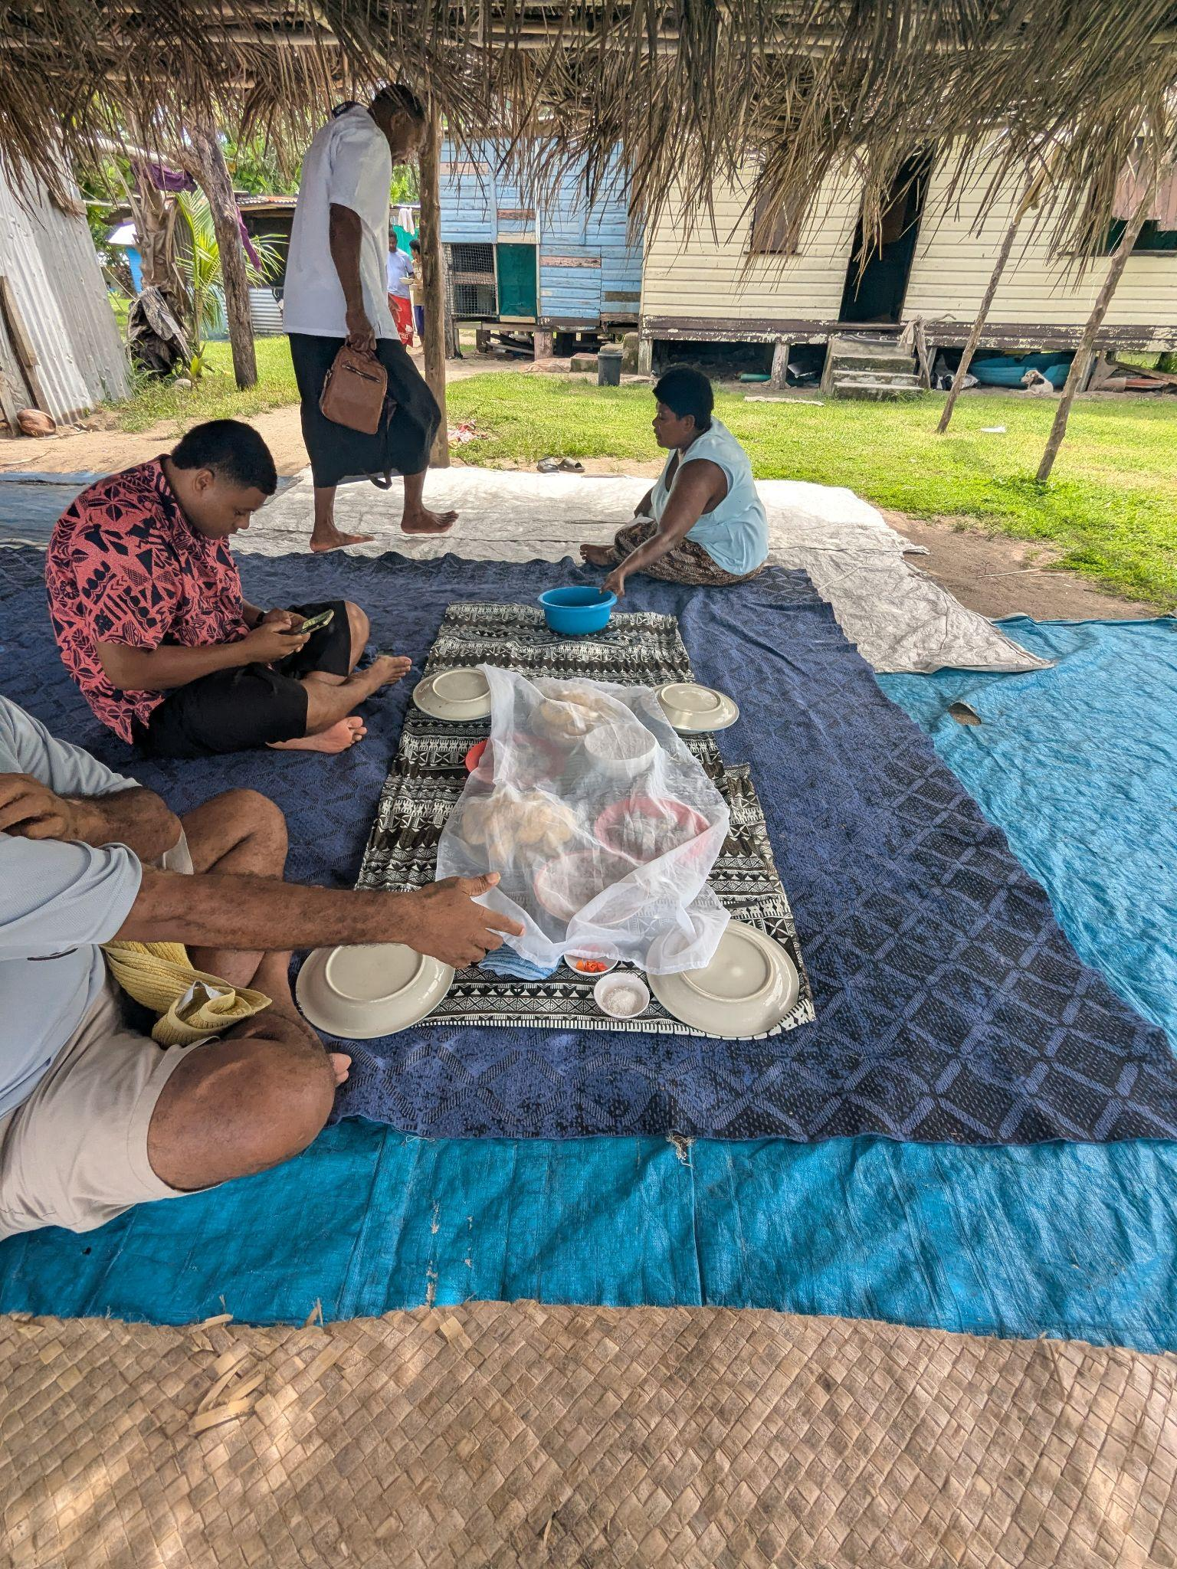

After lunch we began work, discussing the challenges Marou Village faced, from erosion, to flooding to water security and cyclonic weather. We discussed:

* The difficulty and high cost in landing barges
* The lack of local natural building resources or skills
* The absence of heavy equipment
* Difficulty in maintaining assets was a key issue, NGO’s investing, then leaving
* Houses suffering from regular flood inundation and minimal means, tools or skills to repair them
* Tanks and wells running out in the dry season

I was beginning to understand how complex this project was going to be. The challenges were simply enormous.

I was eager to know the answer to my most pressing question so I asked, *“what is the one thing that would make the biggest positive impact for this community?*” After some chatter in the local language, the guides replied that they had decided upon an answer… “*a place to go during the storms, to keep dry, to stay when Marou Village is flooded and a place to gather* ”. This was what I needed to know. We now had a direction.

A structure, big enough to accommodate all of the Marou Villagers, strong enough to be resistant to cyclonic winds, raised high enough to avoid flood waters, and of course able to achieve the requirements of LAGI - generate power and collect rainwater.

In any other developed place this would not be so daunting but what I learnt that day changed everything…

**Vunilagi**

*…the place and relationship between humans, earth, sea, and sky — where they meet, at the horizon, and become one - Vunilagi - a place for the future that encompasses people’s aspirations*

**1. The Concept Narrative**

Vunilagi is an approach which seeks to strike the right balance between technical feasibility, local community empowerment, skills development and land art aesthetics. It is important to us that Vunilagi can be a reality for Marou Village by being built by the community itself.

| **Concept** | **Logic** |
| --- | --- |
| **Design**  A safe place which meets community needs | Our design provides Marou Village with a 500m² multifunctional space—large enough to shelter the entire community and more during severe weather and recovery.  This safe community place may also serve as a hub for meetings, receiving Marou Village visitors, workshops and knowledge exchange, women’s activities, exchange of food from the nearby orchard - fostering community pride.  The building breathes and is open to cooling breezes, features a roof designed for 400m² of solar panels, and harvests rainwater to support the entire Marou Village needs.    A roof designed to support a 75kW PV system and capture 190 litres of water per mm of rain (substantial). |
| **Materials**  Made from local materials that are sustainable and lightweight | The use of bamboo is a key feature of the structure and is a material already used in Marou Village. It is being promoted by Fiji’s Ministry of Forestry for its sustainability, agribusiness opportunities, and cyclone resistance [1].  With 20 species in Fiji—including the native *Bitu Dina*—bamboo is widely available, non-invasive, and construction-ready in around three years.  It requires only basic tools and skills, it is lightweight and easily transported by boat or floated to site. Bamboo is strong enough to support solar panels and offers Marou Village a chance to be a leader in sustainable agribusiness and construction. |
| **Community**  Built by the Marou Villagers | Whatever is made, it is our view that it must be built by the local people, so:   * they can maintain it * they can develop the much needed specialist skills to create income * knowledge is captured in the Marou Village not taken away * Vinulagi is cherished as a shared community asset co-created by the community itself * the Marou villagers can adapt the knowledge to solve their other housing problems using raised bamboo structures - much wider adaptability |
| **Skills**  Incorporating local skills already in existence | What if we could use existing palm leaf mat-making skills to create the covering for the roof, walls and floor?  We will work with community knowledge to create lightweight, weather resistant coverings which are able to be locally replenished with existing skills. |
| **Construction**  A practical construction methodology | Our goal is to support community knowledge, and provide new skills via practical and replicable construction methods.  The design uses straight bamboo sections assembled on a hand-carried ‘jig’, with basic joinery, rope, minimal concrete, and no steel.  An experienced bamboo builder at the beginning will be helpful but not essential, while a qualified electrician will be needed for solar and battery installation.  This approach builds local skills and creates a scalable, adaptable model for future projects in Marou Village and other island communities.  Concrete is difficult to transport and store in Marou Village. Our design minimises its use by bringing only cement dust, mixing it on-site with local coral rubble and sand - reducing weight and meeting structural requirements. |
| **Landscape**  Fits into the local landscape and character | Made from natural materials and cloaked in locally made coverings for all surfaces, this structure will be immediately part of the landscape and local culture, nestled and sited within the context of Vatu Rua. |
| **Culture**  Artistically reinterprets Fijiian cultural history | The structure makes four culturally connected moves:   1. Geometric repetition in building form reflects traditional Fijian and Polynesian art, especially Tapa mats 2. The triangular entrance symbolizes Fiji’s volcanic origins 3. Palm leaf mats functioning as retractable walls are based on the methods used to make the sails of traditional Fijian Drua boats 4. Vunaliagi’s frames are modular variations of a triangle, symbolizing the relationship between humans, earth, sea, and sky—each point representing a natural system. |
| **Energy Independence**  Harvests the right amount of power | A 75 kW solar PV system will meet Marou Village’s daytime energy needs, with excess stored in a 50 kW/100 kWh modular battery energy storage system (BESS).  All solar system components will be selected keeping in mind easy transportation, future demand expansion, and end of life logistics. |
| **Fresh Water Supply**  Harvests enough water to sustain the Marou Village through the dry season | The structure will collect around 300,000 litres of rainwater annually—boosting Marou Village’s storage by 33%. Centralised *flat packed* tanks will be installed within the Marou Village, chosen for durability, water quality and logistics.  With taps and sand–charcoal filters, the water is safe to drink.  Components are lightweight, easy to replace, and maintainable by Marou villagers. Future upgrades could connect residential tanks to the central system. |

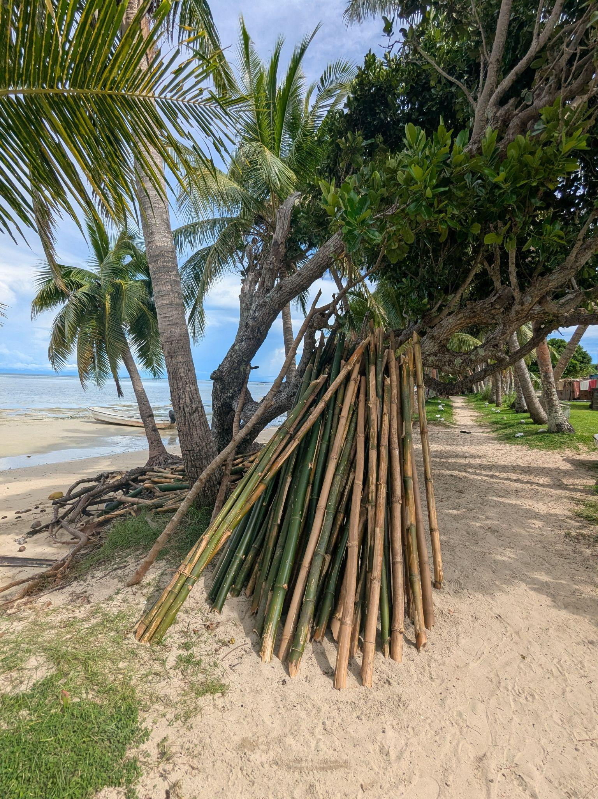

Bamboo is already in use in Marou Village albeit in a limited way.

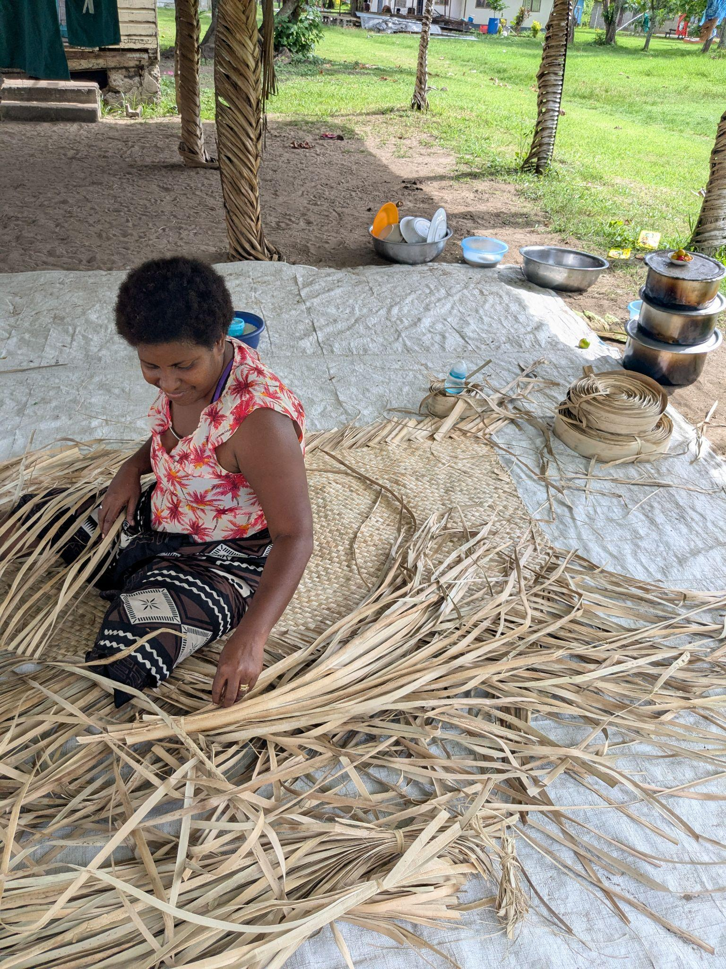

Making palm leaf mats is a common practice in Marou Village.

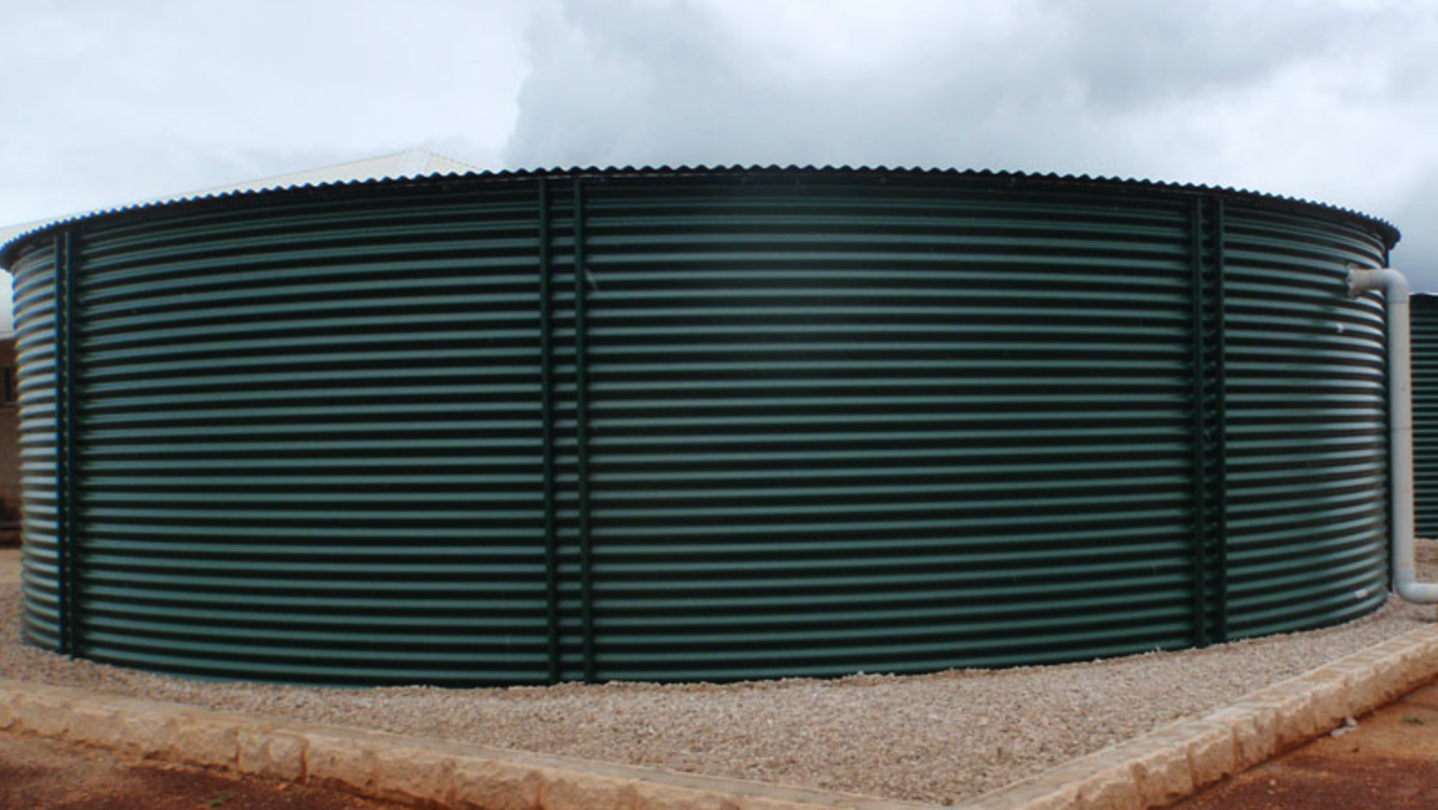

This 105 000L tank is flat packed for transport, it can be broken up for ease of lifting, and then assembled onsite. Three are proposed for Marou Village.

**2. Technical Narrative**

The guiding principle for our technology selection was to choose well-proven and practical solutions from original equipment manufacturers (OEMs) that offer reliable support, while ensuring seamless integration into the design and maintaining the project's aesthetic appeal.

**Solar, battery and fresh water systems**

* **Photovoltaic Panels**:~200 monocrystalline 1x2 m panels, certified to IEC61730 or UL1703, from well established suppliers [2]. Chosen for certification, modularity, customer support and ease of replacement, e.g. if a number of panels are damaged after a cyclone, they could be easily replaced using the spare parts kept on the island without compromising the whole system. Furthermore, since this is an off-grid system, power optimisers are considered in the design to maximise energy output from each panel by reducing the impact of shading, mismatch and other inefficiencies.
* **Battery Energy Storage System (BESS):** Modular, off-the-shelf LFP batteries from well established suppliers, housed in weatherproof cabinets which are located off the ground in the structure, require minimal maintenance and allow future storage capacity expansion [3].
* **Energy Generation**: using the solar potential curve on an average day, it was estimated that the yearly energy generation will be between 130-140 MWhr
* **Water Collection:** Considering only collection during the wet season, the roof tilt angle and a collection coefficient of 70%, it was estimated that approximately 300,000 litres of water can be harvested. This offers the 160 Marou Village residents an additional 15 litres per person per day of fresh water over the 3 month dry season. This is also upscaleable with future further investment.

**Cyclone-resistant construction**

Bamboo is increasingly recognised as a cyclone-resistant construction material due to its high strength-to-weight ratio and flexibility [4]. When properly treated and engineered, bamboo structures can withstand strong winds and dynamic loads, as the material can bend without breaking, an essential quality in cyclone-prone areas. Its lightweight nature reduces the risk of structural collapse during extreme weather events, and its sustainability makes it a compelling option for resilient, eco-friendly building in tropical and subtropical regions.

Research [5] highlights that features of traditional Fijian construction can support cyclone resistance and these were considered in the design, including:

* Sloped roofs without gable ends, and lower degree roof pitches experience lowest wind pressures.
* A low centre of gravity with short walls supports cyclone resistance (our walls can be entirely raised).
* The use of traditional and local materials supports maintenance and reconstruction.

For the solar panels installation, cyclone-rated mounting systems compliant with AS/NZS 1170.2 standards or equivalent are considered such as [Clenergy PV-ezRack](https://www.clenergy.com.au/display-product/mounting-systems/solarroof/) and [SunLock](https://static1.squarespace.com/static/64a366d941a9ac3c89c5e557/t/64e7f828b1d6bc649133a537/1692923997254/installmanualV3.pdf) solutions. Additionally, the installation must be supervised by an accredited installer to make sure proper anchoring is achieved.​

**3. Construction Prototyping and Pilot Implementation Statement**

Our approach is an engagement methodology, to co-create the training approach and pilot implementation of Vunilagi with integrated solar and freshwater design solutions.

Principles of Engagement:

1. *Respect for Indigenous Knowledge*: Valuing traditional techniques and wisdom around resilience, local materials and craftsmanship.
2. *Transparency and Accountability*: Clear communication of timelines, responsibilities, and project limitations.
3. *Community Capacity Building*: Building on existing community knowledge, and ensuring new skills remain with the community after the project ends.
4. *Flexibility and Adaptation*: Adapting the project as new insights and *talanoa* (dialogue) emerge from community input.
5. *Delivering Community Outcomes*: Marou Village should expect that this project has been designed to be delivered, promises matched with commitment.

**1. Preparation Phase**

A. Stakeholder Identification and Relationships

* Re-engage with the Ba Provincial Office, Vinaka Fiji, Marou Village leaders and community, including the Yasawa school leadership and youth.
* Meet and engage local NGOs, government and international initiatives (i.e. Vinaku Fiji; Fiji Rural Electrification Fund [6], Fiji Bamboo Project [7]).
* Seek the appointment of a local liaison coordinator via the community and Provincial Office for support and recommendations.

B. Context Research

* Understand traditional knowledge on bamboo use, current construction materials and techniques.
* Respect and understand the importance of traditional burial sites and places of cultural significance for project design.
* Reaffirm the current minimum energy, water and cyclone shelter requirements.
* Confirm the site location and constraints with the help of the Ministry of Lands and Rural Development, Mineral Resources Department and Forestry Department of Fiji.
* Confirm the materials list, availability and alignment to costing of $USD15/watt

C. Early Buy-in

* Conduct meetings and invite feedback (*talanoa*-style — open, respectful, inclusive and transparent dialogue) to introduce Vunilagi training and pilot implementation; reinforcing community ownership.
* Share clear objectives, community benefits (resilience, clean energy, skills development), and co-creation principles.

**2. Co-Design Phase**

A. Participatory Workshops Facilitated by Our Engagement Specialists with Vast Experience in Fiji Engagement Processes

Workshop 1: Visioning and Needs Assessment

* + Understand the community challenges and needs regarding energy and water insecurity, and safety in extreme weather.
  + Jointly define what success looks like today and into the future.

Workshop 2: Co-Design of Training Structures and Pilot Introduction

* + Training structures are smaller constructed elements using the necessary techniques for the pilot project.
  + Present structures and pilot ideas using simple sketches, 3D models, and participatory design.
  + Confirm training requirements, materials resourcing; partner and community roles (i.e. infrastructure providers, builders, trainees, maintenance).

B. Integration with School Curriculum

* Develop a "Junior Energy Champions" program for Yasawa school students, building on their excellent work and knowledge to date.
* Establish lessons and skills related to site survey and EIA; renewable energy, bamboo construction, water sensitive design and climate resilience through fun activities, posters, and ongoing ‘community (citizen) science’ projects.

C. Gender and Inclusion Strategy

* Ensure cultural inclusiveness of workshops and construction, skills and maintenance training, considering all opportunities for accessibility to women, youth, people from different religious denominations and marginalised groups.
* Ensure all voices are embedded in the short, medium and long term project outcomes and successes, including spiritual leaders, elders and traditional healers.

**3. Skills Development, Training and Construction Prototyping**

A. Bamboo Construction Training

* Hands-on, expert instructed, competency-based construction training for selected community members.
* Incorporation of traditional methods, and the introduction to the framework ‘jig’ to establish the range of construction techniques .
* Training is focused on constructing and assembling bamboo ‘prototype’ components for installation on smaller scale ‘in-Marou Village’ over-water tank projects.
* It focuses on practicing and refining the techniques to establish the larger pilot project structure (i.e. construction layout, footings and anchoring, connections and lashings).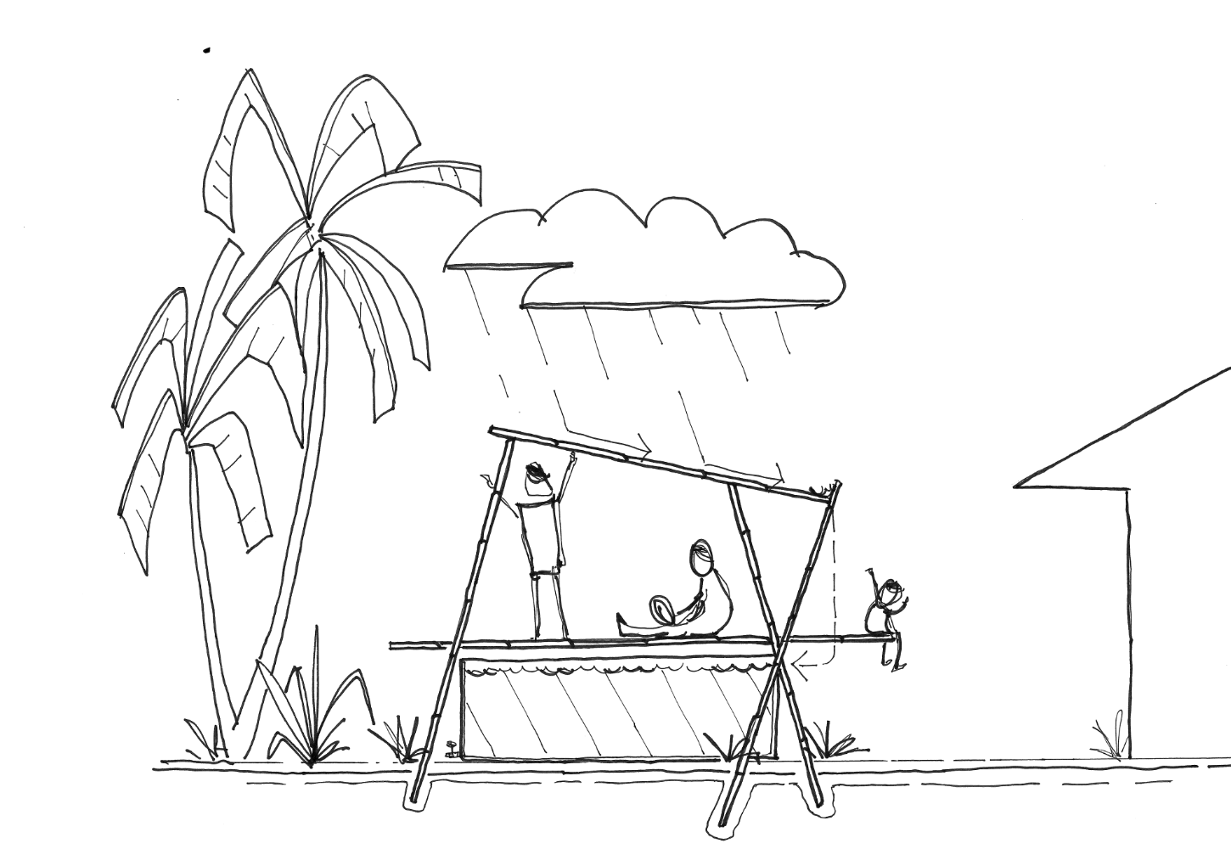

Skills development involves making small scale shelters that capture rainwater and sit above new collapsible rainwater tanks. All processes for the larger prototype are tested in this format.

B. Solar Installation Training

* Practical sessions introducing solar componentry, installation, wiring safety, and maintenance.
* Training can include the installation of Solar LED lighting [8] at ‘in-Marou Village’ water tank locations.
* Create a local “solar team” that can lead training, maintenance and repairs.

C. Training Certification

* Partner with Fijian technical institutes or NGOs to offer certificates to support training and ongoing employment prospects.
* Finalise the training and certification of selected community members for the monitoring of solar system performance and operation, as well as construction and project management.
* Organise cultural celebrations to follow certificate presentations to ensure that capacity building and training programs are celebrations of stewardship.

**4. Pilot Implementation** **and Construction Phase**

A. Pilot Implementation & Shelter Construction

* Our trained community members will work with the expert team and commence the pilot construction involving the whole community.
* This will involve the construction of approximately ⅓ of the bamboo shelter to demonstrate success (frames 37 - 22 - see presentation boards page 3).
* Expert solar system installers working with the ‘solar team’ will incorporate a proportion of the PV capacity - 2KW (5 or 6 PV panels) coupled to a 5kWh [9] modular battery to demonstrate the concept.
* Focus on "learning-by-doing" — alternating layout and construction tasks with explanation and problem-solving discussions.

**5. Monitoring, Celebration, and Handover**

A. Community Ownership Ceremony

* Host a celebration ("opening day") involving traditional ceremonies, music, blessings and speeches.
* Symbolically hand over the shelter, solar energy and freshwater design solutions to the Marou Village community.

B. Ongoing Monitoring and Feedback

* Support the established monitoring team (Yasawa school students - Energy Champions and EIA Trainees) to regularly check environmental and structure conditions, energy outputs and water collection systems.
* Plan regular check-ins (bi-monthly) with the Marou Village community for the first year.

C. Reflection and Learning Session

* After 6 months, hold Marou Village visit and a *talanoa* session to discuss what worked, what did not, and document lessons to move from pilot to full project implementation.
* The benefits and gaps from this design project can be transferred to other communities in Fiji that have similar needs and geographies with the help of government and external donor support.

**4. Operations, Maintenance and Resource Recovery (OMRR) Statement**

This OMRR statement is essential to ensure the long term safety, sustainability and functionality of the Vunilagi. A precautionary principle approach only proceeds via community co-creation; on the side of doing no harm; and always acting with care.

**Waste Management and Resource Recovery**

* From the design phase, a waste management plan will be established for each phase of the project, which will identify opportunities for waste stream minimisation and separation, in addition to the recovery and reuse of resources.
* The successful solar and battery component providers will incorporate a maintenance agreement, in addition to supporting the decommissioning of the system and pre-established return logistics.

**Site Assessment**

* The EIA and site assessment training will encompass a *Resource Recovery and Waste Management Plan* for the construction, operation, maintenance and any decommissioning required of the project.

**Design**

* The design uses a predominance of natural and local materials.
* The components of each aspect - construction, solar, water systems - are modular for ease of repair and maintenance.

**Operations**

* The project is as much about community as it is the technology and outcomes - Vunilagi prioritises local knowledge sharing, training and certification to build and operate the systems.
* The school community through our Energy Champions and EIA Trainees, can support the monitoring, reporting and impact of the project from its inception and over its lifecycle.

**Maintenance**

* The project will also train, establish and certify community members specifically responsible for monitoring and maintenance of the project systems - shelter, solar and water.
* Establish a community maintenance fund in via an appropriate NGO (i.e. Vinaka Fiji) for future financial requirements for maintenance aspects of Vunilagi.
  + For example, when community members undertake contract work in other communities, levy a small fee that becomes a community fund for maintenance.

**5. Environmental Impact Assessment**

**Positive Environmental Impacts**

*Climate Resilience for Marou Village*

* Clean energy independence, additional fresh water capacity and sustainable economic enterprises - cooperatively support climate and economic resilience.

*Site Assessment & EIA Training*

* Engage qualified professionals to train community members in environmental impact and ecological site assessments.
* Develop a suite of context-sensitive indicators for ‘community scientists’ to monitor all aspects of the solar, fresh water and agribusiness projects.

*Visual and Landscape Amenity Impact*

* The project is presented to the community to be respectful to the landscape and align and respond to the significance of the Vatu Rua.
* The location of training, work, and preparation areas will be carefully considered to represent a source of community pride, enterprise and independence.

*Impacts of Bamboo as Construction Materials & Agribusiness Opportunity*

* Vunilagi will use native bamboo (*Schizostachyum Glaucifolium*) and government and community approved naturalised species (i.e. *Bambusa Vulgaris; Bambusa Oldhamii*) [10].
* Bamboo as both a Marou Village resource and as a community-based agribusiness enterprise has a numerous benefits [11]:
* Environmental
  + Renewable resource, constantly reproducing itself .
  + Minimal maintenance - no need for fertilisers or pesticides.
  + Drought and flood tolerant.
  + Captures up to 2 tons of Co2/year, and 35% more oxygen than an equivalent stand of trees.
  + Soil erosion prevention - binds topsoil and prevents landslide and erosion.
* Material Properties
  + Cost effective, affordable renewable resource.
  + Flexibility, durability and strength – bamboo fibres are stronger than wood fibres plus strength to weight ratio higher than steel.
* Community Benefits
  + Offer new economic, skills and training opportunities for Marou Village.
  + Production cycle: propagation, growing, harvesting, treatment, drying and construction, are all transferable skills for the Marou Village to become regional leaders.
  + Food source – bamboo shoots are a versatile, high fibre, food source and leaves a source of animal feed in dry seasons.
  + Medicine – shoots have antioxidant properties and a long history in traditional medicine.
  + Working with bamboo agribusiness NGOs, a sustainable enterprise may be established which mitigates unintended consequences.

**Minimal Adverse Environmental Impacts**

Our precautionary principle approach seeks to always proceed on the side of doing no harm, and acting with care.

*Ecological site assessment*

* Ecological site assessment and EIA will seek to mitigate adverse impacts, including:
  + Site preparation - designated access routes to the site with low impact and no use of heavy machinery.
  + Site soil erosion or sedimentation - only clearing what is necessary and construct outside the rainy season.

*Concrete mixing*

* Cement powder (binder) mixed with locally sourced aggregate, dead coral rubble and coarse sand - local EIA will identify locations for extraction with minimal impact.

*Waste generation*

* Project and community approaches to waste during construction, operations and maintenance are detailed in our OMMR.

*Transportation and Logistics*

* Seek to maximise the use (>90%) of natural and locally sourced and Fijian supplied materials.
* Use of modular PV panels and BESS components will enable the use of existing local transport networks.

**References**

[1] Fiji Ministry of Forestry. (2023). *Bamboo Provides Alternative Livelihood for Communities.* Press Release. January 30, 2023.<https://www.forestry.gov.fj/pressdetail.php?id=151>

[2] Photovoltaic Panels suitable for weather conditions: [Qcells](https://us.qcells.com/wp-content/uploads/2023/06/Qcells_Data_sheet_Q.PEAK_DUO_BLK_ML-G10_series_385-410_DA_2023-01_Rev03_NA.pdf), [Phonosolar](https://phonosolar.com.au/wp-content/uploads/2024/01/Sumec-Phono-HJT-Helios-435-440-v3.pdf), or [Maxeon](https://static1.squarespace.com/static/6740dc6b95218e0ecdaa68f6/t/67a9562cac578d0b396d505e/1739150905560/Maxeon+6+COM%2C+450-475+W.pdf).

[3] Battery Energy Storage Systems suitable for the Marou Village demand: [Sungrow](https://info-support.sungrowpower.com/application/pdf/2024/03/29/DS_20240327_SBH200_250_300_350_400_Datasheet_V3_EN.pdf), [Goodwe](https://www.goodwe.com.au/Ftp/EN/Downloads/ZUO/GW_Lynx-C-100kWh_Datasheet-AU_C.pdf), and [Yilink](https://www.yilink-energy.com/ProductsStd_504.html)

[4] Tuilevuka, N. (2024, August 31). *Fiji bamboo mooted*. The Fiji Times.<https://www.fijitimes.com.fj/fiji-bamboo-mooted/>

[5] Elkharboutly, M., & Wilkinson, S. (2022). Cyclone resistant housing in Fiji: The forgotten features of traditional housing. *International Journal of Disaster Risk Reduction*, 82, 103301.<https://www.sciencedirect.com/science/article/pii/S2212420922005209#fig4>

[6] United Nations Development Programme. (2024). *Fiji Rural Electrification Fund Support Project*.<https://www.undp.org/pacific/projects/fiji-rural-electrification-fund-support-project>

[7] Global Green Growth Institute. (2024, August 30). *Fiji Bamboo Project to promote resilient construction*.<https://gggi.org/?p=65336>

[8] Star 8 Green. (2025). Solar flood light. Star 8 Green. https://www.star8green.com.au/product/solar-flood-light/

[9] Springers Solar. (2025). *SBH5 Sungrow 5kWh HV LFP battery*.<https://www.springers.com.au/shop/sbh5-sungrow-5kwh-hv-lfp-battery-17769>

[10] Pacific Agribusiness Research in Development Initiative 2 (PARDI 2): *Bamboo Agribusiness Compendium (October 2021)*<https://www.pidf.int/wp-content/uploads/2022/08/PARDI-2-_Bamboo-Agribusiness-Compendium_-2021-1.pdf>

[11] Guadua Bamboo (2025) *10 Reasons Why Bamboo is the World's Most Amazing Plant*. <https://www.guaduabamboo.com/why-bamboo>