1. **Concept Narrative**

LOTO KAVA RING

The design concept is inspired by the yaqona ceremony in Fiji, one of the most culturally and spiritually significant traditional social events dating back from Fijian clan society to the present day. It aims to create a public space that integrates local art and culture, sustainable energy and continuous public participation.

 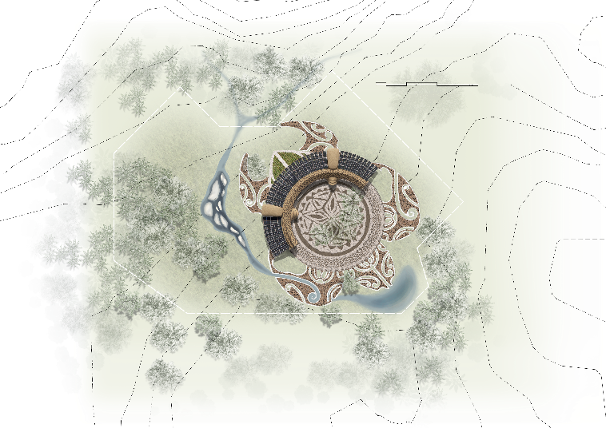

The paving of the core plaza is made of natural stone in two colors, dark and light, spliced into the pattern of Fiji's national flower. It is not only a visual decoration but also a symbol of a gift from the gods to the people of Fiji, signifying holiness and beauty.

The peripheral colonnade of the plaza is derived from the kava bowl, creating a multi-functional space shared by tourists and local villages, which provides both shade and shelter from the sun and rain. The interior of the colonnade is constructed using local materials such as coconut shell and volcanic rock, with rattan hangings, floor mats and roofing in a highly ethnic style. The colonnade can be used as a small marketplace for traditional handicrafts or as a gathering place for social functions such as kava ceremonies. In the future, it can also be used as a restaurant, leisure space, or even a hotel in conjunction with the tourism industry.

The external clean energy demonstration area mainly utilizes photovoltaic arrays to provide villagers and tourists with a constant supply of clean and reliable electricity. During cyclone alarm, the units of the PV arrays can be folded and stored in two wind resistant shells with the streamlined body shapes, effectively preventing them from being damaged by heavy falling objects such as coconuts or be overturned by cyclones, reflecting the practicality and locality of the design. An electrical equipment room and a storage room are arranged under each wind resistant shell.

Underneath the photovoltaic arrays, a garden themed around peppercorn roots is set up to showcase the growing process and cultural significance, particularly echoing the core aspect of kava making, to enhance visitors' experience.

The rainwater harvesting system alongside the site can collect, store, purify and recycle rainwater to supplement local villagers’ daily clean and reliable freshwater use, further enhancing the sustainability of the project. Community members participate in the use, management, operation and maintenance of the land artwork.

Looking down from the top of the mountain, the totem of the sea turtle quietly emerges from the earth. The turtle is the enduring cultural call of this land, which carries countless prayers and tells the story between humans and nature.

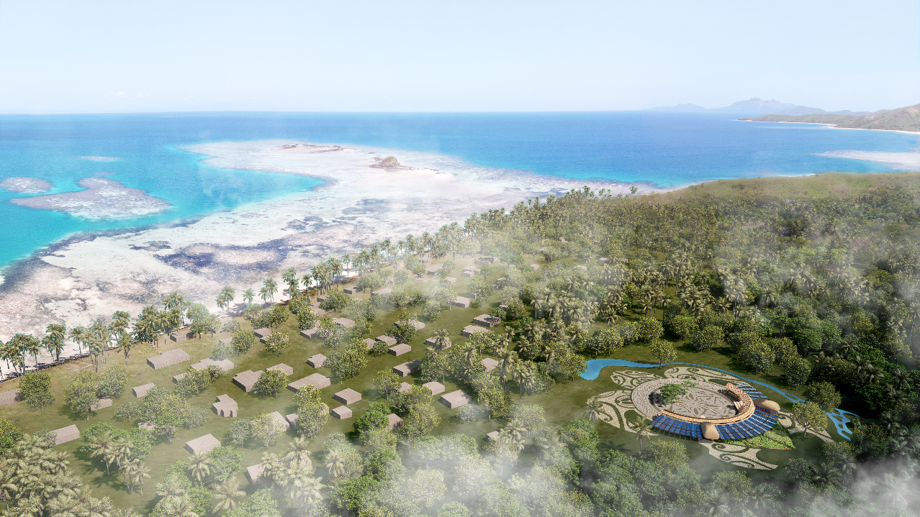

In summary, the overall design is based on Fijian culture, integrating the sacredness, sharing and sustainability of the site into the art installation. It not only replicates the form of the Kava ceremony, but also focuses on conveying the concepts of ‘symbiosis between humans and nature’ and ‘harmonious coexistence of communities’ in Fijian culture, aiming to provide a place of mutual benefit for both visitors and local villagers with both cultural identity and spiritual healing.

1. **Technical Narrative**

The land artwork design incorporates the following innovative technological features for improving PV system performance, enhancing sustainability of the rainwater collection, and mitigating the potential cyclone hazard.

**PV System Design Highlights**

The photovoltaic system of this project adopts mono-crystalline silicon photovoltaic modules. Each module is 250W, with 10 modules forming one array unit. A total of 40 array units are installed, resulting in a total installed capacity of 100kW and **an annual power generation of approximately 134,438kWh for the village**. The energy storage system is equipped with a 200kWh lithium iron phosphate battery pack, which can basically meet the daily electricity demands (excluding air conditioning) of 67 households. To avoid cyclone damage to the photovoltaic array, the system is designed with the expandable and foldable modes. When expanded, the PV array covers a total area of approximately 445m², and it can slide along a circular track, allowing adjustment to the optimal local orientation and tilt angle for power generation. The arc-shaped arrangement of the photovoltaic array helps achieve daily electricity production homogeneity. A smaller tilt angle is adopted for the photovoltaic modules to maximize power generation during high-load periods in summer (e.g., air conditioning usage) and during cloudy conditions. When folded, the PV array minimizes its footprint and slides into the high-strength steel wind-resistant shells along the circular track, effectively resisting impacts from debris during cyclones.

**Rain Water Collection and Treatment**

The rainwater collection system integrates ecological water features. An ecological pool (eco-pool) acts as a miniature reservoir, collecting rainwater from mountain runoff, the photovoltaic arrays, and the colonnade roofs annually. **The total reservoir capacity is about 1200m3**, which can provide nearly 45L fresh water to each household every day. To ensure water cleanliness, photovoltaic-powered pumps circulate water from the ecological pool to an elevated water tank, which then flows into an artificial landscape brook and returns to the pool. During circulation, prefilters and ecological floating beds purify the water. Additionally, ultraviolet sterilization lamps powered by photovoltaic energy eliminate bacteria in the water, ensuring the stored water is clean and safe for daily village use.

**Wind Resistance and Cyclone Hazard Mitigation**

Natural ventilation and wind-resistant strategies are incorporated into the design. The colonnade roofs and foldable photovoltaic arrays are segmented to create airflow channels, facilitating cross ventilation. When gales are forecasted, the photovoltaic array is folded into the wind resistant shell, and vulnerable colonnade components are temporarily disassembled and stored in the storm-proof storage room to prevent damage. During cyclone warnings, the entire colonnade roofs and partition structures are disassembled and stored, leaving only the steel framework. This ensures effective resistance against cyclone impacts.

1. **Prototyping and Pilot Implementation Statement**

The prototyping process and the full-scale pilot implementation process will be carried out according to the following scheme.

Firstly, the design and construction of the land artwork have been developed with the consideration of the transportation conditions of the Yasawa island, particularly the convenience of using small barges (4m×14m to 4m×20m) to transport building components. The technical feasibility of constructing and installing the land artwork using only small construction tools, without the need for large machinery, was also evaluated. Additionally, the implementation plans emphasized reducing transportation need by utilizing local raw materials for certain components of the land artwork and involving local villagers in the construction process.

In the prototype, the main steel structure supporting the photovoltaic array was designed as a prefabricated assembly, connected via bolt sleeves. The wind resistant shells can be decomposed into the prefabricated steel plate modules, bolted and welded after assembly. Each component’s dimensions do not exceed 2.4m×6m, and the weight is under 80kg, ensuring ease of transportation and installation.

All steel structure modules and mechanical components of the prototype will be manufactured in the original supplier’s factories. The Mono-crystalline silicon photovoltaic components will be sourced to ensure their product quality and cost-effectiveness. All parts will be undergoing trial assembly in the factory to verify the mechanism of the foldable PV array and the performance of the photovoltaic grid, ensuring the prototype met the design purpose.

After the trial assembly testing, all the structural and photovoltaic parts of the prototype will be disassembled, grouped, labeled, and packaged—along with the standard water tank modules, pumps, and other accessories—into multiple 20-foot containers. These were then transported to Fiji’s port via sea-land logistics and further transferred to the project site on the island using small barges.

To facilitate installation, small local forklifts were rented for loading, unloading, and construction tasks, eliminating the need for cranes while improving efficiency for lifting larger components. Local villagers will be asked to collect local materials such as timber, coconut fiber, and coconut shells. Small cutting and drilling tools were used to craft decorative elements of the land artwork. Throughout construction, particularly during the installation of the photovoltaic electrical equipment, hazard warnings were labeled in both the local language and English. Safety barriers were installed to prevent children from accessing the dangerous areas and ensure accident-free operations.

1. **Operations and Maintenance Statement**

Community representatives will be invited to participate in the design review and construction supervision. Post-construction operation and maintenance are mainly done by the community members trained by the PV experts.

**Photovoltaic System Maintenance**

Except during the rainy season, clean the photovoltaic surface once a month using a soft cloth and fresh water in the early morning, twilight hours, or on cloudy days. Remove bird droppings, leaves, and other obstructions to avoid hot spot effects that reduce the PV power generation efficiency. Avoid maintenance under high temperatures or strong sunlight to prevent module micro-cracks or electric shock risks. Ensure the contact resistance between the module frame and the support is no more than 4Ωfor secure grounding. Keep the inverter clean and well-ventilated, and check if the cooling fan starts and stops automatically based on temperature. Monitor the inverter display for power generation data and fault indicators, addressing anomalies promptly. Ensure batteries are stored in a dry, ventilated environment, avoiding extreme temperatures. Check battery terminals for looseness or corrosion. Prevent overcharging or over-discharging, maintaining the charge level within 20% to 80%.

**Water System Maintenance**

Monitor water quality parameters (pH, dissolved oxygen, residual chlorine, ammonia nitrogen, etc.) in the landscape pool and rainwater cisterns to ensure compliance with hygiene standards. Skim floating debris (e.g., leaves, trash) from the pool daily. Clean sediment from rainwater cisterns monthly using suction equipment to prevent organic decay and water quality deterioration. Inspect pump operation and replace the prefilter’s filter element. Regularly trim dead leaves and overgrown roots of the plants on the ecological floating beds, and replant missing vegetation to maintain ecological balance.

**Maintenance of the Colonnade**

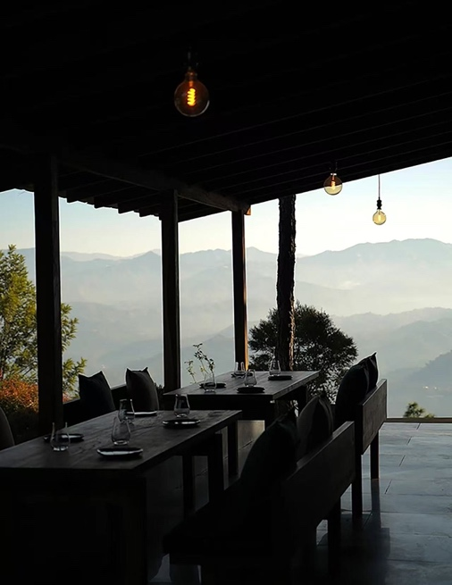This design mainly uses steel structures and rattan roofs. The steel structures are durable since they are painted with rust converting agent. The only thing that is needed is to check the rattan material regularly and do simple regular maintenance. When a hurricane passes, the rattan roof may be damaged and need to be replaced.

**Activities in the Colonnade**

It can be used for events such as yaqona ceremonies, various gatherings, handicraft displays, etc. It can also serve as a place for dining, leisure activities, accommodation (like a hotel) and other functions to support tourism.

**Operation with the Landscape of the Site**

Turtle motifs can be put together gradually by allowing visitors or residents to buy or collect local tree trunk slices. Messages written on the wood slices can also serve as a lasting memento. This enhances the sense of public participation and cultural identity of tourists and residents, transforming them from “short-term experiencers” to “long-term guardians”, and realizing the sustainable goal of “people and landscape growing together”.

1. **Environmental Impact Assessment**

This land artwork is highly environmentally friendly and has a variety of functions to ensure the positive impact on the natural ecosystem.

**Low Impact PV System**

The construction site of the photovoltaic system does not involve habitats of endangered species. Trees within the site are preserved during construction, ensuring no disruption to the natural ecosystem of the original vegetation. During the operation and maintenance of the photovoltaic system, there is no noise or emission of harmful substances. Only clean freshwater is used for cleaning the photovoltaic panels, avoiding pollution from chemical detergents. Photovoltaic components and equipment resistant to island salt spray environments are employed to suit the local conditions.

**Eco-friendly Rainwater Harvesting System and Landscape Design**

The rainwater harvesting system are integrated with the site’s natural landscape, creating an eco-pool and an artificial brook with ecological floating beds. Engineering measures such as retaining walls and interception ditches are used to collect rainwater while preserving the site’s natural infiltration pathways. This ensures the post-construction soil and water conservation capacity, prevents soil erosion, and avoids groundwater depletion or seawater intrusion. The landscape design incorporates a large number of native plants with low evapotranspiration rates. These plants release less water into the atmosphere than non-native plants, and cover about 30% of the total site area, which can reduce water loss through transpiration by an estimated 15-20%, thus effectively maintaining soil moisture and mitigating drought conditions.

**Enhances Biodiversity**

The land artwork creates a variety of habitats to support a wide range of species. The eco-pool not only stores rainwater, but also serves as a habitat for aquatic plants, insects and small fish. It is estimated that within one year of operation, the eco-pool will support at least 10 to15 different aquatic species. In addition, the peppercorn root themed garden and the surrounding greenbelt provide a habitat and food source for birds, butterflies and small mammals. The number of butterfly species in the area is expected to increase within two years through the planting of a variety of native flowering plants that attract different pollinators. Meanwhile, the land artwork site includes wildlife corridors connecting the site to nearby natural areas. These corridors are 3m to 5m wide and are planted with native trees and shrubs to allow small animals to move freely between habitats. It is expected that within 5 years, the number of small mammal species using these corridors may increase by 15% to 20% as they gain access to new food sources and breeding sites.

**Sustainable Construction and Operation**

Construction strictly complies with waste management and environmental protection regulations. Prefabricated assembly methods minimize dust generation, and locally sourced materials are prioritized to eliminate construction waste. Construction schedules are tightly controlled to reduce noise disturbances to the environment. This land artwork project, with its regional symbolism and natural affinity, serves as an exemplary model of sustainable development. It will attract tourists, boost local tourism, and provide additional livelihood opportunities for villagers.

Overall, through these carefully planned measures, the project not only provides clean and reliable electricity and drinking water, but also positively improves the local microenvironment, enhances biodiversity and minimizes potential negative impacts on natural ecosystems.