Vatu Rua Kaukauwa
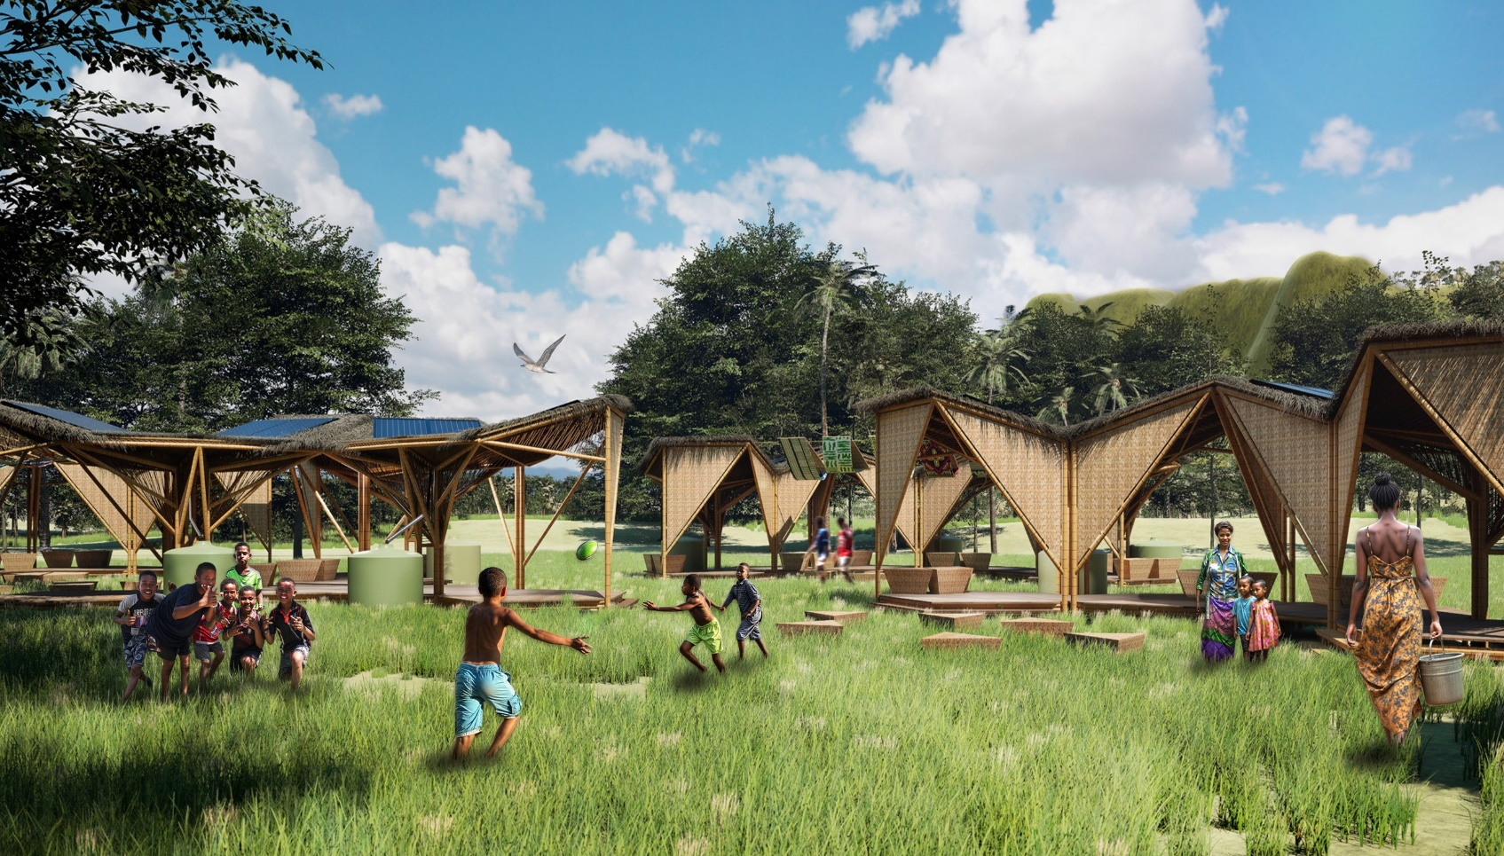
Vatu Rua Kaukauwa - Overall Project Vision

LAGI 2025 FIJI


Vatu Rua Kaukauwa
MAROU VILLAGE

TABLE OF CONTENTS
01

Concept Narrative 04
02

Technical Narrative 06
03

Prototyping and Pilot Implementation 08
04

Operations and Maintenance Statement 10
05

Environmental Impact Assessment 10
06

Indicative Budget 11

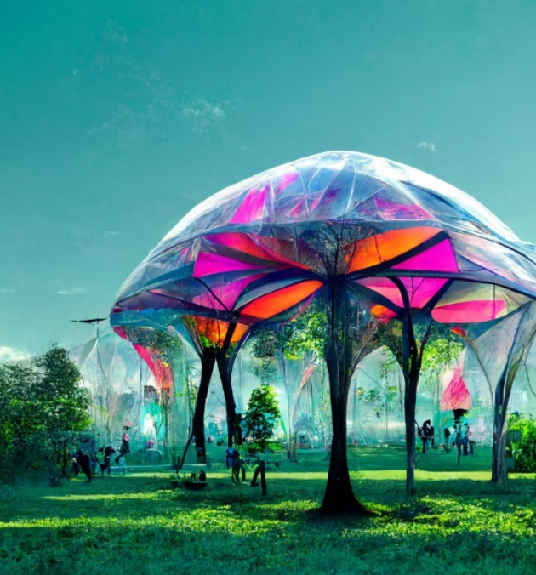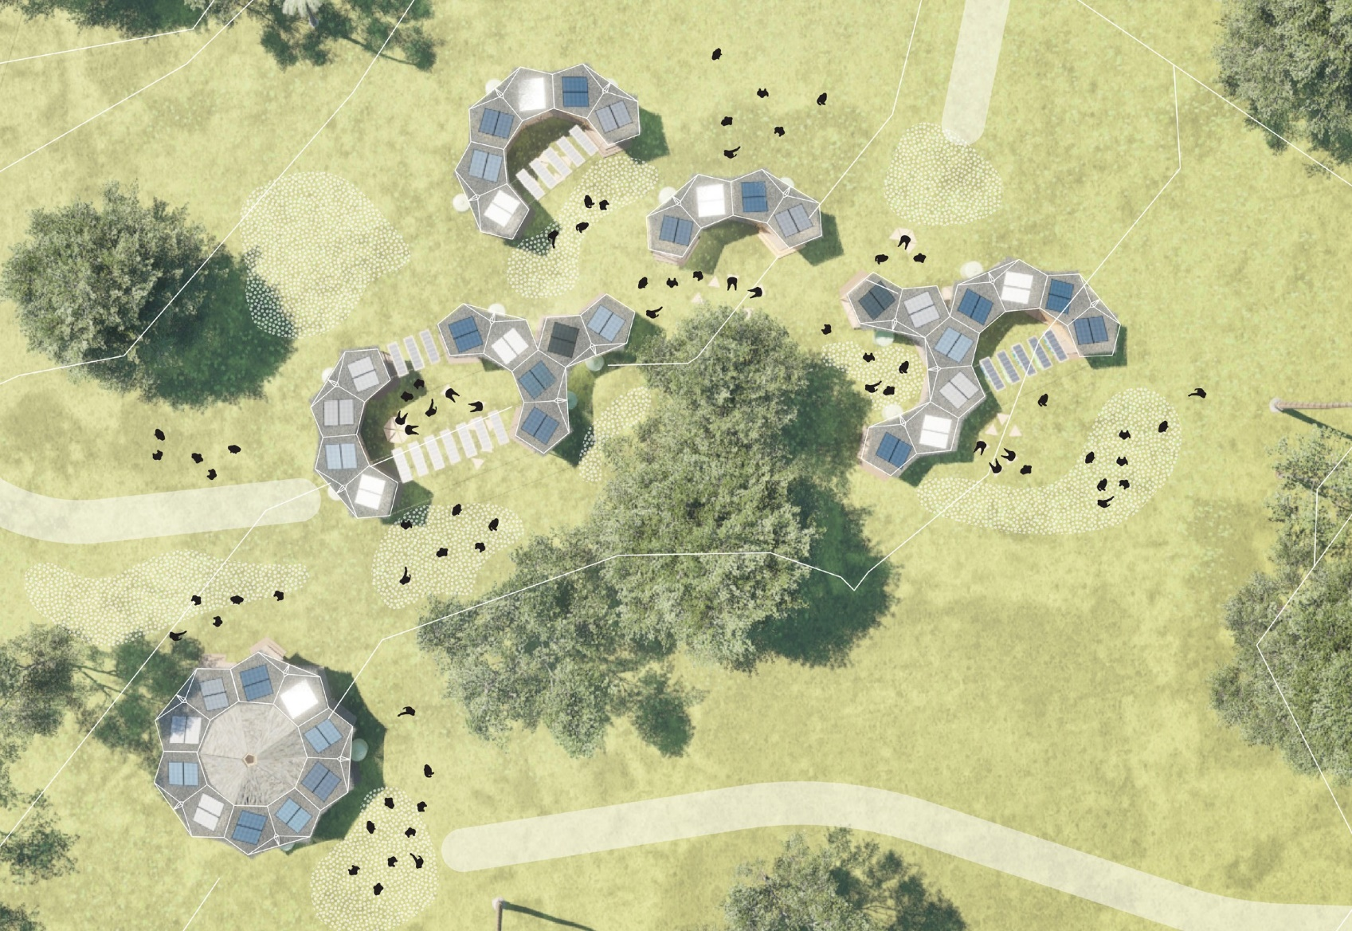
Masterplan Phase 1
Masterplan Phase 2
T 04
T 02
T 03
T 01
T 05
Vatu Rua Kaukauwa - Masterplan Vision

Masterplan Phase 1 - Total Energy Produced: 77kWh daily - Total Rainwater Storage Capacity: 155,000 liters




T01 - Typology 1

Total energy produced per typology:
6kWH daily approx
Total rainwater storage capacity per typology:
28,000 Liters per typology.
T02 - Typology 2

Total energy produced per typology:
27kWH daily approx
Potential Additional Flexible Panel Energy:
6kWH daily
Total rainwater storage capacity per typology:
37,000 Liters per typology.
T03 - Typology 3

Total energy produced per typology:
17kWH daily approx
Potential Additional Flexible Panel Energy:
6kWH daily
Total rainwater storage capacity per typology:
42,000 Liters per typology.
T04 - Typology4

Total energy produced per typology:
27kWH daily approx
Potential Additional Flexible Panel Energy:
12kWH daily
Total rainwater storage capacity per typology:
48,000 Liters per typology.

Masterplan Phase 2

T05 - Typology 5

Total energy produced per typology:
27kWH daily approx
Total rainwater storage capacity per typology:
48,000 Liters per typology.

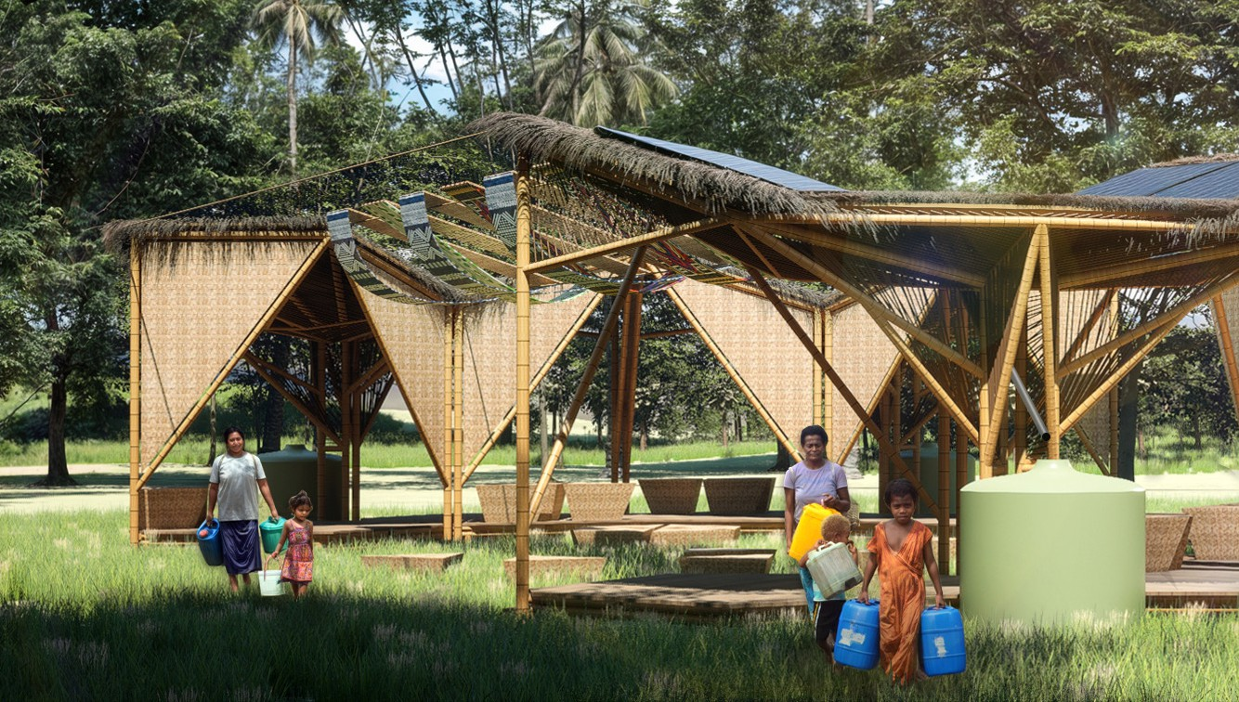
Concept Narrative
Masterplan Phase 1 & Phase 2 - Overall Image of the Project

Competition Framework & Design Response

The Vatu Rua Kaukauwa proposal draws inspiration from the pristine natural beauty and the imposing mountainous landscape of Marou Village in Fiji. This proposal serves as a lasting symbol of strength and resilience, representing the cultural and geographical essence of the Fijian people. The project derives its name from the phrase meaning ‘two resilient rocks’, thus highlighting its deep roots in both local cultural and ecological identity. The introduction of a modular, flexible system is proposed, offering climate-resilient solutions for coastal island communities. This system is designed
to address social, economic, and environmental challenges through sustainable architectural strategies that deliver both immediate and long-term benefits.
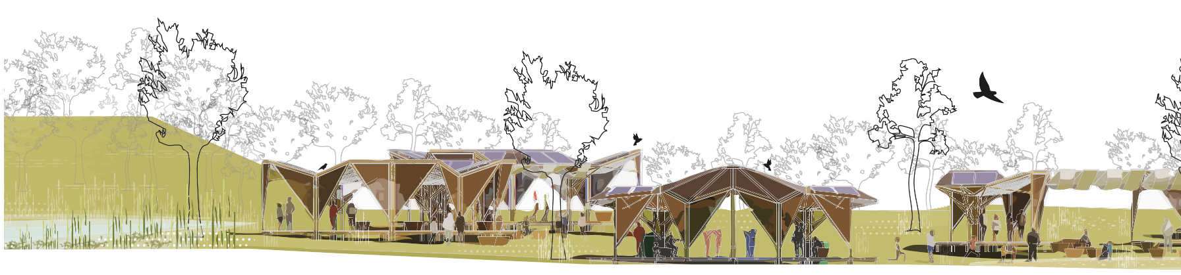
The project aims to empower local residents as active stakeholders, preserve cultural heritage, foster social interaction, and support traditional lifestyles, whilst promoting economic and energy independence without compromising the environment.
At its heart are two pentagonal structures conceived as principal bamboo modules. Designed as a flexible and scalable system, these modules accommodate multiple configurations and adapt to diverse terrain conditions, allowing the architecture to evolve organically with the community’s changing needs. This strategy enables a transition from a linear economy to a circular and metabolic model. Circularity involves closing production and resource loops, whereas a metabolic approach emphasises restorative and regenerative systems, guided by ecological dynamics and mindful resource stewardship. Aligned with Fiji’s long-term sustainability vision, the project prioritises the use of local materials such as bamboo, valued for being fast-growing,

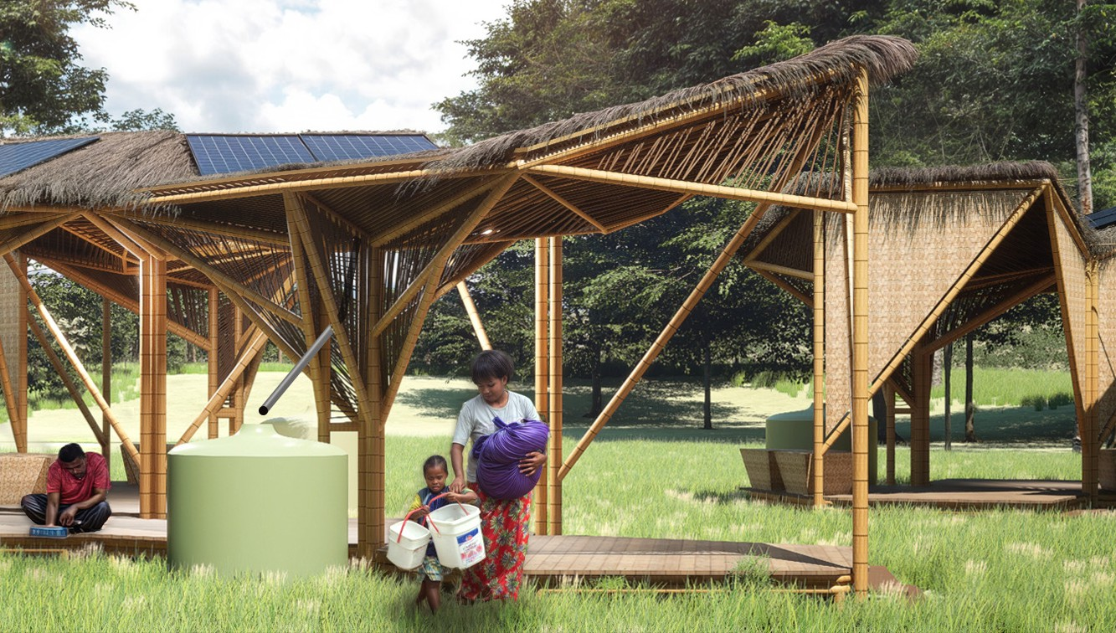

locally cultivable, and low in carbon emissions. By integrating reclaimed indigenous knowledge with flexible modular construction systems, the initiative enables the creation of adaptable, cyclone- resistant architecture that responds to the diverse needs of island communities. Importantly, communities are empowered to grow their own construction material by cultivating bamboo, further enhancing self-sufficiency and sustainability.

The project’s ambition extends beyond mere functionality and resilience, seeking to establish itself as an iconic destination that will attract visitors and contribute to the growth of the tourism sector. This objective is underpinned by the principles of the circular and metabolic economy. The aesthetic appeal of bamboo architecture is multifaceted, encompassing both the elegance of its design and the celebration of local materials, systems, economies, and social knowledge. The aforementioned qualities collectively
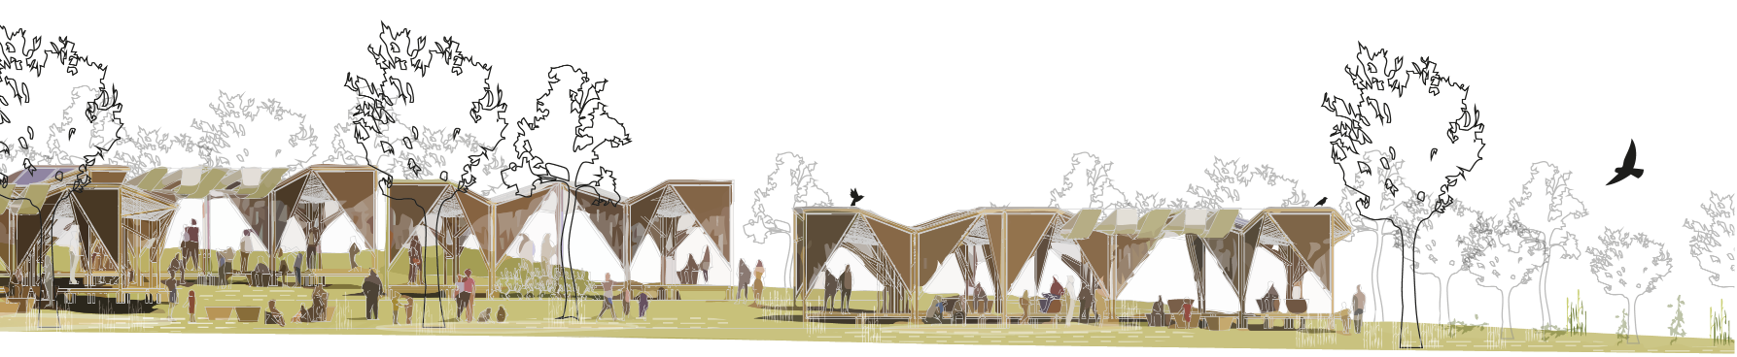
serve to position the village as a living showcase of sustainability, cultural identity, and innovation, thereby attracting tourists with a keen interest in ecological design, community-driven development, and authentic cultural experiences. The project is positioned as
a model of regenerative architecture and land stewardship, with the aim of inspiring both locals and visitors, thereby strengthening Marou’s profile as a hub for eco-tourism and circular economy excellence.

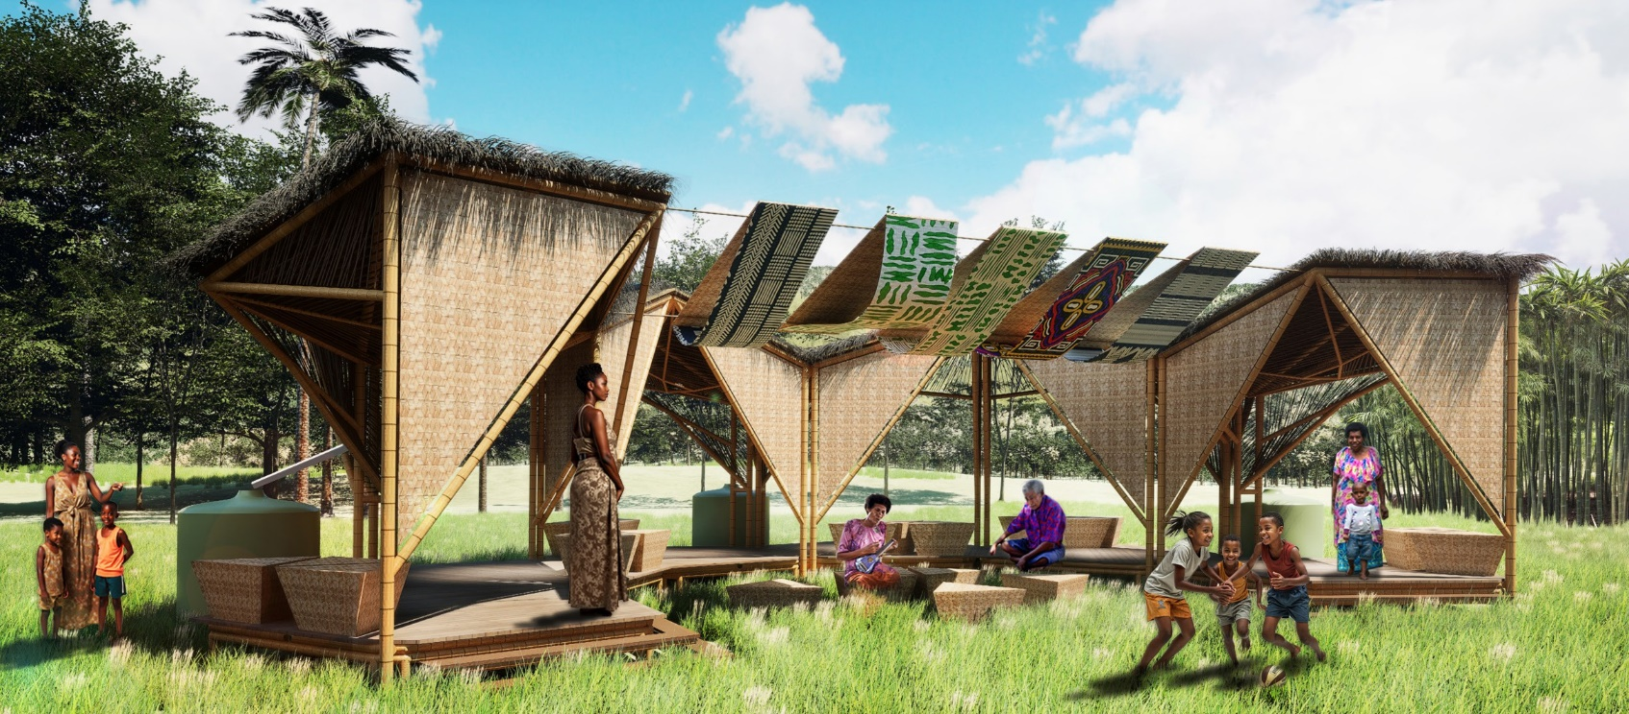
Masterplan Phase 1 - Typology 3

Technical Narrative

Renewable energy is seamlessly incorporated, both by extending the lifespan and increasing the social value of existing solar panels, and by facilitating the scalable installation of new panels to meet evolving community energy demands. Water resilience is enhanced through rainwater harvesting systems with mobile, standardised storage tanks that provide decentralised and reliable access.
The primary module, consisting of two pentagons, is engineered to harvest rainwater and store it in standardised tanks with
capacities from 1,000 to 14,000 litres. Its adaptable design enables the seamless integration of both natural filtration systems and advanced reverse osmosis filters, ensuring a
reliable and safe water supply.
The project foregrounds Nature-Based Solutions (NbS), emphasising ecosystem restoration over the use of non-native materials and by cultivating a resilient, productive landscape. This landscape not only strengthens community resilience but also provides habitats for native animal species, enriching local biodiversity. Strategic deployment of native vegetation for flood mitigation—including levee setbacks and water retention areas— further enhances ecosystem services and ensures hydrological management attuned to the site’s unique topography, ultimately fostering long-term harmony between the community and its
natural environment. The modules’ flexibility allows them to adapt seamlessly to the terrain and respond effectively to designated flood zones, while cultivating a social space on the other side.
Featured species include Intsia bijuga, Decaspermum vitiense, and Hibiscus tiliaceus, all supported by native sedges such as Rhynchospora and Fimbristylis.

This analysis estimates the size and output of a solar minigrid system designed for Marou, Fiji. The calculations are based on several key assumptions to reflect typical, real-world conditions. The system is assumed to be installed in Marou, where solar resources are abundant, providing an average of 2,000 annual peak sun hours, which is equivalent to approximately 5.48 hours of full sun per day. The proposed system assumes high-quality installation with panels oriented to maximize solar exposure
and minimal shading interference throughout the day. A system loss factor of 85% is incorporated to account for inevitable efficiency losses in wiring, inverters, and other balance-of-system components. These assumptions ensure that the estimated energy output closely represents what can be expected from a properly installed and maintained solar minigrid in this location.

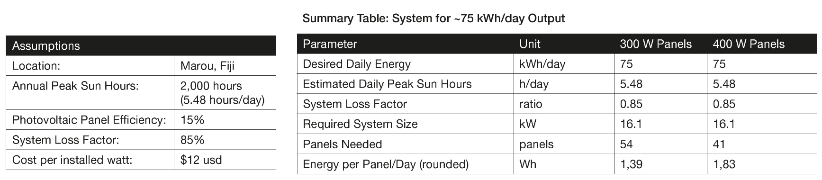
System configurations

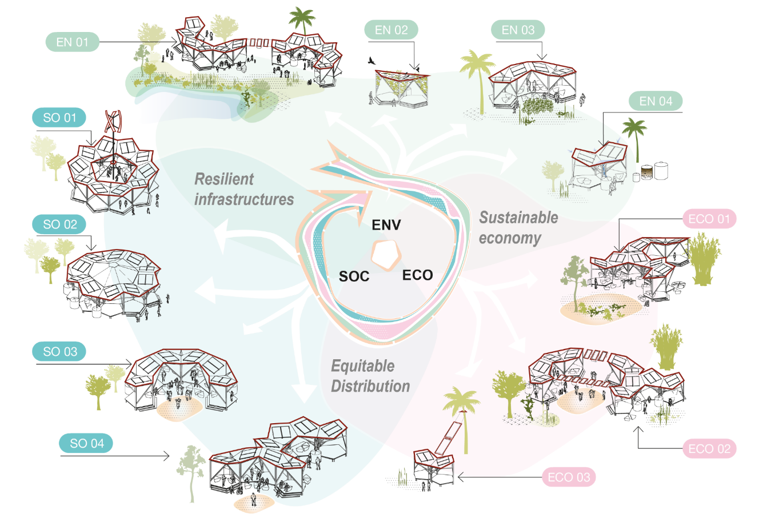

Environmental System Benefits
EN 01
Composed of two Typology 3 modules arranged in a U-shape and connected by flexible photovoltaic modules. This layout allows the building to adapt to the terrain and respond to controlled flood zones on one side, while creating a social space on the other.
Some species include: Intsia bijuga, Decaspermum vitiense, Hibiscus tiliaceus, supported by native sedges (Rhynchospora, Fimbristylis)

EN 02
Composed of the fundamental two-pentagon module, it is designed to function as a holistic ecosystem for birds and native species, with both the roof and panels serving as habitats to support and promote local biodiversity.
EN 03
Configured with Typology 1, utilising two main modules, this layout establishes a central area for production, integrating small crops and gardens.
EN 04
The primary module, consisting of two pentagons, is engineered to harvest rainwater and store it in standardised tanks with capacities from 1,000
to 14,000 litres. Its adaptable design enables the seamless integration of both natural filtration systems and advanced reverse osmosis filters, ensuring a reliable and safe water supply.
Social System Benefits
SO 01
Organised in a Typology 5 layout, the Vertical Axis Wind Turbine (VAWT) is a central feature. The design includes centralised water collection and an open roof, ideal for VAWT installation. This setup enhances energy harvesting, efficiently capturing and utilising wind power for sustainability.
SO 02
Typology 5 in Phase 2 transforms into a versatile community centre, featuring full coverage for rain protection while maintaining natural lighting at its core. This multifunctional design generates energy and collects water in perimeter tanks, ensuring resilience and sustainability.

SO 03

Typology 3 showcases a central U-shaped design that harmoniously blends with its surroundings. Perfect
for outdoor community meetings, presentations, communal meals, and other shared activities, it fosters connection and collaboration.
SO 04
A typology derived from Typology 2 offers flexibility with a U-shaped design by incorporating modules in varying positions. This configuration is ideal for creating three distinct centres, each dedicated to a unique social purpose, fostering adaptability and community engagement.
Economic System Benefits
ECO 01
Utilising Typology 2 in a compact layout, this configuration serves as a versatile module that generates energy, harvests rainwater, and establishes a productive core for cultivating crops like taro, cassava, breadfruit, bananas,
coconuts, and yams. Additionally, it incorporates a dedicated social space to foster community interaction.
ECO 02
Typology 4 integrates modular photovoltaic units to form a central hub, while productive activities and water collection are efficiently arranged along the two flanking sides

ECO 03
Using the primary two-pentagon module, this configuration focuses on energy production by connecting to nearby homes, trees, and taller structures, ensuring photovoltaic modules are ideally positioned for maximum solar energy efficiency.

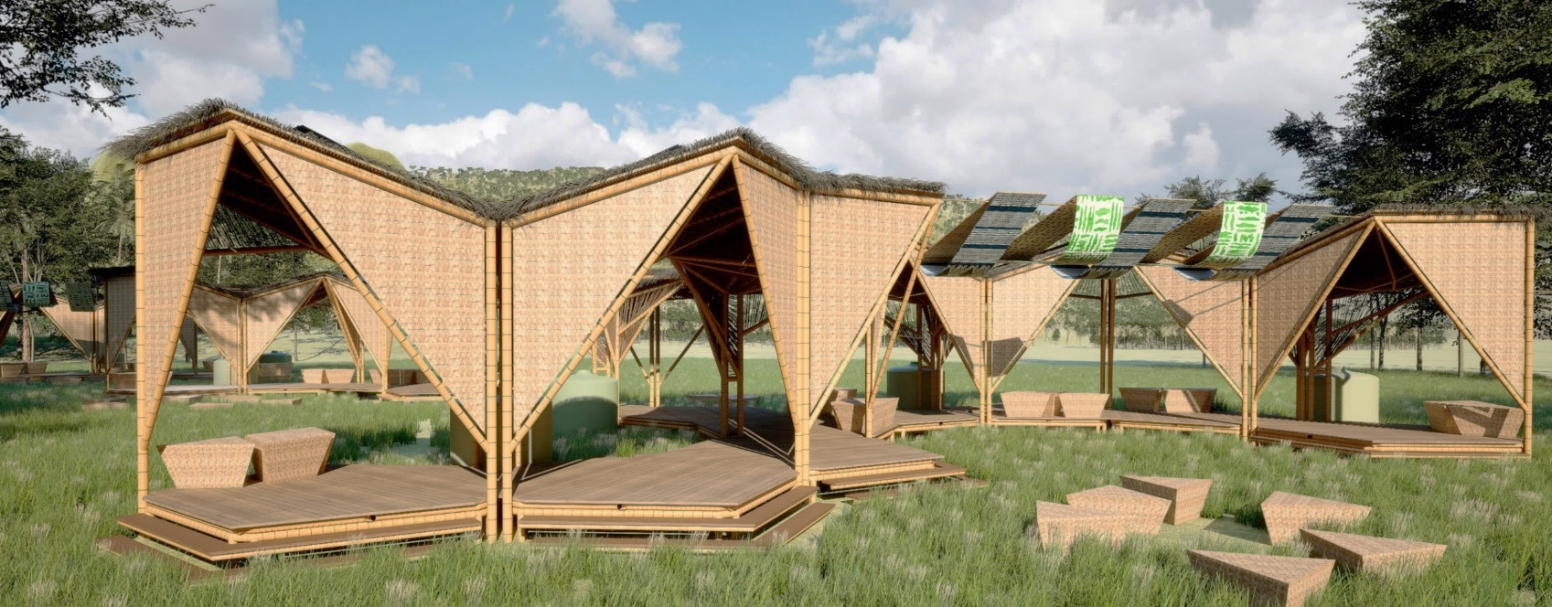

Prototyping and Pilot Implementation

The prototyping and full-scale pilot implementation processes leverage the system’s modularity and capacity for growth.
The fundamental module, composed of two pentagons, is straightforward to completely assemble, enabling meticulous functional analysis and refinement of every component through real-scale testing. The construction of two modules (four pentagons) would facilitate a more comprehensive understanding of the project’s feasibility and its potential implementation on
a larger scale. The construction sequence for these modules has been meticulously aligned with traditional bamboo building methods, thereby ensuring cultural appropriateness and ease of adoption. This approach facilitates the refinement of the design
and provides the local community with practical experience at each
stage of the process, thereby contributing to the long-term success and adaptability of the system.

This modular prototype for Marou represents a synthesis of conventional building techniques and sustainable innovations. The structure is composed of a bamboo main structure and concrete foundations, durable Fijian Mahogany decking, and a lightweight bamboo roof. The design is intended to ensure resilience and encourage community involvement. The incorporation of locally crafted woven panels and thatched roofing is a testament to the celebration of Fijian heritage, while the integration of photovoltaic panels and a stormwater collection system is indicative of the commitment to achieving energy and water self-sufficiency.

Circular and Metabolic Principles

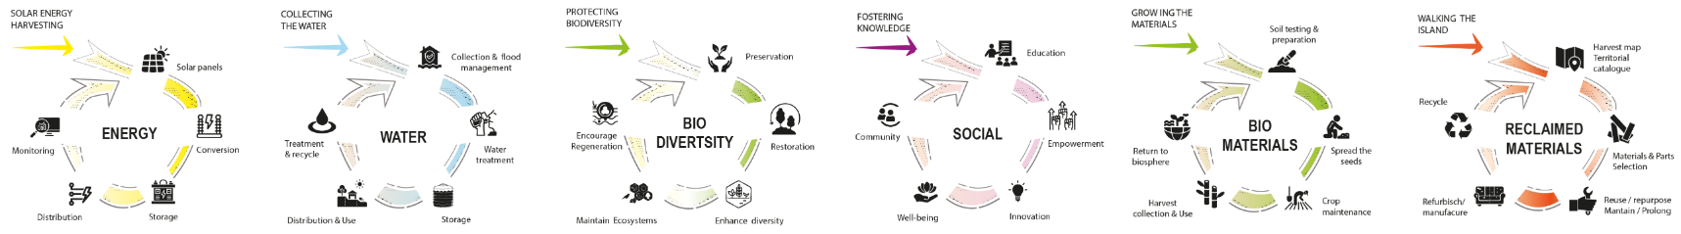

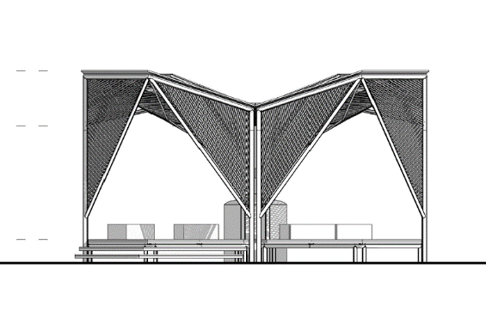

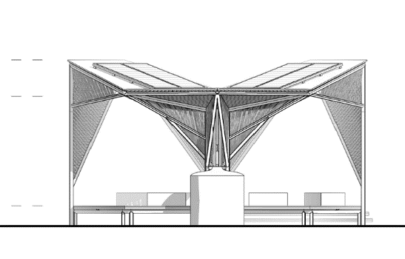


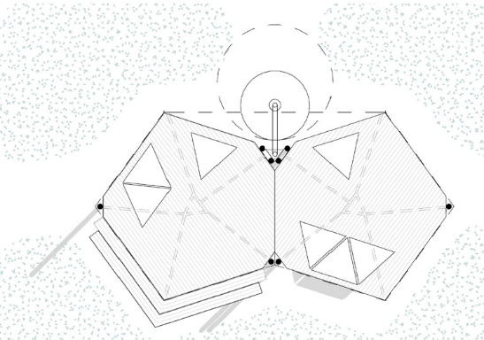







Prototype Floor Plan Prototype Front Elevation Prototype Back Elevation
+4.30

+3.10
+0.50

0.00
3800
3800
7700
+4.30

+3.30
+0.50

0.00
3800
3800
7700
7400
3700
3700
4000
2000
2000
2200
ø 1500
18%
18%

0 0.5m 1.5m
4.0m

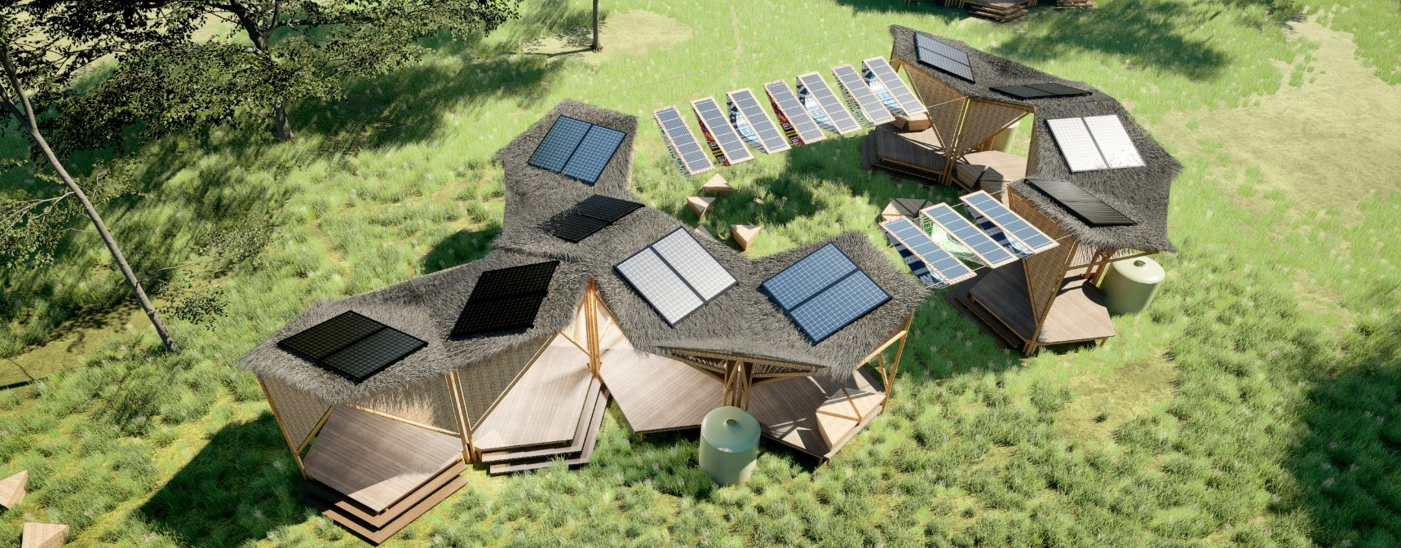

Prototype Exploded Axonometric View

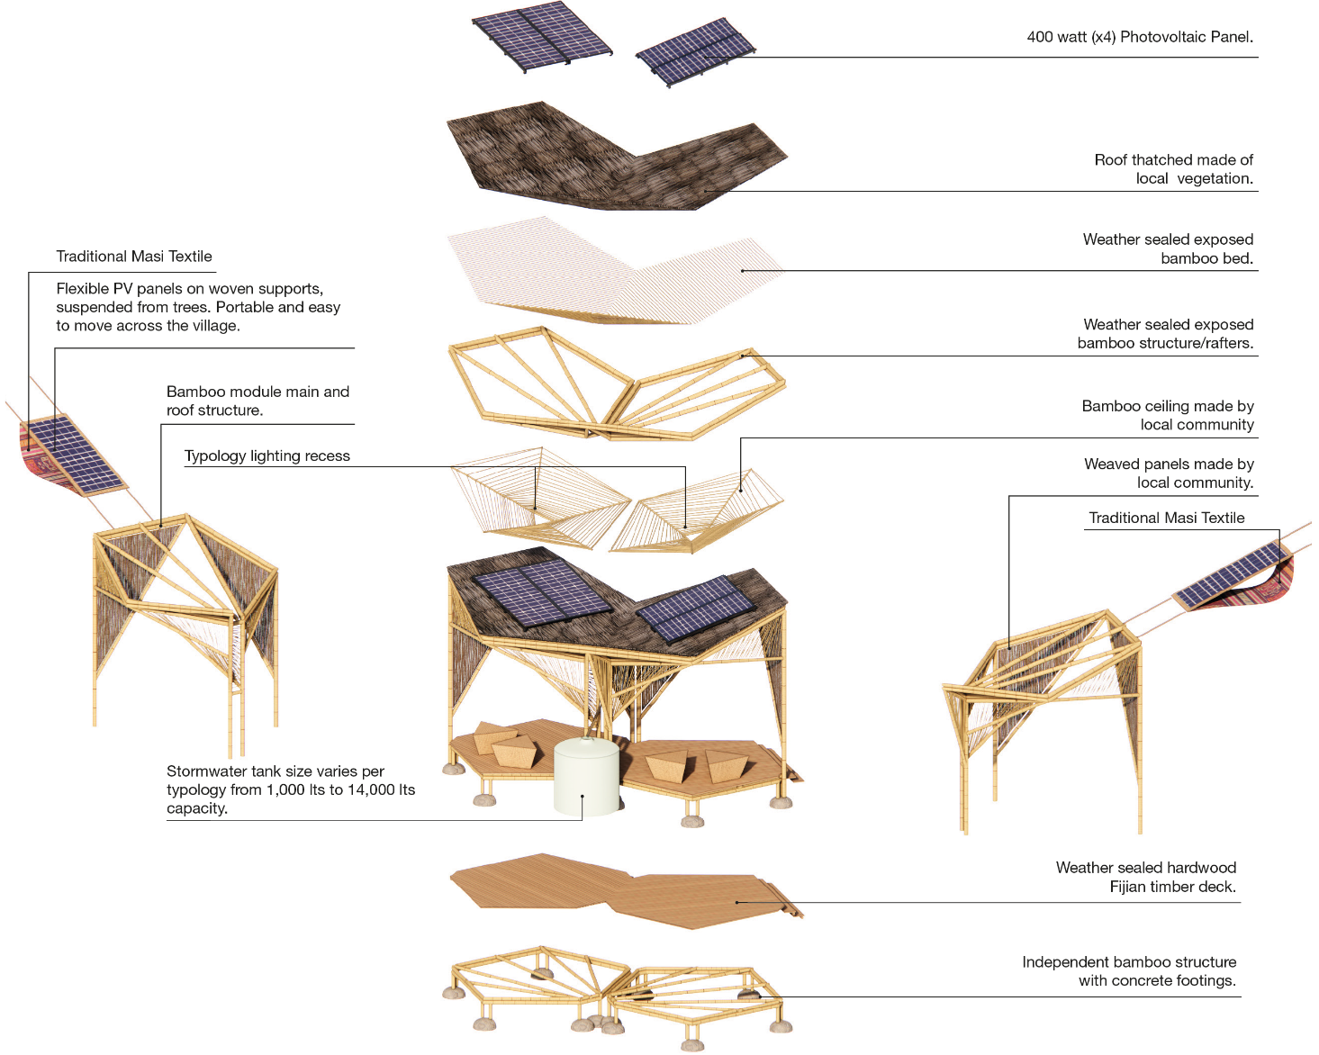.

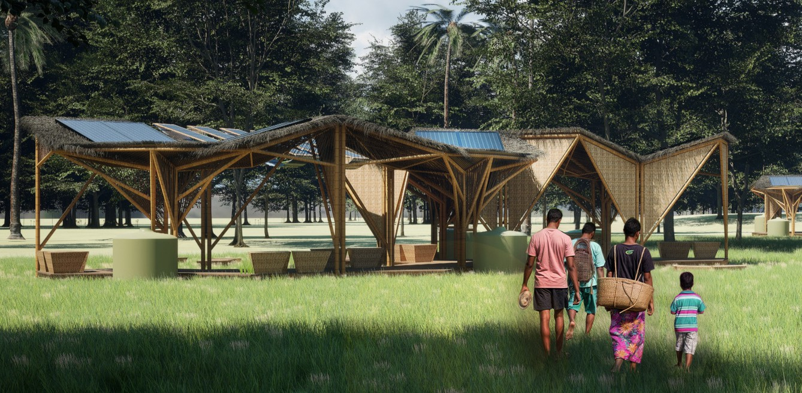
Operations and Maintenance Statement
Masterplan Phase 1 & Phase 2 - Overall Image of the Project

The system has been developed to enable rapid and uncomplicated construction, whilst incorporating traditional bamboo techniques. This enables the local community to acquire knowledge and expand their skillset. It is asserted that residents are empowered to construct multiple solutions that are tailored to their specific needs. Furthermore, they are also able to participate in ongoing maintenance, repair and adaptation. The structure
is composed of flexible yet robust natural materials, primarily fast-growing, renewable bamboo sourced locally in Fiji. This is
reinforced strategically with steel connectors to enhance resilience against cyclones and extreme weather conditions.
The design of all elements is intended to ensure longevity, cultural relevance, and minimal environmental impact. Standardised
solar panels are integrated on the roof, which offers ample space for panels of various sizes and simplifies installation and future upgrades. By utilising local materials and employing
straightforward joining techniques, the community can sustainably replace and enhance any component as required, thereby ensuring the system remains straightforward to maintain throughout its life cycle. This participatory and adaptive approach not only secures the system’s durability and flexibility, but also strengthens the community’s sense of ownership, resilience, and capacity for innovation over time.

Environmental Impact Assessment

The installation has been designed to have a minimal impact on the surrounding natural ecosystems, with the aim of ensuring that the principles of sustainable development and context-sensitivity have been met. The construction process utilises footings composed
of a blend of local stones and minimal amounts of concrete. This approach significantly reduces soil disturbance and minimises overall cement usage, while also preserving the existing vegetation. The project employs a flood mitigation approach that utilises indigenous flora to regulate flooding in vulnerable areas, thereby supporting natural water cycles and enhancing habitat resilience. The project supports both ecosystem health and the regional economy by sourcing rapidly renewable bamboo and utilising
other locally available durable timber. The active involvement of the community in the design process is instrumental in ensuring the responsible management of resources.
The utilisation of a modular, repairable design approach serves to minimise waste and facilitate efficient adaptation over time. It is evident that certain module typologies, such as EN02, have been specifically dedicated to supporting native fauna. The roof and structure of this module have been designed to serve as
habitats for birds and other local species, thus actively promoting biodiversity.

Other typologies emphasise the development of sustainable, productive areas that enhance both community livelihoods and ecological resilience. The preservation of traditional knowledge, in conjunction with the ongoing maintenance of communities, is instrumental in ensuring the efficacy of stewardship over the long term. This, in turn, facilitates the system’s capacity to adapt to future environmental challenges.

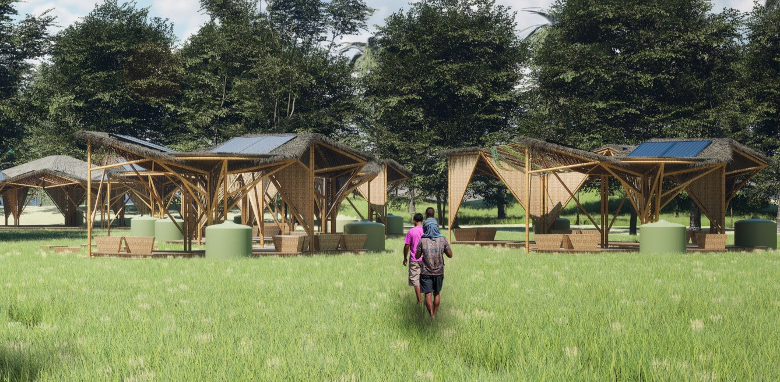

Indicative Budget
The prices listed below provide an estimated cost for the main module, which includes two pentagons and four solar panels. This estimate is subject to adjustment if the project advances to the second stage of the competition.

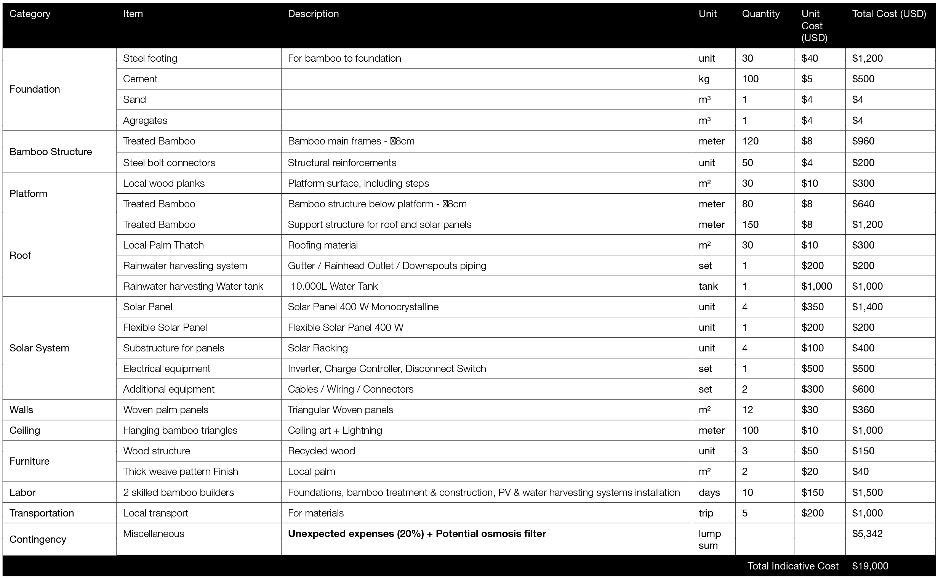
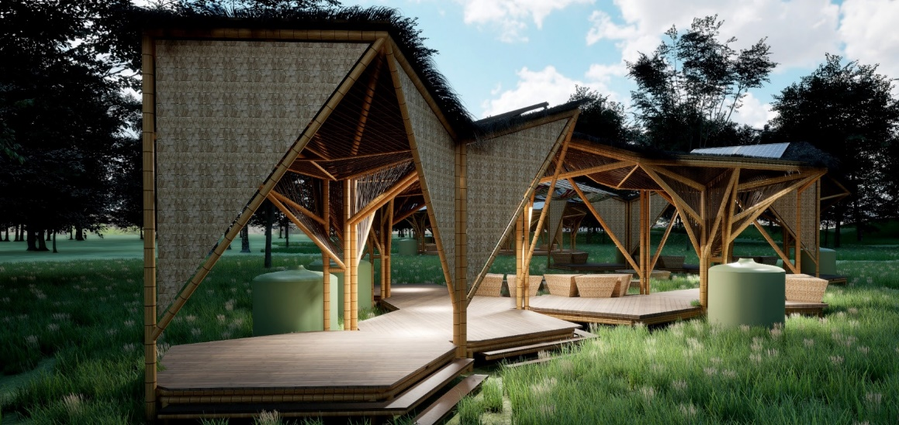


Vatu Rua Kaukauwa
LAGI 2025
FIJI
MAROU
VILLAGE

