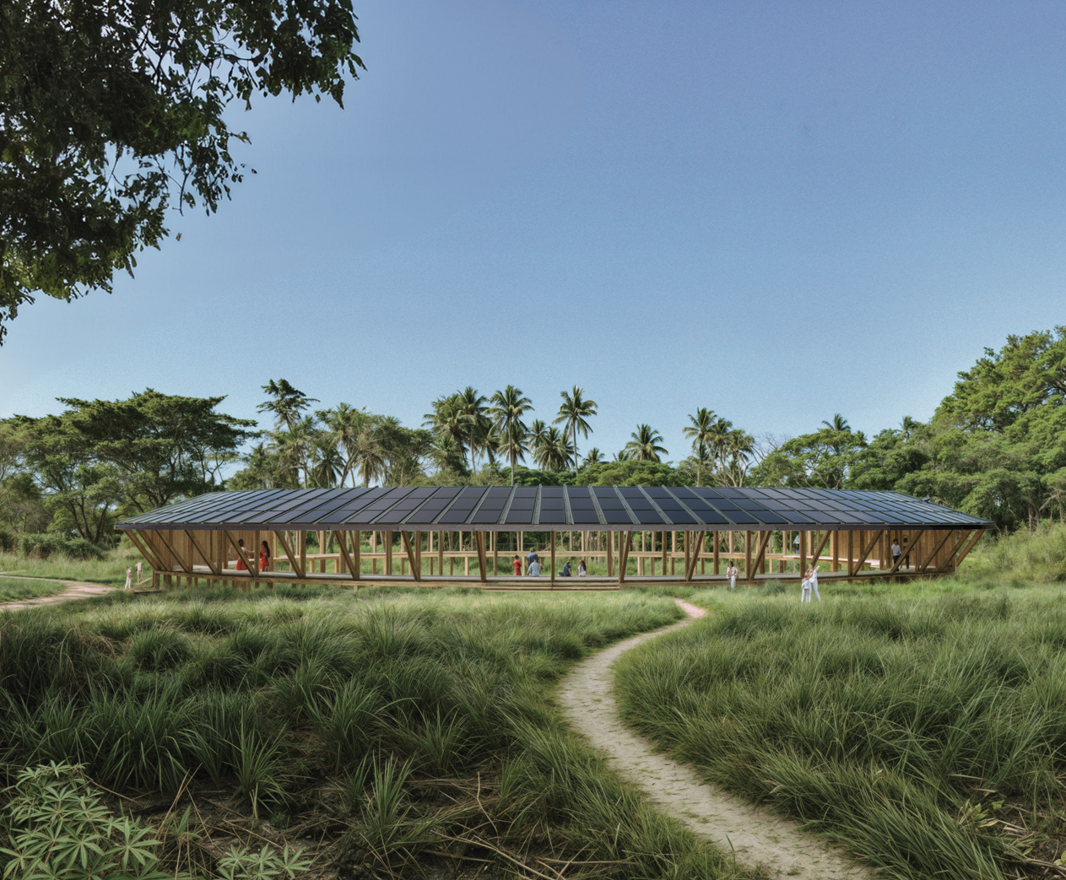

***“The O” is a symbol of harmony between landscape, energy, and architecture.   
Shaped as a perfect circle, it represents the infinite cycles of nature, the continuous flow of energy, and the deep interconnection of all life.***

**Concept Narrative**

“The O” is a multifunctional installation that unites energy generation, water harvesting, and social spaces into a single, poetic gesture – supporting the Marou community in their transition toward a more sustainable and self-reliant future.  
  
Shaped as a 40-meter-wide circle, the installation blends gently into the rich Fijian landscape, while actively contributing to its vitality. Its elevated solar canopy, crafted from over 300 monocrystalline solar panels, generates renewable energy, collects rainwater, and shelters over 600 square meters of shaded space beneath, offering a platform for everyday community use.  
  
Constructed primarily from timber, the installation embodies a dialogue between ecological sensitivity and technological innovation, with its solar canopy rising as a distinctive symbol of resilience and regeneration.

1. **Technical Narrative**

“The O” is guided by a design philosophy rooted in simplicity, modularity, and adaptability, where every element is conceived to be easy to produce, transport, assemble, and maintain.   
This principle extends to the project’s two main integrated systems: solar energy generation and rainwater harvesting. Ready-to-go modular market solutions were selected for their reliability, longevity, cost-efficiency and ease of use - ensuring that they are not only simple to install and maintain but also intuitive for the Marou community to engage with over time. This approach offers a resilient foundation while providing a flexible set up for future adaptability.

**SOLAR ENERGY GENERATION**: *the installation produces 150 MWh per year.*  
The system is made of 336 monocrystalline full-black solar panels of standard size (1000x1600x40mm), arranged on the canopy along three lines, with a 19° tilt towards North. For its circular layout, the system has an efficiency of 76-78%, and it is divided into 18 strings ensuring efficient load distribution and system resilience. The panel used as references is LG Neon H Black 370 and is mounted and connected through standard roof rails.   
A 15 sqm insulated and ventilated technical room houses 15 lithium-ion battery units, providing a total energy storage capacity of 750 kWh. This allows reliable energy backup and stable power supply for both day and night use, as well as during periods of low solar input.  
  
**RAINWATER HARVESTING**: *the installation harvests more than 1,2 million liters of water per year.*   
Based on 2000 mm rainfall per year, the 768 sqm surface of the canopy can capture up to 1.228.800 per year. Rainwater is collected through gutters along the roof and channeled through a system of filters (flush diverter, screen filter, sediment filter, carbon filter, and/or UV/UF membrane) to 10 modular underground storage tanks of 10.000 liters each, with a total capacity of 100.000 liters. Depending on the needs of Marou, the system can easily be adapted for fully potable freshwater or just domestic use by implementing the UV/UF membrane sterilizer. This will be decided with the community in next stage.

**LANDSCAPING**   
In addition to solar generation and water harvesting, the intention for coming phases is to explore how the landscape - and more specifically the design/retrofit of overrun canals - can contribute to the generation of freshwater by helping to direct and store water from heavy rains.

1. **Prototyping and Pilot Implementation Statement**

**PROTOTYPING PROCESS**The prototyping phase will serve as both a technical and social testing ground, aligning the project with feedback from the jury, technical experts, and the local community, and deliver a 1:1 prototype which embeds the key principles of the project. The main steps of this phase include:

* Aligning the overall design with jury and experts feedback;
* Defining clear goals for the prototype;
* Involving community through workshops;
* Involving structural experts for consultation;
* Engaging with PV and timber manufacturers - prioritizing regional expertise if possible;
* Detailing 1:1 design;
* Testing & delivering the structure.

**PROTOTYPING PROCESS - Community collaboration:**   
“The O” is envisioned not only as a physical structure but as a living platform—owned, shaped, and iterated by the community of Marou. For this reason, community involvement is essential from the earliest stages. Two primary lines of collaboration are proposed during the prototyping process:

*1) Co-design session(s) on the overall vision.*   
Through one or more open workshops, the design will be presented and discussed with members of the Marou community to identify shared needs and specific functions the installation should support, and explore potential adaptations. Key questions might include: do we need more enclosed or open spaces? Should we test different materials? Can we support any other needs by adding/modifying part of the design? This dialogue will help refine the spatial layout and programmatic potential of the installation.

*2) Design of specific elements.*   
Some parts of the installation can be fully designed and created by the community and can be tested in the prototyping phase. For example, the flooring decoration offers a beautiful opportunity to activate Fiji artistic and cultural expression. Drawing on insights from the paper *“iTaukei Indigenous Fijian masi as an education framework”*, the floor design can become a participatory and pedagogical moment, especially for youth. The community could co-design a masi-inspired pattern and directly paint, carve, or assemble it, embedding traditional meaning and contemporary reflection into the structure.

**FULL-SCALE IMPLEMENTATION**  
The full-scale construction will build directly on the lessons learned from the prototype, adjusting critical design elements as needed to improve performance, usability, and cost-efficiency.  
The approach for this phase is about optimizing the various aspect of the design and making sure to orchestrate a smooth delivery of the structure across the stakeholders and collaborators. Collaboration here is key.

**FULL-SCALE IMPLEMENTATION - Community collaboration:**  
Community involvement will not only continue but expand during the full-scale implementation phase. Additional workshops will be organized following the prototyping phase to collectively analyze results, identify improvements, and apply lessons learned. Beyond the floor decoration, other architectural elements—such as lightweight partition walls, room façades, and smaller construction details—can also be adapted and co-designed through collaborative community sessions. The ultimate goal is to transform “The O” into a truly collective act of making.

1. **Operations and Maintenance Statement**

The long-term operation and maintenance of “The O” are again grounded in the principles of simplicity, easy accessibility, and community ownership. The installation is intentionally designed using modular, ready-to-use technologies and elements that are durable, easy to operate, and require minimal specialized knowledge. Solar panels and battery systems will be accompanied by clear, illustrated manuals in the local language, and community members will be trained during the installation phase to monitor energy production, battery status, and basic troubleshooting. The main elements are placed in one single control room to facilitate monitoring. Similarly, the rainwater harvesting system will include simple filtration units and accessible tanks that can be maintained with routine inspections and periodic cleaning.

A small team of local stewards, selected in collaboration with the Marou community, can be trained as caretakers of the structure. These individuals will act as point persons for maintenance, and they will be supported by occasional visits from technical partners or local manufacturers when deeper servicing is required.

In addition to technical care, the community will play an ongoing role in shaping the social life of the structure. As a flexible space, “The O” can host cultural events, educational workshops, support on site farming and seasonal gatherings—activating it as a living structure that evolves with the community.

1. **Environmental Impact Assessment**

ENVIRONMENT - The environmental impact of “The O” has been carefully considered throughout the design process to ensure minimal disruption and maximum benefit to the surrounding natural ecosystem. The installation is designed to sit lightly on the land, avoiding large-scale excavation or permanent foundations that could disturb soil ecology, while the open and elevated design allows for continued airflow, plant growth, and biodiversity movement beneath the structure, which help to preserve and grow the surrounding landscape.   
  
MATERIALS - Most of the structure is made of timber, which guarantee a low carbon structure, which is also durable and available in the region. Furthermore, “The O” follows principles of circular design by prioritizing modularity,and design for disassembly. Each component of the installation -whether structural, technological, or architectural- is conceived as part of a system that can be easily assembled, disassembled, reused, or repurposed. This approach significantly reduces construction waste and extends the lifespan of materials beyond a single use.

CONSTRUCTION - To mitigate potential issues during construction, a site-specific environmental survey might be conducted to identify sensitive vegetation and wildlife habitats. The construction process will follow best practices to avoid waste, soil compaction, or contamination, and any temporary disturbance will be limited and reversible.

The intention with “The O” is to create a tangible example of Fiji’s Vision 2050 - not only by offering clean energy and water - but also combining nature-based solutions, low carbon design, circular strategies, and emphasis on community empowerment, in one integrated, regenerative installation.

