**LAGI 2025 Fiji Narrative Template  
Concept Narrative**

**The concept of this project stems from the idea of ​​including design as a fundamental element in a single plan. An analysis is made from the general to the specific, first observing the spatial and sociocultural functions and needs in relation to the use and incorporation of clean renewable energy technology.**

**To this end, the conceptual proposal is divided into two major fundamental components.**

**1. On the one hand, it aims to create an inclusion zone on the site that, through architectural and landscaping spaces, promotes the experience of living in a holistic and inclusive manner for both island residents and for tourist expeditions or trips, cultural gatherings, and scientific research.**

**2. On the other hand, it aims to adapt within these spaces an infrastructure of technological elements that contain a solution to the needs of clean alternative energy required by the surrounding populations and innovate in some of them for future development.**

**MASTER PLAN**

**A). - SOCIO-CULTURAL DEVELOPMENT**

**-Green areas and landscaping. Consider a complete integration of the site's landscape with the island to beautify and unify the place, using a green language that provides biotic and abiotic environments that promote the integration and recovery of native species.**

**-Multipurpose building. - A central building containing multipurpose spaces where the Maru population can carry out activities and events in different environments: enclosed, semi-enclosed, and open, with all the amenities for living and technological integration. It will house exhibitions, conferences, meeting areas, and adaptive multipurpose spaces that serve as cultural development and, secondarily, as a refuge or shelter for the population in the event of a major natural event such as hurricanes. This space was conceived as an iconic architectural expression to ensure the value and image of the surrounding communities and islands will be enduring worldwide in terms of cultural innovation and development.**

**- Pavilion. The pavilion was designed as a multipurpose space supporting the building for activities such as exhibitions, product sales, family gatherings, tourism, or any other planned activity.**

**- Huts or cabins. - Cabins or spaces for staying and spending the night on-site, to increase the flow of tourism and the mobility of people, from families on leisure trips to those dedicated to research and technological development in green renewable energy.**

**The objectives of these spaces are as follows: Promote innovation and development. Promote employment and productivity. Increase social wealth. Develop local production. Promote a culture of innovation and competitiveness.**

**B). - TECHNOLOGY AND INNOVATION**

**-** **Flexible, roll-up, deployable solar panel system for hurricane protection.**

**-Wind turbines, medium-power horizontal rotor wind turbines.**

**-Rainwater harvesting system for rooftop, gardens and pavements.**

**-Economical water distillation systems.**

1. **Technical Narrative.**

**Within technology and innovation, two primary renewable sources are chosen for the generation of electrical energy: solar energy and wind energy; both technologies work perfectly as a hybrid and complement each other in an efficient system.**

**a).- WIND TURBINES. Marou area is an island and directly connected to the sea, the wind speeds are ideal for energy production. Wind turbines are an excellent option.**

**For this case, the wind turbines chosen are horizontal rotors. These wind turbines will be installed off-site to optimize wind power and reduce noise levels, ensuring that the population is not affected.**

**The medium-power wind turbine for industrial consumption was chosen, with a three-bladed upwind rotor made of fiberglass and epoxy composite material, and a nominal power of 100 kW. This type of wind turbine is easy to transport, assemble, and supply to hard-to-reach areas, thanks to its dimensions, where tower heights range between 25 and 30 meters, and rotor diameters range between 22 and 25 meters. This type of turbine is ideal for small grids and works very well in hybrid systems with photovoltaics, even as the sole source of energy.**

**In the Naviti Island region, monthly sustained winds range mostly from 10 to 50 km/h, averaging between 20 to 30 km/h, equivalent to 5.56 to 8.33 meters per second. This means that the wind's kinetic energy is abundant for implementing wind turbines as a renewable energy source. In this case, the proposed wind turbine produces an average of 250 to 400 megawatts annually at the converter output with a standard air density of 1225 kg/cm2 (Rayleigh energy) and has a useful life of 20 years or more. Source: Norvento nEd100. Therefore, the annual production of one wind turbine is sufficient to supply the population of Marou annually, if desired.**

**b). - FLEXIBLE, ROLL-UP, DEPLOYABLE SOLAR PANEL SYSTEM FOR HURRICANE PROTECTION. Furthermore, to support wind turbine production, a solution in innovation and technological development is being implemented for this competition. The idea is to create a flexible solar panel system that can be folded on normal sunny days and then retracted or rolled into a special casing to protect them from damage and prevent large storms like hurricanes. Flexible solar cells are currently a cutting-edge technology under development; these solar cells are manufactured by depositing photovoltaic material on flexible substrates. Research is currently being conducted on silicon cells with a high power-to-weight ratio, and they are being made flexible so that the panels can be adapted to almost any surface. This is because it is a very efficient and abundant material in nature, with efficiencies of up to more than 27%. This means that flexible silicon solar cells could soon be a substitute for the rigid cells that account for the majority of the market. These panels can have a useful life of 25 years.**

**Number of solar panels and nominal power proposed for power generation.**

**The desired power is greater than 75 KW. The proposed flexible panel has a power of 300 W, the output requirements of the panel system are 75 KW or 75,000 W, so 75,000 W / 300 W gives us a total of 250 solar panels. Each panel covers an area of ​​approximately 1.7 m2, (this area is estimated for this analysis) so we need an estimated area of ​​more than 425 m2 to cover the 75 KW requirement in six hours a day of better efficiency.**

**Module 1.- Photovoltaic surface of the Pavilion**

**The pavilion has an area of ​​460 sqm dedicated to the integration of the flexible photovoltaic system, thus covering the need to provide the required nominal energy.**

**Module 2.- Photovoltaic surface of the Multipurpose Building**

**The multipurpose building has an area of ​​800 sqm designated for the integration of the flexible photovoltaic system, so it is considered for future growth in the nominal energy requirement.**

**The annual energy production range.**

**The annual energy production range explained below is based on the analysis of 30 years of historical meteorological data in the Naviti region, and is intended to provide an indication of the potential interannual variability in the generation of a photovoltaic system. Source: PVWatts.**

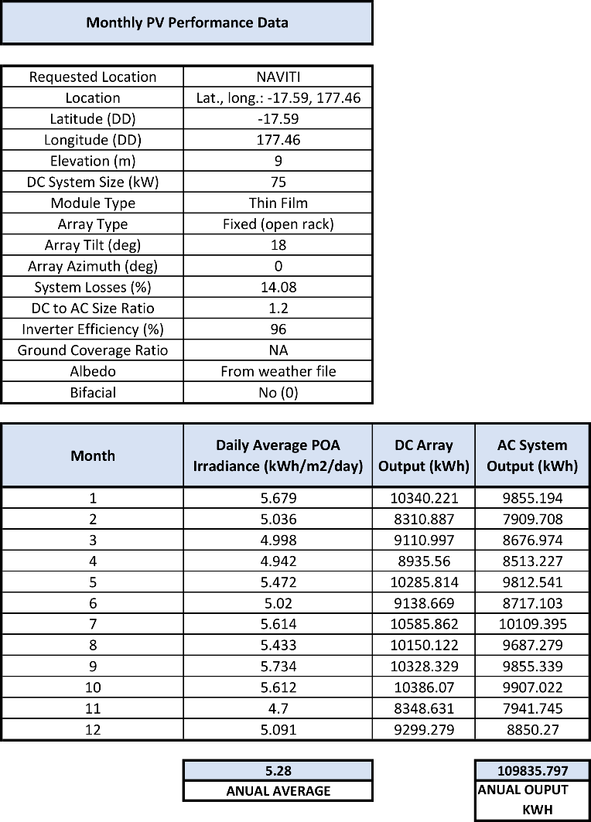

1. **Prototyping and Pilot Implementation Statement**

**The hybrid system composed of wind turbines and flexible solar panels will have different implementation and development methods.**

**WIND TURBINES**

**For wind turbines, the option will be to acquire products already on the market, as the development of these devices is well-defined and the companies' specialization is strong. There are examples of companies developing medium-power wind turbines with cutting-edge technology, where the installation of this equipment has been well integrated in specific cases such as islands and isolated external communities; as well as in factories and communities where the incorporation of large wind turbines is not necessarily due to the proximity to the population. In this case, the nED100 wind turbine from the Spanish company Norvento Enerxia is proposed, which meets all the specifications and regulations required to establish a grid and supply electricity to the population of Marou and surrounding areas.**

**SOLAR PANELS**

**On the other hand, regarding the introduction of flexible solar panels that can be unfolded or rolled up for hurricane protection, this is a technological foundation yet to be implemented. Therefore, the prototype that will guide the creation of the device must be studied, and collaboration with the best technology companies and appropriate universities must be incorporated into the research and development for its implementation. In this case, research will be conducted to determine which type of panel and rolling system would be ideal. It should be noted that the rolling and unrolling of solar panels is a technology that has been demonstrated since the beginning of space exploration because in space, this type of procedure is necessary to transport solar panels outside the Earth's atmosphere and deploy them in synchronized movements.**

**RAINWATER HARVESTING SYSTEM.**

**Within the site, various forms of rainwater harvesting will be integrated into the general plan. The idea is to create a rainwater harvesting system covering more than 80% of the site's surface area. All collections will be gravity-fed, channeling them through filters with natural, sealed elements away from sunlight, and thus into the storage system without the need for electricity. Once the water is sealed, it will be supplied to the site and adjacent communities.**

**a). -Rainwater harvesting in natural areas. A plan will be made to adapt the natural slopes of the site's terrain, as well as the natural integration of the watershed created by the mountains and natural relief so that runoff flows naturally and by gravity to the conduction, filtration, and storage systems.**

**b). -Rainwater harvesting on building roofs. Rainwater harvesting on the roofs of the buildings being proposed represents a small percentage of the total catchment; however, as it is a construction, the harvesting is direct and therefore more efficient.**

**c). -Rainwater harvesting on decks (outdoor platforms) and exterior pavements. Rainwater harvesting is proposed within the surfaces of decks and exterior pavements and channeled by gravity to the conveyance, sealed filtration, and storage systems.**

**According to the monthly precipitation table provided by lagi2025fiji.org, the region receives an average annual total of approximately 250 mm of rainfall, which is a low index; however, this proposed implementation of rainwater collection promotes large areas, suggesting all possible areas. The site area has an approximate area of ​​14,618 sqm. If we consider that 80% of the surface area is promoted for collection, we find that it corresponds to 11,694.4 sqm of collection area proposed for this project. On the other hand, if we include a runoff factor of 70% efficiency (this factor represents the amount of rainwater actually collected compared to the total amount that falls, which corresponds to the soil or mud factor), we find that we could capture an annual average of 2 923 600 liters equivalent to 2,923.6 cubic meters of rainwater. (250 * 11694.4) * 0.70 = 2,923,600 liters. Note: Water collection factors for roof surfaces, decks, and pavements were not included; only a single factor was used.**

**However, since the region's rainfall is low, a comprehensive study of the functioning of the watersheds surrounding the site can also be conducted to scientifically determine how to increase the area's rainwater catchment area; thus, the annual rainwater capture coefficient can be increased.**

**SOLAR SEA WATER DISTILLATION, FOG AND AMBIENT AIR CATCHING SYSTEMS**

**To address the region's lack of rainfall, economical water distillation and processing systems are also proposed. Three proposals are included in this case, some of which are already in production.**

**-Hydropanels transform ambient air using self-sufficient technology that converts atmospheric vapor into clean fresh drinking water. Source Hydropanel has created a panel-shaped device that transforms condensation from ambient air into mineral-filtered water, making it drinkable, using solar energy. Each panel can produce between 2 and 5 liters of drinking water per day.**

**-Spheres that distill seawater using only the sun. Helio Water offers an innovative solution for seawater distillation with its self-contained, spherical water distillation device; one unit can produce 8 to 10 liters of water per day for human consumption.**

**-The conceptual design of the site includes seawater distillation through the installation of simple and inexpensive structures, primarily of the Glogau type, which, through membranes and the action of the sun, can condense seawater.**

**-Fog catcher membranes. Or as well as inexpensive fog-catching membranes to collect water from the environment by dripping.**

**-** **Other economical seawater distillation systems. Distillation system with a wind-driven margarita rotor pump and shallow solar still.**

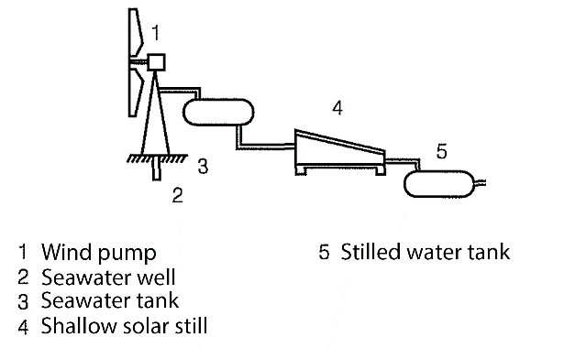

**Seawater feeds a shallow solar still measuring 8.3 m2, which has an average annual production of 50 liters per day. The still is a hermetic box with a waterproof bottom consisting of a black silicone membrane and a glass cover tilted approximately 5° to the horizontal, on whose interior the distilled water condenses. The distilled water is collected through a stainless-steel channel with a two percent slope and stored in a 200-liter tank.**

1. **Operations and Maintenance Statement**

**PHASED DEVELOPMENT AND PLANNING**

**It is worth mentioning that one of the main ideas of the conceptual project is that each part of the master plan can be implemented in stages and progressively according to the community's economic and social needs. For example, one could begin with the infrastructure to meet the population's electricity needs with wind power or wind turbines and their electricity storage and distribution network. Subsequently, the infrastructure for solar panel systems could be gradually built, along with proposals for rainwater collection, and management. This would be a completely comprehensive project that would meet the current and future needs of the population.**

**A project that would meet the current and future needs of the population, under the principles of gradual, phased implementation, all procedures for operation and maintenance required throughout the development's lifespan can be subsequently established, with a thorough understanding of the dynamics of each area and planning phase, and fully integrating the population into its operation and maintenance, in an associative relationship with the resulting socio-cultural and economic activities.**

1. **Environmental Impact Assessment.**

**We believe the environmental impact will be positive for the island, as this is a comprehensive project that addresses environmental, social, and economic factors.**

**In this case, since renewable clean technologies are involved, the impact will be less, as these technologies are key to the transition to a more sustainable energy system and to reducing greenhouse gas emissions.**

**Energy diversity increases local energy security by eliminating the need for constant foreign energy sources. It encourages innovation and the creation of new jobs in this sector. It seeks zero pollution and proper waste management.**

**Planting, biodiversity restoration, and landscape design for sustainable development. Promote transformed ecosystems and preserve intact ones to create a healthier ecosystem with richer biodiversity, providing greater benefits such as more fertile soils.**

**The costs of renewable technologies have decreased considerably in recent years, making them more competitive with traditional energy sources.**