**Bula Bloom**

**Location on the Site**

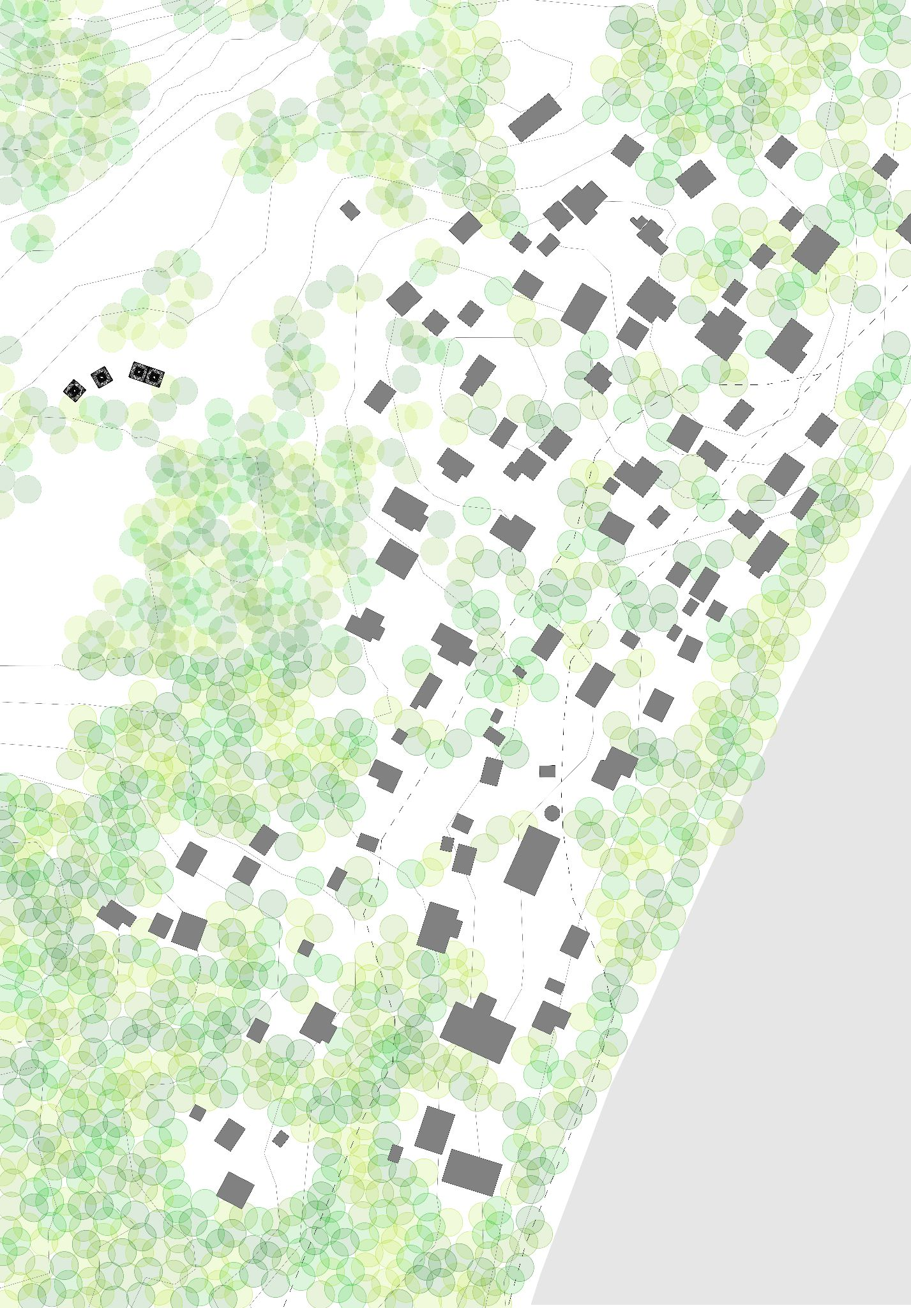

**Concept**

This design proposes a modular, community-centered infrastructure that generates solar energy, harvests and stores drinking water, and supports the local ecology. Inspiration was drawn from the natural systems and ecological relationships already in place on Naviti Island. Each module mimics the form and function of Fijian flora, particularly bromeliad leaves. The canopy of the module is derived from the upward curved and arched forms of bromeliad leaves to help direct water to temporary or permanent water storage. (Fig #1) The primary structure of the modules uses bent bamboo anchored to the ground with ashcrete pylons, minimizing the ecological harm caused during implementation. These pylons are integrated into the structure of underground ashcrete cisterns that will be carefully scaled to store the rainwater harvested by the canopy (Fig #2). 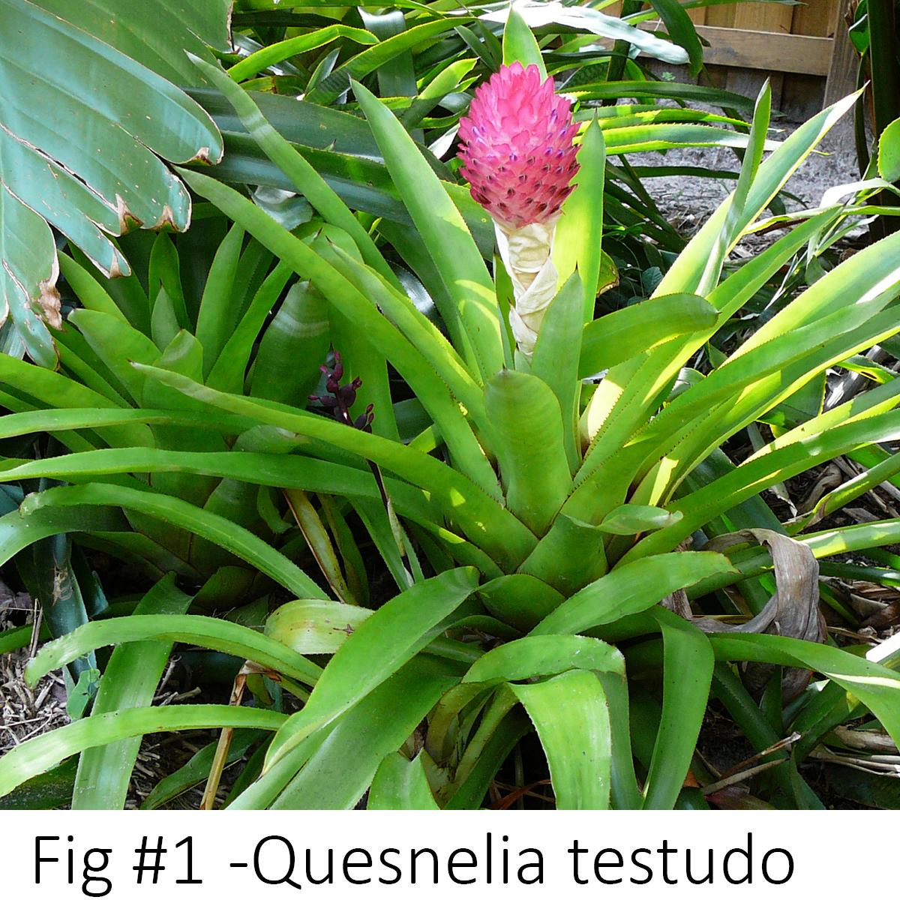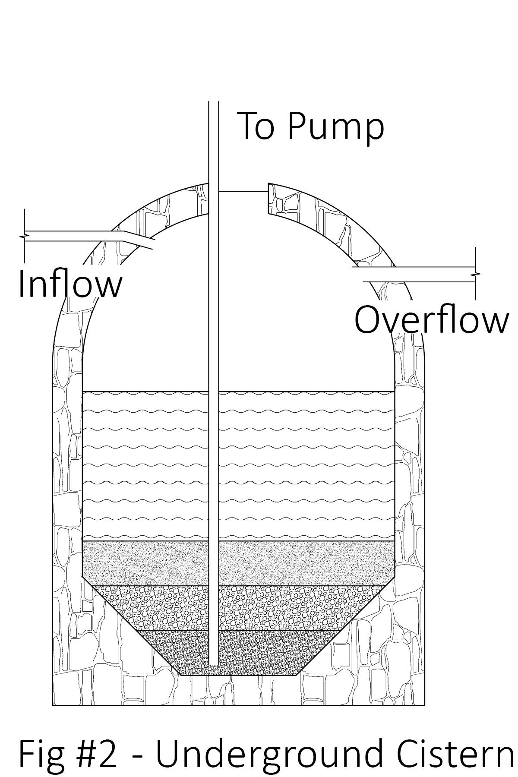

The concept is exhaustively rooted in biocentrism, aiming to place the needs of the environment on equal footing with those of Marou Village. Every element and material of each module is either harvested from Naviti Island itself (such as bamboo and ashcrete aggregates) or easily transportable to the site, making this a versatile design for other island communities. The shaded space beneath the canopies can be utilized for a variety of community needs, including recreational space, shaded market space for tourist engagement, and educational pavilions.

Community experience and involvement are central to the design, as the construction and maintenance of the modules will rely heavily upon the generational knowledge ingrained in Fijian culture. The materials were chosen not only for their accessibility and regenerative properties, but also for the familiarity of their traditional uses in the community.

The modules will appeal to locals and visitors due to their organic form which creates an inviting, non-intrusive landmark that can be expanded as needed. The openness of the structure creates a physically and socially welcoming space, not only for humans but for all other species to enjoy. The design has been presented as a singular module as well as in an aggregated form to demonstrate its expansion capabilities and adaptability to various site conditions and community needs.

**Technical**

Integrated Technologies

* Monocrystalline flexible PVT panels - mounted to the canopy, generating electricity
* Rainwater filtration system - a system designed with natural materials to filter water entering and leaving the cisterns.
* Battery Storage - to be installed outside of the modules in a centralized location; the battery system stores electricity for use during non-peak solar hours.

System Outputs

* 92-136 kWh per day
* 160,000 liters of filtered rainwater per year
* Storage for approximately 100,000 liters of water

System Inputs

* Sunlight
* Rainwater

**Prototyping and Pilot Implementation System**

Several digital simulations have already been developed and performed to test the performance capabilities of this modular system. During the prototyping phase, these simulations will be expanded to ensure the best materials and construction techniques are implemented, primarily concerning stress and load testing. An engineer will be employed to ensure all connections and anchors are designed with materials capable of withstanding the island’s climate and weather patterns.

Where possible, local Fijian entities will be employed to ensure a thorough understanding of the materials and conditions. A single module will be constructed with collaboration from local craftspeople, using regionally sourced materials. The economic and experiential gain from the entire process will benefit the Fijian people.

Community participation will play an integral role in the final design decisions as well as material research and development. The community will receive thorough training on maintaining and adapting the system to their needs.

**Operation and Maintenance**

The modular design emphasizes ease of maintenance in a long-term, sustainable manner. The use of local materials ensures that residents have the ability to preserve and repair the system as needed. The water filtration system is enclosed and redundant to limit maintenance needs but access to the system can be gained from the rooftop by removing the lightweight and manageable solar array.

The village residents will be trained in the assembly, disassembly, and complete operation of the system to inspire the independence that a renewable energy and resource system can provide.

**Environmental Impact**

The installation process for the cisterns will have the most impactful change to the environment. However, installing them below grade ensures that their presence will not be disruptive to any existing ecological conditions. A primary focus of this design is to avoid negatively altering the relationships that exist between the other species that inhabit the site. Helical piers were chosen to anchor the slabs upon which the columns meet the ground to reduce the amount of displacement necessary to install the system.

Material choices were made based on what is readily available and regenerative on the island for a low-impact outcome. Bamboo is rapidly renewable and ashcrete will be made from local aggregates and industrial waste like fly ash or volcanic ash.

Due to the minimal contact with the ground, existing water flow patterns should be minimally disrupted. Imported materials will be limited and used only when necessary to preserve the sustainability of the installation.

All of these impacts can be mitigated through using natural materials for scaffolding, the employment of local labor, and encouraging community involvement in the construction and preservation of the site.

**Form Development and Algorithmic Design**

The initial form for this design was carefully developed through an algorithmic process rooted in biomimicry. The primary inspiration came from the upward-curving geometry of bromeliad leaves, which are naturally optimized for water collection. These forms were analyzed and compared to more conventional roof forms using a parametric process to determine which design offered the greatest potential for rainwater harvesting while still meeting the necessary solar energy requirements.

The structural logic of catenary arches was also explored for their efficiency in distributing loads with minimal material use. These arches were adapted to define the canopy shape of each module, ensuring both structural stability and an open, inviting space beneath.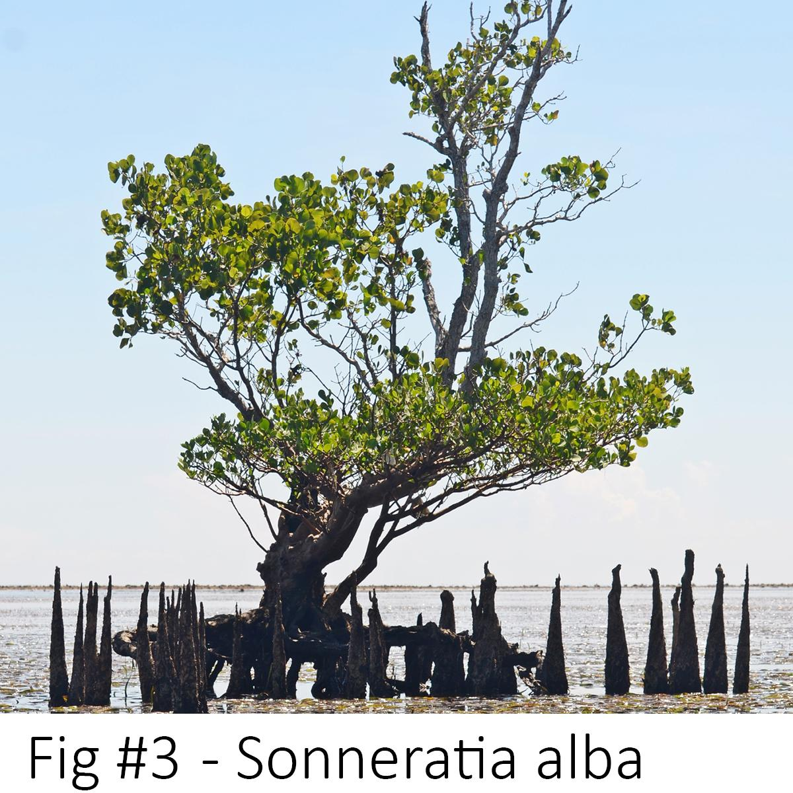

Where the structure meets the ground, the design draws inspiration from mangrove trees (Fig #2), known for their elevated root systems that allow water to flow beneath while stabilizing the plant. In emulation of this, the modules are anchored with a minimal footprint. Slender clusters of bamboo columns and helical piers elevate the canopy to preserve the site's natural hydrology and minimize ecological impact.

This algorithmic workflow enabled the creation of an adaptable form that can be implemented across a variety of environmental conditions. The inputs for the simulations can be adjusted to respond to other climates or site-specific variables, making this a scalable and context-sensitive solution.

**Image Citations**

Site Plan - Scott McCallister - Own Work

Fig #1 - Quesnelia testudo - John Thagard - Own work, CC BY-SA 3.0, https://commons.wikimedia.org/w/index.php?curid=24500827

Fig #2 - Cistern Diagram - Scott McCallister - Own Work

Fig #3 - Sonneratia alba - Ariefrahman - Own work, CC BY-SA 4.0, https://commons.wikimedia.org/w/index.php?curid=40614845