**The WovenEarth   
*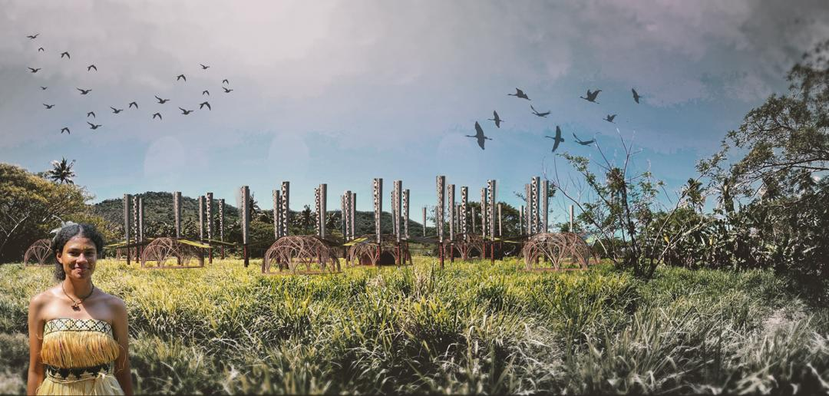***

**Concept Narrative**

The islands of Fiji face a dual crisis—one environmental, and one cultural. On the one hand, these remote communities are struggling with increasing scarcity of clean water and energy due to climate change, infrastructure limitations, and geographic isolation. On the other hand, the forces of globalization have gradually eroded traditional practices, weakening local identity and reducing the role of indigenous knowledge in shaping the built environment. this proposal is a direct response to both of these issues, offering not just a technological solution but a cultural one as well. The main idea is to work against the loss of native vegetation and animals and provide energy for the indigenous people of Fiji.

There are Two types of materials were used in this pavilion: One is a local and indigenous material, bamboo wood, to create interaction with the Fijian people .The second is a material that is made in the factory, such as brick and clay. The pavillion used both on land and in water. If it is placed in water, it becomes a place for corals and aquatic animals to grow and live and If it is placed on land, it is a space for bird nests and plant growth.

The inside of the pavilion is also a place for activities such as people gathering for dancing and ceremonies.

Built using locally sourced bamboo and assembled through traditional hand-weaving techniques, the structure serves as a living example of how indigenous knowledge can be reactivated and respected in contemporary sustainable design. The bamboo framework is not only symbolic, but also highly functional: it is lightweight, rapidly renewable, and familiar to local craftsmen. Its organic form echoes Fijian architectural aesthetics while offering a platform for contemporary energy systems. These natural materials are interlaced with lightweight, semi-transparent solar panels embedded in a delicate polymer mesh, creating a dynamic interplay between traditional craftsmanship and high-tech functionality. These solar elements are not treated as technological add-ons, but as an artistic skin that dances with light and shadow—merging function and form into a coherent whole. The visual softness of the panels invites curiosity and pride, while their high efficiency ensures the production of clean, renewable energy for the community. Beyond solar, the design also incorporates bladeless wind turbines, which are strategically positioned to capture gentle island breezes. These turbines operate with minimal noise and are safer for local bird populations, aligning with the project’s minimal-impact philosophy. In aquatic installations, the substructure of the pavilion provides a stable surface for coral reef regeneration and aquatic life habitats, contributing to marine ecosystem health. Another key function of the pavilion is rainwater harvesting. The curved form of the roof channels rain into a series of gutters that feed into a central cistern. The collected water is then filtered through natural and mechanical processes, providing the community with reliable access to clean drinking water. This is not a neutral piece of infrastructure—it is a space of memory, pride, and learning. Local artisans are not just consulted, but employed and empowered through the construction process. The act of weaving, which is deeply embedded in Fijian identity, becomes both metaphor and method: a way of threading together past and future, nature and technology, function and meaning. The pavilion thus functions on multiple levels: it is an energy generator, a water collector, a community space, and a symbol of cultural resilience. It provides for immediate material needs while also inspiring a longer-term shift toward local self-sufficiency and ecological balance. By embedding high-performance technology into a form that is familiar, participatory, and meaningful to the local population, the design builds not only a physical structure but also a sense of ownership and continuity.

**1-Technical Narrative**

The pavilion integrates a dual renewable energy strategy tailored to Fiji’s coastal and island context. The selected technologies—Vortex-Induced Vibration (VIV) Wind Turbines and Organic Photovoltaic (OPV) Panels—were chosen for their compatibility with both the natural conditions and the cultural aesthetics of the region. Together, these systems harvest the two most abundant local resources: sunlight and wind, while seamlessly integrating with water collection techniques.

Energy Generation Technologies

1. Vortex-Induced Vibration (VIV) Resonant Wind Turbines

The use of VIV-based wind technology addresses the unique wind patterns along the Fijian coastline, where daily sea breezes and nighttime land breezes create a consistent, low-speed wind flow. Unlike traditional turbines with rotating blades—which are noisy, require high maintenance, and can harm bird populations—the VIV system captures wind energy through aeroelastic vibrations. Vertical poles oscillate in response to the vortices generated by passing air currents, converting this kinetic motion into electricity through electromagnetic induction. Positioned along the shorelines—where consistent wind flows occur as air circulates from sea to land during the day and reverses at night—these turbines capture low-speed coastal winds efficiently.This bladeless technology is ideal for the coastal and semi-aquatic environment of the project. Its silent operation ensures minimal disturbance to wildlife, and its form factor allows for safe integration into both land-based pavilions (where it may serve as vertical habitat for birds and plants) and marine-based structures (supporting coral growth and aquatic ecosystems). Additionally, the simplicity of its mechanics makes it more accessible for local maintenance and adaptation.In total, 30 units of VIV turbines have been distributed throughout the site, each generating approximately 0.5 kW. Together, they provide a total installed capacity of 15 kW, producing an estimated 54,750 kWh annually, based on average local wind speeds of 5.5 m/s.

2. Organic Photovoltaic (OPV) Panels

The second key energy system is the use of Organic Photovoltaics, a lightweight, flexible solar technology chosen for its visual, cultural, and spatial adaptability. Unlike rigid silicon-based panels, OPVs can be produced in a wide range of colors and transparencies, allowing them to blend into the architectural skin of the pavilion as an expressive, ornamental surface. In the context of Fijian culture—where color plays a vital role in textiles, rituals, and visual symbolism—this technology becomes more than a utility; it becomes an artistic extension of place-based identity. Covering an area of 820 square meters, the OPVs are lightweight, colorful, and semi-transparent—reflecting the importance of color in Fijian culture. These flexible panels follow the curves of the bamboo framework, doubling as shading devices and solar skins. Their spherical geometry also enables efficient rainwater redirection into integrated gutter systems. The OPV system provides a peak power output of 98.4 kW, with daily production reaching approximately 492 kWh, and an annual output of 179,580 kWh under typical sunlight conditions. This hybrid energy model ensures round-the-clock generation and resilience in variable weather.

Environmental Inputs

The pavilion operates on two primary environmental inputs:

• Sunlight – Captured via organic photovoltaic panels.

• Rainwater – Collected from the pavilion’s contoured roofing and directed through a filtration system into underground storage tanks.

Community Outputs

The system provides the following outputs essential for local well-being:

• Electricity – To power lighting, refrigeration, water purification, mobile device charging, and educational activities.

• Potable Water – Harvested rain is filtered for community use, reducing reliance on centralized or imported water systems.

Estimated Annual Output Summary

• Solar Energy Production: ~179,500 kWh/year

• Wind Energy Production: ~54,500 kWh/year

• Total Energy Output: ~234,000 kWh/year

• Water Collection Capacity: Dependent on local rainfall, with rooftop surface geometry optimized for maximum catchment efficiency.

**2-Prototyping and Pilot Implementation Statement**

The prototyping and pilot implementation process will be approached as a collaborative, site-specific, and iterative design-build exercise, grounded in both technological testing and cultural exchange. Our goal is not only to construct a functional pavilion, but also to empower the local community as co-creators, builders, and long-term stewards of the installation.

1. Prototyping Phase
2. The initial phase will take place in two parallel streams: material and technology prototyping in an off-site laboratory, and community-based craft prototyping in Fiji.

Off-site lab prototyping will focus on performance testing for the Organic Photovoltaic (OPV) panels, rainwater filtration systems, and bladeless wind turbines (Vortex-Induced Vibration). We will assess structural resilience, energy yield, and water efficiency at scale. On-site prototyping in Fiji will involve workshops with local craftspeople to explore traditional bamboo weaving techniques, testing different modular joint systems and natural finishes. This phase is vital for aligning the project’s physical form with vernacular knowledge and aesthetics.

2. Full-scale Implementation: Once the prototyping phase is validated, the full-scale pavilion will be assembled with direct involvement from the local community. The process will be organized as a skill-sharing platform, where our design team works alongside local artisans, students, and volunteers. The use of locally available materials like bamboo, clay bricks, and organic textiles allows for easier adoption, lower cost, and meaningful community ownership.

Construction will be phased:

• Phase 1: Site preparation and substructure.

• Phase 2: Structural bamboo assembly and solar integration.

• Phase 3: Water harvesting and turbine installation.

• Phase 4: Landscaping and habitat formation (bird perches, coral-seeding modules, etc.).

Throughout, we will integrate knowledge exchange sessions, encouraging dialogue between engineers, local builders, and youth, aiming to build capacity for replicating the system elsewhere. By embedding the local community in both the prototyping and building process, the pavilion becomes not just a structure, but a living extension of local knowledge, identity, and environmental stewardship.

**3-Operations and Maintenance Statement**

The long-term success of this pavilion lies not only in its initial construction but in its ability to be operated, maintained, and adapted by the local community with minimal external dependency. Every system, material, and connection has been carefully chosen to reflect low-tech reliability, modular adaptability, and cultural familiarity, ensuring the structure becomes a living, self-sustaining part of the local landscape.

1. Energy Systems Operation & Maintenance

The hybrid energy system—comprising Organic Photovoltaic (OPV) panels and bladeless wind turbines based on Vortex-Induced Vibration (VIV)—has been selected specifically for its low-maintenance requirements.

* OPV panels, installed on lightweight bamboo structures, are durable, modular, and accessible. Their surface can be cleaned with soft cloths and rainwater, and replacement is easy due to the use of standardized panel dimensions. These panels also act as shading and ornamental elements, making maintenance part of everyday use.
* VIV turbines, unlike traditional wind systems, have no rotating blades or mechanical gearboxes. This dramatically reduces the risk of mechanical failure and allows for long-term, low-risk energy generation. Local operators will be trained to check the vertical masts for structural integrity and ensure the base electromagnetic units are secure.

2. Water Collection and Purification System

Rainwater is collected via the curved OPV panel surfaces and bamboo roof structures, funneled through passive gutters, and directed into a multi-stage filtration system. This includes sediment traps and carbon-based filters that are easily replaceable and locally maintainable. Storage tanks are positioned underground or below raised decks and are designed with drainage ports for periodic cleaning. All water-related elements use gravity-fed systems to minimize reliance on electric pumps, reducing both energy use and risk of malfunction. Replacement filters and basic plumbing tools will be provided to the community with bilingual maintenance manuals.

3. Structural Maintenance

The pavilion’s structure is primarily built from locally harvested bamboo, compressed earth bricks, and woven natural fibers, following traditional Fijian construction techniques. This allows for intuitive repairs by local craftspeople using skills and materials already present in the region. Bamboo joints will be secured using natural binding systems such as rope lashings or bio-resins, enabling easy tightening or replacement without advanced tools. Earth bricks can be re-formed and re-fired if damaged, and natural coatings such as lime or clay slip finishes can be reapplied periodically.

4. Community Engagement

From the beginning, the community will not only be involved in the building process but will be equipped to maintain and adapt the system long-term. We propose forming a local stewardship group, composed of community leaders, craftspeople, and youth. This group will be trained through hands-on workshops and provided with illustrated guides for troubleshooting, seasonal inspections, and material renewal. Educational materials will be introduced to schools and cultural centers to promote knowledge-sharing and intergenerational learning, ensuring the pavilion remains not only a source of clean energy and water, but also a symbol of self-reliance, pride, and regenerative culture. This approach transforms maintenance from a technical task into a shared ritual of care, reinforcing both environmental responsibility and cultural resilience.

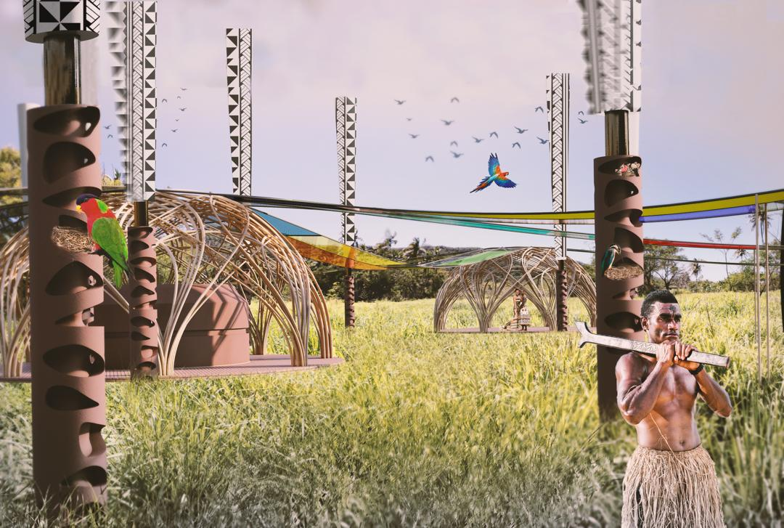

**4-Environmental Impact Assessment**

Our design approach prioritizes ecological sensitivity and regenerative interaction with the surrounding natural ecosystems of Fiji—both terrestrial and marine. Rather than being a disruptive intervention, the installation functions as an environmental amplifier, supporting biodiversity, resource circularity, and climate resilience.

1. Minimal Ecological Footprint

The pavilion is designed with lightweight and reversible foundations, avoiding deep excavation or land degradation. The modular bamboo structure can be disassembled and reused, and no synthetic concrete is used. Instead, compressed earth bricks and locally sourced natural materials ensure minimal embodied carbon and support local economies. All technological components—solar panels, water tanks, and wind turbines—are surface-mounted and do not penetrate sensitive soil or coral structures.

2. Habitat Enhancement

One of the most unique aspects of the design is its dual role as human infrastructure and natural habitat. The pavilion is intentionally designed to host and support native life forms:

• In terrestrial settings, the bamboo framework provides shelter and perching spaces for local birds and supports climbing plants and mosses, enhancing green cover and promoting pollination cycles.

• When installed in shallow coastal waters, the base structures—made from porous ceramics or bio-polymer mesh—serve as coral reef substrates, allowing for the growth of corals, algae, and marine invertebrates. These structures offer shelter for small fish and contribute to reef regeneration.

3. Low-impact Energy Generation

Both energy systems were selected with ecosystem compatibility in mind:

• Bladeless wind turbines (VIV) eliminate the noise, vibration, and wildlife hazards associated with traditional turbines. They pose no threat to birds or bats and can be installed without disturbing soil or marine beds.

• Organic Photovoltaic (OPV) panels are lightweight, non-toxic, and designed to degrade safely at end-of-life, unlike conventional silicon panels that pose recycling challenges.

4. Water Management and Circularity

Rainwater collection prevents overuse of groundwater and reduces dependency on trucked-in water, which carries high ecological and carbon costs. The water system is closed-loop, meaning it captures, filters, and stores rain without discharging pollutants into the ground or ocean. Overflow channels are bio-integrated into surrounding landscapes or seaweed gardens to support micro-ecosystems.

5. Mitigation Measures

To address any potential risks:

• Site-specific ecological surveys will be conducted before implementation to avoid disturbing nesting zones, coral beds, or protected flora.

• Biodegradable materials will be prioritized in all temporary construction processes.

• Any technology requiring maintenance or replacement (e.g., OPV panels) will follow a “take-back and recycle” agreement with suppliers to prevent environmental waste.

• Community-based monitoring teams will be trained to observe local ecological changes, such as bird behavior, coral health, and water quality, with support from environmental NGOs or academic partners.

By designing for integration rather than domination, the pavilion not only reduces harm but actively contributes to ecosystem restoration and resilience. It becomes a hybrid space where culture, climate, and nature collaborate—offering a replicable model for low-impact development in sensitive island environments.