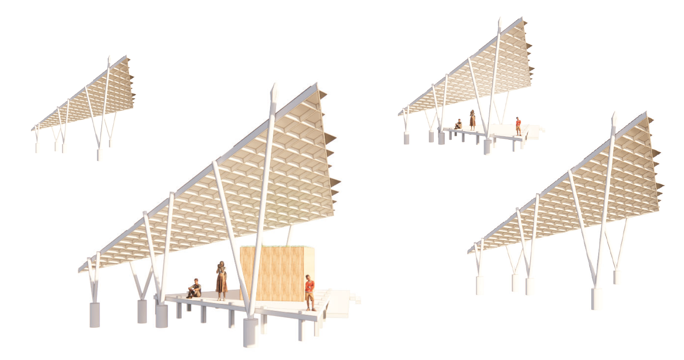

Land art for a changing climate

The Drua Fleet Of Energy

LAGI FIJI 2025

1. Concept Narrative

Our design responds to the LAGI 2025 challenge through the physical form and deep cultural meaning of the drua – Fiji’s iconic traditional sailing vessel. Historically the largest and most advanced sea-going canoe in the Pacific, the drua symbolises unity, innovation and resilience. Our proposal reimagines this heritage through a fleet of six triangular lateen solar sails “navigating” the treetops above Marou Village – restoring their silhouette to the landscape as sculptural, functional energy systems.

Each **lateen sail** structure comprises native timber and biocomposite materials that utilise post-consumer plastic and coconut coir, honouring Fijian material traditions and circular economy values. Each roof’s interlocking lattice evokes traditional pandanus mats, supporting photovoltaic panels angled for optimal solar exposure. The sails are elevated above ground and create shaded platforms for productive and communal use.

The sails offer interconnected benefits – electricity, clean water, food, learning, enterprise and cultural identity. All six harvest solar energy and rainwater, with integrated systems that collect, filter and store water for agriculture and village needs. One sail houses battery storage and intelligent energy systems. Two others accommodate a Fibre Hub and a Food Hub – commercial production spaces connected to a regional network of micro-enterprises linked to national and international markets. Based on a “learning by doing” approach, these hubs enable hands-on processing of local resources such as coconut and botanical waste, into coir geotextiles, essential oils, biochar and preserved foods – generating income and supporting climate-resilient livelihoods. A fourth sail is dedicated to regenerative tourism and cultural exchange. Visitors participate in seasonal harvesting, essential oil distillation and cooking classes of traditional Fijian cuisine reimagined through clean-energy-powered food processing, while the fifth and sixth sails serve as inclusive community meeting spaces. This immersive experience connects guests with Marou’s regenerative innovation and ancestral wisdom.

Adjacent to each sail, coconut-based Strata Intercropped Horticultural **Demo Plots** showcase climate-resilient farming using coconut pith (cocopeat), rain-fed irrigation and companion planting. These 10×10 metre plots improve food security, soil health and biodiversity while producing nutritious staples and high-value botanicals. Integrating traditional and modern techniques reflects the linguistic roots of drua – dua (one) and rua (two) – a union of forms moving as one.

Community experience is central. The site welcomes workshops, school groups and visitors, acting as a learning landscape and public gathering space. The lateen sails themselves become iconic landmarks – rooted in the past yet pointing toward a regenerative future utilising appropriate technology.

Co-benefits span multiple SDG-aligned priorities: renewable energy, clean water, sustainable agriculture, reduced emissions, skills development, women-led enterprise, and the protection and celebration of cultural heritage and diversity. Aligned with Fiji’s Climate Change Act, National Development Plan Vision 2050 and the FREF mission, this project fosters climate adaptation while catalysing local leadership and economic empowerment.

At its heart, the Drua sails are more than infrastructure – they are living symbols of movement, discovery and transformation. Marou becomes a guardian of ancestral innovation and a beacon of regenerative design for island communities across the Pacific and beyond.

**This design delivers a locally adapted, sustainable solution providing clean electricity, secure water access and income-generating opportunities. Every element is functional, culturally meaningful and climate-resilient, offering a scalable and replicable model for Pacific Island communities.**

|  |  |
| --- | --- |
| **a. Modular infrastructure design** | The site’s six elevated structures, inspired by lateen sails, are modular for ease of deployment, maintenance and scalability. Each sail module integrates three systems: solar energy, rainwater harvesting and productive land use. Raised on triangulated timber struts, the structures minimise soil disturbance and are engineered to withstand Category 5 cyclones and seismic activity. Redundant load paths are built into all structural elements, ensuring resilience during extreme events. The elevated design also enhances passive ventilation and flood protection. |
|   **b. Solar mini-grid system** | The 124.2 kW solar PV mini-grid is the project’s energy backbone with built-in capacity for battery banks and growth. It powers 67 households (75kW), a modular food processing hub (up to 25kW), and a modular fibre processing unit (up to 24.2 kW). Dual-glass N-type TOPCon PV modules mounted on cyclone-rated racking maximise durability and solar capture. The system is managed by an AI-driven SCADA platform, enabling real-time optimisation based on irradiance and consumption forecasts.  Key components include:   * 124.2 kW of solar PV capacity * 200 kW hybrid inverters * 800 kWh HV LiFePO₄ modular battery banks * SCADA – AI-based management real-time monitoring and controlling * IoT-enabled smart meters and controllers for each load point. |

|  |  |
| --- | --- |
|  | The grid uses predictive machine-learning algorithms to allocate surplus solar to productive use appliances such as drying, oil extraction and water pumping. This significantly increases solar utilisation while reducing curtailment, ensuring each kilowatt supports livelihoods and economic activity. |
| **c. Rainwater harvesting and water security** | Each sail’s roof (~100 m²) feeds into a dual-stream rainwater system:   * Two 30,000 L UV-stabilised HDPE tanks for potable water, filtered with leaf screens, first flush diverters, carbon filtration (Activated Charcoal from coconut shells) and UV sterilisation. * A 150,000 L stormwater storage area supports gravity-fed irrigation and non-potable uses such as fibre processing and sanitation.   Nature-based treatment via coir-geotextile-lined vetiver swales enables sediment removal and phytoremediation, improving water quality and reducing runoff velocity. |
|   **d. Regenerative land use** | To support visitor experience, Demo Plots are located next to each sail. Intercropped staples (e.g. cassava, coconut) and high-value botanicals (turmeric, lemongrass) are supported by legumes and vetiver for soil restoration. A 24,000 m² commercial agroforestry zone supports the Food and Fibre Hubs with inputs from coconuts and botanicals for processing into oils, food and geotextiles. |

|  |  |
| --- | --- |
| **e. Climate resilience** | The energy, water, and processing systems are physically and operationally resilient. Platforms are elevated ≥0.5 m above flood levels, and all critical infrastructure is cyclone-rated with passive ventilation and surge protection. Materials include biocomposites which are UV-stable, suited for saline coastal environments. Modular infrastructure enables rapid repair and recovery post-disaster.  Together, these integrated systems demonstrate how culturally rooted design and advanced technology can deliver clean energy, water and sustainable livelihoods in small island developing states, setting a replicable benchmark for just climate transitions in the Pacific. |

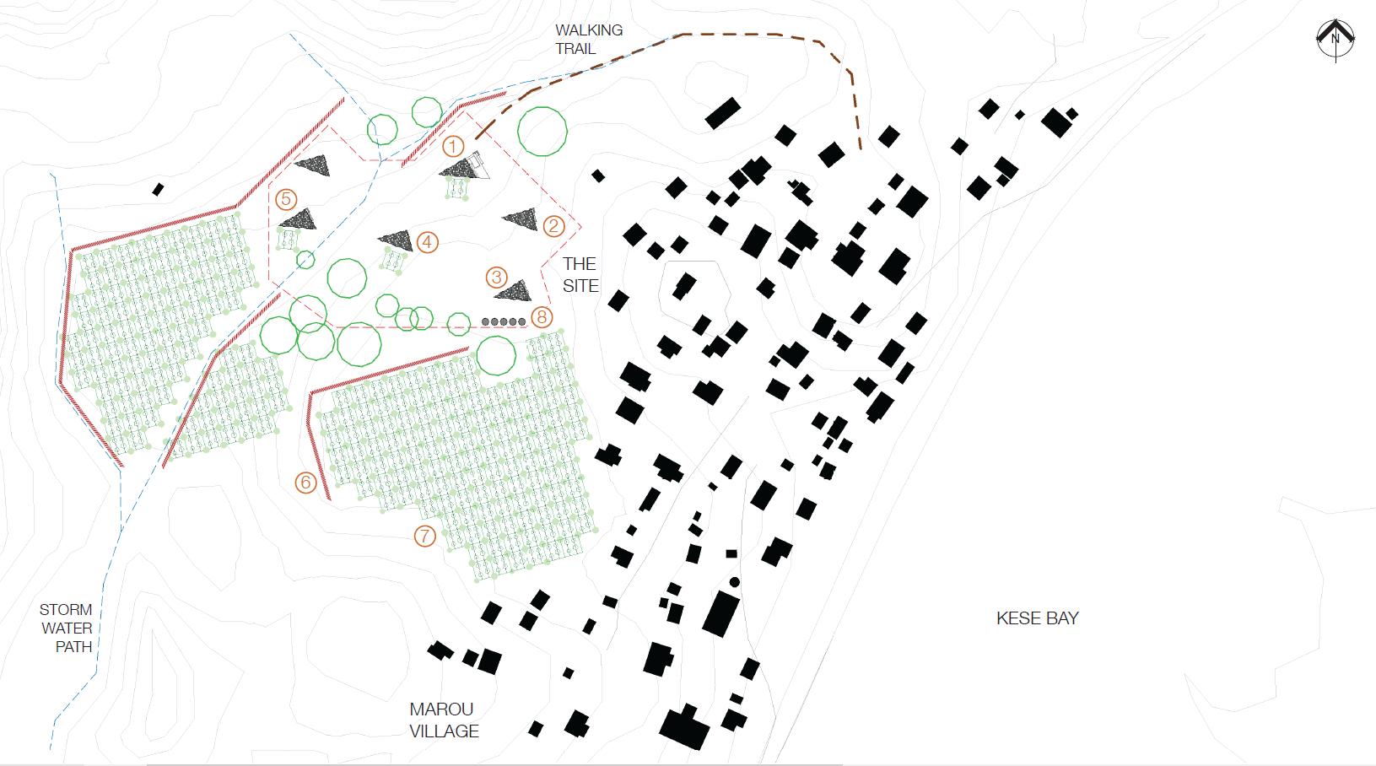

Proposed site plan

**Implementation will follow a two-phased approach: an initial prototype to validate technical, social and environmental performance, followed by a full-scale pilot to deliver resilient infrastructure to 67 households.**

This staged approach enables iterative learning and de-risks larger investments. The site will serve as a regional demonstration hub for climate-resilient, circular infrastructure, potentially informing national policy frameworks and regional investment strategies.

# Phase 1: Prototype Development (USD 100,000)

This phase involves constructing one lateen sail to demonstrate and test the integrated functions of the system – solar energy generation, rainwater harvesting, regenerative agriculture and productive-use enterprise.

The prototype will be implemented at the designated site in Suva, which means we can engage with local engineers and builders with prototyping and co-develop with residents on Marou. All components are designed for demountability and relocation, with sourcing and manufacturing localised in Fiji to support capacity-building and supply chain development.

|  |  |
| --- | --- |
| **Features of the prototype** | The prototype will include:   * One full lateen sail, constructed with:   + 5x triangulated timber struts set in concrete footings, to form the core structure.   + Triangle roof structure built with an interlocking lattice of beams made from an extruded biocomposite comprising post-consumer plastic and coconut fibre.   + One third of the roof structure clad in the solar PV array to test technical performance.   + Floor platform structure again utilising plastic/coconut fibre biocomposite structural joists and floorboards.   + Coconut fibre weather screens. |

|  |  |
| --- | --- |
|  | * A Demo Plot using reusable planter boxes suitable for relocation. * One mini anchor enterprise – either a Micro Food Processing Unit or Fibre Hub module, selected through community decision-making. * A cut-away view of the passive stormwater and erosion management system via swales, bunds and coir-based filtration systems. * A green roof installed above the processing unit for insulation and water management. |
| Budget Line Icon Vector, Budget Icon, Budget, Business PNG ...  **USD 100,000**  **Budget breakdown** | * Sail infrastructure and materials: 45,000 * Anchor enterprise module (Food/Fibre Hub): 10,000 * Community engagement and governance setup: 5,000 * Travel and coordination (NZ–Fiji): 10,000 * Solar and water systems, Demo Plot, green roof and stormwater features: 30,000 |
| **Prototype outcomes** | * Delivery and installation of a scaled-down sail module * Validation of load-bearing capacity and energy/water performance * Documentation of construction techniques, O&M protocols * Verification of real-time monitoring and smart controls * Community governance and enterprise co-design validation * Refinement of financial and scalability models based on live data. |

# Phase 2: Pilot Implementation

**(Estimated budget: USD 1.863 million, USD 15 per watt)**

The pilot will serve 67 households and two anchor enterprises (Food and Fibre Hubs) through a 124.2 kW smart solar mini-grid. The system integrates battery storage, cyclone-rated structures, smart meters and real-time energy management. Designed for resilience and circularity, it embeds rainwater systems, green infrastructure and productive agriculture.

|  |  |
| --- | --- |
| **Major cost items** | * Solar Mini-Grid with controls & battery storage: USD 920,000 * Food and Fibre Hubs, processing systems, water-energy integration: USD 150,000 * Additional: logistics, governance training, local fabrication, spares and capacity building |

The system is designed to be modular and scalable, allowing implementation to respond to available capital and co-financing from private sector partners. This adaptability makes it possible to tailor the system to different sites, budget envelopes or phases of development, ensuring investment readiness at all stages.

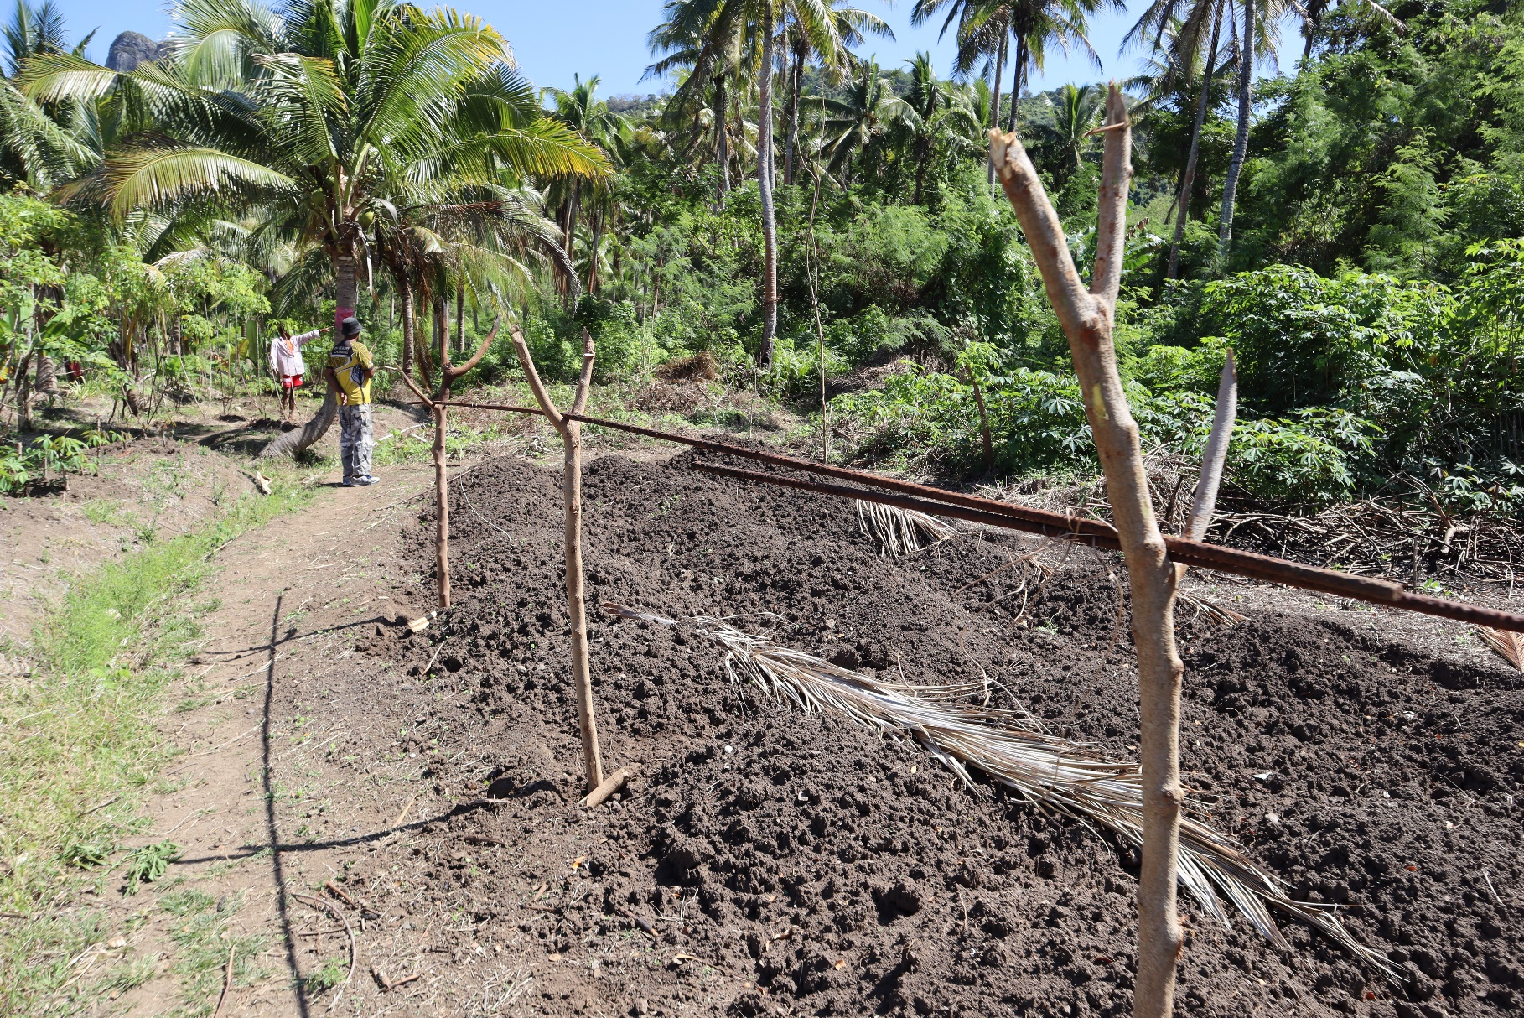

Farming on Marou. LAGI

**This project positions the mini-grid as a platform for inclusive economic growth, not merely energy delivery. Its high-efficiency 124.2 kW solar PV system, paired with HV LiFePO₄ battery storage and an AI-based control system, is designed to optimise energy generation, load management and productive use.**

Anchored by productive-use enterprises – the Food Processing Unit and Fibre Hub – the system generates daytime demand, improves system utilisation and creates long-term financial resilience. The strategy aligns with the FREF model's focus on cost recovery, lifecycle planning and community affordability.

|  |  |
| --- | --- |
|   **a. Productive-use anchors: Food and Fibre Hubs** | The system's financial resilience is underpinned by productive anchor loads that operate during solar peak hours:   * The **Food Processing Unit** is self-contained with cold storage, dryers, and canning equipment to preserve local produce, support micro-enterprises and reduce post-harvest loss. * The **Fibre Hub** processes coconut husks into cocopeat and coir fibre products. It functions as a modular demand stabiliser.   These daytime loads increase the capacity factor and reduce dependency on battery storage, directly supporting financial models targeting an 18–20% equity IRR aligned with the FREF framework. |
| **b. Cooperative governance** | Operations are managed by a **Community Energy & Enterprise Cooperative (CEEC)**, formed in partnership with private sector developers and enterprise operators.  Core responsibilities include:   * Energy service oversight via an SLA with certified engineering firms * Revenue-sharing from anchor enterprises * Maintenance reserve and lifecycle planning * Adherence to FREF-based tariff models for affordability.   CEEC bylaws will formalise transparent governance, dividend distribution and reinvestment in local infrastructure. |

|  |  |
| --- | --- |
| capacity building – The Fuse News  **c. Capacity building and technical support** | CEEC partners with FREF, Fiji National University and private contractors to deliver training in:   * Mini-grid safety, O&M protocols and digital tools * Food and fibre hygiene standards, equipment handling and quality control * Business management, inventory and cost accounting.   AI-enabled smart meters and controllers at each home enable real-time monitoring and load optimisation. In addition to community-based training, these systems apply predictive analytics and remote diagnostics to pre-empt faults, monitor inverter and battery health and water tank levels, and trigger alerts – minimising downtime and reducing external technician reliance. This sensor-driven approach supports the CEEC's long-term reliability goals and reduces reliance on external technical teams for everyday maintenance while fostering local confidence in digital tools. |
| **d. Financial sustainability and tariff structure** | The system uses a tiered tariff based on FREF analysis:   * Community tariff: FJD 0.3859/kWh * Battery replacement fee: FJD 0.1795/kWh (for Year 10 replacement) * Effective tariff: FJD 0.5654/kWh * Willingness to pay benchmark: FJD 0.4100/kWh.   Cash flow is sustained through energy sales and value-added products – dried goods, coir fibre products, cocopeat, and essential oils. Contracts with local hotels and resorts diversify revenue and reduce risk. Profits are ringfenced for reinvestment, scaling and lifecycle maintenance. |

|  |  |
| --- | --- |
| **e. Resilience and lifecycle planning** | System redundancy is built into power, water, and enterprise systems. Onsite spare parts and trained operators enable rapid cyclone-response procedures. All critical hardware is housed in cyclone-rated, ventilated enclosures. A 10-year battery replacement is pre-funded through tariffs, reducing future donor dependence.  This O&M model ensures long-term reliability, local empowerment and economic viability. |

**This project adopts a “light but robust” design approach – minimising ecological disruption while delivering regenerative outcomes across land, water, energy and food systems. It aligns with the LAGI 2025 vision, Fiji’s National Building Code (Sustainability Chapter), and the National Adaptation Plan by enhancing climate resilience, restoring ecosystems and reducing reliance on fossil fuels and imported goods.**

|  |  |
| --- | --- |
| Land Use Icons - Free SVG & PNG Land Use Images - Noun Project  **a. Land use and disturbance** | Modular infrastructure is designed to follow natural topography, integrating existing surface water flows into the layout. Sails are carefully sited to avoid flood-prone areas. Raised platforms reduce soil compaction and allow stormwater to pass beneath, preserving hydrological and ecological function. Natural stormwater flows are directed into swales, contour bunds and vegetated infiltration zones. These reduce runoff velocity, control erosion and promote groundwater recharge. Coir geotextiles and vetiver grass stabilise the soil. Overflow from rooftops supports passive, gravity-fed irrigation for nearby cropping systems – turning stormwater into a productive resource. |
| Soil Plant Icons - Free SVG & PNG Soil Plant Images - Noun Project  **b. Soil and vegetation** | The project enhances soil structure using regenerative inputs like cocopeat and biochar, which are produced in the Fibre Hub. These are applied as mulch and soil conditioners, improving moisture retention, supporting microbial life and contributing to carbon sequestration, which aligns with Fiji’s Paris Agreement commitments. |
| Water Resource Icons - Free SVG & PNG Water Resource Images - Noun Project  **c. Water resources** | Rainwater harvesting reduces pressure on groundwater sources, particularly during dry seasons. Stormwater is filtered through swales, coir-geotextile-lined channels and vetiver systems that remove turbidity and heavy metals. This improves water quality and reduces pollutant loads entering nearby freshwater and marine environments. |

|  |  |
| --- | --- |
| 2+ Hundred Food Insecurity Icon Royalty-Free Images, Stock Photos &  Pictures | Shutterstock  **d. Biodiversity and food security co-benefits** | Agroecological planting within **Coconut-Based Strata Intercropping Grids** combines native and non-invasive crops such as coconut, banana, cassava, bele, turmeric, ginger, pigeon pea, and lemongrass. These systems increase food security, support biodiversity and attract pollinators, creating shaded, productive microclimates. |
| **e. Energy and emissions** | The 124.2-kW solar mini-grid replaces diesel generation, reducing emissions, noise and fuel transport. Powering 67 homes and anchor enterprises, the system is expected to offset 900 tonnes of CO₂ over 20 years, directly contributing to Fiji’s NDC targets and renewable energy transition by 2030. |
|   **f. Materials and waste** | Construction prioritises low-impact, locally appropriate materials, including FSC-certified timber, natural fibres and recovered plastic waste. All food and fibre by-products are reused on-site and processed into compost, soil-enhancing compounds, cocopeat, ropes, and biodegradable weed mats. These locally-produced alternatives replace synthetic inputs such as plastic farming mats and nylon fishing ropes, helping reduce marine debris, diverting waste from landfills and advancing a circular, regenerative local economy. |

|  |  |
| --- | --- |
| **g. Cultural and community considerations** | Planning is co-developed with local women, youth and elders to reflect cultural values and land-use customs. Training in regenerative farming, fibre processing and clean energy ensures local ownership and stewardship. This inclusive approach supports dignified livelihoods and long-term ecological care. |

The Drua sails create a renewable energy artwork that honours tradition and integrates regenerative solutions in Marou – drawing on Fiji's ocean-voyaging heritage to embody communities’ resilience and ingenuity in building sustainable futures.