THE SOLAR VILLAGE
A village powered by the Sun and inspired by Nature
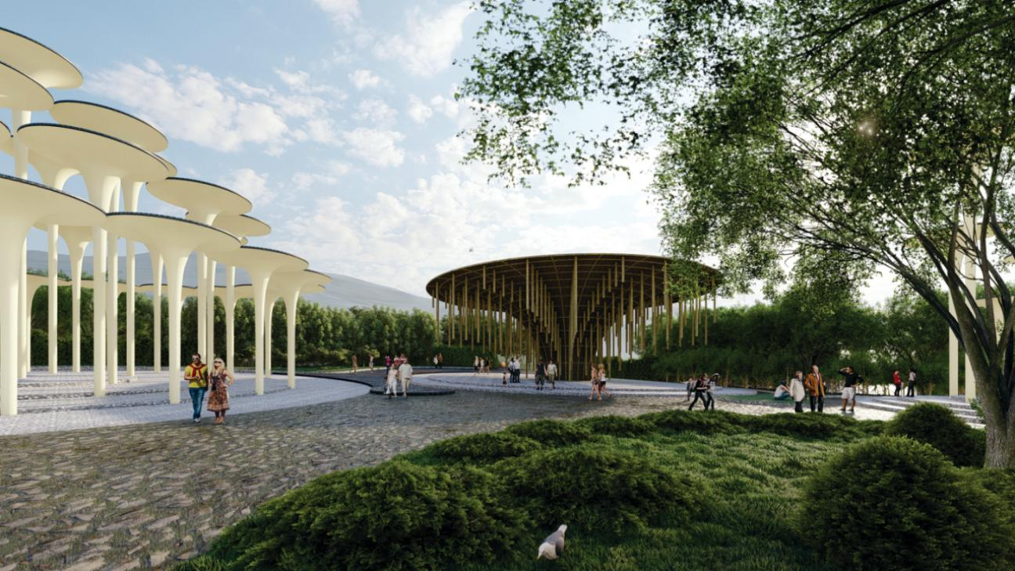

CONTENT

Chapter 1:

Concept Narrative

Chapter 2:
Technical Narrative

Chapter 3:
Prototyping and Pilot Implementation Statement

Chapter 4:
Operations and Maintenance Statement

Chapter 5:
Environmental Impact Assessment

CHAPTER 1

INTRODUCTION : Weaving Energy with Nature and Culture

The proposal is rooted in the deep interconnection between Fiji’s natural heritage and its vibrant cultural traditions. Inspired by the indigenous respect for the five classical

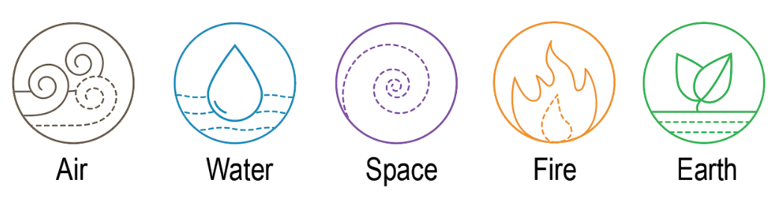

The proposed structure featuring a tall, elegant shaft expanding into a broad canopy can be culturally connected to the people of Marou through symbolism rooted in nature as symbol of the Tree or representation of the Spirit Totem. The smooth, aerodynamic form of the module minimizes wind resistance, making it more resilient to cyclonic conditions.

EXISTING VEGETATION IS UNDISTURBED/PRESERVED

At the heart of the concept is the Fijian philosophy of Land, which views land not just as a resource, but as a living being deeply connected to identity,
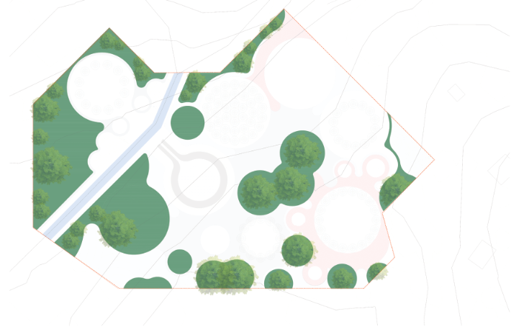ancestry, and community. In keeping with this, the site's existing vegetation is preserved to safeguard essential habitats for pollinators and native wildlife.

PROPOSED VEGETATION

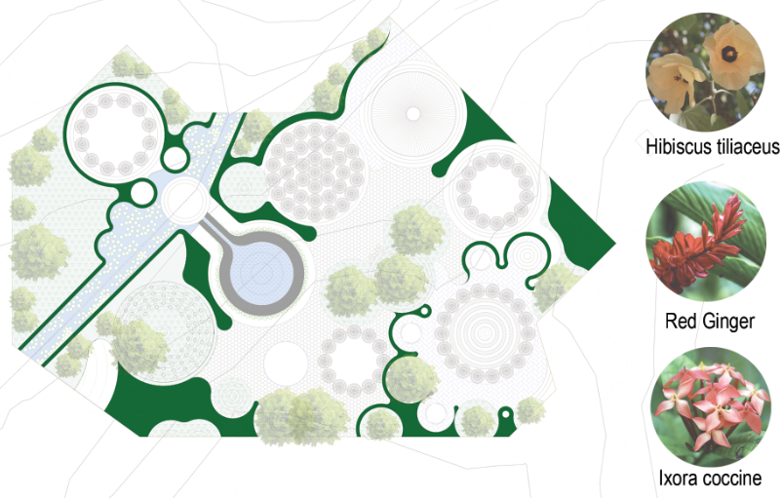The proposed landscape is thoughtfully enhanced with native plant species, strengthening biodiversity and promoting ecological resilience. The site's natural stream is integrated as a key design element, forming part of a rainwater harvesting system that supports irrigation and aids passive environmental cooling. This approach draws inspiration from traditional Fijian practices that emphasize harmony between water, land, and people.

PROPOSED SOLAR MODULES
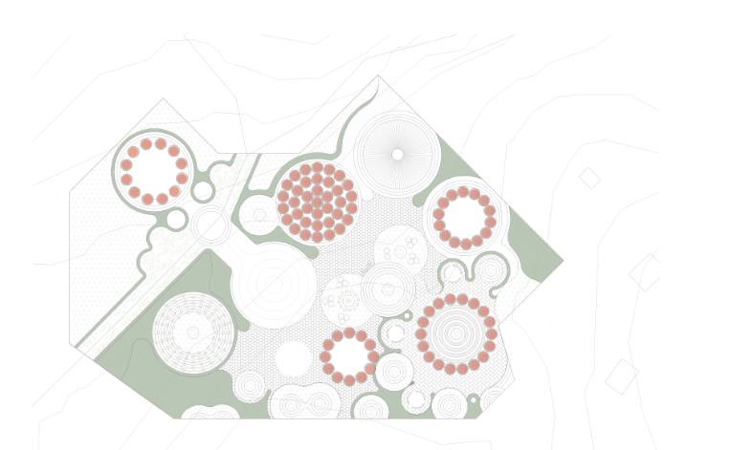Above the landscape, sculptural solar towers rise, designed to evoke the forms of native trees and coral structures. Varying in height and density, these towers symbolize the layered ecosystems of Fiji’s forests and reefs, transforming solar energy collection into a visually expressive and culturally grounded experience.

EROSION RESISTANT & ECOLOGICAL PATHWAY
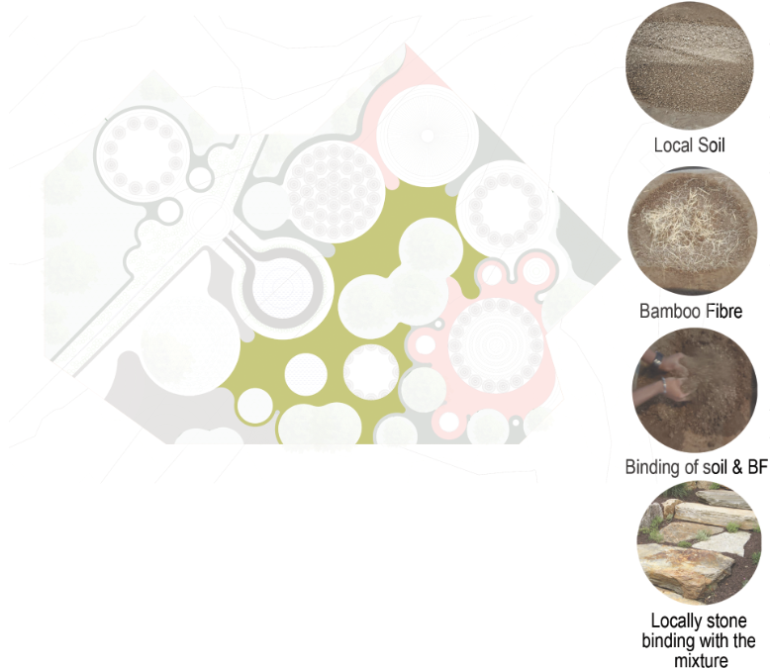A compacted, stabilized earth surface made from locally sourced soil, strengthened with natural binders such as lime, volcanic ash if available, or bamboo Fibre. The pathway integrates hand-laid locally sourced boulders ,creating a durable, erosion-resistant surface that honors Fijian culture and meaningful opportunities for local labors.

PROPOSED FIJIAN PATTERN INTEGRATED PATHWAY
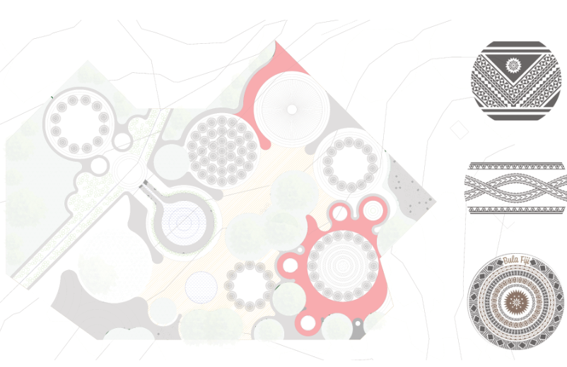Geometric masi motifs (zigzag, diamond, triangle),Ocean waves and sun rays,Turtle shell patterns (vonu),Palm fronds or mangrove roots, Traditional tattoo motifs (lines, combs, spears)etc. with the help of local artisan can be inscribed on this proposed area & inlayed with the help of broken coral rocks / coastal pebbles etc depends on the availability of the resources.

SITE PLAN
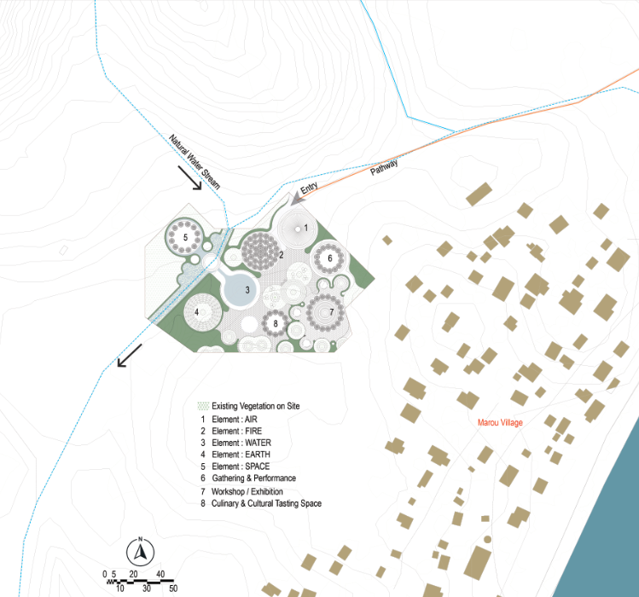

SWOT ANALYSIS - PROPOSED DESIGN
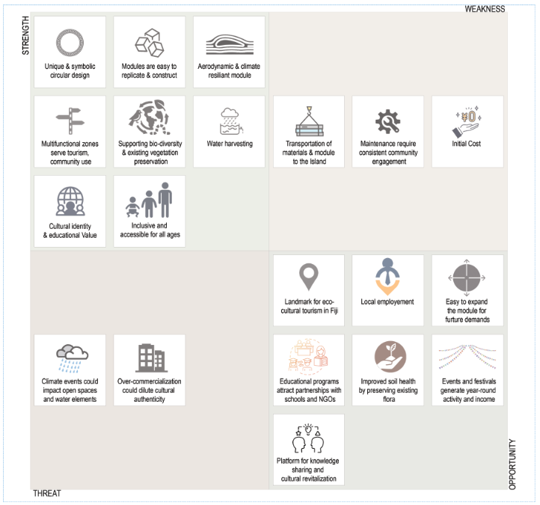

ELEMENT - AIR (CAGI)
Whispering Chimes - Welcome & Storytelling Pavilion

Winds are vital for island life, used for navigation, fishing, and weather. Once read by chiefs and priests as signs from ancestors or gods.
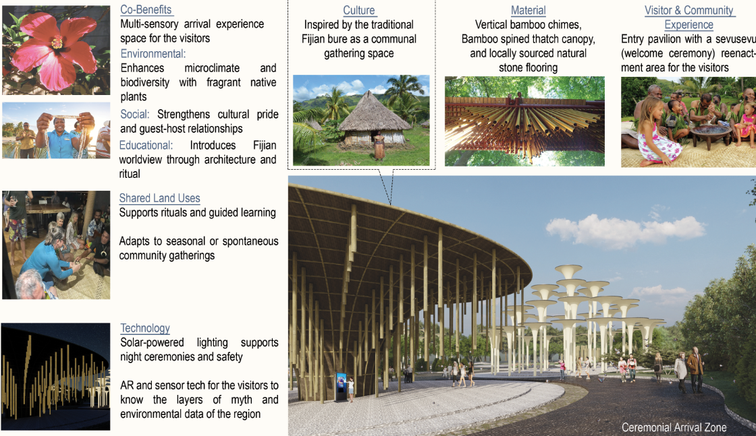A ceremonial arrival zone, inspired by wind's movement and song, features a bamboo pavilion with swaying chimes that echo ancestral whispers, inviting reflection and connection to unseen guiding forces.

ELEMENT - FIRE (KAMA)
The Ancestral Piers - A living tribute to lineage, wisdom, and continuity.

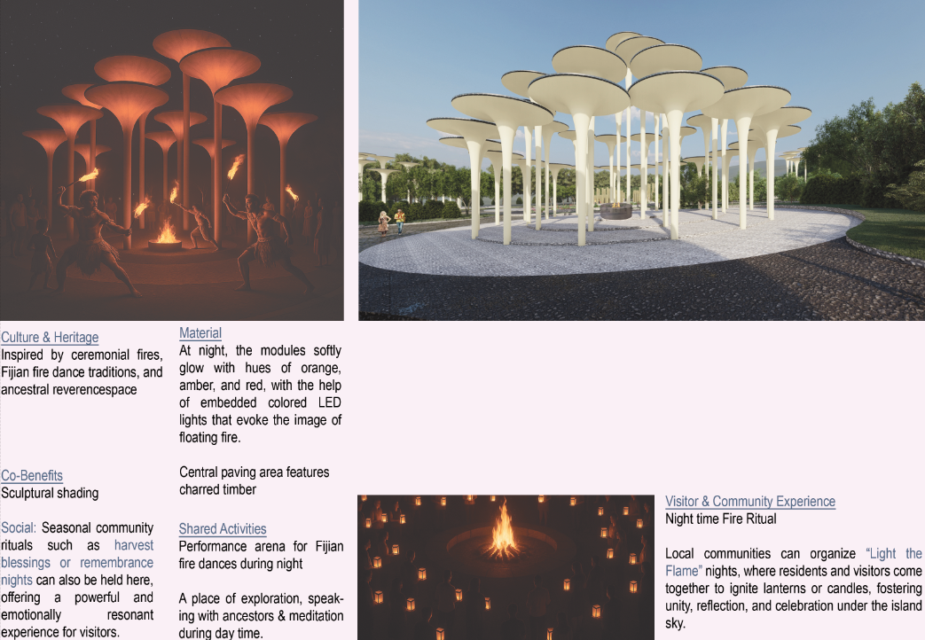This design represents a gathering of ancestral piers reimagined through the element of fire.Each column stands as a symbolic ‘pier’ rising from the earth, honouring the foundations laid by those who came before us.

ELEMENT - WATER (WAI)
Water as a Sacred Element - Cultural Connection
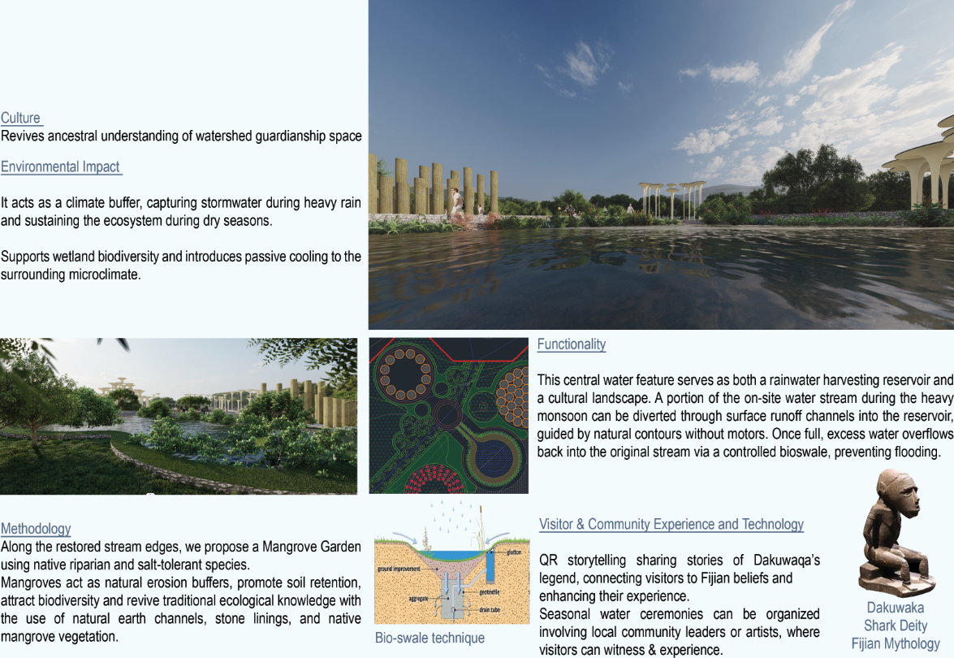In traditional Fijian cosmology, water (wai) is not a resource, it is a living spirit. It is linked to Ancestral presence.

ELEMENT - EARTH (Vanua)
Totems of the Earth: Rooted in Culture, Rising for the Future.
“Vanua” in Fijian means not just land, but the people, traditions, and responsibilities tied to it.
A symbolic landscape where totems rise from the land, reflecting our connection to Earth, culture, and community. The puzzled layout speaks to the fragmentation of modern relationships with nature, while inviting a path to healing and reconnection.
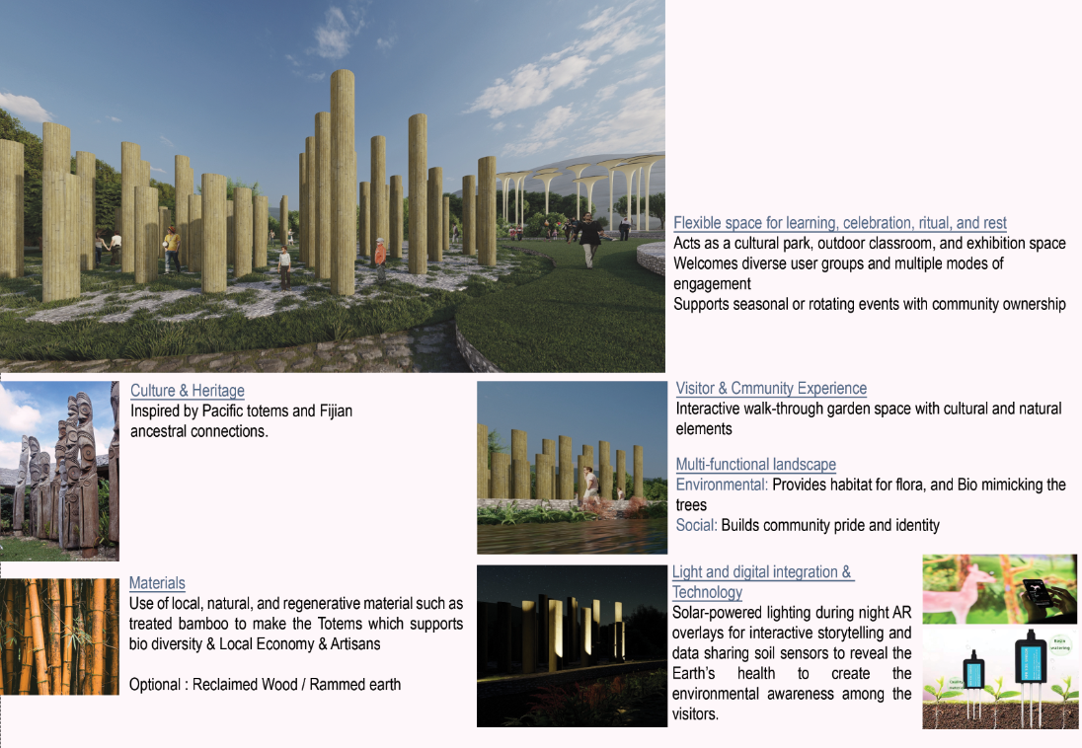

ELEMENT - SPACE (LAGI)
Celestial Chorus Garden - Voices of the Sky

The lagi (sky/heaven) is the domain of gods and ancestors.
A poetic sky-bound landscape where light-filled structures reach upward, echoing the harmony between humanity and the cosmos.
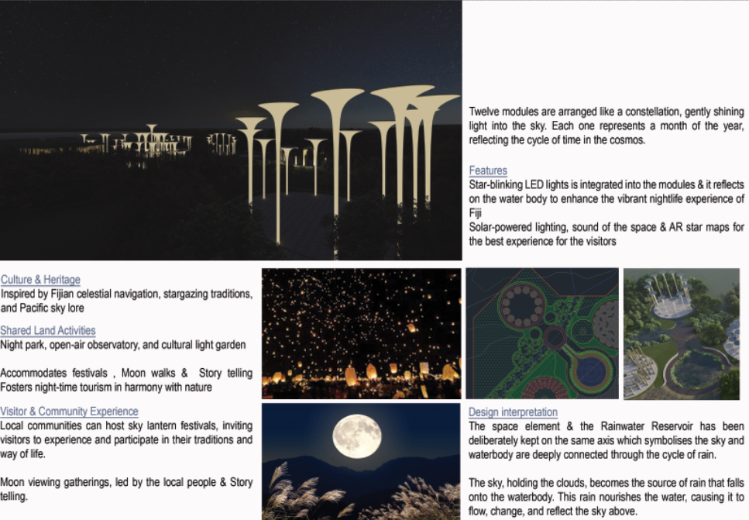

GATHERING & PERFORMANCE : CANOPIES OF CULTURE

Canopies of Culture is a sculptural performance space inspired by Fijian dance and natural forms. Rising from the land, its modules provide shade, gathering areas, and a stage for cultural expression. The varying heights of the modules represent the diverse dance forms of Fijian culture.

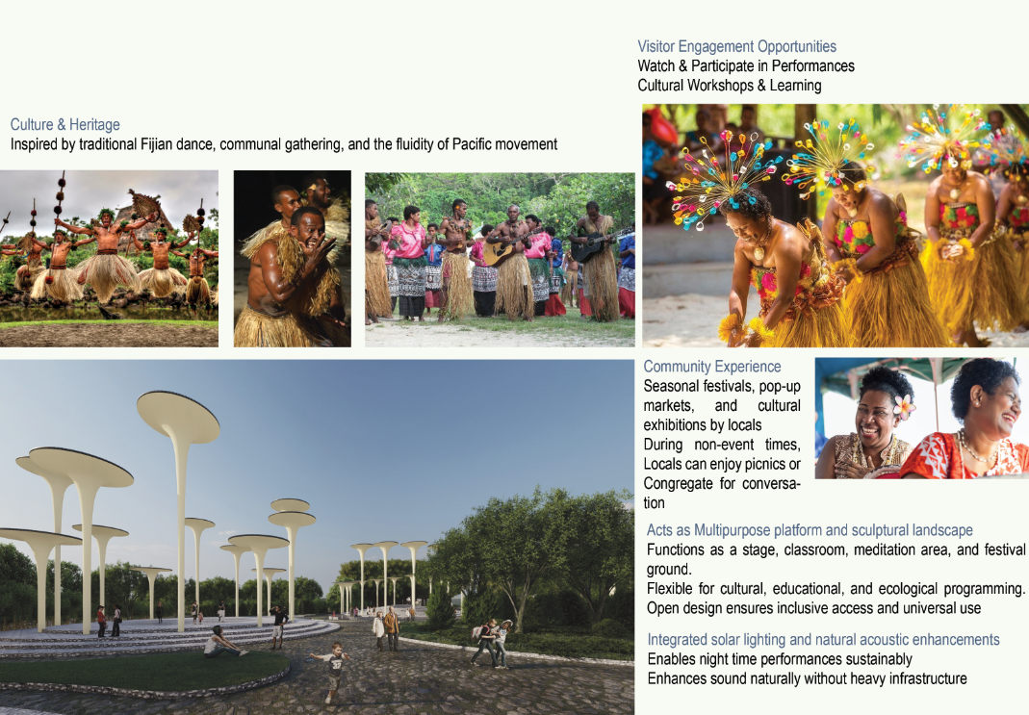

WORKSHOP & EXHIBITION PAVILION

Reinterprets indigenous gathering structures in a contemporary form, Provides a space for cultural expression through workshops, educational activities, and Craft making activities etc.
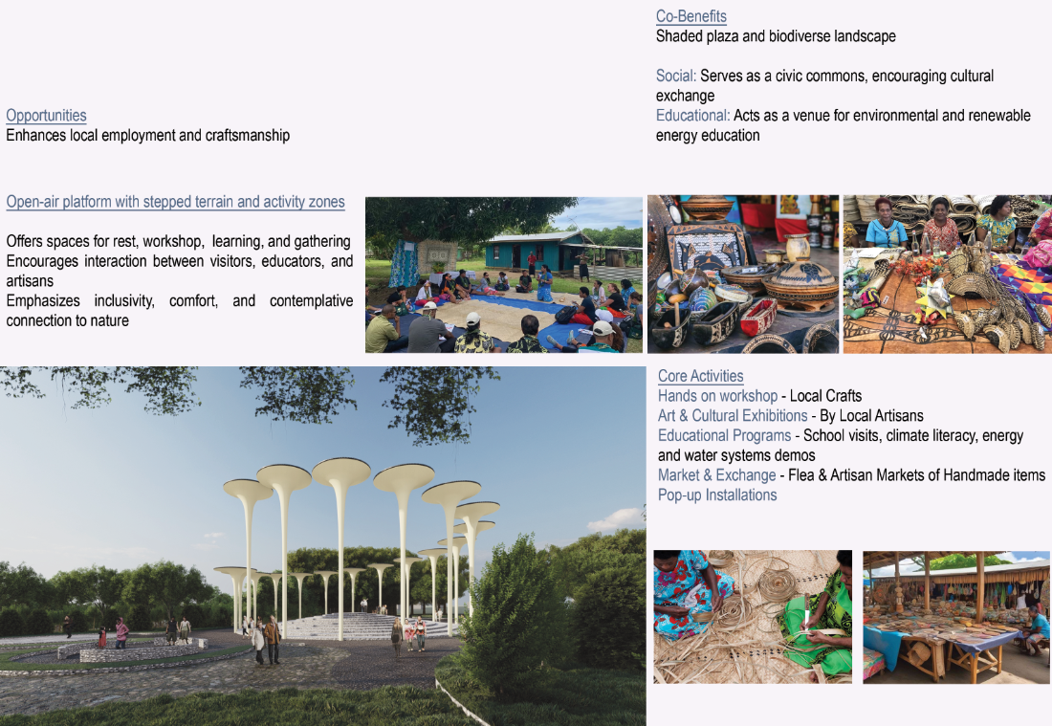
CULINARY & CULTURAL TASTING SPACE
THE MYCELIAL TABLE
Where Culture Gathers, Grows, and Feeds the Future

The Mycelial Table is a regenerative cultural pavilion and edible landscape that brings together culinary heritage and sustainable land use.
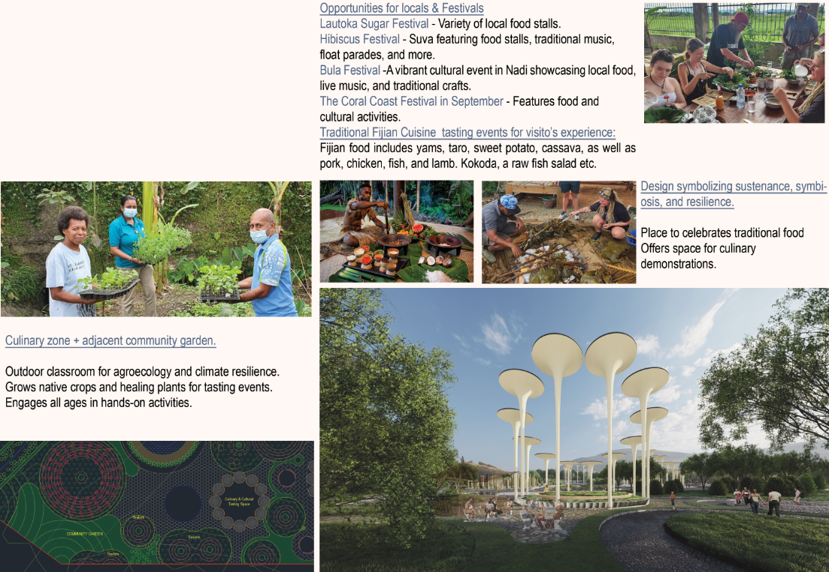Surrounding community garden cultivates native crops and medicinal plants. Inspired by the interconnectedness of mycelial networks, the design fosters symbiosis between people, place, and ecology.
CHAPTER 2

SOLAR MODULE TECHNICAL DETAIL
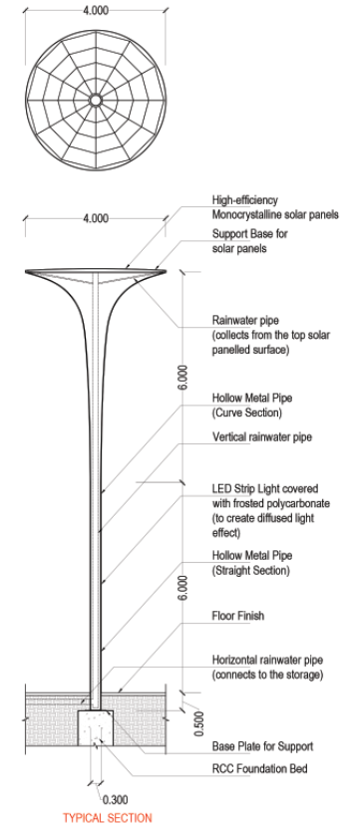

MODULES OF VARIOUS HEIGHTS - ELEVATION
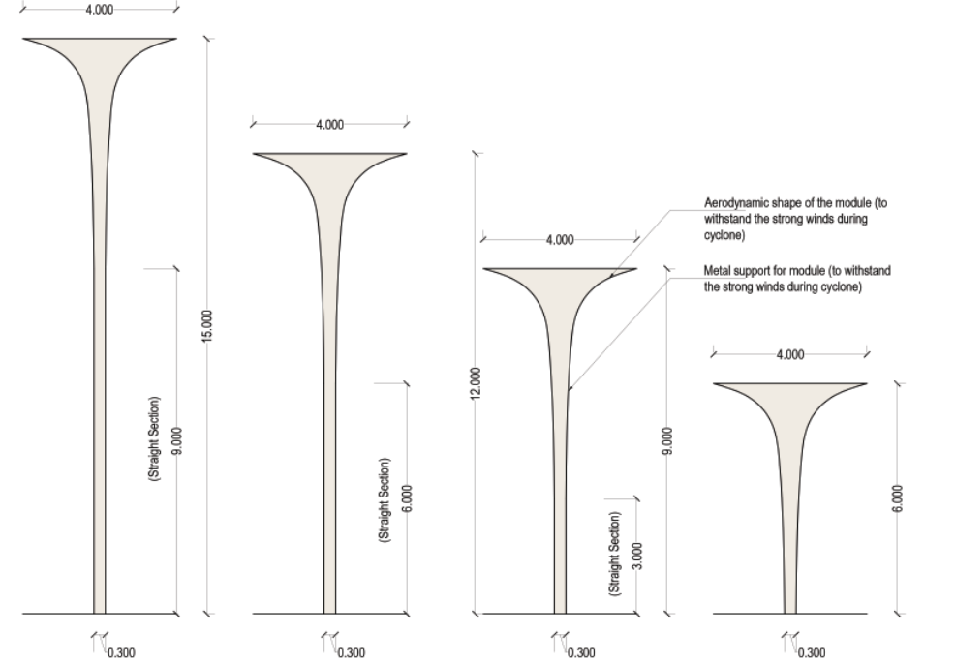

SOLAR ENERGY CALCULATION

1 Module = 12 sq.m (Approx.)
Total no. of module = 91
Total area (proposed solar power generation) = 1092 sq.m

Considering, 3.5hrs of maximum sunlight exposure & standard PV panels generating 200watt / sq.m

Note: Standard 2m X 1m solar panels available, which generates 400-500watt depends on location & sun exposure

Total solar power generated in a day by 1sq.m PV Panels = 200 watt X 3.5 hr
= 0.2 KW X 3.5 hr
= 0.7 KWh
Total solar power generated in a day by 1092sq.m PV Panels (Proposed Design) = 0.7 KWh X 1092
= 764.4 KWh
Total solar power generated in a month by 1092sq.m PV Panels (Proposed Design) = 764.4 KWh X 30
= 22932 KWh
Total solar power generated annually by 1092sq.m PV Panels (Proposed Design) = 22932 KWh X 12
= 275,184 KWh

Keeping in mind, the cost involved we limited it to approx. 1000sq.m
Incase, more electricity required by the village, there is a huge provision for expansion, as the module is simple & easy to replicate

SOLAR ENERGY DISTRUBUTION SYSTEM
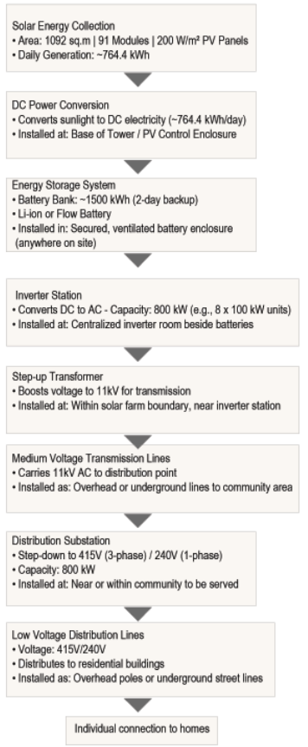

WATER MANAGEMENT TECHNICAL DETAIL
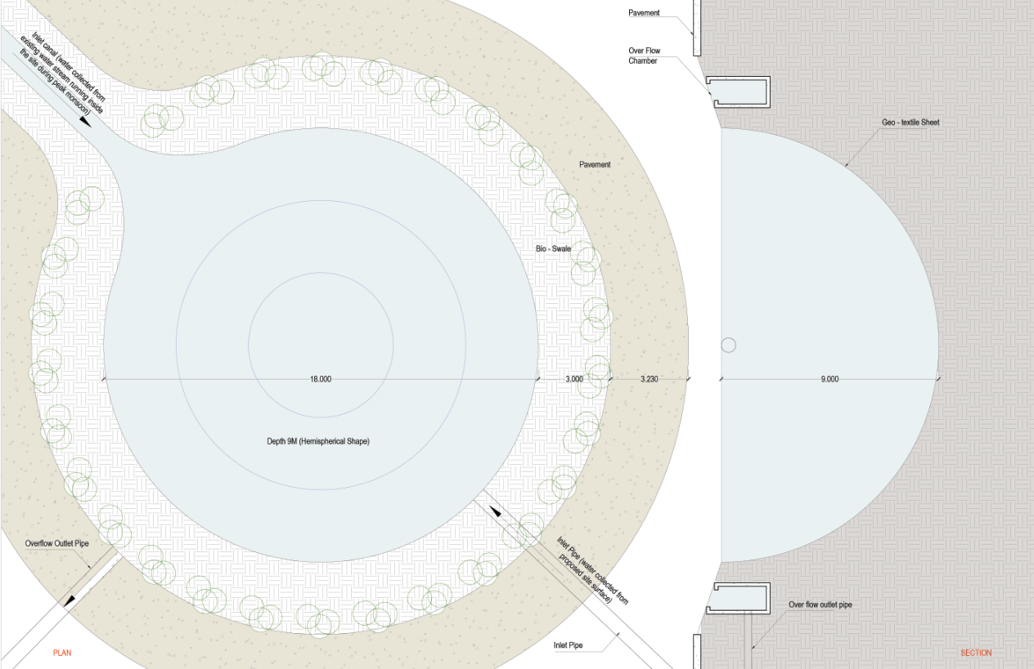

WATER MANAGEMENT CALCULATION

Water requirement per person per day = 100 ltrs (Approx.)
Total no. of Household = 67
Assuming 5 persons in a house, total persons = 335
For 355 people, water required (domestic) per day = 335 X 100 ltrs
= 33500 ltrs

Total water requirement for half-year (dry season) = 33500 ltrs X 180 = 6,030,000 ltrs

Total Solar panel area (proposed) = 1092 sq.m
Total Paved area (proposed) = 5400 sq.m (approx.)
Annual Rainfall Marou Village (approx.) = 118 mm

Total Rainwater can be collected from the proposal = (1092+5400) X 0.118
X 0.85(run-off coefficient)
X 1000 ltrs
= 651,147.6 ltrs / year

10.8% of the requirement is met by the site rainwater harvesting.

Total capacity of reservoir = 1526.8 cu.m X 1000ltrs
= 1,526,800 ltrs

25.3% of the requirement can be stored (current proposal) in the reservoir for dry season. Keeping in mind, the cost involved we limited it for 1/4th of the requirement.

Incase, more storage required by the village, there is a huge provision for expansion, as we are going for geo-textile layer for storage, rather than any concrete filling.It can be expanded at any time, as per need.
WATER DISTRIBUTION SYSTEM
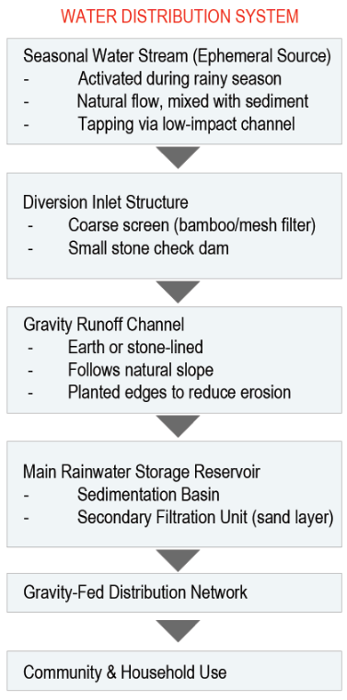
CHAPTER 3
Prototyping process

Typical Solar Module

To begin, We will develop a working prototype to test key aspects of the design, such as energy generation, structure, and environmental impact. This might be a scaled model of 6m high panels or a full-size section of the installation, depending on what is most effective to test. We will decide this by having a active Community collaboration during the workshop for the prototyping.
We will conduct the hold co-design workshops with local community members, inviting elders, youth, and craftspeople to make sure cultural values and local knowledge shape the design from the start.
And, involve local students and artisans in building the prototype, providing skill-building opportunities and fostering ownership.
Also, we will organize a public presentation or open day where the prototype is shared with the community, inviting feedback to improve the final version.

One of the key advantages of our design is that we do not need to complete the entire installation at once. By installing just a single module, we can assess its performance and structural stability. If any issues arise, however small ,they can be addressed and resolved before proceeding with the rest of the modules. This approach keeps the initial costs minimal. Additionally, the modular system allows for flexible height options for the initial prototype, we plan to use an average height of 12 meters.
During the prototyping stage(Assuming 12m high prototype is decided to implemented as Pilot project),
we will construct a functional prototype starting with the constant 6-meter base, and stack 1-meter segmented panels above it, likely building up to the 12-meter in the Gathering & Performance Area in the proposed site (Implementing one module is cost-effective for the initial testing period)
We will then assess the,
Structural stability (Wind load performance)
Ease of segment assembly (Local labors)
Material behavior and finishing (With climate)
Energy or environmental performance (With Climate)
With the help of the Local technical labors & the Volunteer Technicians from NGOs.
On-Site Assembly Testing
We will also evaluate how easily the structure can be assembled using local labors.
Structural and Functional Testing
We will check its stability, wind resistance, and load-bearing capacity,Weather performance, Resistance to any wild life interruption etc. with the help of the trained local operators or caretakers.
Scaling-Up
If the system operates consistently without issues, we will proceed with a follow-up workshop to evaluate its performance, identify any emerging concerns, and redesign components if needed to improve functionality.
If all the assessments are satisfactory, we will proceed to scale it up.
CHAPTER 4
Operations & Maintanance Statement

We will encourage the community to take an active role in maintaining the prototype on a weekly and monthly basis, using the knowledge they gained during the workshops on how to operate, maintain, and utilize the solar panels.

Design Operation and Life-cycle Overview
Our design will operate as a renewable energy generating public space and cultural hub with integrated solar panels. It will function year-round, providing clean energy, educational resources, community gathering spaces and also a landmark for the village to promote tourism. The system is designed to be low-maintenance, resilient to Fiji's climate conditions, and adaptable to future needs & expansion.
Community Contribution to Operations
The local community will play a central role in daily and long-term operations:
Trained local operators or caretakers will be responsible for monitoring system performance (e.g., solar output, battery health etc)
Community-Led Maintenance Plan
Routine maintenance tasks (e.g., cleaning solar panels, minor repairs) will be handled by trained community members or youth employment programs.
Annual community workshops will include refresher training, knowledge sharing, and planning for upgrades or adaptations.
Local labor and skills will be used for minor repairs to ensure cost-efficiency and long-term sustainability.
Governance and Ownership
A community committee or local cooperative could oversee operations and maintenance, funded partially through (Micro-revenue generation like charging stations, small markets, or events) reinforcing local ownership.
CHAPTER 5
Environmental Impact Assessment

Potential Effects on the Natural Ecosystem

Habitat Disturbance

1.If the modules are placed on natural land, they may disturb local flora and fauna, particularly ground-nesting birds, insects, or small mammals.

2.Shading from panels may change micro-climates and affect plant growth below.
Mitigating Issues :
We will avoid ecologically sensitive areas by conducting a baseline biodiversity survey before installation. This helps identify active nesting zones, rare plants, or key wildlife corridors.

Soil and Water
- The panel supports, if dug into the ground, could lead to soil compaction or erosion if not properly anchored.
Mitigating Issues :
We will implement erosion mats, geotextiles, or natural mulch around the panel bases to protect disturbed soil.
We will also plant native groundcover or stabilizing vegetation around the base to bind soil and absorb water runoff.

Mobility and Fragmentation
- While modular structures are often light-touch, any road or path construction for access might lead to habitat fragmentation, making it harder for animals to move freely.
Mitigating Issues :
We will integrate wildlife corridors by leaving gaps in access routes to allow free movement of terrestrial and ground-dwelling species.Also,maintain buffer zones of natural vegetation along access paths to preserve cover and continuity of habitat.

