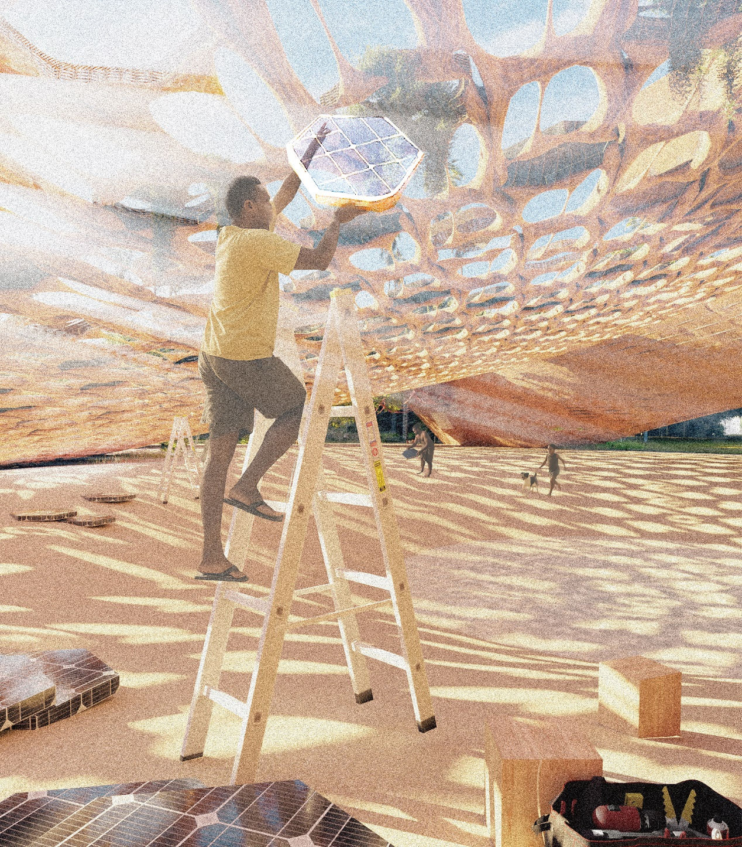**VALE NI SIGA**

**01**

**Concept Narrative**

Due to global climate change, coastal villages are facing increasingly severe challenges — rising sea levels, stronger hurricanes, and prolonged droughts.

In Fiji, these are no longer distant threats. They have become part of daily life. Unstable weather patterns are putting growing pressure on freshwater supplies, electricity access, farming livelihoods, and the cultural traditions that have sustained communities for generations.

In response to these challenges, we envision a new kind of space — one that works with nature rather than against it. Rooted in the land and cultural practices of Marou Village, **VALE NI SIGA** is a multifunctional landscape structure that brings energy, water, food, and community life together in one integrated system. It meets the village’s growing electricity needs while fusing traditional wisdom with renewable technology through locally sourced materials and modular design. Built from native bamboo and clay, each module is both functional and meaningful — generating solar power, harvesting rainwater, or growing edible and medicinal plants. Together, these modules form a stable foundation for ecological resilience and community self-sufficiency.

**VALE NI SIGA** is like a woven fabric of the earth, gently stretched across the land. Powered by sunlight, rain, and plants, it channels the rhythms of nature and gives that energy back — quietly and generously — to the hardworking, warm-hearted people of Fiji. It stands as a solid shelter, but it breathes like living land. You might see families gathering beneath shifting patterns of light and shadow, children laughing in water channels, or friends singing around a fire under the stars. This place holds more than function. It holds life.

At its heart lies a modular system: adaptable, replicable, and always rooted in place — a design that can grow wherever people and land are ready to grow together.

**02**

**Technical Narrative**

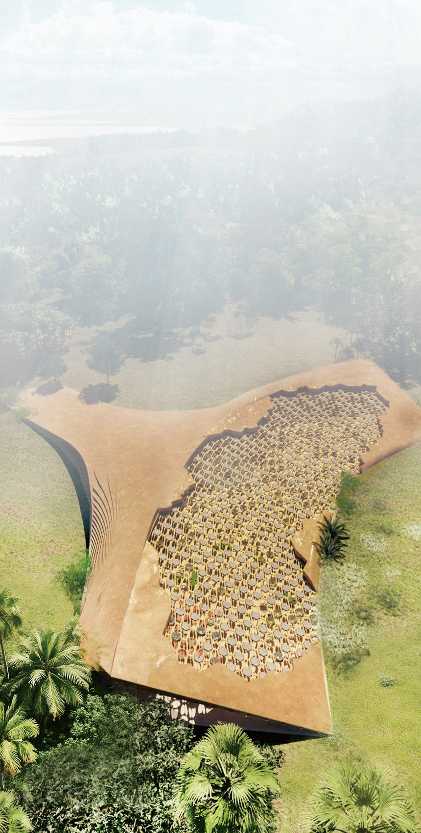

**VALE NI SIGA** centers around a prefabricated modular system as its core construction logic, utilizing locally sourced bamboo to build the primary roof framework and a hexagonal groove network for module installation. Clay is used as the foundational surfacing material.  
Each woven bamboo platform is embedded with evenly spaced hexagonal interfaces, allowing for the flexible insertion and replacement of functional modules. All modules are standardized in size, enhancing the efficiency of production, maintenance, and deployment.

Modules are categorized into three types:

* Photovoltaic Modules: Integrated with high-efficiency hexagonal solar panels to provide stable electricity generation.
* Water Diversion Modules: Equipped with rain funnels and drainage components to enable rainwater harvesting and storage.
* Planting Modules: Fitted with native planting beds for herbs, medicinal plants, or edible crops.

This construction approach improves the adaptability and maintainability of the system, allowing the configuration of modules to be adjusted according to community needs. It also offers structural flexibility for deployment in various island environments.

The project employs commercially available crystalline silicon solar modules (monocrystalline or polycrystalline), custom-shaped into hexagons with 0.6 m side length and approximately 0.935 m² in area. A total of 450 panels will be installed, covering about 420 m², with a combined system capacity of approximately 75 kW and an estimated annual output of 110,000–115,000 kWh. All modules comply with international safety standards such as IEC 61730-1/2 or UL 1703, and are rated for a service life of ≥25 years.

Where budget permits, the use of custom aesthetic photovoltaic modules—such as flexible, colored, or patterned glass—may be adopted to enhance visual integration and cultural expression. A lithium iron phosphate (LiFePO₄) battery system is used for energy storage to ensure stable electricity supply at night or on cloudy days. The system is designed for easy maintenance and strong resistance to natural hazards. Core components are housed in elevated or waterproof compartments to minimize corrosion risk from salt air and prevent child contact. The estimated unit installation cost is approximately **$2.09 USD/W**, making it a scalable and cost-effective demonstration model.

The total bamboo roofing surface area is 1,700 m², with 420 m² occupied by the hexagonal PV panels (each 0.6 m side length, ~0.935 m² area). The remaining 1,280 m² is available for rainwater diversion and collection. Based on data from the Yasawa-i-Rara weather station, the average annual rainfall is approximately 1,716 mm. Assuming an 80% collection efficiency, the projected annual rainwater yield is between 1,000–1,600 m³ (i.e., 100,000–160,000 liters). This volume is sufficient for irrigation, site cleaning, and partial household use, significantly improving local water resilience and independence.

**-Cost Estimate Summary (excluding rainwater system)**

* Photovoltaic panels: 450 units × $180 = $81,000
* Battery storage system: 40 kWh × $350 = $14,000
* Inverters and electrical wiring: $8,000
* Bamboo structure (1,700 m² × $10): $17,000
* Clay platform paving (4,200 m² × $3): $12,600
* Local labor and training: $10,000
* Contingency (10%): $14,260

Total estimated cost: $156,860 (excluding rainwater system)  
Unit installation cost:  
$156,860 ÷ 75,000 W ≈ $2.09/W

The system functions like an engine working in harmony with nature, powered by a set of thoughtful inputs: solar radiation, rainfall, local labor, and essential components such as photovoltaic panels, batteries, and inverters. These seemingly simple elements come together to generate meaningful outputs: approximately 112,000 kWh of electricity per year for lighting, refrigeration, and communication; between 1,000 and 1,600 cubic meters of harvested rainwater annually for agriculture and site maintenance; and a stable, scalable, and weather-resistant structural platform that supports the integration of energy, water, and greenery. In addition, the system collects valuable data and operational records to support future optimization and large-scale replication.

In this system, technology, nature, and community are woven into a true cycle of mutual support.

With its low-cost construction and modular system, **VALE NI SIGA** offers more than just basic infrastructure — it provides a flexible foundation for future growth. As resources allow, the structure can evolve in both function and meaning: patterned or colored photovoltaic panels can celebrate local identity; soft LED lighting powered by surplus energy can make the space safe and vibrant at night; and educational modules, such as signage or interactive screens, can engage visitors in learning about renewable energy and green infrastructure. Additional battery storage can be added as energy demand increases, and connector slots already built into the bamboo structure make future solar expansion simple. Because it starts with less, it has room to become much more — a living, growing space shaped by the community it supports. VALE NI SIGA represents a prototypical integration of sustainable technology and local culture. As a modular demonstration system, it provides not only basic solar infrastructure, but also an open framework that enables communities to adapt and reconfigure modules according to their local conditions. Through expansion into different communities, the module network can respond flexibly to diverse terrains, cultural habits, and spatial needs—allowing the system to function not only as infrastructure, but as an embedded expression of place-based aesthetics and community spirit.

**03**

**Prototyping and Pilot Implementation Statement**

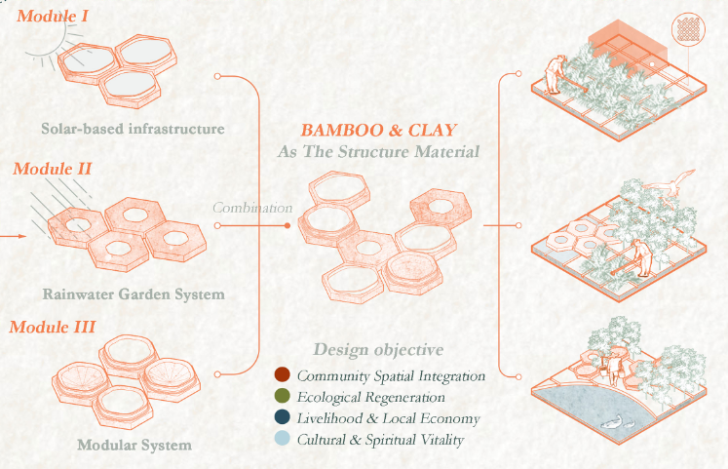

The prototype phase will focus on constructing a fully functional hexagonal module unit, simulating its structural performance within the bamboo woven framework under various external forces — including wind, rainfall, water flow, and load-bearing stress. The goal is to ensure that modules remain stable and secure under extreme weather conditions such as hurricanes, and that they do not deform or fracture under human-induced loads.

Testing will also assess:

-The connection strength between the modules and the woven bamboo frame,

-And the bonding reliability with the clay platform foundation.

Additionally, the prototype will be used to evaluate multi-functional integration performance, including:

-Whether the solar panel can be stably mounted at an optimal tilt angle to maximize energy output;

-Whether the rainwater diversion and storage system causes any shading or structural interference with the solar panel;

-And whether the planting trough design obstructs cable routing, maintenance access, or inter-module connectivity.

The prototype will be constructed in a controlled environment, using the same local bamboo and clay techniques intended for final implementation, to validate its adaptability and durability in tropical, high-humidity, and high-wind conditions.

Based on the results of prototype testing, a pilot site will be selected within a representative open area of Marou Village for initial deployment.The first phase will include constructing no fewer than 12 modular units to form a fully functional core cluster.

* 6 solar power modules,
* 4 rainwater collection and drainage modules,
* and 2 planting modules,

During the pilot process, the following actions will be undertaken:

* Confirm material sources and procurement channels with residents and local stakeholders to ensure affordability and availability of locally sourced materials;
* Recruit local residents to participate in component fabrication and on-site assembly;
* Provide skill training workshops on structural assembly and system maintenance;
* Establish standardized workflows for material transport, on-site assembly, and rainy-season construction;
* Collaborate with local organizations to gather community feedback — both technical and cultural — to further refine the system design.

This pilot will serve as a technical validation platform and community training site for future scale-up, ensuring high feasibility, low implementation risk, and strong replicability of the system in other South Pacific Island communities.

**04**

**Operations and Maintenance Statement**

A dedicated operations and maintenance team will grow from within the community, co-organized with support from local partners and stakeholders. This team won’t just look after the system — they will care for it like their own. Together, they’ll take on routine tasks such as:

* -Cleaning or replacing solar panels,
* -Clearing drainage paths and checking water flow,
* -Pruning and nurturing the planting modules.

Beyond upkeep, the team will actively gather feedback from neighbors and visitors to keep improving the system’s performance and user experience.At the heart of the team, one or two local technical coordinators will be identified to receive in-depth training. They will serve as key contacts and mentors, helping others in the village gradually learn how to manage the system independently. Together, we’ll build a simple maintenance schedule — including what to check, how often, what tools to use, and which spare parts to keep — so the community can confidently care for the system for years to come.

To prepare for storms and other extreme weather, we’ll also help establish emergency protocols and structural reinforcement routines to keep everything safe and running smoothly.

If any part is damaged, it can be quickly repaired or swapped using local materials — no complicated imports or delays. And because this isn’t just a technical system but a shared space, maintenance time can become more than just a task — it can become a gathering. These check-ins can be moments of creativity, where residents explore how to weave in local crafts, stories, or even play — making the space a true reflection of the people who care for it.

**05**

**Environmental Impact Assessment**

**V**ALE NI SIGA is rooted in what the land already offers — bamboo and clay — using low-impact construction methods grounded in local culture. All materials are drawn from nature and designed to return to nature, ensuring minimal disruption to the surrounding ecosystem in Marou Village. The construction process avoids introducing non-native species or packaging that may carry microorganisms, protecting the integrity of the local environment.

Given the intense tropical sun, the modular layout and roof configuration may lead to localized heat buildup. To mitigate potential heat island effects, non-solar surfaces are finished with light-colored clay coatings and woven bamboo, which help reflect heat. The open design allows natural breezes to flow through, while green planter modules placed between structures cool the air through evapotranspiration — like small trees in a village courtyard. Together, these strategies create a breathable and comfortable microclimate.

When heavy rains arrive, the system responds by working with water, not against it. Permeable joints between modules and a clay–gravel paving mix promote infiltration, while rain gardens and bioswales slow runoff and filter impurities. In lower areas, water is stored in collection barrels or underground tanks for reuse during the dry season — a simple yet effective strategy for water resilience.

Planting modules incorporate native edible and medicinal plants, supporting both community self-sufficiency and biodiversity. These green layers offer food and shelter for birds, insects, and small animals. As the system matures, these pockets of vegetation may connect into an ecological patch network, enhancing biodiversity and habitat continuity across the site.

Should challenges arise — such as soil erosion, plant decline, or drainage issues — the community maintenance team can act quickly using low-tech solutions like replacing species, adjusting surface layouts, or redirecting runoff paths. With ongoing feedback and shared stewardship, this landscape is designed to adapt and thrive alongside the people it serves.

**06**

**Phased Implementation Strategy**

The development of the project follows a three-stage path, gradually cultivating a spatial atmosphere that evolves from basic self-sufficiency to community collaboration, and ultimately to cultural integration. In the first stage, modular structures are used as carriers to provide solar energy, rainwater collection, and local planting systems, meeting the village’s fundamental needs for energy, water, and food while creating a stable and naturally rooted living environment. As the system matures, the second stage focuses on building community resilience by encouraging villagers to participate in equipment maintenance, structural adaptation, and operational training. This process fosters a shared understanding of the system and gradually shapes a community atmosphere grounded in adaptability and mutual support. Building upon this, the third stage introduces functions such as ecotourism, cultural exhibitions, and educational activities, further enhancing the site’s public and cultural roles. The space becomes a shared platform that connects the local community with the outside world, integrating cultural exchange with sustainable economic development. As the system continues to evolve and expand, it opens up broad possibilities for education, co-creation, cultural preservation, and local industry. Importantly, these stages are not fixed or strictly sequential — they can unfold in parallel, and may be adapted flexibly based on the specific conditions and evolving needs of each community. In this way, the project forms a dynamic and organic system capable of continuous growth and adaptation.

This village-based initiative not only responds to the pressing challenges of climate change, but also continues to explore new ways of connecting people with nature, and communities with technology. Like a single tree taking root in fertile soil, it holds the potential to grow — not in isolation, but as part of a larger forest of resilient, interlinked island communities across the South Pacific. In time, it may become a replicable, scalable, and culturally grounded prototype for sustainable human habitation.