# **Solara Siga**

# ***Solara Siga*** *– "Solara" combines "solar" with "ara," meaning path in Fijian, symbolizing a journey towards sustainable energy. "Siga" means sun in Fijian, emphasizing solar power.*

### **Design Objective:**

# **01 Climate Resilience**: Our design features address flooding and freshwater scarcity, incorporating hazard-resistant systems.​

# **02 Cultural Integration**: Incorporate traditional Fijian design elements and materials to ensure community acceptance and celebrate local heritage.​

# **03 Community Involvement**: Engage indigenous people in the planning and implementation phases to ensure the project meets their needs and fosters a sense of ownership.​

# **04 Zero-Carbon Sustainability**: Utilize renewable energy sources, such as solar panels, and sustainable materials to minimize environmental impact.​

# **05 Accessibility**: Ensure the space is accessible to all community members, including those with disabilities, by incorporating inclusive design principles.

# **01 Project Concept Statement**

**Design Statement: Solar Garden for Community Resilience in Marou, Naviti Island, Fiji**

This design integrates a regenerative solar and rainwater collection landscape into the cultural and ecological fabric of Marou, a small village on Naviti Island, Fiji. Anchored by a central hexagonal plaza, the project unites renewable energy production with inclusive community functions, local identity, and environmental stewardship.

#### **Materials and Systems**

To ensure durability, sustainability, and efficient performance in the island’s tropical climate, the solar infrastructure uses recyclable aluminum and marine-grade stainless steel framing for the photovoltaic modules and rainwater collection system. These materials offer high corrosion resistance and minimal maintenance. Transparent organic photovoltaic (OPV) panels form shaded walkways and waterproof pavilions, combining structure and function while allowing filtered light to nourish plantings below. Locally sourced native plants reduce water demand and enhance biodiversity. Earth-toned rammed earth benches and permeable paths blend into the landscape, providing thermally comfortable, low-impact resting spaces. All electrical components are enclosed in weather-resistant conduit, with insulated underground cabling integrated into the frame design to minimize visual clutter and ensure safety.

#### **Concept and Form**

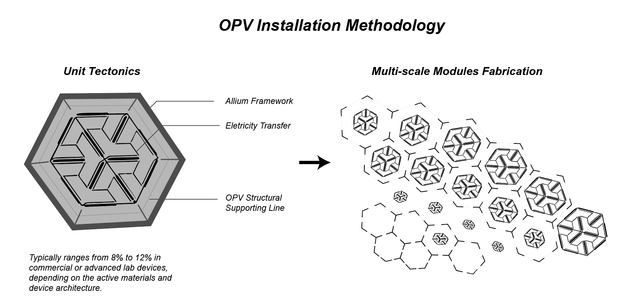

Inspired by hexagonal cellular structures found in both coral and traditional Fijian patterns, the layout organizes solar panels into a central honeycomb formation. This biomimetic geometry reflects the interconnectedness of life systems and community ties. The sloped installation aligns with the island’s natural contours, preserving long views to the ocean and minimizing site disruption and erosion.

1. **Visitor and Community Experience**

Visitors enter through a sequence of shaded walkways featuring interpretive signage on solar energy, resilience, and Fijian cultural narratives. Along the route, solar-powered seating pods and interactive displays engage users with live data on energy yield and storage. At the heart of the site, a transparent-roofed pavilion serves as a communal hub for storytelling, charging mobile devices, and hosting educational workshops. Real-time dashboards communicate system performance, promoting energy literacy and transparency. Night-safe lighting powered by stored solar energy extends the usability of the site into evening hours for community learning and health services.

1. **Co-Benefits and Shared Land Use**

Beyond energy provision, the design supports food security and ecological regeneration through an agro-solar approach. Solar panels are spaced to permit partial sunlight, enabling cultivation of low-height crops and native plants beneath them. Community garden plots provide shared land use opportunities for villagers, while youth groups and schools utilize the space for environmental education and innovation projects. The system is designed to be modular and expandable, allowing for phased growth and adaptation to future community needs.

1. **Environmental and Social Impact**

This project models a holistic approach to infrastructure as public space. It delivers resilient, year-round renewable energy and rainwater collection while fostering intergenerational learning, cultural continuity, and ecological sensitivity. The inclusive design ensures accessibility for all users, from children to elders, reinforcing equity and shared ownership. By embedding energy generation within a multifunctional landscape, the design redefines utility infrastructure as a catalyst for environmental awareness, social connection, and local empowerment.

# **02 Technologies Incorporated and Output Yield**

The system integrates a suite of resilient, climate-appropriate technologies to address Marou’s core needs—energy access, water security, and socio-environmental autonomy—through a multifunctional infrastructure strategy tailored to Fiji’s tropical island context.

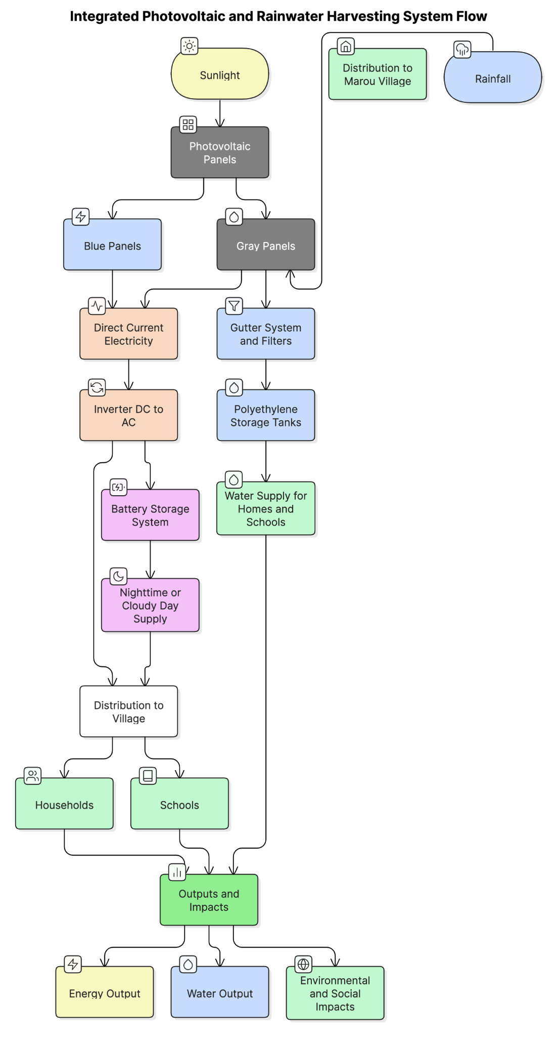

**Fig1. Solar Energy and Rainwater Harvesting System – Marou Village**

#### **Tech 1: Solar Energy Generation**

The backbone of the system is a 1,265 m² solar array using high-efficiency **monocrystalline photovoltaic (PV) panels** (95 BLUE and 285 GRAY units), with an average module efficiency of 16%. This generates an estimated **~411,124 kWh annually**, providing a continuous output of **~112.7 kW**, well above the required 75 kW. The selection of monocrystalline panels reflects their high energy density, longevity (25+ years), and ability to perform reliably in humid, coastal environments with strong solar irradiance.

#### **Tech 2: Lithium Iron Phosphate (LFP) Battery Storage**

Given Marou's nighttime consumption profile and sunset timing, battery storage is a critical system component. Demand remains high after 18:00, peaking at ~9.7 kW at 17:00 and ~8.5 kW at 21:00. The system therefore incorporates a battery array sized for **100–120 kWh nightly load**, with a **1.2–1.5x buffer** to ensure availability during cloudy days or maintenance periods. **LFP batteries** were chosen for their thermal safety, deep discharge cycles, and low long-term costs.

#### **Tech 3: Smart Inverter and Controller System**

A **hybrid inverter system** manages electricity flows between solar panels, batteries, and direct users. Inverters are rated at **≥20 kW** to handle peak loads, ensuring future scalability. Additionally, **Maximum Power Point Tracking (MPPT) controllers** optimize the solar energy yield throughout the day by adjusting voltage levels in response to changing light angles.

#### **Tech 4: Solar Array Design & Orientation**

Panel orientation and tilt are optimized to align with **peak irradiance between 7:00 and 16:00**, matching the community’s highest demand hours. The array sizing accounts for both current energy needs and **a 15% buffer** for system resilience and village growth.

#### **Tech 5: Rainwater Harvesting and Filtration**

GRAY panels double as water catchment surfaces, contributing to a **1,034 m² collection area**. With an average annual rainfall of 2.2 meters and a runoff coefficient of 0.9, the system can collect approximately **2.05 million liters/year**, exceeding village demand. Water is stored in **polyethylene tanks** and filtered using **low-energy, nature-based systems** such as sand or gravel filters—ideal for low-maintenance, low-tech conditions.

#### **Tech 6: Local Grid and Distribution**

A **mini-grid design** connects energy nodes to household and school clusters via low-voltage AC or DC lines, supporting **load balancing**, metering, and easy integration of future energy modules. This system architecture fosters both technical scalability and community-wide inclusion.

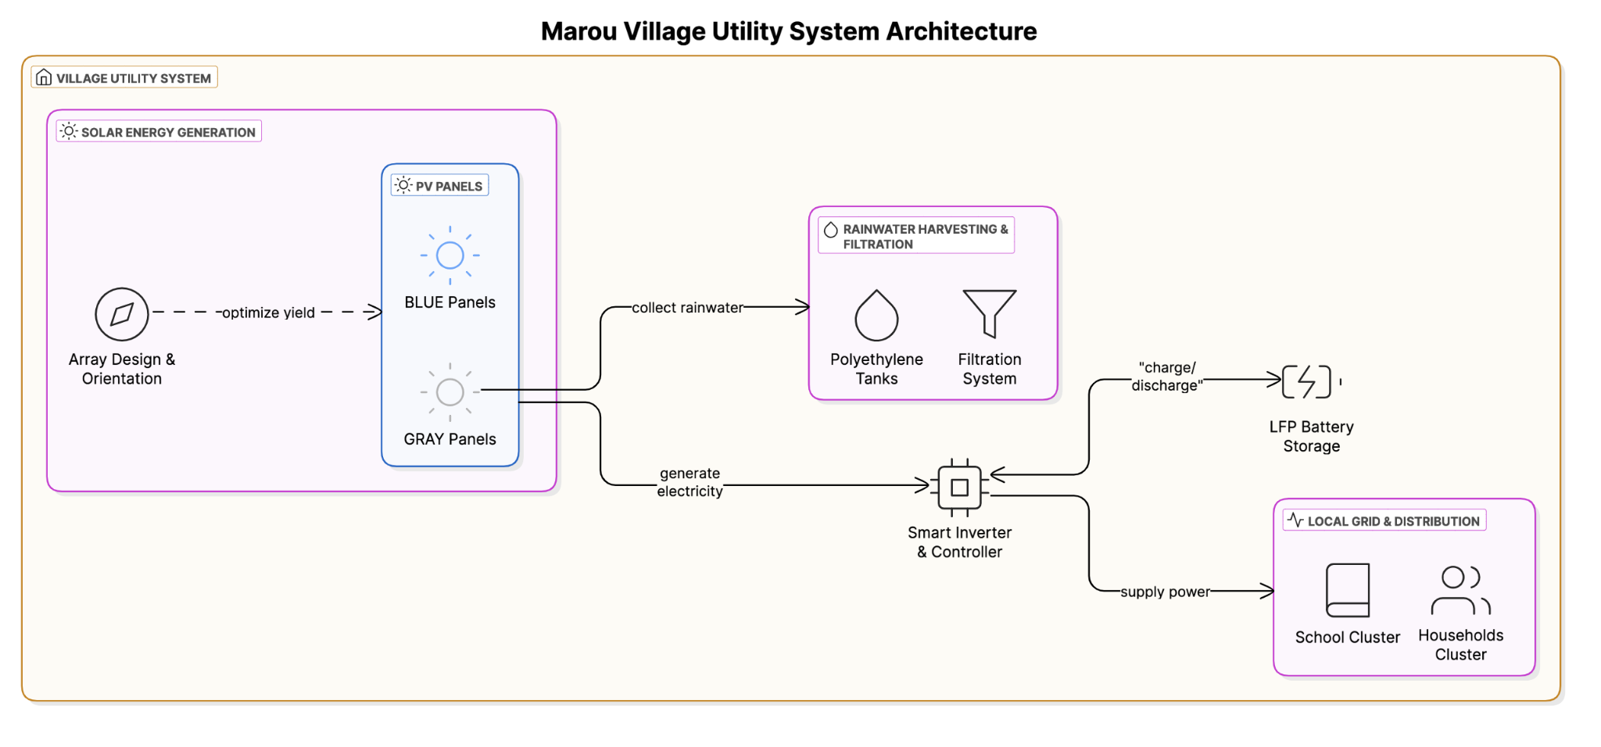

**Fig2. Involved Technology: Marou Village Utility System Architecture**

**Table 1: System Inputs Summary: Marou Village – LAGI 2025 Fiji Proposal**

| **INPUT** | **Details** |
| --- | --- |
| **Solar Energy Source** | • 380 photovoltaic panels total (95 BLUE + 285 GRAY units)  • Total PV area: **1,265 m²**  • Estimated output: ~112.7 kW peak (75 kW min.)  • Efficiency: 16% • Optimized for tropical sun path & coastal wind load |
| **Capital Inputs** | • Structure & connection: 58%  • PV panels: 8% • Inverter & control systems: 8%  • Battery storage (LFP): 24%  • Reserve backup (optional): 2%  • Local financing, permits, admin: <1%  • Scalable budget based on sourcing/panels |
| **Community & Environmental Inputs** | • Community-led maintenance and water usage  • Cultural fit with village aesthetic  • Dual land uses: water harvesting + power generation |

**Table 2: System Onputs Summary: Marou Village – LAGI 2025 Fiji Proposal**

| **OUTPUT** | **Details** |
| --- | --- |
| **Energy Generation** | • Estimated yield: ~411,124 kWh/year  • Peak capacity: ~112.7 kW  • Nighttime access via battery storage  • Modular nodes for Marou school + homes |
| **Water Yield** | • Rainwater harvesting via 1,034 m² GRAY panels  • Estimated: ~2,046,000 liters/year  • Passive rainy season collection in poly tanks  • Supports school + household use |
| **Economic Outputs** | • Power for 67 households + schools  • Avoids diesel cost, future tariff potential  • Resilient infrastructure  • Modular growth possible |
| **Environmental Outputs** | • Cuts fossil fuel use  • Reduces generator CO₂ emissions  • Reduces runoff/erosion |
| **Social Outputs** | • Boosts STEM education  • Local training + jobs  • Enhances community autonomy + climate adaptation |

**In summary**, the technologies were selected for their resilience, safety, and modular scalability. Their synergy addresses multiple SDGs: **energy (SDG 7), clean water (SDG 6), climate resilience (SDG 13), and sustainable infrastructure (SDG 9)**, all grounded in a design logic that prioritizes cultural fit, community ownership, and long-term autonomy.

# **03 Prototyping and Pilot Implementation**

We will approach the prototyping and pilot implementation process through a structured, participatory, and context-sensitive method that emphasizes technical reliability and local empowerment. Our team will begin with a small-scale prototype system implemented in a representative cluster of Marou village. This prototype will include a fully functional solar PV array, battery storage, water purification unit, and digital monitoring systems. The goal of this stage is to validate system performance under real-world conditions and ensure smooth integration of all components. We will closely monitor energy generation, battery performance, load profiles, and user interactions to identify any technical or operational refinements before moving to full-scale deployment.

The prototype will serve as a proof of concept to refine both the physical setup and the digital interface. Lessons learned will directly inform the design of the full-scale pilot system. We will use a modular approach to ensure scalability, allowing each component—whether battery units, inverters, or panels—to be added or replicated efficiently across the village. Implementation of the full pilot will be carried out in phases, prioritizing zones with the greatest unmet need. This strategy allows for manageable logistics, iterative improvements, and thorough community engagement throughout the process.

We will actively collaborate with the local community at every stage. Before the prototype is deployed, we will organize a series of co-design and technical literacy workshops. These sessions will introduce the system’s function and benefits while gathering feedback on preferences related to installation locations, user interfaces, and usage expectations. We will work directly with local leaders, women’s groups, and youth to ensure that infrastructure decisions reflect local needs and cultural values.

As part of our implementation, we will train local residents—particularly youth and technicians—through practical, hands-on sessions that cover system maintenance, troubleshooting, and data interpretation. This local workforce will become a key part of our maintenance network, reducing dependence on external support and increasing long-term sustainability. We will provide step-by-step guides, visual aids, and on-call technical support to reinforce local capacity.

During both the prototype and pilot phases, we will establish a structured feedback mechanism. Monthly community forums will allow residents to raise questions, report issues, and offer feedback, while also allowing our team to share performance data and system updates. Additionally, we will use digital tools to remotely monitor system health and usage trends, enabling proactive maintenance and transparent reporting.

We will also engage local governance structures to ensure oversight, accountability, and inclusive decision-making. Village council members will be part of implementation planning, monitoring visits, and community benefit distribution discussions. Our aim is not only to deliver infrastructure but to embed technical knowledge, management skills, and institutional capacity within the community.

Ultimately, our team’s approach to prototyping and full-scale implementation is designed to build trust, empower users, and create a replicable and sustainable model. We will leave behind not just a functioning energy system, but a community equipped to manage and expand it with confidence and autonomy.

**Table 3: Climate-Aware Design, Lifecycle Operation, and Community-Centered Maintenance for Fiji’s Off-Grid Solar Systems**

| **Component** | **Prototyping, Implementation, and Marou Community Collaboration Plan** |
| --- | --- |
| **Prototyping Process** | - Deploy a small-scale Hexogon example, a functional prototype in one representative village cluster  - Include solar PV array, battery bank, water purification, metering system  - Test performance under real conditions: load demands, night-time autonomy, system integration, and user interaction |
| **Monitoring & Evaluation** | - Collect data on peak and night loads, system efficiency, and battery cycling- Use digital monitoring tools to analyze system behavior  - Refine system design before scaling |
| **Full-Scale Pilot Implementation** | - **Phase 1**: Expand to priority clusters with urgent energy needs  - **Phase 2**: Scale to additional village zones based on success and feedback  - **Phase 3**: Optimize long-term operation, document learnings, plan for permanent operations  - Use modular system design for flexibility and scalability |
| **Community Collaboration** | - **Co-design workshops** to gather input on siting, needs, and cultural factors  - **Technical literacy training** for youth and adults on maintenance and troubleshooting  - **Regular feedback loops** to adapt system to user experience |
| **Capacity Building** | - Provide visual manuals and toolkits in local languages- Conduct hands-on sessions on system operation- Pair external engineers with local apprentices for skills transfer |
| **Governance & Ownership** | - Collaborate with local leaders to define roles and responsibilities  - Establish a **community energy committee** for maintenance oversight and local governance- Introduce shared monitoring systems to enable collective energy management |
| **Long-Term Sustainability** | - Leave behind a resilient energy system that is community-operated- Build a trained local workforce  - Empower local structures to evolve and adapt the infrastructure over time |

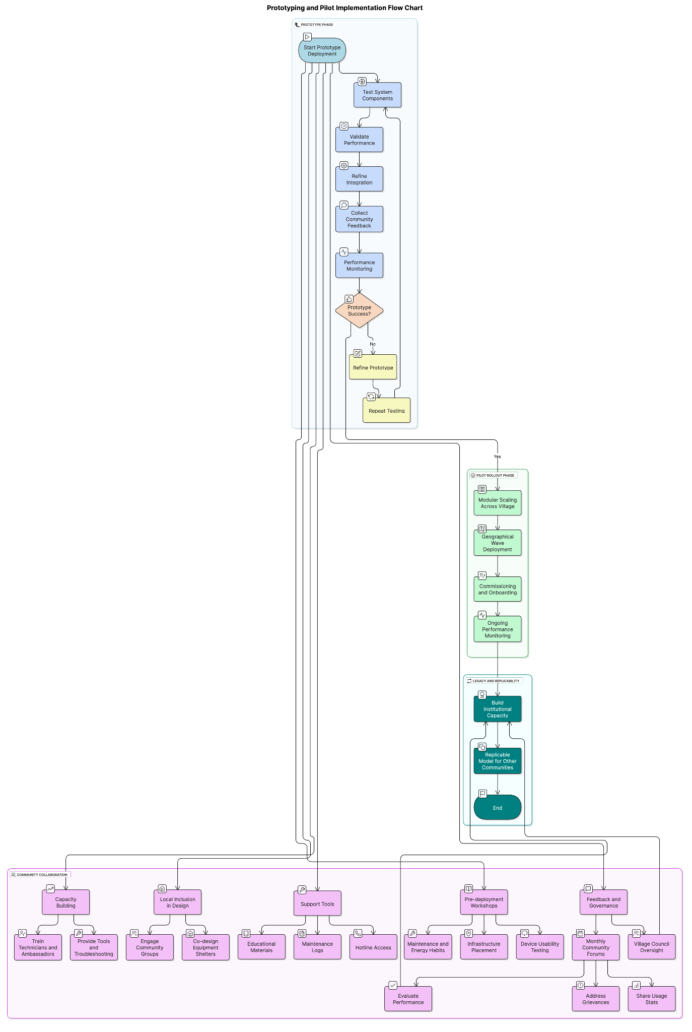

**Fig3. Prototyping and Pilot Implementation Approach**

# **04 Operation and Maintenance Strategy**

The system is designed for Marou’s tropical coastal climate, using durable solar and water infrastructure optimized for heat, humidity, rainfall, and wind. Local “energy stewards” will be trained to manage daily operations, including PV cleaning, battery checks, and rainwater maintenance, all integrated into existing communal labor traditions (*solesolevaki*). A village-run maintenance fund, supported by small household contributions, will cover routine costs. This model ensures low-cost, long-term sustainability through local ownership, climate-adapted technology, and community resilience.

Our team will adopt a climate-aware and lifecycle-oriented design tailored to Fiji’s tropical, humid conditions. We will elevate and angle solar photovoltaic (PV) modules to optimize solar irradiance and facilitate rapid rainwater runoff during the wet season. Mounting frames will be reinforced to withstand tropical cyclone conditions and resist corrosion from salt-laden coastal winds. Rainwater collection tanks will be constructed from UV-stabilized materials and shaded where possible to minimize internal temperature and prevent algae growth.

For energy storage, we will use lithium iron phosphate (LFP) batteries, known for their thermal stability, long operational life (10–15 years), and low maintenance needs. These batteries are well-suited to the local temperature range. The system will include automated load-balancing protocols and backup mechanisms to prevent deep discharge and extend battery longevity.

Inverters and MPPT charge controllers will be pre-programmed to manage peak local loads and will be equipped with GSM or Wi-Fi modules for basic remote monitoring. Even in low-connectivity contexts, this will enable efficient oversight and rapid response to faults.

We will center community engagement in the operation and maintenance of the system. To reduce reliance on external technicians, we will establish local training programs in partnership with vocational institutions or NGOs. These will equip 4–6 “energy stewards” per site with the skills for routine inspection, basic troubleshooting, and data reporting.

Routine maintenance will include:

* **Monthly** cleaning of PV panels by local teams using rainwater and soft brushes to remove debris or salt buildup.
* **Quarterly** battery and inverter inspections, with community checklists for identifying cable corrosion, logging temperatures, and monitoring storage health.
* **Seasonal** rainwater system maintenance, managed by local women’s or water user groups, including mosquito mesh and sediment filter care.

We will introduce a participatory data system, where energy stewards manually log basic usage data or use a simple app interface. This will support adaptive load prioritization (e.g., ensuring power supply to schools before households).

We will integrate maintenance schedules into existing communal labor practices (e.g., *solesolevaki*), enhancing cultural alignment and sustainability.

To support long-term resilience, we will:

* Store spare parts kits locally with training on their use.
* Collaborate with regional suppliers to localize sourcing and build ownership.
* Establish village-managed maintenance funds through small household contributions, reducing long-term dependence on donor cycles.

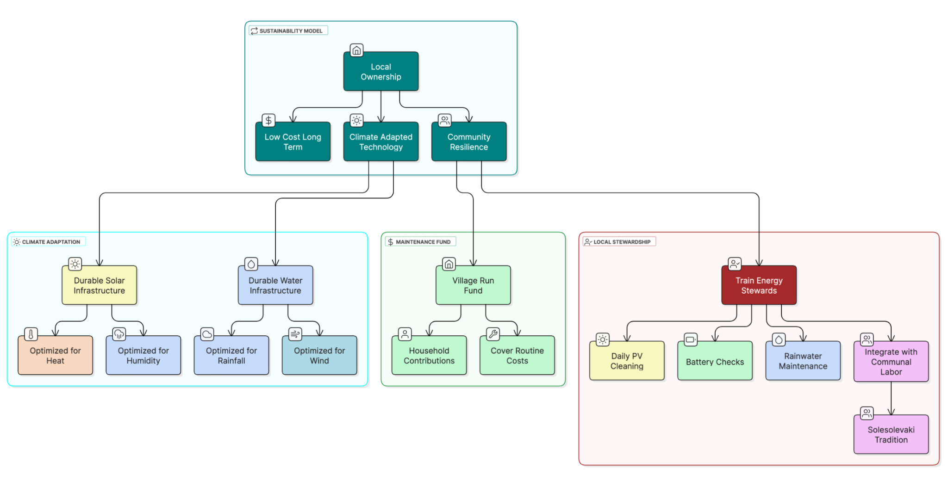

**Fig4. Climate-Aware Design, Lifecycle Operation, and Community-Centered Maintenance for Fiji’s Off-Grid Solar Systems**

# **05 Ecological Effects of Solar Microgrid Installation and Mitigation Measures**

Our team recognizes that even well-intentioned renewable energy systems can have unintended ecological consequences if not planned with environmental sensitivity. Therefore, we will carefully assess and mitigate potential impacts on natural ecosystems throughout the design, installation, and operation of the solar microgrid systems in Fiji.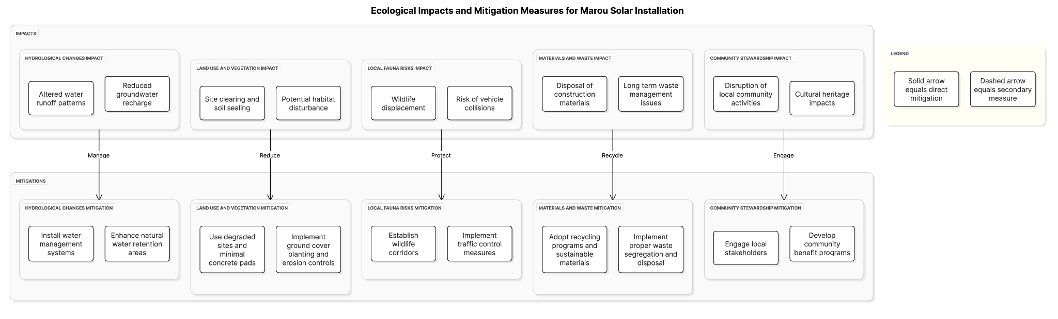

**Fig5. Ecological Impacts and Mitigation Measures for Marou Solar Installation**

**Land Use and Vegetation Disturbance** The installation of solar panels, battery enclosures, and distribution lines may require site clearing, which could disturb native vegetation or displace local fauna. To minimize this, we will prioritize the use of already-disturbed land or previously cleared areas, such as degraded agricultural plots or community commons, rather than pristine forest or ecologically sensitive zones. Site selection will be guided by ecological baseline surveys conducted in collaboration with local environmental authorities or NGOs.

We will use modular racking systems with minimal concrete foundations to reduce soil sealing. Where necessary, we will implement erosion control measures, such as planting ground cover vegetation around installations, using geotextiles, and creating buffer zones to prevent runoff into nearby waterways.

**Impacts on Local Fauna** Solar installations may alter habitat conditions or introduce risks such as bird collisions with reflective surfaces. To address this, we will use anti-reflective PV coatings and avoid placing arrays near known bird migration paths, wetlands, or breeding grounds. We will also avoid artificial night lighting in the system layout to minimize disruptions to nocturnal species.

Battery and electrical equipment housings will be sealed and elevated to prevent intrusion by small animals or reptiles. These units will be ventilated in a way that prevents nesting or access by local fauna, thereby minimizing direct harm and reducing the risk of equipment failure due to biological interference.

**Hydrological Impacts and Rainwater Systems** Our rainwater collection infrastructure may affect local hydrology if not properly designed. To mitigate this, we will size tanks appropriately to avoid runoff issues and position overflow drainage to recharge groundwater or support adjacent vegetation. Filtered rainwater will be used for panel cleaning and other maintenance tasks, reducing the need for freshwater extraction from local sources.

**Materials and Waste Management** We are committed to environmentally responsible procurement and waste management. All materials, including batteries and electronics, will be sourced with certified environmental standards (e.g., RoHS, ISO 14001) where feasible. Packaging and installation waste will be sorted and either repurposed locally or returned to suppliers for responsible disposal. End-of-life planning for batteries and panels will be incorporated from the outset, with recycling partnerships sought at regional or national levels.

**Community Engagement in Ecological Stewardship** We will involve community members in monitoring and managing ecological impacts. Local “energy stewards” will be trained in technical maintenance and identifying and reporting environmental concerns. Feedback loops will allow adaptive responses—for example, adjusting panel angles or shading if unexpected heat or runoff effects are observed.

Through these integrated strategies, we aim to ensure that the project's minimal environmental footprint becomes a platform for local ecological awareness and stewardship.

