RESONANCE
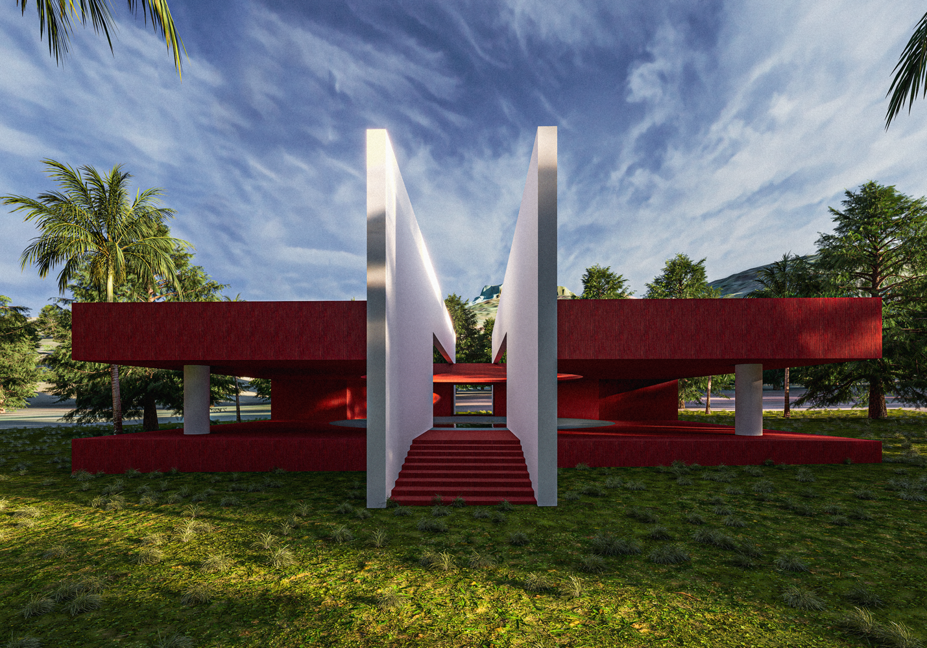
- Concept Narrative
Resonance is a vision for a self-sustaining, community-rooted future in Marou Village—a place where nature, technology, and local culture operate in harmony. Responding to environmental realities such as limited clean water, expensive energy, land scarcity, and climate vulnerability, this concept introduces integrated technologies that not only serve functional needs but also become part of daily life and landscape.
The design utilizes locally appropriate, low-impact materials—such as bamboo, volcanic stone, and recycled aluminum—to construct modular systems that are durable, replicable, and easy to maintain. Renewable energy sources are central: bladeless wind turbines quietly capture wind in compact spaces, curved photovoltaic towers optimize solar collection while serving as bird sanctuaries and scenic platforms, and household seawater converters transform ocean water into fresh water using solar-powered desalination.
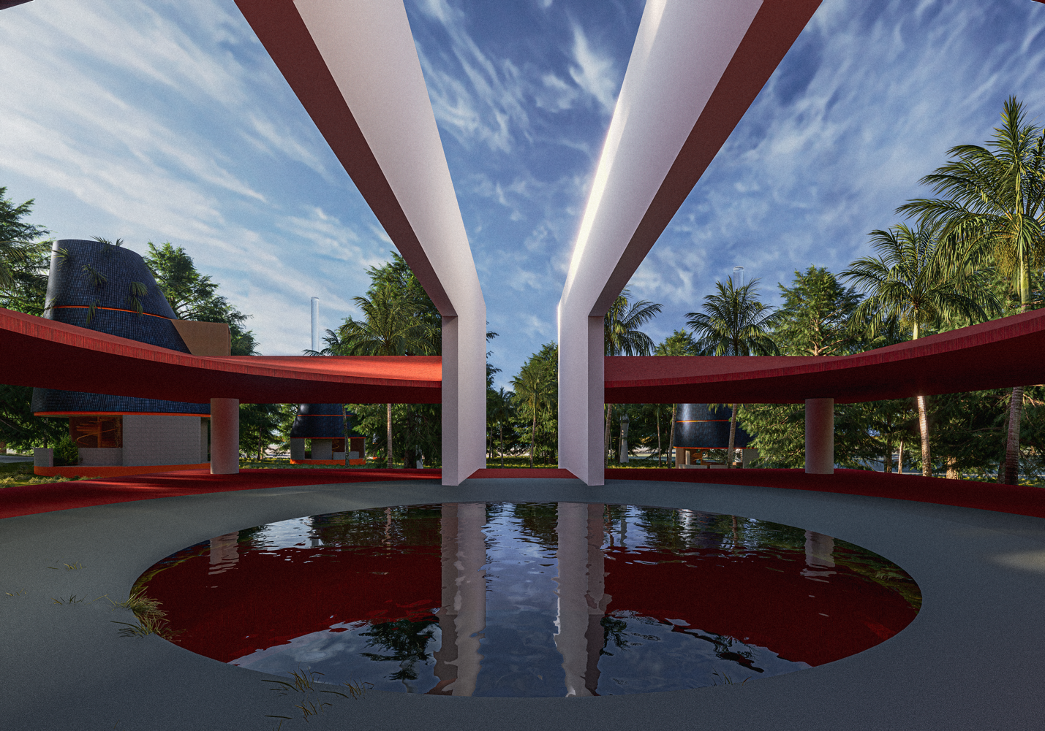
The water treatment plant (WTP) doubles as a social space—a shaded plaza where locals can gather, rest, and learn about water stewardship. The photovoltaic tower offers panoramic views and cultural engagement, encouraging pride in local biodiversity. By embedding these technologies within communal and aesthetic contexts, the design turns infrastructure into opportunity—supporting recreation, education, and conservation.
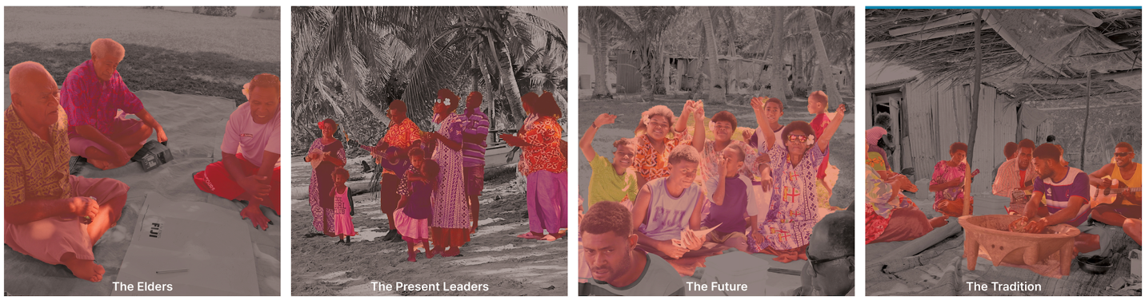

Visitors and community members alike are invited to interact with each space—not just as observers, but as stewards and beneficiaries. Shared land use is a key principle: energy systems coexist with farming, bird habitats, and cultural spaces. Co-benefits include reduced fuel dependency, improved public health through clean water access, enhanced biodiversity, and new avenues for eco-tourism and environmental education.
Resonance is not just a collection of systems—it’s a living rhythm between people and place. It models a future where sustainable technology is not an intrusion but a shared language, embedded seamlessly into the life, culture, and landscape of Marou Village.

- Technical Narrative
Technologies and Rationale Behind the Design
The Resonance concept integrates four core technologies—each selected for its suitability to Marou Village’s environmental conditions, spatial limitations, and cultural context.
- Water Treatment Plant (WTP)
The WTP uses a gravity-fed filtration system combined with solar-assisted purification to improve poor-quality mountain water.
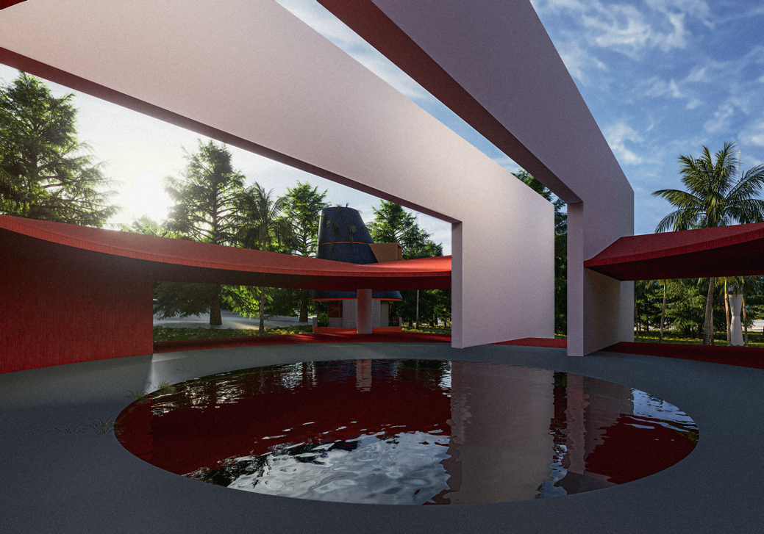

This system is chosen for its low energy demand and ease of maintenance. It also doubles as a gathering space, promoting awareness of water conservation.
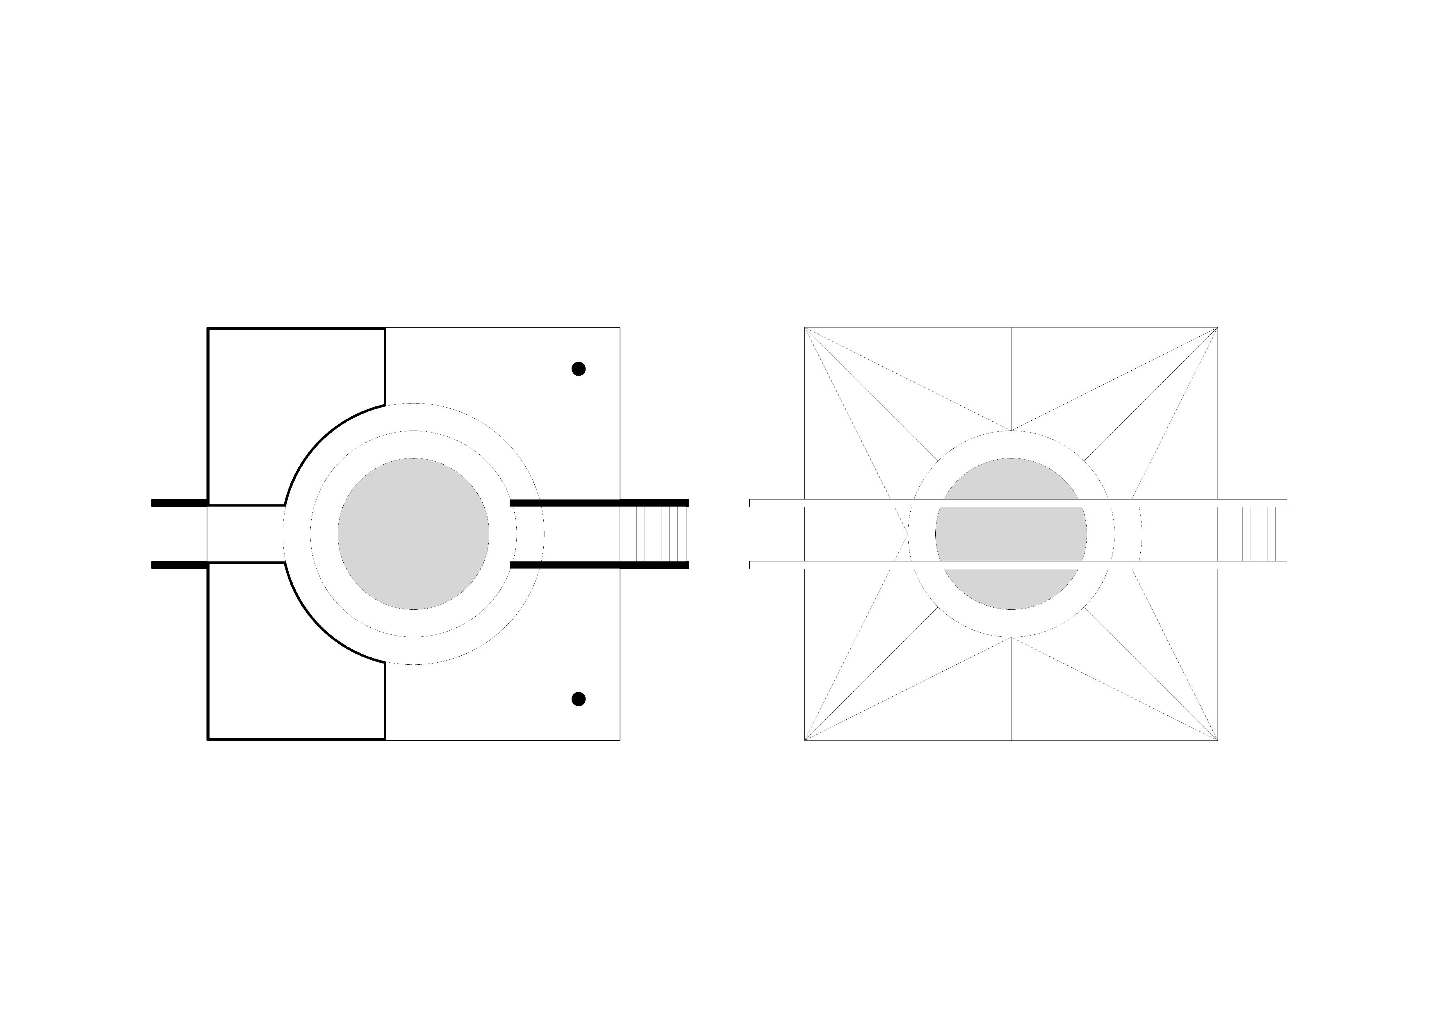

- Photovoltaic Tower
A vertically-oriented, curved solar array harnesses the region’s high solar irradiance efficiently while minimizing land use.
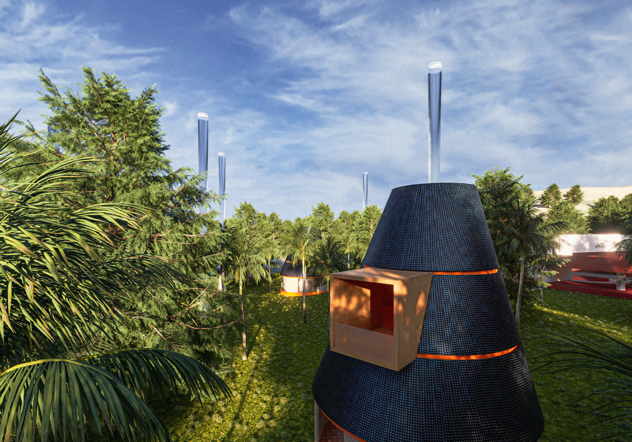
Its height allows for secondary functions such as bird habitat integration and recreational viewpoints, blending energy generation with biodiversity and ecotourism.
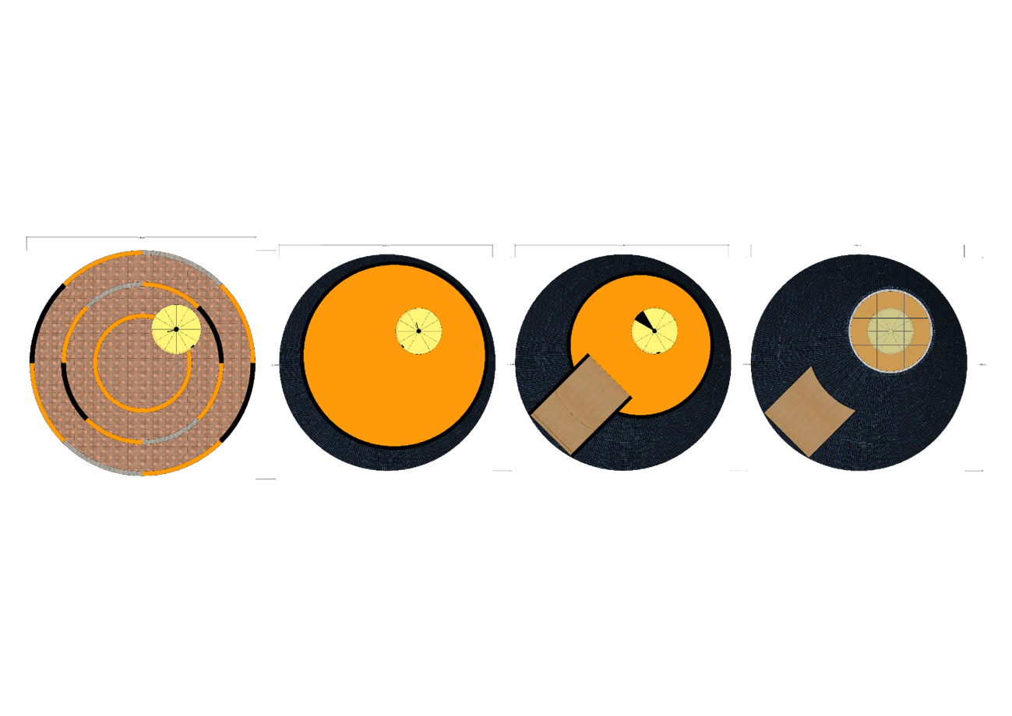

- Bladeless Wind Turbine
This wind energy system employs vortex-induced vibration to generate electricity without rotating blades. It is chosen for its compact form, safety, silent operation, and ability to perform well in variable wind conditions typical of coastal Fiji. Its modular design allows widespread, non-intrusive deployment across the village.
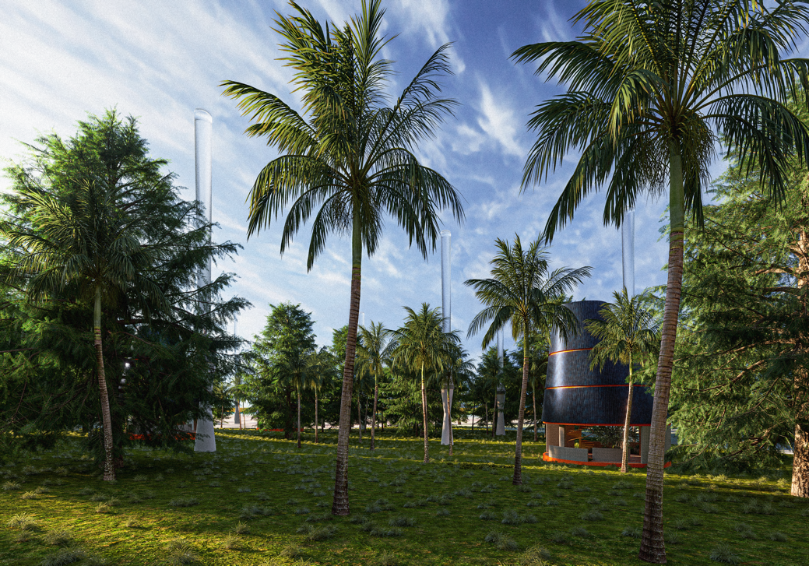
- Seawater Converter (Household Desalination Unit)
A solar-powered reverse osmosis or membrane distillation system provides clean water from the sea at the household level. This decentralized approach ensures water access for families while reducing dependency on limited freshwater sources. It is cost-effective, scalable, and tailored to Marou’s coastal geography.

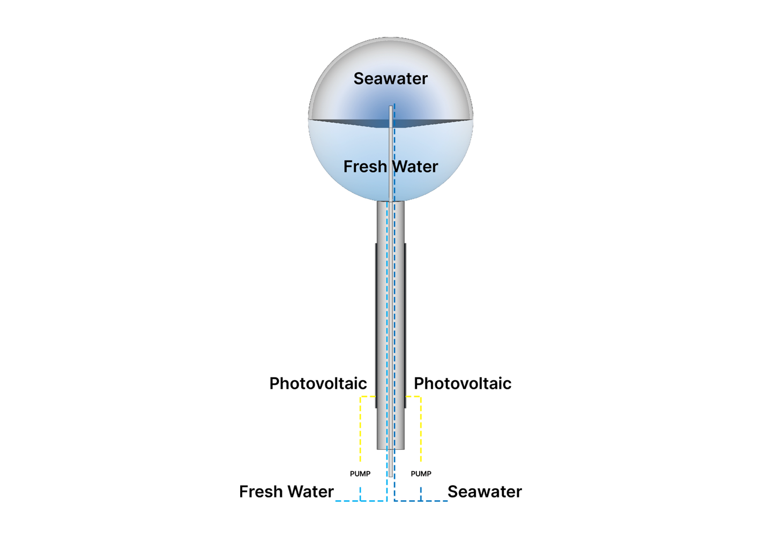
Each technology was selected not only for its technical performance but also for its minimal ecological footprint, replicability, and integration with community life. Together, they form a resilient network of infrastructure that is adaptable, culturally resonant, and environmentally responsible.

Calculation of Energy generated per year
- Water Treatment Plan (WTP)
The following table provides the breakdown of the estimated annual energy for a Water Treatment Plant (WTP) treating 569.88 m³ of water daily. The energy consumption is based on an average of 0.5 kWh per cubic meter of treated water.
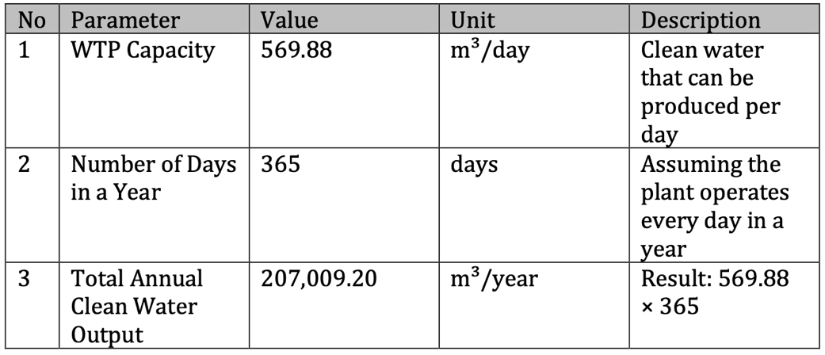

- Photovoltaic Tower (PV-Tower)
The following table provides the breakdown of the estimated annual energy output from a photovoltaic system with a total area of 223.51 m². The calculation assumes an average solar irradiance of 5 kWh/m²/day and a panel efficiency of 18.0%.
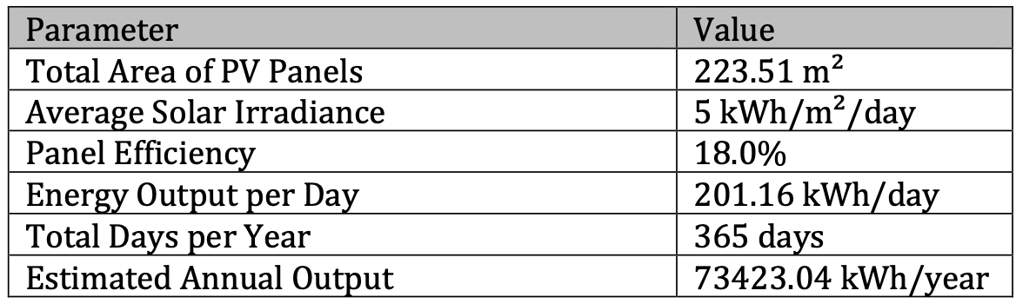
- Bladeless Wind Turbine
In designing resilient and sustainable renewable energy systems for Marou Village, Fiji, a comparative analysis of bladeless wind turbines and horizontal-axis wind turbines (HAWTs) is critical. Based on meteorological data from the diagrams are from https://www.meteoblue.com which uses ERA5T datasets., wind speeds in this region vary significantly, ranging from 4.1 m/s to 10 m/s, with prevailing winds from the east and southeast.
This analysis leverages the vortex-induced vibration model from the peer-reviewed study "Efficiency comparison of horizontal axis wind turbines and bladeless turbines" to calculate the power and annual energy output of both technologies under three wind speed scenarios: 4.1 m/s, 7 m/s, and 10 m/s. The goal is to assess the viability of bladeless turbines for Marou Village’s 75 kW energy demand.

The calculations incorporate technical parameters such as turbine area, energy conversion efficiency, and capacity factors, while addressing local challenges like cyclonic winds and logistical constraints. The findings will inform design recommendations aligned with LAGI 2025’s vision: infrastructure that harmonizes beauty, climate resilience, and community empowerment.
Input Parameters
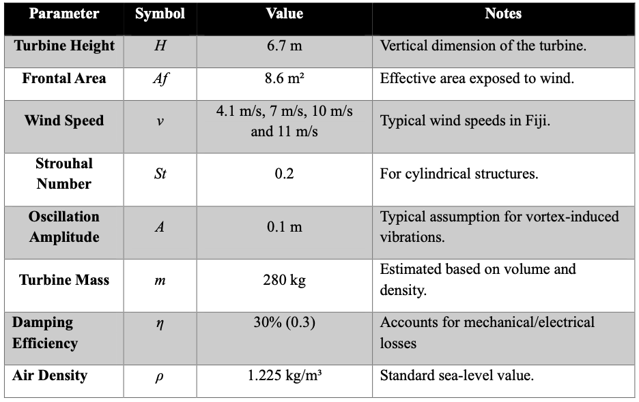
Step-by-Step Calculation
Calculate Turbine Diameter
- The bladeless turbine is cylindrical. Frontal area (Af​) = Height (H) × Diameter (D):
$$D=\frac{Af}{H}​​=\frac{8.6 m^{2}}{6.7 m}​≈1.28m.$$

Vortex Shedding Frequency
- The frequency of vortices detaching from the turbine is given by:
$$f= \frac{St ×v}{D}$$
$$where St=0.2, v=11 m/s, and D=1.28 m$$
$$f=\frac{0.2 ×11 m/s}{1.28 m}≈1.72Hz.$$

Angular Frequency
- Time rate at which an object rotates, or revolves, about an axis, or at which the angular displacement between two bodies changes.
$$ω=2πf=2⋅3.1416⋅1.72≈10.8 rad/s.$$
Spring Constant (kk)
- From the natural frequency equation $ω=\sqrt{\frac{k}{m}:}$
$$k=m⋅ω2=280kg⋅{(10.8rad/s)}^{2}$$
$$k=280⋅116.64≈32,659N/m.$$

$$Mechanical Energy per Oscillation Cycle$$
$$E=\frac{1}{2}​kA^{2}=\frac{1}{2}​⋅32,659N/m⋅{(0.1m)}^{2}.$$
$$E=0.5⋅32,659⋅0.01≈163.3J.$$
Raw Power Output
- Power is energy per unit time. For $f=1.72Hz:$
$$P_{raw}​=E⋅f=163.3J⋅1.72Hz≈280.9W.$$

Net Power After Efficiency Losses
$$Pnet​=η⋅Praw​=0.3⋅280.9≈84.3W(0.084kW).$$
Energy generate each year
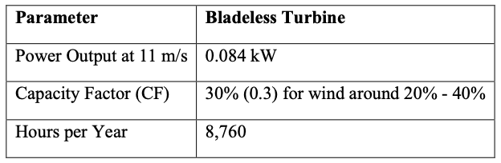
Capacity Factor:
- Bladeless turbines have lower CF due to inefficiency at variable speeds
Annual energy Formula
$$Annual Energy (kWh)=Power (kW)×Capacity Factor×8,760hours$$
$$Annual Energy=0.084kW×0.15×8,760≈220.7 \frac{kWh}{year​}/turbine$$
With the same steps and formulas, we perform the calculations again at several speed variations. The results of the comparison of the energy obtained per year are as follows
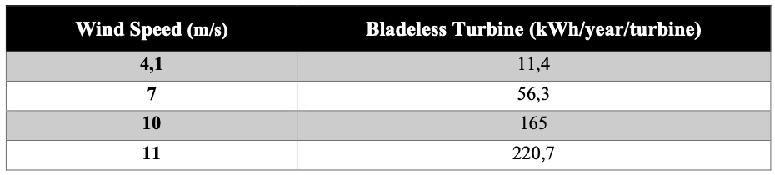
Table : Energy generated per year at variation wind velocity

Figure : Comparison chart of wind speed and energy produced per year for 1 wind turbine

Flow Simulation with Ansys CFD
A Computational Fluid Dynamics (CFD) simulation was conducted to evaluate the structural safety of the bladeless wind turbine under aerodynamic loads. In this simulation, an average wind speed of 11 m/s was applied based on local meteorological data. The results show that the turbine experiences an aerodynamic force of 135 Newtons due to wind interaction. This force serves as a key reference for structural strength analysis and foundation design, ensuring that the turbine can operate safely and remain stable under typical wind conditions."
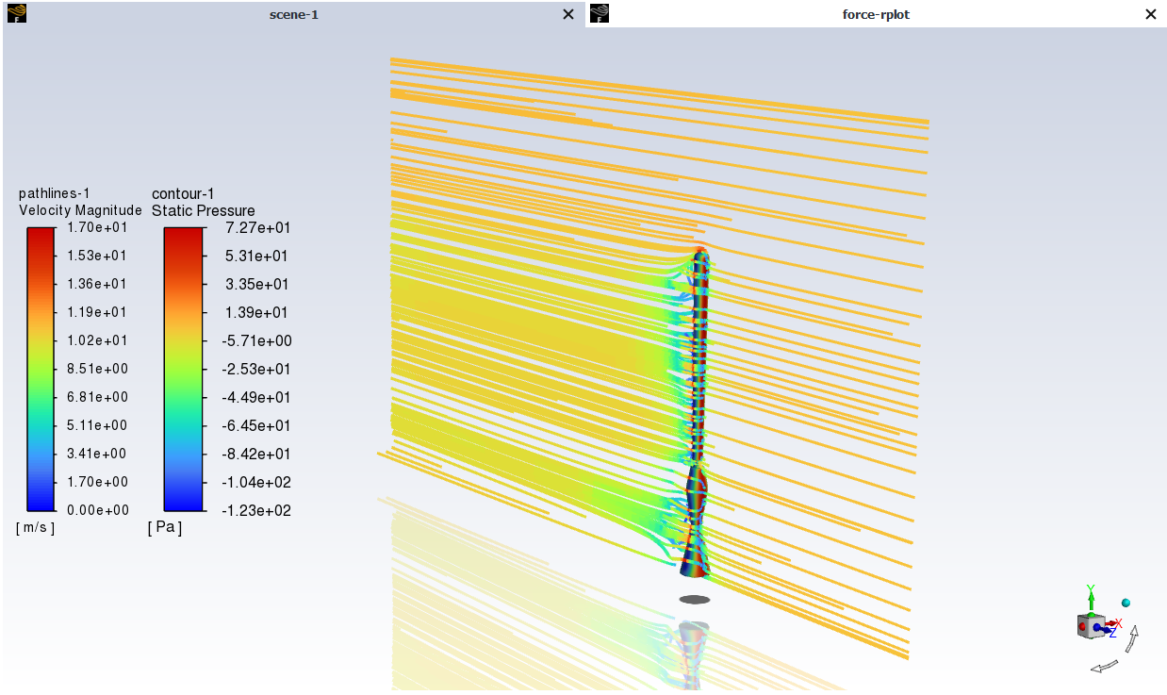
Figure : Flow Pathline at 11 m/s velocity


Figure : Force Calculation Ansys

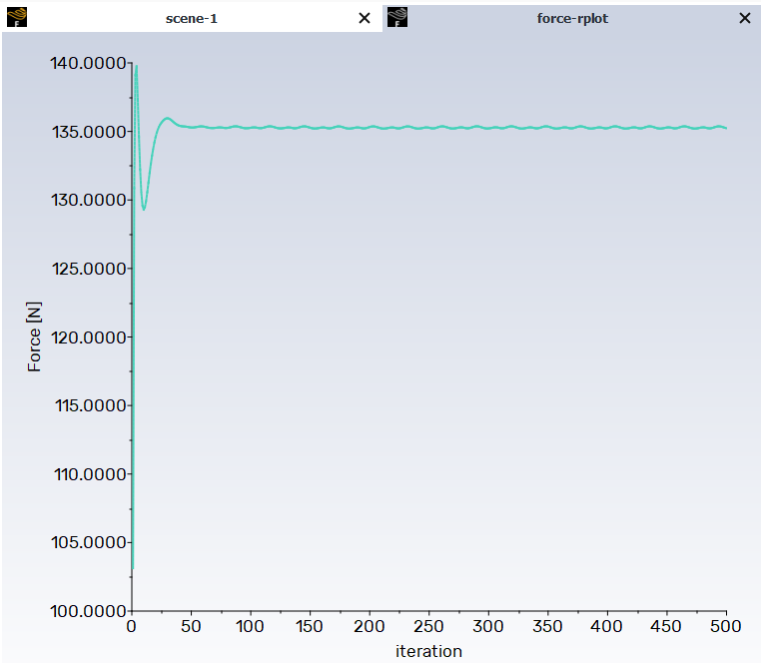
Figure : Force Iteration Plot Convergen

The aerodynamic force of 135 Newtons obtained from the CFD simulation was subsequently used as an input in the structural simulation conducted in ANSYS Structural. This simulation aimed to evaluate the mechanical response of the bladeless wind turbine under wind-induced loading. Specifically, the analysis focused on determining the total deformation, equivalent (von Mises) stress distribution, and the overall safety factor of the structure. These parameters are critical to ensure that the turbine can maintain structural integrity and operate reliably under the expected wind conditions.

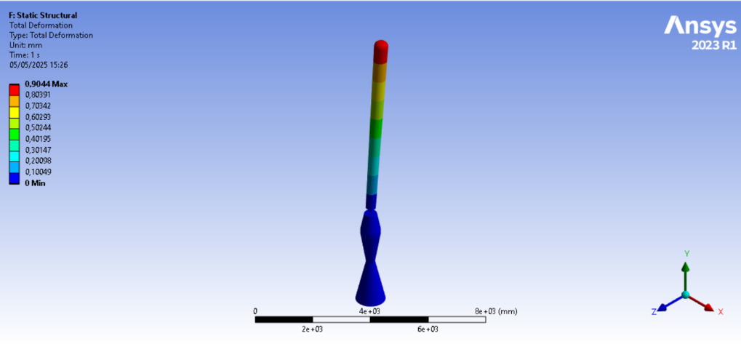
Figure : Total Deformation (m)

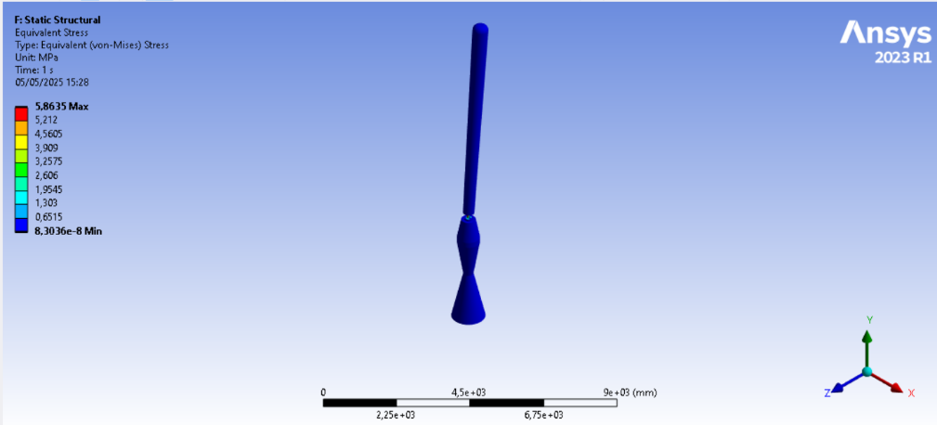
Figure : Stress (Pa)

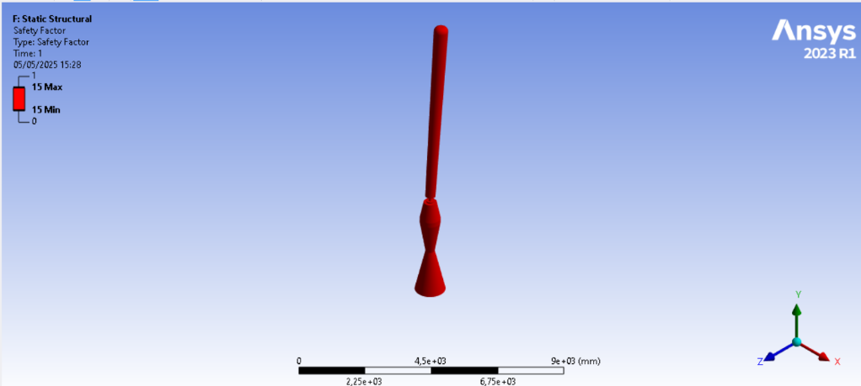
Figure : Safety Factor

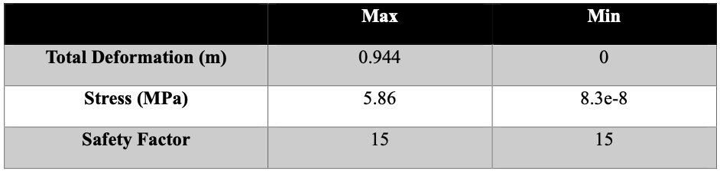
Table : Simulation Result

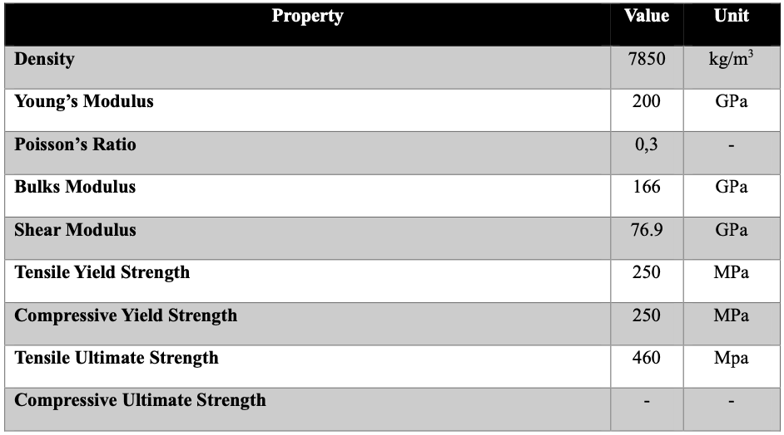
Table : Steel Structural Material Mechanical Property
The results from the structural simulation indicate that the bladeless wind turbine experiences a maximum total deformation of only 0.944 mm under the applied aerodynamic load. The equivalent (von Mises) stress observed in the structure is approximately 5.86 MPa, which remains significantly below the material’s yield strength. Furthermore, the calculated safety factor is exceptionally high, reaching a value of 15. These findings demonstrate that the structural response of the turbine is well within the allowable mechanical limits, confirming that the design is safe and not at risk of mechanical failure under the specified loading conditions.

- Seawater Converter
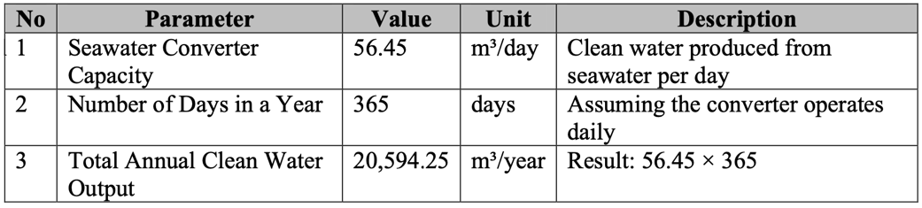
The following table summarizes the inputs and outputs of each technology incorporated in the Resonance design. Each system is designed to use natural, renewable resources efficiently while delivering clean water, energy, and community value.
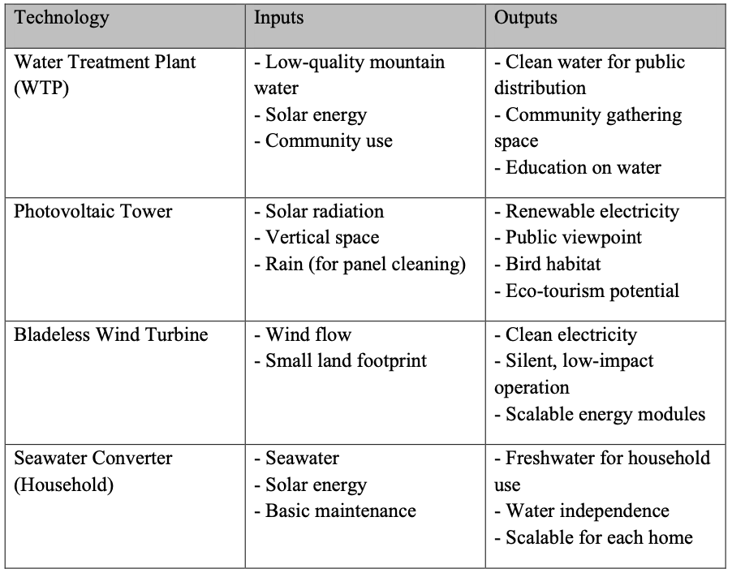
Collectively, the system uses natural, renewable resources as inputs (sunlight, wind, seawater, and mountain water) and outputs clean energy, potable water, and shared community value, aligning technological function with local need and environmental responsibility.
- Prototyping and Pilot Implementation Statement
Our team will approach the prototyping and pilot implementation of Resonance through a phased, community-driven process that emphasizes co-creation, transparency, and adaptability. The prototyping phase will begin with small-scale, modular installations—starting with a pilot seawater-to-freshwater converter and bladeless wind turbine in select households, followed by a mini water treatment unit and a portion of the photovoltaic tower structure. These prototypes will be constructed using local materials and supported by local labor, ensuring cultural relevance and ease of replication.
Community collaboration is central to both prototyping and full-scale deployment. We will hold participatory workshops and feedback sessions throughout the design-build process, allowing residents to share knowledge, express concerns, and help shape the final outcome. Local artisans, builders, and youth will be engaged in hands-on training to build capacity and ownership of the systems.
During the pilot implementation, our team will partner with local governance bodies, schools, and environmental organizations to embed the project within existing social and ecological networks. We will also establish monitoring stations and maintenance training programs to ensure long-term success and adaptation, supported by simple visual guides and multilingual instruction materials.
The pilot will be evaluated based on technical performance, community engagement, and social-environmental impact, with results shared openly. These insights will inform the expansion of the systems across the village and neighboring communities. Our goal is to ensure the Resonance concept not only responds to immediate needs but evolves as a scalable, community-owned model for climate-resilient infrastructure.

- Operations and Maintenance Statement
The Resonance design is intentionally created for low-maintenance, long-term use using durable, locally available materials and simple mechanical systems. Each component—such as the seawater converter, bladeless wind turbine, photovoltaic tower, and water treatment plant—is designed to function with minimal moving parts and low energy requirements, reducing the likelihood of breakdowns.
To ensure ongoing operations and care, we will establish a community-led maintenance cooperative, trained during the prototyping and pilot phases. Local residents will be equipped with the necessary skills through hands-on workshops, covering basic upkeep, troubleshooting, and sustainable use practices. This group will oversee daily checks, routine servicing, and minor repairs, with support from remote technical advisors when needed.
We will also implement a shared responsibility model, where users—particularly households and small groups—take ownership of specific units like household desalination devices. Maintenance guides will be provided in local languages using visual tools to simplify instruction and encourage independent action.
Revenue from eco-tourism activities at the photovoltaic tower and community programs at the WTP plaza can help fund toolkits, spare parts, and periodic professional inspections. In the long term, the system promotes community self-reliance, ensuring that operations and maintenance remain locally governed, culturally appropriate, and economically sustainable.
- Environmental Impact Assessment
The integration of technological infrastructure into natural and built environments holds significant potential for both ecological enhancement and disruption. Through a resonance design approach, this installation seeks not only to fulfill functional and social needs but also to harmonize with its surrounding ecosystems. The deliberate use of environmentally benign materials—such as bamboo, volcanic stone, and recycled aluminum—reflects a commitment to sustainable construction. Moreover, the incorporation of systems such as water treatment plants, photovoltaic towers, bladeless wind turbines, and seawater converters exemplifies a strategy that merges technology with ecological responsibility.
Despite these intentions, each of these technologies may exert specific pressures on natural systems. A critical evaluation of their environmental implications is essential to ensure long-term sustainability:
- Water Treatment Plants (WTPs)
While vital for ensuring clean water supply, the construction and operation of WTPs can result in deforestation, soil erosion, and contamination of natural resources if poorly managed. The extraction of construction materials and the use of treatment chemicals pose additional environmental risks, including air and water pollution and greenhouse gas emissions.
Mitigation strategies should include comprehensive environmental impact assessments, erosion control plans during construction, selection of renewable and recycled materials, and the implementation of chemical management protocols. Furthermore, treated water should be reused where possible, and public education campaigns should support water conservation efforts.
- Photovoltaic (PV) Towers
The deployment of solar infrastructure, though central to carbon reduction goals, can lead to habitat fragmentation and disruption of local biodiversity if sited in ecologically sensitive areas. The production and disposal of photovoltaic panels also carry environmental footprints through emissions and waste.
To minimize impacts, PV systems should be preferentially located on degraded or low-value land, incorporate wildlife-friendly designs, and employ low-impact manufacturing processes. Lifecycle assessments should guide design, while environmental monitoring supports adaptive management.
- Bladeless Wind Turbines
Although bladeless turbines present a less intrusive alternative to conventional models, they may still disturb wildlife through physical presence and acoustic emissions. Species sensitive to vibrations or low-frequency noise may be particularly vulnerable.
Mitigation requires careful site selection—avoiding migratory corridors and critical habitats—alongside the use of deterrent systems and pre-installation biodiversity assessments to identify risks.
- Seawater Converters (Desalination Systems)
Desalination technologies can affect marine ecosystems by increasing water salinity and temperature, disturbing benthic life, and risking entrainment or impingement of marine organisms. Additionally, the energy demands of desalination may contribute to greenhouse gas emissions if not sourced renewably.
Mitigation measures include powering plants with renewable sources (e.g., solar or wind), employing energy-efficient membranes or reverse osmosis technologies, and designing intake/discharge systems to minimize ecological disruption.
In conclusion, while technological systems can enhance resilience and quality of life, they must be deployed with ecological sensitivity. A multi-scalar mitigation framework—grounded in site-specific assessments, sustainable material selection, adaptive management, and continuous monitoring—is essential. This ensures that innovations not only serve human needs but also preserve the integrity and function of the ecosystems in which they are embedded.

