LAGI 2025 – Arrays of Vanua
- Concept Narrative
For the LAGI Fiji 2025 competition, our proposal is grounded in the Fijian concept of Vanua. While Vanua literally translates to ‘tribe’, its meaning runs far deeper—it reflects the profound interconnectedness between people, knowledge, values, spirituality, and nature. This holistic view aligns seamlessly with LAGI’s mission to inspire climate action through artistic innovation and community-driven design.
The LAGI Pavilion brings this philosophy to life by integrating traditional Fijian architectural forms with modern sustainable technologies. The pitched roof is oriented to maximize exposure for photovoltaic panels while also enabling efficient rainwater runoff. It is directed into an underground reservoir where to undergo filtration and pumped to storage tanks for distribution to the village. Surplus water is properly calculated and used for the pavilion. This water is then used for irrigation, passive cooling, and seasonal transformation of the landscape through a shallow water feature during the rainy season or a green strip during the dry season.
Constructed from readily available, local materials using a modular and scalable system, the design adapts to diverse terrains while remaining culturally rooted. It serves as an open village extension, offering a space for cultural participation, festivals, workshops, and shared learning—bridging environment, heritage, and future resilience.
- Technical Narrative
For the LAGI Fiji 2025 competition we have two main objectives:
- Providing clean and effective renewable power to the village
- Providing a rainwater storage system which is efficient and does not consume too much power as well as covering the potable water needs of the village during the drought season (60-70 days)
PV Panels
We have incorporated PV panels into the design as this technology currently represents the most economical approach to renewable energy and the industry expectation is that the collector efficiency will increase exponentially over the next 10 years and this will allow our modular approach to the village infrastructure to be scaled up exponentially over the next decade.
We are proposing basing the modular design on a 715 Watt PV panel which represents the best value and most economical product available on the market.
The proposed PV panel farm will produce enough power to cover the requirements of the stormwater collection, treatment and distribution. We are proposing the use of 4 inverters and a room has been designed for that purpose.
Storm Water Collection and Treatment
To cover the needs of the village’s potable water during the drought season we are proposing a hybrid underground/ above ground tank collection system via gravity which will attempt to utilize the difference in elevation of the terrain to minimize the pump size and power. We will be collecting the rainwater in the proposed catchment area over the course of 10 months, treating it and storing it to allow the village to utilize this water when other sources are not available. Any overflow that may occur during the 10 months may be used for irrigation of the planned native vegetation for the site.
PV Panels (Energy)
We are proposing an array of 176 panels which will produce 125 kW of power year-round. This will allow the village to function with its basic necessities such as lighting, small power (sockets) and basic kitchen equipment. This plant shall also cover the power needs of the stormwater treatment plant and distribution.
The power shall be distributed to each household via an underground cable from the planned main electrical room for the PV plant. This room has been planned and incorporated into the modular design. The room shall be below grade and easily accessible for routine or major maintenance when needed.
Using Stormwater for Potable usage (Water)
We are proposing a storage capacity (Underground/Aboveground) of 2.1 Million liters of water for use within the village during the drought season. This represents an average consumption of 70 days. The hybrid proposal is to mitigate the costs of the underground water tanks.
We estimate based on recent rainfall data from Fiji that the system will be able to collect up to 2.5 million liters of water and we envisage that any overflow can be used to provide irrigation to adjacent areas where needed.
Our proposal allows for modular expansion of the above-ground water tanks and at a minimal cost the storage can be expanded easily to 3 million liters + should the rainfall season be heavier than usual.
Solar Energy
The proposed pavilion consists of 44 modular segments, which collectively include a total of 176 units of 715-watt panels. This arrangement not only meets the minimum energy requirement of 75 kW but also generates surplus energy for water harvesting. Each modular segment features a roof panel that can be either a standard bamboo sheet or a photovoltaic (PV) panel. A modular segment can accommodate up to 8 PV panels to achieve the desired 200 kW capacity.
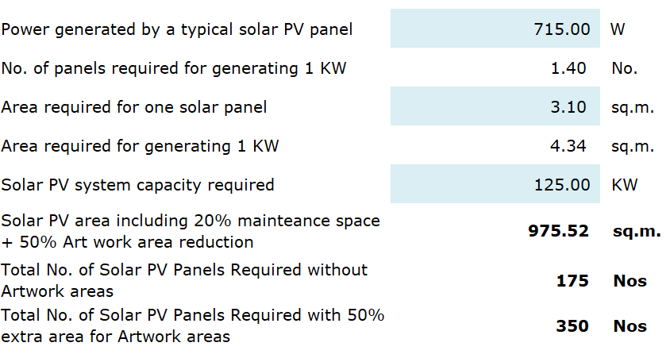
However, an ideal scenario of 312 panels is possible to provide for future demand provision requirements.
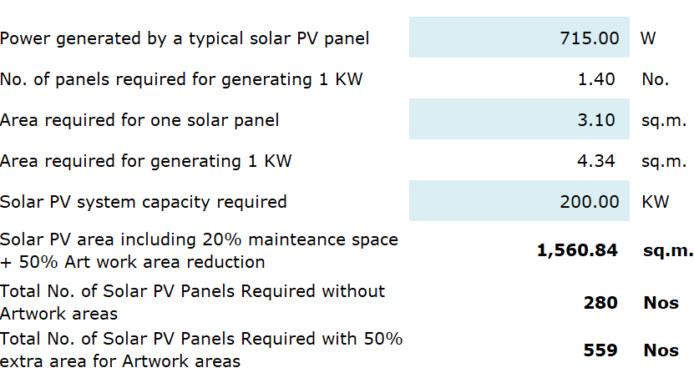
Stormwater
Collection: 8,333 liters/day(avg) Total: 2,500,000 liters/day(300 days)
Village Usage:
No of People: 300
No of Days: 70
Demand/Person: 100 liters/person/day
Expected demand: 2,100,000 liters (Over 70 days)

- Prototyping and Pilot Implementation Statement
The prototype will be manufactured off-site, Possibly the Philippines and be sent over by shipment and since it’s just a section it won’t require a large space. Feedback from these prototypes will inform refinements before moving to a full-scale pilot.
Community collaboration is central to this process. We plan to hold design workshops and feedback sessions with local stakeholders—residents, community leaders, artisans—inviting them to participate in usability trials, and adaptation of the design to meet cultural needs.

During pilot implementation, community members will be engaged through volunteer programs and co-building exercises, allowing for local ownership, knowledge-sharing, and early operational familiarization.
- Operations and Maintenance Statement
Our design prioritizes simplicity, durability, and community stewardship for long-term sustainability. The design is meant to be buildable using common construction techniques and locally accessible material is used.
PV Panels
Operations will be largely passive, with solar panels integrated into the canopy providing energy for ambient lighting and any minimal mechanical systems (such as irrigation or filtration for the water feature). This ensures low ongoing energy costs and promotes environmental responsibility. The building integrates thoughtful and practical maintenance access strategies for its photovoltaic system and underground utilities. For the solar panels installed along the sloped roof structure, a custom-designed rolling ladder system—similar to those used in libraries—will be incorporated. This ladder is mounted on a secure horizontal rail running along the sides, allowing it to roll laterally across different roof sections. The ladder features an extendable lower segment that can be pulled down from ground level using a hook, eliminating the need for separate lifting equipment or access scaffolds.
This solution allows maintenance personnel to safely and efficiently access the PV panels for cleaning, inspection, or minor repairs while maintaining a low visual impact and minimizing roof wear. Safety harness anchor points are also included for fall protection during elevated work.
Water Harvesting
For the water plumbing system, the underground pump room is accessible via a surface-level maintenance hatch. This hatch provides direct access for routine inspection, servicing, and repair of pumps and associated piping. The hatch will be lockable for safety and designed to blend with the surrounding landscape. Any above ground rooms will just have a maintenance door.
Maintenance
Activities will include:
- Periodic cleaning of glass or reflective water surfaces to maintain visual clarity.
- Routine inspections of structural elements to ensure safety and integrity, particularly of timber, steel, and connection points.
- Landscaping care focused on trimming, replanting native species if necessary, and managing the health of surrounding flora.
Local community contribution will be embedded into the design's lifecycle. A community stewardship program will be established, engaging nearby residents or local organizations to:
- Participate in simple maintenance activities such as light cleaning, basic landscape care, and seasonal checks.
- Organize regular 'Community Care Days' where volunteers come together to help clean and care for the space, while also using the time to connect, share food, and enjoy meaningful gatherings.
- Act as local custodians who take pride and ownership of the space, promoting a long-term bond between the installation and its users.
- Environmental Impact Assessment

What Effects Might Your Installation Have on Natural Ecosystems
- Temporary habitat disturbance during construction due to human activity, equipment, and material staging.
- Soil compaction and potential loss of native vegetation in areas of high foot traffic or foundation works.
- Alteration of surface water flow, which could affect existing drainage paths and local hydrology.
- Disturbance to local wildlife caused by construction noise, lighting, and movement.
- Increased water demand during dry seasons if not managed properly.
- Visual and acoustic impact on a natural landscape if infrastructure is not integrated sensitively.
- Potential carbon emissions from material transport and energy use if not offset.

What Steps Can Be Taken to Mitigate Any Foreseeable Issues
- Elevated skeletal foundation to minimize ground disturbance and preserve soil permeability.
- Compact construction footprint and use of prefabricated components to reduce time and impact on-site.
- Rainwater harvesting system with seasonal water feature to regulate runoff and support biodiversity.
- Underground, acoustically insulated pump room to reduce noise and visual impact.
- Use of solar PV panels to provide clean, off-grid energy and reduce emissions.
- Overflow systems and capacity buffers in tanks to prevent flooding or over-extraction.
- Use of regionally sourced, durable materials with low environmental load and long lifecycle.
- Certain existing trees are kept and not removed from the site.
- New plantings of local flora to provide new habitats.

