**BURE RING**

**Marou Village, Fiji: Coastal Community Challenges**

Climate change is a global issue and the Marou village in Fiji in Oceania isn’t remain untouched with huge impact on the lives of its residents, it resulted I rising sea levels, rapidly warming waters, prolonged droughts and storms of increasing severity due to atmospheric greenhouse gas pollution.

1. **Concept Narrative**

In adverse climatic situations as Fiji experience the Cyclone of range 5, which is a highly severe category, a sustainable cyclone resistant structure has been proposed **BURE RING**, the term derived honoring traditional homes ***‘Bure’*** in traditional Fijian houses which are of vernacular typology and were cyclone resistant structures. It is often observed that renewable energy elements when merged in a built form often tends to degrade the aesthetics of the architecture. In designing the Bure Ring, it has been taken care that the renewable energy elements not just only act as a catalyst to the functioning of the building but also enhances the aesthetics of the built form. In fact, the form has been derived to facilitate the renewable energy elements.

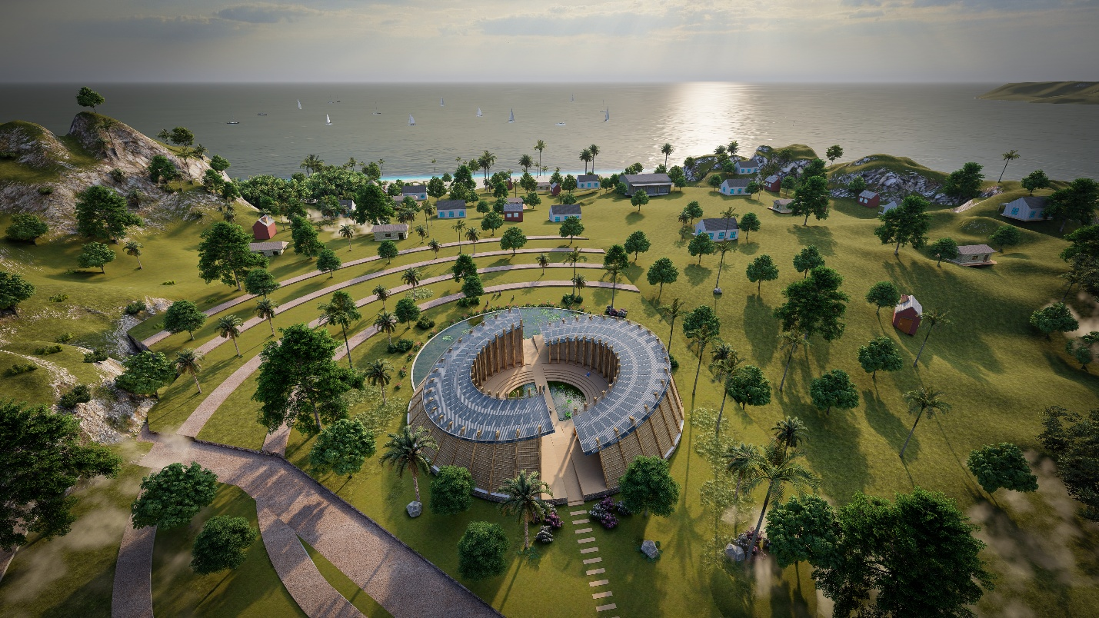

Fact file: BURE RING…a cyclone resilient structure

**Evolution of Form:**

A circular donut shaped form considered to be a cyclone resistant structure, so initially circular form was created with a central courtyard with a pond.

*So, to bifurcate the Community space or Recreational space and the Service space, the circular block is divided into two halves with a passage in the mid which enters into a courtyard and divides the large central pond into two smaller D-shaped central ponds with a bridge between them which act as a passage. The Community space will be used to accommodate* 67 *households during cyclone and the Service space for enclosure of service units* for Cold storage units used for caught fish, placement of water pumps to fetch water from wells to houses and farms, ice making, digital banking, tele-communication, water treatment, water heating, equipment’s for local businesses, healthcare facilities- medicine storage.

*The central courtyard will act as recreational space for the community for celebration of festivals, for gathering of people. The soothing calm of waters enhances the beauty of the space.*

As per energy requirement, 75kW photovoltaic Solar unit need to installed over the Bure Ring. So, the roof of the two blocks tilted 16 degrees as per Solar System guidelines for pacific region. A *moon shaped pond* has been made at the exterior of the Bure Ring for aquaculture.

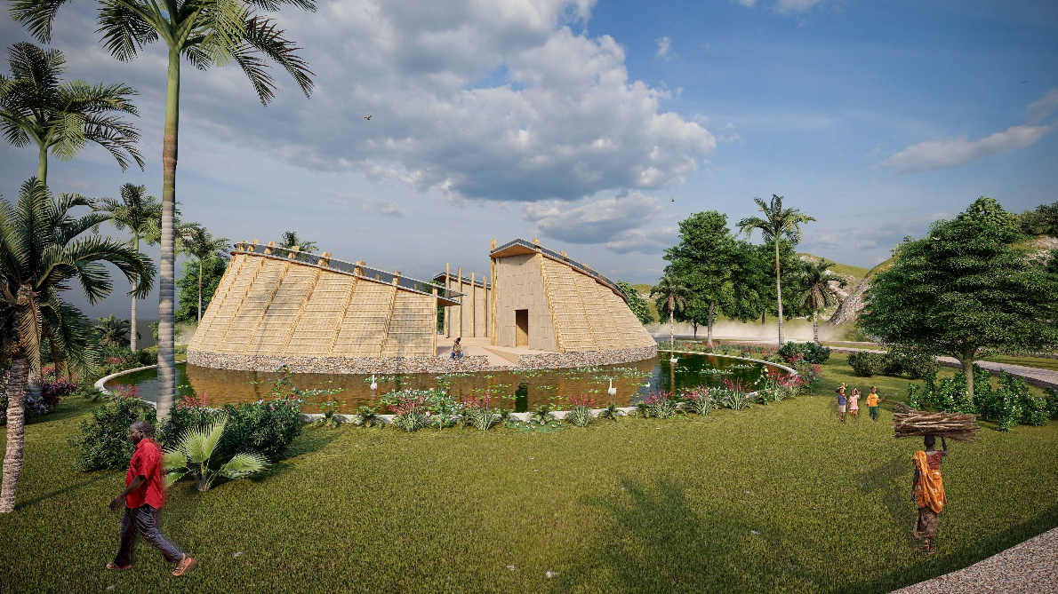

Fact file: Bure Ring

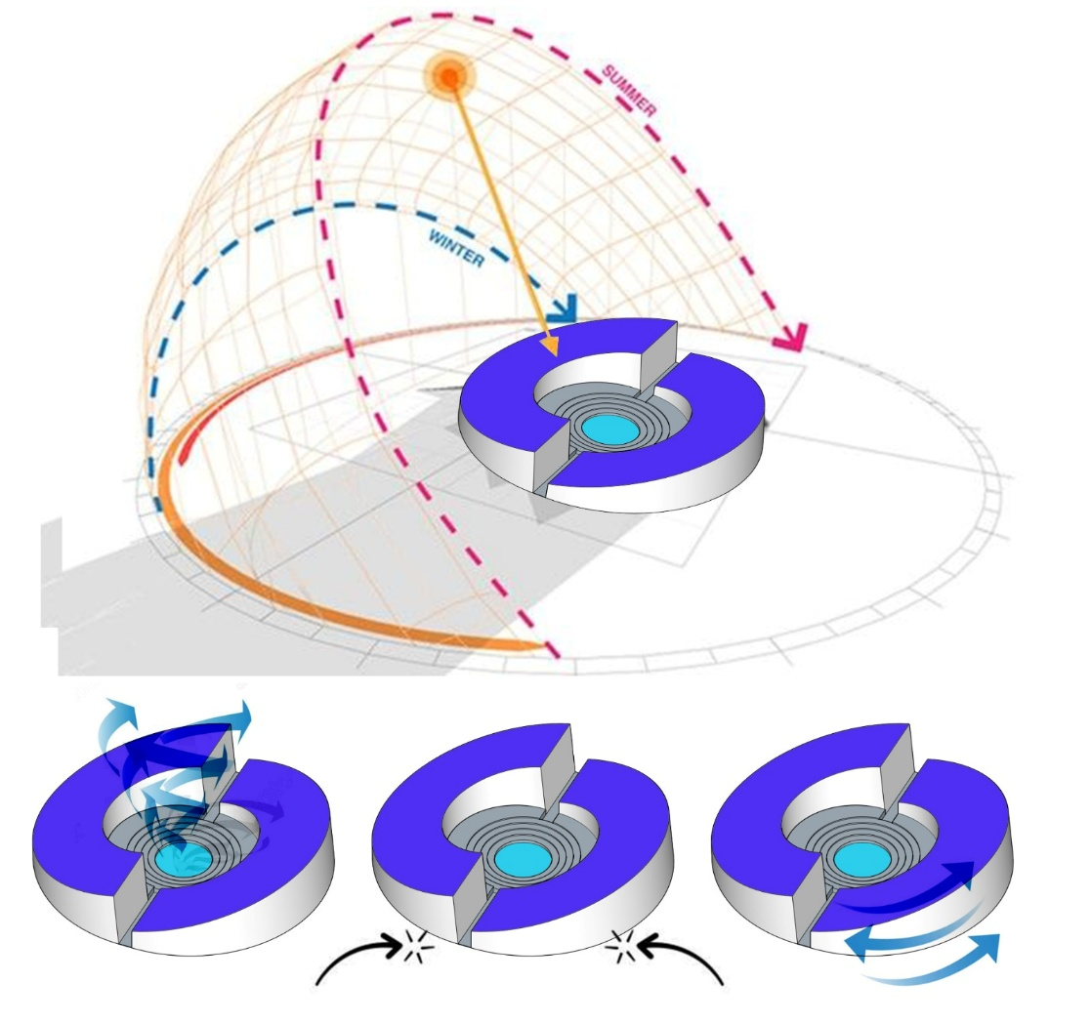

**Wind Resistance**

The aerodynamic shape of circular buildings minimizes wind turbulence. Wind flows smoothly around curved edges.

**Solar efficiency**

Circular form provides 360 degrees orientation for placement of solar panels to capture sunlight.

**Cyclone Resistance**

With no sharp edges to catch gusts, circular buildings are better suited to cyclonic winds. Continuous rounded surface helps reduce drag, lowering chances of structural damage during extreme weather events.

**2. Technical Narrative**

**Construction of BURE RING**

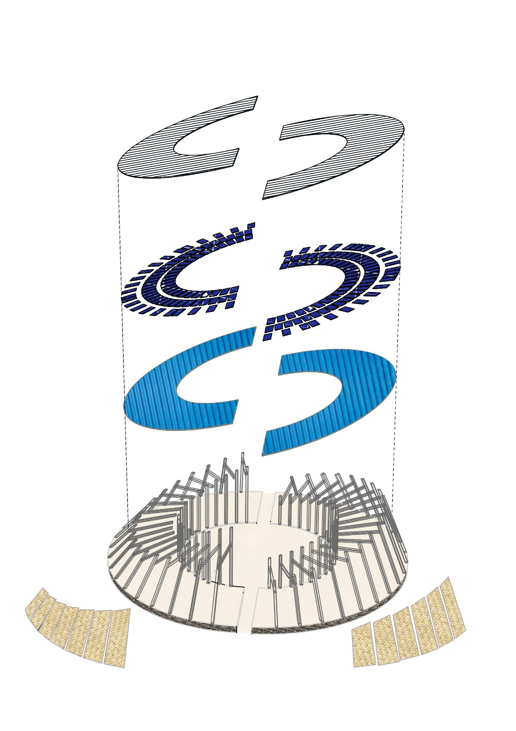

**Fact file: Construction of BURE RING**

**Foundation and Plinth:**

Bure houses in Fiji were built on an elevated earthen platform- ***Yavu***used to be 1m above the ground to manage runoff during cyclones. Similarly, Bure ring is placed on an elevated plinth of local stones which is 1.2m above the ground to manage the cyclonic runoff.

**Flooring:**

Traditional Fijian floor construction reflects the island’s use of natural, locally available materials suited to the tropical climate. Floors in traditional Fijian bures (houses) are typically built on a raised foundation made from compacted earth, stones, or coral rock to protect against moisture and flooding. Over this base, a layer of flattened and well-compacted earth is applied, sometimes mixed with sand or clay for improved stability. In some areas, crushed coral or volcanic ash is used to create a firmer surface. The floor may be finished with mats woven from pandanus leaves or coconut fronds, which add insulation, comfort, and cultural value. These mats are often replaced or refreshed during ceremonies or major family events. This approach results in a breathable, cool, and sustainable floor ideal for the Fijian environment.

**Wooden columns and beams:**

Wooden columns and beams have been used as framed structure element like in Fijian vernacular architecture timber was used as a crucial element for Bure house structure.

**Corrugated Sheet:**

These are modern elements which are used as roofing material instead of traditional thatch roof. The corrugated sheets rests on wooden beams.

**Solar Panels:**

75kW photovoltaic mini grid capacity solar panel unit will be required to fulfill the needs of the Marou village. The entire roof of the Bure Ring will be covered with around 250 Solar panels.

**Mesh:**

*The mesh fixed over Solar panels act as shield to protect solar panels during cyclone from flying coconuts. The mesh placement will reduce the efficiency of Solar panels by 5% only which is negligible.*

**Renewable Energy:**

**Solar Energy requirements for Marou Village:**

Target capacity: 75 kW (kilowatts) = 75,000 watts

Considering we are aiming for peak power (instantaneous capacity):

We'll assume 75 kW peak capacity (i.e., at full sun, the array can produce 75 kW).

*Number of Panels Needed*

75,000W / 500W per panel =150 panels

Number of panels= 500 W/panel

75,000 W =150 panels

*Area Required*

Each 500W panel is about 2 m² (including spacing):

*Total area=150×2=300m2*

*Energy Output per Day*

Let’s assume an average sunlight availability of 5 peak sun hours/day (varies by location).

*Daily energy=75 kW×5 h=375 kWh/day*

*Inverter and System Losses*

System losses (inverter inefficiency, dust, shading, wiring, etc.) are typically around 15%:

*Effective output=375kWh/day×0.85=318.75kWh/day*

To actually get 375 kWh/day, you may need to oversize the array:

*Required array=75/ 0.85≈88.2kW⇒88,200/ 500=176.4⇒177 panels*

To generate 75 kW of peak power using solar panels, we typically need around 150 panels rated at 500 W each, covering approximately 300–350 m² of area. Assuming an average of 5 peak sun hours per day, the system would produce about 375 kWh daily, but after accounting for 15% system losses (inverter, wiring, dust), the effective daily output would be around 319 kWh. To fully offset losses and ensure consistent output, the array may need to be oversized to around 88 kW or 177 panels.

**Water harvesting and treatment**

During the rains from November till April, there is a plenty of fresh water that is collected in the 2 large central ponds created inside the Bure Ring and 10 large water tanks placed in the Energy Design Site.

Rain water collected from the roof top of the Bure ring will be collected in the ***Central* *ponds*** and the outer ***Moon* *pond****s* which will be channelized to the 10 large tanks placed on Energy Design Site. Each Water tank has the capacity of 2000 liters.

**Storm Water management**

The water channel run down from the mountains to the sea is close to the energy design site. The water can be used and stored for farming purpose or other secondary usage. The storm water can be treated using **Green Bridge Technology**.

**Green Bridge Technology:**

**The Green Bridge refers to an eco-friendly natural system designed to treat polluted water using a combination of physical filtration and biological purification.**

Key benefits of Green Bridge technology include reductions of 40–90% in Chemical Oxygen Demand (COD) and Biochemical Oxygen Demand (BOD), 50–100% in fecal coliforms, and increases in dissolved oxygen levels by 150–1200%, all achieved without the need for electricity or chemicals.

To assess the feasibility of implementing the Green Bridge technology in Marou Village, Fiji, we consider the village's demographics and environmental challenges. Marou Village, located on the southeast coast of Naviti Island in the Yasawa Group, comprises 67 households, totaling approximately 300–350 residents. The community faces significant water quality issues, with a 2021 survey indicating that 72% of rural water supplies in Fiji are contaminated with E. coli, leading to health concerns such as enteric diseases and typhoid outbreaks.

**Green Bridge Implementation Plan:**

Design Specifications:

**Structure:** A horizontal filtration system constructed using locally available materials such as stones, gravel, sand, and coconut coir.

**Biological Components:** Integration of aquatic plants and microbial consortia to facilitate biodegradation and biosorption of pollutants.

**Dimensions:** A filtration bed approximately 20 meters in length and 3 meters in width, suitable for treating the village's wastewater output.

**Performance Metrics:**

Pollutant Reduction: Expected reductions of 40–90% in Chemical Oxygen Demand (COD) and Biochemical Oxygen Demand (BOD), and 50–100% in fecal coliforms.

**Oxygenation:** Increase in dissolved oxygen levels by 150–1200%, promoting the return of aquatic life.

**Resource Requirements:**

**Materials:** Utilization of local resources minimizes costs and supports community involvement.

**3. A Pilot Project: Logistics and Implementation on Site**

The Technical narrative and the construction technique clearly reflects it is a community driven programme. The design can be implemented collaborating with the locals.

The design of the Bure ring is scalable and replicable in any island of the Fiji.

Its community driven pilot project which doesn’t require an expert for execution, all has been designed keeping traditional construction techniques in mind.

**4. Operations and Maintenance**

75kW photovoltaic mini grid Solar Panels comes with a warranty of 25 years. The solar panels need regular cleaning, which can be easily done by the locals without any skill.

The Solar panel battery backup setup can be placed inside the Service block of the Bure Ring.

**Maintenance of Green Bridge:** Low-maintenance design requiring periodic removal of accumulated solids and replanting of vegetation as needed, which can be easily done by the locals with the community involvement.

Implementing the Green Bridge in Marou Village offers a sustainable, low-cost solution to improve water quality and public health. By leveraging local materials and community participation, the project aligns with the village's environmental and socio-economic context, providing a replicable model for similar communities facing water pollution challenges.

Artificial ponds can be maintained easily by regular cleaning, again a community driven initiative.

**5. Environment Impact**

From Foundation and Plinth development which is made up of earth and stone, flooring- use of natural, locally available materials suited to the tropical climate with a layer of flattened and well-compacted earth is applied, sometimes mixed with sand or clay for improved stability. This approach results in a breathable, cool, and sustainable floor ideal for the Fijian environment.

Wooden columns and beams have been used as framed structure element like in Fijian vernacular architecture.

Corrugated Sheets for roofing and 75kW photovoltaic mini grid capacity solar panel unit.

During this entire construction no disgrace will be done to the environment.

**It is a sustainable structure made up of eco-friendly materials.**

*******