**LAGI 2025 Fiji Narrative**   
**Concept Narrative: DRUA**

* Discuss materials, design concept, visitor and community experience, co-benefits, shared land uses, and any other important aspects of your design.

The **Drua** is today at the pinnacle of a double-hull racing sailboat, as it was centuries ago. One of the fastest ever made and known for its ability to sail against the wind, at speed. We believe in local knowledge, know-how, material, and capacity to shape those materials with the know-how. We believe in community self-reliance, and the local ability to maintain and repair technology, and advance knowledge that stays local. In this light, we are proposing to engage the incredible local knowledge invested in the Drua. We propose to use the wood-working knowledge and local timber to create multiple small wooden “leaky dams” along the mountain drainage routes to slow the running water in rainy season, avoiding floods, and harvesting rainy season water in retention ponds and filtering it using proven low-tech solutions of bio and sand filtration. We propose to use the two wooden hulls of the Drua to retain, filter, and store water and to provide a “deck” for public and community gatherings, to celebrate, commune, and play rugby. We see the construction of the “leaky dams” and the two Drua hulls as community efforts that bring everyone together and pass on community knowledge to the younger generations.

The “sail” includes Photo-Voltaic panels that generate power for the community, protect the retention-pond from evaporation, and provide shade for the “deck” during community gatherings. The PV panel technology is, obviously, imported to the village. However, its sub-structure is constructed using timber technology of the Drua, once again relying on local knowledge and material, this time, paired with imported high technology.

The Drua serves as the model for this proposal, in that it brings together local knowledge with the pinnacle of international achievement.

1. **Technical Narrative**

* What technologies does your design incorporate? Why did you choose them?
* How much energy and water does your installation generate each year?
* What are the system inputs? (for example, sunlight or rainwater)
* What are the system outputs? (for example, electricity or clean drinking water)

The proposed design aims to address the water and energy needs of the households in Marou Village, Fiji, using traditional, long-lasting, nature-based, low-tech strategies for stormwater management and rainwater harvesting combined with a PV electricity generation system. The proposed design enhances community resilience by addressing the seasonal and infrastructural challenges faced by the community.

**PV electricity generation:** The proposed PV electricity generation system will be an 85-kW system to meet both the current and future energy needs of Marou Village, Fiji. The proposed system exceeds the required 75-kW requirement of design guidelines and provides for future expansion. The proposed PV system will be a fixed open-track crystalline PV system to reduce the cost and maintenance needs. Assuming the annual average irradiance of 5.07 kWh per square meter per day, the system will generate more than 120,000 kWh of AC electricity output in a year. More details about the PV system specification, input, and output can be found in Table 1.

*Table 1. PV system specification, input and output based on modeling in PVWatts Calculator.*

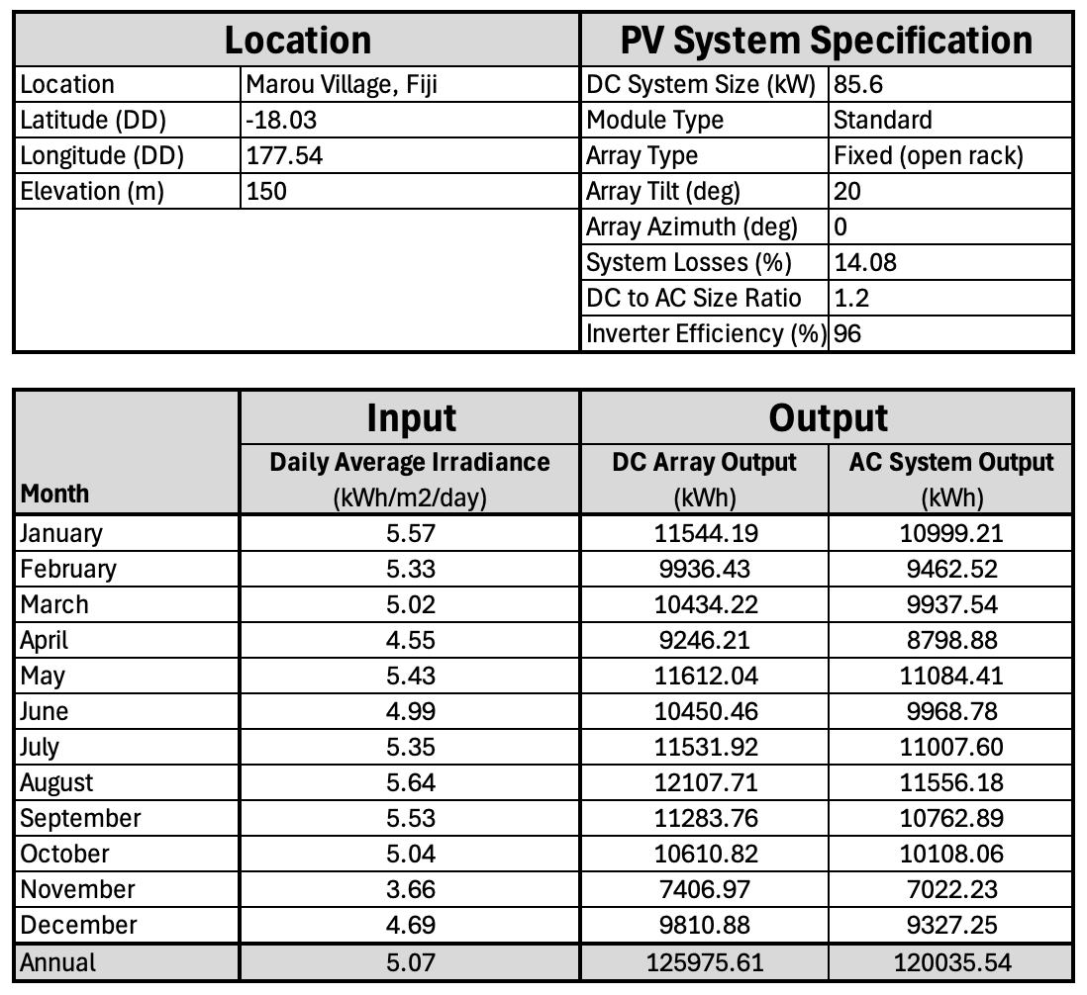

**Stormwater management and rainwater harvesting:** The proposed design will use locally available culturally appropriate technologies to collect, filter, and store safe decentralized drinking water while producing renewable electricity and strengthening community resilience. The system begins at the upper elevations of the island, where mountain runoff and seasonal rainfall are slowed and guided through a chain of “leaky dams;” i.e., dams that are designed to allow for infiltration of water from upper dams to lower ones. This reduces the risk of flooding and will place more water in the soil, instead of surface run-off.

Water then flows into a bio-retention pond, which provides flood buffering, sedimentation removal, and natural filtration. This stage prepares the water for the next phase: a large-scale bio-sand filtration system, now housed inside the first Drua hull. Inside layered sand, gravel, and biological media remove remaining particles, turbidity, and microbial threats, providing a robust, passive purification stage. With this expanded capacity, the system serves as the critical bridge between ecological treatment and safe water delivery.

The second Drua hull is dedicated entirely to storing the clean, filtered water. This large-volume cistern secures over 4.92 million liters of treated water, ensuring over 164 days (30,000 L/day) of reliable supply for the village, even accounting for expected pipe leakage, community fluctuations, and seasonal dry spells.

If the boat-shaped tank is filled once, it can cover approximately 164 days (roughly 5.5 months) of continuous village water demand without refilling. In addition, the system outputs renewable electricity, and a model of sustainable, climate-adapted infrastructure. The system also outputs local capacity, equity, and health benefits, providing households, schools, and health facilities with stable water access throughout the year.

1. **Prototyping and Pilot Implementation Statement**

* How will your team approach the prototyping process and full-scale pilot implementation process and how will you collaborate with the local community in both of those efforts?

Central to our proposed concept is the engagement with the local material, and know-how, fully invested in the people of the community. At the core of our prototype water harvesting and filtration implementation is working with the local community to utilize their expertise in wooden hull construction and to spread that knowledge among the local community, both pragmatically, to use it in construction, and ideologically, to empower the community to construct its own future. Our water harvesting prototype will be a scaled-down version of our proposal, testing the “leaky dam” earth and sand filtration system. We will also test a second hull for water retainage and storage using a membrane liner system.

Our aim in prototyping the PV technology is to follow a similar trajectory, where the local community will be trained to maintain and repair the Photo-Voltaic panels. In addition, the sub-structure of the panels will be constructed by the local community and their timber construction expertise. The prototype will test the angles and the curvatures of our proposal to ensure maximum efficiency.

1. **Operations and Maintenance Statement**

* How will your design be operated and maintained during its life? How will the local community contribute to operations and maintenance?

The proposed design consists of long-lasting low-tech strategies that would require minimal maintenance or need the type of maintenance that could be completed by the local workforce. We also propose a series of training and capacity-building activities to enhance public awareness of the proposed systems and established community-engaged maintenance routines such as PV cleaning, PV inspection, energy generation and use monitoring, cleaning, etc. Through low-tech design, shared responsibility, community engagement, and local governance, the proposed system will yield long-term community benefits.

1. **Environmental Impact Assessment**

* What effects might your installation have on natural ecosystems and what steps can be taken to mitigate any foreseeable issues?

**Positive Environmental Impacts:**

The proposed PV installation in Fiji will positively impact the environment in several ways:

* **Energy independence**: The proposed system will generate 85 kW of electricity, translating into more than 120,000 kWh of electricity per year and about 3 million kWh of electricity in 25 years. The electricity generated by the proposed system exceeds the needs of the current households in Marou village by more than 13%.
* **Operational carbon emission avoidance:** Fiji’s power generation system currently releases 0.276 kg of CO2-eq per kWh of electricity that is generated. The proposed installation with an 85-kW capacity will therefore avoid the release of more than 33 metric tons of CO2-eq emissions in one year and 828 metric tons of CO2-eq emissions in 25 years as the typical life span of PV systems. The quantity of carbon emission saving in 25 years is equivalent to planting 13,500 trees.
* **Payback period**: Our estimations based on the construction and utility cost in Fiji show a payback period of 5 years.
* **Water use saving**: By generating PV power, the consumption of water in power plants for cooling purposes will be avoided.
* **Water generation**: Our proposed treated water storage capacity is 2,272,000 liters, which meets the needs of the Marou village in 75 days.
* **Habitat-friendly development:** The proposed installation will use multiple strategies to avoid habitat disruption. These strategies include wetland development, integration of flora and fauna, and wildlife-friendly lighting and architecture.

**Negative Environmental Impacts:**

While the proposed PV installation in Fiji is associated with some negative impacts on the environment, these impacts are offset by the positive impacts.

* **Life cycle environmental impacts and embodied carbon of the PV system:** Embodied carbon refers to the greenhouse gas emissions associated with the life cycle of the PV systems from material extraction through manufacturing, installation, and end-of-life processes. According to the US National Renewable Energy Laboratory (NREL), the life cycle embodied carbon intensity of PV systems is about 0.046 kg CO2-eq per kWh of PV power, which is well below the embodied carbon emission intensity of diesel-powered electricity generation, which is estimated to be 0.800 kg CO2-eq per kWh. The proposed 85-kW PV system will lead to 138,000 kg CO2-eq of embodied carbon emissions over the 25-year life span of the PV system. These embodied carbon emissions will be offset by the carbon emission savings due to PV energy generation.
* **Embodied carbon of the proposed construction** will be minimized using local wood-based materials.