**LAGI 2025 Fiji Narrative Template  
*The use of this document is optional. It is intended to help you organize your written description that describes your proposal. You do not need to provide answers to each specific question. They are there to help guide you.***

***Do not include any information within the written description file that could identify you or your team members. Please organize your narrative document as per the five sections below. Limit each of the five sections to around 500 words (for a total of no more than 2,500 words in the entire document):***

1. **Concept Narrative**

For our LAGI 2025 proposal, we have created a design inspired by traditional Fijian Masi textiles. Masi are typically square or rectangular in format and radiate outward from the centre with repeated geometric motifs and symmetrical patterns which hold special meanings for Fijian communities. Our concept reflects this cultural heritage and invites the Marou Village community to co-design the project with our team.

The design (Masi Siga Garden) is structured around a central gathering space, anchored to a timber deck and constructed using timber-clad steel and natural materials. This space includes a decorative textile canopy that can be locally produced and replaced when needed. The interior is adaptable, divided into four flexible zones using woven mat partitions, which will be made by local craftspeople. This allows the space to support shared land uses such as education, community meetings, cultural performances, and quiet reflection.

Radiating outward from the central structure are layers in a Masi-inspired grid, integrating tropical gardens, shaded walkways, solar panels, and rainwater channels. The gardens incorporate local species like hibiscus and palms for biodiversity, while walkways are shaded with flowering vines. The solar garden supports energy production, and water harvesting channels double as decorative features.

This multifunctional approach addresses a range of community needs: shelter, energy access, food production, outdoor education, recreation, and climate resilience. Our vision is a space that fosters collaboration, social resilience, and cultural continuity through shared use and sustainable design.

1. **Technical Narrative**

Our design (Masi Siga Garden) focuses on integrated systems for renewable solar energy and sustainable water collection. Custom star-shaped solar panels inspired by Masi motifs are placed around the perimeter, with additional panels installed along the walkway roofs. Together, these panels are designed to meet the 75kW target. Energy produced will be stored in batteries to support uses like space lighting, device charging, water heating, small-scale refrigeration, powering educational tools, and lighting walking paths at night.

Rainwater is collected from the canopy and solar surfaces, channelled through a system of sloped surfaces and pebble-lined channels, filtered using basic gravel and mesh layers, and stored in accessible tanks. This water can be used for agriculture, household needs, cleaning, and community use.

The materials selected are durable and cyclone-resistant, such as timber-clad steel and treated wood. The canopy is designed to be modular and replaceable. The entire system is low-maintenance and suitable for local upkeep without the need for external specialists.

These integrated systems demonstrate how clean energy and water systems can coexist in a shared, culturally-rooted space, enhancing both ecological and social resilience.

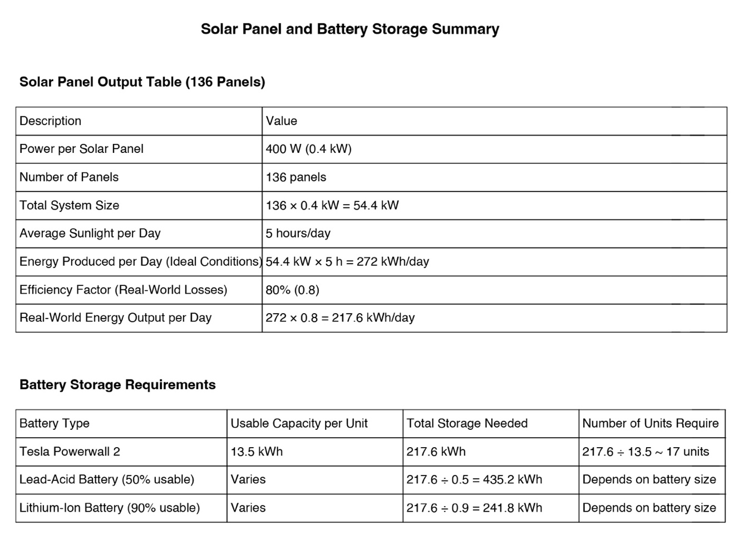

1. **Prototyping and Pilot Implementation Statement**

To commence the project, we propose building a small pilot section. This would include a shelter with seating, a section of the garden bed, several star-shaped solar panels, and a working water collection system. Solar panels would power lighting and device charging, storing energy in a small battery unit. The water system would use the canopy roof to collect rainwater, guiding it into a filtration unit and then into a storage tank.

The prototype would also allow the testing of canopy options: traditional woven matting or Masi-inspired painted cloth. The shelter could serve as a shaded space for gathering, resting, outdoor learning, or quiet reflection. This stage will also involve local builders and craftspeople to evaluate performance, usability, and the potential for scaling the full design.

By incorporating electricity generation, water harvesting, and shared space in one structure, the pilot demonstrates *designing with* rather than *for* the local community and integrated systems can be tested and refined collaboratively.

1. **Operations and Maintenance Statement**

The design (Masi Siga Garden) is intentionally low-maintenance and community-driven. Solar panels are installed close to the ground or on low roofs, making them easy to clean and inspect. Rainwater filters use simple, locally available materials and are easy to replace. All major elements of Masi Siga Garden are designed for durability and seasonal upkeep using basic tools such as a socket set, saws, hammers, screwdrivers, spades, machetes, and a wrench. Maintenance tasks may also require a ladder for access, soft brushes for cleaning solar panels, and hoses or simple equipment to clean rainwater filters. Timber surfaces can be oiled or sealed periodically, and joints or fixings may need occasional tightening. The solar system will require routine checks for cracks, corrosion, and battery condition.

During the construction phase, community members will be trained in the operation and maintenance of the systems. This empowers the village to independently manage energy and water resources, including lighting for safety, device charging, and even supporting small businesses through energy access.

This hands-on approach ensures the system remains resilient, affordable, and adaptable to evolving community needs over time.

1. **Environmental Impact Assessment**

The design (Masi Siga Garden) works with the natural landscape. No major excavation or alteration to the site is required. Gardens use native and climate-resilient species to support biodiversity and promote healthy soil. Water channels support natural infiltration, and solar panels are positioned to avoid obstructing wind or water flow.

The use of local, renewable materials minimizes environmental impact while preserving cultural aesthetics. Any construction disturbances will be carefully managed. Over time, the design will improve soil health, stormwater management, and provide cooling shade and plant life that contributes to the ecosystem.

By promoting shared land use, climate adaptation, and social resilience, the project becomes more than just infrastructure. It becomes a space that supports both ecological wellbeing and cultural vitality, rooted in Fijian tradition and designed for the future.