v

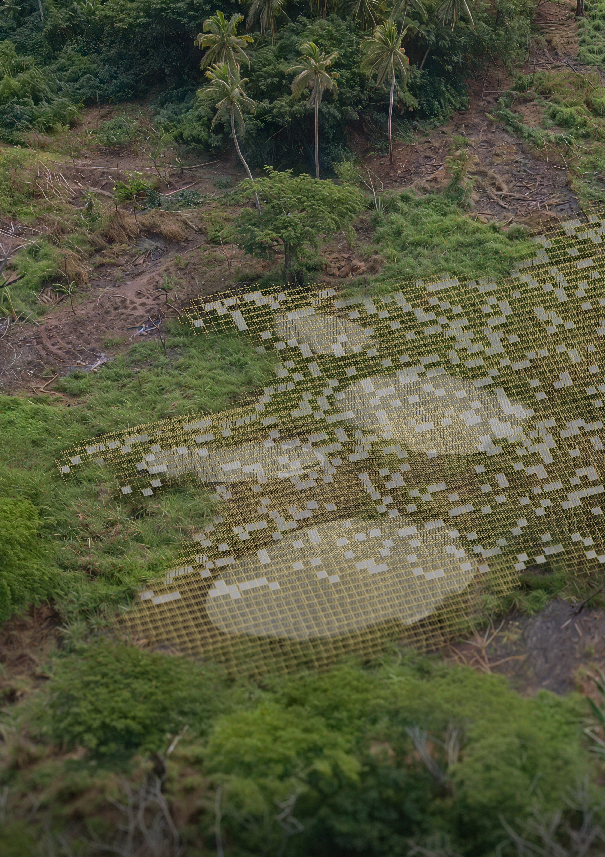

# THE CLOUD

*PROPOSAL DESCRIPTION*

is both structural and adaptable. North-facing elevations support a tessellated solar skin, generating 75kW while shaping a faceted surface visible from the sea. Suspend- ed near the high point of the plot, a series of translucent ampoules collect and store rainwater. These vessels—lo- cated where stormwater channels converge—serve as elevated reservoirs, using gravity to assist both collection and passive distribution. The water is filtered using low- tech systems and stored for year-round use. In plan, the form spirals outward, widening to host gathering, nar- rowing into thresholds and shaded pockets. Its growth is coral-like—incremental, responsive, and inherently local. The largest volume acts as a communal hearth, a place for oral teaching, informal gathering, and interaction.

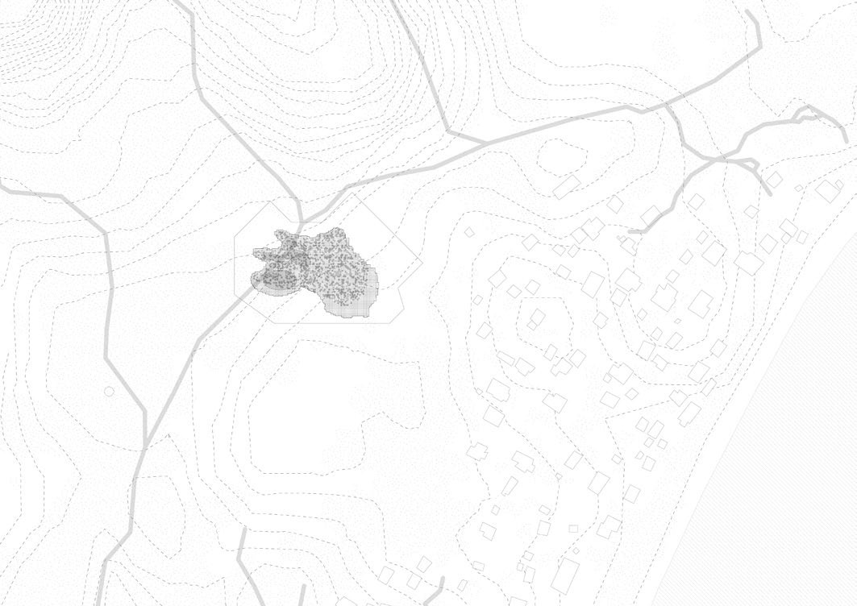

**Site**

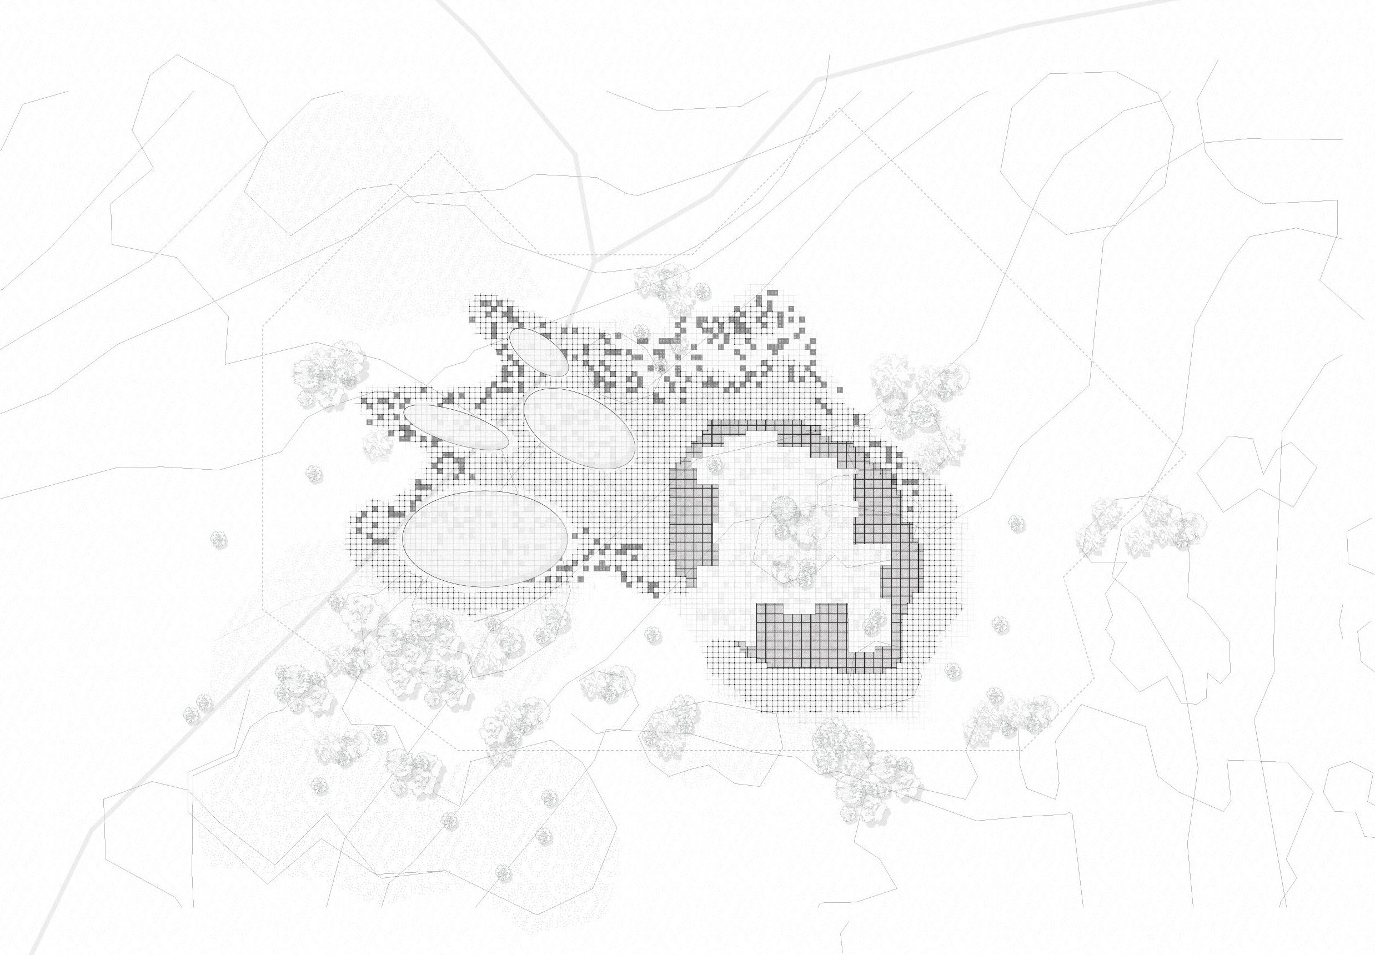

**Plan**

*CONCEPT*

The strongest concepts are often the simplest. The ones that are driven by their constraints rather than fighting them. “The Cloud” is a sacral place of water and sun.

Built with locally known techniques, from materials pres- ent on the island, and withstanding the harsh weather by embracing it and letting it through. Beginning with a 1x1 meter grid, it scales organically, forming a system that

Behind the simplicity are important reasons. Firstly, it can be built by everyone with local knowledge, only bladders and solar panels need to be brought from afar. Secondly, wind affects the structure only minimally, as it is entirely permeable, and the PV panels are oriented to minimise uplift wind just passes through. Bamboo, with its great flexibility, offers unique structural strength given the ap- plied forces. Thirdly, water is stored in large bladders which can be rolled up and stored when not needed, making them easy to transport to the site. Additionally,

their weight when filled can be used to anchor the bam- boo in the ground, creating a strong bond between the solar and water structure. Three drivers that not only ne- cessitate a form but also allow it to flourish.

Aesthetically, the resulting sculpture is familiar, grounded, and rooted in its surroundings, and yet, it is also ephem- eral and ever changing. Alluding to something larger

and greater than what is visible, the building blocks of squares and grids dissolve into a drifting cloud, which is ever changing from perspective. Inside the structure a feeling of a temple arises, spaces that are hard to de- scribe from the outside offer a space to interact with the forces of wind, sun, and water.

*TECHNICAL SPECIFICATIONS*

Monocrystaline photovoltaic panels form the primary part of our concept, not only because of the design brief but also because of its high performance efficiency, it would have also been our first choice. We chose solar because it is well-suited to Fiji’s sunny climate, reliable, and can be maintained locally with basic training. We wished not only to use the PV panels as an afterthought but as in in- tegral part, a highlight of the land art.

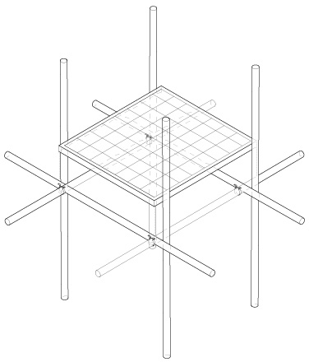

Bamboo Beam Ø 50mm

Solar Panel

Aluminum Clamps

The PV panels are placed horizontally as well as verti- cally facing East, West and North. Orienting the panels towards East and West is done to produce energy when the demand is highest – during mornings and evenings. Diversifying the orientation was done to distribute the pro- duction over the day. The 1000m² of PV proposed could produce ca. 345 MWh/a. This would be enough to supply over 100 households.

The rainwater harvesting system collects water from the structure and stores it in several ampoules (membrane storage) laying at the base of the structure. This system is chosen both for its flexibility, simplicity of installation and maintenance or replacement all resulting in reduced investment costs. The storage is able to provide clean water during the dry season and also act as a stormwater buffer during heavy rains. This helps address local water shortages and reduces flood risks.

We selected this technology vs other technologies such as evaporative water collection, fog- condensation collec- tion, or even ground water because rainwater collection is the easiest, most economical as well as ecologically least invasive method. Since Fiji receives plenty of rain over the year, the bottle neck is not water availability but actu-

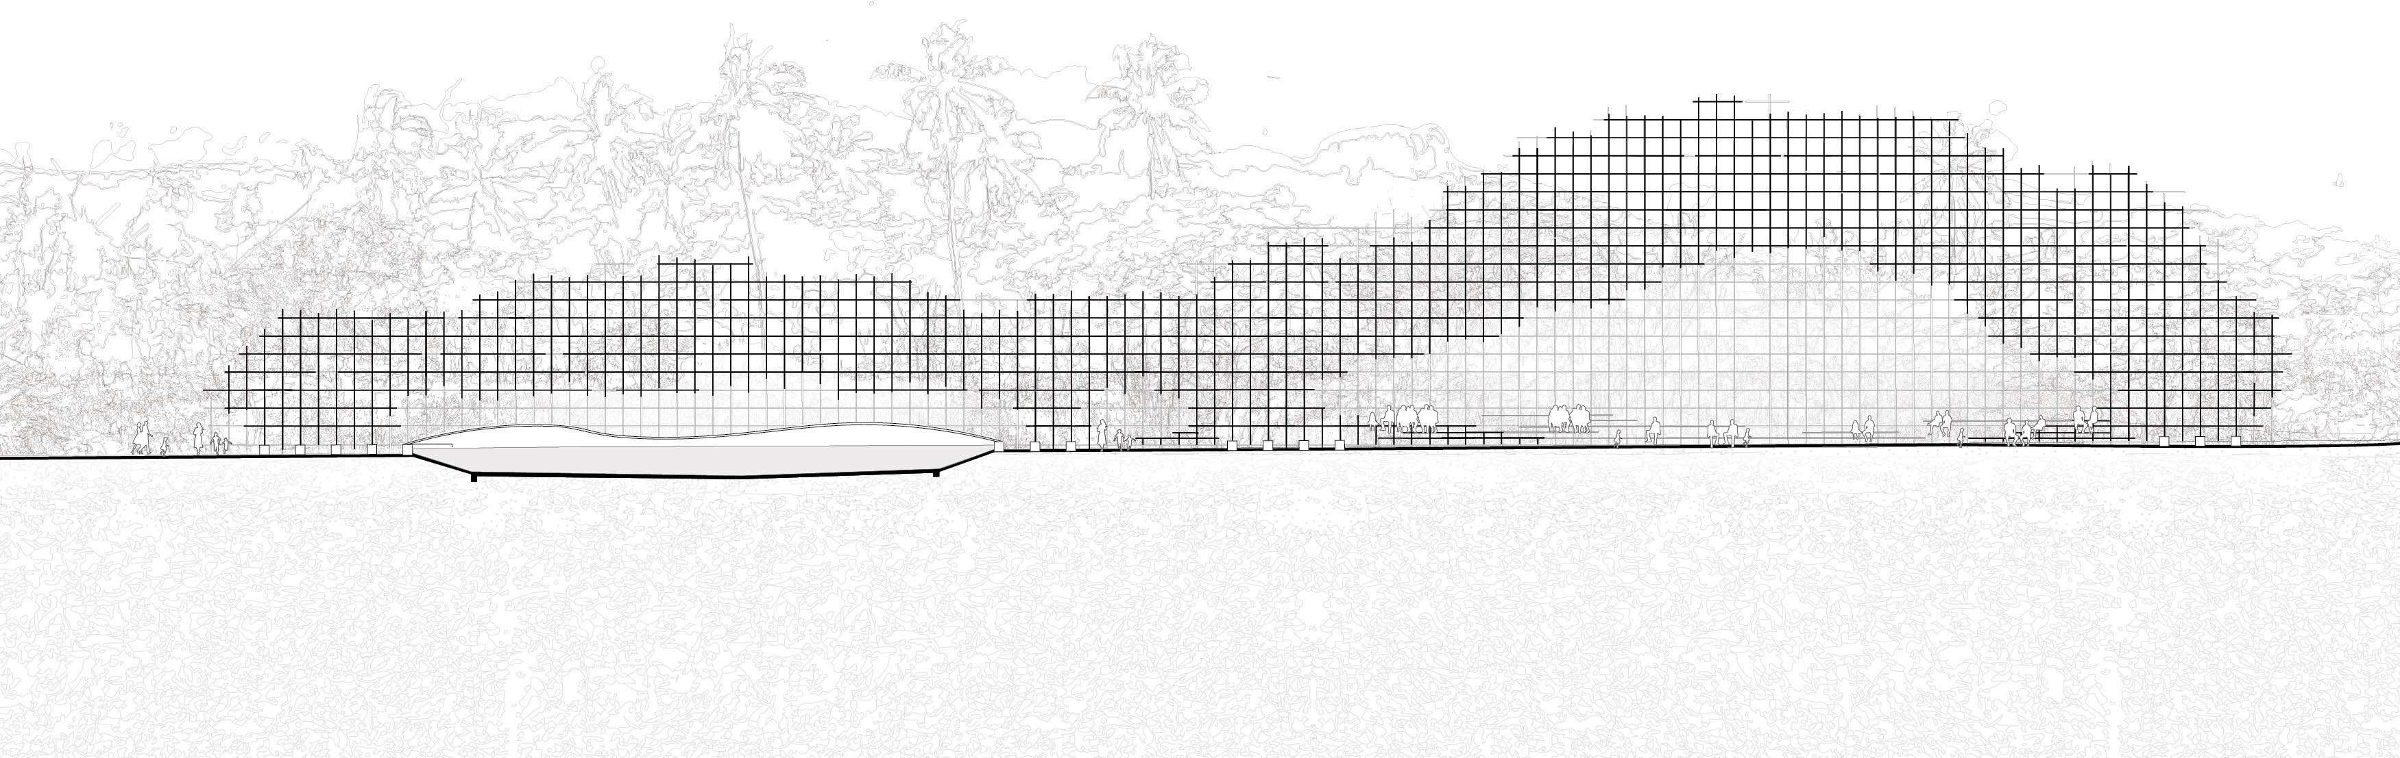

**E-W Section**

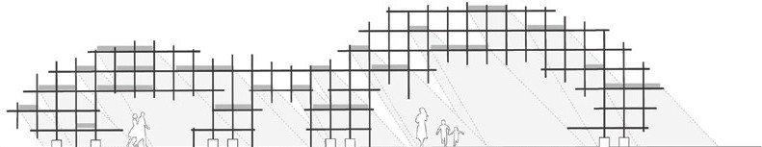

**Sun**

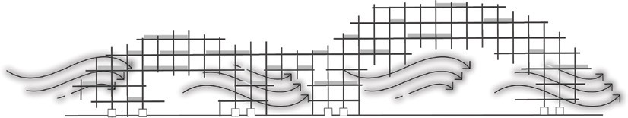

**Wind**

**Assembly Detail Connection Detail**

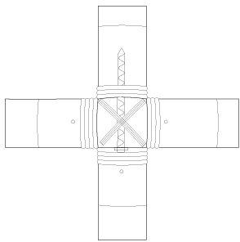

Bamboo Beam Ø 50mm

Renforced Bolt Ø10 mm

Cotton Rope

Woden Peg

ally just storage. The water from the roof and footprint of the structure, which is 1500m², is collected and stored in a reservoir of 140m³. The sizes were calculated consid- ering the existing collective storage in the village and the monthly rainfall collection potential to ensure that there is sufficient water for the village through the entire dry sea- son until October.

*PROTOTYPING, IMPLEMENTATION & OPERATION*

The simplicity of the design allows for simple collabora- tion. Ahead of the final drawings, the international team will take a trip to Fiji to meet with the local team to under- stand their techniques and capabilities for construction in more depth. The international team will then prepare an esti- mation of the material required and coordinate the sourc- ing with the local team. Additionally, all teams will discuss the requirements for the site preparation.

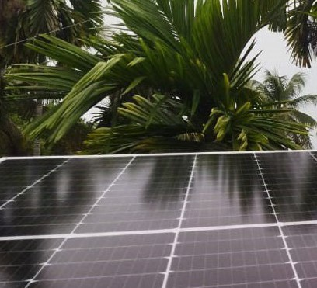Subsequently, the team will finalize their drawings and order the material not available on site. Once everything has arrived, the local team will be able to set up the project based on the prior discussions and instructions developed together.

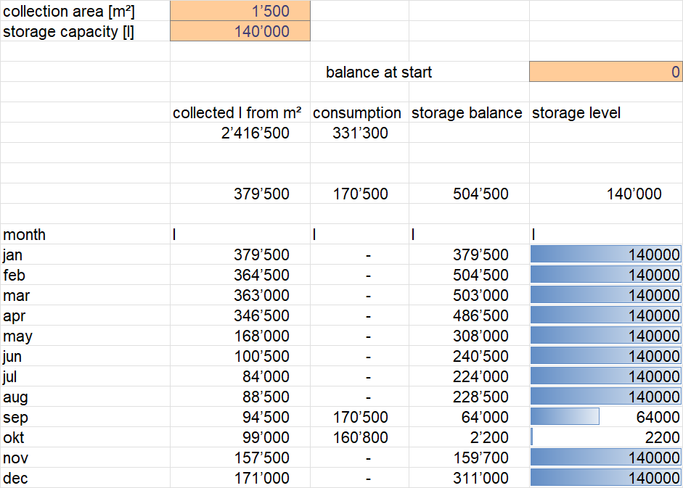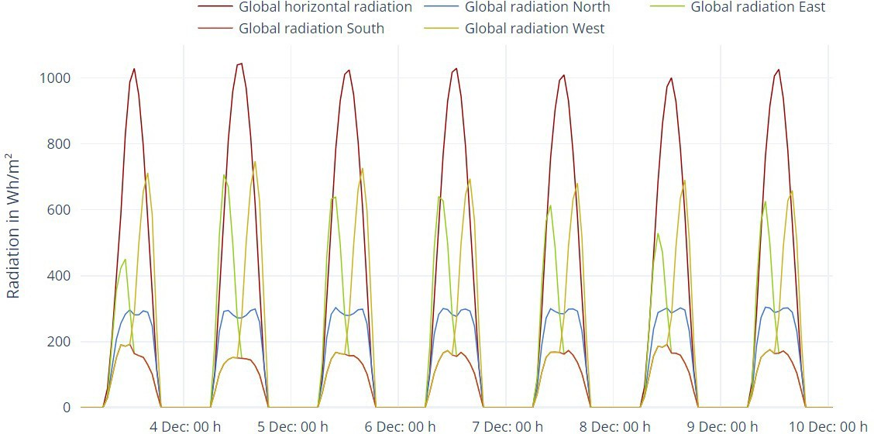

The international team will be available for problems during this phase and will adapt on the fly if necessary. The team will then arrive for a second time once the basic structure is finished and support with the setup for the electrical elements and taking the whole sculpture online. Thus, the integral strategy of prototyping is, discuss and prepare, test and execute, adapt and finish.

The systems were mindfully chosen to be very robust and require minimal uncomplicated maintenance. The structure is to be operated and maintained by the local community through a village water committee. This group is to be responsible for daily use and regular checks.

Community members are to be trained to handle tasks like cleaning the rainwater filters, checking the bamboo frame, and keeping track of the water level in the res- ervoir. The design also encourages people to interact with the structure regularly, which helps build a sense of shared responsibility.

The rainwater system is to be cleaned before and after the rainy season to prevent blockages. The reservoir below the structure has built-in channels to handle extra

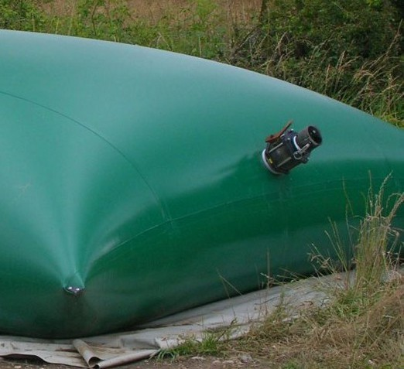

water during storms, so it is to be used to help reduce flooding. Simple water testing kits are to be used every month to make sure the water stays safe for use.

The solar panels are to be cleaned once every 2–3 months during normal, rainy periods (the rain helps clean panels) or every 1–2 months during the dry season. After a cyclone or major storm, it should be checked for dam- age or to remove debris. A trained technician from the village is to check the wiring and batteries once a year.

The bamboo structure is designed to be easy to repair. Every year, it is to be inspected and treated to protect against pests and weather damage. If a part breaks, it is to be replaced using local bamboo and simple building methods. The grid system makes it easy to fix one sec- tion without affecting the whole structure.

The structure is also designed to handle cyclones and heavy rains. It can be reinforced or partly taken down be- fore a storm if needed, and the reservoir is to hold extra rainwater to help reduce the flooding risk in the village.

*ENVIRONMENTAL IMPACT*

The installation is designed to have a minimal impact on the natural ecosystem, but some effects are possible. Using bamboo and modular construction reduces the need for heavy machinery, which helps to minimize the disruptions to the surrounding land and streams during construction. Since bamboo is one of the fastest growing plants, it would be easy to replenish the bamboo used for the construction. the treatment of bamboo is usually done by immersing it in borax solution. The disposal of the solution is to be done in a responsible manner.

Collecting rainwater and storing stormwater can slightly change natural runoff patterns. To avoid negative effects, overflow from the reservoir is to be directed back into natural drainage channels in a controlled way. This helps prevent erosion and protects the seasonal streams. The structure also acts as a buffer during heavy rains, reduc- ing the risk of downstream flooding, which can benefit the local ecosystem.