**MAROU VILLAGE’S**

**OASIS FARM KEREKERE**

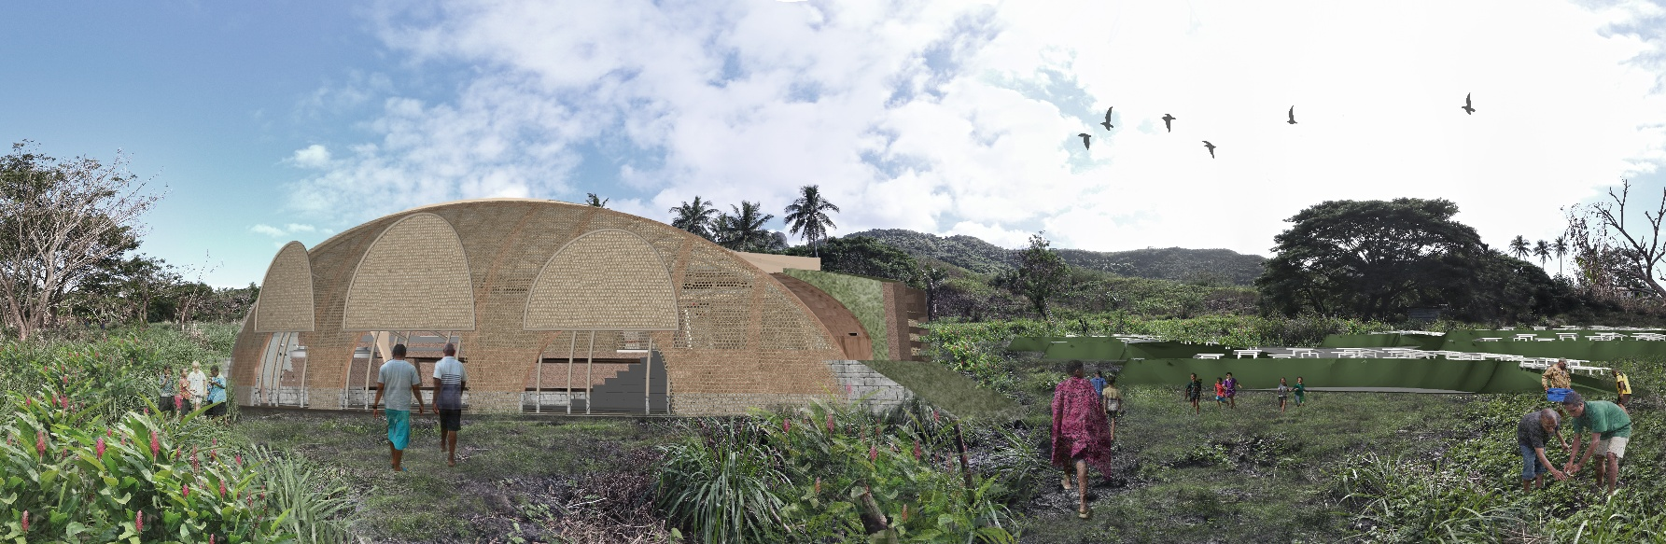

**Concept Narrative**

*Kerekere* in Fijian means a site for "sharing" they need, and that highlight community bonding and collective caring. From a landscape design standpoint, Oasis Farm connects local food production, water use, energy resources, and natural elements. By combining the two ideas, our project gradually expands its design capabilities beyond the production of electricity; it makes use of solar panels and incorporates the natural site's power into an indoor and outdoor community area with multiple uses. With this design strategy, the area is guaranteed to provide economic opportunities, build community facilities that are flood and cyclone-resistant, and eventually improve the quality of life for the Marou villagers.

Oasis Farm Kerekere integrates small-scale building intervention and landscape. Firstly, the community shelter facilitates electricity generator inside. It is resistant to cyclone damage following the Bure House design rules, which call for low-lying construction, less openings, and free-hanging structures. The curved wall and light-steel roof complement the natural contours of the ground, minimizing the need for Major changes to the topography. By utilizing clay, lime, beach sand and mud, the wall materials improvise native construction techniques. These materials serve as both a wind-sound catcher and a cultural expression tool, catching low-frequency sounds and highlighting the distinctive heritage of the Fijian people and region. With its decentralized battery system, solar panel roof, rainwater collection, stormwater treatment, and areas for tourism agendas and community development initiatives, each unit of shelter is ultimately made to be a multipurpose powerhouse of Marou Village.

Secondly, landscape intervention incorporates a low-maintenance amphitheater space and pathway landscape to create a venue for children’s activities, cultural performance, and gatherings events without eliminating the village cassava farming spaces. The injected rainwater harvesting system generously implements land cutting and underground modular tank and piping direct to village, reducing complexity to work with villager community in the field.

Overall, Oasis Farm Kereke is a co-creation that creates a resilient, inclusive, and vibrant environment for the long-term community benefit throughout the enhancement of the community strength to produce cassava food resource, utilize Fijian earth materials, be adaptive to new technological construction, and preserve art culture practice.

**Technical Narrative**

**1. PV Array & Inverter Configuration**  
We will install 138 × 550 Wp photovoltaic modules (50 V DC, 11 A Isc), organized into eight discrete arrays. Six arrays will employ a 3 in series × 6 in parallel configuration (3S6P, 66 A per string), and two arrays will utilize a 3 in series × 5 in parallel configuration (3S5P, 55 A per string), achieving a total DC capacity of 75.9 kW. Each array will be connected to a dedicated 10.2 kW hybrid inverter, accepting up to 150 V DC input and delivering 230 V AC to the grid while simultaneously providing a 48 V DC output for battery charging. All inverters and eight 48 V / 200 Ah (9.6 kWh) Power Walls will be housed within an IP65-rated “Power House” enclosure.

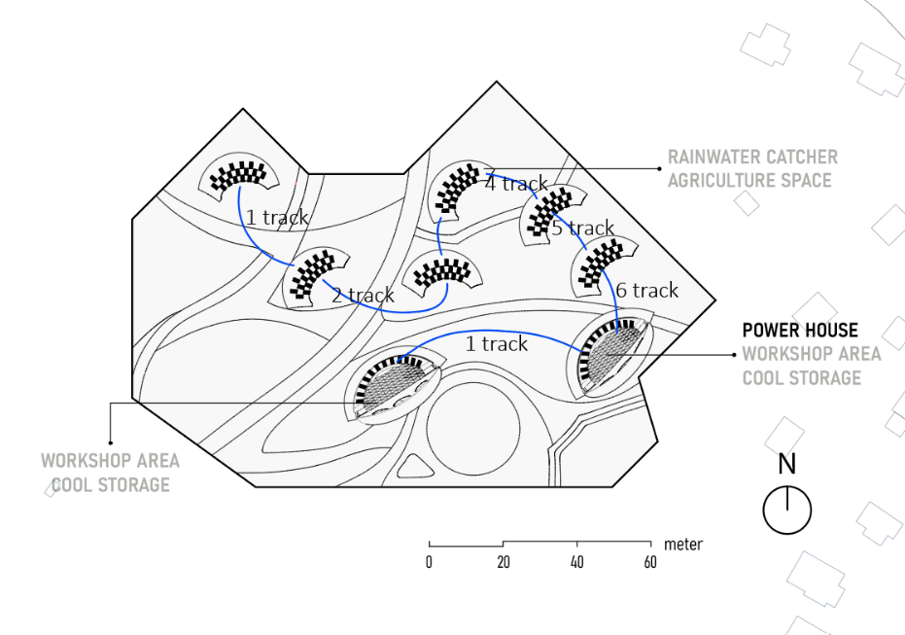

**2. Subterranean DC Conduit for Cyclone Resilience**In order to mitigate risk from wind-driven debris and ultraviolet exposure in this cyclone-prone locale, we shall install all DC conductors within underground conduits extending from each IP66-rated, ventilated combiner/MPPT enclosure to the Power House.

* **Conduit and Trench Specifications:** Schedule-40 PVC or stainless-steel conduit shall be buried at a minimum depth of 300 mm. A detectable warning tape will be placed 150 mm above the conduit, and a minimum separation of 150 mm from AC conduits will be maintained.
* **Cable Selection and Sizing:** We will employ sunlight-resistant, DC-rated, direct-burial conductors (or THHN within conduit), sized to limit voltage drop to ≤ 2 % at 66 A (approximately 70 mm² copper) with an ampacity derating of 10–25 % to account for elevated soil temperatures. Pull-strings and lockable pull-boxes will be provided approximately every 50 m to facilitate future cable replacement or upsizing.

**3. Surge Protection and Earthing**

* **Combiner Enclosures:** Each string input will be protected by a DC surge protection device (SPD).
* **PowerHouse:** AC surge arrestors and additional DC SPDs will be installed at each inverter.
* **Earthing System:** All metallic structures, enclosures, and conduits will be bonded to a centralized earth grid in accordance with relevant standards.

**4. Access for Inspection and Maintenance**Combiner/MPPT enclosures will be mounted just above ground level to permit routine visual inspection. Underground pull-boxes will enable insulation testing and conductor replacement without necessitating further excavation.

**5. Energy Generation Projections**Applying the site’s average irradiance yield of 4.8 kWh/kWp·day:

* **Raw Generation:**
  + Daily: 75.9 kWp × 4.8 kWh/kWp = 364 kWh
  + Weekly: 364 kWh × 7 = 2 548 kWh
  + Monthly: 364 kWh × 30 = 10 920 kWh
  + Annual: 364 kWh × 365 = 132 860 kWh
* **Adjusted Generation (Performance Ratio = 0.75):**
  + Daily: 364 kWh × 0.75 = 273 kWh
  + Weekly: 273 kWh × 7 = 1 911 kWh
  + Monthly: 273 kWh × 30 = 8 190 kWh
  + Annual: 273 kWh × 365 = 99 645 kWh

Seasonal variability (± 10–20 %) will influence these estimates. Nonetheless, the 75.9 kWp array, complemented by 228 kWh of storage capacity, is designed to satisfy Marou Village’s average daily demand of 244 kWh—storing midday surplus and discharging during evening hours.

This configuration, informed by module and inverter specifications, engineered for cyclonic conditions, and incorporating subsurface DC cabling with comprehensive surge protection and maintenance provisions, will ensure both resilience and serviceability. We remain prepared to provide detailed cable-sizing calculations, trench-layout schematics, or wind-load analyses upon request.

**Prototyping and Pilot Implementation Statement**

The masterplan is developed through a prototyping and full-scale pilot implementation process, in close collaboration with the local community. The design strategy optimizes cut and fill techniques based on existing elevation contours, minimizing excavation while maintaining natural terrain integrity. Installation unit placements are oriented to maximize connectivity—both physically and infrastructurally—between mound-shaped structures, while integrating mechanical, electrical, and plumbing (MEP) networks seamlessly across the site.

Architecturally, the installation is conceived to mimic natural hills, blending into the landscape while functioning as passive thermal systems. The exterior structure uses a double-layered retaining wall system, composed of locally sourced bamboo weaving structure and plastered by lime and beach sand mixtures. Special for the powerhouse unit, the wall is using terracotta cooling system inspired by Indian architects. These porous clay materials allow water inside the walls to seep out and evaporate, creating an evaporative cooling effect that naturally regulates interior temperatures and reduces dependency on mechanical cooling systems.

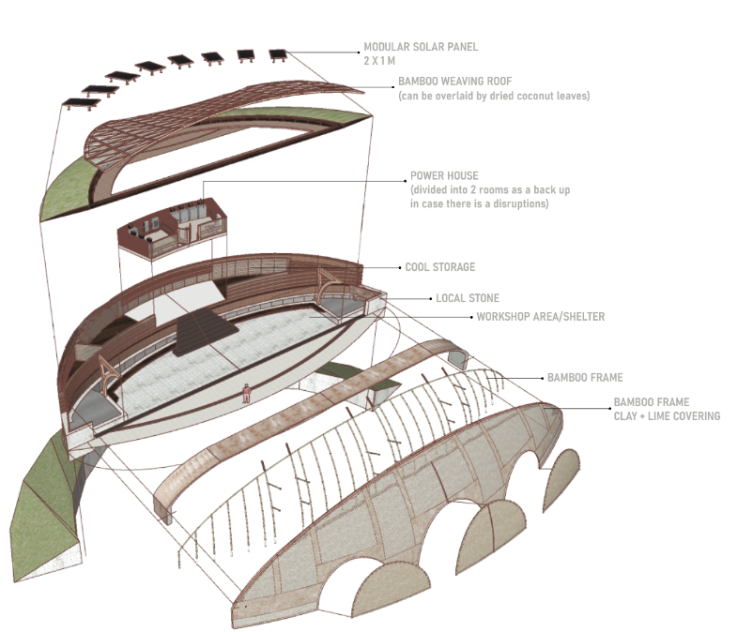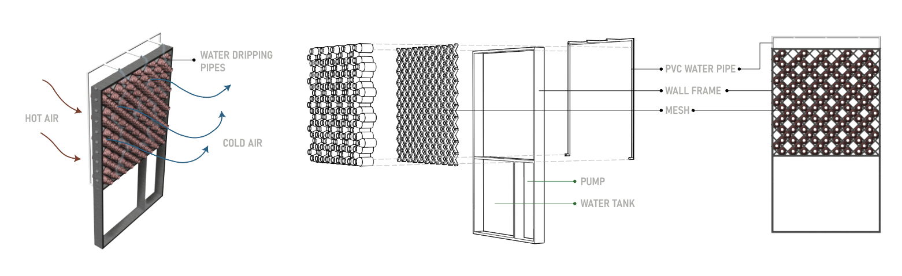

Structural reinforcements include the use of rammed earth cores, combined with timber bracing and steel joint connections to enhance seismic and wind resistance, especially on sloped terrain. Floor slabs use compressed earth blocks (CEB) reinforced with steel mesh, maintaining low thermal mass on interior surfaces while allowing heat release through ventilated cavities.

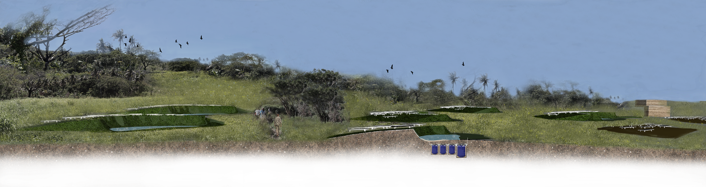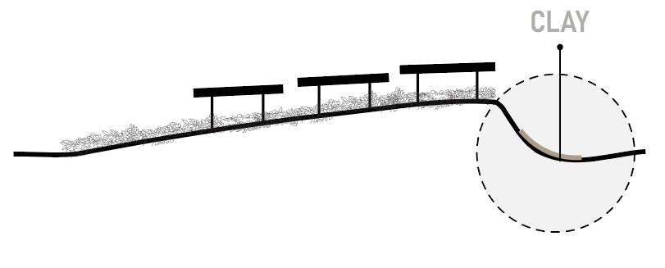

On the other side, local clay is also utilized in the construction of rainwater catchers on the other 6 units other than the powerhouse and workshop area (as the concave surface layering), ensuring material continuity and enhancing sustainability. Meanwhile, the structural integrity is reinforced through the combination of engineered bamboo frames, local hardwood, and recycled corten steel. Pathways and public spaces between buildings are embedded with locally sourced stone and permeable paving (such as local pebbles or stones), promoting water infiltration and reducing surface runoff.

**Operations and Maintenance Statement**

Throughout community workshop agendas, the powerhouse construction can be erected and maintained easier collaboratively by the community as it embraces traditional building material but infuse with modular system of light steel structure and bamboo-lime sand plastered wall. For sturdy bamboo walls with lime-beach sand plaster, operation focuses on ensuring structural integrity and water resistance, while maintenance emphasizes regular cleaning and occasional treatments to extend the lifespan of the bamboo.

1. **POWERHOUSE SHELTER**

***Placement and Support:***

Ensure walls are properly braced and supported to prevent bowing or collapse. Use appropriate foundations such as local black stone inherited from Bure House architecture and ensure proper drainage to prevent water buildup. To find the proper black stone, the project committee can conduct material survey planning together with local villagers who have expertise and knowledge in local material.

***Protection from Moisture:***

Protect walls from direct rain or prolonged exposure to moisture, which can lead to fungal growth and decay. As the shelter is located in an open site, fungal growth can be avoided through the lime-sand plastering.

***Sunlight Protection:***

While bamboo structure is strong, prolonged exposure to sunlight can dry it out and weaken it. Instead of using roof shading from direct sun, the community can use planting material located in front of the building face. The height of the plants should be lower than the powerhouse roof to avoid shading the solar panel area.

***Regular Inspection:***

Periodically inspect walls for any signs of damage, such as cracks, delamination, or insect infestation, and address any issues promptly. This can be conducted annually by a village builder group together with construction specialists assistance.

***Cleaning:***

Regularly clean the earthen clay pots within bamboo structures as well as the mud wall, to remove dirt, debris, and potential fungal growth. Use a soft brush and a mild detergent, if lime washing cannot erase the fungal or dirt. The washing should be carried out at least every year. The treatment can be carried out by trained villagers for regular cleaning.

***Treatments:***

Consider treating the bamboo periodically with a wood oil or sealant to protect it from weathering and staining. The mud wall can be re-plastered by the community every 2 years.

***Addressing Damage:***

The community can participate in local workshops to address any minor damage, such as small cracks to the earth terrcota pot and mud wall or even loose bamboo pieces, to prevent further deterioration. The broken clay pot can be replaced with a new one if necessary. The villagers need to check the component regularly, at least once – twice a year to identify specific damage in the checking list paper.

***Professional Inspection:***

Consider having a professional inspect the walls periodically, especially in areas with harsh weather conditions or high insect activity.

***Repair or Replacement:***

If damage is significant or structural integrity is compromised, consider repairing or replacing damaged sections of the wall to maintain its strength and safety. As the bamboo structure material and claypot making skill are originally traditional practice and knowledge in Marou community, the process of repair or replacement can be improved better through the technical integration using modern joints with a bolt and/or nail system.

1. **SOLAR PANEL**

Community maintenance of solar panels involves regular cleaning and inspections to ensure optimal performance and longevity. Cleaning removes debris and dirt that can reduce sunlight absorption, while inspections check for damage, loose connections, or other issues. Communities can also benefit from monitoring systems and professional maintenance, as well as avoiding shading and ensuring proper panel orientation.

***Cleaning:***

Regular cleaning of solar panels is crucial to remove accumulated dirt, dust, leaves, and bird droppings, which can block sunlight and reduce energy production. Communities can organize cleaning sessions, hire local labor for maintenance, or utilize automated cleaning systems.

***Inspections:***

Regular visual inspections are essential to identify any signs of damage, loose connections, or other issues that may affect the system's performance or safety. These inspections should include checking the panels, mounting systems, wiring, and inverter.

***Monitoring:***

Many modern solar panel systems come with monitoring systems that provide real-time data on energy production and system health. Monitoring can help identify any performance drops or potential problems early on.

***Professional Maintenance:***

Annual inspections and professional assistance, such as servicing the inverters and checking the wiring, are also recommended to ensure the collaborative operation and maintenance are operating safely and efficiently. In this part, the community can be provided with a guidance handbook containing the principle aspect of maintenance to minimize the knowledge gap in using the solar panel technology.

**Environmental Impact Assessment**

1. **OASIS FARM**

Oasis farming, while essential for food production and human survival in arid regions, can have significant impacts on the natural ecosystem. In this project context, our landscape design aims to alter the site as minimally as possible to reduce the risk of degrading existing ecosystem, land degradation, and loss of local biodiversity in the site. We use several landscape approaches, which are:

***Cassava planting areas as Buffer***

Local food sources from cassava farms are maintained and readjusted according to six different locations of the oasis pond and two powerhouse shelter. The surrounding cassava planting, with a few palm tree plantings, can help stabilize the altered landscape. The community can also improvise the sign system with local language and symbol, so it can be functioned as an information system while also a part of unique aesthetic enhancement.

***Water ponding as Support Ecosystems***

The six water pond areas support unique rainwater harvesting ecosystems that are adapted to the site's arid conditions, including various plant and animal species. All the water ponds can be the supportive clean water resource during the emergency situation, especially when villagers are experiencing a long drought. The total volume of clean water contained in all the ground tanks is approximately 8000 L.

1. **SOLAR PANEL**

Solar panels can have both positive and negative impacts on ecosystems. They can reduce greenhouse gas emissions and air pollution but also alter microclimates, potentially affecting plant life and soil health. Additionally, large solar farms can impact land use and habitat availability.

***Microclimate Changes:***

Solar panels can alter the microclimate beneath them, reducing sunlight, temperature, and soil moisture, which can affect plant survival and growth. Therefore, our design keeps the existing farming plants, reorganizes the planting area, supporting with new planting high tree in some areas without covering the solar panel area.

***Hazardous Materials:***

The manufacturing process for solar panels involves the use of some hazardous materials, which can pose environmental risks if not properly managed. The buffer of cassava plants surrounding the solar panel area, with a different height level from the ground, helps to reduce the risk of direct interaction with public events and community activities in the surrounding open space.

1. **BAMBOO-STRUCTURE BUILDING**

To effectively mitigate risks when building with bamboo in emergency situations, focus on rapid construction techniques, durable materials, and community engagement. Utilize prefabricated bamboo components, train local populations in construction methods, and integrate local knowledge with modern engineering principles. Ensuring proper ventilation, moisture control, and pest protection are also crucial, especially when the site experiences an emergency state after a cyclone disaster.

***Modular Design:***

Our design proposes modular bamboo structures that can be quickly assembled and adapted with local material appropriation knowledge in construction practice. The majority of the materials are local, which are terracotta claypot, mud, stone foundations, and bamboo itself.

***Prefabricated Components:***

While bamboo is a vast and fast-growing plant in Fiji, our building design utilizes light steel material to speed up roof construction and reduce on-site processing time.

***Simple Joints:***

Both the bamboo construction and light steel roof are robust and easy-to-learn joint designs for quick assembly conducted by the local builders.