B.U.L.A! (Building Up a Low-carbon Area in marou village)

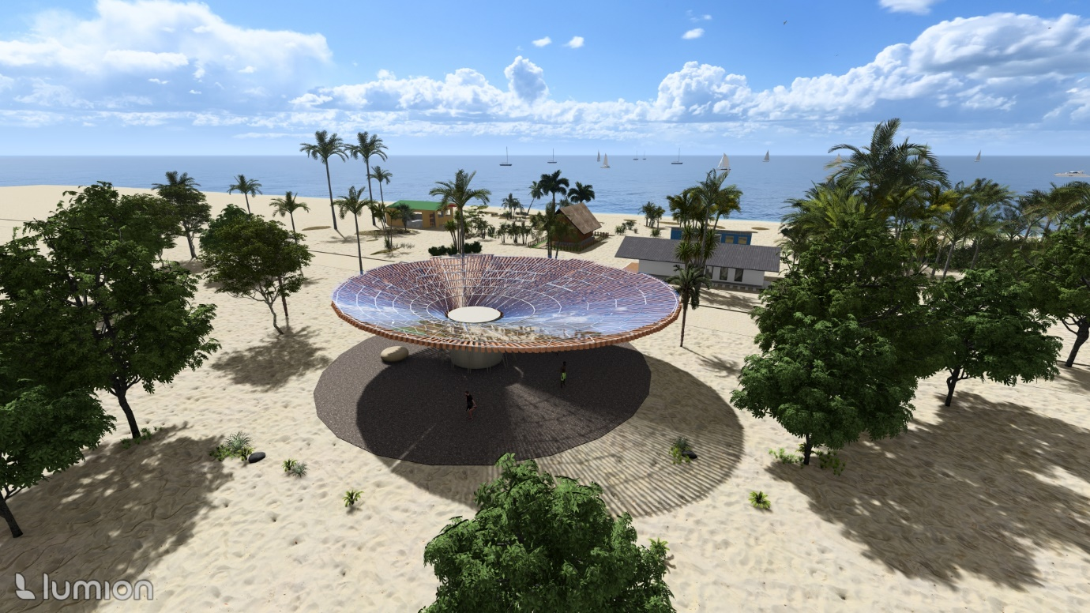

Contents

Prologue: Concept Narrative …2

Chapter 1: Technical Narrative …5
  - Solar energy
  - Wind generated energy
  - Solar chimney
Chapter 2: Prototyping and Pilot Implementation Statement …7

Chapter3: Environmental Impact Assessment

Concepting and site analysis

As global warming intensifies, access to reliable electricity and water is becoming increasingly difficult. Residents of marou village, the project's site, also face challenges in accessing reliable electricity and clean water. I want to solve these problems with renewable energy based on the marou village climate. I tried to design something that the residents could maintain sustainably and that could be integrated into their lives as naturally as possible. The goal is to make the village energy self-sufficient.

Through the site analysis of marou village, I propose a solar power system, wind power system, and heat exchange system with geothermal heat pump.

Technical Narrative
1.Solar energy
Solar panels are installed on top of the pavilion to supply electricity. They also serve as an aesthetic element, functioning as a sculptural feature. Since residents can rest beneath the pavilion, it naturally becomes a communal gathering space.

2. Wind energy
Create gaps between PV modules to allow wind to pass through quickly. A system is proposed in which small wind turbines are installed behind the PV modules, enabling both building-integrated photovoltaics (BIPV) and building-integrated wind power (BIWP) to operate simultaneously.
3. Solar chimney
Hot air is directed underground to undergo heat exchange. The cooled air resulting from the heat exchange then enters the interior space, allowing for ventilation without energy consumption.

