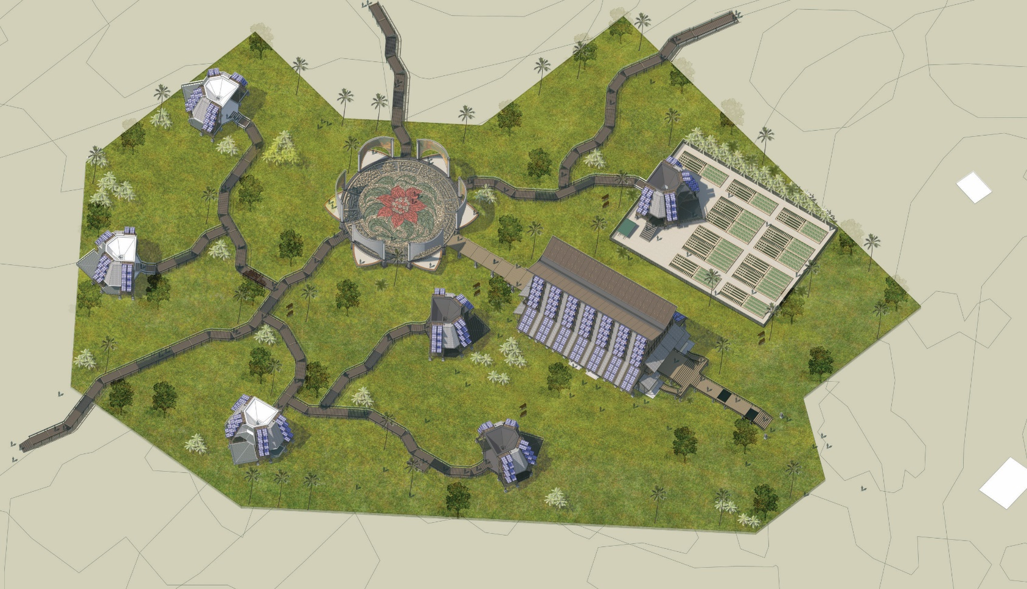
Valevuni Tagimoucia
Preserving Heritage Through the Threads of Culture, People, and Purpose

LAGI 2025 Fiji Narrative Report

- Concept Narrative
Considering the needs of the Marou village, we consider that rather than creating a monumental art installation which might be visually appealing for the villagers and visitors alike, we propose the construction of an art space that will host the performance and culture itself. It can contribute more to society while also incorporating technologies that can harness both sunlight and rainwater.
Our design team surmise our proposal under the concept of Valevuni Tagimoucia Complex, which stands as a profound tribute to the living traditions, natural cycles, and collective spirit of the Fijian people. Named after the rare and sacred Tagimoucia flower, found only on the highlands of Taveuni and said to bloom from tears of love and longing, the complex becomes both sanctuary and socio-cultural symbolism. Its design reflects not only ecological sustainability but also a cultural philosophy of interconnectedness, where every structure, system, and material work in a network of harmony with the land, the people, and their shared identity.
At the entrance of the site is the Vanua Hall, the primary built structure modeled after the great bure kalou and chief meeting halls of the past. Construction also integrates locally sourced timber, volcanic stone, dried palm fronds, and natural lime finishes, the hall speaks the language of place. Its steep, sheltering roof is not only an iconic silhouette but also a functional rainwater harvester, directing flow through bamboo gutters into terraced bioswales and subterranean cisterns. In the sides of the palm-woven eaves, photovoltaic panels absorb the island sun, converting it into power that sustains the complex's lighting, cooling, and educational technology. The solar system is intentionally visible, allowing it to serve as a learning platform for local communities, especially the youth, who can engage with renewable energy as both practicality, science, and stewardship.
Behind the hall lies the Veilua Circle, where stories, songs, and dances unfold. An open amphitheater surrounded by mosaic imagery from Fijian folklores, it is an open art space. Artists and cultural practitioners are invited to co-create, teach, and preserve knowledge through hands-on workshops, oral histories, and seasonal festivals, transforming the complex into a living museum and active archive of Fijian creativity. The site is also supported by the Tagi pods, modular pods that serve as multifunctional space, artist studios, meditation nooks, classrooms, or eco-labs for the community and the visitors. It represents organic medium, like seeds or coconuts, self-contained but part of a larger living system, and reflects emotional depth, personal journey, growth through reflection, and the power of vulnerability leading to beauty. It is also equipped with photovoltaic and rainwater harvester system. It can also support community crop fields through its water reservoir, and the crop land follows traditional rotational cycles and incorporate compost from the complex itself, closing nutrient loops and fostering regenerative agriculture. Elders guide younger generations in planting and harvesting, turning the field into a place of intergenerational learning, self-reliance, and cultural memory.
Connecting all elements is a network of timber pathways, known as the Flower’s Pathwalks, which lead the wanderers of the site towards the art generator infrastructures. These paths meander gently across the site, mirroring old village layouts where no space is too far from storytelling or ceremony. Along the way, small shelters, benches, and story-markers offer pause and reflection, turning the journey between spaces into an experience of its own.
Ultimately, the Valevuni Tagimoucia Complex is not just a place, a built environment that serves the local community through its design and functionality. It is an architectural process: a dynamic interplay of nature, heritage, and innovation. It represents a model of architecture that learns from the past, honors the present, and prepares for a future in which culture, climate, and community are indivisible. It may yeild functional potential to the local community, but it still reflects the history and socio-cultural dynamic of the Marou village while being sustainable and maintanable for the community itself.
- Technical Narrative
In accordance with the needs stated in the design guidelines, the design incorporates two main technologies into the design, which are the photovoltaic module system and the rain harvesting system. The photovoltaic system is used due to the abundance of sunlight in the area and also the need for continuous power supply that can create an independent living condition for the Marou villagers and the surrounding villages. The rain harvesting system is used due to the abundance of rainfall during the rainy season but the lack of water during the dry system. The rain harvester will be able to supply water, be it drinking water or water for irrigation for the villagers. The rain harvester is also symbolically connected to our main concept, as Rain is sacred, tied to ancestral weeping (Tagimoucia), so the harvesting system reflects receiving and repurposing divine gifts.
- The photovoltaic system
Based on the Q+A document provided by the competition, the minimum photovoltaic area needed for a 75KW electricity is 400 m2. Using this calculation as the basis for design, the Valevuni Tagimoucia Complex is equipped with a total of 416 photovoltaic modules (of which 224 are incorporated to the Vanua Hall and 32 are incorporated into each of the Tagi pods), which brings the total of photovoltaic area to 498 m2. The electricity produced by the PV module is then being kept using batteries (in this phase, we proposed the use of Testa Powerwall system), so that they can be used if needed. The PV module is also placed in a dynamic system that can be opened/closed depending on the weather and the sunlight. And as the PV module is integrated in a sloping rooftop, the design also incorporates staircases which the community can use to clean and maintain the PV modules, preserving their full potential.
- The rain harvesting system
The design incorporates metal rooftops on the Vanua Hall (which has about 176 m2 of roof area) and in the Tagi pods (each have 25,5 m2 of roof area). Considering that Naviti Island has an average annual rainfall of ~2,100 mm, we have made a simple calculation to determine the amount of rainwater that can be harvested. As the average is 2,100 mm, we determined that the monthly rainfall average is [2,100mm/year÷12months], yielding a 175mm/month rainfall. Using the formula
[Volume (litres)=Rainfall (mm)×Roof Area (m2)×Runoff Coefficient×1]
    - Rainfall (mm) = Monthly or annual rainfall for your area (get from Fiji Meteorological Service or local weather station).
    - Roof Area (m²) = The horizontal area of your roof (not the sloped surface).
    - Runoff Coefficient = A factor that accounts for loss (typically 0.8–0.9 for metal roofs; less for thatch or porous surfaces).
    - 1 = A constant to convert mm·m² into liters directly.

We calculated that the monthly water harvest estimate is as follows:
Structure | Roof Size Area (m²) | Monthly Volume Calculation | Result (litres/month)
6 Tagi pod modules (each has 25,5m2 roof) | 153 | 175 × 153 × 0.85 | 22.758,75
Vanua Hall | 176 | 175 × 176 × 0.85 | 26.180,00
Combined Total |  |  | 48.938.75

The system can yield an average of 49.000 L of rainwater monthly, which are then being stored in underground reservoir tanks. Some of this is filtered so that it is adequate for drinking, while the rest is used to water the proposed crops around the module.

- Prototyping and Pilot Implementation Statement
Considering the site, the design is developed using modular truss system that incorporates volcanic rocks as the foundation, timber as the main columns (with the help of steel platings as the connectors) and the façade materials, dried palm tree leaves as roof cover, and metal covering for the rooftops used as rain harvester. There are 2 main constructions that are essential in the technical narrative, which are the Vanua Hall and the Tagi pod. If chosen, the design team will give the stakeholders the chance to choose which of the structures should be built first, as both have their own advantages as an art generator structure. The prototyping will be done ex-situ, especially the truss system and the PV modules, and will be sent through cargo to the site. The local community can help with the foundation works, rooftop covering, and the assemblance in-situ. The design team will also bring several skilled workers to give an example on how to assemble the modules.

As our design, especially the Vanua Hall and the Tagi Pods, are inspired by traditional Fijian architecture, we hope that the local community can also give their input and contribute on carving the timbers with local artistical features. Our design also incorporates traditional fabrics as shading system behind the PV modules. We encourage the local community to provide the building with their traditional fabric, strengthening the bond between our design with the social community. We do hope that this unique combination of modern and traditional design can assimilate the skills, knowledge, and wisdom of the local community into our design.
- Operations and Maintenance Statement
The construction of Valevuni Tagimoucia complex embodies a collaborative vision that intertwines local knowledge, cultural heritage, and ecological stewardship. From inception, the project is grounded in participatory engagement with the local community, ensuring that they are actively involved not only in decision-making but in every phase of construction. Traditional artisans and community members are encouraged to contribute their insights into the environmental, social, and spiritual significance of the site, creating a healthy dialog between the design and the genius loci.

The integration of locally sourced materials into the design of the main buildings reflects a deliberate effort to anchor the architecture in its Fijian context, expanding the local’s skills and knowledge of construction. These in-situ materials are prepared through community-led processes, transforming resource collection into culturally meaningful practices. Construction workshops are hosted to combine the proposed modular systems with vernacular craftsmanship, enabling knowledge exchange while building capacity among local laborers and youth. The resulting approach not only reduces costs and enhances maintainability but strengthens local skills and ownership. This will ensure the building not ended up as a monument, but rather as a cultural construction for the local community.

Work crews are organized into village-based teams, rotating through different stages of the project, including foundation work, carpentry, roofing, and systems installation. We also encourage the Elders to oversee ceremonial milestones and provide cultural guidance, while the younger generation can assist in coordination, transportation, and digital documentation. Women’s associations play a central role in assembling woven elements for the shading fabrics, installing their artworks into the buildings, and cultivating the landscape that supports food security and biodiversity. This inclusive model ensures equitable participation across age and gender, fostering a deep sense of community investment.

The Photovoltaic modules and the rain harvesting system are the main features in the complex. Their longevity and sustainability should be guarded by the local community. For the PV modules, we propose to use small-to-medium off-grid PV systems with charge controllers and battery banks that are designed for tropical, humid environments. The modules should also have corrosion-resistant mounting and sealed battery units suitable for humid island climates. We also encourage the local community to have scheduled cleaning of the panels with soft cloth & water, to heck battery health, to spot wiring issues or corrosion, and, if needed, to replace fuses or connectors. As for the rain harvesting system, the focus of maintenance is on their Underground Water Reservoir. We propose to use ready-made water tanks, but if needed, we can also replace it with concrete or heavy-duty plastic tanks with a manhole access, first-flush diverters, and overflow outlets that are easy to clean. Local community can help the maintenance with scheduled community cleaning (using long brushes, mild cleaning solutions (or vinegar), and basic pumps or buckets to empty and scrub the interior of the tanks), and link stewardship of water systems to existing communal rituals, elders' oversight, or youth group responsibilities, fostering ownership

Upon completion, the local community of Marou assumes ongoing stewardship of the complex, organizing maintenance and programming through rotating committees modeled after traditional governance. In this way, the built environment remains a dynamic, living entity—adaptable, locally managed, and intimately tied to the values of its people. The complex thus becomes a resilient and enduring symbol of Fijian identity, sustainability, and unity through shared creation.

- Environmental Impact Assessment
While the Valevuni Tagimoucia complex aims to embody environmental harmony and cultural respect, certain aspects of its construction and systems may pose negative environmental impacts if not carefully managed. The installation of photovoltaic (PV) modules, while essential for renewable energy, involves upstream environmental costs. The extraction and processing of materials such as silicon and rare metals can lead to pollution, habitat disruption, and resource depletion. Over time, improper disposal of aging panels may contribute to electronic waste and potential soil contamination. Similarly, rainwater harvesting systems, though beneficial in reducing reliance on municipal water, can introduce risks to water quality if rooftops contain contaminants or if systems lack proper filtration. Certain roofing materials may leach chemicals into collected water, affecting its usability for irrigation or consumption.

Construction activities also carry broader environmental implications. Site clearing may lead to deforestation, soil erosion, and the loss of native plant and animal habitats. Noise, dust, and waste from machinery and building processes can temporarily disrupt local ecosystems and community life. In regions like Fiji, where natural resilience and biodiversity are vital, such impacts require thoughtful mitigation. Runoff during construction can pollute nearby waterways, especially if land management strategies are not in place. Additionally, construction generates significant material waste—particularly plastics, packaging, and cement by-products—that, if unmanaged, can strain local disposal systems.

To minimize these effects, the project emphasizes sustainable practices such as using recyclable materials, integrating local building techniques, employing proper filtration in water systems, and engaging the community in environmental stewardship. Through proactive design, education, and monitoring, Valevuni Tagimoucia can serve not only as a model of cultural resilience but also as a responsible environmental intervention that balances innovation with protection of the land and its resources.

